1 A parallelogram must be a rectangle when its
1) | diagonals are perpendicular | 3) | opposite sides are parallel
2) | diagonals are congruent | 4) | opposite sides are congruent

2 If is the image of , under which transformation will the triangles not be congruent?
1) | reflection over the x-axis | 3) | dilation centered at the origin with scale factor 2
2) | translation to the left 5 and down 4 | 4) | rotation of 270° counterclockwise about the origin

3 If the rectangle below is continuously rotated about side w, which solid figure is formed?

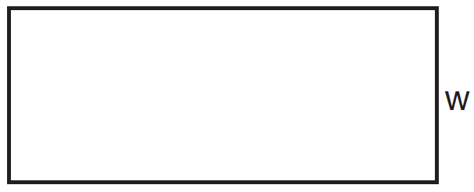
1) | pyramid | 3) | cone
2) | rectangular prism | 4) | cylinder

4 Which expression is always equivalent to when ?
1) |  | 3)
2) |  | 4)

5 In the diagram below, a square is graphed in the coordinate plane.

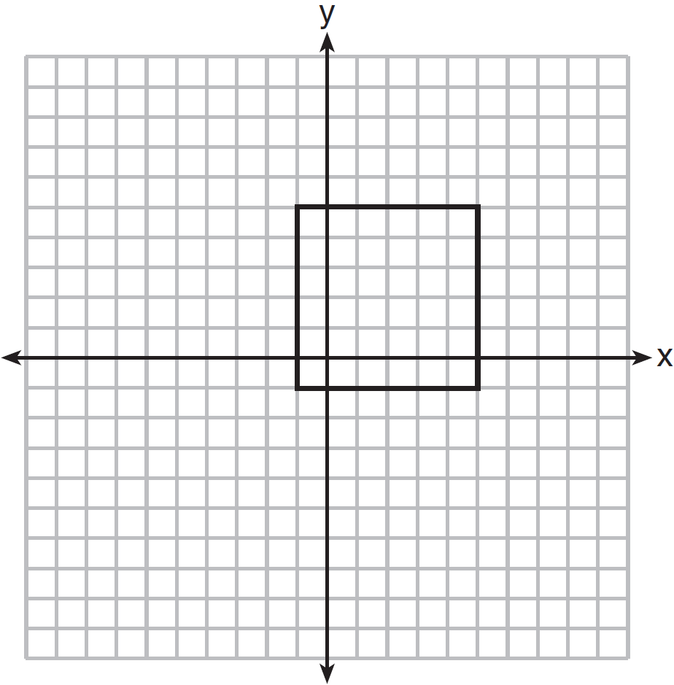

A reflection over which line does not carry the square onto itself?
1) |  | 3)
2) |  | 4)

6 The image of after a dilation of scale factor k centered at point A is , as shown in the diagram below.

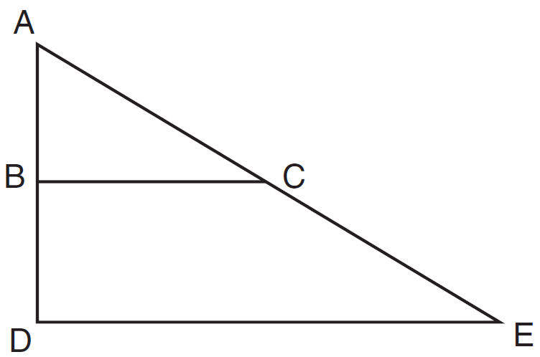

Which statement is always true?
1) |  | 3)
2) |  | 4)

7 A sequence of transformations maps rectangle ABCD onto rectangle A"B"C"D", as shown in the diagram below.

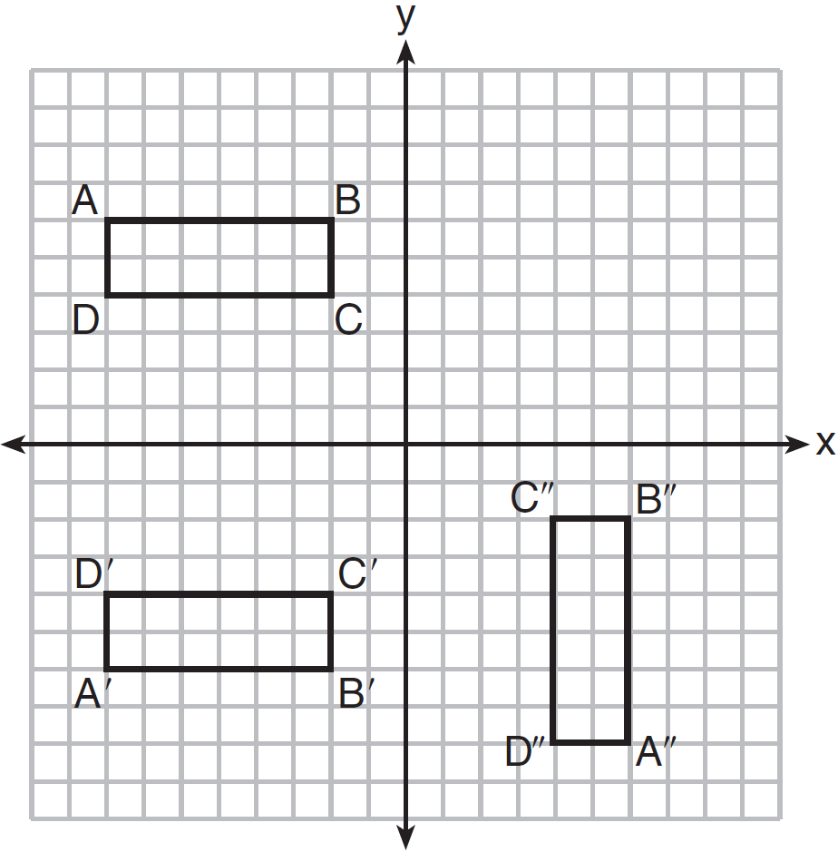

Which sequence of transformations maps ABCD onto A'B'C'D' and then maps A'B'C'D' onto A"B"C"D"?
1) | a reflection followed by a rotation | 3) | a translation followed by a rotation
2) | a reflection followed by a translation | 4) | a translation followed by a reflection

8 In the diagram of parallelogram FRED shown below, is extended to A, and is drawn such that .

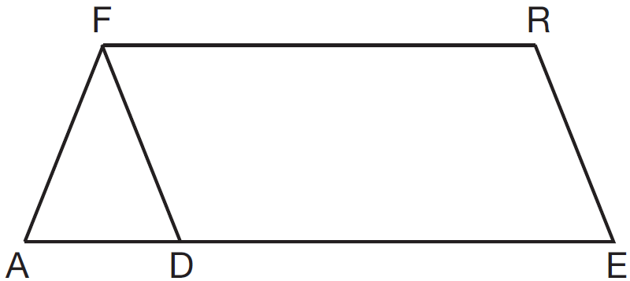

If , what is ?
1) | 124° | 3) | 68°
2) | 112° | 4) | 56°

9 If is the equation of a circle, the length of the radius is
1) | 25 | 3) | 5
2) | 16 | 4) | 4

10 Given shown below, with and , what is an equation of the line that passes through point and is parallel to ?

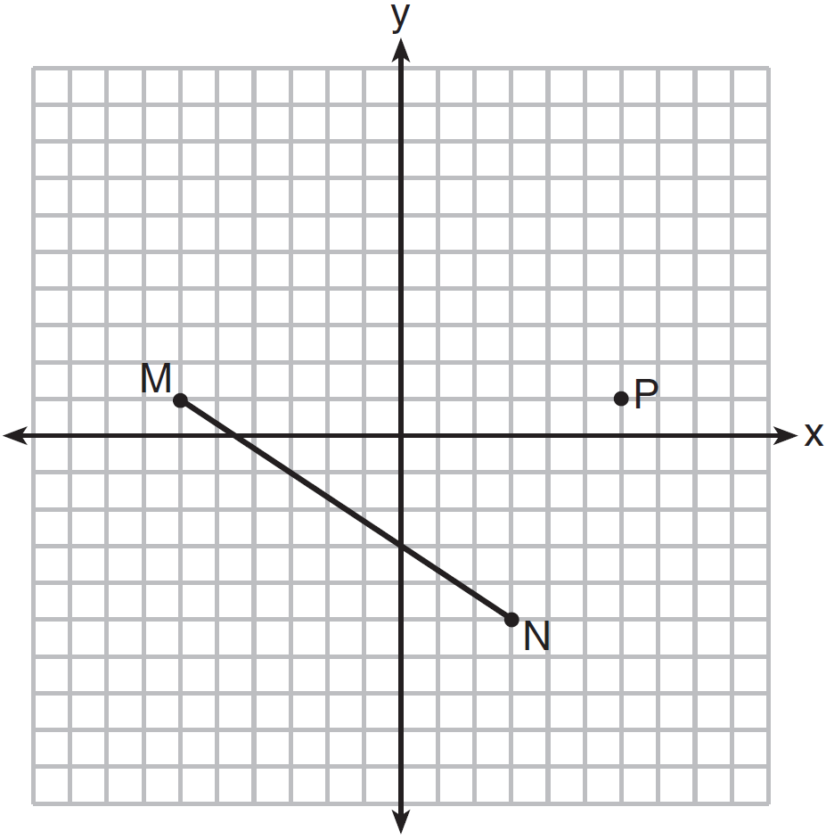
1) | 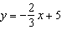 | 3) | 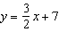
2) | 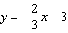 | 4) | 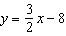

11 Linda is designing a circular piece of stained glass with a diameter of 7 inches. She is going to sketch a square inside the circular region. To the nearest tenth of an inch, the largest possible length of a side of the square is
1) | 3.5 | 3) | 5.0
2) | 4.9 | 4) | 6.9

12 In the diagram shown below, is tangent to circle O at A and to circle P at C, intersects at B, , , and .

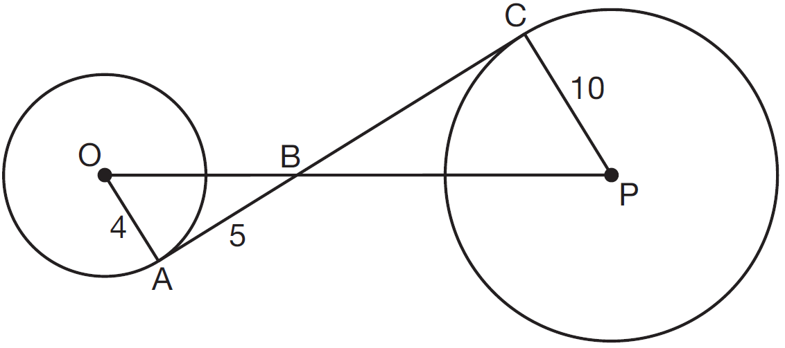

What is the length of ?
1) | 6.4 | 3) | 12.5
2) | 8 | 4) | 16

13 In the diagram below, which single transformation was used to map triangle A onto triangle B?

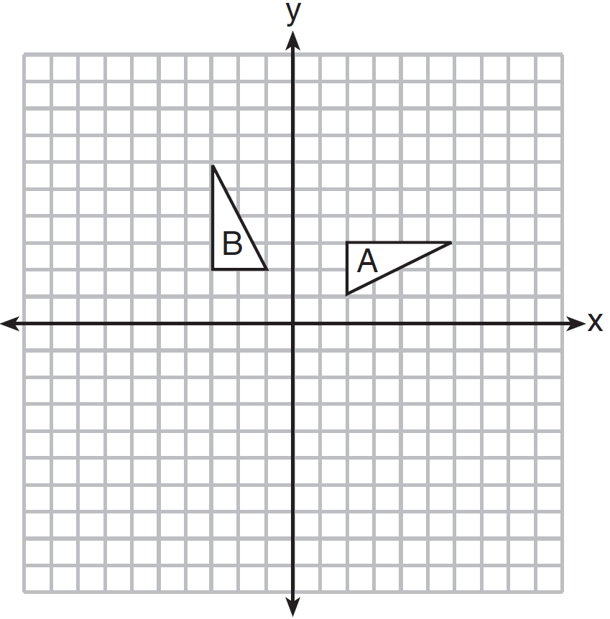
1) | line reflection | 3) | dilation
2) | rotation | 4) | translation

14 In the diagram below, is the image of after a clockwise rotation of 180° and a dilation where , , , , , and .

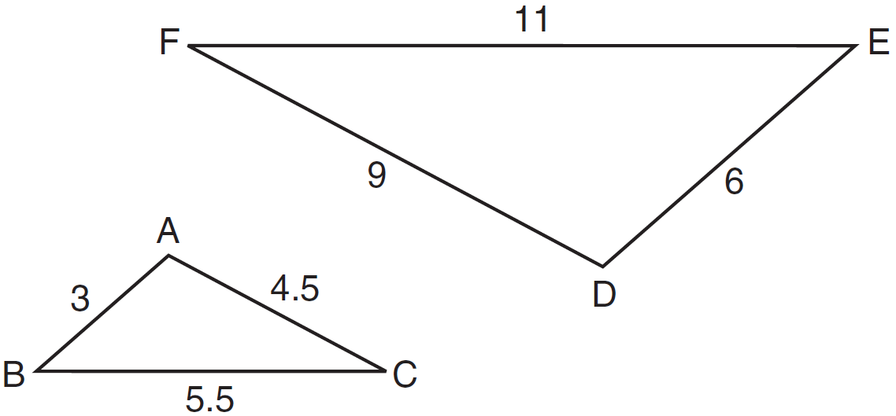

Which relationship must always be true?
1) | 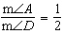 | 3) | 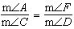
2) | 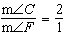 | 4) | 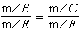

15 In the diagram below, quadrilateral ABCD is inscribed in circle P.

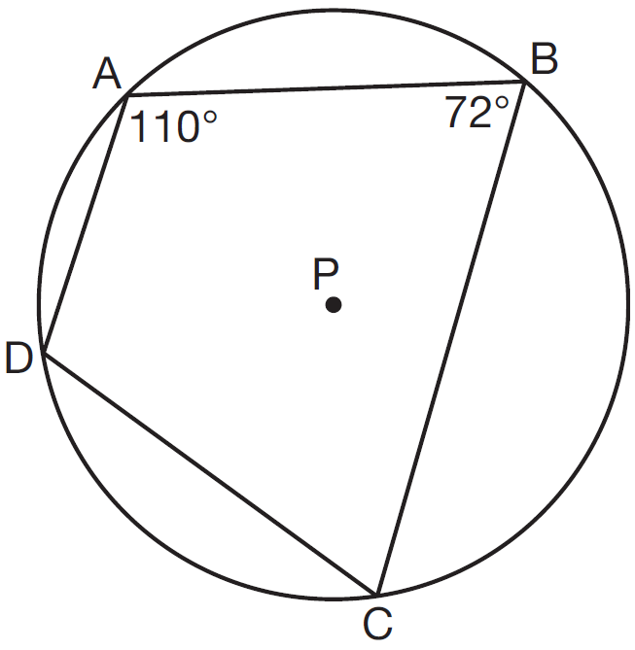

What is ?
1) | 70° | 3) | 108°
2) | 72° | 4) | 110°

16 A hemispherical tank is filled with water and has a diameter of 10 feet. If water weighs 62.4 pounds per cubic foot, what is the total weight of the water in a full tank, to the nearest pound?
1) | 16,336 | 3) | 130,690
2) | 32,673 | 4) | 261,381

17 In the diagram below, .

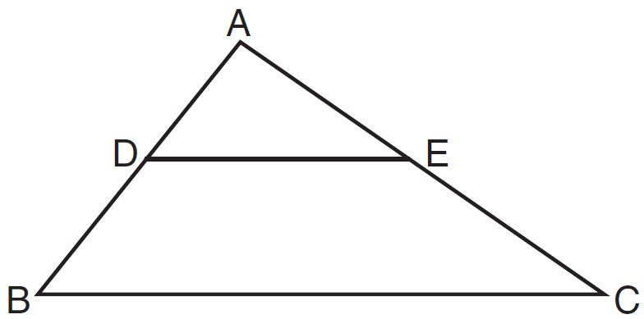

Which measurements are justified by this similarity?
1) | , , , and | 3) | , , , and
2) | , , , and | 4) | , , , and

18 Triangle FGH is inscribed in circle O, the length of radius is 6, and .

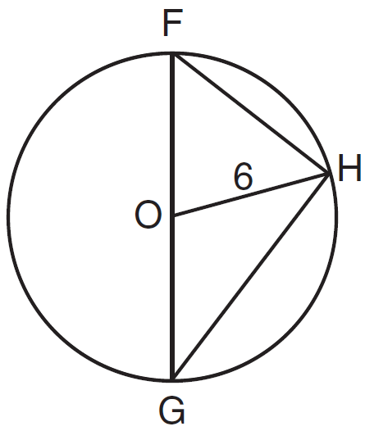

What is the area of the sector formed by angle FOH?
1) |  | 3)
2) |  | 4)

19 As shown in the diagram below, and intersect at E, and .

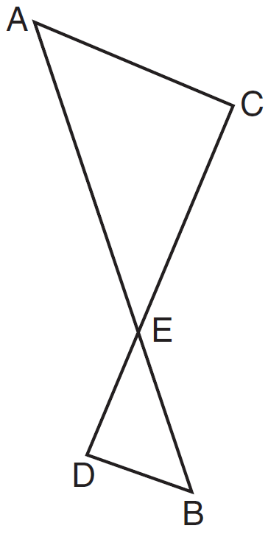

Given , which equation is true?
1) | 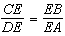 | 3) | 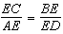
2) | 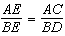 | 4) | 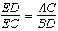

20 A triangle is dilated by a scale factor of 3 with the center of dilation at the origin. Which statement is true?
1) | The area of the image is nine times the area of the original triangle. | 3) | The slope of any side of the image is three times the slope of the corresponding side of the original triangle.
2) | The perimeter of the image is nine times the perimeter of the original triangle. | 4) | The measure of each angle in the image is three times the measure of the corresponding angle of the original triangle.

21 The Great Pyramid of Giza was constructed as a regular pyramid with a square base. It was built with an approximate volume of 2,592,276 cubic meters and a height of 146.5 meters. What was the length of one side of its base, to the nearest meter?
1) | 73 | 3) | 133
2) | 77 | 4) | 230

22 A quadrilateral has vertices with coordinates , , , and . Which type of quadrilateral is this?
1) | rhombus | 3) | square
2) | rectangle | 4) | trapezoid

23 In the diagram below, is the image of after a dilation centered at the origin. The coordinates of the vertices are , , , , and .

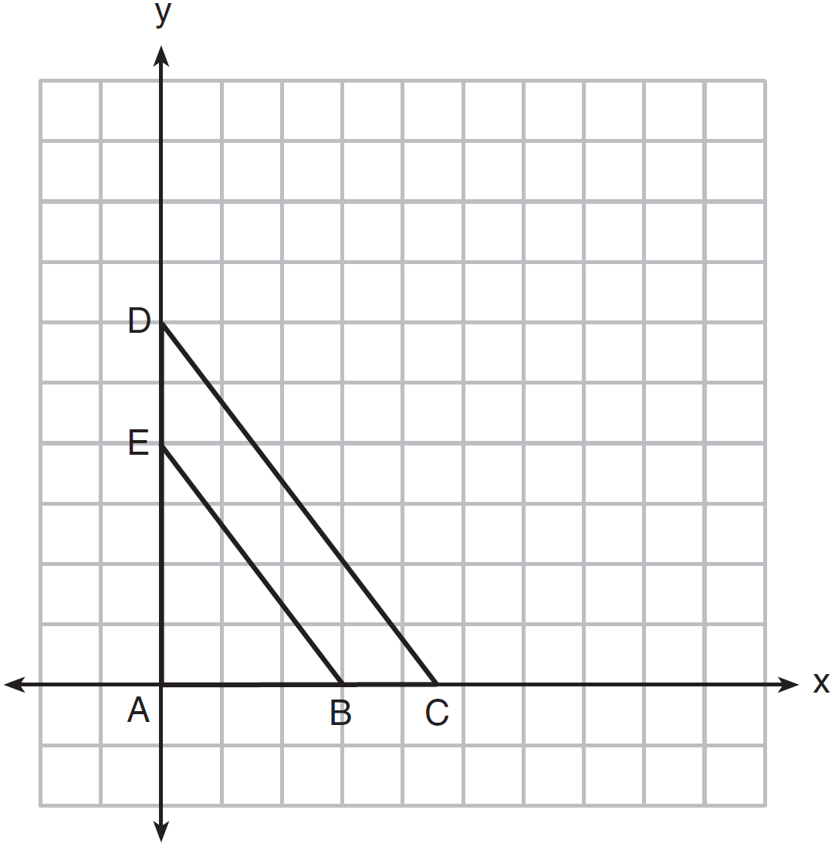

The ratio of the lengths of to is
1) |  | 3)
2) |  | 4)

24 Line is transformed by a dilation with a scale factor of 2 and centered at . The line's image is
1) |  | 3)
2) |  | 4)

25 A wooden cube has an edge length of 6 centimeters and a mass of 137.8 grams. Determine the density of the cube, to the nearest thousandth. State which type of wood the cube is made of, using the density table below.

Type of Wood | Density  (g/cm³)
Pine | 0.373
Hemlock | 0.431
Elm | 0.554
Birch | 0.601
Ash | 0.638
Maple | 0.676
Oak | 0.711

26 Construct an equilateral triangle inscribed in circle T shown below. [Leave all construction marks.]

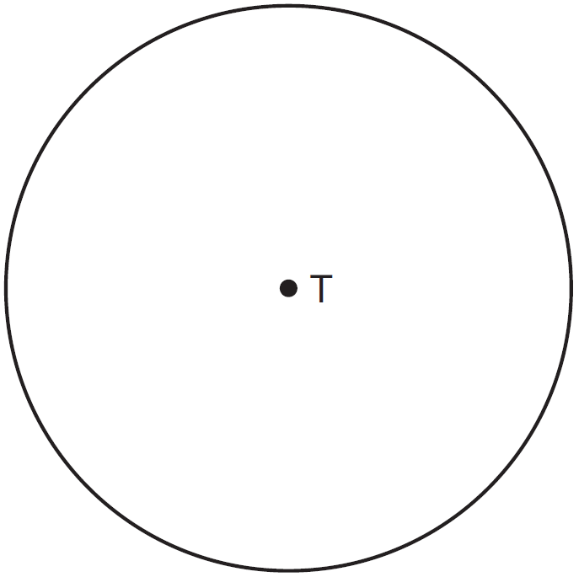

27 To find the distance across a pond from point B to point C, a surveyor drew the diagram below. The measurements he made are indicated on his diagram.

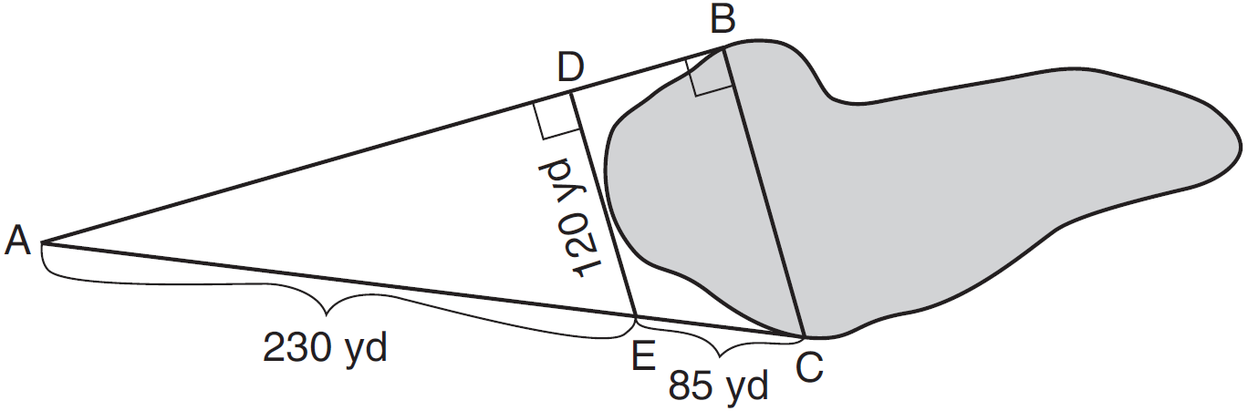

Use the surveyor's information to determine and state the distance from point B to point C, to the nearest yard.

28 In parallelogram ABCD shown below, diagonals and intersect at E.

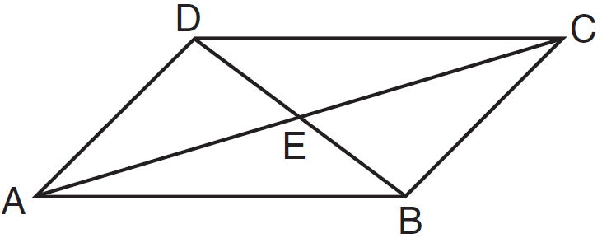

Prove:

29 Triangles RST and XYZ are drawn below. If , , , , and , is similar to ? Justify your answer.
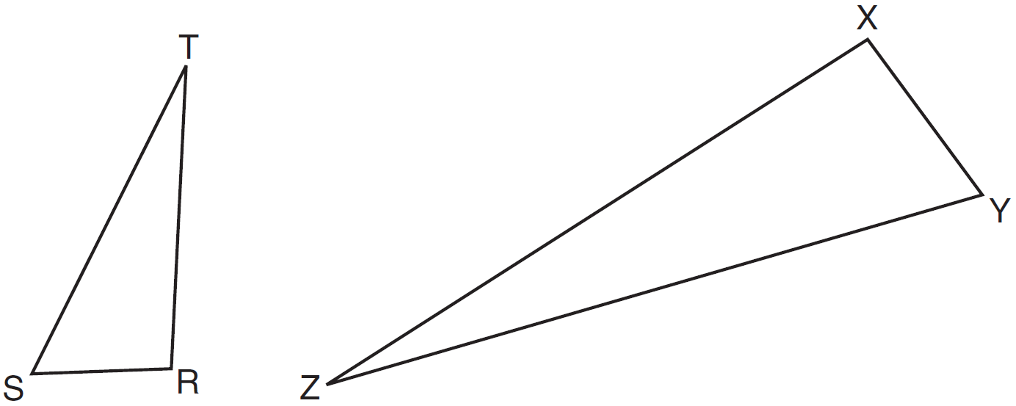

30 In the diagram below, and are graphed.

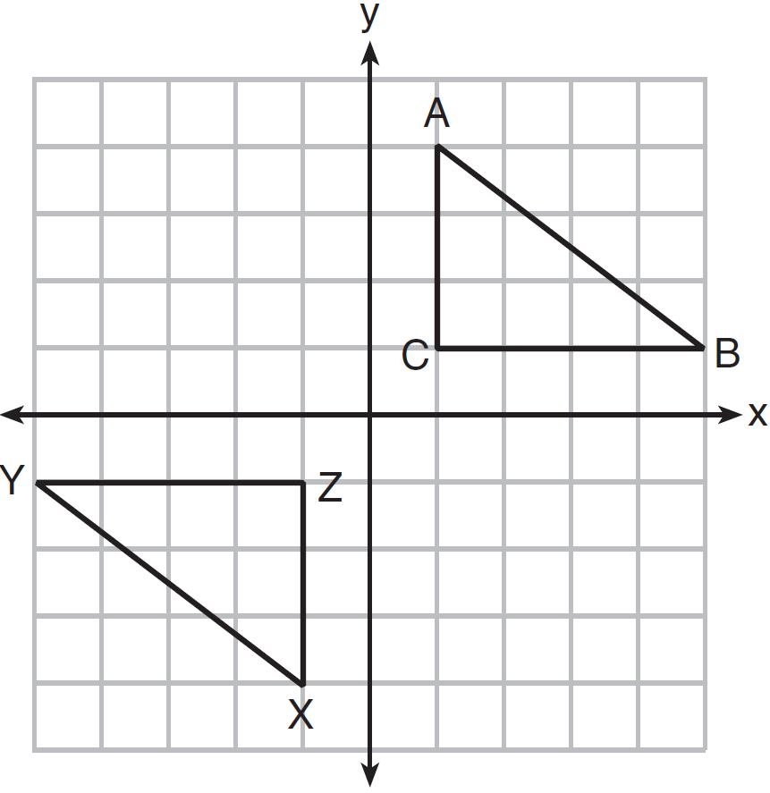

Use the properties of rigid motions to explain why .

31 The endpoints of are and . Determine and state the coordinates of point E, if .

32 As shown in the diagram below, a ship is heading directly toward a lighthouse whose beacon is 125 feet above sea level. At the first sighting, point A, the angle of elevation from the ship to the light was 7°. A short time later, at point D, the angle of elevation was 16°.

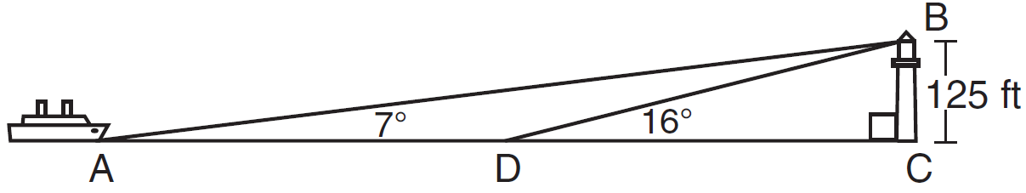

To the nearest foot, determine and state how far the ship traveled from point A to point D.

33 Triangle ABC has vertices with , , and . Determine and state a value of x that would make triangle a right triangle. Justify why is a right triangle. [The use of the set of axes below is optional.]

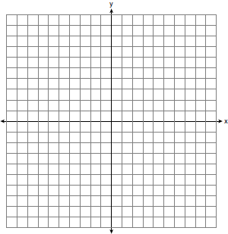

34 In the diagram below, and points A, C, D, and F are collinear on line .

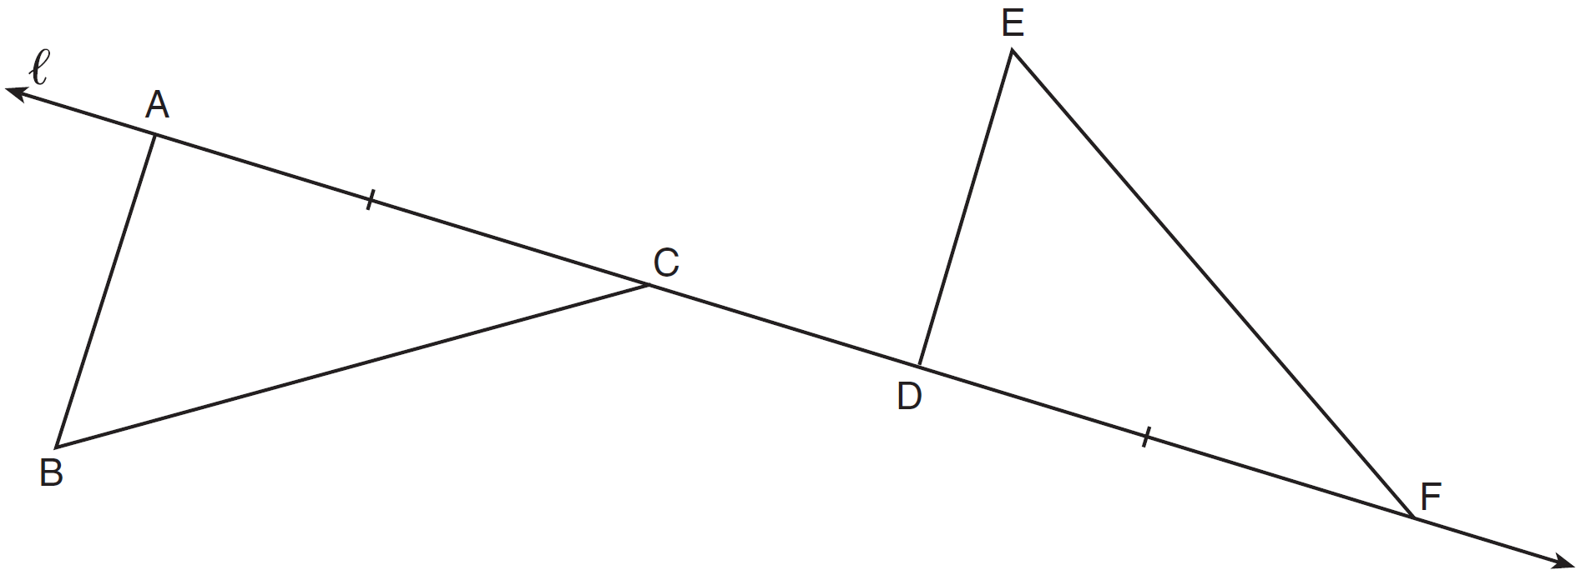

Let be the image of after a translation along , such that point D is mapped onto point A. Determine and state the location of F'. Explain your answer. Let be the image of after a reflection across line . Suppose that E" is located at B. Is congruent to ? Explain your answer.

35 In the diagram of parallelogram ABCD below, , , .

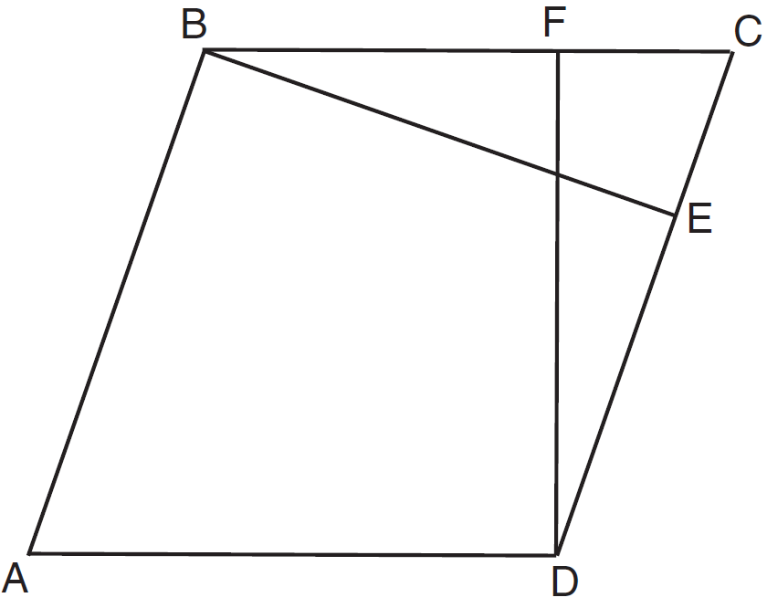

Prove ABCD is a rhombus.

36 Walter wants to make 100 candles in the shape of a cone for his new candle business. The mold shown below will be used to make the candles. Each mold will have a height of 8 inches and a diameter of 3 inches. To the nearest cubic inch, what will be the total volume of 100 candles?

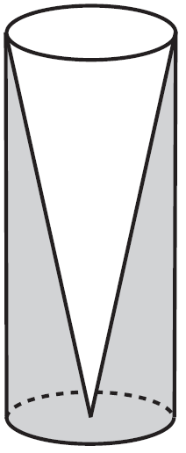

Walter goes to a hobby store to buy the wax for his candles. The wax costs $0.10 per ounce. If the weight of the wax is 0.52 ounce per cubic inch, how much will it cost Walter to buy the wax for 100 candles? If Walter spent a total of $37.83 for the molds and charges $1.95 for each candle, what is Walter's profit after selling 100 candles?
1 ANS: 2 PTS: 2 REF: 081501geo NAT: G.CO.C.11
TOP: Special Quadrilaterals

2 ANS: 3 PTS: 2 REF: 081502geo NAT: G.CO.A.2
TOP: Identifying Transformations KEY: basic

3 ANS: 4 PTS: 2 REF: 081503geo NAT: G.GMD.B.4
TOP: Rotations of Two-Dimensional Objects

4 ANS: 1 PTS: 2 REF: 081504geo NAT: G.SRT.C.7
TOP: Cofunctions

5 ANS: 1 PTS: 2 REF: 081505geo NAT: G.CO.A.3
TOP: Mapping a Polygon onto Itself

6 ANS: 4 PTS: 2 REF: 081506geo NAT: G.SRT.A.2
TOP: Dilations

7 ANS: 1 PTS: 2 REF: 081507geo NAT: G.CO.A.5
TOP: Compositions of Transformations KEY: identify

8 ANS: 3
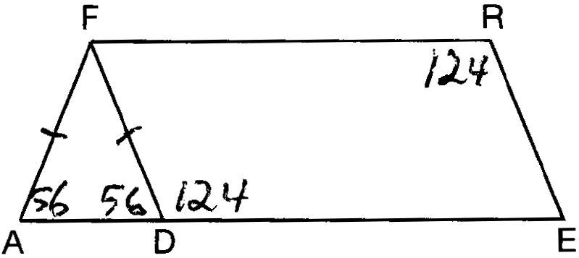

PTS: 2 REF: 081508geo NAT: G.CO.C.11 TOP: Interior and Exterior Angles of Polygons

9 ANS: 3
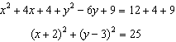

PTS: 2 REF: 081509geo NAT: G.GPE.A.1 TOP: Equations of Circles
KEY: completing the square

10 ANS: 1
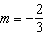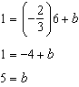

PTS: 2 REF: 081510geo NAT: G.GPE.B.5 TOP: Parallel and Perpendicular Lines
KEY: write equation of parallel line

11 ANS: 2
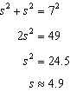

PTS: 2 REF: 081511geo NAT: G.SRT.C.8 TOP: Pythagorean Theorem

12 ANS: 3
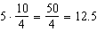

PTS: 2 REF: 081512geo NAT: G.C.A.2 TOP: Chords, Secants and Tangents
KEY: common tangents

13 ANS: 2 PTS: 2 REF: 081513geo NAT: G.CO.A.2
TOP: Identifying Transformations KEY: graphics

14 ANS: 4 PTS: 2 REF: 081514geo NAT: G.SRT.A.2
TOP: Compositions of Transformations KEY: grids

15 ANS: 3 PTS: 2 REF: 081515geo NAT: G.C.A.3
TOP: Inscribed Quadrilaterals

16 ANS: 1
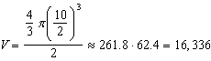

PTS: 2 REF: 081516geo NAT: G.MG.A.2 TOP: Density

17 ANS: 4
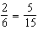

PTS: 2 REF: 081517geo NAT: G.SRT.B.5 TOP: Side Splitter Theorem

18 ANS: 3
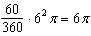

PTS: 2 REF: 081518geo NAT: G.C.B.5 TOP: Sectors

19 ANS: 2 PTS: 2 REF: 081519geo NAT: G.SRT.B.5
TOP: Similarity KEY: basic

20 ANS: 1

PTS: 2 REF: 081520geo NAT: G.SRT.A.2 TOP: Dilations

21 ANS: 4
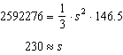

PTS: 2 REF: 081521geo NAT: G.GMD.A.3 TOP: Volume
KEY: pyramids

22 ANS: 4
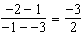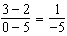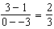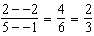

PTS: 2 REF: 081522geo NAT: G.GPE.B.4 TOP: Quadrilaterals in the Coordinate Plane
KEY: general

23 ANS: 1
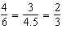

PTS: 2 REF: 081523geo NAT: G.SRT.A.2 TOP: Dilations

24 ANS: 4
The line passes through the center of dilation, so the dilated line is not distinct.

PTS: 2 REF: 081524geo NAT: G.SRT.A.1 TOP: Line Dilations

25 ANS:
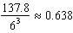 Ash

PTS: 2 REF: 081525geo NAT: G.MG.A.2 TOP: Density

26 ANS:
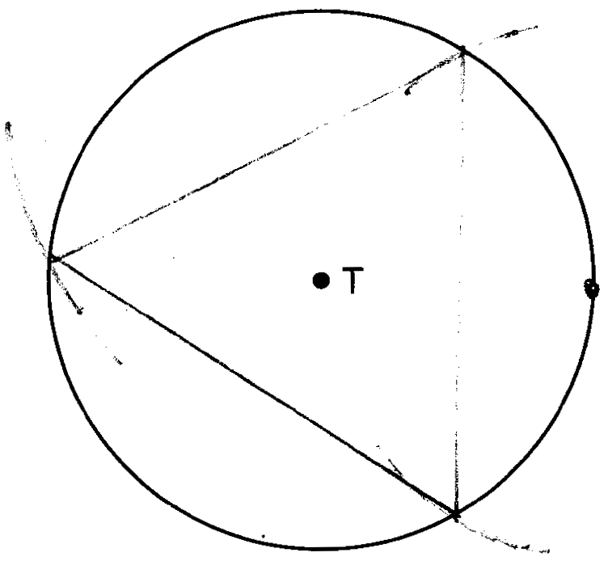

PTS: 2 REF: 081526geo NAT: G.CO.D.13 TOP: Constructions

27 ANS:
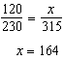

PTS: 2 REF: 081527geo NAT: G.SRT.B.5 TOP: Similarity
KEY: basic

28 ANS:
Parallelogram ABCD, diagonals and intersect at E (given). (opposite sides of a parallelogram are parallel). (alternate interior angles formed by parallel lines and a transversal are congruent).

PTS: 2 REF: 081528geo NAT: G.CO.C.11 TOP: Quadrilateral Proofs

29 ANS:
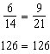 SAS

PTS: 2 REF: 081529geo NAT: G.SRT.B.5 TOP: Similarity
KEY: basic

30 ANS:
The transformation is a rotation, which is a rigid motion.

PTS: 2 REF: 081530geo NAT: G.CO.B.7 TOP: Triangle Congruency

31 ANS:
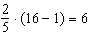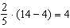

PTS: 2 REF: 081531geo NAT: G.GPE.B.6 TOP: Directed Line Segments

32 ANS:
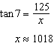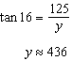

PTS: 4 REF: 081532geo NAT: G.SRT.C.8 TOP: Using Trigonometry to Find a Side
KEY: advanced

33 ANS:
The slopes of perpendicular line are opposite reciprocals. Since the lines are perpendicular, they form right angles and a right triangle. 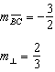 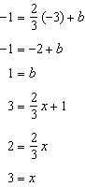 or 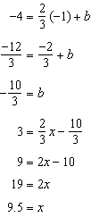 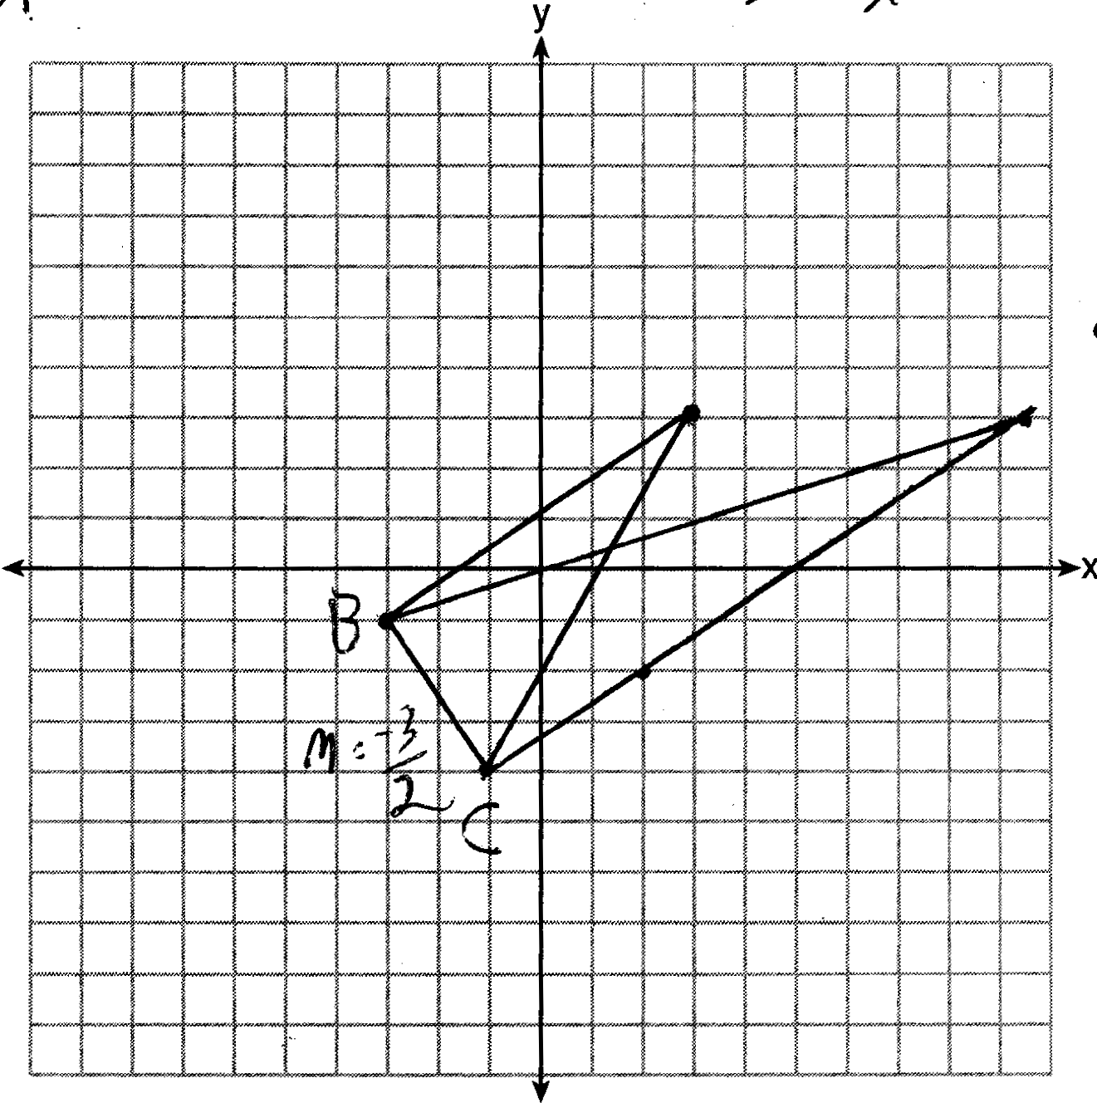

PTS: 4 REF: 081533geo NAT: G.GPE.B.4 TOP: Triangles in the Coordinate Plane

34 ANS:
Translations preserve distance. If point D is mapped onto point A, point F would map onto point C. as and points are collinear on line and a reflection preserves distance.

PTS: 4 REF: 081534geo NAT: G.CO.B.7 TOP: Triangle Congruency

35 ANS:
Parallelogram ABCD, , , (given). (perpendicular lines form right angles, which are congruent). (reflexive property). (ASA). (CPCTC). ABCD is a rhombus (a parallelogram with consecutive congruent sides is a rhombus).

PTS: 6 REF: 081535geo NAT: G.SRT.B.5 TOP: Quadrilateral Proofs

36 ANS:
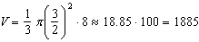

PTS: 6 REF: 081536geo NAT: G.MG.A.2 TOP: Density

