1 In the diagram below, is the image of after a translation. Triangle CAT is the image of after a line reflection.

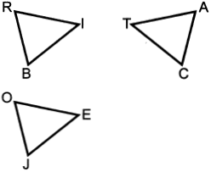

Which statement is always true?
1) |  | 3)
2) |  | 4)

2 A right cylinder is cut parallel to its base. The shape of this cross section is a
1) | cone | 3) | triangle
2) | circle | 4) | rectangle

3 What is the minimum number of degrees that a regular hexagon must rotate about its center to carry it onto itself?
1) | 45° | 3) | 60°
2) | 72° | 4) | 120°

4 In the diagram below, a sphere is inscribed inside a cube. The cube has edge lengths of 18.

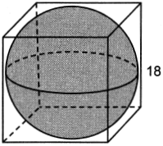

What is the volume of the sphere, in terms of ?
1) |  | 3)
2) |  | 4)

5 In the diagram below, intersects at J, , and .

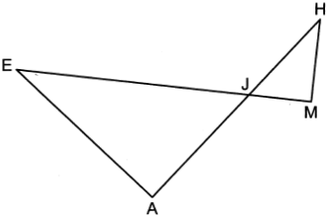

If , , , and , what is the length of , to the nearest hundredth?
1) | 2.47 | 3) | 4.11
2) | 2.63 | 4) | 4.39

6 Which equation represents the line that passes through the point and is perpendicular to the line whose equation is 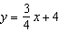?
1) | 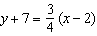 | 3) | 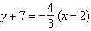
2) | 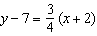 | 4) | 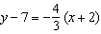

7 In below, and .

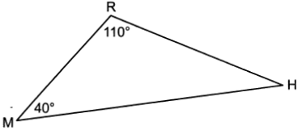

If is reflected over side to form quadrilateral RHR'M, which statement is always true?
1) | Quadrilateral RHR'M is a parallelogram. | 3)
2) |  | 4)

8 The funnel shown below can be used to decorate cookies with melted chocolate. The funnel can be modeled by a cone whose radius is 6 cm and height is 13 cm.

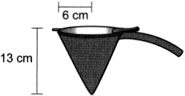

The baker uses 2 cubic centimeters of chocolate to decorate each cookie. When the funnel is completely filled, what is the maximum number of cookies that can be decorated with the melted chocolate?
1) | 78 | 3) | 490
2) | 245 | 4) | 735

9 In circle O below, chords and intersect at point A. Chords and are drawn.

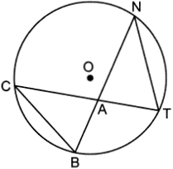

Which statement is always true?
1) | 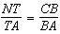 | 3) | 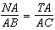
2) |  | 4)

10 In the diagram below of , is drawn, bisects , and .
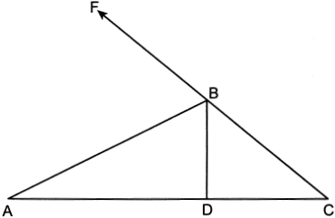
If what is ?
1) | 24º | 3) | 48º
2) | 33º | 4) | 66º

11 In circle O below, , and .
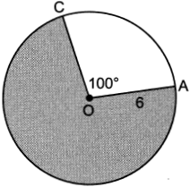
What is the area of the shaded sector?
1) |  | 3)
2) |  | 4)

12 In rectangle ABCD, diagonal is drawn. The measure of is 37° and the length of is 7.6 cm. What is the length of , to the nearest tenth of a centimeter?
1) | 4.6 | 3) | 10.1
2) | 9.5 | 4) | 12.6

13 A peanut butter manufacturer would like to use a cylindrical jar with a volume of 1180 cm³. The jar has a height of 10 cm. What is the diameter of the jar, to the nearest tenth of a centimeter?
1) | 3.8 | 3) | 10.9
2) | 6.1 | 4) | 12.3

14 Triangle KLM is dilated by a scale factor of 3 to map onto triangle DRS. Which statement is not always true?
1) |  | 3) | The area of is 3 times the area of .
2) | 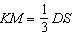 | 4) | The perimeter of is 3 times the perimeter of .

15 A rectangle with dimensions of 4 feet by 7 feet is continuously rotated about one of its 4-foot sides. The resulting three-dimensional object is a
1) | cylinder with a height of 7 feet and a base radius of 4 feet. | 3) | cone with a height of 7 feet and a base radius of 7 feet.
2) | cylinder with a height of 4 feet and a base radius of 7 feet. | 4) | cone with a height of 4 feet and a base radius of 7 feet.

16 In right triangle ABC, altitude is drawn to hypotenuse . If and , the length of is
1) |  | 3) | 12
2) |  | 4) | 16

17 If ABCD is a parallelogram, which additional information is sufficient to prove that ABCD is a rectangle?
1) |  | 3)
2) |  | 4)

18 Line segment APB has endpoints and . What are the coordinates of P if is in the ratio ?
1) | (-2,2) | 3)
2) |  | 4)

19 In the diagram below, and intersect at E, and and are drawn.

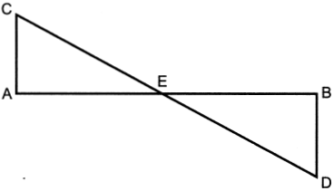

If , which statement is always true?
1) |  | 3)
2) |  | 4)

20 If , what is the value of x?
1) | 8 | 3) | 33
2) | 11 | 4) | 42

21 Which set of integers could represent the lengths of the sides of an isosceles triangle?
1) |  | 3)
2) |  | 4)

22 In the diagram shown below, altitude is drawn to the hypotenuse of right triangle ABC.

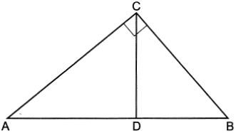

Which equation can always be used to find the length of ?
1) | 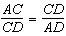 | 3) | 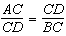
2) | 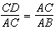 | 4) | 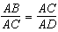

23 Which congruence statement is sufficient to prove parallelogram MARK is a rhombus?
1) |  | 3)
2) |  | 4)

24 A line whose equation is is dilated by a scale factor of 4 centered at . Which equation represents the image of the line after the dilation?
1) |  | 3)
2) |  | 4)

25 In below, , , and .

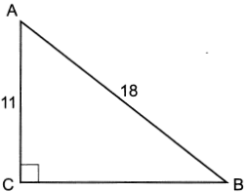

Determine and state the measure of angle A, to the nearest degree.

26 Use a compass and straightedge to construct an equilateral triangle inscribed in circle A below. [Leave all construction marks.]

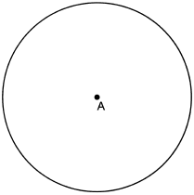

27 Quadrilateral DEAR and its image, quadrilateral D'E'A'R', are graphed on the set of axes below.
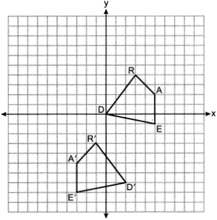
Describe a sequence of transformations that maps quadrilateral DEAR onto quadrilateral D'E'A'R'.

28 In circle P below, tangent and secant are drawn.

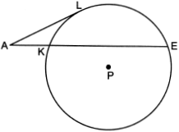

If and , determine and state the length of .

29 The equation of a circle is . Determine and state the coordinates of the, center and the length of the radius of the circle.

30 On the set of axes below, is drawn with vertices that have coordinates , , and .

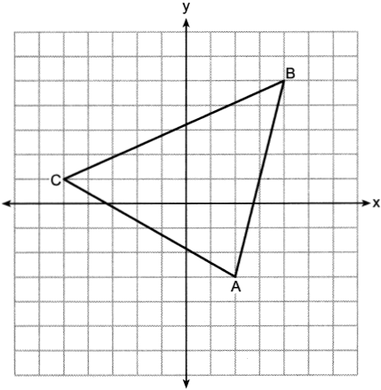

Determine and state the area of .

31 In the diagram below, , , , and .

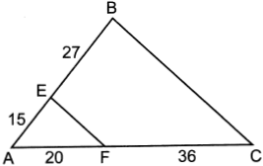

Explain why .

32 A building is composed of a rectangular pyramid on top of a rectangular prism, as shown in the diagram below. The rectangular prism has a length of 38 feet, a width of 15 feet, and a height of 22 feet. The rectangular pyramid sits directly on top of the rectangular prism, and its height is 12 feet.

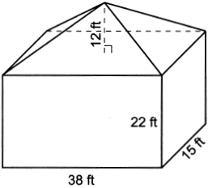

An air purification filter was installed that will clean all the air in the building at a rate of 2400 cubic feet per minute. Determine and state how long it will take, to the nearest tenth of a minute, for the filter to clean the air contained in the building.

33 Given: , , , , , and

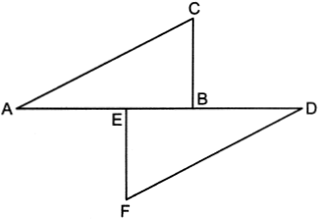

Prove:

34 In the diagram below, a boat at point A is traveling toward the most powerful waterfall in North America, the Horseshoe Falls. The Horseshoe Falls has a vertical drop of 188 feet. The angle of elevation from point A to the top of the waterfall is 15°.

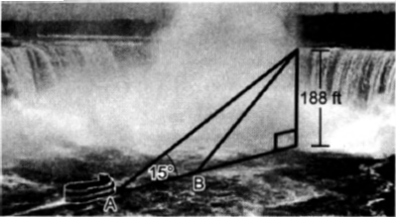

After the boat travels toward the falls, the angle of elevation at point B to the top of the waterfall is 23°. Determine and state, to the nearest foot, the distance the boat traveled from point A to point B.

35 Triangle JOE has vertices whose coordinates are , , and . Prove that is isosceles. Point is on . Prove that is the perpendicular bisector of . [The use of the set of axes below is optional.]

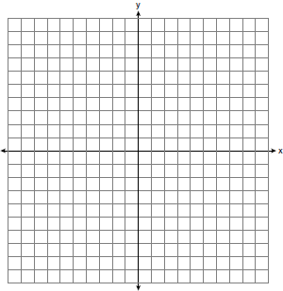
1 ANS: 4 PTS: 2 REF: 062401geo NAT: G.CO.B.6
TOP: Properties of Transformations

2 ANS: 2 PTS: 2 REF: 062402geo NAT: G.GMD.B.4
TOP: Cross-Sections of Three-Dimensional Objects

3 ANS: 3
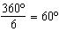

PTS: 2 REF: 062403geo NAT: G.CO.A.3 TOP: Mapping a Polygon onto Itself

4 ANS: 3
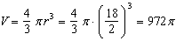

PTS: 2 REF: 062404geo NAT: G.GMD.A.3 TOP: Volume
KEY: spheres

5 ANS: 1
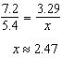

PTS: 2 REF: 062405geo NAT: G.SRT.B.5 TOP: Similarity
KEY: basic

6 ANS: 3
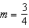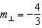

PTS: 2 REF: 062406geo NAT: G.GPE.B.5 TOP: Parallel and Perpendicular Lines
KEY: write equation of perpendicular line

7 ANS: 3 PTS: 2 REF: 062407geo NAT: G.CO.B.6
TOP: Properties of Transformations

8 ANS: 2
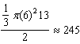

PTS: 2 REF: 062408geo NAT: G.GMD.A.3 TOP: Volume
KEY: cones

9 ANS: 1 PTS: 2 REF: 062409geo NAT: G.C.A.2
TOP: Chords, Secants and Tangents KEY: inscribed

10 ANS: 1
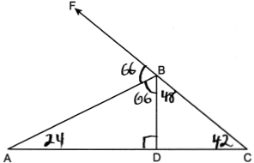

PTS: 2 REF: 062410geo NAT: G.CO.C.10 TOP: Interior and Exterior Angles of Triangles

11 ANS: 2
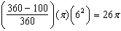

PTS: 2 REF: 062411geo NAT: G.C.B.5 TOP: Sectors

12 ANS: 4
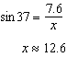

PTS: 2 REF: 062412geo NAT: G.SRT.C.8 TOP: Using Trigonometry to Find a Side

13 ANS: 4
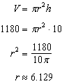

PTS: 2 REF: 062413geo NAT: G.GMD.A.3 TOP: Volume
KEY: cylinders

14 ANS: 3 PTS: 2 REF: 062414geo NAT: G.SRT.A.2
TOP: Dilations

15 ANS: 2 PTS: 2 REF: 062415geo NAT: G.GMD.B.4
TOP: Rotations of Two-Dimensional Objects

16 ANS: 4
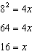

PTS: 2 REF: 062416geo NAT: G.SRT.B.5 TOP: Similarity
KEY: altitude

17 ANS: 3 PTS: 2 REF: 062417geo NAT: G.CO.C.11
TOP: Special Quadrilaterals

18 ANS: 1
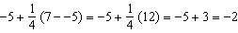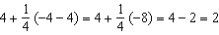

PTS: 2 REF: 062418geo NAT: G.GPE.B.6 TOP: Directed Line Segments

19 ANS: 3 PTS: 2 REF: 062419geo NAT: G.SRT.B.5
TOP: Similarity KEY: basic

20 ANS: 2
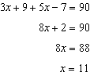

PTS: 2 REF: 062420geo NAT: G.SRT.C.7 TOP: Cofunctions

21 ANS: 4

PTS: 2 REF: 062421geo NAT: G.CO.C.10 TOP: Triangle Inequality Theorem

22 ANS: 4 PTS: 2 REF: 062422geo NAT: G.SRT.B.5
TOP: Similarity KEY: altitude

23 ANS: 1 PTS: 2 REF: 062423geo NAT: G.CO.C.11
TOP: Special Quadrilaterals

24 ANS: 1 PTS: 2 REF: 062424geo NAT: G.SRT.A.1
TOP: Line Dilations

25 ANS:
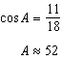

PTS: 2 REF: 062425geo NAT: G.SRT.C.8 TOP: Using Trigonometry to Find an Angle

26 ANS:
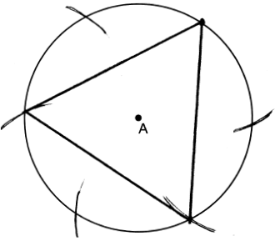

PTS: 2 REF: 062426geo NAT: G.CO.D.13 TOP: Constructions

27 ANS:

PTS: 2 REF: 062427geo NAT: G.CO.A.5 TOP: Compositions of Transformations

28 ANS:
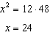

PTS: 2 REF: 062428geo NAT: G.C.A.2 TOP: Chords, Secants and Tangents
KEY: secant and tangent drawn from common point, length

29 ANS:
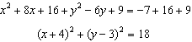

PTS: 2 REF: 062429geo NAT: G.GPE.A.1 TOP: Equations of Circles
KEY: completing the square

30 ANS:
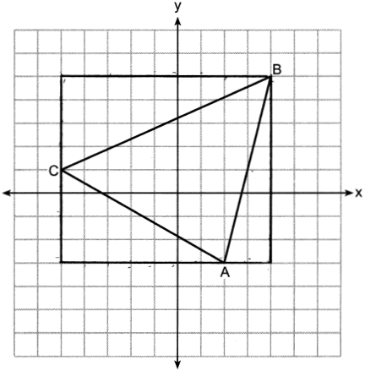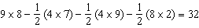

PTS: 2 REF: 062430geo NAT: G.GPE.B.7 TOP: Polygons in the Coordinate Plane

31 ANS:
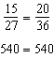 is parallel to because divides the sides proportionately.

PTS: 2 REF: 062431geo NAT: G.SRT.B.5 TOP: Side Splitter Theorem

32 ANS:
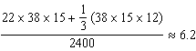

PTS: 4 REF: 062432geo NAT: G.GMD.A.3 TOP: Volume
KEY: compositions

33 ANS:
, , , , , and (Given); (Perpendicular lines form congruent angles); (Parallel lines cut by a transversal form congruent alternate interior angles); (Symmetric Property); 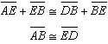 (Segment Addition); (ASA)

PTS: 4 REF: 062433geo NAT: G.SRT.B.5 TOP: Triangle Proofs
KEY: proof

34 ANS:
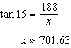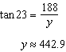

PTS: 4 REF: 062434geo NAT: G.SRT.C.8 TOP: Using Trigonometry to Find a Side

35 ANS:
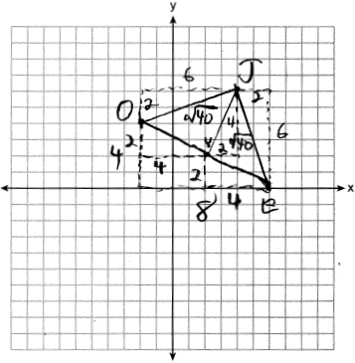 Since has two congruent sides, it is isosceles. Since , is a bisector of . 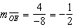 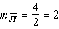 Since the slopes are opposite reciprocals, .

PTS: 6 REF: 062435geo NAT: G.GPE.B.4 TOP: Triangles in the Coordinate Plane

