1 A square pyramid is intersected by a plane passing through the vertex and perpendicular to the base.

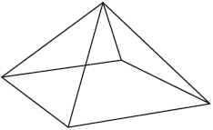

Which two-dimensional shape describes this cross section?
1) | square | 3) | pentagon
2) | triangle | 4) | rectangle

2 Trapezoid ABCD is drawn such that . Trapezoid A'B'C'D' is the image of trapezoid ABCD after a rotation of 110° counterclockwise about point P.

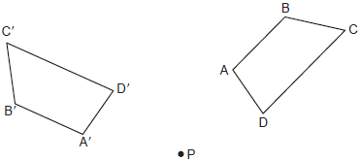

Which statement is always true?
1) |  | 3)
2) |  | 4)

3 What is the volume of a right circular cone that has a height of 7.2 centimeters and a radius of 2.5 centimeters, to the nearest tenth of a cubic centimeter?
1) | 37.7 | 3) | 113.1
2) | 47.1 | 4) | 141.4

4 In the diagram below of right triangle SUN, where is a right angle, and .
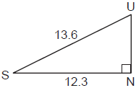

What is , to the nearest degree?
1) | 25° | 3) | 48°
2) | 42° | 4) | 65°

5 In the diagram below of Circle O, diameter and chord are drawn, and .

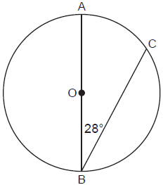

What is ?
1) | 56º | 3) | 152º
2) | 124º | 4) | 166º

6 In the diagram below of parallelogram ABCD, diagonal and are drawn, , , and .
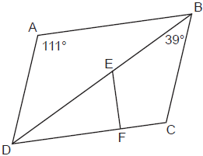

What is ?
1) | 30º | 3) | 60º
2) | 51º | 4) | 120º

7 In the diagram below of , is drawn parallel to such that E is on and S is on .

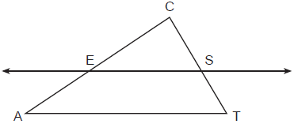

Which statement is always true?
1) | 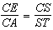 | 3) | 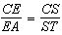
2) | 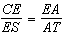 | 4) | 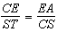

8 On the set of axes below, congruent triangles ABC and DEF are drawn.

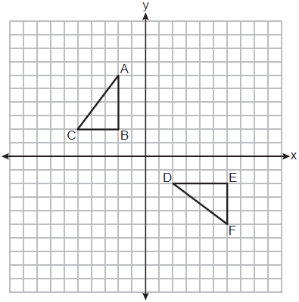

Which sequence of transformations maps onto ?
1) | A counterclockwise rotation of 90 degrees about the origin, followed by a translation 8 units to the right. | 3) | A counterclockwise rotation of 90 degrees about the origin, followed by a translation 4 units down.
2) | A counterclockwise rotation of 90 degrees about the origin, followed by a reflection over the y-axis. | 4) | A clockwise rotation of 90 degrees about the origin, followed by a reflection over the x-axis.

9 An equation of circle M is . What are the coordinates of the center and the length of the radius of circle M?
1) | center and radius 9 | 3) | center and radius 9
2) | center and radius 3 | 4) | center and radius 3

10 Parallelogram BETH, with diagonals and , is drawn below.

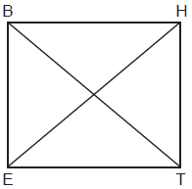

What additional information is sufficient to prove that BETH is a rectangle?
1) |  | 3)
2) |  | 4)

11 A gardener wants to buy enough mulch to cover a rectangular garden that is 3 feet by 10 feet. One bag contains 2 cubic feet of mulch and costs $3.66. How much will the minimum number of bags cost to cover the garden with mulch 3 inches deep?
1) | $3.66 | 3) | $14.64
2) | $10.98 | 4) | $29.28

12 In the diagram below, , where and are right angles.

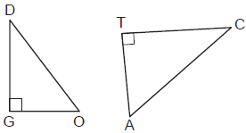

Which expression is always equivalent to ?
1) |  | 3)
2) |  | 4)

13 On the set of axes below, is the image of after a dilation of scale factor .

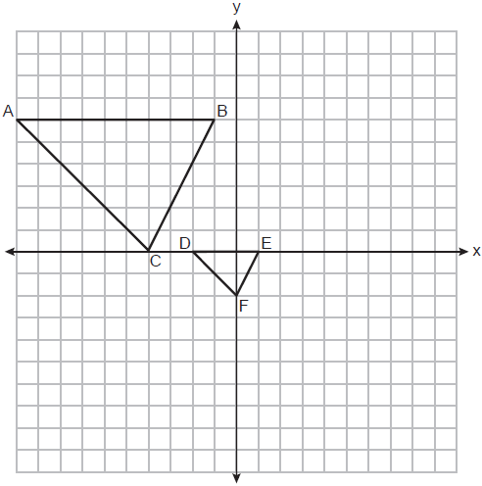

The center of dilation is at
1) |  | 3)
2) |  | 4)

14 In the diagram below of isosceles triangle AHE with the vertex angle at H, and .

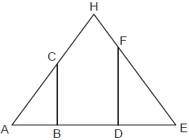

Which statement is always true?
1) | 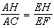 | 3) | 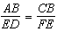
2) | 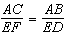 | 4) | 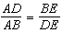

15 Rectangle ABCD has two vertices at coordinates and . The slope of is
1) |  | 3)
2) |  | 4)

16 In right triangle ABC, , , and . To the nearest tenth, the length of is
1) | 2.5 | 3) | 24.6
2) | 8.4 | 4) | 25.9

17 The measure of one of the base angles of an isosceles triangle is 42°. The measure of an exterior angle at the vertex of the triangle is
1) | 42° | 3) | 96°
2) | 84° | 4) | 138°

18 In the diagram below, , , , and bisects .

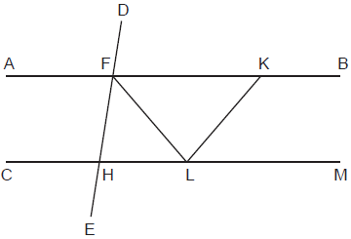

Which statement is always true?
1) |  | 3)
2) |  | 4)

19 The line whose equation is is dilated by a scale factor of 2 centered at the point . An equation of its image is
1) |  | 3)
2) |  | 4)

20 Which figure will not carry onto itself after a 120-degree rotation about its center?
1) | equilateral triangle | 3) | regular octagon
2) | regular hexagon | 4) | regular nonagon

21 Triangle ADF is drawn and .

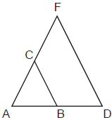

Which statement must be true?
1) | 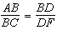 | 3)
2) | 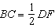 | 4)

22 In , M is the midpoint of and N is the midpoint of . If and , what is the length of ?
1) | 3.5 | 3) | 16.5
2) | 9 | 4) | 22

23 In the diagram below of isosceles trapezoid STAR, diagonals and intersect at O and , with nonparallel sides and .

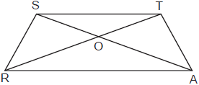

Which pair of triangles are not always similar?
1) | and | 3) | and
2) | and | 4) | and

24 The endpoints of are and . Which equation of a line represents the perpendicular bisector of ?
1) | 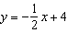 | 3)
2) |  | 4)

25 In below, use a compass and straightedge to construct the altitude from C to . [Leave all construction marks.]

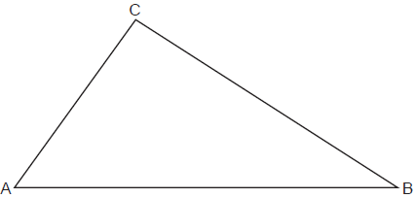

26 Triangles ABC and DEF are graphed on the set of axes below.

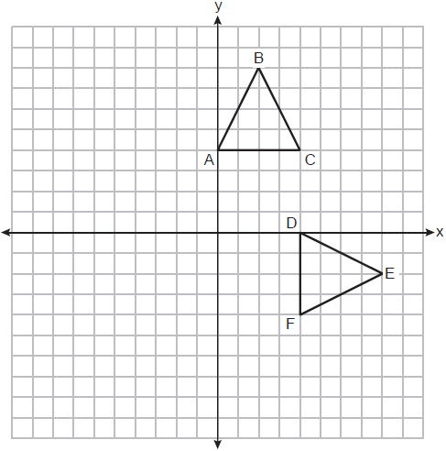

Describe a sequence of transformations that maps onto .

27 Line segment PQ has endpoints and , and point R is on . Determine and state the coordinates of R, such that . [The use of the set of axes below is optional.]

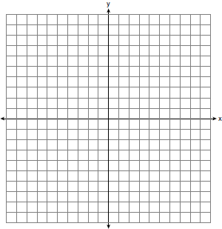

28 A circle has a radius of 6.4 inches. Determine and state, to the nearest square inch, the area of a sector whose arc measures 80°.

29 A large snowman is made of three spherical snowballs with radii of 1 foot, 2 feet, and 3 feet, respectively. Determine and state the amount of snow, in cubic feet, that is used to make the snowman. [Leave your answer in terms of .]

30 In the diagram below of right triangle ACB, altitude is drawn to hypotenuse , and .

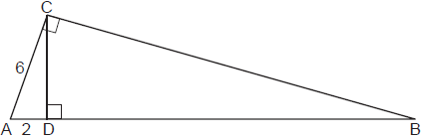

Determine and state the length of .

31 Triangle RST has vertices with coordinates , and . Determine and state an equation of the line parallel to that passes through point S. [The use of the set of axes below is optional.]

32 Cape Canaveral, Florida is where NASA launches rockets into space. As modeled in the diagram below, a person views the launch of a rocket from observation area A, 3280 feet away from launch pad B. After launch, the rocket was sighted at C with an angle of elevation of 15°. The rocket was later sighted at D with an angle of elevation of 31°.

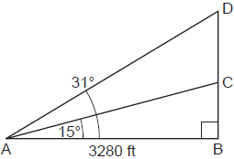

Determine and state, to the nearest foot, the distance the rocket traveled between the two sightings, C and D.

33 A small can of soup is a right circular cylinder with a base diameter of 7 cm and a height of 9 cm. A large container is also a right circular cylinder with a base diameter of 9 cm and a height of 13cm. Determine and state the volume of the small can and the volume of the large container to the nearest cubic centimeter. What is the minimum number of small cans that must be opened to fill the large container? Justify your answer.

34 Parallelogram MATH has vertices , , , and . Prove that parallelogram MATH is a rhombus. [The use of the set of axes below is optional.] Determine and state the area of MATH.

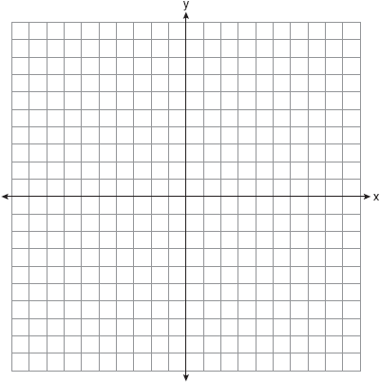

35 Given: Quadrilateral ABCD, , , diagonal intersects at G, and

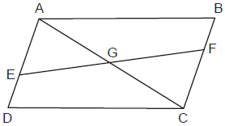

Prove: G is the midpoint of
1 ANS: 2 PTS: 2 REF: 062301geo NAT: G.GMD.B.4
TOP: Cross-Sections of Three-Dimensional Objects

2 ANS: 3 PTS: 2 REF: 062302geo NAT: G.CO.B.6
TOP: Properties of Transformations KEY: graphics

3 ANS: 2
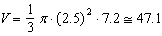

PTS: 2 REF: 062303geo NAT: G.GMD.A.3 TOP: Volume
KEY: cones

4 ANS: 1
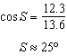

PTS: 2 REF: 062304geo NAT: G.SRT.C.8 TOP: Using Trigonometry to Find an Angle

5 ANS: 2
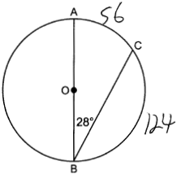

PTS: 2 REF: 062305geo NAT: G.C.A.2 TOP: Chords, Secants and Tangents
KEY: inscribed

6 ANS: 3
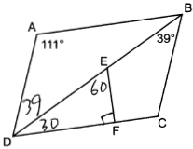

PTS: 2 REF: 062306geo NAT: G.CO.C.11 TOP: Interior and Exterior Angles of Polygons

7 ANS: 3 PTS: 2 REF: 062307geo NAT: G.SRT.B.5
TOP: Side Splitter Theorem

8 ANS: 1 PTS: 2 REF: 062308geo NAT: G.CO.A.5
TOP: Compositions of Transformations

9 ANS: 4
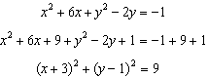

PTS: 2 REF: 062309geo NAT: G.GPE.A.1 TOP: Equations of Circles
KEY: completing the square

10 ANS: 3 PTS: 2 REF: 062310geo NAT: G.CO.C.11
TOP: Special Quadrilaterals

11 ANS: 3
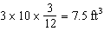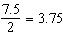

PTS: 2 REF: 062311geo NAT: G.GMD.A.3 TOP: Volume
KEY: prisms

12 ANS: 1 PTS: 2 REF: 062312geo NAT: G.SRT.C.7
TOP: Cofunctions

13 ANS: 2
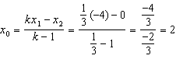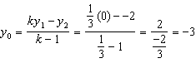

PTS: 2 REF: 062313geo NAT: G.SRT.A.2 TOP: Dilations

14 ANS: 2
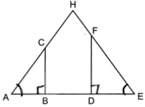

PTS: 2 REF: 062314geo NAT: G.SRT.B.5 TOP: Similarity
KEY: basic

15 ANS: 1
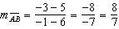

PTS: 2 REF: 062315geo NAT: G.GPE.B.7 TOP: Polygons in the Coordinate Plane

16 ANS: 4
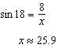

PTS: 2 REF: 062316geo NAT: G.SRT.C.8 TOP: Using Trigonometry to Find a Side

17 ANS: 2

PTS: 2 REF: 062317geo NAT: G.CO.C.10 TOP: Exterior Angle Theorem

18 ANS: 4 PTS: 2 REF: 062318geo NAT: G.CO.C.9
TOP: Lines and Angles

19 ANS: 2
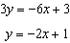

PTS: 2 REF: 062319geo NAT: G.SRT.A.1 TOP: Line Dilations

20 ANS: 3
1) 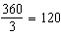; 2) 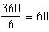; 3) 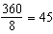; 4) 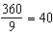. 120 is not a multiple of 45.

PTS: 2 REF: 062320geo NAT: G.CO.A.3 TOP: Mapping a Polygon onto Itself

21 ANS: 4 PTS: 2 REF: 062321geo NAT: G.SRT.B.5
TOP: Side Splitter Theorem

22 ANS: 4
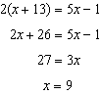

PTS: 2 REF: 062322geo NAT: G.CO.C.10 TOP: Midsegments

23 ANS: 3 PTS: 2 REF: 062323geo NAT: G.CO.C.11
TOP: Trapezoids

24 ANS: 4
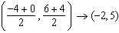; 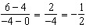; ; 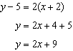

PTS: 2 REF: 062324geo NAT: G.GPE.B.5 TOP: Parallel and Perpendicular Lines
KEY: perpendicular bisector

25 ANS:
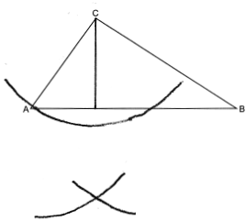

PTS: 2 REF: 062325geo NAT: G.CO.D.12 TOP: Constructions
KEY: parallel and perpendicular lines

26 ANS:
, followed by a 90º clockwise rotation about point D.

PTS: 2 REF: 062326geo NAT: G.CO.A.5 TOP: Compositions of Transformations

27 ANS:
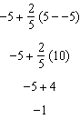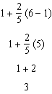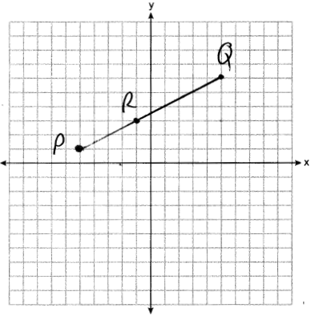

PTS: 2 REF: 062327geo NAT: G.GPE.B.6 TOP: Directed Line Segments

28 ANS:
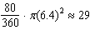

PTS: 2 REF: 062328geo NAT: G.C.B.5 TOP: Sectors

29 ANS:
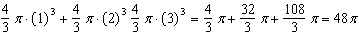

PTS: 2 REF: 062329geo NAT: G.GMD.A.3 TOP: Volume
KEY: spheres

30 ANS:
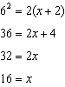;

PTS: 2 REF: 062330geo NAT: G.SRT.B.5 TOP: Similarity
KEY: leg

31 ANS:
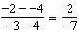; 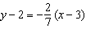

PTS: 2 REF: 062331geo NAT: G.GPE.B.4 TOP: Triangles in the Coordinate Plane

32 ANS:
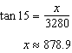; 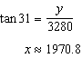;

PTS: 4 REF: 062332geo NAT: G.SRT.C.8 TOP: Using Trigonometry to Find a Side

33 ANS:
; ; 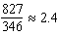; 3 cans

PTS: 4 REF: 062333geo NAT: G.GMD.A.3 TOP: Volume
KEY: cylinders

34 ANS:
A rhombus has four congruent sides. Since each side measures , all four sides of MATH are congruent, and MATH is a rhombus. 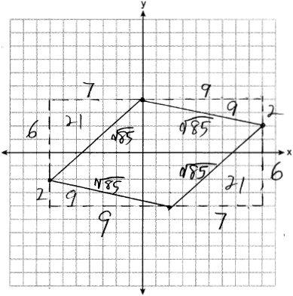

PTS: 4 REF: 062334geo NAT: G.GPE.B.4 TOP: Quadrilaterals in the Coordinate Plane

35 ANS:
Quadrilateral ABCD, , , diagonal intersects at G, and (given); ABCD is a parallelogram (a quadrilateral with a pair of opposite sides is a parallelogram); (opposite side of a parallelogram are congruent); (subtraction postulate); (opposite side of a parallelogram are parallel); (if parallel sides are cut by a transversal, the alternate interior angles are congruent); (vertical angles); (AAS); (CPCTC): G is the midpoint of (since G divides into two equal parts, G is the midpoint of ).

PTS: 6 REF: 062335geo NAT: G.SRT.B.5 TOP: Quadrilateral Proofs

