1 Triangle A'B'C' is the image of after a dilation centered at the origin. The coordinates of the vertices of are , , and .

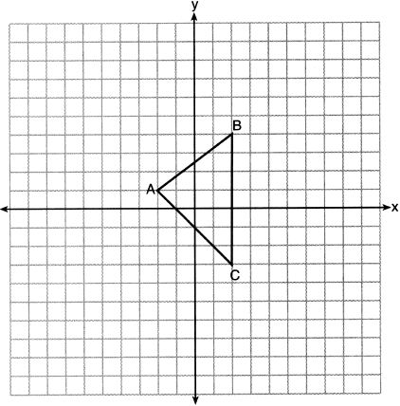

If the coordinates of are , the coordinates of are
1) |  | 3)
2) |  | 4)

2 In the diagram below, a plane intersects a square pyramid parallel to its base.

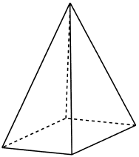

Which two-dimensional shape describes this cross section?
1) | circle | 3) | triangle
2) | square | 4) | pentagon

3 In the diagram below, is the image of after a dilation of centered at C.

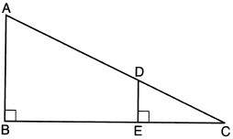

Which statement is always true?
1) | 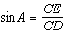 | 3) | 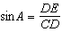
2) | 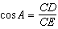 | 4) | 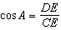

4 A regular pentagon is rotated about its center. What is the minimum number of degrees needed to carry the pentagon onto itself?
1) | 72° | 3) | 144°
2) | 108° | 4) | 360°

5 On the set of axes below, .

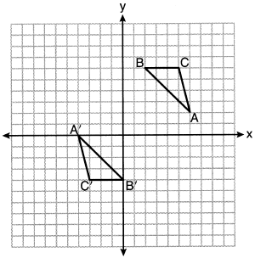
Triangle ABC maps onto after a
1) | reflection over the line | 3) | rotation of 180° centered at (1,1)
2) | reflection over the line | 4) | rotation of 180° centered at the origin

6 Right triangle TMR is a scalene triangle with the right angle at M. Which equation is true?
1) |  | 3)
2) |  | 4)

7 In the diagram below of and , .

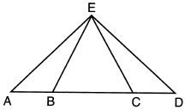

Which statement is always true?
1) |  | 3)
2) |  | 4)

8 As shown in the diagram below, right triangle ABC has side lengths of 8 and 15.

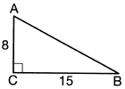

If the triangle is continuously rotated about , the resulting figure will be
1) | a right cone with a radius of 15 and a height of 8 | 3) | a right cylinder with a radius of 15 and a height of 8
2) | a right cone with a radius of 8 and a height of 15 | 4) | a right cylinder with a radius of 8 and a height of 15

9 In the diagram below, lines k and intersect lines m and n at points A, B, C, and D.

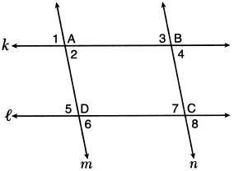

Which statement is sufficient to prove ABCD is a parallelogram?
1) |  | 3) | and
2) |  | 4) | and

10 Which transformation does not always preserve distance?
1) |  | 3)
2) |  | 4)

11 In the diagram below, , , , , and .

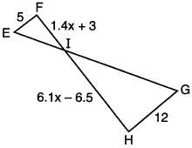

What is the length of ?
1) | 1 | 3) | 10
2) | 5 | 4) | 24

12 The square pyramid below models a toy block made of maple wood.

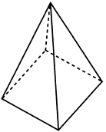

Each side of the base measures 4.5 cm and the height of the pyramid is 10 cm. If the density of maple is 0.676 g/cm³, what is the mass of the block, to the nearest tenth of a gram?
1) | 45.6 | 3) | 136.9
2) | 67.5 | 4) | 202.5

13 In the diagram below of right triangle EFG, altitude intersects hypotenuse at H.

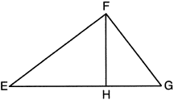

If and , what is EG?
1) | 6.75 | 3) | 18.75
2) | 12 | 4) | 25

14 In triangle ABC below, D is a point on and E is a point on , such that .

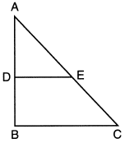

Which statement is always true?
1) | and are right angles. | 3) | 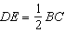
2) |  | 4)

15 If one exterior angle of a triangle is acute, then the triangle must be
1) | right | 3) | obtuse
2) | acute | 4) | equiangular

16 Given the information marked on the diagrams below, which pair of triangles can not always be proven congruent?
1) | 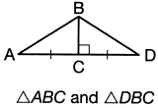 | 3) | 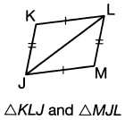
2) | 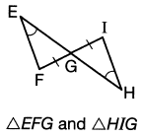 | 4) | 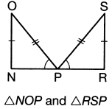

17 The diagram below shows a tree growing vertically on a hillside. The angle formed by the tree trunk and the hillside is 100°. The distance from the base of the tree to the bottom of the hill is 140 feet.

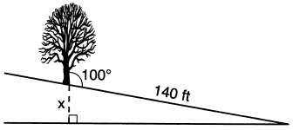

What is the vertical drop, x, to the base of the hill, to the nearest foot?
1) | 24 | 3) | 70
2) | 25 | 4) | 138

18 On the set of axes below, and are graphed in the coordinate plane where .

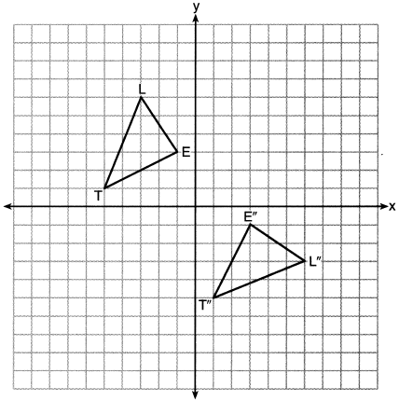

Which sequence of rigid motions maps onto ?
1) | a reflection over the y-axis followed by a reflection over the x-axis | 3) | a rotation of 90° counterclockwise about the origin followed by a reflection over the y-axis
2) | a rotation of 180° about the origin | 4) | a reflection over the x-axis followed by a rotation of 90° clockwise about the origin

19 Diameter of circle O is extended through Q to point P, and tangent is drawn. If , what is ?
1) | 10° | 3) | 40°
2) | 20° | 4) | 50°

20 Segment JM has endpoints and . An equation of the perpendicular bisector of is
1) | 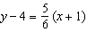 | 3) | 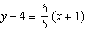
2) | 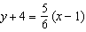 | 4) | 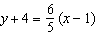

21 Quadrilateral EBCF and are drawn below, such that ABCD is a parallelogram, , and .

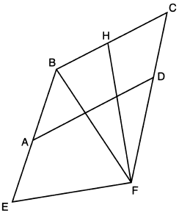

If and , what is ?
1) | 79º | 3) | 73º
2) | 76º | 4) | 62º

22 Point P divides the directed line segment from point to point in the ratio . The coordinates of point P are
1) |  | 3)
2) |  | 4)

23 A line is dilated by a scale factor of centered at a point on the line. Which statement is correct about the image of the line?
1) | Its slope is changed by a scale factor of . | 3) | Its slope and y-intercept are changed by a scale factor of .
2) | Its y-intercept is changed by a scale factor of . | 4) | The image of the line and the pre-image are the same line.

24 In the diagram below of circle O, tangent is drawn from external point B, and secant and diameter are drawn.

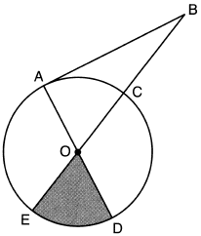

If and , what is the area of shaded sector DOE?
1) |  | 3)
2) |  | 4)

25 The Leaning Tower of Pisa in Italy is known for its slant, which occurred after its construction began. The angle of the slant is 86.03° from the ground. The low side of the tower reaches a height of 183.27 feet from the ground.

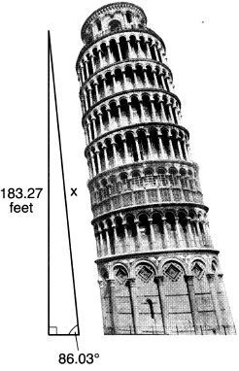

Determine and state the slant height, x, of the low side of the tower, to the nearest hundredth of a foot.

26 In the diagram below, quadrilateral ABCD is inscribed in circle O, and .

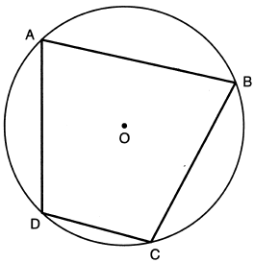

Determine and state .

27 In the diagram below, a right circular cone has a diameter of 10 and a slant height of 13.

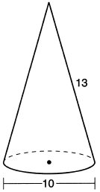

Determine and state the volume of the cone, in terms of .

28 In the diagram below, parallelogram EFGH is mapped onto parallelogram IJKH after a reflection over line .

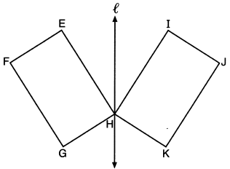

Use the properties of rigid motions to explain why parallelogram EFGH is congruent to parallelogram IJKH.

29 Izzy is making homemade clay pendants in the shape of a solid hemisphere, as modeled below. Each pendant has a radius of 2.8 cm.

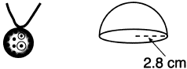

How much clay, to the nearest cubic centimeter, does Izzy need to make 100 pendants?

30 Determine and state the coordinates of the center and the length of the radius of the circle whose equation is .

31 Use a compass and straightedge to construct a line parallel to through point C, shown below. [Leave all construction marks.]

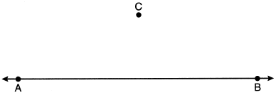

32 As modeled below, a projector mounted on a ceiling is 3.74 m from a wall, where a whiteboard is displayed. The vertical distance from the ceiling to the top of the whiteboard is 0.41 m, and the height of the whiteboard is 1.17 m.

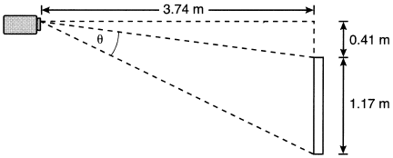

Determine and state the projection angle, , to the nearest tenth of a degree.

33 Given: Parallelogram PQRS, ,

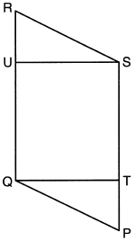

Prove:

34 A concrete footing is a cylinder that is placed in the ground to support a building structure. The cylinder is 4 feet tall and 12 inches in diameter. A contractor is installing 10 footings.

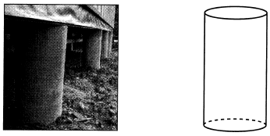

If a bag of concrete mix makes of a cubic foot of concrete, determine and state the minimum number of bags of concrete mix needed to make all 10 footings.

35 The coordinates of the vertices of are , , and . Prove that is isosceles. State the coordinates of , the image of , after a translation 5 units to the right and 5 units down. Prove that quadrilateral AA'C'C is a rhombus. [The use of the set of axes below is optional.]

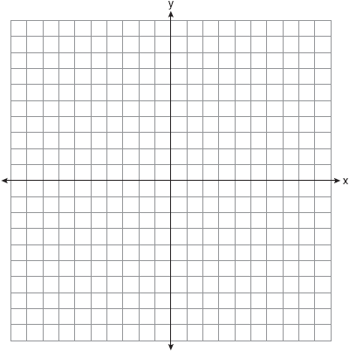
1 ANS: 2
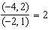

PTS: 2 REF: 062201geo NAT: G.SRT.A.2 TOP: Dilations

2 ANS: 2 PTS: 2 REF: 062202geo NAT: G.GMD.B.4
TOP: Cross-Sections of Three-Dimensional Objects

3 ANS: 1
A dilation preserves angle measure, so .

PTS: 2 REF: 062203geo NAT: G.SRT.C.6 TOP: Trigonometric Ratios

4 ANS: 1
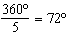

PTS: 2 REF: 062204geo NAT: G.CO.A.3 TOP: Mapping a Polygon onto Itself

5 ANS: 3
Since orientation is preserved, a reflection has not occurred.

PTS: 2 REF: 062205geo NAT: G.CO.A.2 TOP: Identifying Transformations
KEY: graphics

6 ANS: 3
Sine and cosine are cofunctions.

PTS: 2 REF: 062206geo NAT: G.SRT.C.7 TOP: Cofunctions

7 ANS: 4
Isosceles triangle theorem.

PTS: 2 REF: 062207geo NAT: G.SRT.B.5 TOP: Isosceles Triangle Theorem

8 ANS: 1 PTS: 2 REF: 062208geo NAT: G.GMD.B.4
TOP: Rotations of Two-Dimensional Objects

9 ANS: 3
Therefore . Since opposite angles are congruent, ABCD is a parallelogram.

PTS: 2 REF: 062209geo NAT: G.CO.C.11 TOP: Parallelograms

10 ANS: 3
A dilation does not preserve distance.

PTS: 2 REF: 062210geo NAT: G.CO.A.2
TOP: Analytical Representations of Transformations KEY: basic

11 ANS: 4
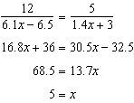

PTS: 2 REF: 062211geo NAT: G.SRT.B.5 TOP: Similarity
KEY: basic

12 ANS: 1
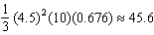

PTS: 2 REF: 062212geo NAT: G.MG.A.2 TOP: Density

13 ANS: 3
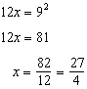

PTS: 2 REF: 062213geo NAT: G.SRT.B.5 TOP: Similarity
KEY: altitude

14 ANS: 2
and

PTS: 2 REF: 062214geo NAT: G.SRT.B.5 TOP: Side Splitter Theorem

15 ANS: 3 PTS: 2 REF: 062215geo NAT: G.CO.C.10
TOP: Exterior Angle Theorem

16 ANS: 4
1) SAS; 2) AAS; 3) SSS

PTS: 2 REF: 062216geo NAT: G.SRT.B.5 TOP: Triangle Congruency

17 ANS: 1
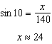

PTS: 2 REF: 062217geo NAT: G.SRT.C.8 TOP: Using Trigonometry to Find a Side

18 ANS: 3
1) and 2) are wrong because the orientation of has changed, implying one reflection has occurred. The sequence in 4) moves back to Quadrant II.

PTS: 2 REF: 062218geo NAT: G.CO.A.5 TOP: Compositions of Transformations
KEY: identify

19 ANS: 1
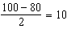

PTS: 2 REF: 062219geo NAT: G.C.A.2 TOP: Chords, Secants and Tangents
KEY: secant and tangent drawn from common point, angle

20 ANS: 4
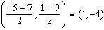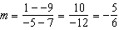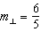

PTS: 2 REF: 062220geo NAT: G.GPE.B.5 TOP: Parallel and Perpendicular Lines
KEY: perpendicular bisector

21 ANS: 1
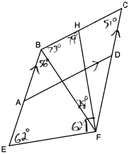

PTS: 2 REF: 062221geo NAT: G.CO.C.11 TOP: Interior and Exterior Angles of Polygons

22 ANS: 2
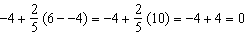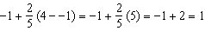

PTS: 2 REF: 062222geo NAT: G.GPE.B.6 TOP: Directed Line Segments

23 ANS: 4 PTS: 2 REF: 062223geo NAT: G.SRT.A.1
TOP: Line Dilations

24 ANS: 4
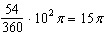

PTS: 2 REF: 062224geo NAT: G.C.B.5 TOP: Sectors

25 ANS:
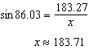

PTS: 2 REF: 062225geo NAT: G.SRT.C.8 TOP: Using Trigonometry to Find a Side

26 ANS:
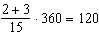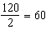

PTS: 2 REF: 062226geo NAT: G.C.A.3 TOP: Inscribed Quadrilaterals

27 ANS:
If 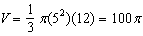

PTS: 2 REF: 062227geo NAT: G.GMD.A.3 TOP: Volume
KEY: cones

28 ANS:
Reflections preserve distance and angle measure.
PTS: 2 REF: 062228geo NAT: G.CO.B.6 TOP: Properties of Transformations
KEY: graphics

29 ANS:
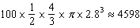

PTS: 2 REF: 062229geo NAT: G.GMD.A.3 TOP: Volume
KEY: spheres

30 ANS:
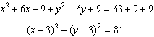

PTS: 2 REF: 062230geo NAT: G.GPE.A.1 TOP: Equations of Circles
KEY: completing the square

31 ANS:
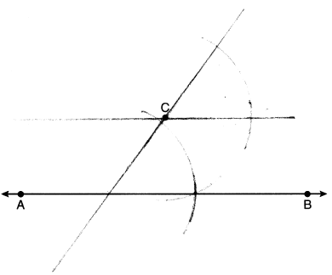

PTS: 2 REF: 062231geo NAT: G.CO.D.12 TOP: Constructions
KEY: parallel and perpendicular lines

32 ANS:
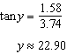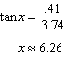

PTS: 4 REF: 062232geo NAT: G.SRT.C.8 TOP: Using Trigonometry to Find an Angle

33 ANS:
Parallelogram PQRS, , (given); (opposite sides of a parallelogram are parallel; Quadrilateral QUST is a rectangle (quadrilateral with parallel opposite sides and opposite right angles is a rectangle); (opposite sides of a rectangle are congruent); (opposite sides of a parallelogram are congruent); and are right angles (the supplement of a right angle is a right angle), (HL); (CPCTC)

PTS: 4 REF: 062233geo NAT: G.SRT.B.5 TOP: Quadrilateral Proofs

34 ANS:
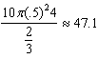 48 bags

PTS: 4 REF: 062234geo NAT: G.GMD.A.3 TOP: Volume
KEY: cylinders

35 ANS:
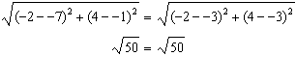 Since and are congruent, is isosceles. . 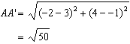, (translation preserves distance), 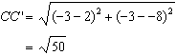 Since all four sides are congruent, AA'C'C is a rhombus. 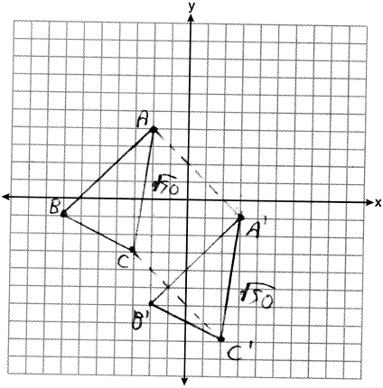

PTS: 6 REF: 062235geo NAT: G.GPE.B.4 TOP: Quadrilaterals in the Coordinate Plane
KEY: grids

