1 After a counterclockwise rotation about point X, scalene triangle ABC maps onto , as shown in the diagram below.

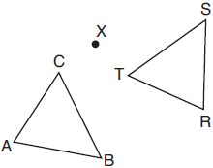

Which statement must be true?
1)
2)
3)
4)

2 In the diagram below, , and intersect at C, , and .

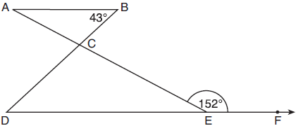

Which statement is true?
1)
2)
3)
4)

3 In the diagram below, line m is parallel to line n. Figure 2 is the image of Figure 1 after a reflection over line m. Figure 3 is the image of Figure 2 after a reflection over line n.

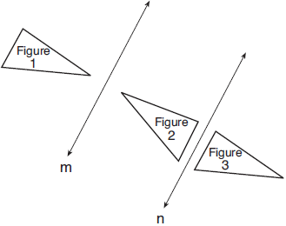

Which single transformation would carry Figure 1 onto Figure 3?
1) | a dilation
2) | a rotation
3) | a reflection
4) | a translation

4 In the diagram below, , and intersect at C, and and are drawn such that , , , , and .
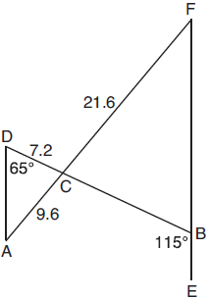
What is the length of ?
1) | 3.2
2) | 4.8
3) | 16.2
4) | 19.2

5 Given square RSTV, where cm. If square RSTV is dilated by a scale factor of 3 about a given center, what is the perimeter, in centimeters, of the image of RSTV after the dilation?
1) | 12
2) | 27
3) | 36
4) | 108

6 In right triangle ABC, hypotenuse has a length of 26 cm, and side has a length of 17.6 cm. What is the measure of angle B, to the nearest degree?
1) | 48°
2) | 47°
3) | 43°
4) | 34°

7 The greenhouse pictured below can be modeled as a rectangular prism with a half-cylinder on top. The rectangular prism is 20 feet wide, 12 feet high, and 45 feet long. The half-cylinder has a diameter of 20 feet.
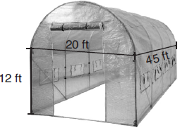

To the nearest cubic foot, what is the volume of the greenhouse?
1) | 17,869
2) | 24,937
3) | 39,074
4) | 67,349

8 In a right triangle, the acute angles have the relationship . What is the value of x?
1) | 20
2) | 21
3) | 24
4) | 25

9 In the diagram below, , , and and are drawn.
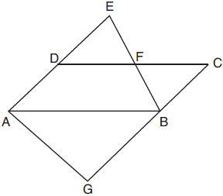
Which statement is always true?
1)
2)
3)
4)

10 The base of a pyramid is a rectangle with a width of 4.6 cm and a length of 9 cm. What is the height, in centimeters, of the pyramid if its volume is 82.8 cm³?
1) | 6
2) | 2
3) | 9
4) | 18

11 In the diagram below of right triangle AED, .
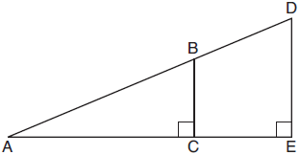
Which statement is always true?
1) | 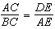
2) | 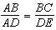
3) | 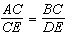
4) | 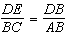

12 What is an equation of the line that passes through the point and is perpendicular to a line with equation 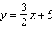?
1) | 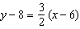
2) | 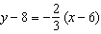
3) | 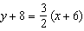
4) | 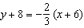

13 The diagram below shows parallelogram ABCD with diagonals and intersecting at E.

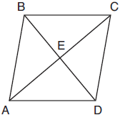

What additional information is sufficient to prove that parallelogram ABCD is also a rhombus?
1) | bisects .
2) | is parallel to .
3) | is congruent to .
4) | is perpendicular to .

14 Directed line segment DE has endpoints and . Point F divides such that is 2:3. What are the coordinates of F?
1)
2)
3)
4)

15 Triangle DAN is graphed on the set of axes below. The vertices of have coordinates , , and .

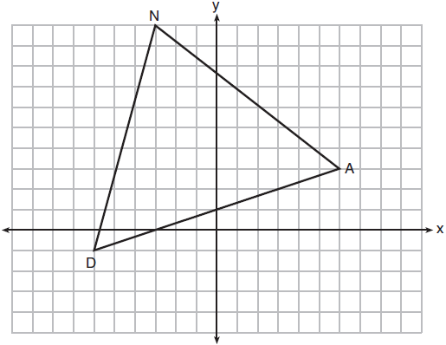

What is the area of ?
1) | 60
2) | 120
3)
4)

16 Triangle ABC, with vertices at , , and , is graphed on the set of axes shown below.

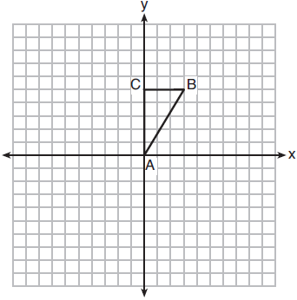

Which figure is formed when is rotated continuously about ?
1) | 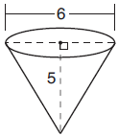
2) | 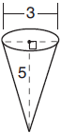
3) | 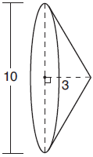
4) | 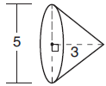

17 In the diagram below of circle O, chords and intersect at E.

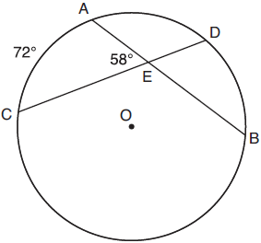

If and , how many degrees are in ?
1) | 108º
2) | 65º
3) | 44º
4) | 14º

18 In triangle SRK below, medians , , and intersect at M.

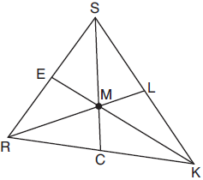

Which statement must always be true?
1)
2) | 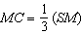
3)
4)

19 The regular polygon below is rotated about its center.

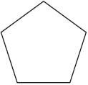

Which angle of rotation will carry the figure onto itself?
1) | 60°
2) | 108°
3) | 216°
4) | 540°

20 What is an equation of circle O shown in the graph below?

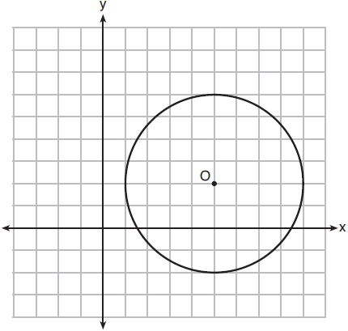
1)
2)
3)
4)

21 In the diagram below of , is drawn parallel to , , , and .
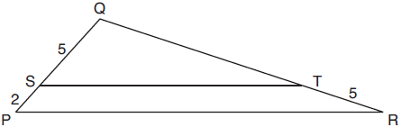
What is the length of ?
1) | 7
2) | 2
3)
4)

22 The diagram below shows circle O with radii and . The measure of angle AOB is 120°, and the length of a radius is 6 inches.
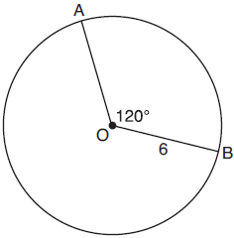
Which expression represents the length of arc AB, in inches?
1) | 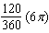
2)
3) | 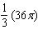
4) | 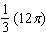

23 Line segment CD is the altitude drawn to hypotenuse in right triangle ECF. If and , then, to the nearest tenth, ED is
1) | 4.2
2) | 5.4
3) | 15.5
4) | 21.8

24 Line MN is dilated by a scale factor of 2 centered at the point . If is represented by , which equation can represent , the image of ?
1)
2)
3)
4)

25 Triangle A'B'C' is the image of triangle ABC after a translation of 2 units to the right and 3 units up. Is triangle ABC congruent to triangle A'B'C'? Explain why.

26 Triangle ABC and point are graphed on the set of axes below.

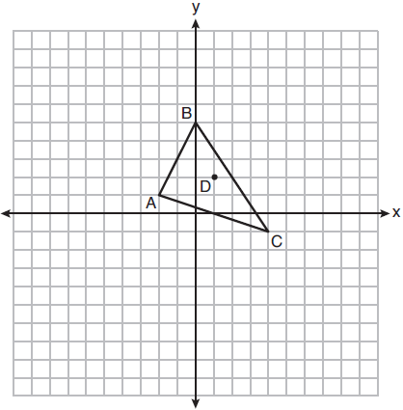

Graph and label , the image of , after a dilation of scale factor 2 centered at point D.

27 Quadrilaterals BIKE and GOLF are graphed on the set of axes below.

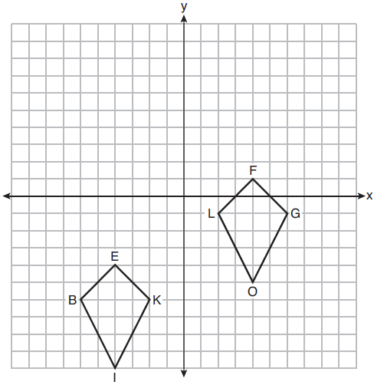

Describe a sequence of transformations that maps quadrilateral BIKE onto quadrilateral GOLF.

28 In the diagram below, secants and , drawn from point R, intersect circle O at S, T, Q, and P.

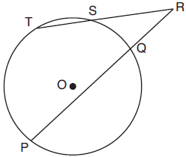

If , , and , what is the length of ?

29 Using a compass and straightedge, construct the median to side in below. [Leave all construction marks.]

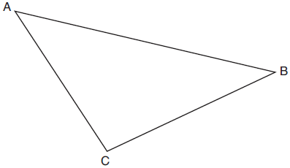

30 Skye says that the two triangles below are congruent. Margaret says that the two triangles are similar.

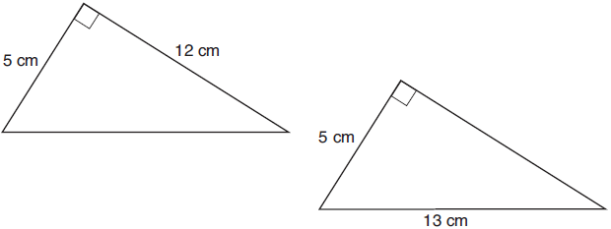

Are Skye and Margaret both correct? Explain why.

31 Randy's basketball is in the shape of a sphere with a maximum circumference of 29.5 inches. Determine and state the volume of the basketball, to the nearest cubic inch.

32 Triangle ABC has vertices with coordinates , , and . Prove that is an isosceles triangle but not an equilateral triangle. [The use of the set of axes below is optional.]

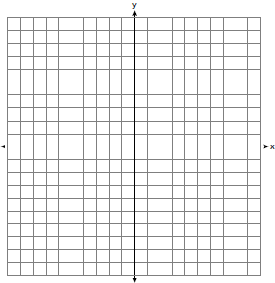

33 The map of a campground is shown below. Campsite C, first aid station F, and supply station S lie along a straight path. The path from the supply station to the tower, T, is perpendicular to the path from the supply station to the campsite. The length of path is 400 feet. The angle formed by path and path is 72°. The angle formed by path and path is 55°.

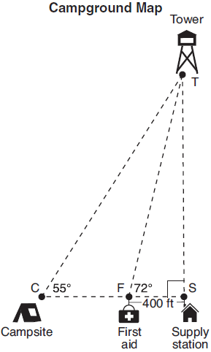

Determine and state, to the nearest foot, the distance from the campsite to the tower.

34 Shae has recently begun kickboxing and purchased training equipment as modeled in the diagram below. The total weight of the bag, pole, and unfilled base is 270 pounds. The cylindrical base is 18 inches tall with a diameter of 20 inches. The dry sand used to fill the base weighs 95.46 lbs per cubic foot.

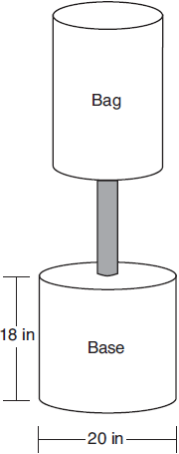

To the nearest pound, determine and state the total weight of the training equipment if the base is filled to 85% of its capacity.

35 Given: Parallelogram ABCD, , and

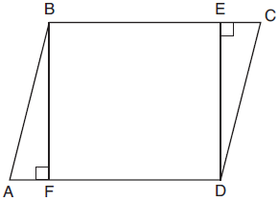

Prove: BEDF is a rectangle
1 ANS: 1 PTS: 2 REF: 061801geo NAT: G.CO.B.6
TOP: Properties of Transformations KEY: graphics

2 ANS: 3 PTS: 2 REF: 061802geo NAT: G.CO.C.9
TOP: Lines and Angles

3 ANS: 4 PTS: 2 REF: 061803geo NAT: G.CO.A.2
TOP: Identifying Transformations KEY: graphics

4 ANS: 3
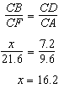

PTS: 2 REF: 061804geo NAT: G.SRT.B.5 TOP: Similarity
KEY: basic

5 ANS: 4
,

PTS: 2 REF: 061805geo NAT: G.SRT.A.2 TOP: Dilations

6 ANS: 2
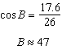

PTS: 2 REF: 061806geo NAT: G.SRT.C.8 TOP: Using Trigonometry to Find an Angle

7 ANS: 1
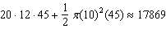

PTS: 2 REF: 061807geo NAT: G.GMD.A.3 TOP: Volume
KEY: compositions

8 ANS: 1
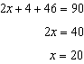

PTS: 2 REF: 061808geo NAT: G.SRT.C.7 TOP: Cofunctions

9 ANS: 4
AA

PTS: 2 REF: 061809geo NAT: G.SRT.A.3 TOP: Similarity Proofs

10 ANS: 1
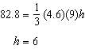

PTS: 2 REF: 061810geo NAT: G.GMD.A.3 TOP: Volume
KEY: pyramids

11 ANS: 2

PTS: 2 REF: 061811geo NAT: G.SRT.B.5 TOP: Similarity
KEY: basic

12 ANS: 2
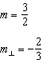

PTS: 2 REF: 061812geo NAT: G.GPE.B.5 TOP: Parallel and Perpendicular Lines
KEY: write equation of perpendicular line

13 ANS: 4 PTS: 2 REF: 061813geo NAT: G.CO.C.11
TOP: Special Quadrilaterals

14 ANS: 2
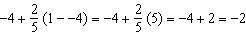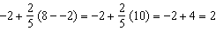

PTS: 2 REF: 061814geo NAT: G.GPE.B.6 TOP: Directed Line Segments

15 ANS: 1
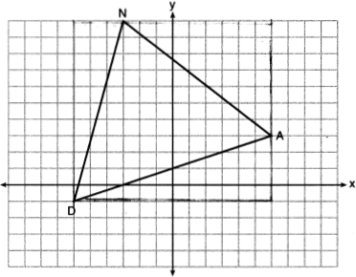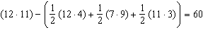

PTS: 2 REF: 061815geo NAT: G.GPE.B.7 TOP: Polygons in the Coordinate Plane

16 ANS: 3 PTS: 2 REF: 061816geo NAT: G.GMD.B.4
TOP: Rotations of Two-Dimensional Objects

17 ANS: 3
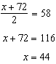

PTS: 2 REF: 061817geo NAT: G.C.A.2 TOP: Chords, Secants and Tangents
KEY: intersecting chords, angle

18 ANS: 1
M is a centroid, and cuts each median .

PTS: 2 REF: 061818geo NAT: G.CO.C.10
TOP: Centroid, Orthocenter, Incenter and Circumcenter

19 ANS: 3
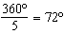 216º is a multiple of 72º

PTS: 2 REF: 061819geo NAT: G.CO.A.3 TOP: Mapping a Polygon onto Itself

20 ANS: 2
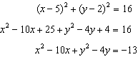

PTS: 2 REF: 061820geo NAT: G.GPE.A.1 TOP: Equations of Circles
KEY: write equation, given graph

21 ANS: 4
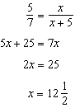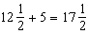

PTS: 2 REF: 061821geo NAT: G.SRT.B.5 TOP: Side Splitter Theorem

22 ANS: 4
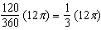

PTS: 2 REF: 061822geo NAT: G.C.B.5 TOP: Arc Length
KEY: arc length

23 ANS: 1
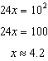

PTS: 2 REF: 061823geo NAT: G.SRT.B.5 TOP: Similarity
KEY: leg

24 ANS: 2
The line passes through the center of dilation, so the dilated line is not distinct.

PTS: 2 REF: 061824geo NAT: G.SRT.A.1 TOP: Line Dilations

25 ANS:
Yes, as translations do not change angle measurements.

PTS: 2 REF: 061825geo NAT: G.CO.B.6 TOP: Properties of Transformations
KEY: basic

26 ANS:
, ,

PTS: 2 REF: 061826geo NAT: G.SRT.A.2 TOP: Dilations

27 ANS:
Reflection across the y-axis, then translation up 5.

PTS: 2 REF: 061827geo NAT: G.CO.A.5 TOP: Compositions of Transformations
KEY: grids

28 ANS:
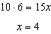

PTS: 2 REF: 061828geo NAT: G.C.A.2 TOP: Chords, Secants and Tangents
KEY: secants drawn from common point, length

29 ANS:
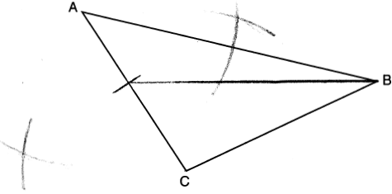

PTS: 2 REF: 061829geo NAT: G.CO.D.12 TOP: Constructions
KEY: line bisector

30 ANS:
Yes. The triangles are congruent because of SSS . All congruent triangles are similar.

PTS: 2 REF: 061830geo NAT: G.SRT.B.5 TOP: Triangle Congruency

31 ANS:
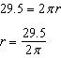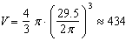

PTS: 2 REF: 061831geo NAT: G.GMD.A.3 TOP: Volume
KEY: spheres

32 ANS:
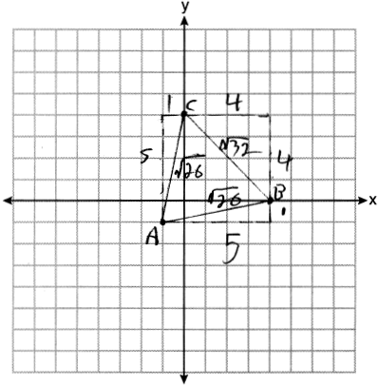Because , has two congruent sides and is isosceles. Because is not true, has sides that are not congruent and is not equilateral.

PTS: 4 REF: 061832geo NAT: G.GPE.B.4 TOP: Triangles in the Coordinate Plane

33 ANS:
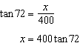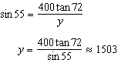

PTS: 4 REF: 061833geo NAT: G.SRT.C.8 TOP: Using Trigonometry to Find a Side
KEY: advanced

34 ANS:
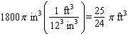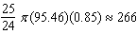

PTS: 4 REF: 061834geo NAT: G.MG.A.2 TOP: Density

35 ANS:
Parallelogram ABCD, , and (given); (opposite sides of a are ); (parts of lines are ); (two lines to the same line are ); BEDF is (a quadrilateral with both pairs of opposite sides is a ); is a right ( lines form right ); BEDF is a rectangle (a with one right is a rectangle).

PTS: 6 REF: 061835geo NAT: G.CO.C.11 TOP: Quadrilateral Proofs

