1 In the diagram below, .

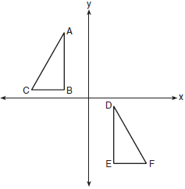

Which sequence of transformations maps onto ?
1) | a reflection over the x-axis followed by a translation | 3) | a rotation of 180° about the origin followed by a translation
2) | a reflection over the y-axis followed by a translation | 4) | a counterclockwise rotation of 90° about the origin followed by a translation

2 On the set of axes below, the vertices of have coordinates , , and .

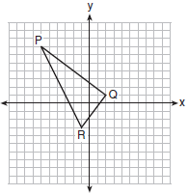

What is the area of ?
1) | 10 | 3) | 25
2) | 20 | 4) | 50

3 In right triangle ABC, . If 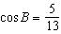, which function also equals ?
1) |  | 3)
2) |  | 4)

4 In the diagram below, .
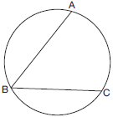

What is the number of degrees in the measure of ?
1) | 134º | 3) | 68º
2) | 92º | 4) | 46º

5 Given shown below, with trapezoid PTRO, , , and .

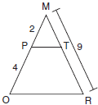

What is the length of ?
1) | 4.5 | 3) | 3
2) | 5 | 4) | 6

6 A line segment is dilated by a scale factor of 2 centered at a point not on the line segment. Which statement regarding the relationship between the given line segment and its image is true?
1) | The line segments are perpendicular, and the image is one-half of the length of the given line segment. | 3) | The line segments are parallel, and the image is twice the length of the given line segment.
2) | The line segments are perpendicular, and the image is twice the length of the given line segment. | 4) | The line segments are parallel, and the image is one-half of the length of the given line segment.

7 Which figure always has exactly four lines of reflection that map the figure onto itself?
1) | square | 3) | regular octagon
2) | rectangle | 4) | equilateral triangle

8 In the diagram below of circle O, chord bisects chord at E.

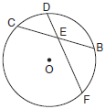

If and FE is 5 more than DE, then FE is
1) | 13 | 3) | 6
2) | 9 | 4) | 4

9 Kelly is completing a proof based on the figure below.

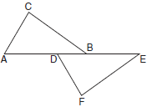

She was given that , and has already proven . Which pair of corresponding parts and triangle congruency method would not prove ?
1) | and SAS | 3) | and AAS
2) | and SAS | 4) | and ASA

10 In the diagram below, divides and proportionally, , , and bisects .
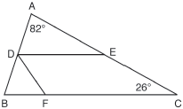

The measure of angle is
1) | 36° | 3) | 72°
2) | 54° | 4) | 82°

11 Which set of statements would describe a parallelogram that can always be classified as a rhombus?
I. Diagonals are perpendicular bisectors of each other.
II. Diagonals bisect the angles from which they are drawn.
III. Diagonals form four congruent isosceles right triangles.
1) | I and II | 3) | II and III
2) | I and III | 4) | I, II, and III

12 The equation of a circle is . What are the coordinates of the center and the length of the radius of the circle?
1) | center and radius 4 | 3) | center and radius 16
2) | center and radius 4 | 4) | center and radius 16

13 In the diagram of below, , , and .

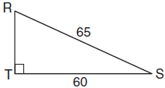

What is the measure of , to the nearest degree?
1) | 23º | 3) | 47º
2) | 43º | 4) | 67º

14 Triangle is the image of after a dilation followed by a translation. Which statement(s) would always be true with respect to this sequence of transformations?
I.
II.
III.
IV.
1) | II, only | 3) | II and III
2) | I and II | 4) | II, III, and IV

15 Line segment RW has endpoints and . Point P is on such that is 2:3. What are the coordinates of point P?
1) |  | 3)
2) |  | 4)

16 The pyramid shown below has a square base, a height of 7, and a volume of 84.
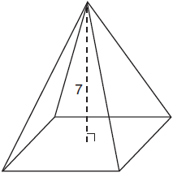

What is the length of the side of the base?
1) | 6 | 3) | 18
2) | 12 | 4) | 36

17 In the diagram below of triangle MNO, and are bisected by and , respectively. Segments MS and intersect at T, and .
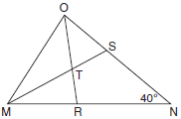

If , the measure of angle OTS is
1) | 40º | 3) | 60º
2) | 50º | 4) | 70º

18 In the diagram below, right triangle ABC has legs whose lengths are 4 and 6.
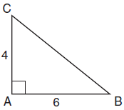

What is the volume of the three-dimensional object formed by continuously rotating the right triangle around ?
1) | 32π | 3) | 96π
2) | 48π | 4) | 144π

19 What is an equation of a line that is perpendicular to the line whose equation is and passes through ?
1) | 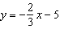 | 3) | 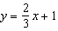
2) | 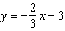 | 4) | 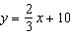

20 In quadrilateral BLUE shown below, .

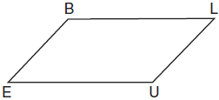

Which information would be sufficient to prove quadrilateral BLUE is a parallelogram?
1) |  | 3)
2) |  | 4)

21 A ladder 20 feet long leans against a building, forming an angle of 71° with the level ground. To the nearest foot, how high up the wall of the building does the ladder touch the building?
1) | 15 | 3) | 18
2) | 16 | 4) | 19

22 In the two distinct acute triangles ABC and DEF, Triangles ABC and DEF are congruent when there is a sequence of rigid motions that maps
1) | onto , and onto | 3) | onto , and onto
2) | onto , and onto | 4) | point A onto point D, and onto

23 A fabricator is hired to make a 27-foot-long solid metal railing for the stairs at the local library. The railing is modeled by the diagram below. The railing is 2.5 inches high and 2.5 inches wide and is comprised of a rectangular prism and a half-cylinder.

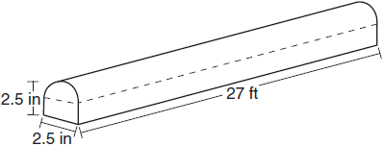

How much metal, to the nearest cubic inch, will the railing contain?
1) | 151 | 3) | 1808
2) | 795 | 4) | 2025

24 In the diagram below, and .

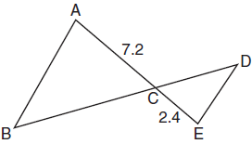

Which statement is not sufficient to prove ?
1) |  | 3) | and
2) | and | 4) | , , , and

25 Given: Trapezoid JKLM with
Using a compass and straightedge, construct the altitude from vertex J to . [Leave all construction marks.]

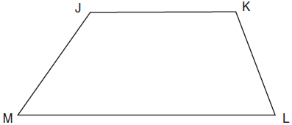

26 Determine and state, in terms of π, the area of a sector that intercepts a 40° arc of a circle with a radius of 4.5.

27 The diagram below shows two figures. Figure A is a right triangular prism and figure B is an oblique triangular prism. The base of figure A has a height of 5 and a length of 8 and the height of prism A is 14. The base of figure B has a height of 8 and a length of 5 and the height of prism B is 14.

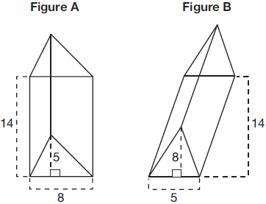

Use Cavalieri's Principle to explain why the volumes of these two triangular prisms are equal.

28 When volleyballs are purchased, they are not fully inflated. A partially inflated volleyball can be modeled by a sphere whose volume is approximately 180 in³. After being fully inflated, its volume is approximately 294 in³. To the nearest tenth of an inch, how much does the radius increase when the volleyball is fully inflated?

29 In right triangle ABC shown below, altitude is drawn to hypotenuse . Explain why .

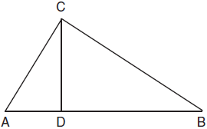

30 Triangle ABC and triangle DEF are drawn below.

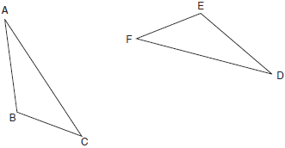

If , , and , write a sequence of transformations that maps triangle ABC onto triangle DEF.

31 Line n is represented by the equation . Determine and state the equation of line p, the image of line n, after a dilation of scale factor centered at the point . [The use of the set of axes below is optional.] Explain your answer.

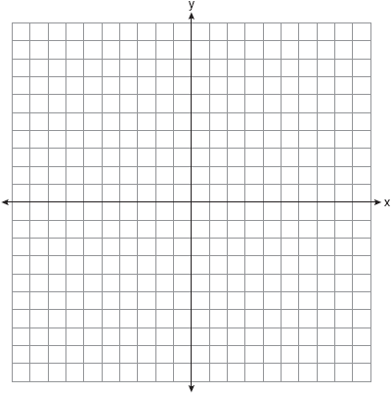

32 Triangle ABC has vertices at , , and , and triangle DEF has vertices at , , and . Graph and label and on the set of axes below. Determine and state the single transformation where is the image of . Use your transformation to explain why .

33 Given: and bisect each other at point X
and are drawn

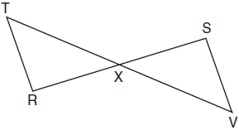

Prove:

34 A gas station has a cylindrical fueling tank that holds the gasoline for its pumps, as modeled below. The tank holds a maximum of 20,000 gallons of gasoline and has a length of 34.5 feet.

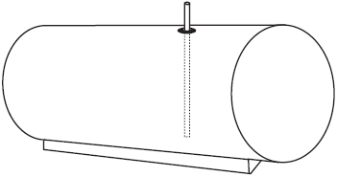

A metal pole is used to measure how much gas is in the tank. To the nearest tenth of a foot, how long does the pole need to be in order to reach the bottom of the tank and still extend one foot outside the tank? Justify your answer. [1 ft³=7.48 gallons]

35 Quadrilateral PQRS has vertices , , , and . Prove that PQRS is a rhombus. Prove that PQRS is not a square. [The use of the set of axes below is optional.]

36 Freda, who is training to use a radar system, detects an airplane flying at a constant speed and heading in a straight line to pass directly over her location. She sees the airplane at an angle of elevation of 15° and notes that it is maintaining a constant altitude of 6250 feet. One minute later, she sees the airplane at an angle of elevation of 52°. How far has the airplane traveled, to the nearest foot? Determine and state the speed of the airplane, to the nearest mile per hour.
1 ANS: 2 PTS: 2 REF: 061701geo NAT: G.CO.A.5
TOP: Compositions of Transformations KEY: identify

2 ANS: 3 PTS: 2 REF: 061702geo NAT: G.GPE.B.7
TOP: Polygons in the Coordinate Plane

3 ANS: 3 PTS: 2 REF: 061703geo NAT: G.SRT.C.7
TOP: Cofunctions

4 ANS: 4
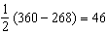

PTS: 2 REF: 061704geo NAT: G.C.A.2 TOP: Chords, Secants and Tangents
KEY: inscribed

5 ANS: 4
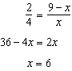

PTS: 2 REF: 061705geo NAT: G.SRT.B.5 TOP: Side Splitter Theorem

6 ANS: 3 PTS: 2 REF: 061706geo NAT: G.SRT.A.1
TOP: Line Dilations

7 ANS: 1 PTS: 2 REF: 061707geo NAT: G.CO.A.3
TOP: Mapping a Polygon onto Itself

8 ANS: 2
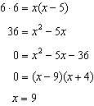

PTS: 2 REF: 061708geo NAT: G.C.A.2 TOP: Chords, Secants and Tangents
KEY: intersecting chords, length

9 ANS: 2 PTS: 2 REF: 061709geo NAT: G.SRT.B.5
TOP: Triangle Proofs KEY: statements

10 ANS: 2
; ; ; 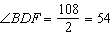;

PTS: 2 REF: 061710geo NAT: G.CO.C.10 TOP: Interior and Exterior Angles of Triangles

11 ANS: 4 PTS: 2 REF: 061711geo NAT: G.CO.C.11
TOP: Special Quadrilaterals

12 ANS: 1
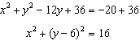

PTS: 2 REF: 061712geo NAT: G.GPE.A.1 TOP: Equations of Circles
KEY: completing the square

13 ANS: 1
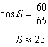

PTS: 2 REF: 061713geo NAT: G.SRT.C.8 TOP: Using Trigonometry to Find an Angle

14 ANS: 1
NYSED accepts either (1) or (3) as a correct answer. Statement III is not true if A, B, A’ and B’ are collinear.

PTS: 2 REF: 061714geo NAT: G.SRT.A.2 TOP: Compositions of Transformations
KEY: basic

15 ANS: 2
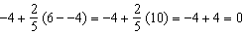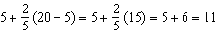

PTS: 2 REF: 061715geo NAT: G.GPE.B.6 TOP: Directed Line Segments

16 ANS: 1
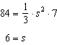

PTS: 2 REF: 061716geo NAT: G.GMD.A.3 TOP: Volume
KEY: pyramids

17 ANS: 4
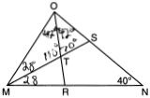

PTS: 2 REF: 061717geo NAT: G.CO.C.10 TOP: Interior and Exterior Angles of Triangles

18 ANS: 1
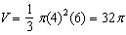

PTS: 2 REF: 061718geo NAT: G.GMD.B.4 TOP: Rotations of Two-Dimensional Objects

19 ANS: 2
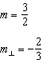. 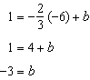

PTS: 2 REF: 061719geo NAT: G.GPE.B.5 TOP: Parallel and Perpendicular Lines
KEY: write equation of perpendicular line

20 ANS: 2 PTS: 2 REF: 061720geo NAT: G.CO.C.11
TOP: Parallelograms

21 ANS: 4
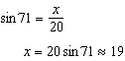

PTS: 2 REF: 061721geo NAT: G.SRT.C.8 TOP: Using Trigonometry to Find a Side
KEY: without graphics

22 ANS: 3
NYSED has stated that all students should be awarded credit regardless of their answer to this question.

PTS: 2 REF: 061722geo NAT: G.CO.B.7 TOP: Triangle Congruency

23 ANS: 3
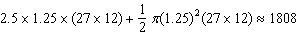

PTS: 2 REF: 061723geo NAT: G.GMD.A.3 TOP: Volume
KEY: compositions

24 ANS: 2
(1) AA; (3) SAS; (4) SSS. NYSED has stated that all students should be awarded credit regardless of their answer to this question.

PTS: 2 REF: 061724geo NAT: G.SRT.B.5 TOP: Similarity
KEY: basic

25 ANS:
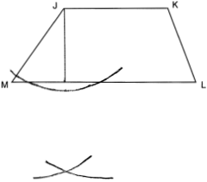

PTS: 2 REF: 061725geo NAT: G.CO.D.12 TOP: Constructions
KEY: parallel and perpendicular lines

26 ANS:
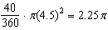
PTS: 2 REF: 061726geo NAT: G.C.B.5 TOP: Sectors

27 ANS:
Each triangular prism has the same base area. Therefore, each corresponding cross-section of the prisms will have the same area. Since the two prisms have the same height of 14, the two volumes must be the same.
PTS: 2 REF: 061727geo NAT: G.GMD.A.1 TOP: Volume

28 ANS:
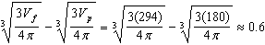
PTS: 2 REF: 061728geo NAT: G.GMD.A.3 TOP: Volume
KEY: spheres

29 ANS:
If an altitude is drawn to the hypotenuse of a triangle, it divides the triangle into two right triangles similar to each other and the original triangle.
PTS: 2 REF: 061729geo NAT: G.SRT.B.5 TOP: Similarity
KEY: altitude

30 ANS:
Rotate clockwise about point C until . Translate along so that C maps onto F.
PTS: 2 REF: 061730geo NAT: G.CO.A.5 TOP: Compositions of Transformations
KEY: identify

31 ANS:
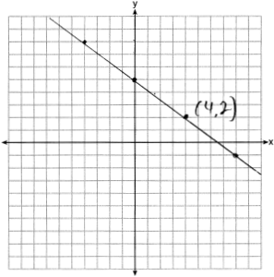 The line is on the center of dilation, so the line does not change.
PTS: 2 REF: 061731geo NAT: G.SRT.A.1 TOP: Line Dilations

32 ANS:
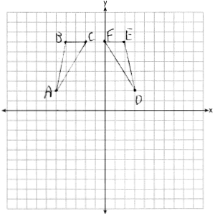 Reflections are rigid motions that preserve distance, so .
PTS: 4 REF: 061732geo NAT: G.CO.A.2 TOP: Identifying Transformations
KEY: graphics

33 ANS:
and bisect each other at point X; and are drawn (given); and (segment bisectors create two congruent segments); (vertical angles are congruent); (SAS); (CPCTC); (a transversal that creates congruent alternate interior angles cuts parallel lines).
PTS: 4 REF: 061733geo NAT: G.SRT.B.5 TOP: Triangle Proofs
KEY: proof

34 ANS:
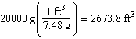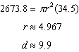
PTS: 4 REF: 061734geo NAT: G.GMD.A.3 TOP: Volume
KEY: cylinders

35 ANS:
PQRS is a rhombus because all sides are congruent. 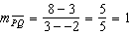 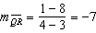 Because the slopes of adjacent sides are not opposite reciprocals, they are not perpendicular and do not form a right angle. Therefore PQRS is not a square. 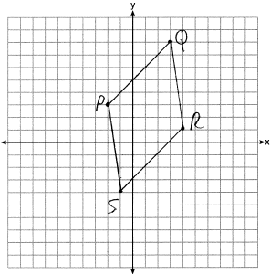
PTS: 6 REF: 061735geo NAT: G.GPE.B.4 TOP: Quadrilaterals in the Coordinate Plane
KEY: grids

36 ANS:
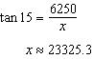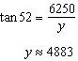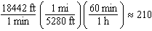
PTS: 6 REF: 061736geo NAT: G.SRT.C.8 TOP: Using Trigonometry to Find a Side
KEY: advanced

