1 A student has a rectangular postcard that he folds in half lengthwise. Next, he rotates it continuously about the folded edge. Which three-dimensional object below is generated by this rotation?
1) | 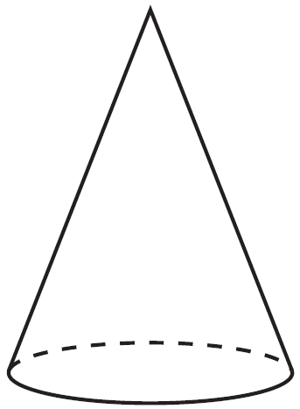 | 3) | 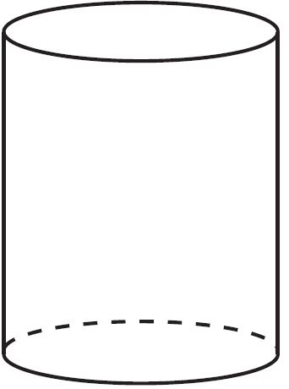
2) | 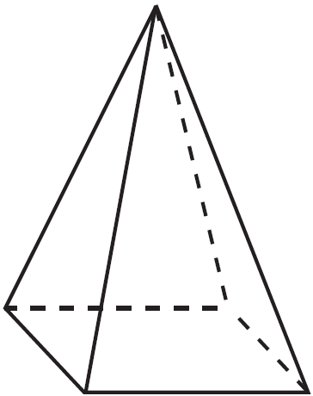 | 4) | 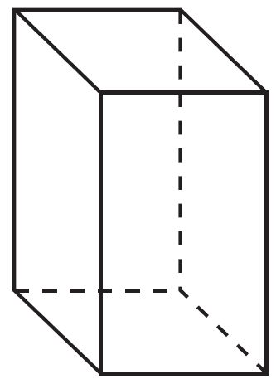

2 A three-inch line segment is dilated by a scale factor of 6 and centered at its midpoint. What is the length of its image?
1) | 9 inches | 3) | 15 inches
2) | 2 inches | 4) | 18 inches

3 Kevin’s work for deriving the equation of a circle is shown below.
STEP 1
STEP 2
STEP 3
STEP 4
In which step did he make an error in his work?
1) | Step 1 | 3) | Step 3
2) | Step 2 | 4) | Step 4

4 Which transformation of would result in an image parallel to ?

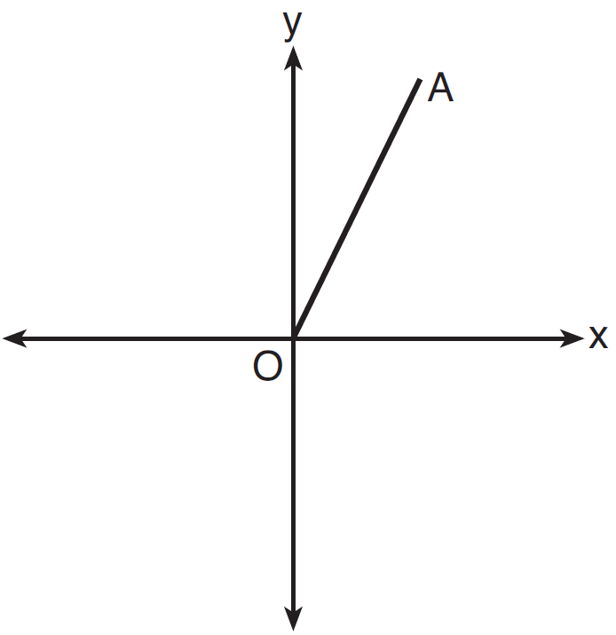
1) | a translation of two units down | 3) | a reflection over the y-axis
2) | a reflection over the x-axis | 4) | a clockwise rotation of 90° about the origin

5 Using the information given below, which set of triangles can not be proven similar?
1) | 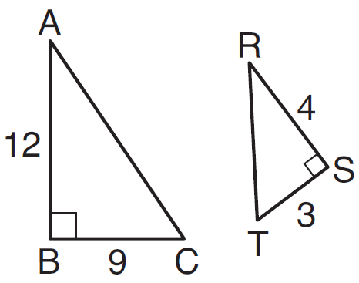 | 3) | 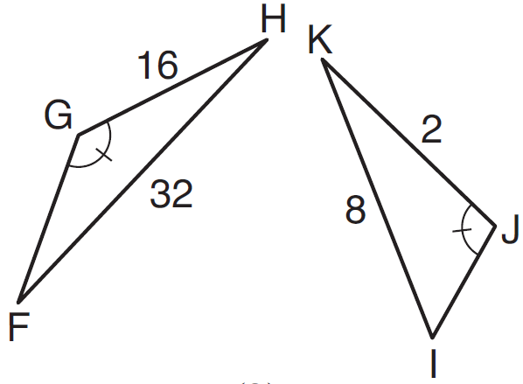
2) | 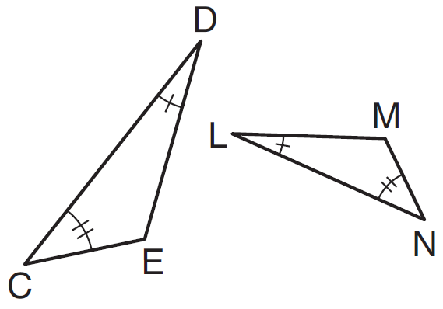 | 4) | 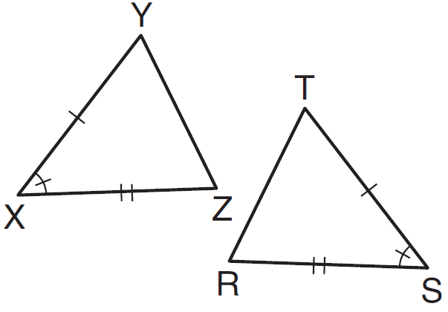

6 A company is creating an object from a wooden cube with an edge length of 8.5 cm. A right circular cone with a diameter of 8 cm and an altitude of 8 cm will be cut out of the cube. Which expression represents the volume of the remaining wood?
1) |  | 3) | 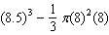
2) |  | 4) | 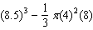

7 Two right triangles must be congruent if
1) | an acute angle in each triangle is congruent | 3) | the corresponding legs are congruent
2) | the lengths of the hypotenuses are equal | 4) | the areas are equal

8 Which sequence of transformations will map onto ?

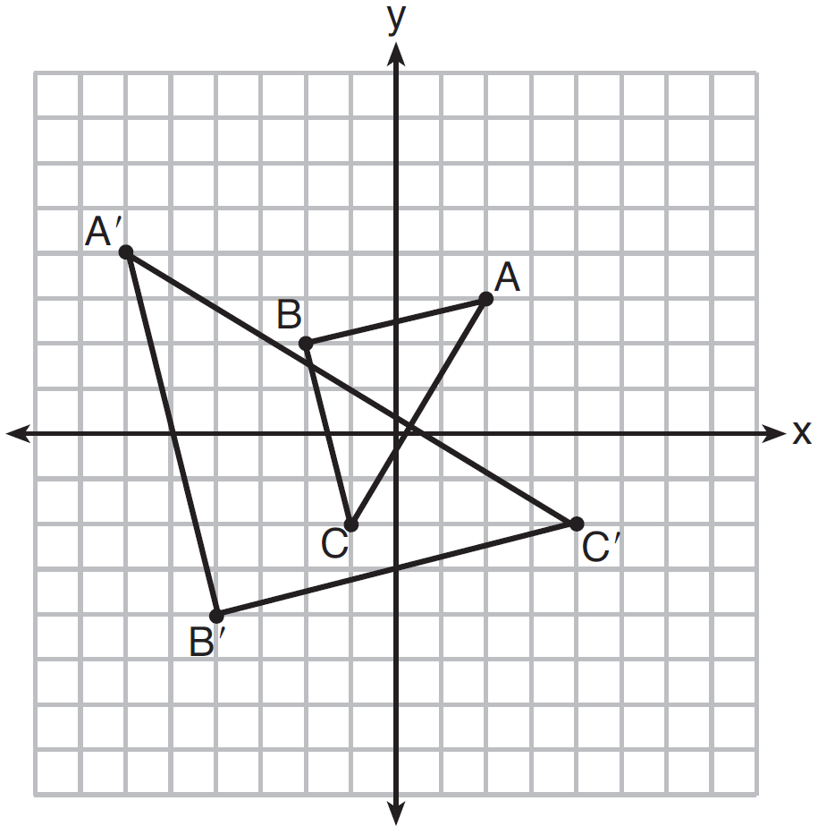
1) | reflection and translation | 3) | translation and dilation
2) | rotation and reflection | 4) | dilation and rotation

9 In parallelogram ABCD, diagonals and intersect at E. Which statement does not prove parallelogram ABCD is a rhombus?
1) |  | 3)
2) |  | 4) | bisects

10 In the diagram below of circle O, and are radii, and chords , , and are drawn.

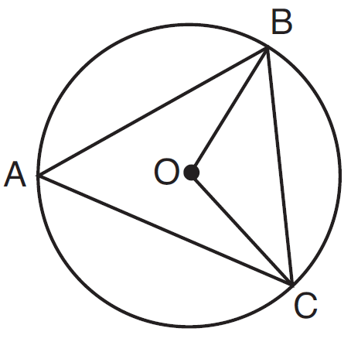

Which statement must always be true?
1) |  | 3) | and are isosceles.
2) |  | 4) | The area of is twice the area of .

11 A 20-foot support post leans against a wall, making a 70° angle with the ground. To the nearest tenth of a foot, how far up the wall will the support post reach?
1) | 6.8 | 3) | 18.7
2) | 6.9 | 4) | 18.8

12 Line segment NY has endpoints and . What is the equation of the perpendicular bisector of ?
1) | 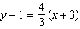 | 3) | 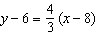
2) | 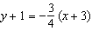 | 4) | 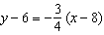

13 In shown below, altitude is drawn to at U.

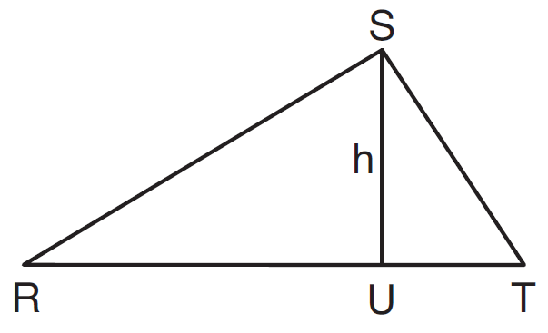

If , , and , which value of h will make a right triangle with as a right angle?
1) |  | 3)
2) |  | 4)

14 In the diagram below, has vertices , , and .

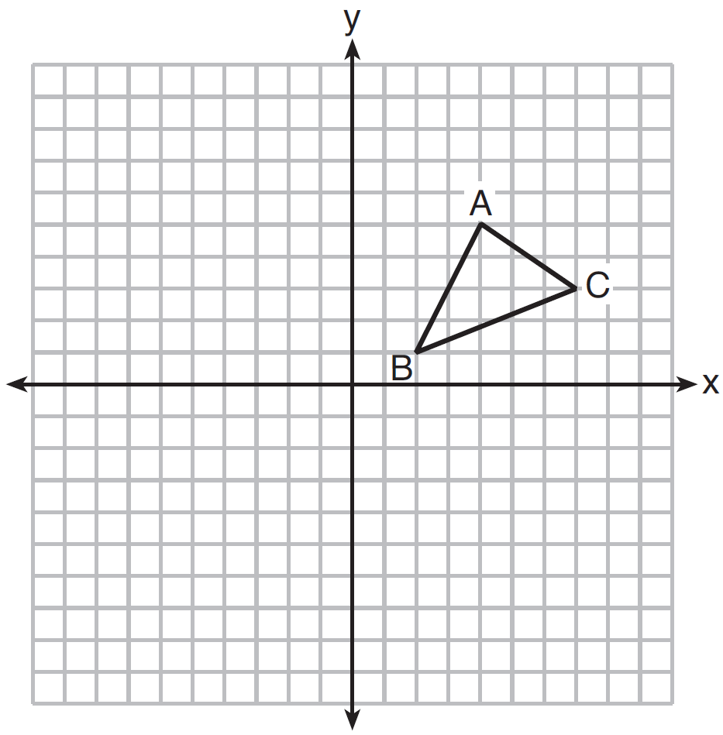

What is the slope of the altitude drawn from A to ?
1) |  | 3)
2) |  | 4)

15 In the diagram below, .

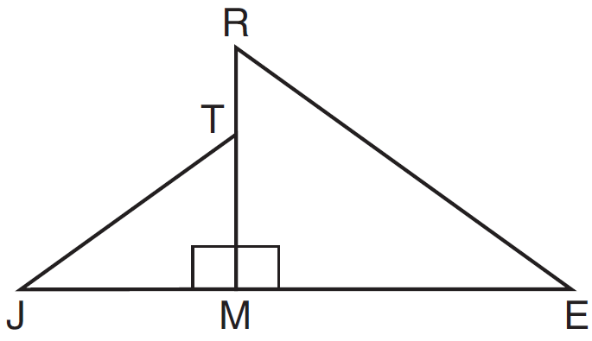

Which statement is always true?
1) | 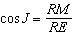 | 3) | 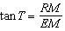
2) | 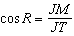 | 4) | 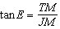

16 On the set of axes below, rectangle ABCD can be proven congruent to rectangle KLMN using which transformation?

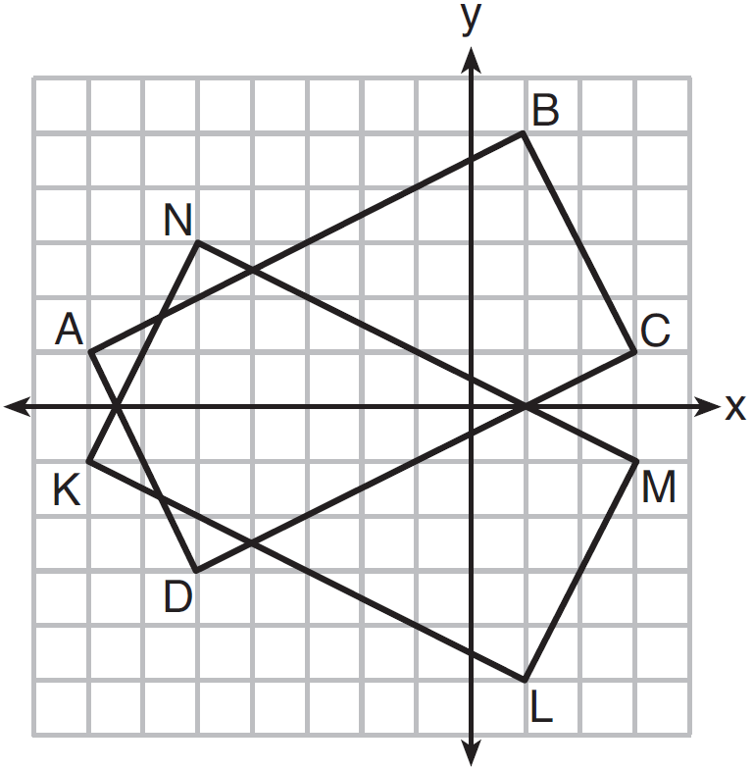
1) | rotation | 3) | reflection over the x-axis
2) | translation | 4) | reflection over the y-axis

17 In the diagram below, and intersect at point C, and and are drawn.
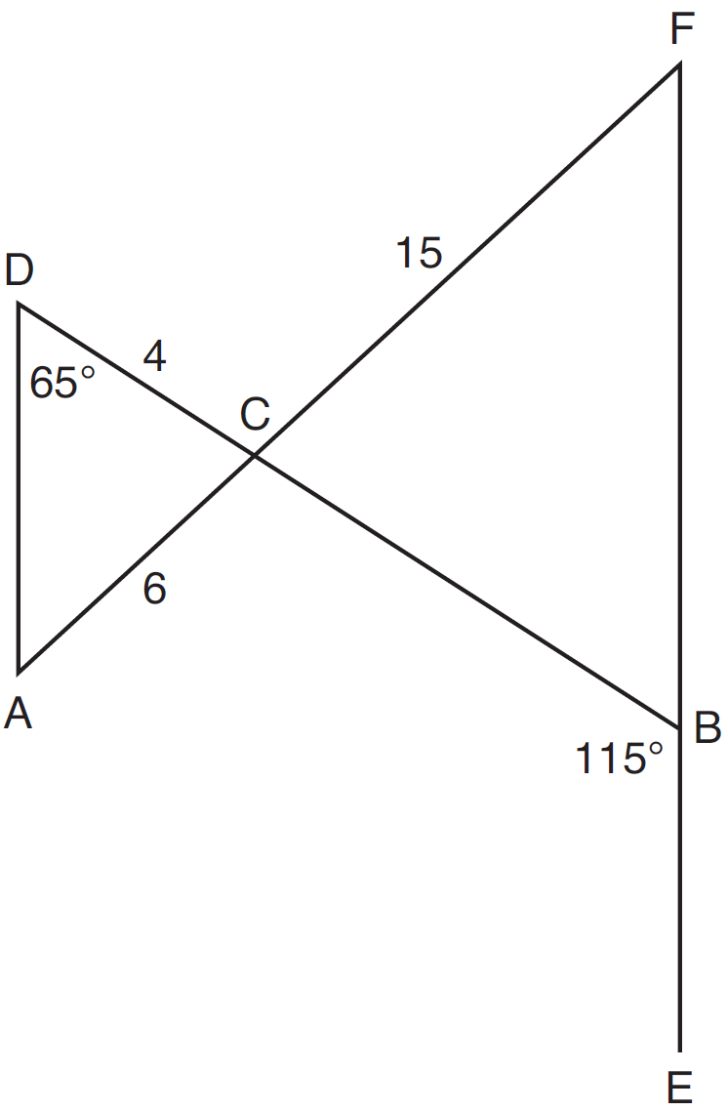

If , , , , and , what is the length of ?
1) | 10 | 3) | 17
2) | 12 | 4) | 22.5

18 Seawater contains approximately 1.2 ounces of salt per liter on average. How many gallons of seawater, to the nearest tenth of a gallon, would contain 1 pound of salt?
1) | 3.3 | 3) | 4.7
2) | 3.5 | 4) | 13.3

19 Line segment EA is the perpendicular bisector of , and and are drawn.
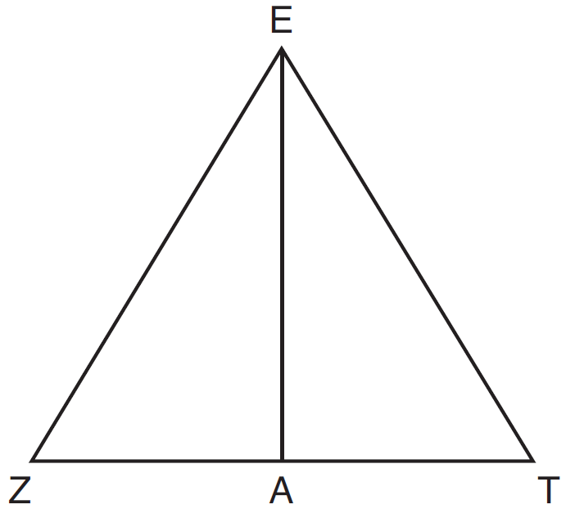

Which conclusion can not be proven?
1) | bisects angle ZET. | 3) | is a median of triangle EZT.
2) | Triangle EZT is equilateral. | 4) | Angle Z is congruent to angle T.

20 A hemispherical water tank has an inside diameter of 10 feet. If water has a density of 62.4 pounds per cubic foot, what is the weight of the water in a full tank, to the nearest pound?
1) | 16,336 | 3) | 130,690
2) | 32,673 | 4) | 261,381

21 In the diagram of , points D and E are on and , respectively, such that .

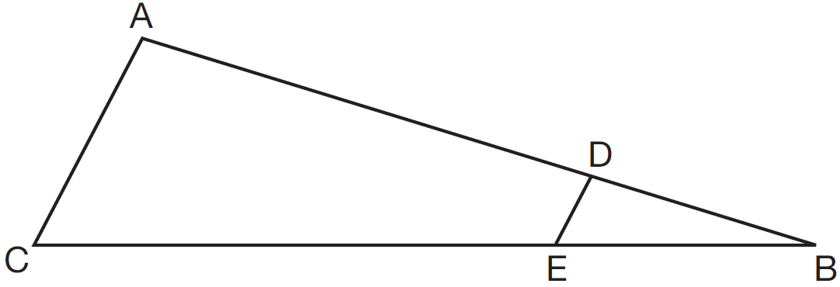

If , , and , what is the length of ?
1) | 8 | 3) | 16
2) | 12 | 4) | 72

22 Triangle RST is graphed on the set of axes below.

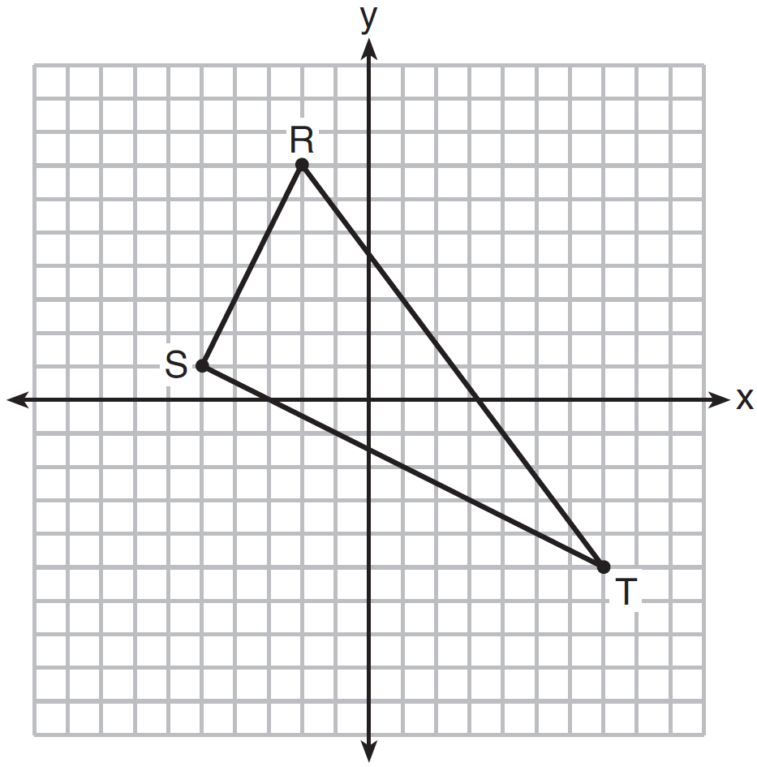

How many square units are in the area of ?
1) |  | 3) | 45
2) |  | 4) | 90

23 The graph below shows , which is a chord of circle O. The coordinates of the endpoints of are and . The distance from the midpoint of to the center of circle O is 2 units.

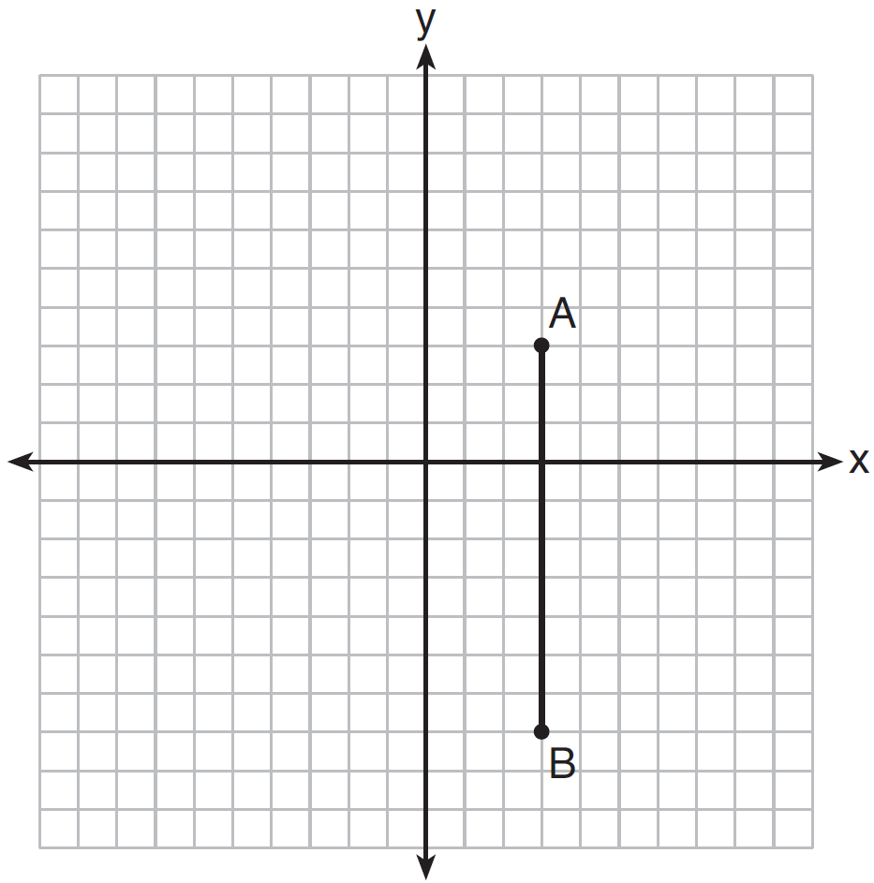

What could be a correct equation for circle O?
1) |  | 3)
2) |  | 4)

24 What is the area of a sector of a circle with a radius of 8 inches and formed by a central angle that measures 60°?
1) |  | 3)
2) |  | 4)

25 Describe a sequence of transformations that will map onto as shown below.

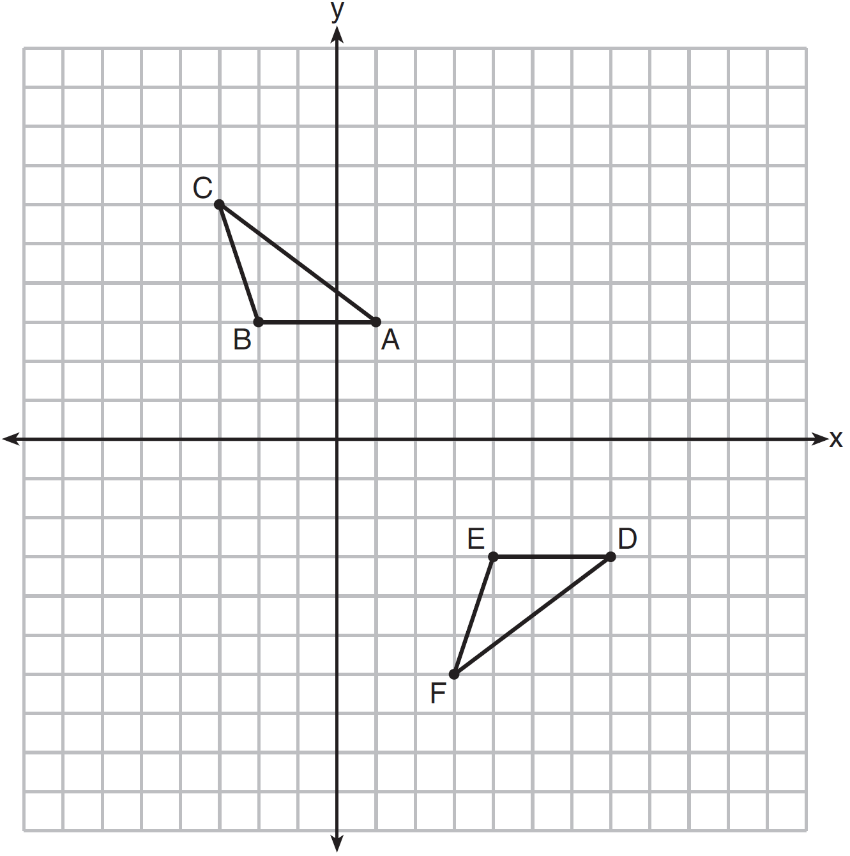

26 Point P is on segment AB such that is . If A has coordinates , and B has coordinates , determine and state the coordinates of P.

27 In as shown below, points A and B are located on sides and , respectively. Line segment AB is drawn such that , , , and .

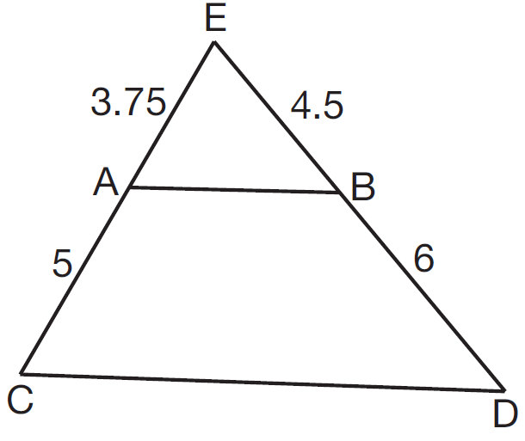

Explain why is parallel to .

28 Find the value of R that will make the equation true when . Explain your answer.

29 In the diagram below, Circle 1 has radius 4, while Circle 2 has radius 6.5. Angle A intercepts an arc of length , and angle B intercepts an arc of length .

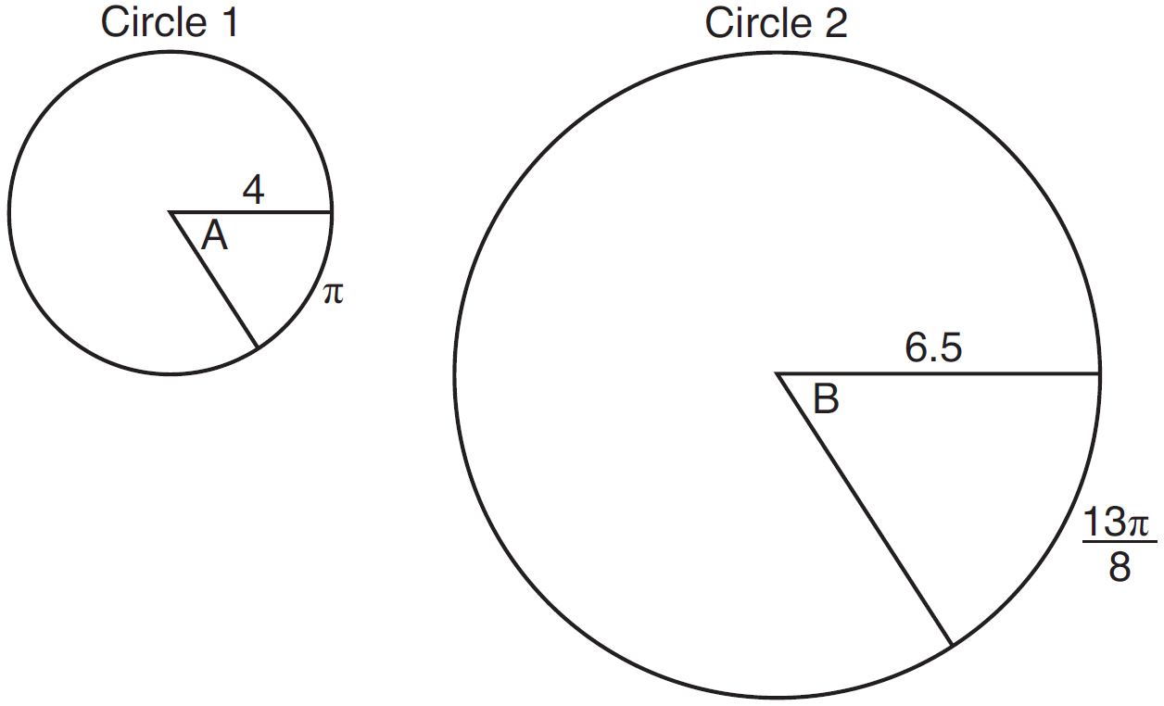

Dominic thinks that angles A and B have the same radian measure. State whether Dominic is correct or not. Explain why.

30 A ladder leans against a building. The top of the ladder touches the building 10 feet above the ground. The foot of the ladder is 4 feet from the building. Find, to the nearest degree, the angle that the ladder makes with the level ground.

31 In the diagram below, radius is drawn in circle O. Using a compass and a straightedge, construct a line tangent to circle O at point A. [Leave all construction marks.]

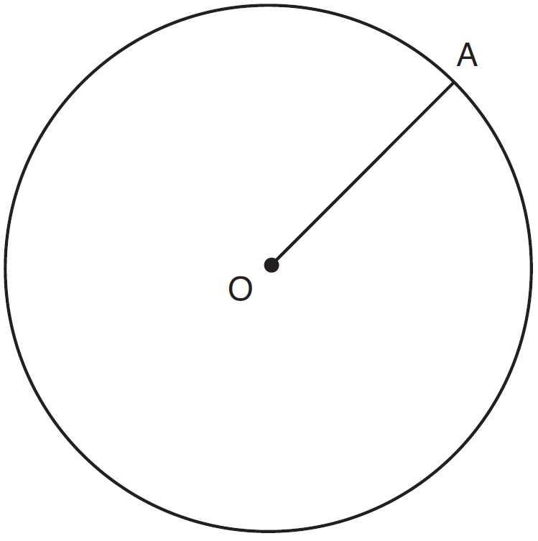

32 A barrel of fuel oil is a right circular cylinder where the inside measurements of the barrel are a diameter of 22.5 inches and a height of 33.5 inches. There are 231 cubic inches in a liquid gallon. Determine and state, to the nearest tenth, the gallons of fuel that are in a barrel of fuel oil.

33 Given: Parallelogram ABCD, , and diagonal
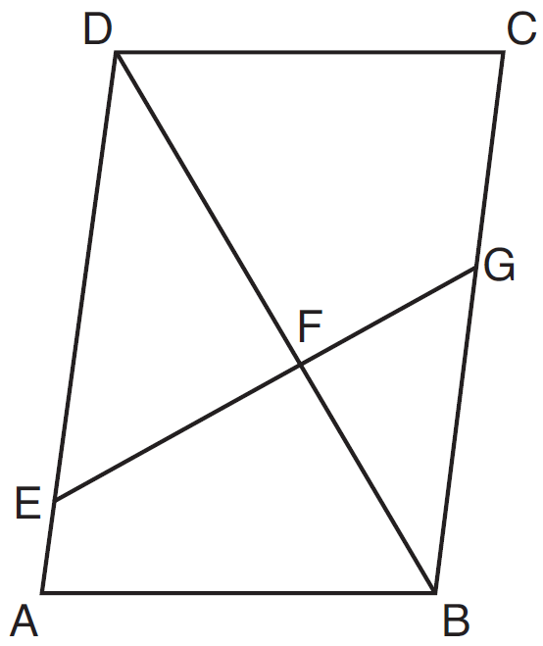

Prove:

34 In the diagram below, is the image of after a transformation.

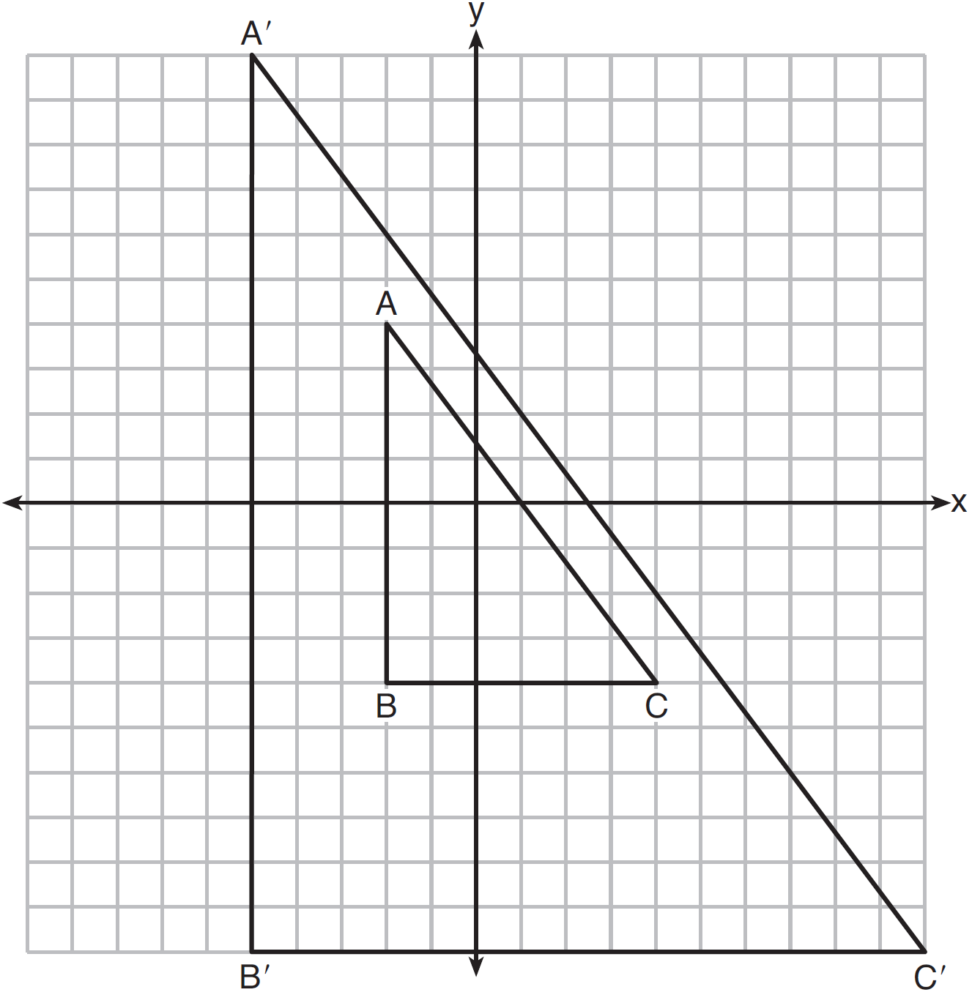

Describe the transformation that was performed. Explain why .

35 Given: Quadrilateral ABCD with diagonals and that bisect each other, and

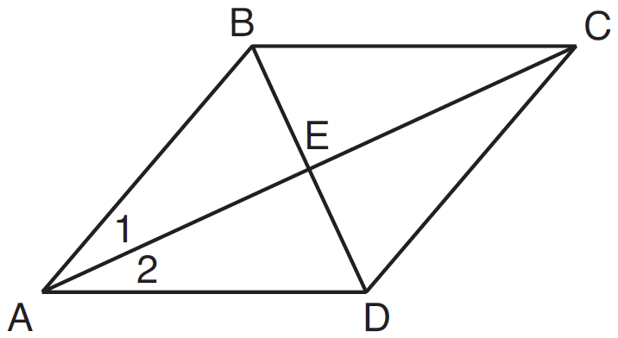

Prove: is an isosceles triangle and is a right triangle

36 A water glass can be modeled by a truncated right cone (a cone which is cut parallel to its base) as shown below.

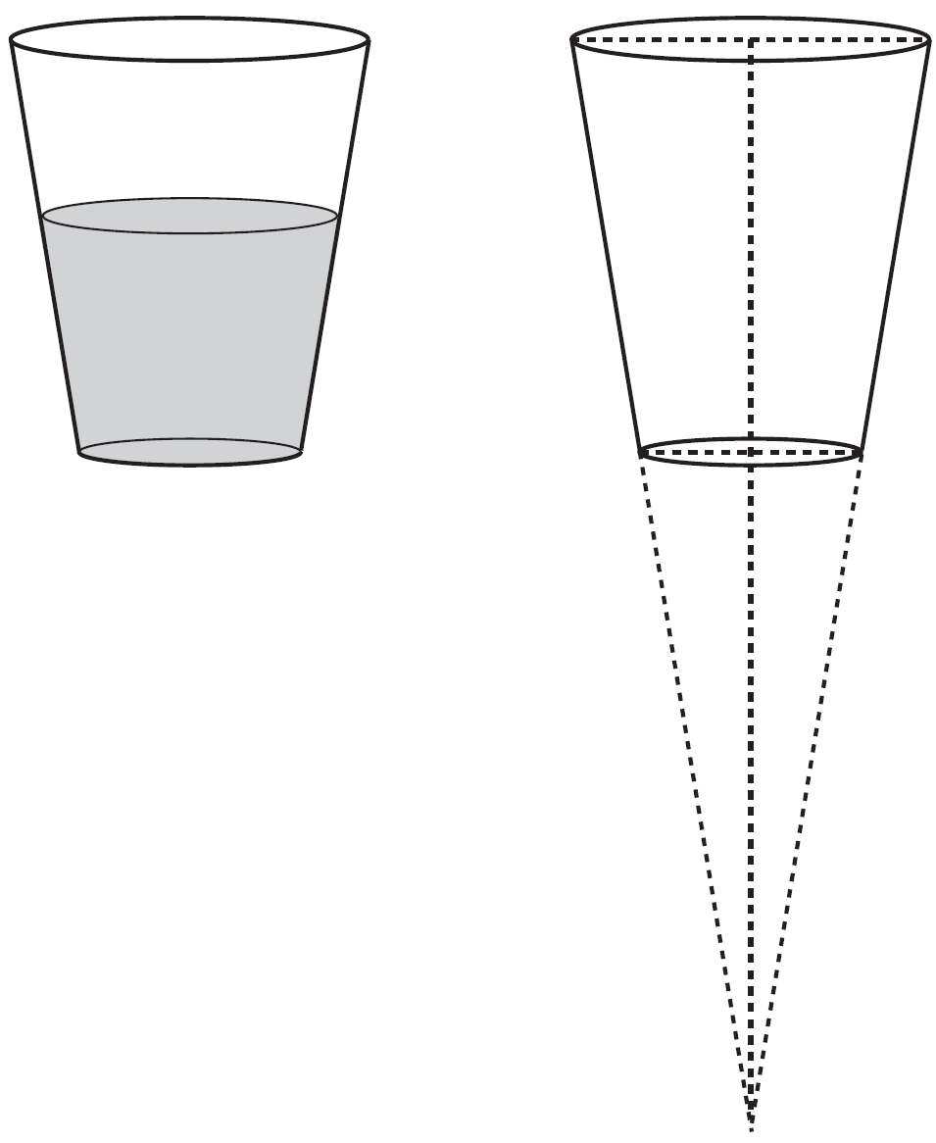

The diameter of the top of the glass is 3 inches, the diameter at the bottom of the glass is 2 inches, and the height of the glass is 5 inches. The base with a diameter of 2 inches must be parallel to the base with a diameter of 3 inches in order to find the height of the cone. Explain why. Determine and state, in inches, the height of the larger cone. Determine and state, to the nearest tenth of a cubic inch, the volume of the water glass.
1 ANS: 3 PTS: 2 REF: 061601geo NAT: G.GMD.B.4
TOP: Rotations of Two-Dimensional Objects

2 ANS: 4

PTS: 2 REF: 061602geo NAT: G.SRT.A.1 TOP: Line Dilations

3 ANS: 2 PTS: 2 REF: 061603geo NAT: G.GPE.A.1
TOP: Equations of Circles KEY: find center and radius | completing the square

4 ANS: 1 PTS: 2 REF: 061604geo NAT: G.CO.A.2
TOP: Identifying Transformations KEY: graphics

5 ANS: 3
1) 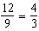 2) AA 3) 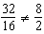 4) SAS

PTS: 2 REF: 061605geo NAT: G.SRT.B.5 TOP: Similarity
KEY: basic

6 ANS: 4 PTS: 2 REF: 061606geo NAT: G.GMD.A.3
TOP: Volume KEY: compositions

7 ANS: 3
1) only proves AA; 2) need congruent legs for HL; 3) SAS; 4) only proves product of altitude and base is equal

PTS: 2 REF: 061607geo NAT: G.SRT.B.5 TOP: Triangle Proofs
KEY: statements

8 ANS: 4 PTS: 2 REF: 061608geo NAT: G.SRT.A.2
TOP: Compositions of Transformations KEY: grids

9 ANS: 1
1) opposite sides; 2) adjacent sides; 3) perpendicular diagonals; 4) diagonal bisects angle

PTS: 2 REF: 061609geo NAT: G.CO.C.11 TOP: Special Quadrilaterals

10 ANS: 2 PTS: 2 REF: 061610geo NAT: G.C.A.2
TOP: Chords, Secants and Tangents KEY: inscribed

11 ANS: 4
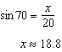

PTS: 2 REF: 061611geo NAT: G.SRT.C.8 TOP: Using Trigonometry to Find a Side
KEY: without graphics

12 ANS: 1
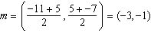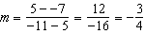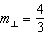

PTS: 2 REF: 061612geo NAT: G.GPE.B.5 TOP: Parallel and Perpendicular Lines
KEY: perpendicular bisector

13 ANS: 2
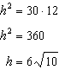

PTS: 2 REF: 061613geo NAT: G.SRT.B.5 TOP: Similarity
KEY: altitude

14 ANS: 4
The slope of is . Altitude is perpendicular, so its slope is .

PTS: 2 REF: 061614geo NAT: G.GPE.B.5 TOP: Parallel and Perpendicular Lines
KEY: find slope of perpendicular line

15 ANS: 4 PTS: 2 REF: 061615geo NAT: G.SRT.C.6
TOP: Trigonometric Ratios

16 ANS: 3 PTS: 2 REF: 061616geo NAT: G.CO.A.2
TOP: Identifying Transformations KEY: graphics

17 ANS: 1
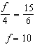

PTS: 2 REF: 061617geo NAT: G.CO.C.9 TOP: Lines and Angles

18 ANS: 2
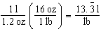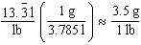

PTS: 2 REF: 061618geo NAT: G.MG.A.2 TOP: Density

19 ANS: 2
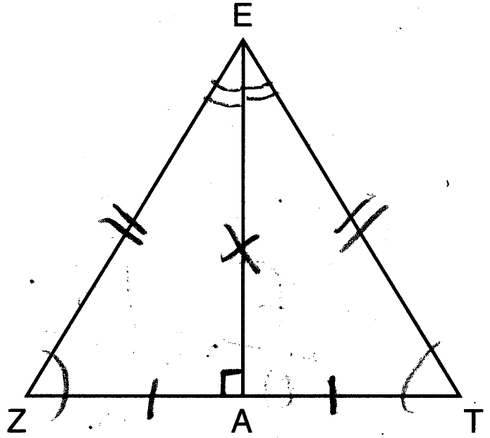

PTS: 2 REF: 061619geo NAT: G.CO.C.10 TOP: Triangle Proofs

20 ANS: 1
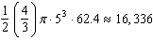

PTS: 2 REF: 061620geo NAT: G.MG.A.2 TOP: Density

21 ANS: 2
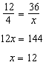

PTS: 2 REF: 061621geo NAT: G.SRT.B.5 TOP: Side Splitter Theorem

22 ANS: 3
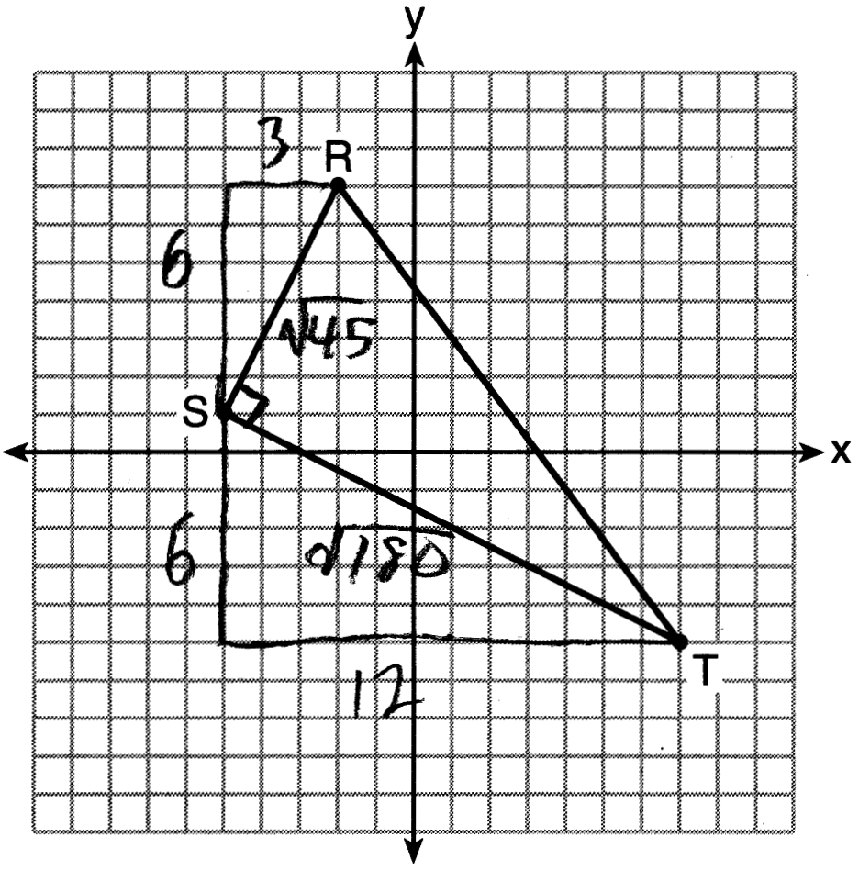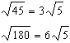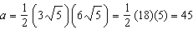
PTS: 2 REF: 061622geo NAT: G.GPE.B.7 TOP: Polygons in the Coordinate Plane

23 ANS: 1
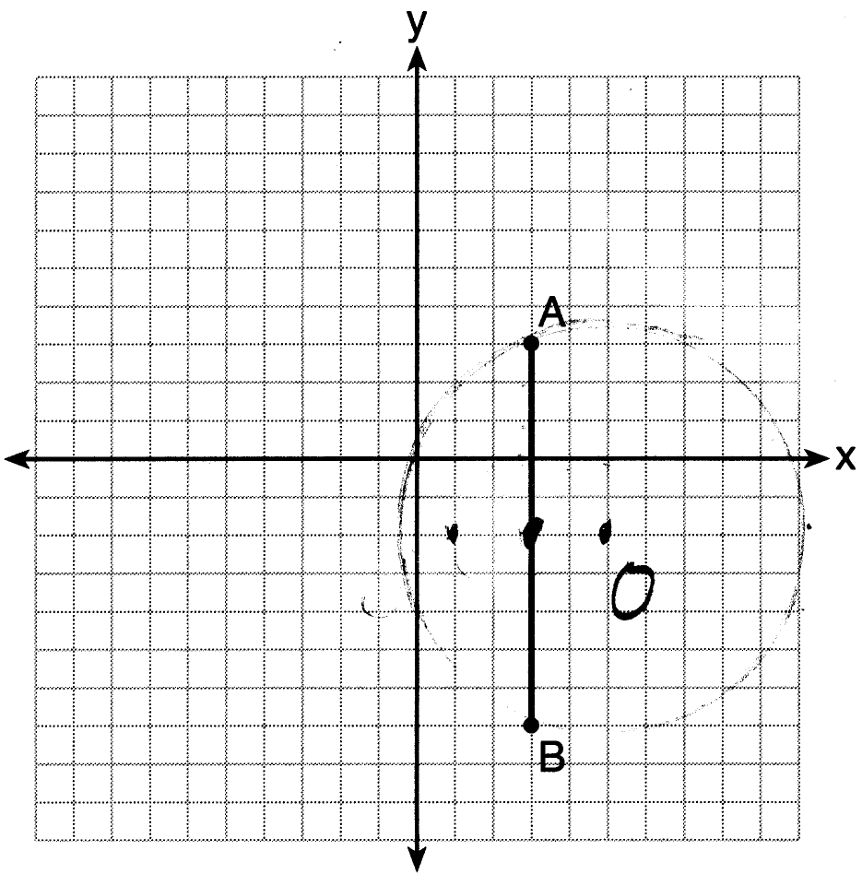 Since the midpoint of is , the center must be either or .
PTS: 2 REF: 061623geo NAT: G.GPE.A.1 TOP: Equations of Circles
KEY: other

24 ANS: 3
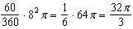
PTS: 2 REF: 061624geo NAT: G.C.B.5 TOP: Sectors

25 ANS:
PTS: 2 REF: 061625geo NAT: G.CO.A.5 TOP: Compositions of Transformations
KEY: identify

26 ANS:
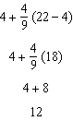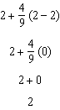
PTS: 2 REF: 061626geo NAT: G.GPE.B.6 TOP: Directed Line Segments

27 ANS:
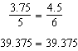 is parallel to because divides the sides proportionately.
PTS: 2 REF: 061627geo NAT: G.SRT.B.5 TOP: Side Splitter Theorem

28 ANS:
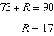 Equal cofunctions are complementary.
PTS: 2 REF: 061628geo NAT: G.SRT.C.7 TOP: Cofunctions

29 ANS:
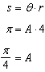 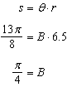 Yes, both angles are equal.
PTS: 2 REF: 061629geo NAT: G.C.B.5 TOP: Arc Length
KEY: arc length

30 ANS:
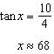
PTS: 2 REF: 061630geo NAT: G.SRT.C.8 TOP: Using Trigonometry to Find an Angle

31 ANS:
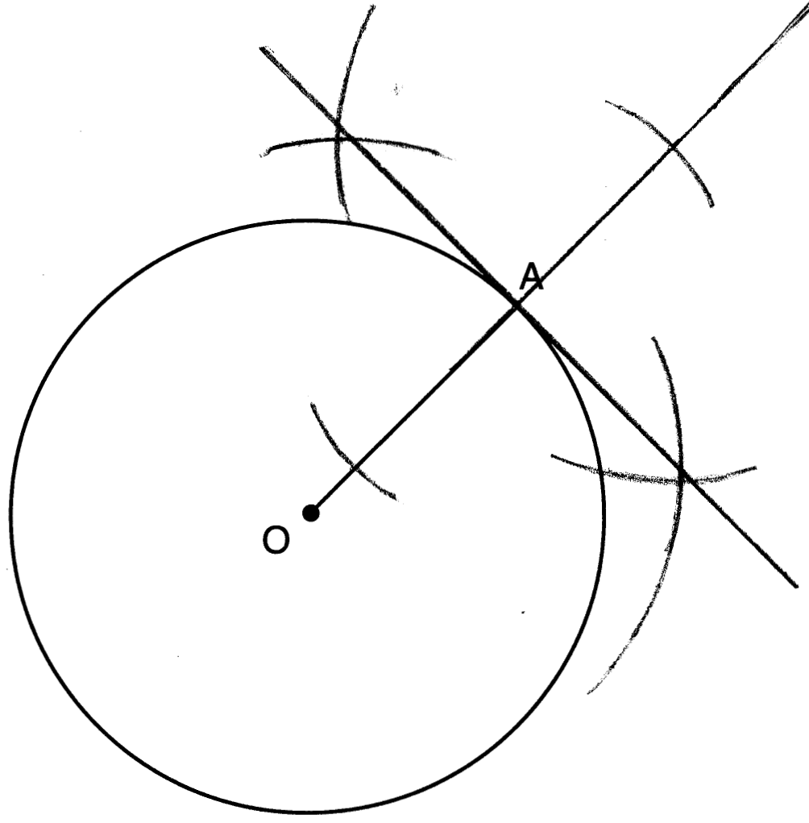
PTS: 2 REF: 061631geo NAT: G.CO.D.12 TOP: Constructions
KEY: parallel and perpendicular lines

32 ANS:
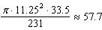
PTS: 4 REF: 061632geo NAT: G.GMD.A.3 TOP: Volume
KEY: cylinders

33 ANS:
Parallelogram ABCD, , and diagonal (given); (vertical angles); (opposite sides of a parallelogram are parallel); (alternate interior angles are congruent); (AA).
PTS: 4 REF: 061633geo NAT: G.SRT.A.3 TOP: Similarity Proofs

34 ANS:
A dilation of about the origin. Dilations preserve angle measure, so the triangles are similar by AA.
PTS: 4 REF: 061634geo NAT: G.SRT.A.3 TOP: Similarity Proofs

35 ANS:
Quadrilateral ABCD with diagonals and that bisect each other, and (given); quadrilateral ABCD is a parallelogram (the diagonals of a parallelogram bisect each other); (opposite sides of a parallelogram are parallel); and (alternate interior angles are congruent); and (substitution); is an isosceles triangle (the base angles of an isosceles triangle are congruent); (the sides of an isosceles triangle are congruent); quadrilateral ABCD is a rhombus (a rhombus has consecutive congruent sides); (the diagonals of a rhombus are perpendicular); is a right angle (perpendicular lines form a right angle); is a right triangle (a right triangle has a right angle).
PTS: 6 REF: 061635geo NAT: G.CO.C.11 TOP: Quadrilateral Proofs

36 ANS:
Similar triangles are required to model and solve a proportion. 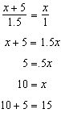 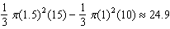
PTS: 6 REF: 061636geo NAT: G.GMD.A.3 TOP: Volume
KEY: cones

