1 On the set of axes below, is the image of .
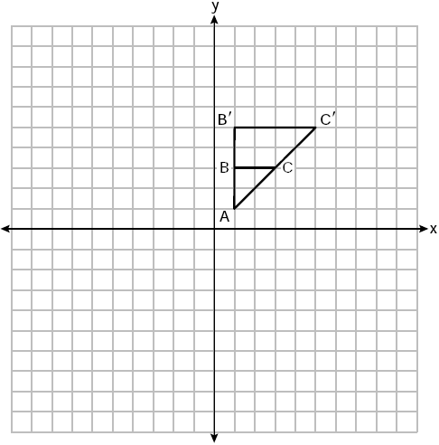

What is the scale factor and center of dilation that maps onto ?
1) | and the origin | 3) | and vertex A
2) | 2 and the origin | 4) | 2 and vertex A

2 Line segment PAQ has endpoints whose coordinates are and . What are the coordinates of point A, such that ?
1) |  | 3)
2) |  | 4)

3 On the set of axes below, congruent parallelograms ABCD and RSTU are graphed.

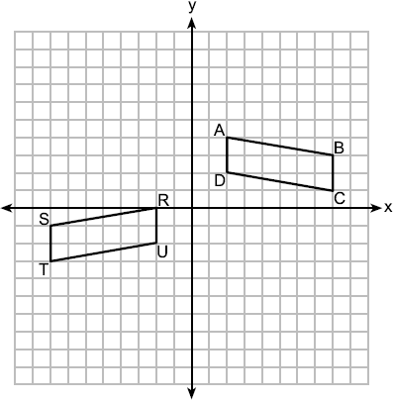

Which sequence of transformations maps ABCD onto RSTU?
1) | a reflection over the x-axis followed by a translation ten units to the left and one unit up | 3) | a reflection over the y-axis followed by a translation of two units down
2) | a translation four units down followed by a reflection over the y-axis | 4) | a translation ten units to the left followed by a reflection over the x-axis

4 Triangle ABC has a right angle at C. If and , what is AB, to the nearest tenth?
1) | 18.9 | 3) | 8.4
2) | 17.3 | 4) | 3.1

5 Given and with , which additional statement is sufficient to always prove ?
1) | and | 3) | and
2) | and | 4) | and

6 The equation of a circle is . What are the coordinates of the center and the length of the radius?
1) | center and radius 5 | 3) | center and radius 25
2) | center and radius 5 | 4) | center and radius 25

7 A square with a side length of 3 is continuously rotated about one of its sides. The resulting three-dimensional object is a
1) | cube with a volume of 9. | 3) | cylinder with a volume of 27.
2) | cube with a volume of 27. | 4) | cylinder with a volume of 54.

8 Line k is represented by the equation . Which equation represents a line that is perpendicular to line k and passes through the point ?
1) | 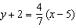 | 3) | 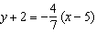
2) | 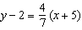 | 4) | 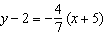

9 Scalene triangle JKL is drawn below.

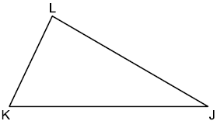

If median is drawn to side , which statement is always true?
1) |  | 3)
2) | 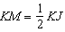 | 4)

10 In circle O, chord intersects diameter at S.
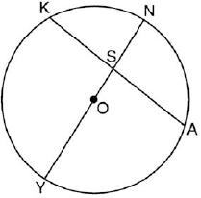
If and , what is ?
1) | 22.5º | 3) | 97.5º
2) | 75º | 4) | 120º

11 Triangle ABC is graphed on the set of axes below. The vertices of have coordinates , , and .
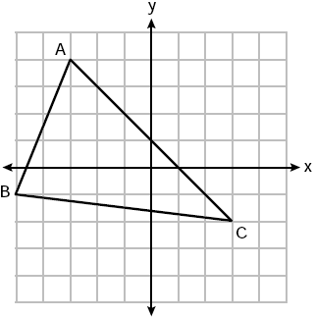
What is the area of ?
1) | 16 | 3) | 21
2) | 20 | 4) | 24

12 In below, is a midsegment, and .
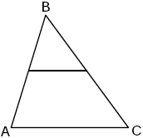

Which statement is always true?
1) | is isosceles | 3)
2) | is scalene | 4)

13 As shown in the diagram below, , , and .

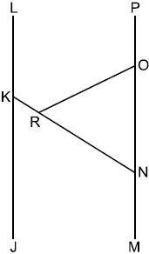

If , what is ?
1) | 58º | 3) | 122º
2) | 116º | 4) | 128º

14 The ratio of similarity of square ABCD to square WXYZ is . If and , then the perimeter of ABCD is
1) | 8 | 3) | 32
2) | 20 | 4) | 80

15 In parallelogram ABCD below, diagonals and intersect at E.

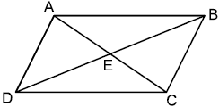

Which transformation would map onto ?
1) | a reflection over | 3) | a clockwise rotation of 90° about point E
2) | a reflection over | 4) | a clockwise rotation of 180° about point E

16 The square pyramid drawn below has a volume of 175.

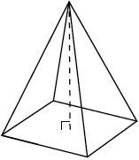

If the height of the pyramid is 21, what is the perimeter of the base?
1) | 5 | 3) | 20
2) | 10 | 4) | 25

17 A glass fish tank is designed to be placed on a stand in the corner of a room with perpendicular walls. The tank can be modeled using part of a cylinder, as shown below. The inner length of the fish tank along the wall is 22 inches, and the height of the tank is 27 inches.

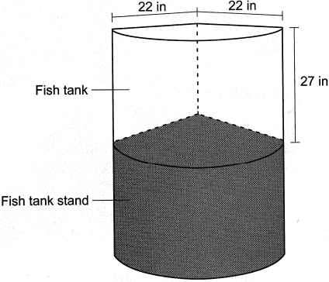

How much water, to the nearest gallon, does the fish tank hold?
1) | 44 | 3) | 89
2) | 59 | 4) | 178

18 Line m, whose equation is , is dilated by a scale factor of centered at the origin. Which equation represents the image of line m?
1) |  | 3)
2) |  | 4)

19 In right triangle RST below, altitude is drawn to hypotenuse .
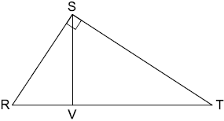
Which statement is always true?
1) | 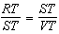 | 3) | 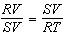
2) | 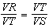 | 4) | 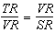

20 What is the measure, in radians, of a central angle that intercepts an arc length of cm in a circle with a diameter of 36 cm?
1) |  | 3)
2) |  | 4)

21 A regular nonagon has a center point, P. What degree of rotation about point P will carry the nonagon onto itself?
1) | 60° | 3) | 180°
2) | 90° | 4) | 200°

22 If two sides of a triangle have lengths of 2 and 7, the length of the third side could be
1) | 9 | 3) | 5
2) | 8 | 4) | 4

23 The car tire shown in the photograph below has a diameter of feet.
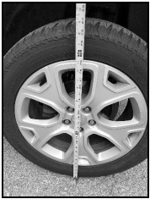

Approximately how many rotations will the tire make in one mile?
1) | 373 | 3) | 1328
2) | 747 | 4) | 2347

24 In quadrilateral TOWN, and . Which additional information is sufficient to prove quadrilateral TOWN is a rhombus?
1) |  | 3)
2) |  | 4) | and bisect each other.

25 In the diagram below, quadrilateral BCDE maps onto quadrilateral JKLM using a sequence of rigid motions.

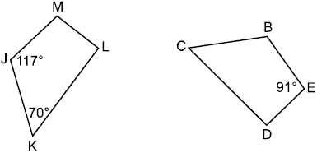

Determine and state the degree measure of angle D.

26 Given below, use a compass and a straightedge to construct a segment that is . [Leave all construction marks.]

27 A dog sees a bird in a tree. The angle of elevation from the dog’s eyes to the bird is 36°, as modeled below.

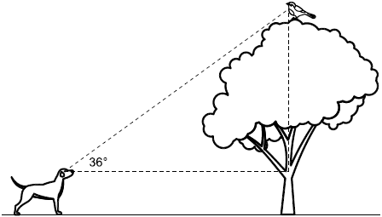

The dog is 18.5 feet away from the base of the tree, and his eyes are 2.5 feet above the ground. Determine and state how high the bird is above the ground, to the nearest foot.

28 Pure silver has a density of 10.5 g/cm³. Samantha has a pure silver charm on her necklace in the shape of a sphere. The radius of the charm is 0.5 cm. Determine and state the mass of the charm, to the nearest tenth of a gram.

29 In below, is drawn such that , , , and .

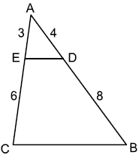

Explain why .

30 In circle E below, tangent and secant are drawn.

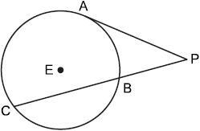

If and , determine and state the length of .

31 In a right triangle, . Determine and state the value of x.

32 Modeled by right triangles below, a surveyor (S) is taking land measurements using a cabin (C), a boulder (B), and a tree (T) as fixed points of reference. The cabin, boulder, and tree are collinear. The surveyor is 917 meters from the cabin, 1048 meters from the boulder, and 1425 meters from the tree.

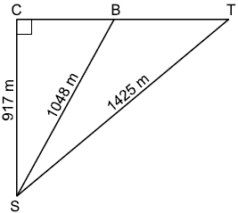

Determine and state, to the nearest degree, the measure of .

33 A garden bed, pictured below, is a square prism with a rectangular prism taken out. The inside length of the square prism is 6 feet. The rectangular prism taken out has a width of 2 feet and a length of 4 feet. The diagram below shows the top view of the garden bed with its inside measurements.
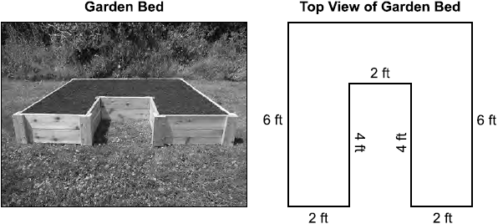

The garden bed is filled with topsoil to a uniform height of 1.25 feet. Determine and state the volume of the topsoil, in cubic feet. Each bag of topsoil sells for $3.68 and contains 2 cubic feet of topsoil. Determine and state the total cost of the bags of topsoil that must be purchased to fill the garden.

34 Given: with , , and
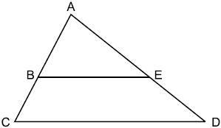

Prove:

35 Triangle PET has vertices with coordinates , , and . Prove is a right triangle. State the coordinates of N, the image of P, after a 180° rotation centered at . Prove PENT is a rectangle. [The use of the set of axes below is optional.]

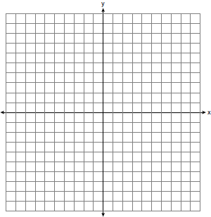
1 ANS: 4 PTS: 2 REF: 012501geo NAT: G.SRT.A.2
TOP: Dilations

2 ANS: 4
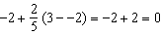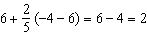

PTS: 2 REF: 012502geo NAT: G.GPE.B.6 TOP: Directed Line Segments

3 ANS: 2 PTS: 2 REF: 012503geo NAT: G.CO.A.5
TOP: Compositions of Transformations

4 ANS: 1
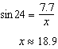

PTS: 2 REF: 012504geo NAT: G.SRT.C.8 TOP: Using Trigonometry to Find a Side

5 ANS: 2
SAS

PTS: 2 REF: 012505geo NAT: G.SRT.B.5 TOP: Triangle Proofs
KEY: statements

6 ANS: 1
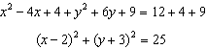

PTS: 2 REF: 012506geo NAT: G.GPE.A.1 TOP: Equations of Circles
KEY: completing the square

7 ANS: 3

PTS: 2 REF: 012507geo NAT: G.GMD.B.4 TOP: Rotations of Two-Dimensional Objects

8 ANS: 4
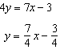 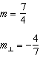.

PTS: 2 REF: 012508geo NAT: G.GPE.B.5 TOP: Parallel and Perpendicular Lines
KEY: write equation of perpendicular line

9 ANS: 2 PTS: 2 REF: 012509geo NAT: G.SRT.B.4
TOP: Medians, Altitudes and Bisectors

10 ANS: 3
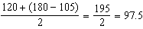

PTS: 2 REF: 012510geo NAT: G.C.A.2 TOP: Chords, Secants and Tangents
KEY: intersecting chords, angle

11 ANS: 3
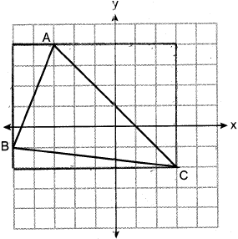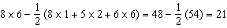

PTS: 2 REF: 012511geo NAT: G.GPE.B.7 TOP: Polygons in the Coordinate Plane

12 ANS: 1 PTS: 2 REF: 012512geo NAT: G.CO.C.10
TOP: Midsegments

13 ANS: 3
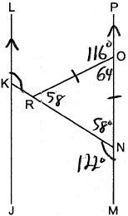

PTS: 2 REF: 012513geo NAT: G.CO.C.9 TOP: Lines and Angles

14 ANS: 3
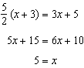

PTS: 2 REF: 012514geo NAT: G.SRT.B.5 TOP: Similarity
KEY: perimeter and area

15 ANS: 4 PTS: 2 REF: 012515geo NAT: G.CO.A.3
TOP: Mapping a Polygon onto Itself

16 ANS: 3
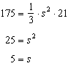

PTS: 2 REF: 012516geo NAT: G.GMD.A.3 TOP: Volume
KEY: pyramids

17 ANS: 1
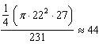

PTS: 2 REF: 012517geo NAT: G.GMD.A.3 TOP: Volume
KEY: cylinders

18 ANS: 2 PTS: 2 REF: 012518geo NAT: G.SRT.A.1
TOP: Line Dilations

19 ANS: 1 PTS: 2 REF: 012519geo NAT: G.SRT.B.4
TOP: Similarity

20 ANS: 3
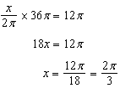

PTS: 2 REF: 012520geo NAT: F.TF.A.1 TOP: Arc Length
KEY: angle

21 ANS: 4
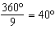 200º is a multiple of 40º

PTS: 2 REF: 012521geo NAT: G.CO.A.3 TOP: Mapping a Polygon onto Itself

22 ANS: 2
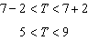

PTS: 2 REF: 012522geo NAT: G.CO.C.10 TOP: Triangle Inequality Theorem

23 ANS: 2
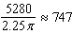

PTS: 2 REF: 012523geo NAT: G.GMD.A.1 TOP: Circumference

24 ANS: 1 PTS: 2 REF: 012524geo NAT: G.CO.C.11
TOP: Special Quadrilaterals

25 ANS:

PTS: 2 REF: 012525geo NAT: G.CO.B.6 TOP: Properties of Transformations

26 ANS:
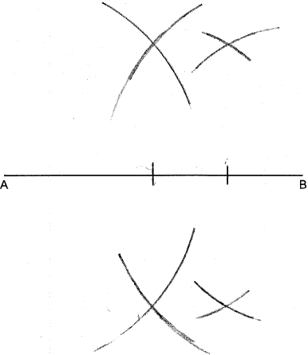

PTS: 2 REF: 012526geo NAT: G.CO.D.12 TOP: Constructions
KEY: line bisector

27 ANS:
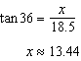

PTS: 2 REF: 012527geo NAT: G.SRT.C.8 TOP: Using Trigonometry to Find a Side

28 ANS:
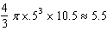

PTS: 2 REF: 012528geo NAT: G.MG.A.2 TOP: Density

29 ANS:
Because divides and proportionally 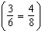, is a side splitter and . Therefore and as corresponding angles. by AA.

PTS: 2 REF: 012529geo NAT: G.SRT.B.4 TOP: Side Splitter Theorem

30 ANS:
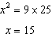

PTS: 2 REF: 012530geo NAT: G.C.A.2 TOP: Chords, Secants and Tangents
KEY: secant and tangent drawn from common point, length

31 ANS:
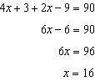

PTS: 2 REF: 012531geo NAT: G.SRT.C.7 TOP: Cofunctions

32 ANS:
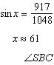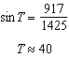

PTS: 4 REF: 012532geo NAT: G.SRT.C.8 TOP: Using Trigonometry to Find an Angle

33 ANS:

PTS: 4 REF: 012533geo NAT: G.GMD.A.3 TOP: Volume
KEY: compositions

34 ANS:
1) with , , and (Given); 2) and (A transversal crossing parallel lines creates congruent corresponding angles; 3) (AA); 4) 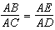 (Corresponding sides of similar triangles are proportional); 5) (Product of the means equals the product of the extremes)

PTS: 4 REF: 012534geo NAT: G.SRT.A.3 TOP: Similarity Proofs

35 ANS:
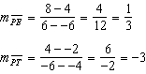 Since the slopes of and are opposite reciprocals, they are perpendicular and form a right angle. is a right triangle because it has a right angle. 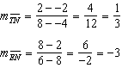 Because the slopes of and are equal, . Because the slopes of and are equal, . Because opposite sides are parallel, PENT is a parallelogram. Because is a right angle, PENT is a rectangle. 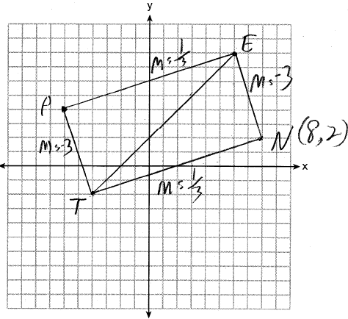

PTS: 6 REF: 012535geo NAT: G.GPE.B.4 TOP: Quadrilaterals in the Coordinate Plane

