1 Which expression is equal to ?
1) |  | 3)
2) |  | 4)

2 In the diagram of below, is drawn such that .

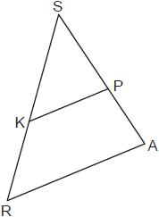

If , , and , what is the length of , to the nearest tenth?
1) | 4.8 | 3) | 8.0
2) | 7.5 | 4) | 13.3

3 A rectangle is graphed on the set of axes below.

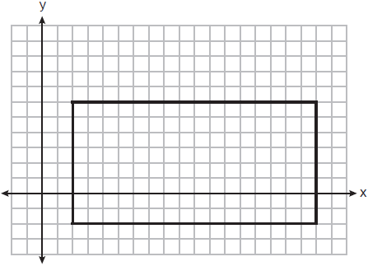

A reflection over which line would carry the rectangle onto itself?
1) |  | 3) | 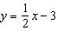
2) |  | 4) | 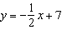

4 The surface of the roof of a house is modeled by two congruent rectangles with dimensions 40 feet by 16 feet, as shown below.

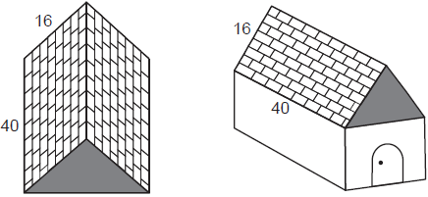

Roofing shingles are sold in bundles. Each bundle covers square feet. What is the minimum number of bundles that must be purchased to completely cover both rectangular sides of the roof?
1) | 20 | 3) | 39
2) | 2 | 4) | 4

5 Which equation represents a line that is perpendicular to the line whose equation is ?
1) | 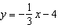 | 3)
2) | 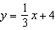 | 4)

6 A vertical mine shaft is modeled in the diagram below. At a point on the ground 50 feet from the top of the mine, a ventilation tunnel is dug at an angle of 47°.

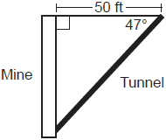

What is the length of the tunnel, to the nearest foot?
1) | 47 | 3) | 68
2) | 54 | 4) | 73

7 On the set of axes below, has vertices with coordinates , , and .

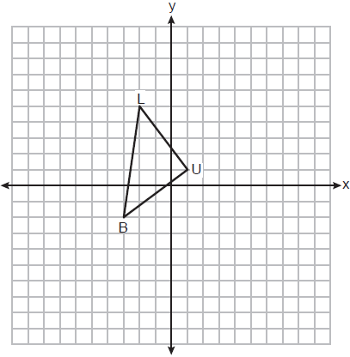

What is the area of ?
1) | 11 | 3) | 14
2) | 12.5 | 4) | 17.1

8 In the diagram below, is mapped onto after a sequence of rigid motions.

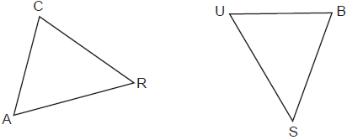

If , , , and , what is the length of ?
1) | 6 | 3) | 20
2) | 16 | 4) | 28

9 In the diagram below, is dilated by a scale factor of centered at point B to map onto .

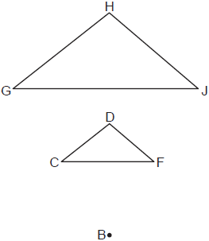

If , what is ?
1) | 20º | 3) | 60º
2) | 40º | 4) | 80º

10 Directed line segment AJ has endpoints whose coordinates are and . Point E is on such that is . What are the coordinates of point E?
1) |  | 3)
2) |  | 4)

11 A tipping platform is a ramp used to unload trucks, as shown in the diagram below.

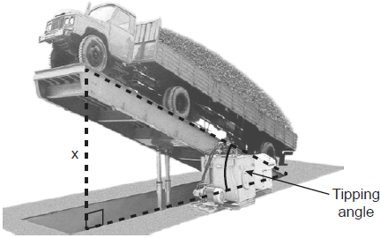

The truck is on a 75-foot-long ramp. The ramp is tipped at an angle of 30°. What is the height of the upper end of the ramp, x, to the nearest tenth of a foot?
1) | 68.7 | 3) | 43.3
2) | 65.0 | 4) | 37.5

12 In the diagram below of right triangle MET, altitude is drawn to hypotenuse .

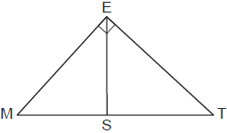

If and , what is MT?
1) | 9 | 3) | 5
2) | 8 | 4) | 4

13 In the diagram below of square CASH, diagonals and intersect at Z.

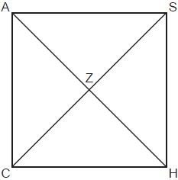

Which statement is true?
1) |  | 3)
2) |  | 4)

14 In the diagram below of circle O, secants and are drawn from external point C.

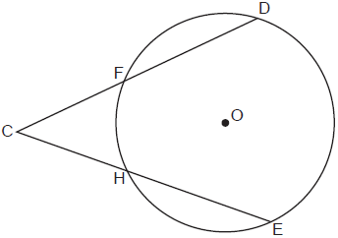

If and , then is
1) | 46° | 3) | 68°
2) | 48° | 4) | 88°

15 A right circular cylinder has a diameter of 8 inches and a height of 12 inches. Which two-dimensional figure shows a cross section that is perpendicular to the base and passes through the center of the base?
1) | 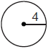 | 3) | 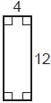
2) | 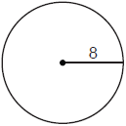 | 4) | 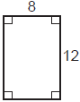

16 On the set of axes below, is drawn and passes through and .

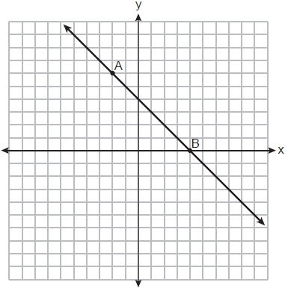

If is the image of after a dilation with a scale factor of centered at the origin, which equation represents ?
1) |  | 3) | 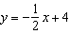
2) |  | 4) | 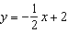

17 In parallelogram ABCD with , and . What is the perimeter of ABCD?
1) | 10 | 3) | 40
2) | 24 | 4) | 56

18 In the diagram of below, and altitude is drawn from vertex A.

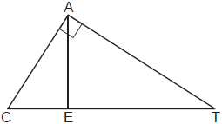

Which statement is always true?
1) | 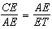 | 3) | 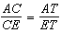
2) | 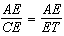 | 4) | 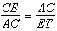

19 A sandbox in the shape of a rectangular prism has a length of 43 inches and a width of 30 inches. Jack uses bags of sand to fill the sandbox to a depth of 9 inches. Each bag of sand has a volume of 0.5 cubic foot. What is the minimum number of bags of sand that must be purchased to fill the sandbox?
1) | 14 | 3) | 7
2) | 13 | 4) | 4

20 Parallelogram EATK has diagonals and . Which information is always sufficient to prove EATK is a rhombus?
1) |  | 3)
2) |  | 4)

21 In the diagram below, , and and are drawn such that .

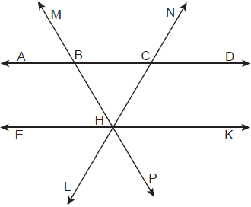

If , what is ?
1) | 118º | 3) | 62º
2) | 68º | 4) | 56º

22 Triangles YEG and POM are two distinct non-right triangles such that . Which statement is sufficient to prove is always congruent to ?
1) | and | 3) | There is a sequence of rigid motions that maps onto and onto .
2) | and | 4) | There is a sequence of rigid motions that maps point Y onto point P and onto .

23 In the diagram of triangles ABD and CBE below, sides and intersect at F, and .

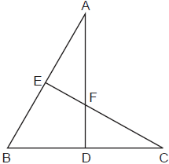

Which statement can not be proven?
1) |  | 3)
2) |  | 4)

24 A small town is installing a water storage tank in the shape of a cylinder. The tank must be able to hold at least 100,000 gallons of water. The tank must have a height of exactly 30 feet. [1 cubic foot holds 7.48 gallons of water] What should the minimum diameter of the tank be, to the nearest foot?
1) | 12 | 3) | 65
2) | 24 | 4) | 75

25 In isosceles triangle ABC shown below, , and altitude is drawn.

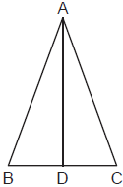

The length of is 12 cm and the length of is 10 cm. Determine and state, to the nearest cubic centimeter, the volume of the solid formed by continuously rotating about .

26 The diagram below models the projection of light from a lighthouse, L. The sector has a radius of 38 miles and spans 102°.
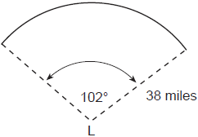
Determine and state the area of the sector, to the nearest square mile.

27 Segment CA is drawn below. Using a compass and straightedge, construct isosceles right triangle CAT where and . [Leave all construction marks.]

28 On the set of axes below, congruent triangles ABC and DEF are graphed.
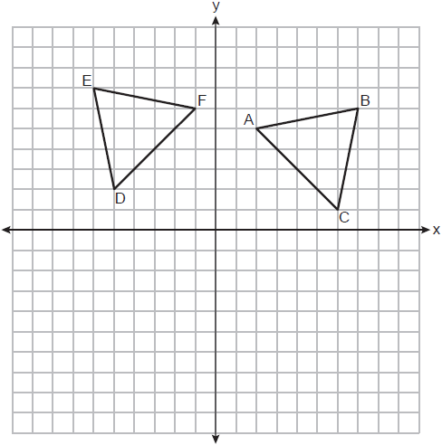
Describe a sequence of rigid motions that maps onto .

29 In below, is drawn such that , , , and .

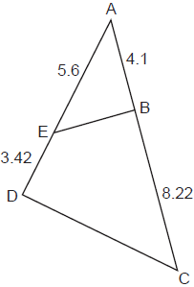
Is similar to ? Explain why.

30 Determine and state the coordinates of the center and the length of the radius of the circle represented by the equation .

31 In the diagram below, and 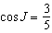.
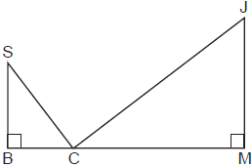

Determine and state , to the nearest degree.

32 Trish is a surveyor who was asked to estimate the distance across a pond. She stands at point C, 85 meters from point D, and locates points A and B on either side of the pond such that A, D, and B are collinear.
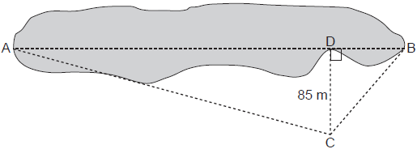

Trish approximates the measure of angle DCB to be 35° and the measure of angle ACD to be 75°. Determine and state the distance across the pond, , to the nearest meter.

33 A candle in the shape of a right pyramid is modeled below. Each side of the square base measures 12 centimeters. The slant height of the pyramid measures 16 centimeters.

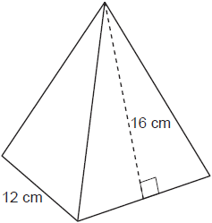

Determine and state the volume of the candle, to the nearest cubic centimeter. The wax used to make the candle weighs 0.032 ounce per cubic centimeter. Determine and state the weight of the candle, to the nearest ounce.

34 In the diagram of quadrilateral ABCD below, , and . Segments CE and AF are drawn to diagonal such that .

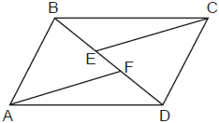`

Prove:

35 Quadrilateral MATH has vertices with coordinates , , , and ). Prove that quadrilateral MATH is a trapezoid. State the coordinates of point Y such that point A is the midpoint of . Prove that quadrilateral MYTH is a rectangle. [The use of the set of axes below is optional.]

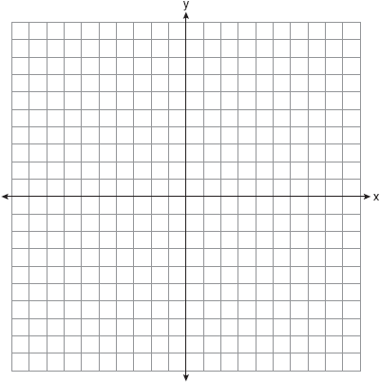
1 ANS: 3

PTS: 2 REF: 012401geo NAT: G.SRT.C.7 TOP: Cofunctions

2 ANS: 2
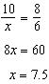

PTS: 2 REF: 012402geo NAT: G.SRT.B.5 TOP: Side Splitter Theorem

3 ANS: 1 PTS: 2 REF: 012403geo NAT: G.CO.A.3
TOP: Mapping a Polygon onto Itself

4 ANS: 3
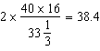

PTS: 2 REF: 012404geo NAT: G.MG.A.3 TOP: Area of Polygons

5 ANS: 1
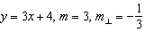

PTS: 2 REF: 012405geo NAT: G.GPE.B.5 TOP: Parallel and Perpendicular Lines
KEY: identify perpendicular lines

6 ANS: 4
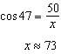

PTS: 2 REF: 012406geo NAT: G.SRT.C.8 TOP: Using Trigonometry to Find a Side

7 ANS: 2
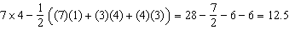

PTS: 2 REF: 012407geo NAT: G.GPE.B.7 TOP: Polygons in the Coordinate Plane

8 ANS: 3
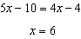

PTS: 2 REF: 012408geo NAT: G.CO.B.6 TOP: Properties of Transformations
KEY: graphics

9 ANS: 2 PTS: 2 REF: 012409geo NAT: G.SRT.A.2
TOP: Dilations

10 ANS: 4
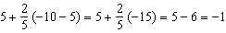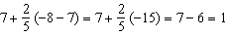

PTS: 2 REF: 012410geo NAT: G.GPE.B.6 TOP: Directed Line Segments

11 ANS: 4
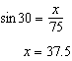

PTS: 2 REF: 012411geo NAT: G.SRT.C.8 TOP: Using Trigonometry to Find a Side

12 ANS: 1
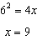

PTS: 2 REF: 012412geo NAT: G.SRT.B.5 TOP: Similarity
KEY: altitude

13 ANS: 3 PTS: 2 REF: 012413geo NAT: G.CO.C.11
TOP: Special Quadrilaterals

14 ANS: 2
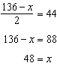

PTS: 2 REF: 012414geo NAT: G.C.A.2 TOP: Chords, Secants and Tangents
KEY: secants drawn from common point, angle

15 ANS: 4 PTS: 2 REF: 012415geo NAT: G.GMD.B.4
TOP: Cross-Sections of Three-Dimensional Objects

16 ANS: 2 PTS: 2 REF: 012416geo NAT: G.SRT.A.1
TOP: Line Dilations

17 ANS: 3
The half diagonals have lengths of 6 and 8, so each side of ABCD is 10.

PTS: 2 REF: 012417geo NAT: G.CO.C.11 TOP: Parallelograms

18 ANS: 1 PTS: 2 REF: 012418geo NAT: G.SRT.B.5
TOP: Similarity KEY: altitude

19 ANS: 1
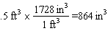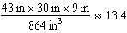

PTS: 2 REF: 012419geo NAT: G.GMD.A.3 TOP: Volume
KEY: prisms

20 ANS: 2 PTS: 2 REF: 012420geo NAT: G.CO.C.11
TOP: Special Quadrilaterals

21 ANS: 4
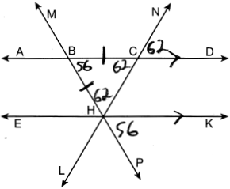

PTS: 2 REF: 012421geo NAT: G.CO.C.9 TOP: Lines and Angles

22 ANS: 3
(3) is AAS, which proves congruency. (1) is AAA, (2) is SSA and (4) is AS.

PTS: 2 REF: 012422geo NAT: G.CO.B.7 TOP: Triangle Congruency

23 ANS: 1
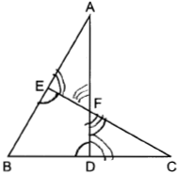

PTS: 2 REF: 012423geo NAT: G.SRT.B.5 TOP: Triangle Proofs
KEY: statements

24 ANS: 2
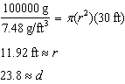

PTS: 2 REF: 012424geo NAT: G.GMD.A.3 TOP: Volume
KEY: cylinders

25 ANS:
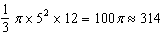

PTS: 2 REF: 012425geo NAT: G.GMD.B.4 TOP: Rotations of Two-Dimensional Objects

26 ANS:
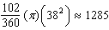

PTS: 2 REF: 012426geo NAT: G.C.B.5 TOP: Sectors

27 ANS:
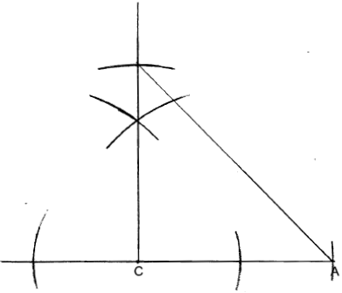

PTS: 2 REF: 012427geo NAT: G.CO.D.12 TOP: Constructions
KEY: polygons

28 ANS:
Rotation of 90º counterclockwise about the origin.

PTS: 2 REF: 012428geo NAT: G.CO.A.2 TOP: Identifying Transformations

29 ANS:
Yes, because of SAS. 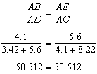

PTS: 2 REF: 012429geo NAT: G.SRT.B.5 TOP: Similarity
KEY: basic

30 ANS:
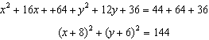

PTS: 2 REF: 012430geo NAT: G.GPE.A.1 TOP: Equations of Circles
KEY: completing the square

31 ANS:
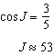

PTS: 2 REF: 012431geo NAT: G.SRT.C.8 TOP: Using Trigonometry to Find an Angle

32 ANS:
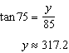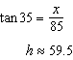

PTS: 4 REF: 012432geo NAT: G.SRT.C.8 TOP: Using Trigonometry to Find a Side

33 ANS:
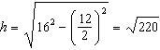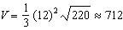

PTS: 4 REF: 012433geo NAT: G.MG.A.2 TOP: Density

34 ANS:
In quadrilateral ABCD, and , segments CE and AF are drawn to diagonal such that (Given); (Parallel lines cut by a transversal form congruent interior angles); (Reflexive); 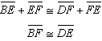 (Addition); (SAS); (CPCTC).

PTS: 4 REF: 012434geo NAT: G.SRT.B.5 TOP: Quadrilateral Proofs

35 ANS:
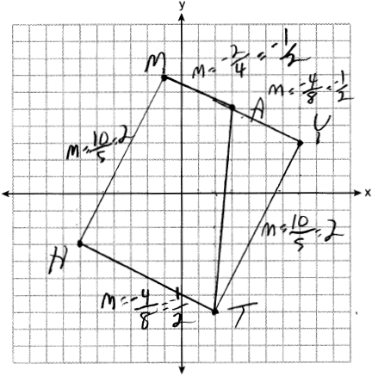The slope of and equals . Distinct lines with equal slope are parallel. MATH is a trapezoid because it has a pair of parallel lines. . The slope of and equals . The slope of and equals 2. The slopes of each side are opposite reciprocals and therefore perpendicular. Perpendicular sides form right angles, so MYTH has four right angles and is a rectangle.

PTS: 6 REF: 012435geo NAT: G.GPE.B.4 TOP: Quadrilaterals in the Coordinate Plane

