1 In the diagram below, , and and are drawn.

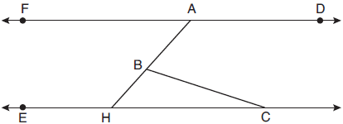

If and , what is ?
1) 18º 2) 48º 3) 66º 4) 114º

2 A cone has a volume of and a base diameter of 12. What is the height of the cone?
1) 27 2) 9 3) 3 4) 4

3 Triangle is similar to triangle . Which statement is not always true?
1) 2) 3) 4)

4 In parallelogram ABCD, diagonals and intersect at E. Which statement proves ABCD is a rectangle?
1) 2) 3) 4) bisects

5 The endpoints of directed line segment PQ have coordinates of and . What are the coordinates of point A, on , that divide into a ratio of 1:3?
1) 2) 3) 4)

6 In trapezoid ABCD below, .

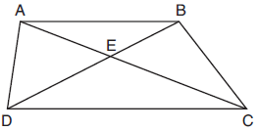

If , , and , what is the length of , to the nearest tenth?
1) 4.7 2) 6.5 3) 8.4 4) 13.1

7 Kayla was cutting right triangles from wood to use for an art project. Two of the right triangles she cut are shown below.

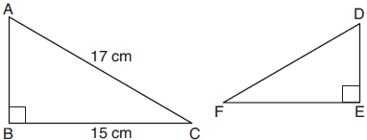

If , with right angles B and E, cm, and cm, what is the measure of , to the nearest degree?
1) 28° 2) 41° 3) 62° 4) 88°

8 The line represented by is dilated by a scale factor of k centered at the origin, such that the image of the line has an equation of 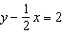. What is the scale factor?
1) 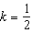 2) 3) 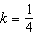 4)

9 In quadrilateral ABCD below, , and E, H, and F are the midpoints of , , and , respectively.

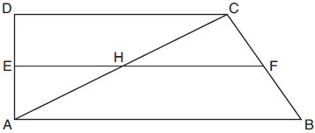

If , , and , then FH is
1) 9 2) 10 3) 12 4) 21

10 Jaden is comparing two cones. The radius of the base of cone A is twice as large as the radius of the base of cone B. The height of cone B is twice the height of cone A. The volume of cone A is
1) twice the volume of cone B 2) four times the volume of cone B 3) equal to the volume of cone B 4) equal to half the volume of cone B

11 A regular hexagon is rotated about its center. Which degree measure will carry the regular hexagon onto itself?
1) 45° 2) 90° 3) 120° 4) 135°

12 In triangle MAH below, is the perpendicular bisector of .

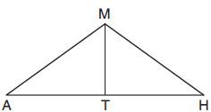

Which statement is not always true?
1) is isosceles. 2) is isosceles. 3) bisects . 4) and are complementary.

13 In circle B below, diameter , radius , and chord are drawn.

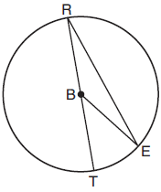

If and , then the area of sector EBR is
1) 2) 3) 4)

14 Lou has a solid clay brick in the shape of a rectangular prism with a length of 8 inches, a width of 3.5 inches, and a height of 2.25 inches. If the clay weighs 1.055 oz/in³, how much does Lou's brick weigh, to the nearest ounce?
1) 66 2) 64 3) 63 4) 60

15 Rhombus ABCD can be mapped onto rhombus KLMN by a rotation about point P, as shown below.

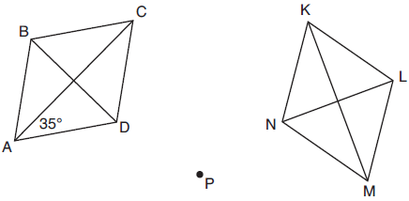

What is the measure of if the measure of ?
1) 35° 2) 55° 3) 70° 4) 110°

16 In right triangle RST below, altitude is drawn to hypotenuse .

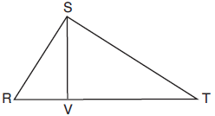

If and , what is the length of , to the nearest tenth?
1) 6.5 2) 7.7 3) 11.0 4) 12.1

17 On the set of axes below, pentagon ABCDE is congruent to A"B"C"D"E".

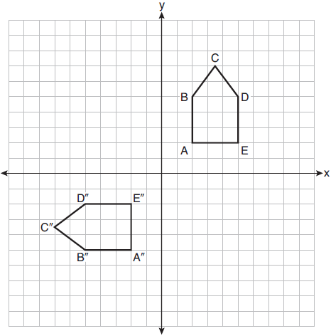

Which describes a sequence of rigid motions that maps ABCDE onto A"B"C"D"E"?
1) a rotation of 90° counterclockwise about the origin followed by a reflection over the x-axis 2) a rotation of 90° counterclockwise about the origin followed by a translation down 7 units 3) a reflection over the y-axis followed by a reflection over the x-axis 4) a reflection over the x-axis followed by a rotation of 90° counterclockwise about the origin

18 On the set of axes below, rhombus ABCD has vertices whose coordinates are , , , and .

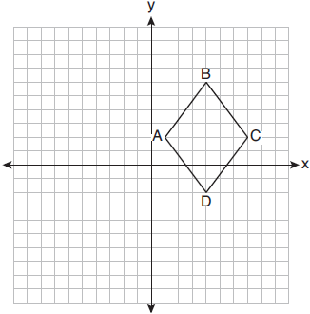

What is the area of rhombus ABCD?
1) 20 2) 24 3) 25 4) 48

19 Which figure(s) below can have a triangle as a two-dimensional cross section?
I. cone
II. cylinder
III. cube
IV. square pyramid
1) I, only 2) IV, only 3) I, II, and IV, only 4) I, III, and IV, only

20 What is an equation of a circle whose center is at and is tangent to the line ?
1) 2) 3) 4)

21 For the acute angles in a right triangle, . What is the number of degrees in the measure of the smaller angle?
1) 11° 2) 13° 3) 44° 4) 52°

22 Triangle PQR is shown on the set of axes below.

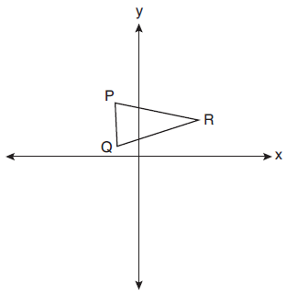

Which quadrant will contain point R", the image of point R, after a 90° clockwise rotation centered at followed by a reflection over the x-axis?
1) I 2) II 3) III 4) IV

23 In the diagram below of right triangle ABC, altitude is drawn.

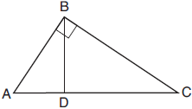

Which ratio is always equivalent to ?
1) 2) 3) 4)

24 In the diagram below of , L is a point on , and M is a point on , such that .
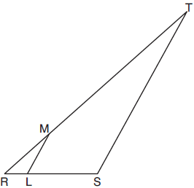

If , , , and , what is the length of ?
1) 10 2) 12 3) 14 4) 16

25 In the diagram below, right triangle PQR is transformed by a sequence of rigid motions that maps it onto right triangle NML.

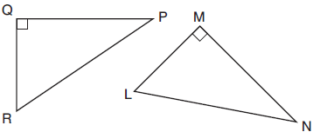

Write a set of three congruency statements that would show ASA congruency for these triangles.

26 Diego needs to install a support beam to hold up his new birdhouse, as modeled below. The base of the birdhouse is inches long. The support beam will form an angle of 38° with the vertical post. Determine and state the approximate length of the support beam, x, to the nearest inch.

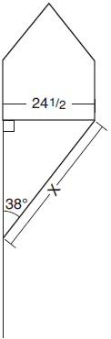

27 A rectangular tabletop will be made of maple wood that weighs 43 pounds per cubic foot. The tabletop will have a length of eight feet, a width of three feet, and a thickness of one inch. Determine and state the weight of the tabletop, in pounds.

28 In the diagram below of circle O, secant and tangent are drawn.

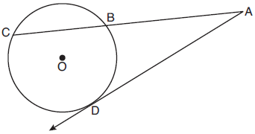

If and , determine and state the length of .

29 Given below, use a compass and straightedge to construct a 45° angle whose vertex is at point M. [Leave all construction marks.]

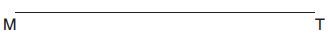

30 In , shown below, medians , , and intersect at C.

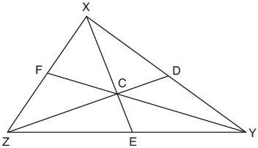

If , , and , determine and state the perimeter of triangle CFX.

31 Determine and state an equation of the line perpendicular to the line and passing through the point .

32 Quadrilateral NATS has coordinates , , , and . Prove quadrilateral NATS is a rhombus. [The use of the set of axes below is optional.]

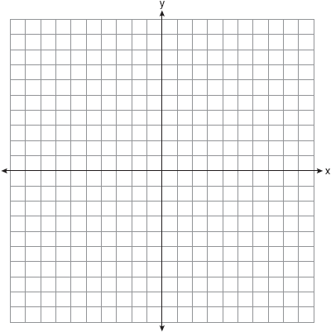

33 David has just finished building his treehouse and still needs to buy a ladder to be attached to the ledge of the treehouse and anchored at a point on the ground, as modeled below. David is standing 1.3 meters from the stilt supporting the treehouse. This is the point on the ground where he has decided to anchor the ladder. The angle of elevation from his eye level to the bottom of the treehouse is 56 degrees. David's eye level is 1.5 meters above the ground.

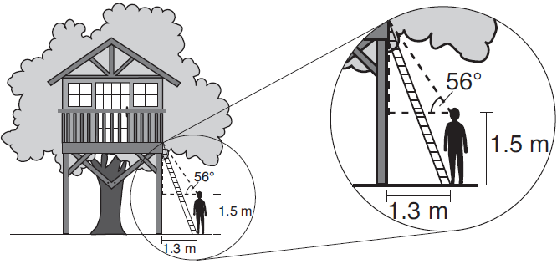

Determine and state the minimum length of a ladder, to the nearest tenth of a meter, that David will need to buy for his treehouse.

34 A manufacturer is designing a new container for their chocolate-covered almonds. Their original container was a cylinder with a height of 18 cm and a diameter of 14 cm. The new container can be modeled by a rectangular prism with a square base and will contain the same amount of chocolate-covered almonds.

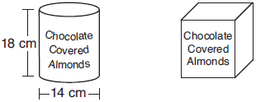

If the new container's height is 16 cm, determine and state, to the nearest tenth of a centimeter, the side length of the new container if both containers contain the same amount of almonds. A store owner who sells the chocolate-covered almonds displays them on a shelf whose dimensions are 80 cm long and 60 cm wide. The shelf can only hold one layer of new containers when each new container sits on its square base. Determine and state the maximum number of new containers the store owner can fit on the shelf.

35 In quadrilateral ABCD, E and F are points on and , respectively, and and are drawn such that , , and .

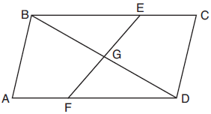

Prove:
1 ANS: 3

PTS: 2 REF: 012001geo NAT: G.CO.C.9 TOP: Lines and Angles

2 ANS: 2
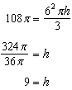

PTS: 2 REF: 012002geo NAT: G.GMD.A.3 TOP: Volume
KEY: cones

3 ANS: 2 PTS: 2 REF: 012003geo NAT: G.SRT.B.5
TOP: Similarity KEY: basic

4 ANS: 1 PTS: 2 REF: 012004geo NAT: G.CO.C.11
TOP: Special Quadrilaterals

5 ANS: 4
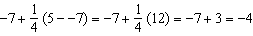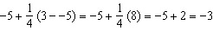

PTS: 2 REF: 012005geo NAT: G.GPE.B.6 TOP: Directed Line Segments

6 ANS: 3
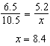

PTS: 2 REF: 012006geo NAT: G.CO.C.11 TOP: Trapezoids

7 ANS: 1
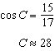

PTS: 2 REF: 012007geo NAT: G.SRT.C.8 TOP: Using Trigonometry to Find an Angle

8 ANS: 1
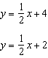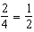

PTS: 2 REF: 012008geo NAT: G.SRT.A.1 TOP: Line Dilations

9 ANS: 3
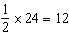

PTS: 2 REF: 012009geo NAT: G.CO.C.10 TOP: Midsegments

10 ANS: 1
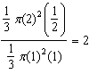

PTS: 2 REF: 012010geo NAT: G.GMD.A.3 TOP: Volume
KEY: cones

11 ANS: 3
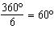 120º is a multiple of 60º

PTS: 2 REF: 012011geo NAT: G.CO.A.3 TOP: Mapping a Polygon onto Itself

12 ANS: 2 PTS: 2 REF: 012012geo NAT: G.CO.C.10
TOP: Medians, Altitudes and Bisectors

13 ANS: 3
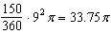

PTS: 2 REF: 012013geo NAT: G.C.B.5 TOP: Sectors

14 ANS: 1

PTS: 2 REF: 012014geo NAT: G.MG.A.2 TOP: Density

15 ANS: 4

PTS: 2 REF: 012015geo NAT: G.CO.B.6 TOP: Properties of Transformations
KEY: basic

16 ANS: 4
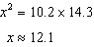

PTS: 2 REF: 012016geo NAT: G.SRT.B.5 TOP: Similarity
KEY: leg

17 ANS: 2 PTS: 1 REF: 012017geo NAT: G.CO.A.5
TOP: Compositions of Transformations KEY: identify

18 ANS: 2
Create two congruent triangles by drawing , which has a length of 8. Each triangle has an area of 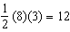.

PTS: 2 REF: 012018geo NAT: G.GPE.B.7 TOP: Polygons in the Coordinate Plane

19 ANS: 4 PTS: 2 REF: 012019geo NAT: G.GMD.B.4
TOP: Cross-Sections of Three-Dimensional Objects

20 ANS: 2
The line will be tangent to the circle at . A segment connecting this point and is a radius of the circle with length 4.

PTS: 2 REF: 012020geo NAT: G.GPE.A.1 TOP: Equations of Circles
KEY: other

21 ANS: 3
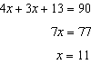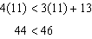

PTS: 2 REF: 012021geo NAT: G.SRT.C.7 TOP: Cofunctions

22 ANS: 1 PTS: 2 REF: 012022geo NAT: G.SRT.A.2
TOP: Compositions of Transformations KEY: grids

23 ANS: 2
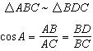

PTS: 2 REF: 012023geo NAT: G.SRT.C.6 TOP: Trigonometric Ratios

24 ANS: 4
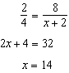

PTS: 2 REF: 012024geo NAT: G.SRT.B.5 TOP: Side Splitter Theorem

25 ANS:

PTS: 2 REF: 012025geo NAT: G.CO.B.7 TOP: Triangle Congruency

26 ANS:
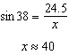

PTS: 2 REF: 012026geo NAT: G.SRT.C.8 TOP: Using Trigonometry to Find a Side
KEY: graphics

27 ANS:
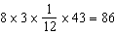

PTS: 2 REF: 012027geo NAT: G.MG.A.2 TOP: Density

28 ANS:
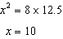

PTS: 2 REF: 012028geo NAT: G.C.A.2 TOP: Chords, Secants and Tangents
KEY: secant and tangent drawn from common point, length

29 ANS:
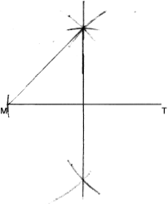

PTS: 2 REF: 012029geo NAT: G.CO.D.12 TOP: Constructions
KEY: parallel and perpendicular lines

30 ANS:
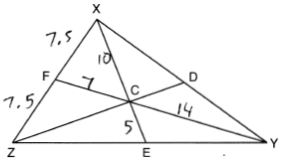

PTS: 2 REF: 012030geo NAT: G.CO.C.10
TOP: Centroid, Orthocenter, Incenter and Circumcenter

31 ANS:
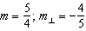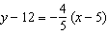

PTS: 2 REF: 012031geo NAT: G.GPE.B.5 TOP: Parallel and Perpendicular Lines
KEY: write equation of perpendicular line

32 ANS:
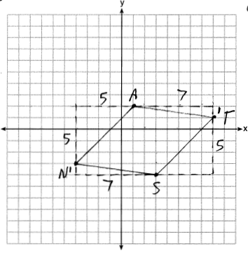 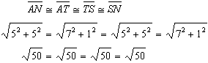 Quadrilateral NATS is a rhombus because all four sides are congruent.

PTS: 4 REF: 012032geo NAT: G.GPE.B.4 TOP: Quadrilaterals in the Coordinate Plane
KEY: grids

33 ANS:
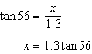

PTS: 4 REF: 012033geo NAT: G.SRT.C.8 TOP: Using Trigonometry to Find a Side
KEY: advanced

34 ANS:
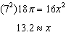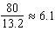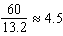

PTS: 4 REF: 012034geo NAT: G.GMD.A.3 TOP: Volume
KEY: cylinders

35 ANS:
Quadrilateral ABCD, E and F are points on and , respectively, and and are drawn such that , , and (given); (reflexive); (SAS); (CPCTC); (segment addition); (segment subtraction); (vertical angles are congruent); (CPCTC); (AAS); (CPCTC).

PTS: 6 REF: 012035geo NAT: G.SRT.B.5 TOP: Quadrilateral Proofs

