1 After a dilation with center , the image of is . If and , the scale factor of this dilation is
1) |  | 3)
2) | 5 | 4) | 4

2 In the diagram below, with sides 13, 15, and 16, is mapped onto after a clockwise rotation of 90° about point P.

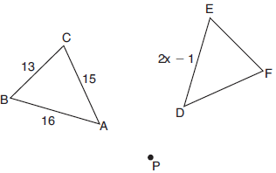

If , what is the value of x?
1) | 7 | 3) | 8
2) | 7.5 | 4) | 8.5

3 On the set of axes below, has vertices at , , , and has vertices at , , .

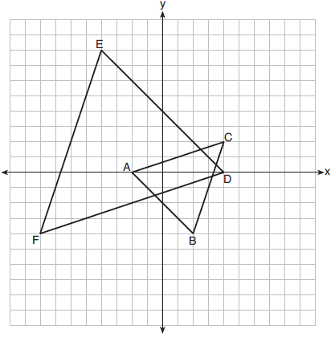

Which sequence of transformations will map onto ?
1) | a dilation of by a scale factor of 2 centered at point A | 3) | a dilation of by a scale factor of 2 centered at the origin, followed by a rotation of 180° about the origin
2) | a dilation of by a scale factor of centered at point A | 4) | a dilation of by a scale factor of centered at the origin, followed by a rotation of 180° about the origin

4 The figure below shows a rhombus with noncongruent diagonals.

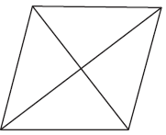

Which transformation would not carry this rhombus onto itself?
1) | a reflection over the shorter diagonal | 3) | a clockwise rotation of 90° about the intersection of the diagonals
2) | a reflection over the longer diagonal | 4) | a counterclockwise rotation of 180° about the intersection of the diagonals

5 In the diagram below of circle O, points K, A, T, I, and E are on the circle, and are drawn, , and .

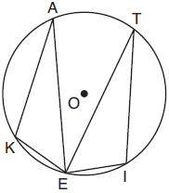

Which statement about and is always true?
1) | They are neither congruent nor similar. | 3) | They are right triangles.
2) | They are similar but not congruent. | 4) | They are congruent.

6 In right triangle ABC shown below, point D is on and point E is on such that .

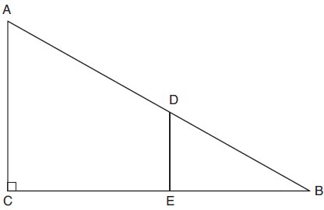

If , , and , what is the length of ?
1) | 8.75 | 3) | 5
2) | 6.25 | 4) | 4

7 In rhombus VENU, diagonals and intersect at S. If and , what is the perimeter of the rhombus?
1) | 80 | 3) | 20
2) | 40 | 4) | 10

8 Given right triangle ABC with a right angle at C, . Given right triangle RST with a right angle at T, .

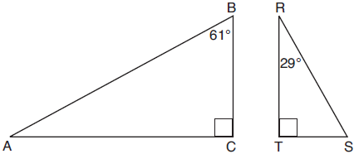

Which proportion in relation to and is not correct?
1) | 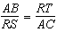 | 3) | 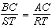
2) | 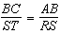 | 4) | 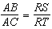

9 A vendor is using an 8-ft by 8-ft tent for a craft fair. The legs of the tent are 9 ft tall and the top forms a square pyramid with a height of 3 ft.

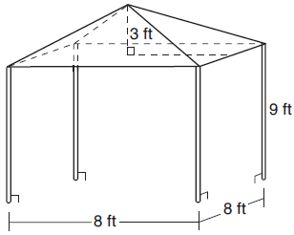

What is the volume, in cubic feet, of space the tent occupies?
1) | 256 | 3) | 672
2) | 640 | 4) | 768

10 In the diagram below of right triangle KMI, altitude is drawn to hypotenuse .

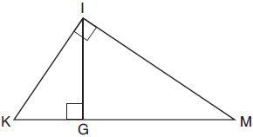

If and , the length of is
1) | 15 | 3) | 20
2) | 16 | 4) | 25

11 Which three-dimensional figure will result when a rectangle 6 inches long and 5 inches wide is continuously rotated about the longer side?
1) | a rectangular prism with a length of 6 inches, width of 6 inches, and height of 5 inches | 3) | a cylinder with a radius of 5 inches and a height of 6 inches
2) | a rectangular prism with a length of 6 inches, width of 5 inches, and height of 5 inches | 4) | a cylinder with a radius of 6 inches and a height of 5 inches

12 Which statement about parallelograms is always true?
1) | The diagonals are congruent. | 3) | The diagonals are perpendicular.
2) | The diagonals bisect each other. | 4) | The diagonals bisect their respective angles.

13 From a point on the ground one-half mile from the base of a historic monument, the angle of elevation to its top is 11.87°. To the nearest foot, what is the height of the monument?
1) | 543 | 3) | 1086
2) | 555 | 4) | 1110

14 The area of a sector of a circle with a radius measuring 15 cm is . What is the measure of the central angle that forms the sector?
1) | 72° | 3) | 144°
2) | 120° | 4) | 180°

15 Point M divides so that . If A has coordinates and B has coordinates , the coordinates of M are
1) |  | 3)
2) | 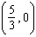 | 4) | 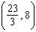

16 In the diagram below of triangle ABC, is extended through point C to point D, and is drawn to .
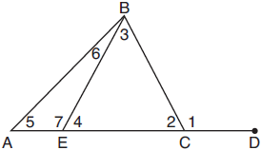
Which equation is always true?
1) |  | 3)
2) |  | 4)

17 In the diagram below of right triangle ABC, , and .
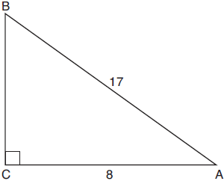
Which equation would determine the value of angle A?
1) | 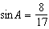 | 3) | 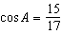
2) | 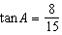 | 4) | 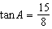

18 Francisco needs the three pieces of glass shown below to complete a stained glass window. The shapes, two triangles and a trapezoid, are measured in inches.
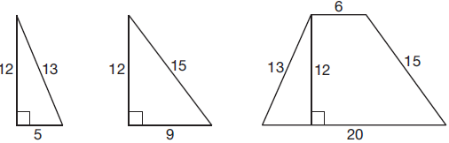

Glass can be purchased in rectangular sheets that are 12 inches wide. What is the minimum length of a sheet of glass, in inches, that Francisco must purchase in order to have enough to complete the window?
1) | 20 | 3) | 29
2) | 25 | 4) | 34

19 In the diagram of quadrilateral NAVY below, , , , and .

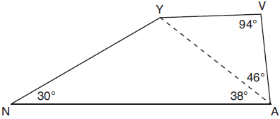

Which segment has the shortest length?
1) |  | 3)
2) |  | 4)

20 What is an equation of a circle whose center is and diameter is 10?
1) |  | 3)
2) |  | 4)

21 On the set of axes below, , altitude , and median are drawn.

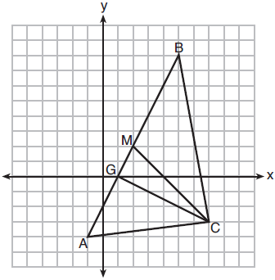

Which expression represents the area of ?
1) | 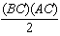 | 3) | 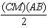
2) | 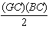 | 4) | 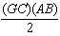

22 In right triangle ABC, and . Which trigonometric ratio is equivalent to ?
1) |  | 3)
2) |  | 4)

23 As shown in the diagram below, the radius of a cone is 2.5 cm and its slant height is 6.5 cm.

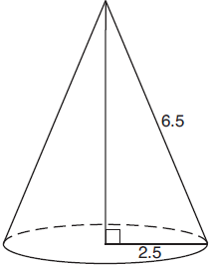

How many cubic centimeters are in the volume of the cone?
1) |  | 3)
2) |  | 4)

24 What is an equation of the image of the line 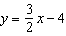 after a dilation of a scale factor of centered at the origin?
1) | 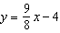 | 3)
2) | 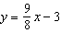 | 4) | 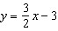

25 Write an equation of the line that is parallel to the line whose equation is and passes through the point .

26 Parallelogram ABCD is adjacent to rhombus DEFG, as shown below, and intersects at H.

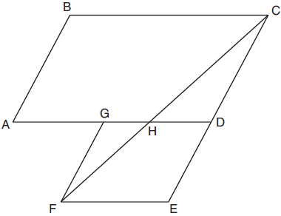

If and , determine and state .

27 As shown in the diagram below, secants and are drawn to circle O from external point P.

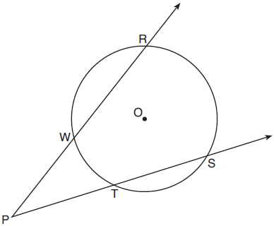

If and , determine and state .

28 On the set of axes below, is graphed with coordinates , , and . Triangle QRS, the image of , is graphed with coordinates , , and .

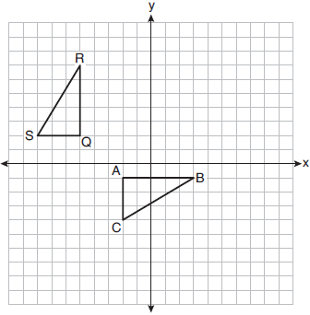

Describe a sequence of transformations that would map onto .

29 Given points A, B, and C, use a compass and straightedge to construct point D so that ABCD is a parallelogram. [Leave all construction marks.]

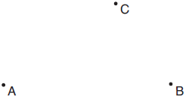

30 On the set of axes below, has vertices at the coordinates , , and , and point G has coordinates . Owen claims the median from point E must pass through point G. Is Owen correct? Explain why.

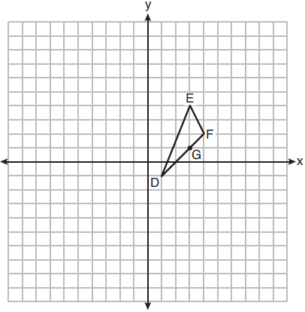

31 A walking path at a local park is modeled on the grid below, where the length of each grid square is 10 feet. The town needs to submit paperwork to pave the walking path. Determine and state, to the nearest square foot, the area of the walking path.

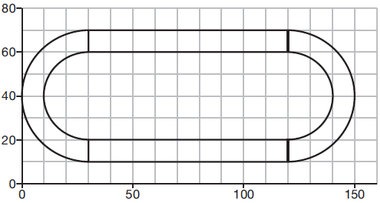

32 A triangle has vertices , , and . Prove that is an isosceles right triangle. [The use of the set of axes below is optional.]

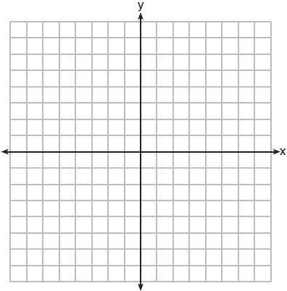

33 Theresa has a rectangular pool 30 ft long, 15 ft wide, and 4 ft deep. Theresa fills her pool using city water at a rate of $3.95 per 100 gallons of water. Nancy has a circular pool with a diameter of 24 ft and a depth of 4 ft. Nancy fills her pool with a water delivery service at a rate of $200 per 6000 gallons. If Theresa and Nancy both fill their pools 6 inches from the top of the pool, determine and state who paid more to fill her pool.

34 As modeled in the diagram below, an access ramp starts on flat ground and ends at the beginning of the top step. Each step is 6 inches tall and 8 inches deep.

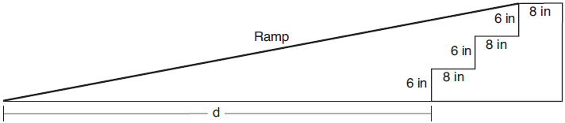

If the angle of elevation of the ramp is 4.76°, determine and state the length of the ramp, to the nearest tenth of a foot. Determine and state, to the nearest tenth of a foot, the horizontal distance, d, from the bottom of the stairs to the bottom of the ramp.

35 In the diagram of quadrilateral ABCD with diagonal shown below, segments GH and EF are drawn, , , , and .

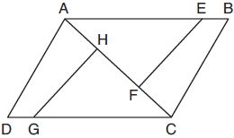

Prove:
1 ANS: 4
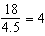

PTS: 2 REF: 011901geo NAT: G.SRT.A.1 TOP: Line Dilations

2 ANS: 4
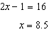

PTS: 2 REF: 011902geo NAT: G.CO.B.6 TOP: Properties of Transformations
KEY: graphics

3 ANS: 3 PTS: 2 REF: 011903geo NAT: G.CO.A.5
TOP: Compositions of Transformations KEY: identify

4 ANS: 3 PTS: 2 REF: 011904geo NAT: G.CO.A.3
TOP: Mapping a Polygon onto Itself

5 ANS: 4 PTS: 2 REF: 011905geo NAT: G.C.A.2
TOP: Chords, Secants and Tangents KEY: inscribed

6 ANS: 2
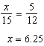

PTS: 2 REF: 011906geo NAT: G.SRT.B.5 TOP: Side Splitter Theorem

7 ANS: 2
for one side

PTS: 2 REF: 011907geo NAT: G.CO.C.11 TOP: Special Quadrilaterals

8 ANS: 1

PTS: 2 REF: 011908geo NAT: G.SRT.B.5 TOP: Similarity
KEY: basic

9 ANS: 2
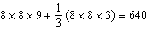

PTS: 2 REF: 011909geo NAT: G.GMD.A.3 TOP: Volume
KEY: compositions

10 ANS: 3
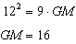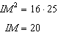

PTS: 2 REF: 011910geo NAT: G.SRT.B.5 TOP: Similarity
KEY: leg

11 ANS: 3 PTS: 2 REF: 011911geo NAT: G.GMD.B.4
TOP: Rotations of Two-Dimensional Objects

12 ANS: 2 PTS: 2 REF: 011912geo NAT: G.CO.C.11
TOP: Parallelograms

13 ANS: 2
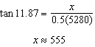

PTS: 2 REF: 011913geo NAT: G.SRT.C.8 TOP: Using Trigonometry to Find a Side

14 ANS: 2
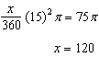

PTS: 2 REF: 011914geo NAT: G.C.B.5 TOP: Sectors

15 ANS: 1
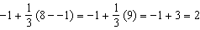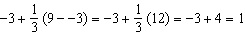

PTS: 2 REF: 011915geo NAT: G.GPE.B.6 TOP: Directed Line Segments

16 ANS: 4 PTS: 2 REF: 011916geo NAT: G.CO.C.10
TOP: Exterior Angle Theorem

17 ANS: 4
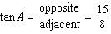

PTS: 2 REF: 011917geo NAT: G.SRT.C.8 TOP: Using Trigonometry to Find an Angle

18 ANS: 1 PTS: 2 REF: 011918geo NAT: G.MG.A.3
TOP: Compositions of Polygons and Circles KEY: area

19 ANS: 3
is the smallest angle in , so side is the shortest side of . is the smallest angle in , so side is the shortest side of both triangles.

PTS: 2 REF: 011919geo NAT: G.CO.C.10 TOP: Angle Side Relationship

20 ANS: 1
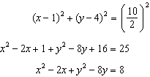

PTS: 2 REF: 011920geo NAT: G.GPE.A.1 TOP: Equations of Circles
KEY: write equation, given center and radius

21 ANS: 4 PTS: 2 REF: 011921geo NAT: G.GPE.B.4
TOP: Triangles in the Coordinate Plane

22 ANS: 1 PTS: 2 REF: 011922geo NAT: G.SRT.C.7
TOP: Cofunctions

23 ANS: 1
, 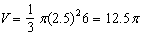

PTS: 2 REF: 011923geo NAT: G.GMD.A.3 TOP: Volume
KEY: cones

24 ANS: 4
The line does not pass through the center of dilation, so the dilated line will be distinct from . Since a dilation preserves parallelism, the line and its image will be parallel, with slopes of . To obtain the y-intercept of the dilated line, the scale factor of the dilation, , can be applied to the y-intercept, . Therefore, 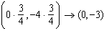. So the equation of the dilated line is .

PTS: 2 REF: 011924geo NAT: G.SRT.A.1 TOP: Line Dilations

25 ANS:
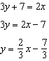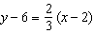

PTS: 2 REF: 011925geo NAT: G.GPE.B.5 TOP: Parallel and Perpendicular Lines
KEY: write equation of parallel line

26 ANS:
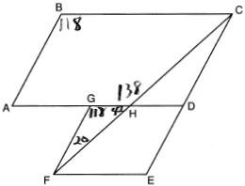20º

PTS: 2 REF: 011926geo NAT: G.CO.C.11 TOP: Interior and Exterior Angles of Polygons

27 ANS:
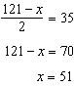

PTS: 2 REF: 011927geo NAT: G.C.A.2 TOP: Chords, Secants and Tangents
KEY: secants drawn from common point, angle

28 ANS:

PTS: 2 REF: 011928geo NAT: G.CO.A.5 TOP: Compositions of Transformations
KEY: identify

29 ANS:
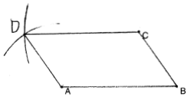

PTS: 2 REF: 011929geo NAT: G.CO.D.12 TOP: Constructions
KEY: equilateral triangles

30 ANS:
No. The midpoint of is 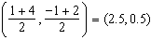. A median from point E must pass through the midpoint.

PTS: 2 REF: 011930geo NAT: G.GPE.B.4 TOP: Triangles in the Coordinate Plane

31 ANS:

PTS: 2 REF: 011931geo NAT: G.MG.A.3 TOP: Compositions of Polygons and Circles
KEY: area

32 ANS:
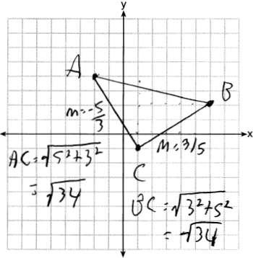Triangle with vertices , , and (given); 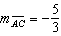, 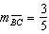, definition of slope; Because the slopes of the legs of the triangle are opposite reciprocals, the legs are perpendicular (definition of perpendicular); is a right angle (definition of right angle); is a right triangle (if a triangle has a right angle, it is a right triangle); (distance formula); is an isosceles triangle (an isosceles triangle has two congruent sides).

PTS: 4 REF: 011932geo NAT: G.GPE.B.4 TOP: Triangles in the Coordinate Plane

33 ANS:
Theresa. 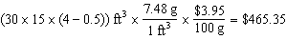, 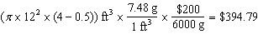

PTS: 4 REF: 011933geo NAT: G.GMD.A.3 TOP: Volume
KEY: cylinders

34 ANS:
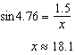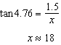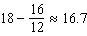

PTS: 4 REF: 011934geo NAT: G.SRT.C.8 TOP: Using Trigonometry to Find a Side

35 ANS:
Quadrilateral ABCD with diagonal , segments GH and EF, , , , and (given); , (reflexive property); 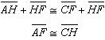, 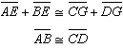 (segment addition); (SSS); (CPCTC); (SAS); (CPCTC).

PTS: 6 REF: 011935geo NAT: G.SRT.B.5 TOP: Quadrilateral Proofs

