1 In the diagram below, a sequence of rigid motions maps ABCD onto JKLM.

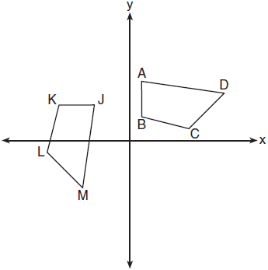

If , , and , the measure of is
1) | 53°
2) | 82°
3) | 104°
4) | 121°

2 Parallelogram HAND is drawn below with diagonals and intersecting at S.

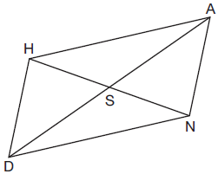

Which statement is always true?
1) | 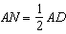
2) | 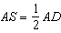
3)
4)

3 The graph below shows two congruent triangles, ABC and A'B'C'.

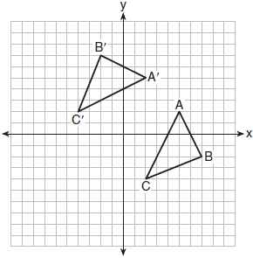

Which rigid motion would map onto ?
1) | a rotation of 90 degrees counterclockwise about the origin
2) | a translation of three units to the left and three units up
3) | a rotation of 180 degrees about the origin
4) | a reflection over the line

4 A man was parasailing above a lake at an angle of elevation of 32° from a boat, as modeled in the diagram below.

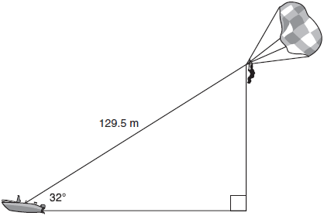

If 129.5 meters of cable connected the boat to the parasail, approximately how many meters above the lake was the man?
1) | 68.6
2) | 80.9
3) | 109.8
4) | 244.4

5 A right hexagonal prism is shown below. A two-dimensional cross section that is perpendicular to the base is taken from the prism.

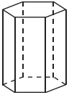

Which figure describes the two-dimensional cross section?
1) | triangle
2) | rectangle
3) | pentagon
4) | hexagon

6 In the diagram below, has endpoints with coordinates and .

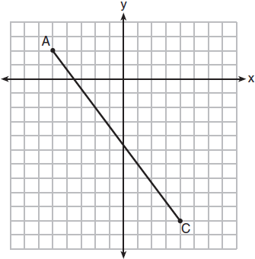

If B is a point on and , what are the coordinates of B?
1)
2) | 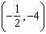
3) | 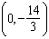
4)

7 An ice cream waffle cone can be modeled by a right circular cone with a base diameter of 6.6 centimeters and a volume of cubic centimeters. What is the number of centimeters in the height of the waffle cone?
1)
2) | 5
3) | 15
4)

8 The vertices of have coordinates , , and . Under which transformation of are distance and angle measure preserved?
1)
2)
3)
4)

9 In shown below, side is extended to point D with , , and .

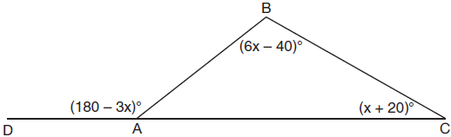

What is ?
1) | 20º
2) | 40º
3) | 60º
4) | 80º

10 Circle O is centered at the origin. In the diagram below, a quarter of circle O is graphed.

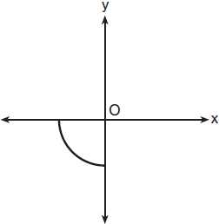

Which three-dimensional figure is generated when the quarter circle is continuously rotated about the y-axis?
1) | cone
2) | sphere
3) | cylinder
4) | hemisphere

11 Rectangle A'B'C'D' is the image of rectangle ABCD after a dilation centered at point A by a scale factor of . Which statement is correct?
1) | Rectangle A'B'C'D' has a perimeter that is the perimeter of rectangle ABCD.
2) | Rectangle A'B'C'D' has a perimeter that is the perimeter of rectangle ABCD.
3) | Rectangle A'B'C'D' has an area that is the area of rectangle ABCD.
4) | Rectangle A'B'C'D' has an area that is the area of rectangle ABCD.

12 The equation of a circle is . What are the coordinates of the center and the length of the radius of the circle?
1) | center and radius 4
2) | center and radius 4
3) | center and radius 16
4) | center and radius 16

13 In the diagram of below, is parallel to , , , and .

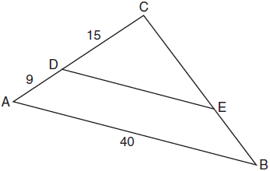

The length of is
1) | 15
2) | 24
3) | 25
4) | 30

14 The line whose equation is is dilated by a scale factor of centered at the origin. Which statement is correct?
1) | The image of the line has the same slope as the pre-image but a different y-intercept.
2) | The image of the line has the same y-intercept as the pre-image but a different slope.
3) | The image of the line has the same slope and the same y-intercept as the pre-image.
4) | The image of the line has a different slope and a different y-intercept from the pre-image.

15 Which transformation would not carry a square onto itself?
1) | a reflection over one of its diagonals
2) | a 90° rotation clockwise about its center
3) | a 180° rotation about one of its vertices
4) | a reflection over the perpendicular bisector of one side

16 In circle M below, diameter , chords and , and radius are drawn.

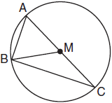

Which statement is not true?
1) | is a right triangle.
2) | is isosceles.
3)
4) | 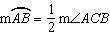

17 In the diagram below, and intersect at Z. Segments XY and RS are drawn perpendicular to to form triangles XYZ and SRZ.

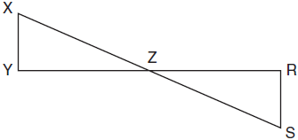

Which statement is always true?
1)
2)
3)
4) | 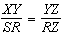

18 As shown in the diagram below, and .

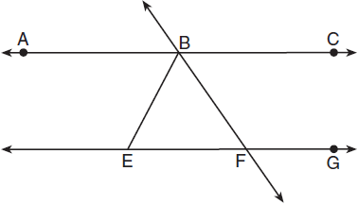

If , then is
1) | 42.5°
2) | 68.75°
3) | 95°
4) | 137.5°

19 A parallelogram must be a rhombus if its diagonals
1) | are congruent
2) | bisect each other
3) | do not bisect its angles
4) | are perpendicular to each other

20 What is an equation of a line which passes through and is perpendicular to the line whose equation is ?
1) | 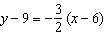
2) | 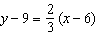
3) | 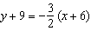
4) | 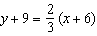

21 Quadrilateral ABCD is inscribed in circle O, as shown below.
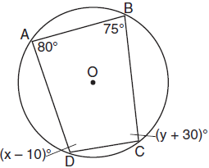

If , , , and , which statement is true?
1) | and
2) | and
3) | and
4) | and

22 A regular pyramid has a square base. The perimeter of the base is 36 inches and the height of the pyramid is 15 inches. What is the volume of the pyramid in cubic inches?
1) | 180
2) | 405
3) | 540
4) | 1215

23 In the diagram below of , is a right angle, , , and altitude is drawn.
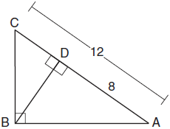

What is the length of ?
1)
2)
3)
4)

24 In the diagram below, two concentric circles with center O, and radii , , , and are drawn.

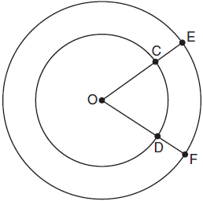

If and , which relationship between the length of arc EF and the length of arc CD is always true?
1) | The length of arc EF is 2 units longer than the length of arc CD.
2) | The length of arc EF is 4 units longer than the length of arc CD.
3) | The length of arc EF is 1.5 times the length of arc CD.
4) | The length of arc EF is 2.0 times the length of arc CD.

25 Given: Parallelogram ABCD with diagonal drawn

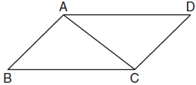

Prove:

26 The diagram below shows circle O with diameter . Using a compass and straightedge, construct a square that is inscribed in circle O. [Leave all construction marks.]

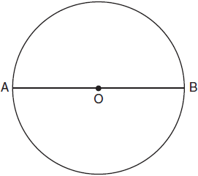

27 Given: Right triangle ABC with right angle at C. If increases, does increase or decrease? Explain why.

28 In the diagram below, the circle has a radius of 25 inches. The area of the unshaded sector is .

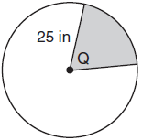

Determine and state the degree measure of angle Q, the central angle of the shaded sector.

29 A machinist creates a solid steel part for a wind turbine engine. The part has a volume of 1015 cubic centimeters. Steel can be purchased for $0.29 per kilogram, and has a density of 7.95 g/cm³. If the machinist makes 500 of these parts, what is the cost of the steel, to the nearest dollar?

30 In the graph below, has coordinates , , and , and has coordinates , , and .
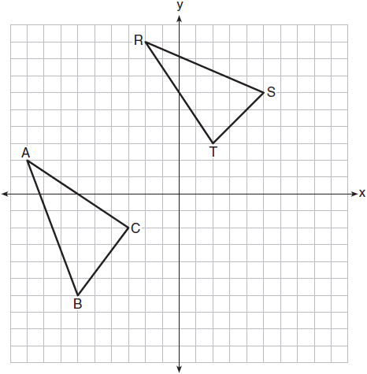

Is congruent to ? Use the properties of rigid motions to explain your reasoning.

31 Bob places an 18-foot ladder 6 feet from the base of his house and leans it up against the side of his house. Find, to the nearest degree, the measure of the angle the bottom of the ladder makes with the ground.

32 Triangle ABC and triangle ADE are graphed on the set of axes below.
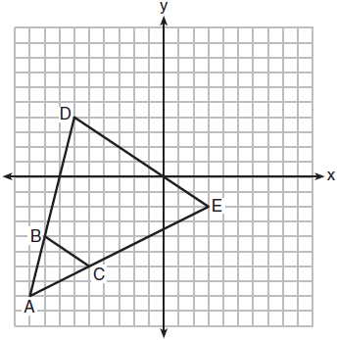

Describe a transformation that maps triangle ABC onto triangle ADE. Explain why this transformation makes triangle ADE similar to triangle ABC.

33 A storage tank is in the shape of a cylinder with a hemisphere on the top. The highest point on the inside of the storage tank is 13 meters above the floor of the storage tank, and the diameter inside the cylinder is 8 meters. Determine and state, to the nearest cubic meter, the total volume inside the storage tank.

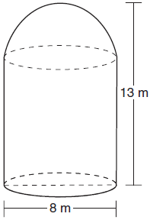

34 As shown in the diagram below, an island (I) is due north of a marina (M). A boat house (H) is 4.5 miles due west of the marina. From the boat house, the island is located at an angle of 54° from the marina.

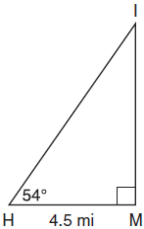

Determine and state, to the nearest tenth of a mile, the distance from the boat house (H) to the island (I). Determine and state, to the nearest tenth of a mile, the distance from the island (I) to the marina (M).

35 In the coordinate plane, the vertices of triangle PAT are , , and . Prove that is an isosceles triangle. [The use of the set of axes below is optional.] State the coordinates of R so that quadrilateral PART is a parallelogram. Prove that quadrilateral PART is a parallelogram.

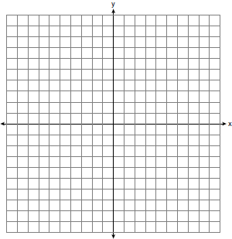
1 ANS: 1
PTS: 2 REF: 011801geo NAT: G.CO.B.6 TOP: Properties of Transformations
KEY: basic

2 ANS: 2 PTS: 2 REF: 011802geo NAT: G.CO.C.11
TOP: Parallelograms

3 ANS: 4 PTS: 2 REF: 011803geo NAT: G.CO.A.2
TOP: Identifying Transformations KEY: graphics

4 ANS: 1
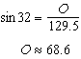
PTS: 2 REF: 011804geo NAT: G.SRT.C.8 TOP: Using Trigonometry to Find a Side

5 ANS: 2 PTS: 2 REF: 011805geo NAT: G.GMD.B.4
TOP: Cross-Sections of Three-Dimensional Objects

6 ANS: 1
PTS: 2 REF: 011806geo NAT: G.GPE.B.6 TOP: Directed Line Segments

7 ANS: 3
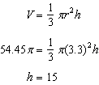
PTS: 2 REF: 011807geo NAT: G.GMD.A.3 TOP: Volume
KEY: cones

8 ANS: 4 PTS: 2 REF: 011808geo NAT: G.CO.A.2
TOP: Analytical Representations of Transformations KEY: basic

9 ANS: 3
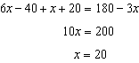
PTS: 2 REF: 011809geo NAT: G.CO.C.10 TOP: Exterior Angle Theorem

10 ANS: 4 PTS: 2 REF: 011810geo NAT: G.GMD.B.4
TOP: Rotations of Two-Dimensional Objects

11 ANS: 1 PTS: 2 REF: 011811geo NAT: G.SRT.A.2
TOP: Dilations

12 ANS: 2
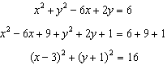
PTS: 2 REF: 011812geo NAT: G.GPE.A.1 TOP: Equations of Circles
KEY: completing the square

13 ANS: 3
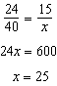
PTS: 2 REF: 011813geo NAT: G.SRT.B.5 TOP: Side Splitter Theorem

14 ANS: 1 PTS: 2 REF: 011814geo NAT: G.SRT.A.1
TOP: Line Dilations

15 ANS: 3 PTS: 2 REF: 011815geo NAT: G.CO.A.3
TOP: Mapping a Polygon onto Itself

16 ANS: 4 PTS: 2 REF: 011816geo NAT: G.C.A.2
TOP: Chords, Secants and Tangents KEY: inscribed

17 ANS: 4 PTS: 2 REF: 011817geo NAT: G.SRT.B.5
TOP: Similarity KEY: basic

18 ANS: 2
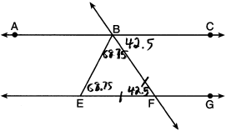
PTS: 2 REF: 011818geo NAT: G.CO.C.9 TOP: Lines and Angles

19 ANS: 4 PTS: 2 REF: 011819geo NAT: G.CO.C.11
TOP: Special Quadrilaterals

20 ANS: 1
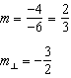
PTS: 2 REF: 011820geo NAT: G.GPE.B.5 TOP: Parallel and Perpendicular Lines
KEY: write equation of perpendicular line

21 ANS: 4
Opposite angles of an inscribed quadrilateral are supplementary.
PTS: 2 REF: 011821geo NAT: G.C.A.3 TOP: Inscribed Quadrilaterals

22 ANS: 2
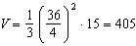
PTS: 2 REF: 011822geo NAT: G.GMD.A.3 TOP: Volume
KEY: pyramids

23 ANS: 2
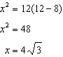
PTS: 2 REF: 011823geo NAT: G.SRT.B.5 TOP: Similarity
KEY: leg

24 ANS: 3
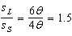
PTS: 2 REF: 011824geo NAT: G.C.B.5 TOP: Arc Length
KEY: arc length

25 ANS:
Parallelogram ABCD with diagonal drawn (given). (reflexive property). and (opposite sides of a parallelogram are congruent). (SSS).
PTS: 2 REF: 011825geo NAT: G.SRT.B.5 TOP: Quadrilateral Proofs

26 ANS:
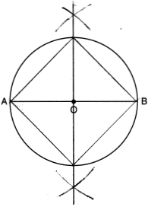
PTS: 2 REF: 011826geo NAT: G.CO.D.13 TOP: Constructions

27 ANS:
increases because and are complementary and .
PTS: 2 REF: 011827geo NAT: G.SRT.C.7 TOP: Cofunctions

28 ANS:
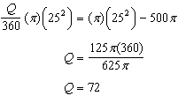
PTS: 2 REF: 011828geo NAT: G.C.B.5 TOP: Sectors

29 ANS:
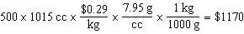
PTS: 2 REF: 011829geo NAT: G.MG.A.2 TOP: Density

30 ANS:
No. Since and are not congruent, the two triangles are not congruent. Since rigid motions preserve distance, there is no rigid motion that maps onto .
PTS: 2 REF: 011830geo NAT: G.CO.B.7 TOP: Triangle Congruency

31 ANS:
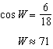
PTS: 2 REF: 011831geo NAT: G.SRT.C.8 TOP: Using Trigonometry to Find an Angle

32 ANS:
A dilation of 3 centered at A. A dilation preserves angle measure, so the triangles are similar.
PTS: 4 REF: 011832geo NAT: G.SRT.A.2 TOP: Dilations

33 ANS:
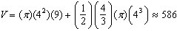
PTS: 4 REF: 011833geo NAT: G.GMD.A.3 TOP: Volume
KEY: compositions

34 ANS:
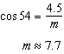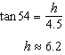
PTS: 4 REF: 011834geo NAT: G.SRT.C.8 TOP: Using Trigonometry to Find a Side

35 ANS:
is an isosceles triangle because sides and are congruent (). . Quadrilateral PART is a parallelogram because the opposite sides are parallel since they have equal slopes 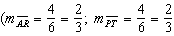; 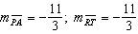) 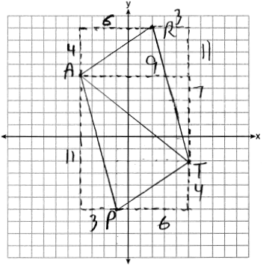
PTS: 6 REF: 011835geo NAT: G.GPE.B.4 TOP: Quadrilaterals in the Coordinate Plane
KEY: grids

