1 Which equation represents the line that passes through the point and is parallel to 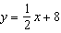?
1) | 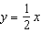
2)
3) | 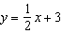
4)

2 In the diagram below, is the image of after a reflection over the line AC followed by a dilation of scale factor centered at point A.

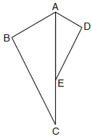

Which statement must be true?
1)
2)
3) | 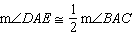
4) | 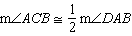

3 Given , which statement is not always true?
1)
2)
3) | area of area of
4) | perimeter of perimeter of

4 In the diagram below, , , and are midsegments of .

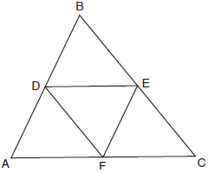

The perimeter of quadrilateral ADEF is equivalent to
1)
2) | 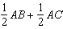
3)
4)

5 In the diagram below, if and is drawn, then it could be proven that quadrilateral ABCD is a

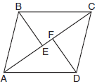
1) | square
2) | rhombus
3) | rectangle
4) | parallelogram

6 Under which transformation would , the image of , not be congruent to ?
1) | reflection over the y-axis
2) | rotation of 90° clockwise about the origin
3) | translation of 3 units right and 2 units down
4) | dilation with a scale factor of 2 centered at the origin

7 The diagram below shows two similar triangles.

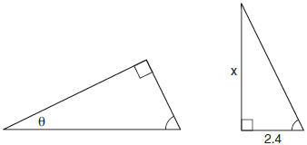

If 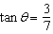, what is the value of x, to the nearest tenth?
1) | 1.2
2) | 5.6
3) | 7.6
4) | 8.8

8 A farmer has 64 feet of fence to enclose a rectangular vegetable garden. Which dimensions would result in the biggest area for this garden?
1) | the length and the width are equal
2) | the length is 2 more than the width
3) | the length is 4 more than the width
4) | the length is 6 more than the width

9 The diagram shows rectangle ABCD, with diagonal .

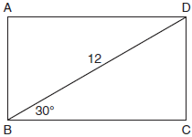

What is the perimeter of rectangle ABCD, to the nearest tenth?
1) | 28.4
2) | 32.8
3) | 48.0
4) | 62.4

10 Identify which sequence of transformations could map pentagon ABCDE onto pentagon A”B”C”D”E”, as shown below.

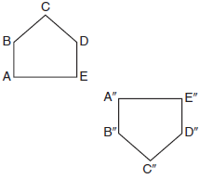
1) | dilation followed by a rotation
2) | translation followed by a rotation
3) | line reflection followed by a translation
4) | line reflection followed by a line reflection

11 A solid metal prism has a rectangular base with sides of 4 inches and 6 inches, and a height of 4 inches. A hole in the shape of a cylinder, with a radius of 1 inch, is drilled through the entire length of the rectangular prism.

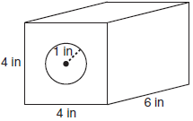

What is the approximate volume of the remaining solid, in cubic inches?
1) | 19
2) | 77
3) | 93
4) | 96

12 Given the right triangle in the diagram below, what is the value of x, to the nearest foot?

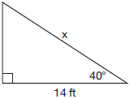
1) | 11
2) | 17
3) | 18
4) | 22

13 On the graph below, point and with coordinates and are graphed.

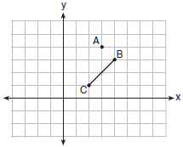

What are the coordinates of B’ and C’ after undergoes a dilation centered at point A with a scale factor of 2?
1) | and
2) | and
3) | and
4) | and

14 In the diagram of right triangle ADE below, .

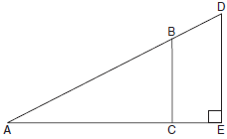

Which ratio is always equivalent to the sine of ?
1)
2)
3)
4)

15 In circle O, secants and are drawn from external point A such that points D, B, E, and C are on circle O. If , , and EC is 12 more than BD, the length of is
1) | 6
2) | 22
3) | 36
4) | 48

16 A parallelogram is always a rectangle if
1) | the diagonals are congruent
2) | the diagonals bisect each other
3) | the diagonals intersect at right angles
4) | the opposite angles are congruent

17 Which rotation about its center will carry a regular decagon onto itself?
1) | 54°
2) | 162°
3) | 198°
4) | 252°

18 The equation of a circle is . What are the coordinates of the center and the length of the radius of this circle?
1) | center and radius
2) | center and radius
3) | center and radius
4) | center and radius

19 Parallelogram ABCD has coordinates and . Which statement would prove that ABCD is a rhombus?
1) | The midpoint of is .
2) | The length of is .
3) | The slope of is .
4) | The slope of is .

20 Point Q is on such that . If M has coordinates and N has coordinates , the coordinates of Q are
1)
2)
3)
4)

21 In the diagram below of circle O, and .
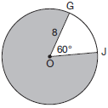
What is the area, in terms of , of the shaded region?
1)
2)
3)
4) | 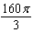

22 A circle whose center is the origin passes through the point . Which point also lies on this circle?
1)
2)
3)
4)

23 A plane intersects a hexagonal prism. The plane is perpendicular to the base of the prism. Which two-dimensional figure is the cross section of the plane intersecting the prism?
1) | triangle
2) | trapezoid
3) | hexagon
4) | rectangle

24 A water cup in the shape of a cone has a height of 4 inches and a maximum diameter of 3 inches. What is the volume of the water in the cup, to the nearest tenth of a cubic inch, when the cup is filled to half its height?
1) | 1.2
2) | 3.5
3) | 4.7
4) | 14.1

25 Using a compass and straightedge, construct the line of reflection over which triangle RST reflects onto triangle R’S’T’. [Leave all construction marks.]

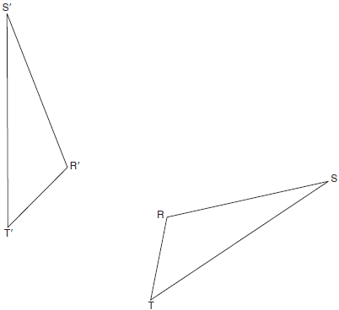

26 The graph below shows and its image, .
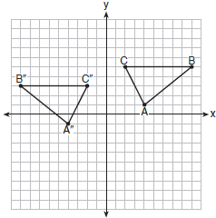

Describe a sequence of rigid motions which would map onto .

27 When instructed to find the length of in right triangle HJG, Alex wrote the equation 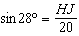 while Marlene wrote 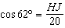. Are both students’ equations correct? Explain why.
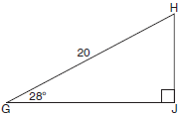

28 In the diagram below, tangent and secant are drawn to circle O from external point D, such that .
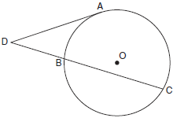

If , determine and state .

29 In the diagram below, is parallel to , and intersects at A.

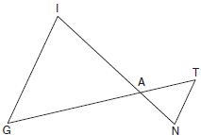

Prove:

30 In the diagram below of isosceles triangle ABC, and angle bisectors , , and are drawn and intersect at X.

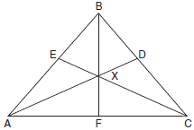

If , find .

31 In square GEOM, the coordinates of G are and the coordinates of O are . Determine and state the coordinates of vertices E and M. [The use of the set of axes below is optional.]

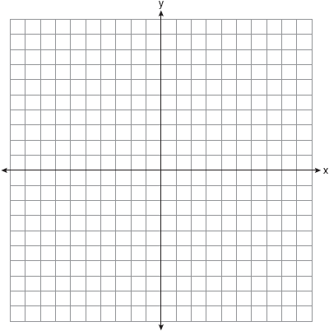

32 Triangle QRS is graphed on the set of axes below.

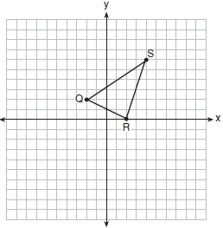

On the same set of axes, graph and label , the image of after a dilation with a scale factor of centered at the origin. Use slopes to explain why .

33 Using a compass and straightedge, construct a regular hexagon inscribed in circle O below. Label it ABCDEF. [Leave all construction marks.]
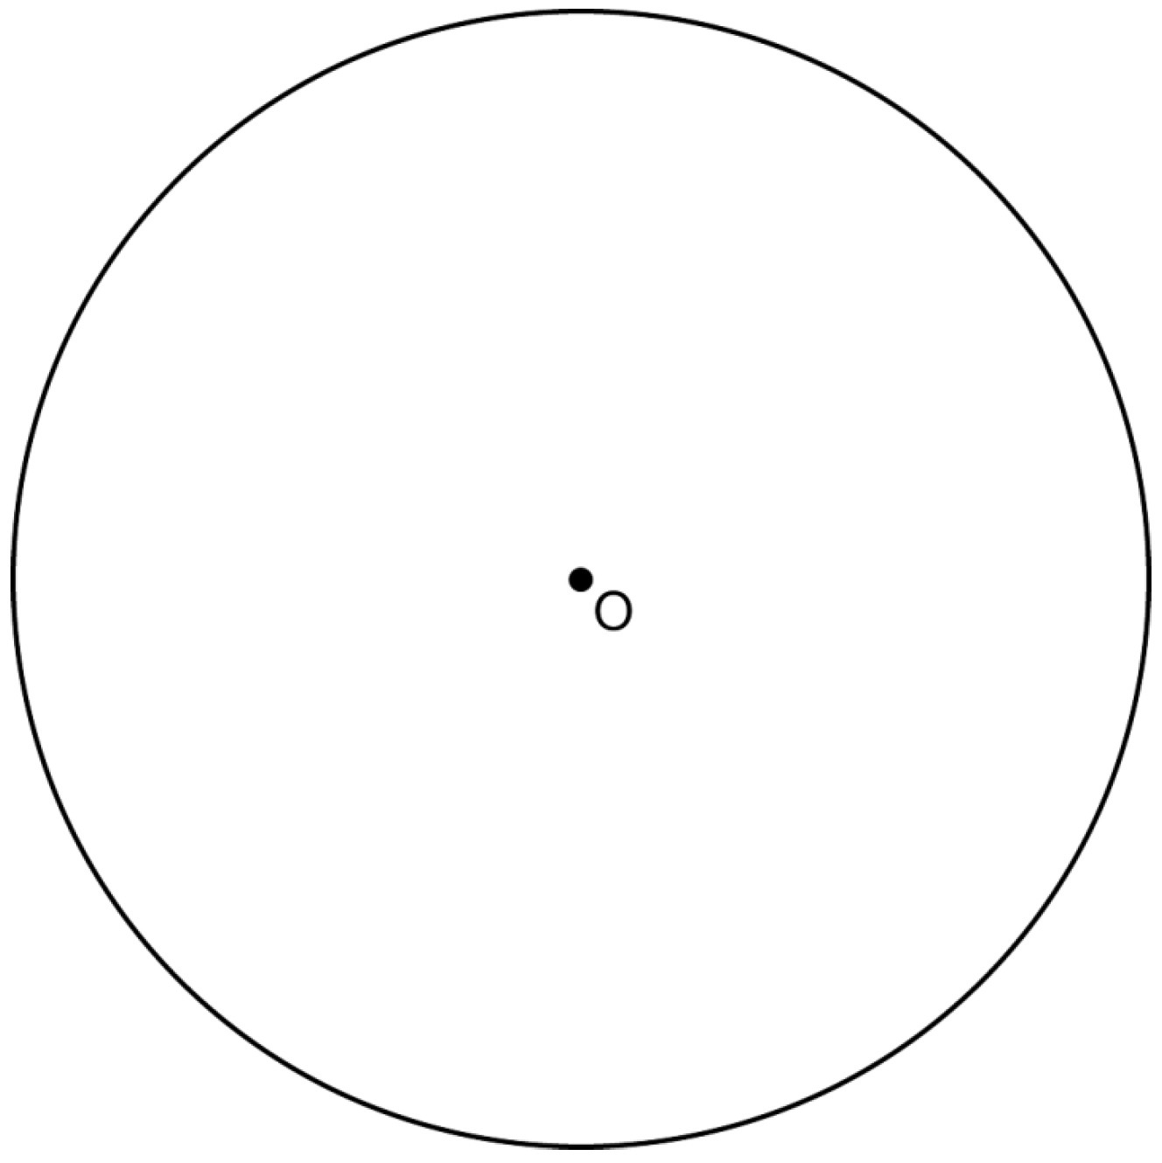

If chords and are drawn, which type of triangle, according to its angles, would be? Explain your answer.

34 A candle maker uses a mold to make candles like the one shown below.

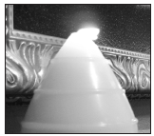

The height of the candle is 13 cm and the circumference of the candle at its widest measure is 31.416 cm. Use modeling to approximate how much wax, to the nearest cubic centimeter, is needed to make this candle. Justify your answer.

35 In quadrilateral ABCD, , , and and are perpendicular to diagonal at points F and E.
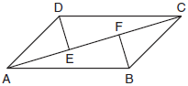

Prove:

36 New streetlights will be installed along a section of the highway. The posts for the streetlights will be 7.5 m tall and made of aluminum. The city can choose to buy the posts shaped like cylinders or the posts shaped like rectangular prisms. The cylindrical posts have a hollow core, with aluminum 2.5 cm thick, and an outer diameter of 53.4 cm. The rectangular-prism posts have a hollow core, with aluminum 2.5 cm thick, and a square base that measures 40 cm on each side. The density of aluminum is 2.7 g/cm3, and the cost of aluminum is $0.38 per kilogram. If all posts must be the same shape, which post design will cost the town less? How much money will be saved per streetlight post with the less expensive design?
1 ANS: 3
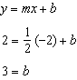

PTS: 2 REF: 011701geo NAT: G.GPE.B.5 TOP: Parallel and Perpendicular Lines
KEY: write equation of parallel line

2 ANS: 2 PTS: 2 REF: 011702geo NAT: G.SRT.A.2
TOP: Compositions of Transformations KEY: basic

3 ANS: 1 PTS: 2 REF: 011703geo NAT: G.SRT.B.5
TOP: Triangle Congruency

4 ANS: 4 PTS: 2 REF: 011704geo NAT: G.CO.C.10
TOP: Midsegments

5 ANS: 4 PTS: 2 REF: 011705geo NAT: G.CO.C.11
TOP: Special Quadrilaterals

6 ANS: 4 PTS: 2 REF: 011706geo NAT: G.CO.A.2
TOP: Identifying Transformations KEY: basic

7 ANS: 2
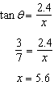

PTS: 2 REF: 011707geo NAT: G.SRT.C.8 TOP: Using Trigonometry to Find a Side

8 ANS: 1
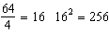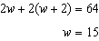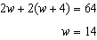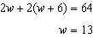

PTS: 2 REF: 011708geo NAT: G.MG.A.3 TOP: Area of Polygons

9 ANS: 2

PTS: 2 REF: 011709geo NAT: G.SRT.C.8 TOP: 30-60-90 Triangles

10 ANS: 3 PTS: 2 REF: 011710geo NAT: G.CO.A.5
TOP: Compositions of Transformations KEY: identify

11 ANS: 2

PTS: 2 REF: 011711geo NAT: G.GMD.A.3 TOP: Volume
KEY: compositions

12 ANS: 3
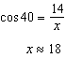

PTS: 2 REF: 011712geo NAT: G.SRT.C.8 TOP: Using Trigonometry to Find a Side

13 ANS: 1
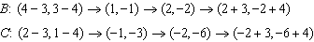

PTS: 2 REF: 011713geo NAT: G.SRT.A.1 TOP: Line Dilations

14 ANS: 3 PTS: 2 REF: 011714geo NAT: G.SRT.C.6
TOP: Trigonometric Ratios

15 ANS: 2
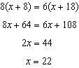

PTS: 2 REF: 011715geo NAT: G.C.A.2 TOP: Chords, Secants and Tangents
KEY: secants drawn from common point, length

16 ANS: 1 PTS: 2 REF: 011716geo NAT: G.CO.C.11
TOP: Special Quadrilaterals

17 ANS: 4
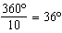 252º is a multiple of 36º

PTS: 2 REF: 011717geo NAT: G.CO.A.3 TOP: Mapping a Polygon onto Itself

18 ANS: 1
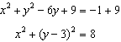

PTS: 2 REF: 011718geo NAT: G.GPE.A.1 TOP: Equations of Circles
KEY: completing the square

19 ANS: 3
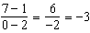 The diagonals of a rhombus are perpendicular.

PTS: 2 REF: 011719geo NAT: G.GPE.B.4 TOP: Quadrilaterals in the Coordinate Plane

20 ANS: 1
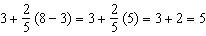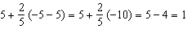

PTS: 2 REF: 011720geo NAT: G.GPE.B.6 TOP: Directed Line Segments

21 ANS: 4
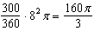

PTS: 2 REF: 011721geo NAT: G.C.B.5 TOP: Sectors

22 ANS: 3

PTS: 2 REF: 011722geo NAT: G.GPE.B.4 TOP: Circles in the Coordinate Plane

23 ANS: 4 PTS: 2 REF: 011723geo NAT: G.GMD.B.4
TOP: Cross-Sections of Three-Dimensional Objects

24 ANS: 1
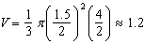

PTS: 2 REF: 011724geo NAT: G.GMD.A.3 TOP: Volume
KEY: cones

25 ANS:
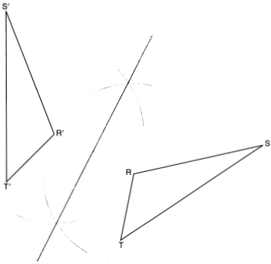

PTS: 2 REF: 011725geo NAT: G.CO.D.12 TOP: Constructions
KEY: line bisector

26 ANS:

PTS: 2 REF: 011726geo NAT: G.CO.A.5 TOP: Compositions of Transformations
KEY: identify

27 ANS:
Yes, because 28º and 62º angles are complementary. The sine of an angle equals the cosine of its complement.

PTS: 2 REF: 011727geo NAT: G.SRT.C.7 TOP: Cofunctions

28 ANS:
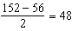

PTS: 2 REF: 011728geo NAT: G.C.A.2 TOP: Chords, Secants and Tangents
KEY: secant and tangent drawn from common point, angle

29 ANS:
is parallel to , and intersects at A (given); , (paralleling lines cut by a transversal form congruent alternate interior angles); (AA).

PTS: 2 REF: 011729geo NAT: G.SRT.A.3 TOP: Similarity Proofs

30 ANS:

PTS: 2 REF: 011730geo NAT: G.SRT.B.5 TOP: Isosceles Triangle Theorem

31 ANS:
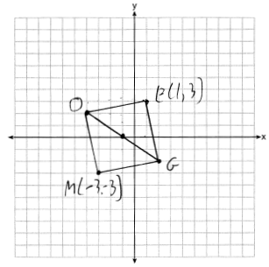

PTS: 2 REF: 011731geo NAT: G.GPE.B.4 TOP: Quadrilaterals in the Coordinate Plane
KEY: grids

32 ANS:
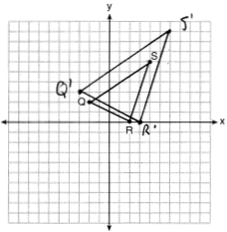 A dilation preserves slope, so the slopes of and are equal. Because the slopes are equal, .

PTS: 4 REF: 011732geo NAT: G.SRT.A.2 TOP: Dilations
KEY: grids

33 ANS:
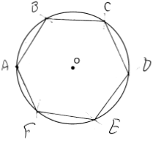 Right triangle because is inscribed in a semi-circle.

PTS: 4 REF: 011733geo NAT: G.CO.D.13 TOP: Constructions

34 ANS:
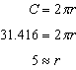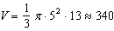

PTS: 4 REF: 011734geo NAT: G.GMD.A.3 TOP: Volume
KEY: cones

35 ANS:
Quadrilateral ABCD, , , and and are perpendicular to diagonal at points F and E (given). and are right angles (perpendicular lines form right angles). (All right angles are congruent). ABCD is a parallelogram (A quadrilateral with one pair of sides congruent and parallel is a parallelogram). (Opposite sides of a parallelogram are parallel). (Parallel lines cut by a transversal form congruent alternate interior angles). (Opposite sides of a parallelogram are congruent). (AAS). (CPCTC).

PTS: 6 REF: 011735geo NAT: G.SRT.B.5 TOP: Quadrilateral Proofs

36 ANS:
C: 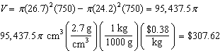
P: 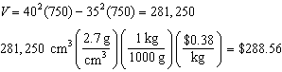

PTS: 6 REF: 011736geo NAT: G.MG.A.2 TOP: Density

