1 William is drawing pictures of cross sections of the right circular cone below.

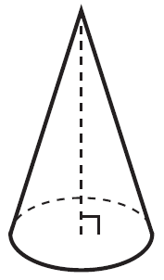

Which drawing can not be a cross section of a cone?
1) |  | 3) | 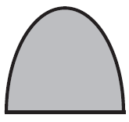
2) | 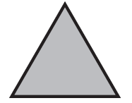 | 4) | 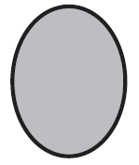

2 An equation of a line perpendicular to the line represented by the equation 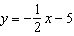 and passing through is
1) | 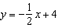 | 3)
2) | 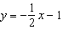 | 4)

3 In parallelogram QRST shown below, diagonal is drawn, U and V are points on and , respectively, and intersects at W.

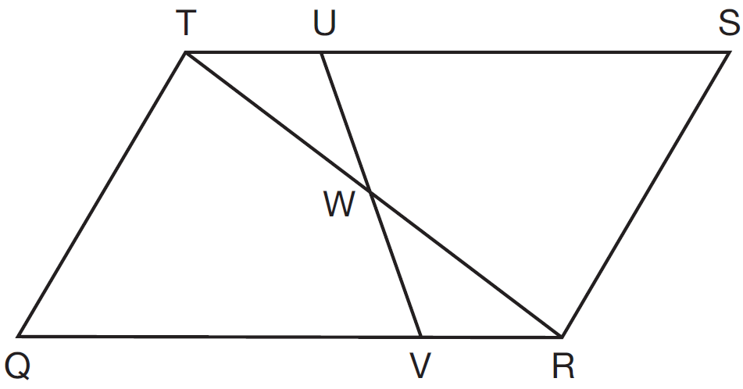

If , , and , what is ?
1) | 37º | 3) | 72º
2) | 60º | 4) | 83º

4 A fish tank in the shape of a rectangular prism has dimensions of 14 inches, 16 inches, and 10 inches. The tank contains 1680 cubic inches of water. What percent of the fish tank is empty?
1) | 10 | 3) | 50
2) | 25 | 4) | 75

5 Which transformation would result in the perimeter of a triangle being different from the perimeter of its image?
1) |  | 3)
2) |  | 4)

6 In the diagram below, bisects at B, and bisects at C.

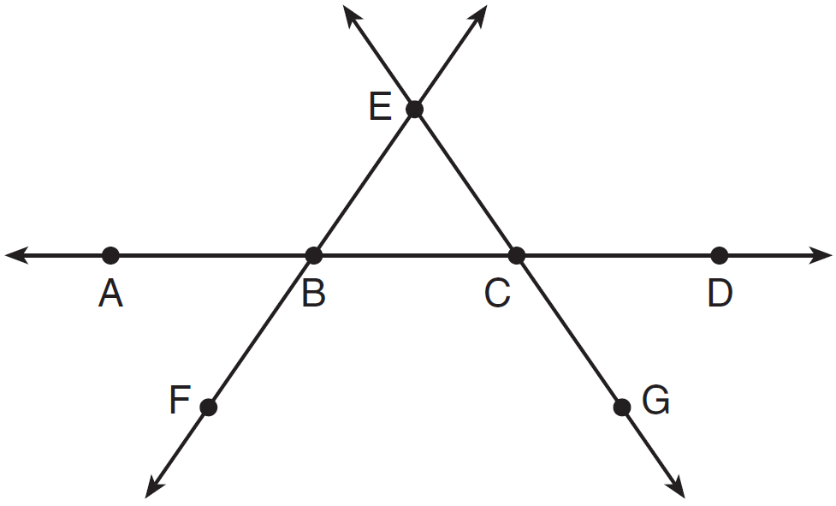

Which statement is always true?
1) |  | 3) | bisects at C.
2) |  | 4) | bisects at B.

7 As shown in the diagram below, a regular pyramid has a square base whose side measures 6 inches.

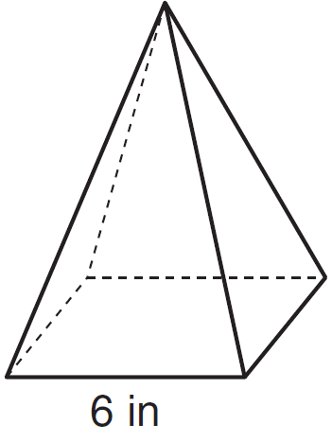

If the altitude of the pyramid measures 12 inches, its volume, in cubic inches, is
1) | 72 | 3) | 288
2) | 144 | 4) | 432

8 Triangle ABC and triangle DEF are graphed on the set of axes below.

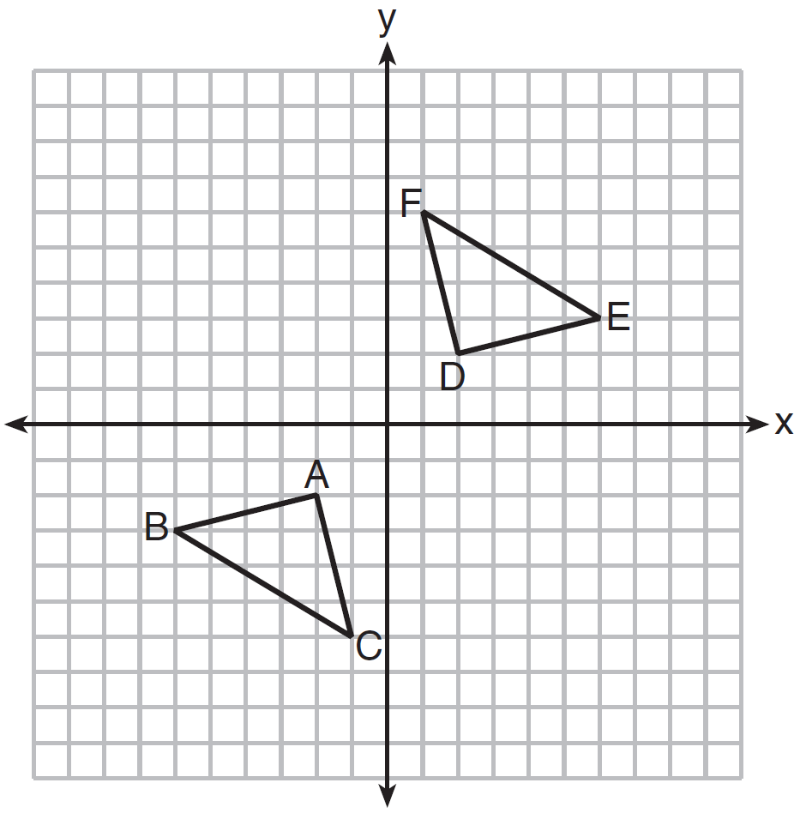

Which sequence of transformations maps triangle ABC onto triangle DEF?
1) | a reflection over the x-axis followed by a reflection over the y-axis | 3) | a 90° clockwise rotation about the origin followed by a reflection over the y-axis
2) | a 180° rotation about the origin followed by a reflection over the line | 4) | a translation 8 units to the right and 1 unit up followed by a 90° counterclockwise rotation about the origin

9 In , the complement of is . Which statement is always true?
1) |  | 3)
2) |  | 4)

10 A line that passes through the points whose coordinates are and is dilated by a scale factor of 3 and centered at the origin. The image of the line
1) | is perpendicular to the original line | 3) | passes through the origin
2) | is parallel to the original line | 4) | is the original line

11 Quadrilateral ABCD is graphed on the set of axes below.

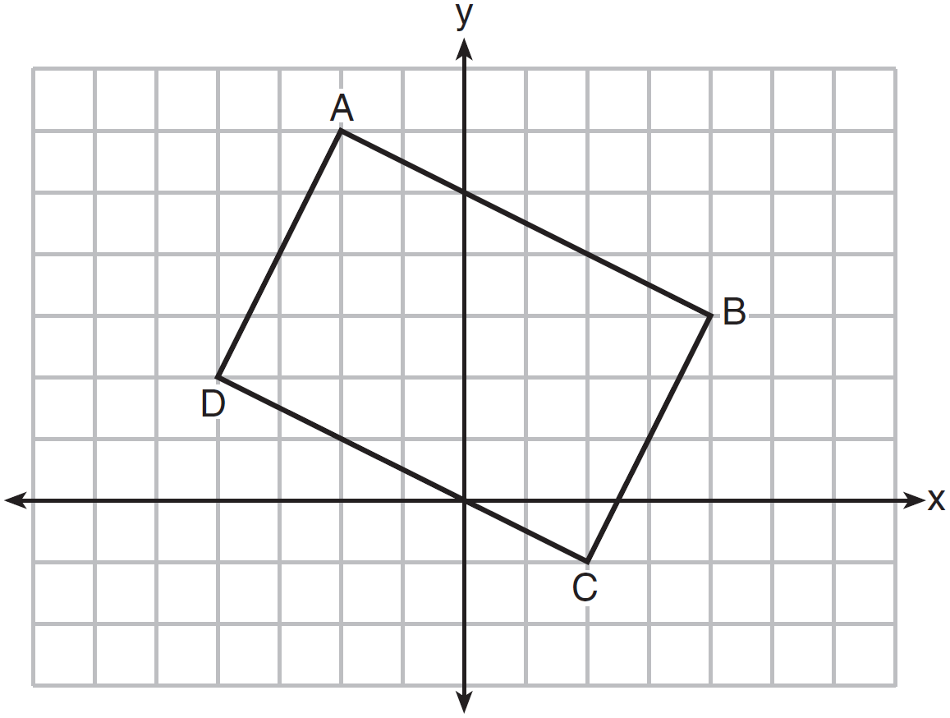

When ABCD is rotated 90° in a counterclockwise direction about the origin, its image is quadrilateral A'B'C'D'. Is distance preserved under this rotation, and which coordinates are correct for the given vertex?
1) | no and | 3) | yes and
2) | no and | 4) | yes and

12 In the diagram below of circle O, the area of the shaded sector LOM is .

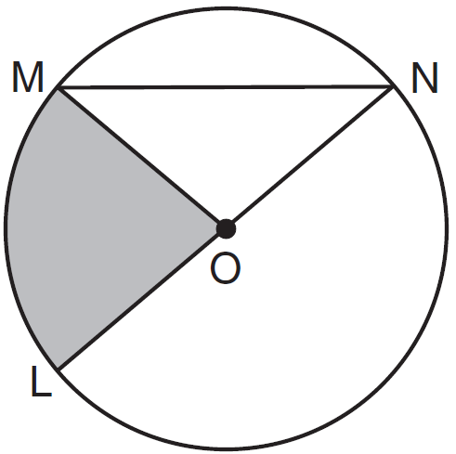

If the length of is 6 cm, what is ?
1) | 10º | 3) | 40º
2) | 20º | 4) | 80º

13 In the diagram below, .

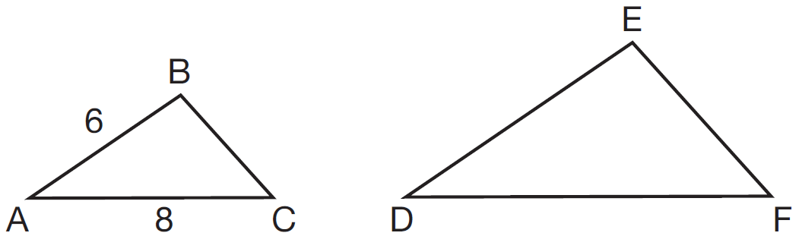

If and , which statement will justify similarity by SAS?
1) | , , and | 3) | , , and
2) | , , and | 4) | , , and

14 The diameter of a basketball is approximately 9.5 inches and the diameter of a tennis ball is approximately 2.5 inches. The volume of the basketball is about how many times greater than the volume of the tennis ball?
1) | 3591 | 3) | 55
2) | 65 | 4) | 4

15 The endpoints of one side of a regular pentagon are and . What is the perimeter of the pentagon?
1) |  | 3)
2) |  | 4)

16 In the diagram of right triangle ABC shown below, and .

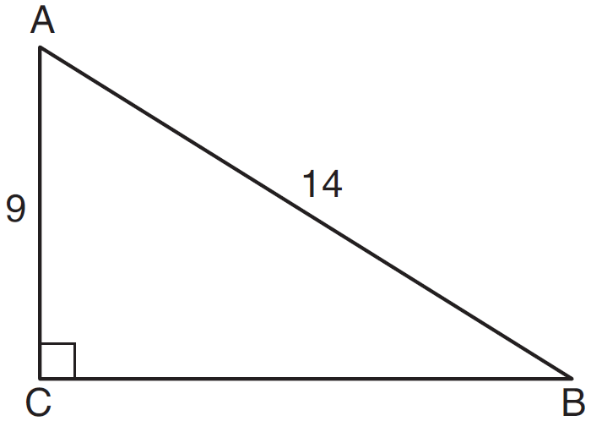

What is the measure of , to the nearest degree?
1) | 33 | 3) | 50
2) | 40 | 4) | 57

17 What are the coordinates of the center and length of the radius of the circle whose equation is ?
1) | and 36 | 3) | and 36
2) | and 6 | 4) | and 6

18 The coordinates of the vertices of are , , and . Which type of triangle is ?
1) | right | 3) | obtuse
2) | acute | 4) | equiangular

19 Molly wishes to make a lawn ornament in the form of a solid sphere. The clay being used to make the sphere weighs .075 pound per cubic inch. If the sphere's radius is 4 inches, what is the weight of the sphere, to the nearest pound?
1) | 34 | 3) | 15
2) | 20 | 4) | 4

20 The ratio of similarity of to is . If and , then the length of is
1) | 5 | 3) | 10
2) | 7 | 4) | 20

21 In the diagram below, , , , , and are chords of circle O, is tangent at point D, and radius is drawn. Sam decides to apply this theorem to the diagram: “An angle inscribed in a semi-circle is a right angle.”

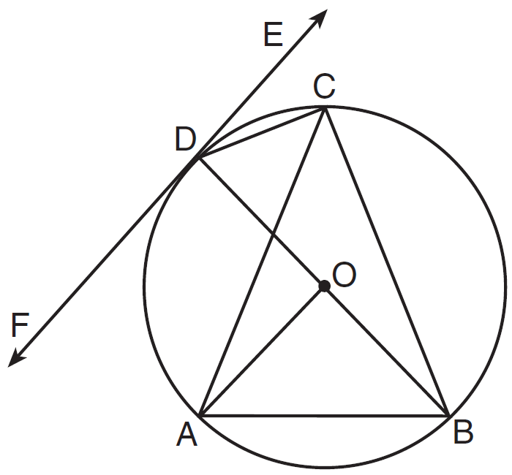

Which angle is Sam referring to?
1) |  | 3)
2) |  | 4)

22 In the diagram below, is the altitude drawn to the hypotenuse of right triangle ABC.

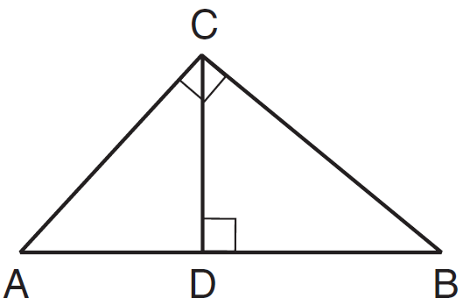

Which lengths would not produce an altitude that measures ?
1) | and | 3) | and
2) | and | 4) | and

23 A designer needs to create perfectly circular necklaces. The necklaces each need to have a radius of 10 cm. What is the largest number of necklaces that can be made from 1000 cm of wire?
1) | 15 | 3) | 31
2) | 16 | 4) | 32

24 In shown below, points T and O are on and , respectively. Segment OT is drawn so that .

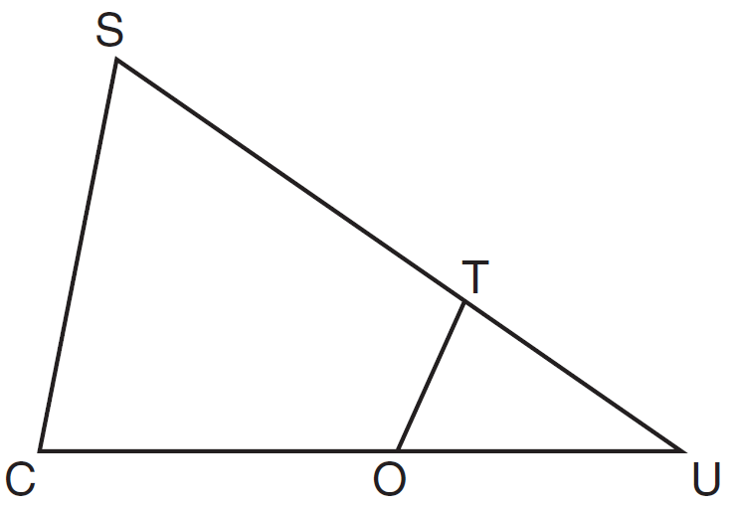

If , , and , what is the length of ?
1) | 5.6 | 3) | 11
2) | 8.75 | 4) | 15

25 Triangle ABC is graphed on the set of axes below. Graph and label , the image of after a reflection over the line .

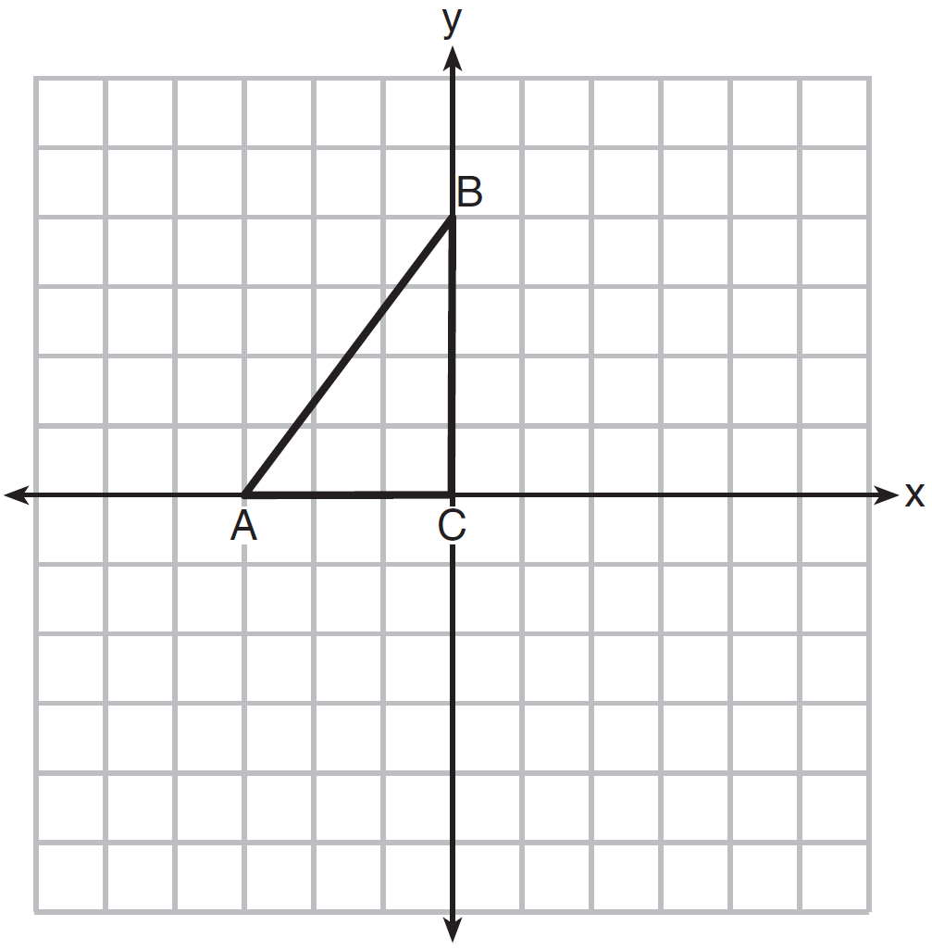

26 In the diagram below of circle O with diameter and radius , chord is parallel to chord .

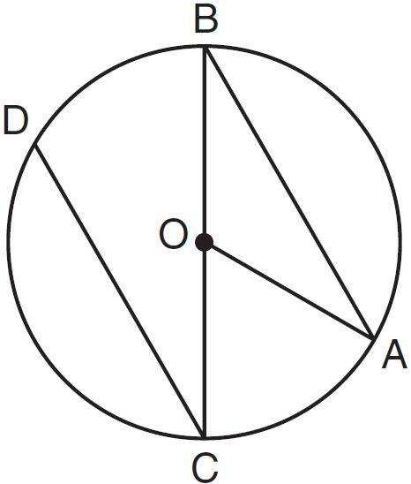

If , determine and state .

27 Directed line segment PT has endpoints whose coordinates are and . Determine the coordinates of point J that divides the segment in the ratio 2 to 1. [The use of the set of axes below is optional.]

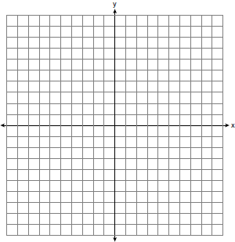

28 As graphed on the set of axes below, is the image of after a sequence of transformations.

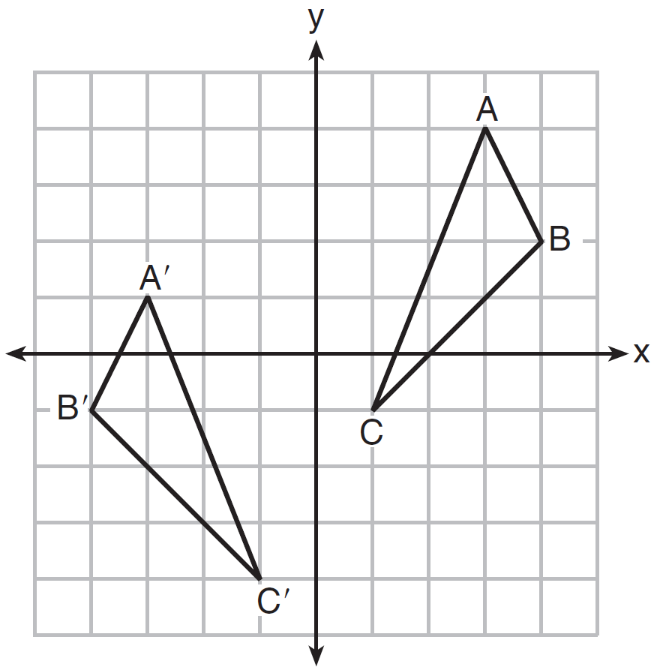

Is congruent to ? Use the properties of rigid motion to explain your answer.

29 A carpenter leans an extension ladder against a house to reach the bottom of a window 30 feet above the ground. As shown in the diagram below, the ladder makes a 70° angle with the ground. To the nearest foot, determine and state the length of the ladder.

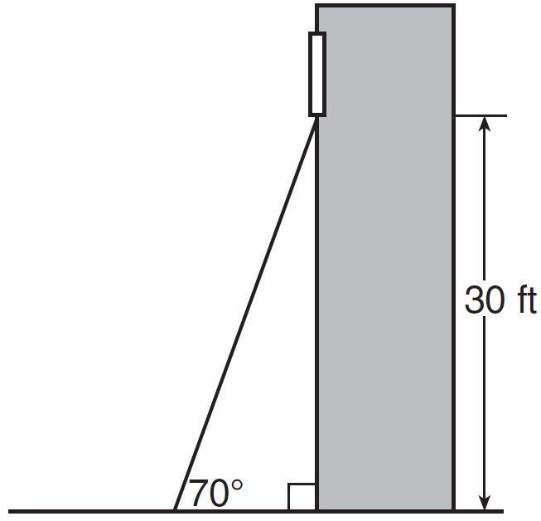

30 During an experiment, the same type of bacteria is grown in two petri dishes. Petri dish A has a diameter of 51 mm and has approximately 40,000 bacteria after 1 hour. Petri dish B has a diameter of 75 mm and has approximately 72,000 bacteria after 1 hour.

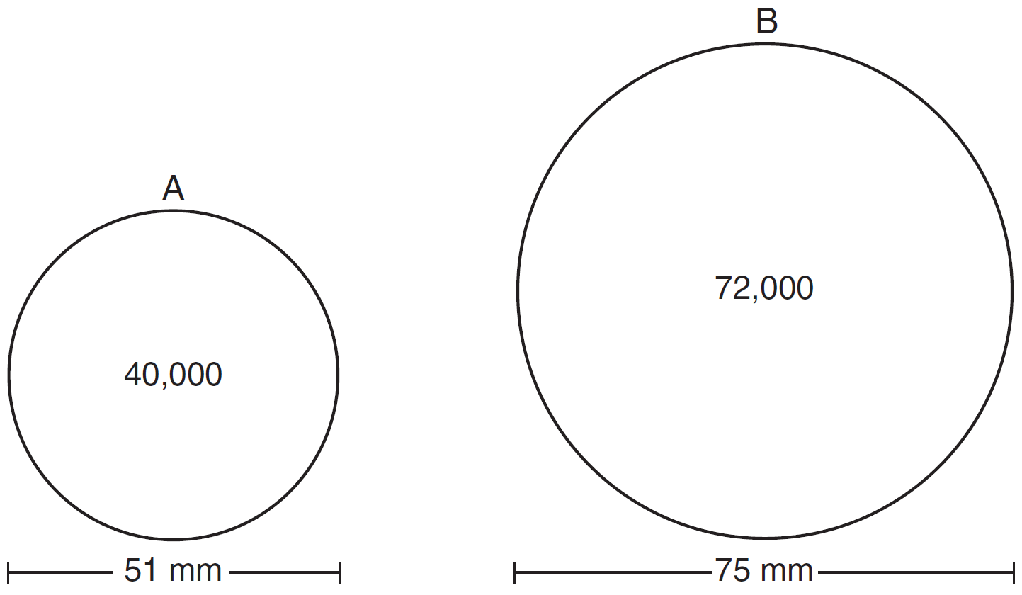

Determine and state which petri dish has the greater population density of bacteria at the end of the first hour.

31 Line is mapped onto line m by a dilation centered at the origin with a scale factor of 2. The equation of line is . Determine and state an equation for line m.

32 The aspect ratio (the ratio of screen width to height) of a rectangular flat-screen television is . The length of the diagonal of the screen is the television's screen size. Determine and state, to the nearest inch, the screen size (diagonal) of this flat-screen television with a screen height of 20.6 inches.

33 Given the theorem, “The sum of the measures of the interior angles of a triangle is 180°,” complete the proof for this theorem.

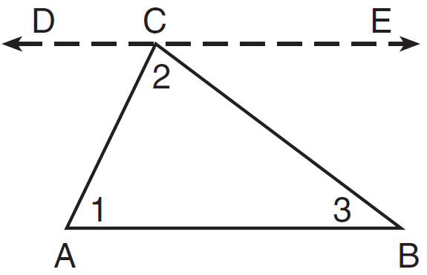

Given:
Prove:
Fill in the missing reasons below.

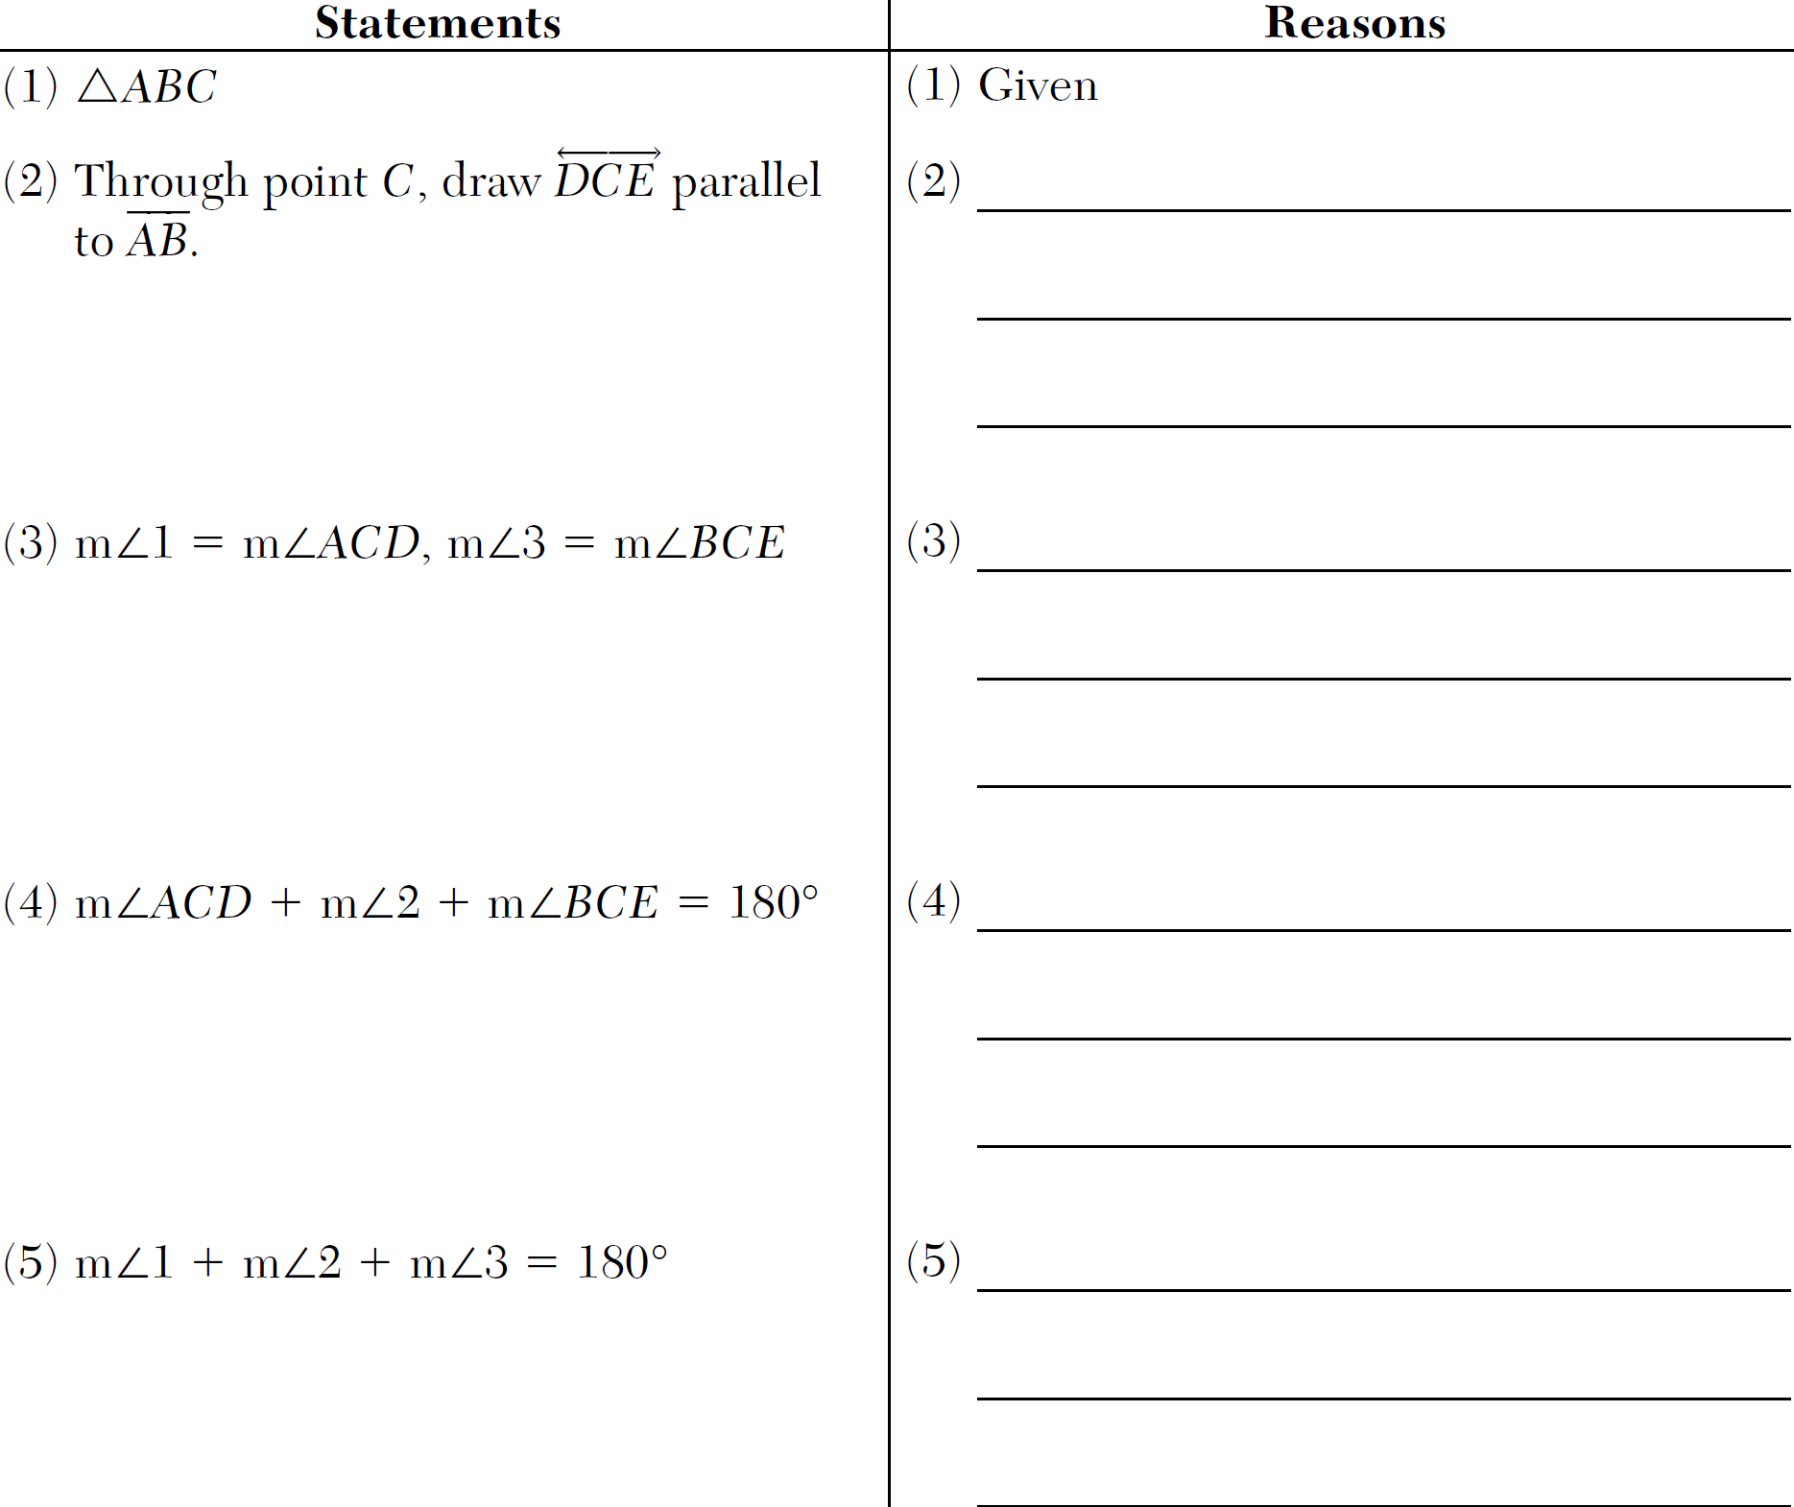

34 Triangle XYZ is shown below. Using a compass and straightedge, on the line below, construct and label , such that . [Leave all construction marks.] Based on your construction, state the theorem that justifies why is congruent to .

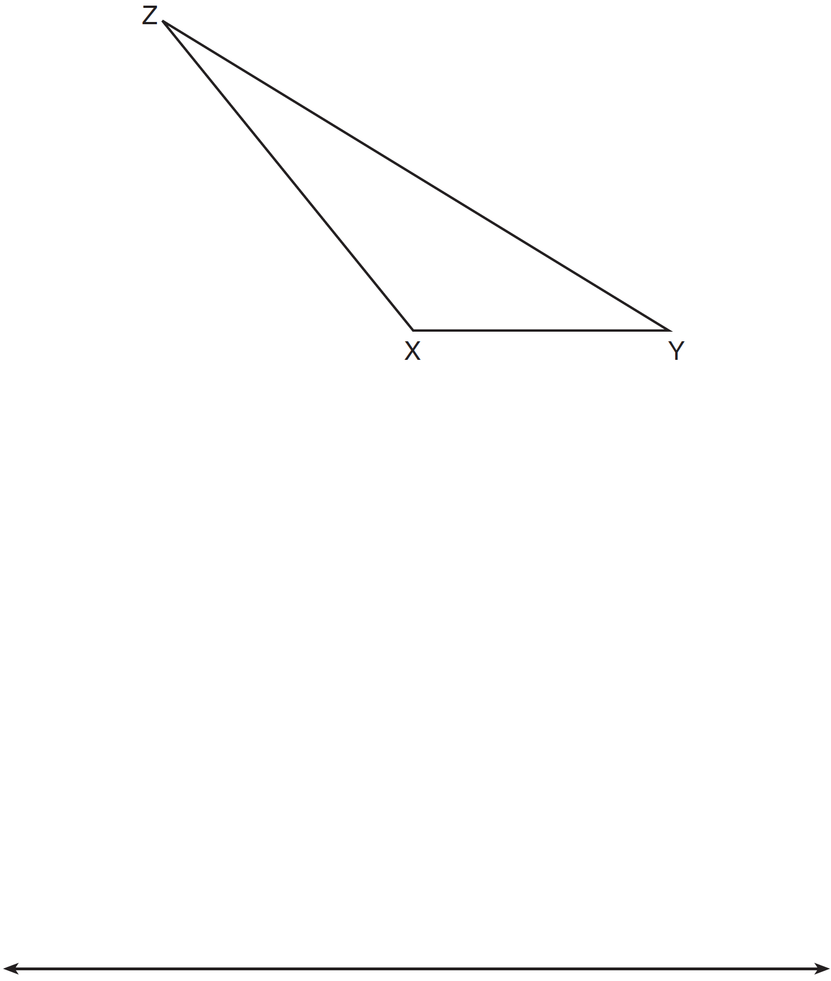

35 Given: Parallelogram ANDR with and bisecting and at points W and E, respectively

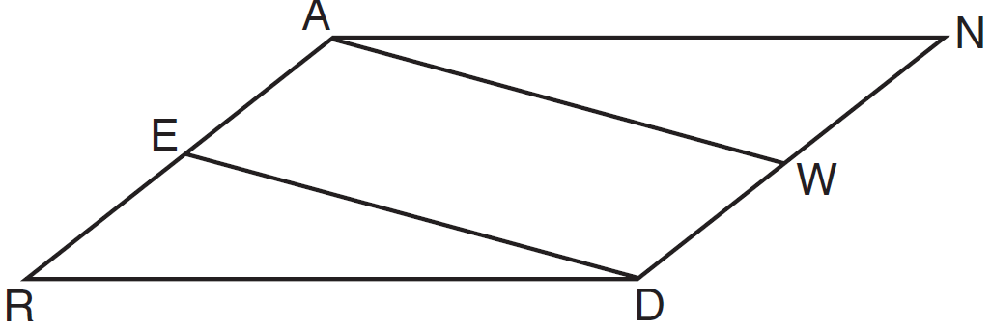

Prove that . Prove that quadrilateral AWDE is a parallelogram.

36 Cathy wants to determine the height of the flagpole shown in the diagram below. She uses a survey instrument to measure the angle of elevation to the top of the flagpole, and determines it to be 34.9°. She walks 8 meters closer and determines the new measure of the angle of elevation to be 52.8°. At each measurement, the survey instrument is 1.7 meters above the ground.

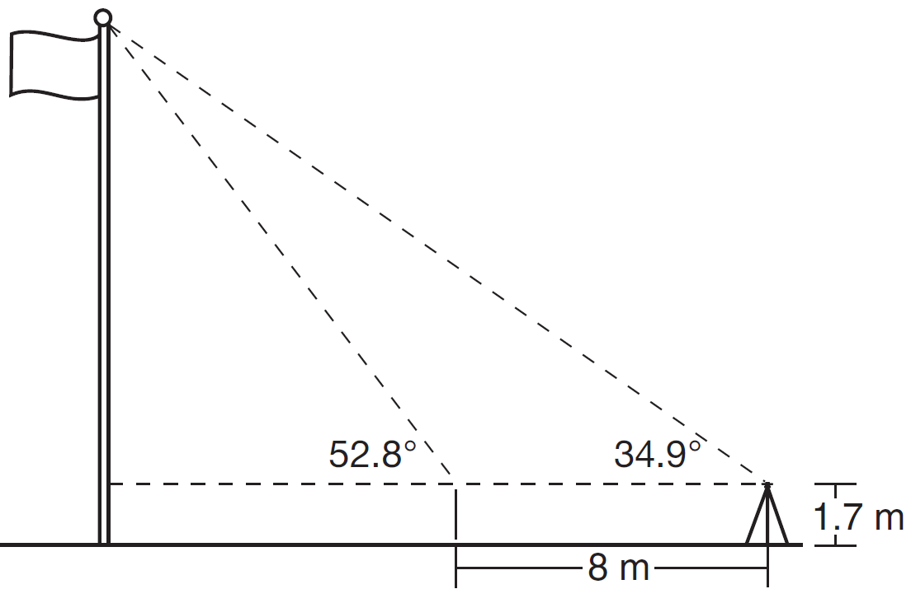

Determine and state, to the nearest tenth of a meter, the height of the flagpole.
1 ANS: 1 PTS: 2 REF: 011601geo NAT: G.GMD.B.4
TOP: Cross-Sections of Three-Dimensional Objects

2 ANS: 4
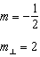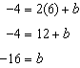

PTS: 2 REF: 011602geo NAT: G.GPE.B.5 TOP: Parallel and Perpendicular Lines
KEY: write equation of perpendicular line

3 ANS: 3
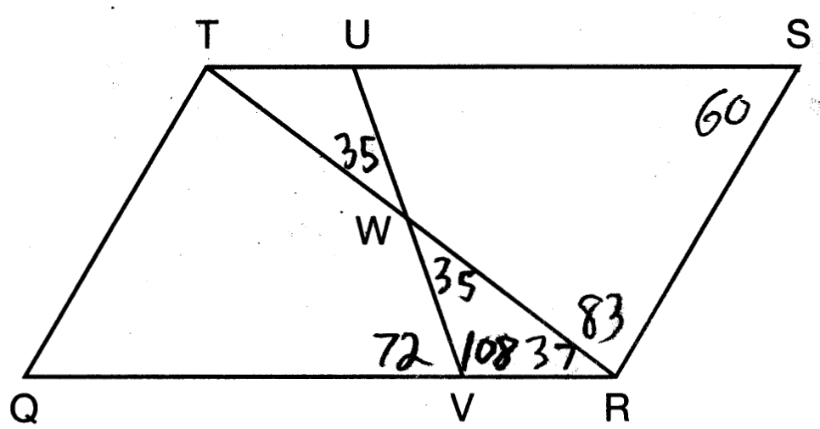

PTS: 2 REF: 011603geo NAT: G.CO.C.11 TOP: Interior and Exterior Angles of Polygons

4 ANS: 2
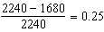

PTS: 2 REF: 011604geo NAT: G.GMD.A.3 TOP: Volume
KEY: prisms

5 ANS: 3 PTS: 2 REF: 011605geo NAT: G.CO.A.2
TOP: Analytical Representations of Transformations KEY: basic

6 ANS: 1 PTS: 2 REF: 011606geo NAT: G.CO.C.9
TOP: Lines and Angles

7 ANS: 2
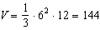

PTS: 2 REF: 011607geo NAT: G.GMD.A.3 TOP: Volume
KEY: pyramids

8 ANS: 1 PTS: 2 REF: 011608geo NAT: G.CO.A.5
TOP: Compositions of Transformations KEY: identify

9 ANS: 4 PTS: 2 REF: 011609geo NAT: G.SRT.C.7
TOP: Cofunctions

10 ANS: 2 PTS: 2 REF: 011610geo NAT: G.SRT.A.1
TOP: Line Dilations

11 ANS: 4 PTS: 2 REF: 011611geo NAT: G.CO.B.6
TOP: Properties of Transformations KEY: graphics

12 ANS: 3
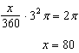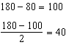

PTS: 2 REF: 011612geo NAT: G.C.B.5 TOP: Sectors

13 ANS: 1
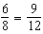

PTS: 2 REF: 011613geo NAT: G.SRT.B.5 TOP: Similarity
KEY: basic

14 ANS: 3
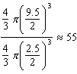

PTS: 2 REF: 011614geo NAT: G.GMD.A.3 TOP: Volume
KEY: spheres

15 ANS: 2

PTS: 2 REF: 011615geo NAT: G.GPE.B.7 TOP: Polygons in the Coordinate Plane

16 ANS: 3
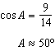

PTS: 2 REF: 011616geo NAT: G.SRT.C.8 TOP: Using Trigonometry to Find an Angle

17 ANS: 4
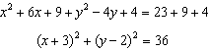

PTS: 2 REF: 011617geo NAT: G.GPE.A.1 TOP: Equations of Circles
KEY: completing the square

18 ANS: 1
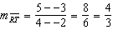 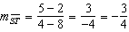 Slopes are opposite reciprocals, so lines form a right angle.

PTS: 2 REF: 011618geo NAT: G.GPE.B.4 TOP: Triangles in the Coordinate Plane

19 ANS: 2
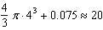

PTS: 2 REF: 011619geo NAT: G.MG.A.2 TOP: Density

20 ANS: 4
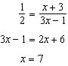

PTS: 2 REF: 011620geo NAT: G.SRT.B.5 TOP: Similarity
KEY: basic

21 ANS: 3 PTS: 2 REF: 011621geo NAT: G.C.A.2
TOP: Chords, Secants and Tangents KEY: inscribed

22 ANS: 2

PTS: 2 REF: 011622geo NAT: G.SRT.B.5 TOP: Similarity
KEY: altitude

23 ANS: 1
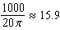

PTS: 2 REF: 011623geo NAT: G.GMD.A.1 TOP: Circumference

24 ANS: 3
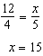

PTS: 2 REF: 011624geo NAT: G.SRT.B.5 TOP: Similarity
KEY: basic

25 ANS:
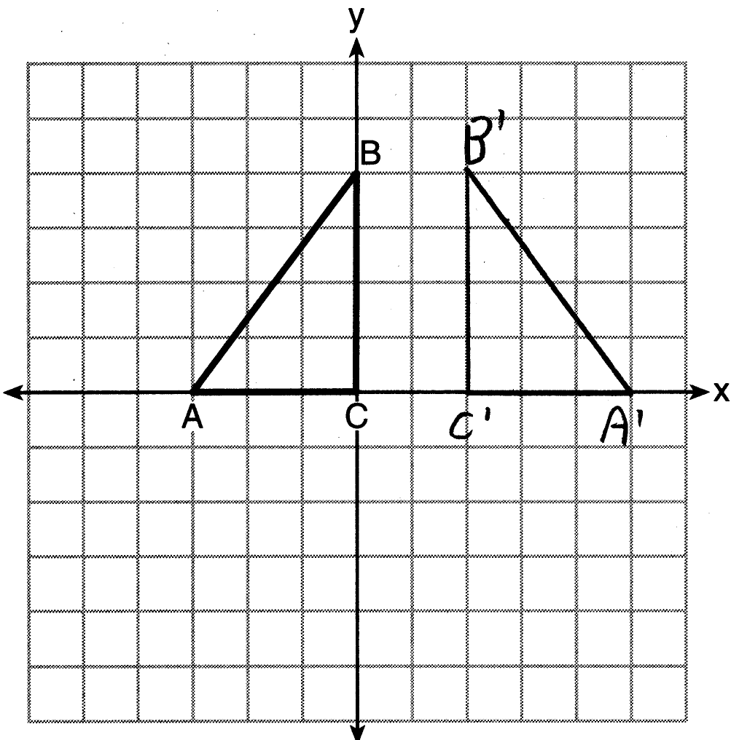

PTS: 2 REF: 011625geo NAT: G.CO.A.5 TOP: Reflections
KEY: grids

26 ANS:
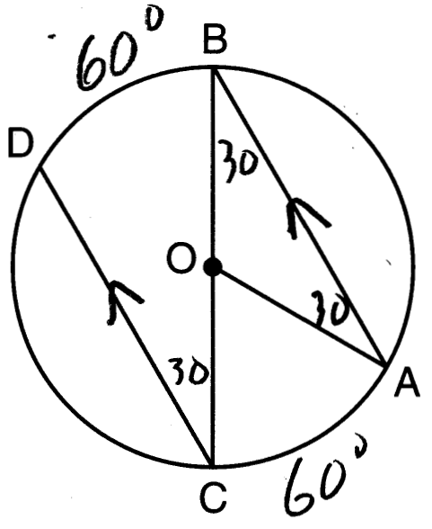

PTS: 2 REF: 011626geo NAT: G.C.A.2 TOP: Chords, Secants and Tangents
KEY: parallel lines

27 ANS:
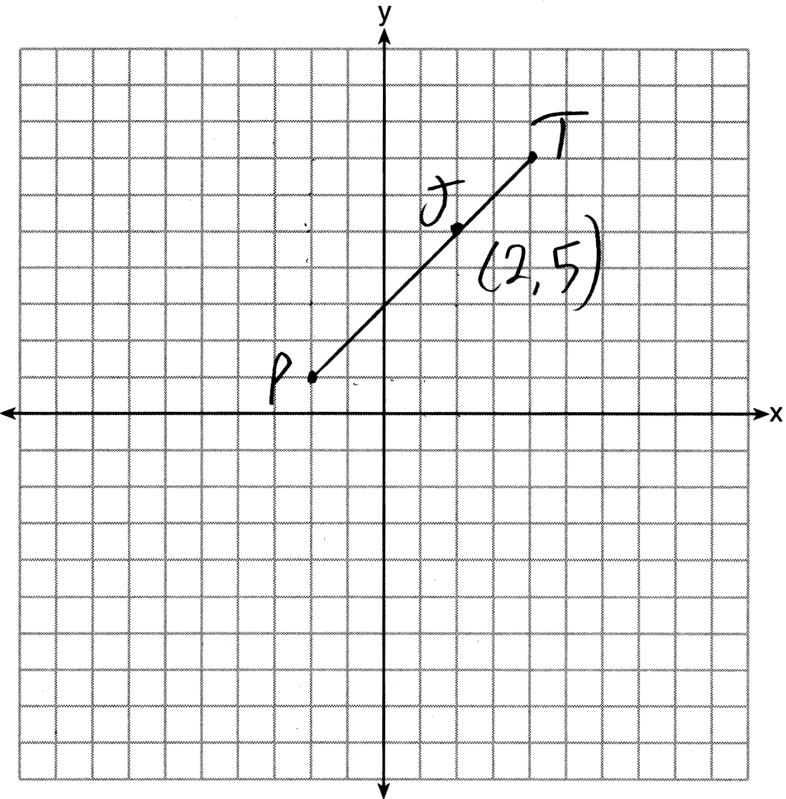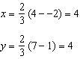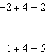

PTS: 2 REF: 011627geo NAT: G.GPE.B.6 TOP: Directed Line Segments

28 ANS:
Yes. The sequence of transformations consists of a reflection and a translation, which are isometries which preserve distance and congruency.

PTS: 2 REF: 011628geo NAT: G.CO.B.7 TOP: Triangle Congruency

29 ANS:
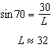
PTS: 2 REF: 011629geo NAT: G.SRT.C.8 TOP: Using Trigonometry to Find a Side
KEY: graphics

30 ANS:
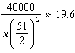 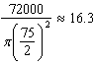 Dish A
PTS: 2 REF: 011630geo NAT: G.MG.A.2 TOP: Density

31 ANS:
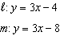
PTS: 2 REF: 011631geo NAT: G.SRT.A.1 TOP: Line Dilations

32 ANS:
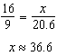
PTS: 4 REF: 011632geo NAT: G.SRT.C.8 TOP: Pythagorean Theorem
KEY: without graphics

33 ANS:
(2) Euclid’s Parallel Postulate; (3) Alternate interior angles formed by parallel lines and a transversal are congruent; (4) Angles forming a line are supplementary; (5) Substitution
PTS: 4 REF: 011633geo NAT: G.CO.C.10 TOP: Triangle Proofs

34 ANS:
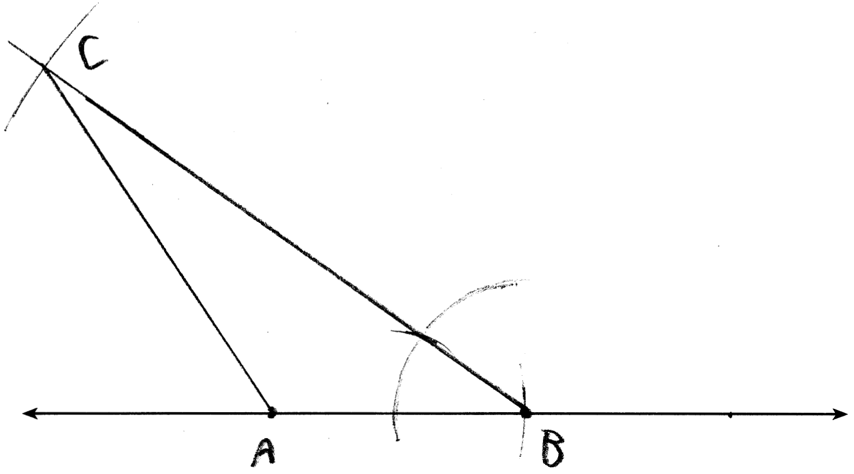
PTS: 4 REF: 011634geo NAT: G.CO.D.12 TOP: Constructions
KEY: congruent and similar figures

35 ANS:
Parallelogram ANDR with and bisecting and at points W and E (Given). , (Opposite sides of a parallelogram are congruent). 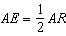, 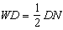, so (Definition of bisect and division property of equality). (Opposite sides of a parallelogram are parallel). AWDE is a parallelogram (Definition of parallelogram). 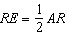, 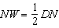, so (Definition of bisect and division property of equality). (Opposite sides of a parallelogram are congruent). (SSS).
PTS: 6 REF: 011635geo NAT: G.SRT.B.5 TOP: Quadrilateral Proofs

36 ANS:
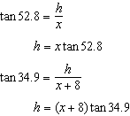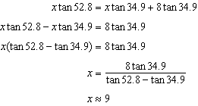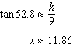
PTS: 6 REF: 011636geo NAT: G.SRT.C.8 TOP: Using Trigonometry to Find a Side
KEY: advanced

