1 Isosceles trapezoid ABCD has diagonals and . If and , what is the value of x?
1) | 28
2)
3) | 3
4)

2 What is the negation of the statement “The Sun is shining”?
1) | It is cloudy.
2) | It is daytime.
3) | It is not raining.
4) | The Sun is not shining.

3 Triangle ABC has vertices , , and . Under a translation, , the image point of A, is located at . Under this same translation, point is located at
1)
2)
3)
4)

4 The diagram below shows the construction of the perpendicular bisector of

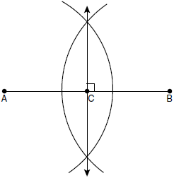

Which statement is not true?
1)
2) | 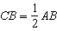
3)
4)

5 Which graph could be used to find the solution to the following system of equations?
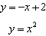
1) | 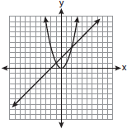
2) | 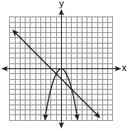
3) | 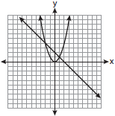
4) | 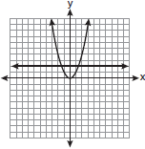

6 Line k is drawn so that it is perpendicular to two distinct planes, P and R. What must be true about planes P and R?
1) | Planes P and R are skew.
2) | Planes P and R are parallel.
3) | Planes P and R are perpendicular.
4) | Plane P intersects plane R but is not perpendicular to plane R.

7 The diagram below illustrates the construction of parallel to through point P.

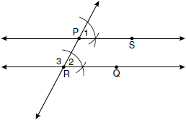

Which statement justifies this construction?
1)
2)
3)
4)

8 The figure in the diagram below is a triangular prism.

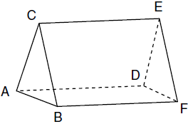

Which statement must be true?
1)
2)
3)
4)

9 The vertices of are and Which conclusion can be made about the angles of ?
1)
2)
3)
4)

10 Given with base , median , altitude , and bisects , which conclusion is valid?

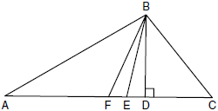

1)
2)
3)
4)

11 In the diagram below, circle O has a radius of 5, and . Diameter is perpendicular to chord at E.

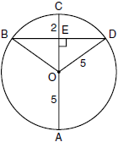

What is the length of ?
1) | 12
2) | 10
3) | 8
4) | 4

12 What is the equation of a line that passes through the point and is parallel to the line whose equation is ?
1)
2)
3) | 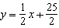
4) | 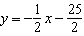

13 Line segment AB has endpoints and . What are the coordinates of the midpoint of ?
1)
2) | 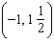
3)
4) | 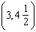

14 What are the center and radius of a circle whose equation is ?
1) | center = ; radius = C
2) | center = ; radius = C
3) | center = ; radius =
4) | center = ; radius =

15 A rectangular prism has a volume of . Its base has a length of and a width of 3. Which expression represents the height of the prism?
1)
2)
3) | 3
4)

16 Lines and intersect at point E. Line m is perpendicular to lines and at point E.

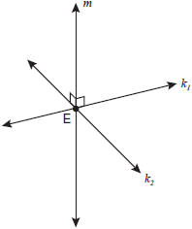

Which statement is always true?
1) | Lines and are perpendicular.
2) | Line m is parallel to the plane determined by lines and .
3) | Line m is perpendicular to the plane determined by lines and .
4) | Line m is coplanar with lines and .

17 In the diagram below, is a tangent to circle O at point S, is a secant, , , and .

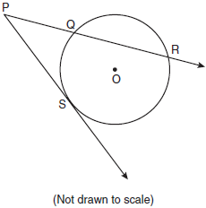

What is the length of ?
1) | 6
2) | 9
3) | 3
4) | 27

18 A polygon is transformed according to the rule: . Every point of the polygon moves two units in which direction?
1) | up
2) | down
3) | left
4) | right

19 In the diagram below of , D is a point on , , , and .

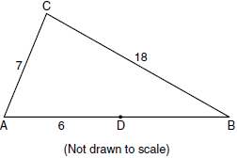

The length of could be
1) | 5
2) | 12
3) | 19
4) | 25

20 The diameter of a circle has endpoints at and . What is an equation of the circle?
1)
2)
3)
4)

21 In the diagram below of , Q is a point on , S is a point on , is drawn, and .

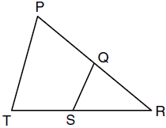

Which reason justifies the conclusion that ?
1) | AA
2) | ASA
3) | SAS
4) | SSS

22 The lines and are
1) | parallel
2) | perpendicular
3) | the same line
4) | neither parallel nor perpendicular

23 The endpoints of are and . If is the result of the transformation of under what are the coordinates of and ?
1) | and
2) | and
3) | and
4) | and

24 In the diagram below, circle A and circle B are shown.

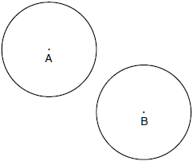

What is the total number of lines of tangency that are common to circle A and circle B?
1) | 1
2) | 2
3) | 3
4) | 4

25 In which triangle do the three altitudes intersect outside the triangle?
1) | a right triangle
2) | an acute triangle
3) | an obtuse triangle
4) | an equilateral triangle

26 Two triangles are similar, and the ratio of each pair of corresponding sides is . Which statement regarding the two triangles is not true?
1) | Their areas have a ratio of .
2) | Their altitudes have a ratio of .
3) | Their perimeters have a ratio of .
4) | Their corresponding angles have a ratio of .

27 What is the measure of an interior angle of a regular octagon?
1) | 45º
2) | 60º
3) | 120º
4) | 135º

28 What is the slope of a line perpendicular to the line whose equation is ?
1)
2)
3)
4)

29 In the diagram below of right triangle ACB, altitude intersects at D. If and , find the length of in simplest radical form.

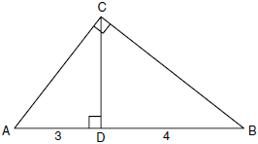

30 The vertices of are , , and . Identify and graph a transformation of such that its image, , results in .



31 The endpoints of are and . Find the length of .

32 Using a compass and straightedge, construct the bisector of the angle shown below. [Leave all construction marks.]

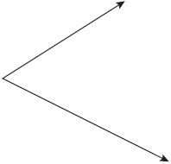

33 The volume of a cylinder is 12,566.4 cm³. The height of the cylinder is 8 cm. Find the radius of the cylinder to the nearest tenth of a centimeter.

34 Write a statement that is logically equivalent to the statement “If two sides of a triangle are congruent, the angles opposite those sides are congruent.” Identify the new statement as the converse, inverse, or contrapositive of the original statement.

35 On the set of axes below, graph and label with vertices at , , and . If G is the midpoint of and H is the midpoint of , state the coordinates of G and H and label each point on your graph. Explain why .

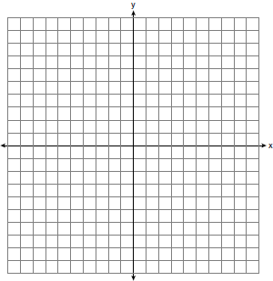

36 In the diagram below of circle O, chords , , , and are drawn such that . Identify one pair of inscribed angles that are congruent to each other and give their measure.

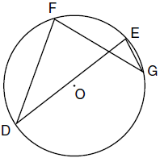

37 A city is planning to build a new park. The park must be equidistant from school A at and school B at . The park also must be exactly 5 miles from the center of town, which is located at the origin on the coordinate graph. Each unit on the graph represents 1 mile. On the set of axes below, sketch the compound loci and label with an X all possible locations for the new park.

38 In the diagram below, quadrilateral ABCD is inscribed in circle O, , and diagonals and are drawn. Prove that .

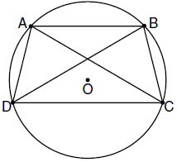
1 ANS: 3
The diagonals of an isosceles trapezoid are congruent. 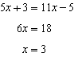.

PTS: 2 REF: fall0801ge STA: G.G.40 TOP: Trapezoids

2 ANS: 4 PTS: 2 REF: fall0802ge STA: G.G.24
TOP: Negations

3 ANS: 1

PTS: 2 REF: fall0803ge STA: G.G.54 TOP: Translations

4 ANS: 3 PTS: 2 REF: fall0804ge STA: G.G.18
TOP: Constructions

5 ANS: 3
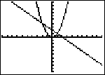

PTS: 2 REF: fall0805ge STA: G.G.70 TOP: Quadratic-Linear Systems

6 ANS: 2 PTS: 2 REF: fall0806ge STA: G.G.9
TOP: Planes

7 ANS: 1 PTS: 2 REF: fall0807ge STA: G.G.19
TOP: Constructions

8 ANS: 3
The lateral edges of a prism are parallel.

PTS: 2 REF: fall0808ge STA: G.G.10 TOP: Solids

9 ANS: 1
Since , under the Isosceles Triangle Theorem.

PTS: 2 REF: fall0809ge STA: G.G.69 TOP: Triangles in the Coordinate Plane

10 ANS: 4
Median bisects so that .

PTS: 2 REF: fall0810ge STA: G.G.24 TOP: Statements

11 ANS: 3
Because is a radius, its length is 5. Since . is a 3-4-5 triangle. If , .

PTS: 2 REF: fall0811ge STA: G.G.49 TOP: Chords

12 ANS: 2
The slope of a line in standard form is , so the slope of this line is 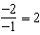. A parallel line would also have a slope of 2. Since the answers are in slope intercept form, find the y-intercept: 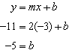

PTS: 2 REF: fall0812ge STA: G.G.65 TOP: Parallel and Perpendicular Lines

13 ANS: 2
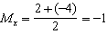. 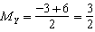.

PTS: 2 REF: fall0813ge STA: G.G.66 TOP: Midpoint

14 ANS: 3 PTS: 2 REF: fall0814ge STA: G.G.73
TOP: Equations of Circles

15 ANS: 1
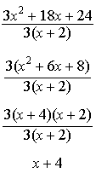

PTS: 2 REF: fall0815ge STA: G.G.12 TOP: Volume

16 ANS: 3 PTS: 2 REF: fall0816ge STA: G.G.1
TOP: Planes

17 ANS: 2
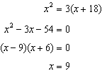

PTS: 2 REF: fall0817ge STA: G.G.53 TOP: Segments Intercepted by Circle
KEY: tangent and secant

18 ANS: 4 PTS: 2 REF: fall0818ge STA: G.G.61
TOP: Analytical Representations of Transformations

19 ANS: 2

PTS: 2 REF: fall0819ge STA: G.G.33 TOP: Triangle Inequality Theorem

20 ANS: 1
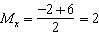. 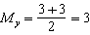. The center is . . If the diameter is 8, the radius is 4 and .

PTS: 2 REF: fall0820ge STA: G.G.71 TOP: Equations of Circles

21 ANS: 1
and share and it is given that .

PTS: 2 REF: fall0821ge STA: G.G.44 TOP: Similarity Proofs

22 ANS: 4
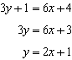. 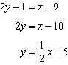

PTS: 2 REF: fall0822ge STA: G.G.63 TOP: Parallel and Perpendicular Lines

23 ANS: 1
After the translation, the coordinates are and . After the dilation, the coordinates are and .

PTS: 2 REF: fall0823ge STA: G.G.58 TOP: Compositions of Transformations

24 ANS: 4 PTS: 2 REF: fall0824ge STA: G.G.50
TOP: Tangents KEY: common tangency

25 ANS: 3 PTS: 2 REF: fall0825ge STA: G.G.21
TOP: Centroid, Orthocenter, Incenter and Circumcenter

26 ANS: 4
Corresponding angles of similar triangles are congruent.

PTS: 2 REF: fall0826ge STA: G.G.45 TOP: Similarity
KEY: perimeter and area

27 ANS: 4
. 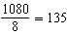.

PTS: 2 REF: fall0827ge STA: G.G.37 TOP: Interior and Exterior Angles of Polygons

28 ANS: 2
The slope of a line in standard form is so the slope of this line is Perpendicular lines have slope that are the opposite and reciprocal of each other.

PTS: 2 REF: fall0828ge STA: G.G.62 TOP: Parallel and Perpendicular Lines

29 ANS:
. 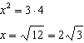

PTS: 2 REF: fall0829ge STA: G.G.47 TOP: Similarity
KEY: altitude

30 ANS:
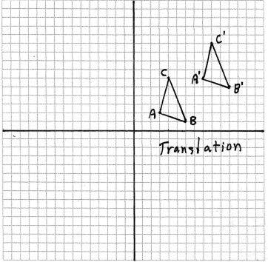

PTS: 2 REF: fall0830ge STA: G.G.55 TOP: Properties of Transformations

31 ANS:
25. .

PTS: 2 REF: fall0831ge STA: G.G.67 TOP: Distance

32 ANS:
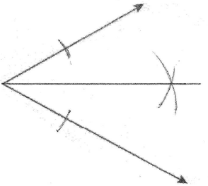

PTS: 2 REF: fall0832ge STA: G.G.17 TOP: Constructions

33 ANS:
22.4. 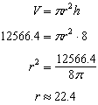

PTS: 2 REF: fall0833ge STA: G.G.14 TOP: Volume and Lateral Area

34 ANS:
Contrapositive-If two angles of a triangle are not congruent, the sides opposite those angles are not congruent.

PTS: 2 REF: fall0834ge STA: G.G.26 TOP: Conditional Statements

35 ANS:
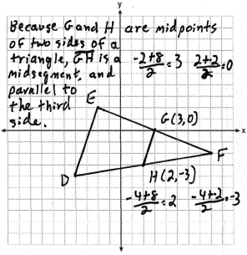

PTS: 4 REF: fall0835ge STA: G.G.42 TOP: Midsegments

36 ANS:
, and 24° or , and 84°. 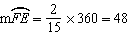. Since the chords forming and are intercepted by , their measure is 24°. 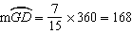. Since the chords forming and are intercepted by , their measure is 84°.

PTS: 4 REF: fall0836ge STA: G.G.51 TOP: Arcs Determined by Angles
KEY: inscribed

37 ANS:
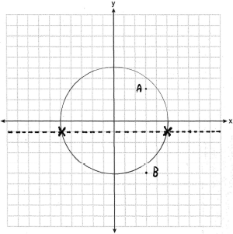

PTS: 4 REF: fall0837ge STA: G.G.23 TOP: Locus

38 ANS:
Because , since parallel chords intersect congruent arcs. because inscribed angles that intercept congruent arcs are congruent. since congruent chords intersect congruent arcs. because inscribed angles that intercept the same arc are congruent. Therefore, because of AAS.

PTS: 6 REF: fall0838ge STA: G.G.27 TOP: Circle Proofs

