1 In shown below with , , , and , .

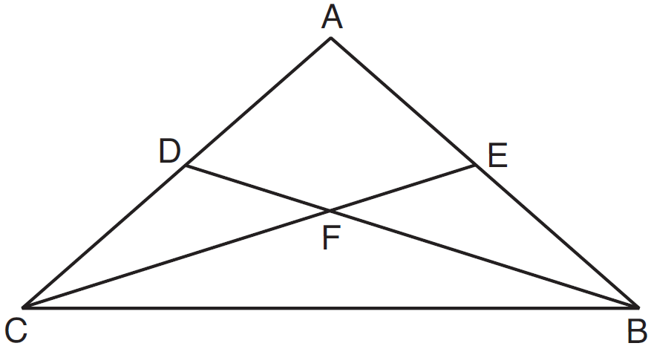

Which statement must be true?
1)
2)
3)
4)

2 In a circle whose equation is , the coordinates of the center and length of its radius are
1) | and
2) | and
3) | and
4) | and

3 Parallel secants and intersect circle O, as shown in the diagram below.

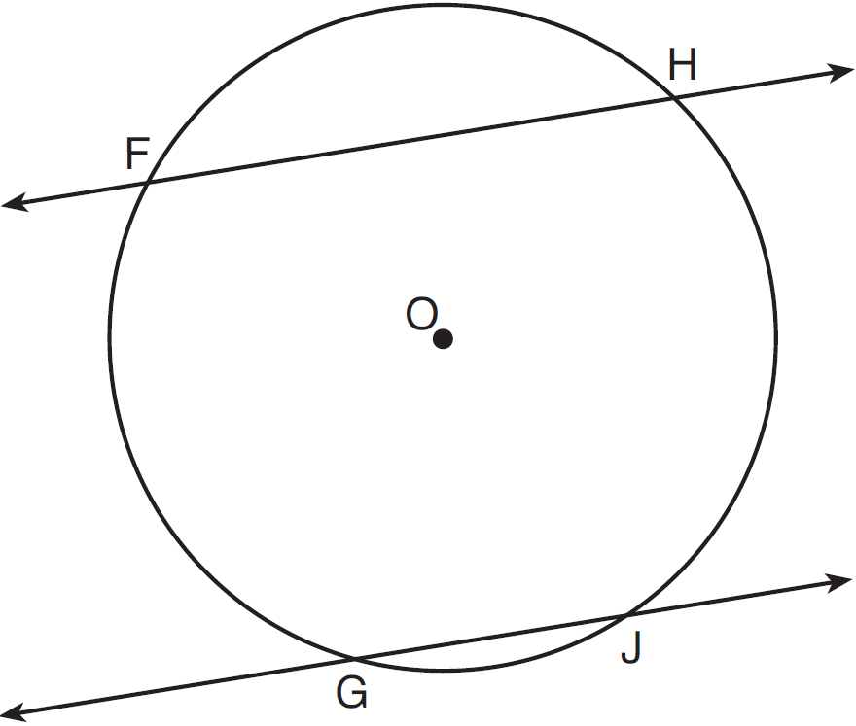

If and , then equals
1) | 106
2) | 115
3) | 130
4) | 156

4 What are the coordinates of , the image of point after translation ?
1)
2)
3)
4)

5 The statement " or " is false when x is equal to
1) | 1
2) | 2
3) | 7
4) | 4

6 Triangle JTM is shown on the graph below.

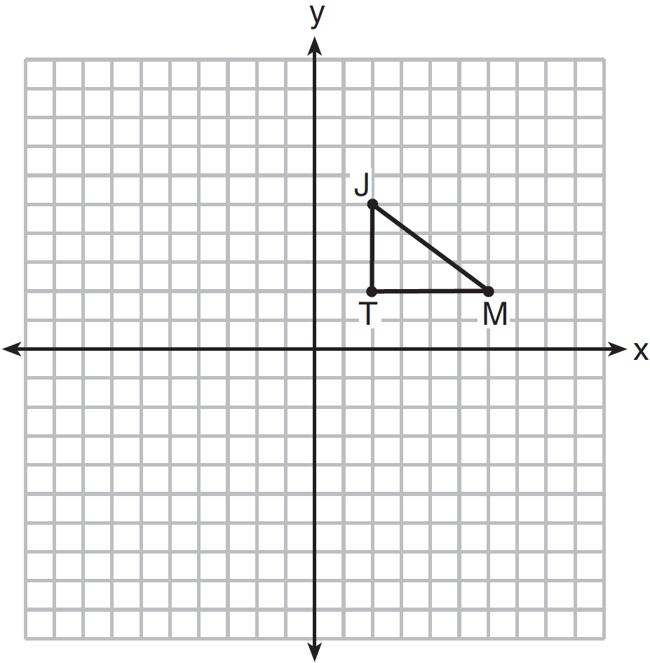

Which transformation would result in an image that is not congruent to ?
1)
2)
3)
4)

7 In the diagram below of , with and , .

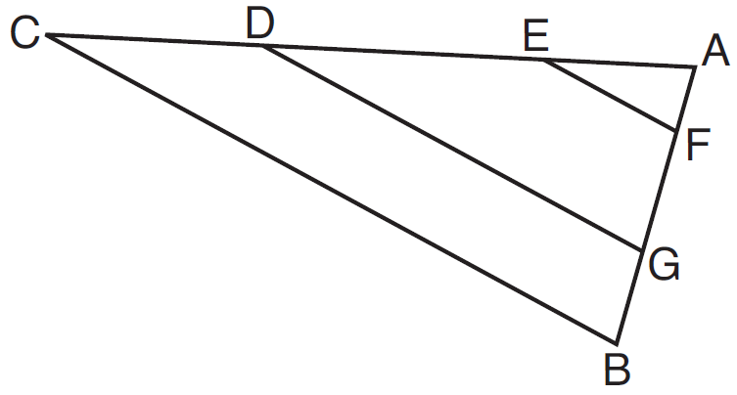

Which statement is false?
1) | 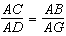
2) | 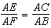
3) | 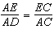
4) | 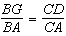

8 Which pair of edges is not coplanar in the cube shown below?

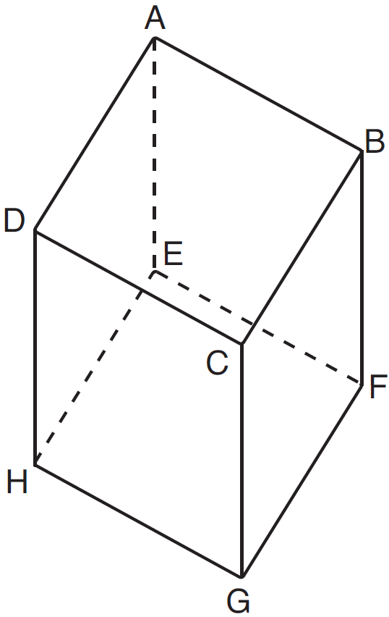
1) | and
2) | and
3) | and
4) | and

9 What is an equation of the line that passes through the point and is parallel to the line whose equation is ?
1) | 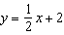
2) | 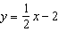
3)
4)

10 In , . If , then is
1) | 61
2) | 64
3) | 116
4) | 122

11 The corresponding medians of two similar triangles are 8 and 20. If the perimeter of the larger triangle is 45, what is the perimeter of the smaller triangle?
1) | 14
2) | 18
3) | 33
4) | 37

12 Which construction of parallel lines is justified by the theorem "If two lines are cut by a transversal to form congruent alternate interior angles, then the lines are parallel"?
1) | 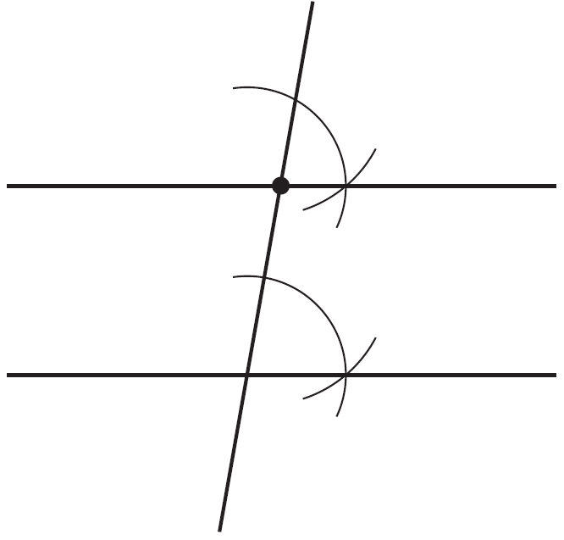
2) | 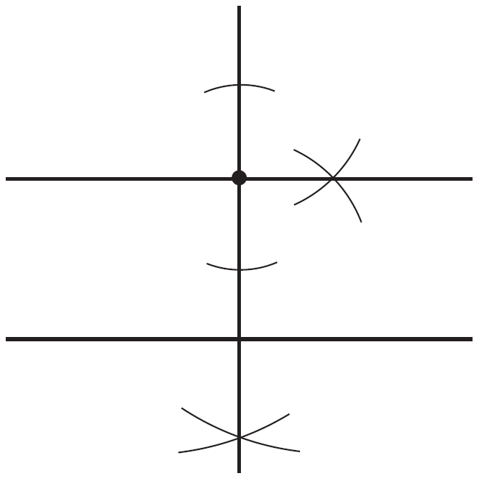
3) | 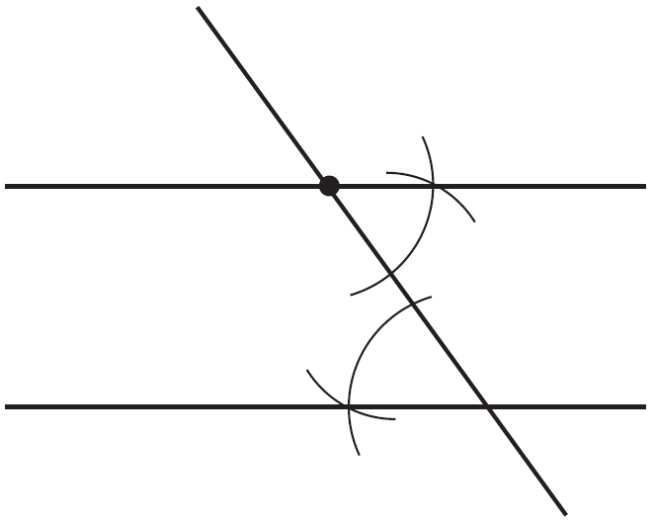
4) | 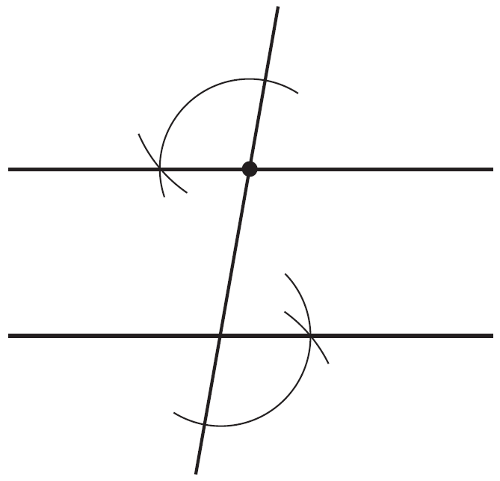

13 Given: "If a polygon is a triangle, then the sum of its interior angles is 180°." What is the contrapositive of this statement?
1) | "If the sum of the interior angles of a polygon is not 180°, then it is not a triangle."
2) | "A polygon is a triangle if and only if the sum of its interior angles is 180°."
3) | "If a polygon is not a triangle, then the sum of the interior angles is not 180°."
4) | "If the sum of the interior angles of a polygon is 180°, then it is a triangle."

14 In the diagram below, point P is not on line .

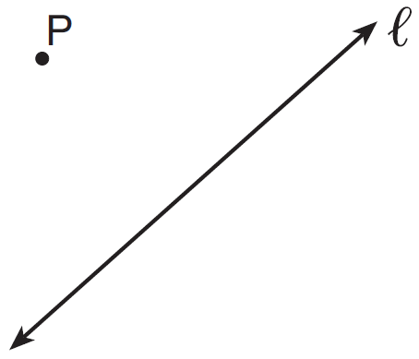

How many distinct planes that contain point P are also perpendicular to line ?
1) | 1
2) | 2
3) | 0
4) | an infinite amount

15 The image of after the transformation is . Which property is not preserved?
1) | distance
2) | orientation
3) | collinearity
4) | angle measure

16 The equations and are graphed on the same set of axes. The coordinates of a point in the solution of this system of equations are
1)
2)
3)
4)

17 Which quadrilateral has diagonals that are always perpendicular bisectors of each other?
1) | square
2) | rectangle
3) | trapezoid
4) | parallelogram

18 As shown in the diagram below, is a diameter of circle O, and chord is drawn.

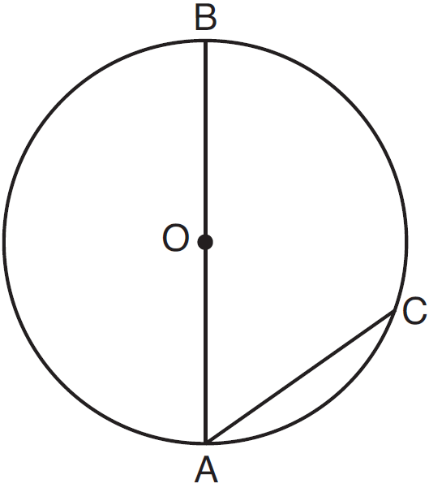

If , then is
1) | 40
2) | 70
3) | 110
4) | 140

19 In parallelogram JKLM, exceeds by 30 degrees. What is the measure of ?
1) | 75°
2) | 105°
3) | 165°
4) | 195°

20 Which equation represents the circle shown in the graph below?

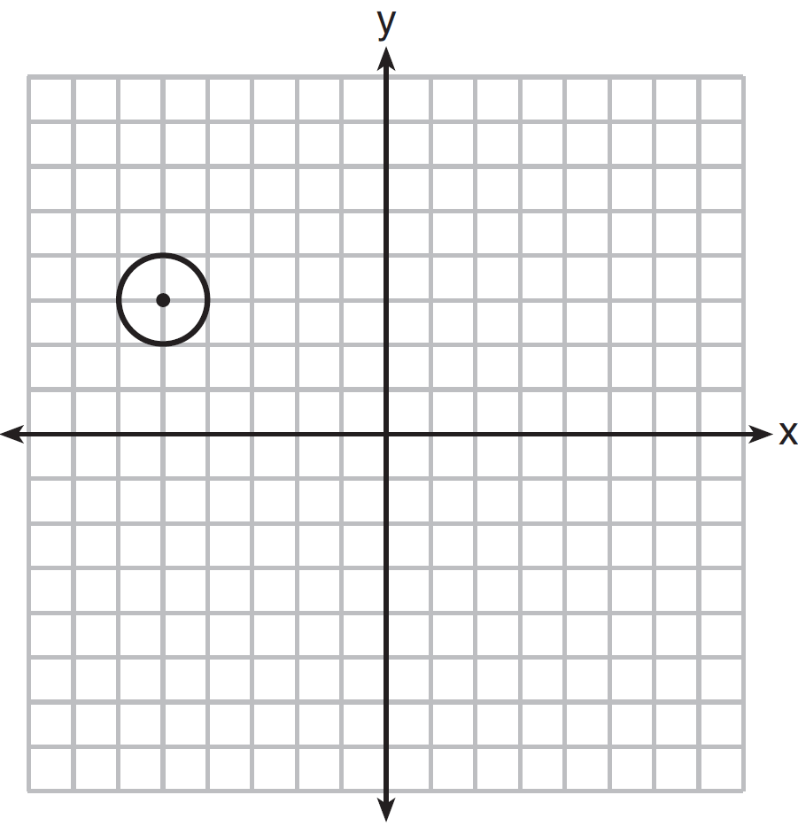
1)
2)
3)
4)

21 What is the measure of each interior angle in a regular octagon?
1) | 108º
2) | 135º
3) | 144º
4) | 1080º

22 Points A and B are on line , and line is parallel to line m, as shown in the diagram below.

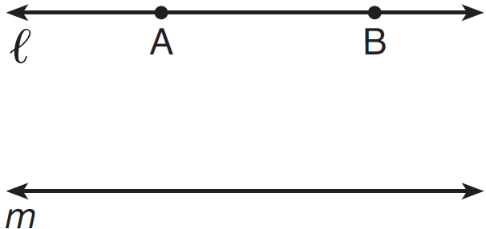

How many points are in the same plane as and m and equidistant from and m, and also equidistant from A and B?
1) | 1
2) | 2
3) | 3
4) | 0

23 A carpenter made a storage container in the shape of a rectangular prism. It is 5 feet high and has a volume of 720 cubic feet. He wants to make a second container with the same height and volume as the first one, but in the shape of a triangular prism. What will be the number of square feet in the area of the base of the new container?
1) | 36
2) | 72
3) | 144
4) | 288

24 In , . Which statement is false?
1)
2)
3)
4)

25 In the diagram below of circle O with radius , tangent and secant are drawn.

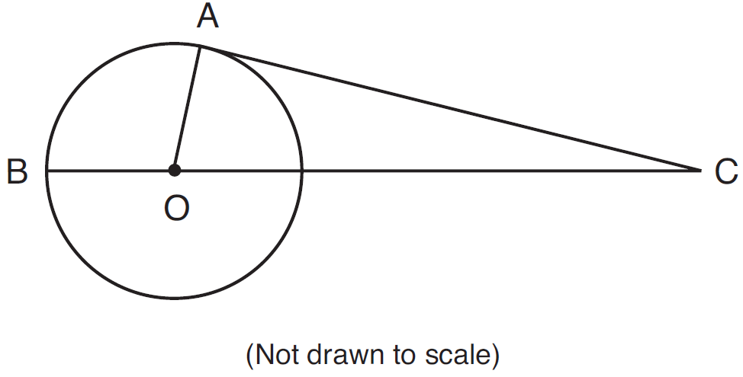

If cm and cm, what is the length of , to the nearest centimeter?
1) | 19
2) | 20
3) | 21
4) | 27

26 In the diagram below of , point H is the intersection of the three medians.

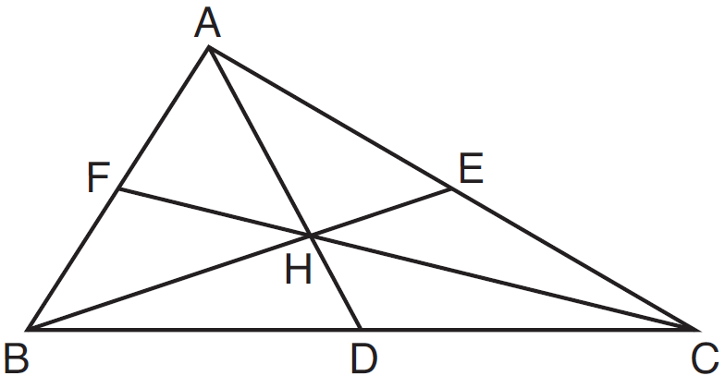

If measures 2.4 centimeters, what is the length, in centimeters, of ?
1) | 3.6
2) | 4.8
3) | 7.2
4) | 9.6

27 Which set of numbers could be the lengths of the sides of an isosceles triangle?
1)
2)
3)
4)

28 In the diagram below of right triangle ABC, is the altitude to hypotenuse , , and .

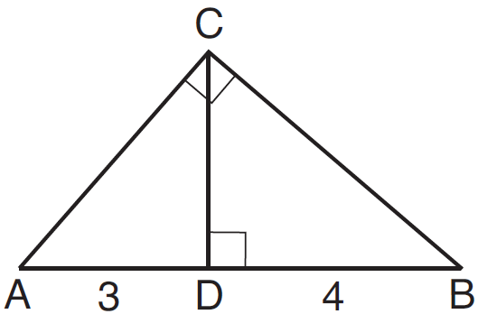

What is the length of ?
1)
2)
3)
4)

29 The image of after a reflection through the origin is . If the coordinates of the endpoints of are and , state and label the coordinates of R' and S'. [The use of the set of axes below is optional.]

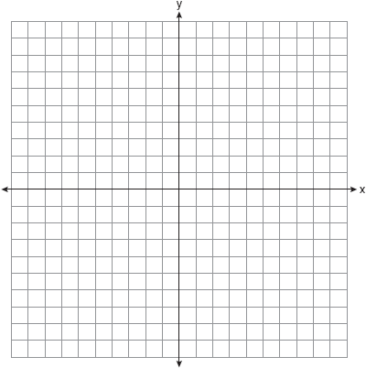

30 A paper container in the shape of a right circular cone has a radius of 3 inches and a height of 8 inches. Determine and state the number of cubic inches in the volume of the cone, in terms of .

31 In isosceles triangle RST shown below, , M and N are midpoints of and , respectively, and is drawn. If and the perimeter of is 25, determine and state the length of .

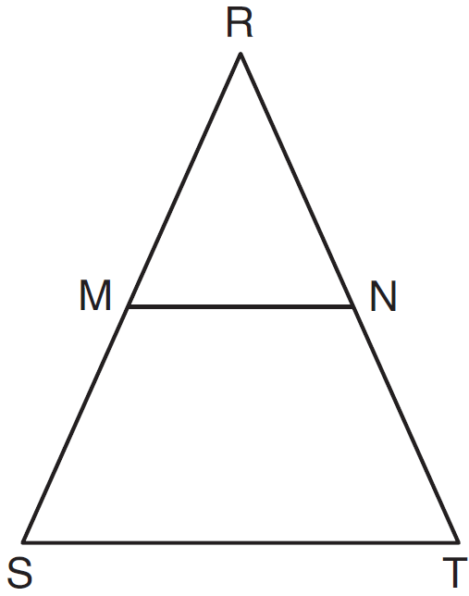

32 In the diagram below, is equilateral.

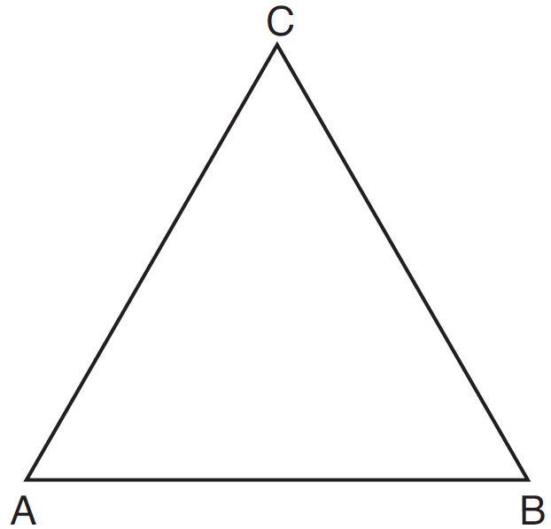

Using a compass and straightedge, construct a new equilateral triangle congruent to in the space below. [Leave all construction marks.]

33 Write an equation of the line that is perpendicular to the line whose equation is and that passes through the origin.

34 Rectangle KLMN has vertices , , , and . Determine and state the coordinates of the point of intersection of the diagonals.

35 On the set of axes below, graph the locus of points 5 units from the point and the locus of points 2 units from the line whose equation is . State the coordinates of all points that satisfy both conditions.

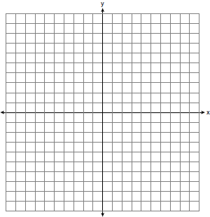

36 If is defined by the endpoints and , write an equation of the line that is the
perpendicular bisector of .

37 On the set of axes below, graph and label circle A whose equation is and circle B whose equation is . Determine, in simplest radical form, the length of the line segment with endpoints at the centers of circles A and B.

38 Given: Parallelogram DEFG, K and H are points on such that and and are drawn.

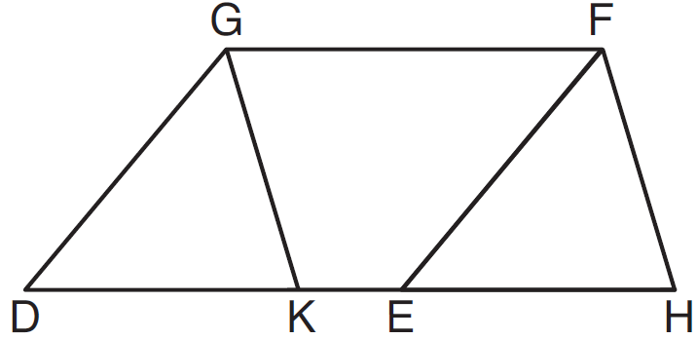

Prove:
1 ANS: 4 PTS: 2 REF: 081501ge STA: G.G.29
TOP: Triangle Congruency

2 ANS: 3 PTS: 2 REF: 081502ge STA: G.G.73
TOP: Equations of Circles

3 ANS: 2
Parallel secants intercept congruent arcs. 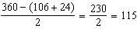

PTS: 2 REF: 081503ge STA: G.G.52 TOP: Chords and Secants

4 ANS: 2 PTS: 2 REF: 081504ge STA: G.G.61
TOP: Analytical Representations of Transformations

5 ANS: 4 PTS: 2 REF: 081505ge STA: G.G.25
TOP: Compound Statements KEY: disjunction

6 ANS: 4 PTS: 2 REF: 081506ge STA: G.G.59
TOP: Properties of Transformations

7 ANS: 3 PTS: 2 REF: 081507ge STA: G.G.46
TOP: Side Splitter Theorem

8 ANS: 1 PTS: 2 REF: 081508ge STA: G.G.10
TOP: Solids

9 ANS: 3
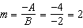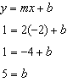

PTS: 2 REF: 081509ge STA: G.G.65 TOP: Parallel and Perpendicular Lines

10 ANS: 2

PTS: 2 REF: 081510ge STA: G.G.31 TOP: Isosceles Triangle Theorem

11 ANS: 2
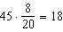

PTS: 2 REF: 081511ge STA: G.G.45 TOP: Similarity
KEY: perimeter and area

12 ANS: 3 PTS: 2 REF: 081512ge STA: G.G.19
TOP: Constructions

13 ANS: 1 PTS: 2 REF: 081513ge STA: G.G.26
TOP: Contrapositive

14 ANS: 1 PTS: 2 REF: 081514ge STA: G.G.2
TOP: Planes

15 ANS: 2 PTS: 2 REF: 081515ge STA: G.G.55
TOP: Properties of Transformations

16 ANS: 4
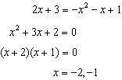

PTS: 2 REF: 081516ge STA: G.G.70 TOP: Quadratic-Linear Systems

17 ANS: 1 PTS: 2 REF: 081517ge STA: G.G.41
TOP: Special Quadrilaterals

18 ANS: 1 PTS: 2 REF: 081518ge STA: G.G.51
TOP: Arcs Determined by Angles KEY: inscribed

19 ANS: 2
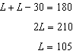

PTS: 2 REF: 081519ge STA: G.G.38 TOP: Parallelograms

20 ANS: 2 PTS: 2 REF: 081520ge STA: G.G.72
TOP: Equations of Circles

21 ANS: 2
. 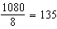.

PTS: 2 REF: 081521ge STA: G.G.37 TOP: Interior and Exterior Angles of Polygons

22 ANS: 1 PTS: 2 REF: 081522ge STA: G.G.22
TOP: Locus

23 ANS: 3
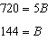

PTS: 2 REF: 081523ge STA: G.G.11 TOP: Volume

24 ANS: 1 PTS: 2 REF: 081524ge STA: G.G.34
TOP: Angle Side Relationship

25 ANS: 3

PTS: 2 REF: 081525ge STA: G.G.50 TOP: Tangents
KEY: point of tangency

26 ANS: 3

PTS: 2 REF: 081526ge STA: G.G.43 TOP: Centroid

27 ANS: 2 PTS: 2 REF: 081527ge STA: G.G.33
TOP: Triangle Inequality Theorem

28 ANS: 3
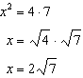

PTS: 2 REF: 081528ge STA: G.G.47 TOP: Similarity
KEY: leg

29 ANS:
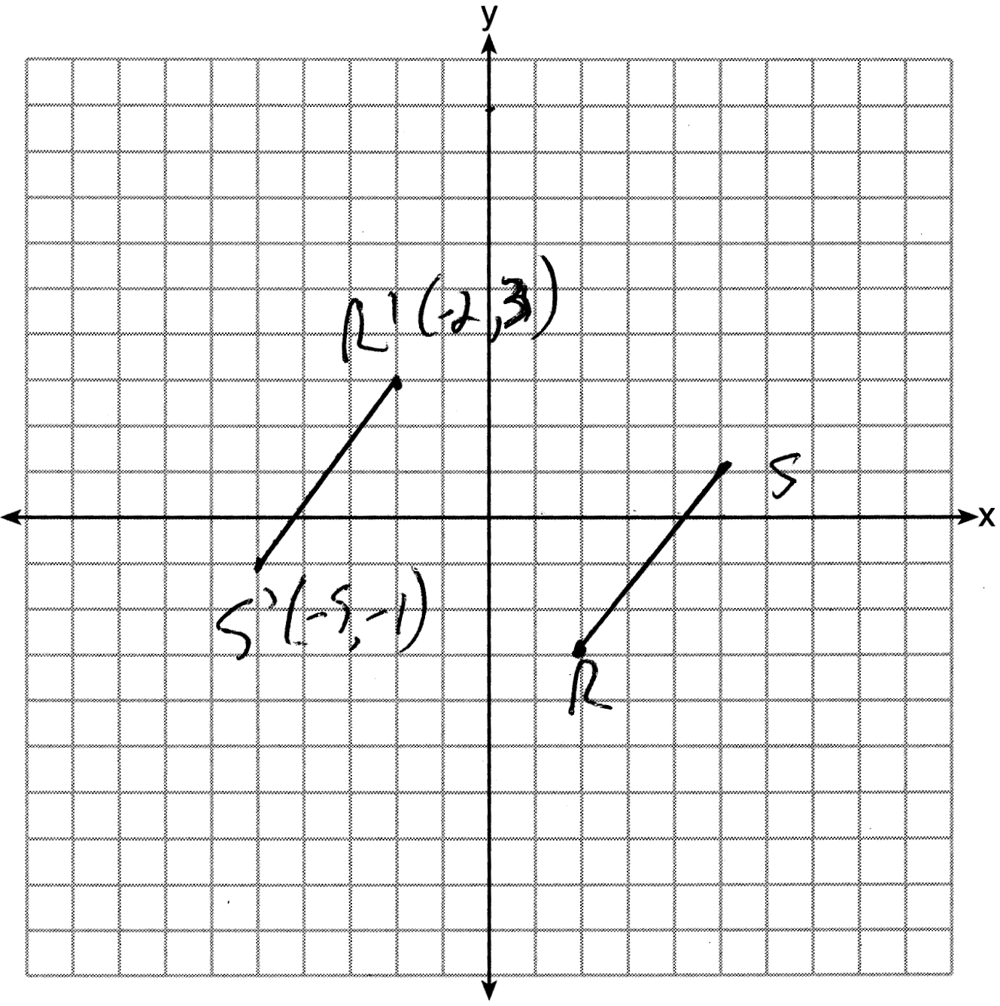

PTS: 2 REF: 081529ge STA: G.G.54 TOP: Reflections
KEY: grids

30 ANS:
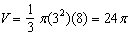

PTS: 2 REF: 081530ge STA: G.G.15 TOP: Volume and Lateral Area

31 ANS:
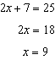

PTS: 2 REF: 081531ge STA: G.G.42 TOP: Midsegments

32 ANS:
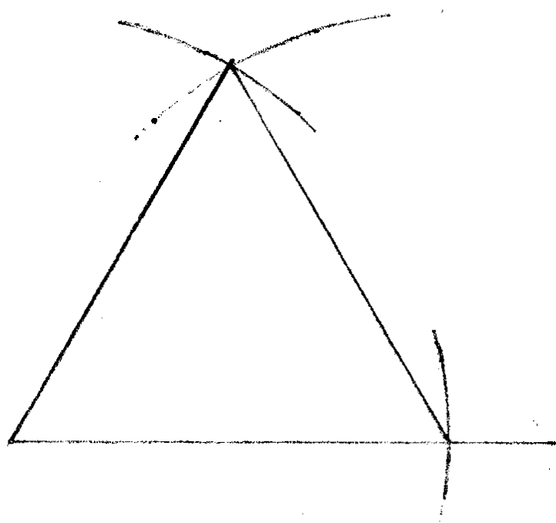

PTS: 2 REF: 081532ge STA: G.G.20 TOP: Constructions

33 ANS:
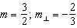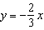
PTS: 2 REF: 081533ge STA: G.G.64 TOP: Parallel and Perpendicular Lines

34 ANS:
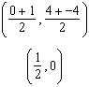
PTS: 2 REF: 081534ge STA: G.G.69 TOP: Quadrilaterals in the Coordinate Plane

35 ANS:
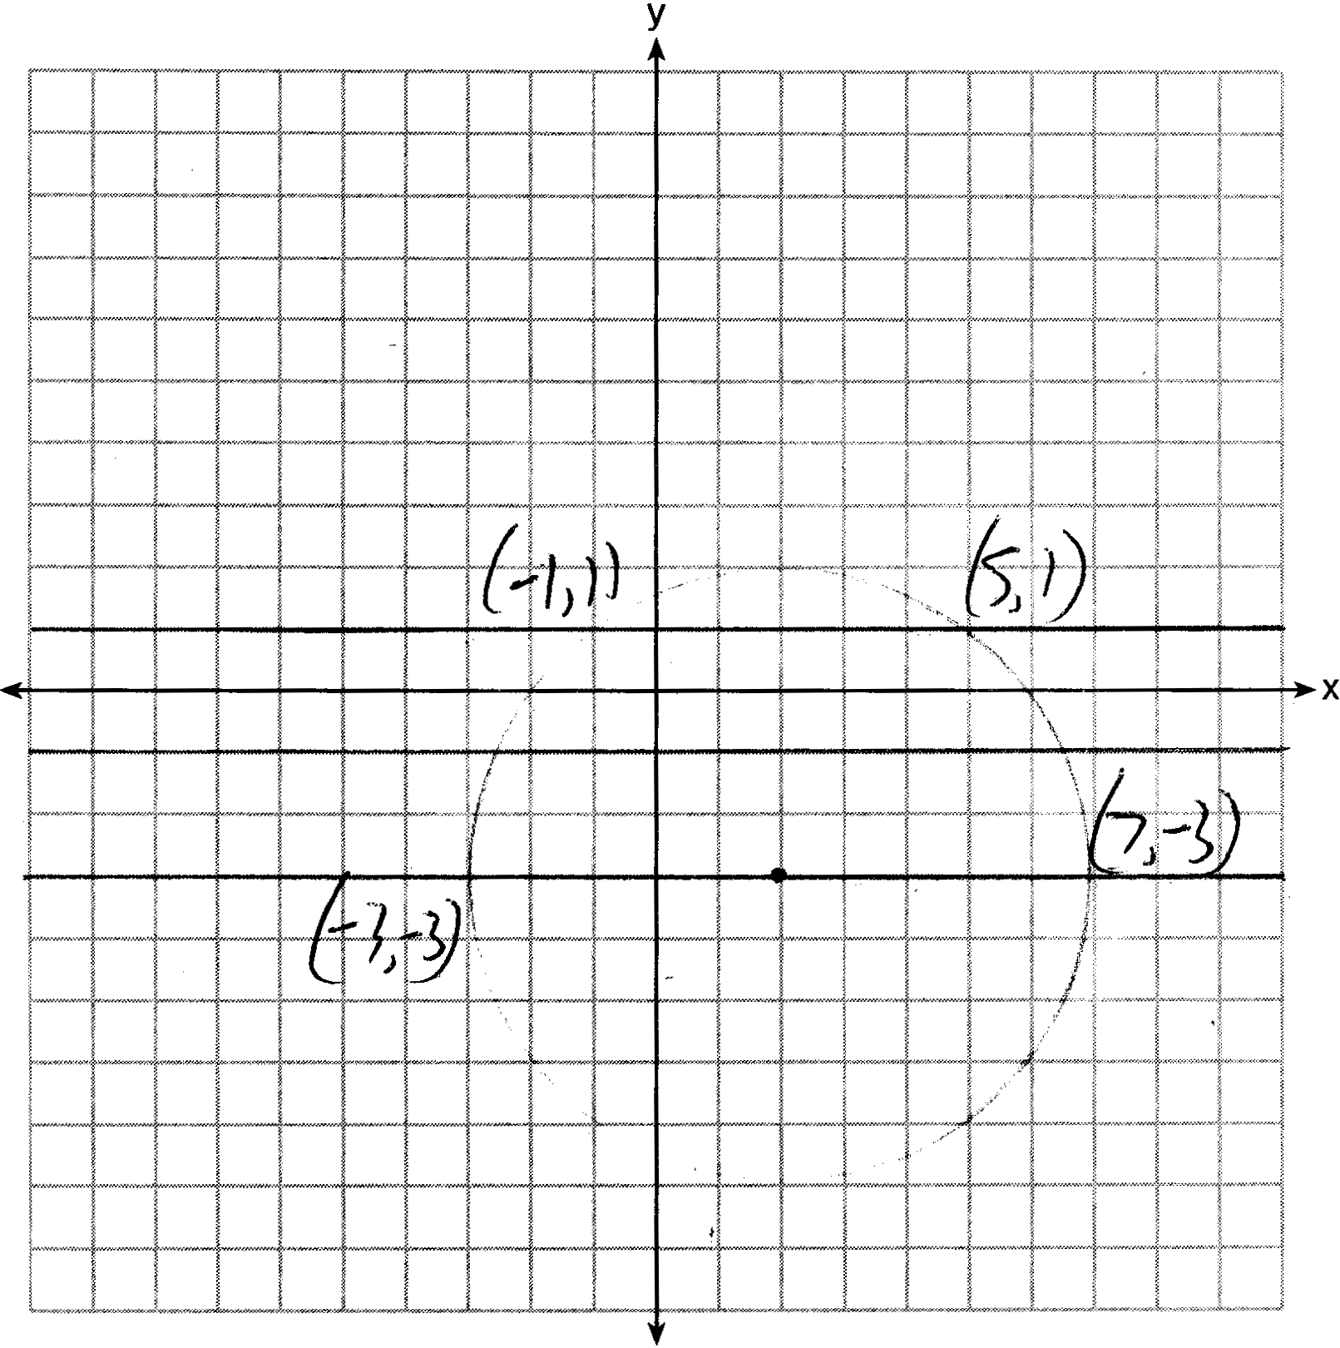
PTS: 4 REF: 081535ge STA: G.G.23 TOP: Locus

36 ANS:
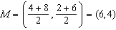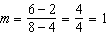
PTS: 4 REF: 081536ge STA: G.G.68 TOP: Perpendicular Bisector

37 ANS:
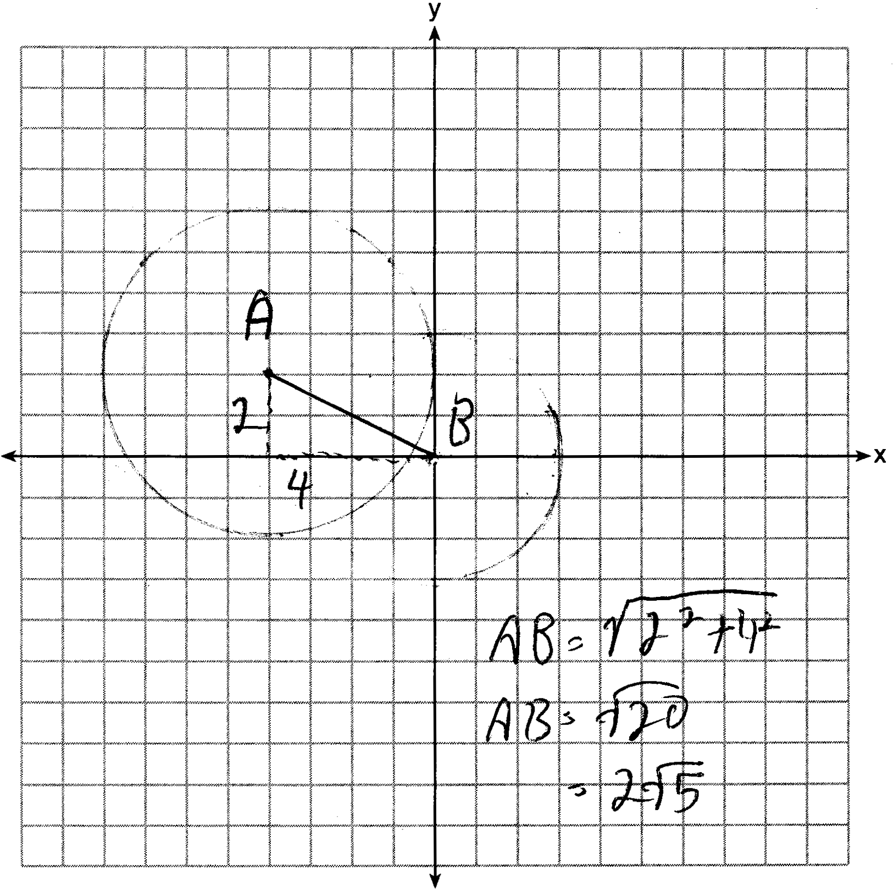
PTS: 4 REF: 081537ge STA: G.G.74 TOP: Graphing Circles

38 ANS:
Parallelogram DEFG, K and H are points on such that and and are drawn (given). (opposite sides of a parallelogram are congruent). (opposite sides of a parallelogram are parallel). (corresponding angles formed by parallel lines and a transversal are congruent). (ASA). (CPCTC). 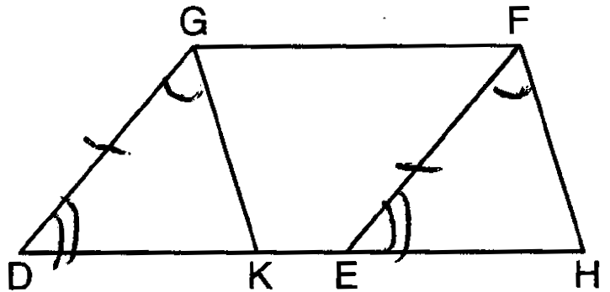
PTS: 6 REF: 081538ge STA: G.G.27 TOP: Quadrilateral Proofs

