1 Given: , is the perpendicular bisector of

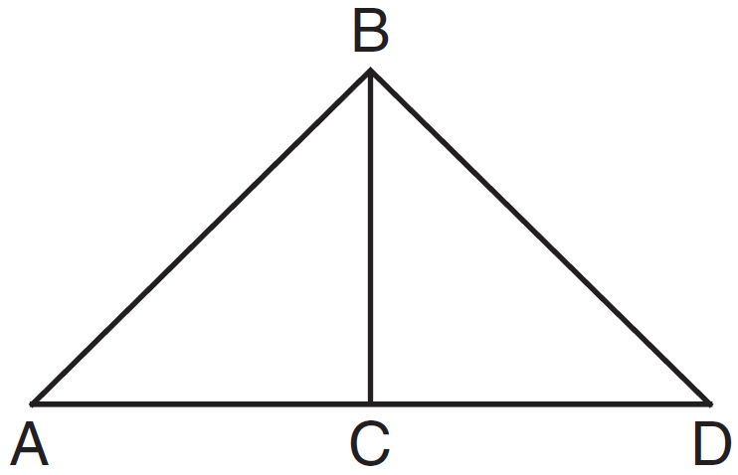

Which statement can not always be proven?
1)
2)
3)
4)

2 In the diagram of circle O below, chord is parallel to diameter and .

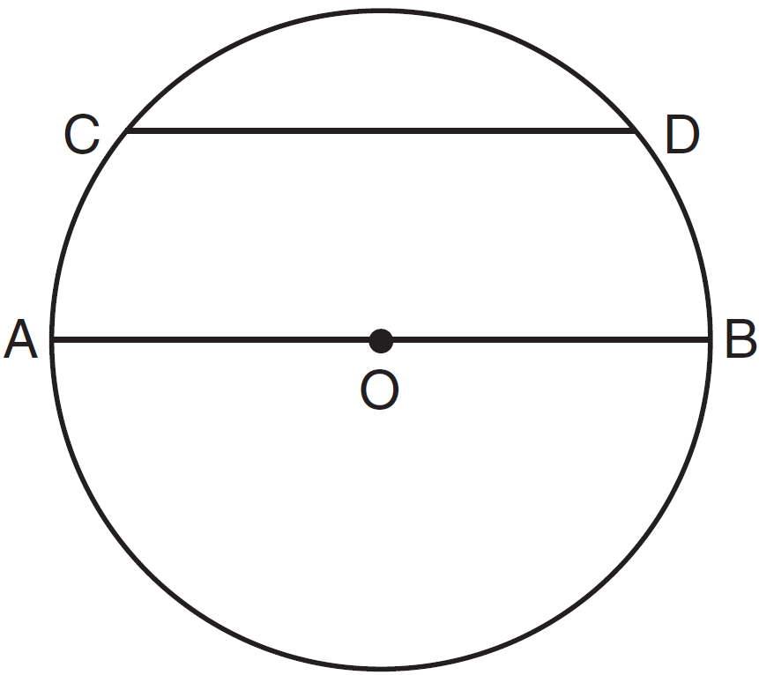

What is ?
1) | 35
2) | 55
3) | 70
4) | 110

3 Given the statement: One is a prime number.
What is the negation and the truth value of the negation?
1) | One is not a prime number; true
2) | One is not a prime number; false
3) | One is a composite number; true
4) | One is a composite number; false

4 Triangle ABC has the coordinates , , and . Triangle ABC is rotated 180° about the origin to form triangle . Triangle is
1) | acute
2) | isosceles
3) | obtuse
4) | right

5 What is an equation of the circle with center and a radius of 7?
1)
2)
3)
4)

6 In , and is an obtuse angle. Which statement is true?
1) | and is the longest side.
2) | and is the longest side.
3) | and is the shortest side.
4) | and is the shortest side.

7 In the diagram of below, medians and intersect at point F.

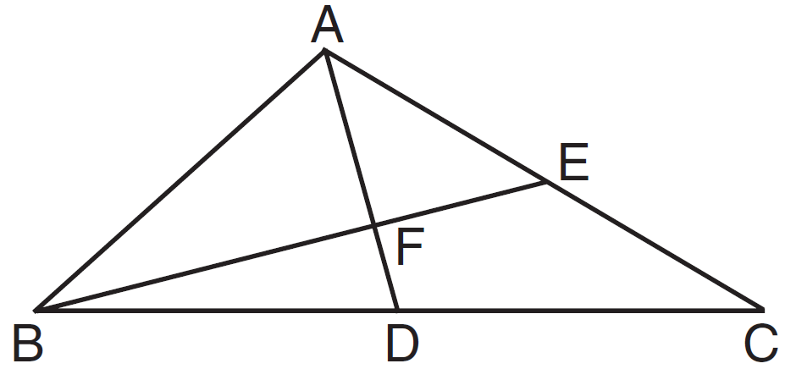

If , what is the length of ?
1) | 6
2) | 2
3) | 3
4) | 9

8 In circle O, diameter intersects chord at E. If , then is which type of angle?
1) | straight
2) | obtuse
3) | acute
4) | right

9 If , then must be congruent to
1)
2)
3)
4)

10 In the diagram of below, is extended to point D.

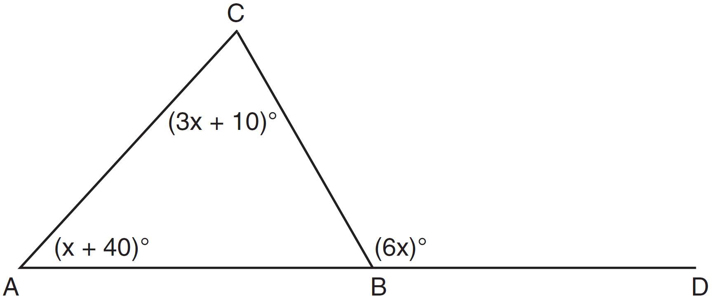

If , , , what is ?
1) | 13
2) | 25
3) | 53
4) | 65

11 The bases of a right triangular prism are and . Angles A and D are right angles, , , and . What is the length of edge ?
1) | 10
2) | 12
3) | 14
4) | 16

12 What is the equation of circle O shown in the diagram below?

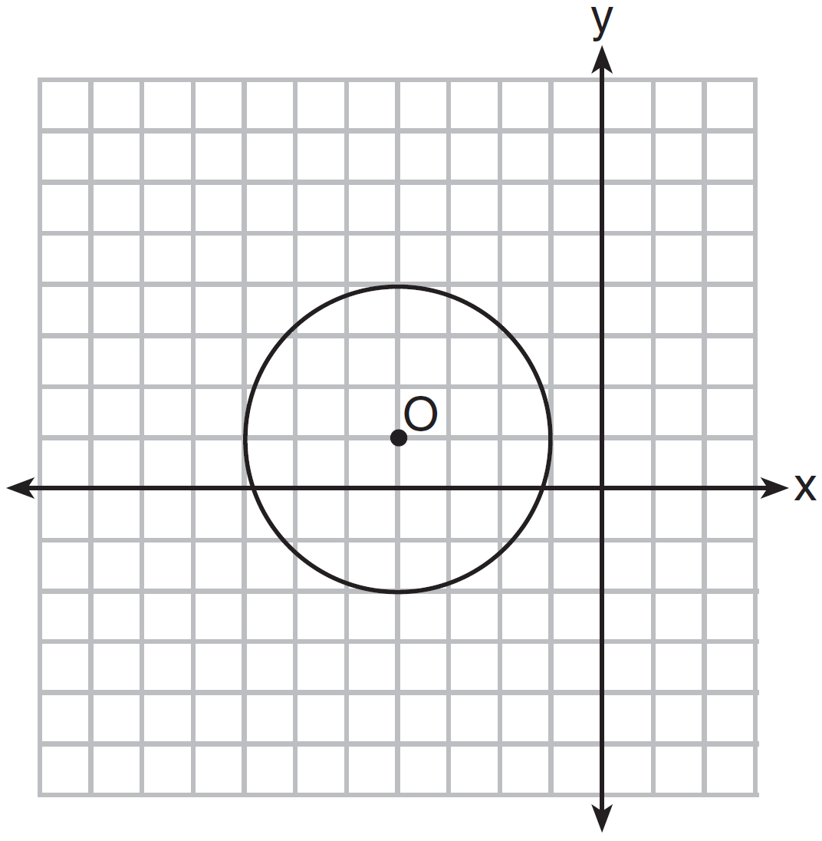
1)
2)
3)
4)

13 The diagram below shows the construction of line m, parallel to line , through point P.

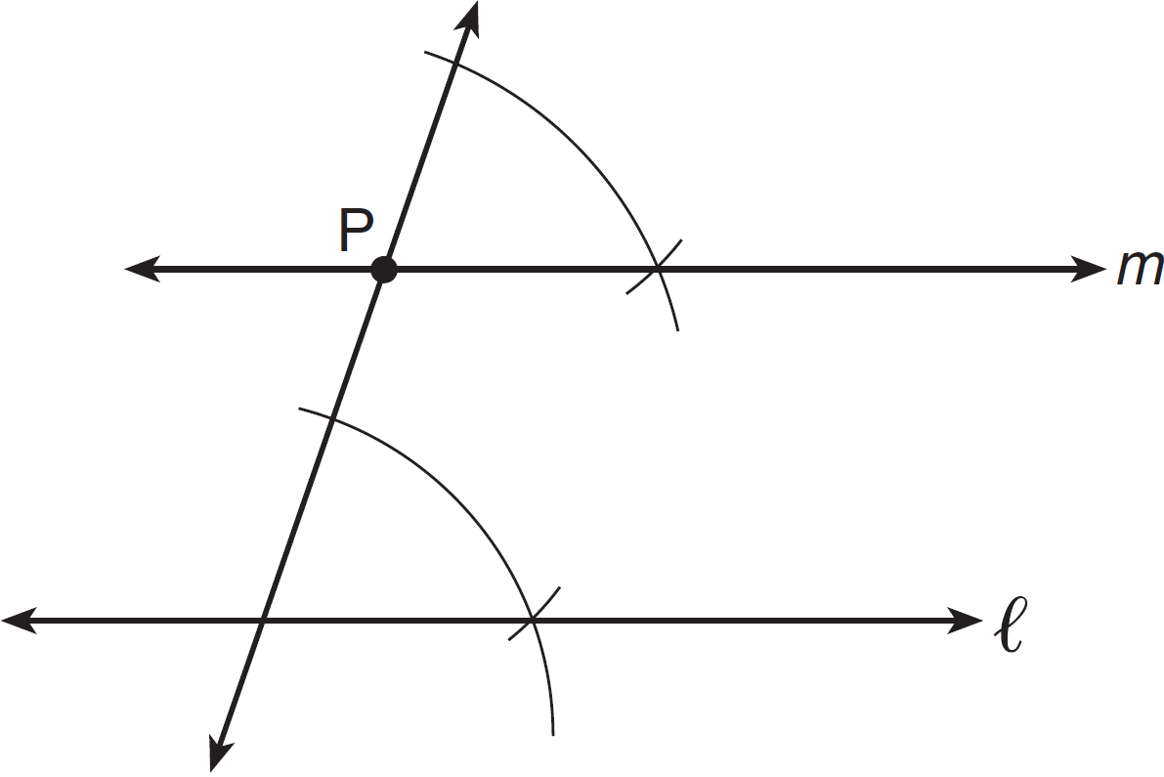

Which theorem was used to justify this construction?
1) | If two lines are cut by a transversal and the alternate interior angles are congruent, the lines are parallel.
2) | If two lines are cut by a transversal and the interior angles on the same side are supplementary, the lines are parallel.
3) | If two lines are perpendicular to the same line, they are parallel.
4) | If two lines are cut by a transversal and the corresponding angles are congruent, they are parallel.

14 The lateral area of a right circular cone is equal to . If the base of the cone has a diameter of 24 cm, what is the length of the slant height, in centimeters?
1) | 2.5
2) | 5
3) | 10
4) | 15.7

15 A student wrote the following equations:
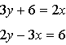
The lines represented by these equations are
1) | parallel
2) | the same line
3) | perpendicular
4) | intersecting, but not perpendicular

16 In a coordinate plane, the locus of points 5 units from the x-axis is the
1) | lines and
2) | lines and
3) | line , only
4) | line , only

17 The sides of a triangle are 8, 12, and 15. The longest side of a similar triangle is 18. What is the ratio of the perimeter of the smaller triangle to the perimeter of the larger triangle?
1)
2)
3)
4)

18 Lines m and n are in plane A. What is the converse of the statement “If lines m and n are parallel, then lines m and n do not intersect”?
1) | If lines m and n are not parallel, then lines m and n intersect.
2) | If lines m and n are not parallel, then lines m and n do not intersect
3) | If lines m and n intersect, then lines m and n are not parallel.
4) | If lines m and n do not intersect, then lines m and n are parallel.

19 When the system of equations and is solved graphically, the solution is
1) | and
2) | and
3) | and
4) | and

20 In the diagram of below, A is the midpoint of , B is the midpoint of , C is the midpoint of , and and are drawn.

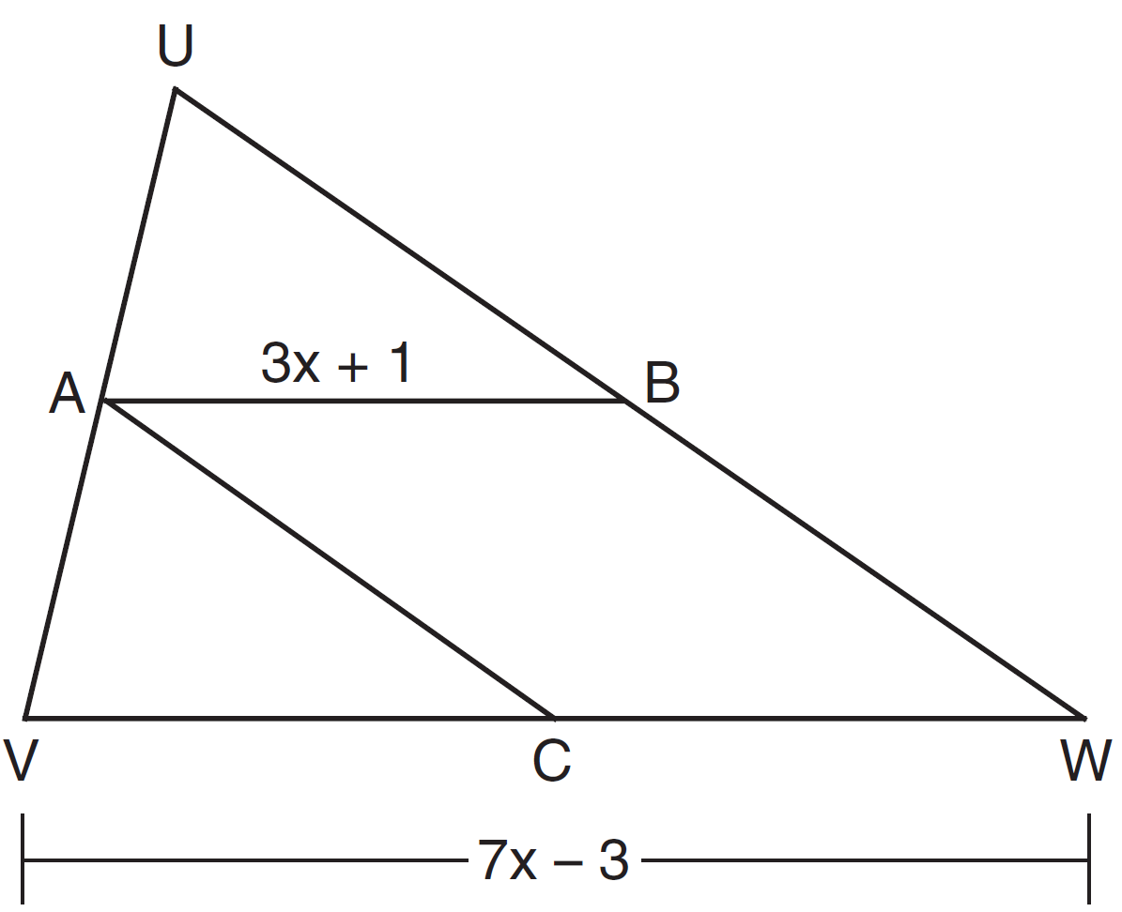

If and , what is the length of ?
1) | 5
2) | 13
3) | 16
4) | 32

21 Two prisms have equal heights and equal volumes. The base of one is a pentagon and the base of the other is a square. If the area of the pentagonal base is 36 square inches, how many inches are in the length of each side of the square base?
1) | 6
2) | 9
3) | 24
4) | 36

22 What is the difference between the sum of the measures of the interior angles of a regular pentagon and the sum of the measures of the exterior angles of a regular pentagon?
1) | 36
2) | 72
3) | 108
4) | 180

23 If line is perpendicular to distinct planes P and Q, then planes P and Q
1) | are parallel
2) | contain line
3) | are perpendicular
4) | intersect, but are not perpendicular

24 Which graph represents a circle whose equation is ?
1) | 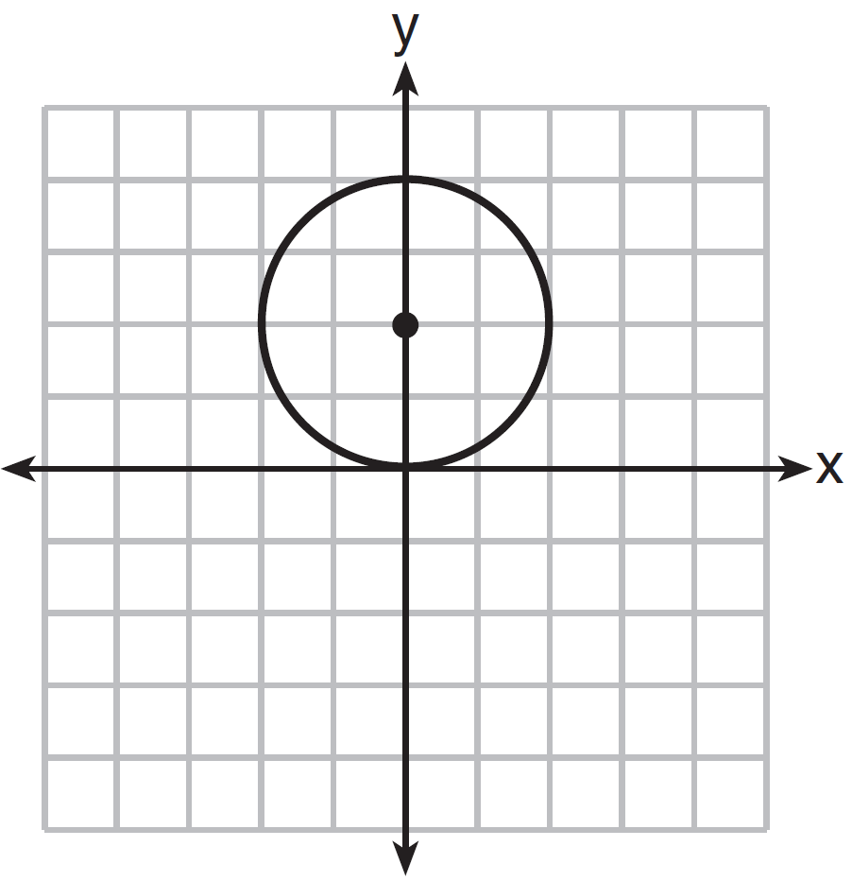
2) | 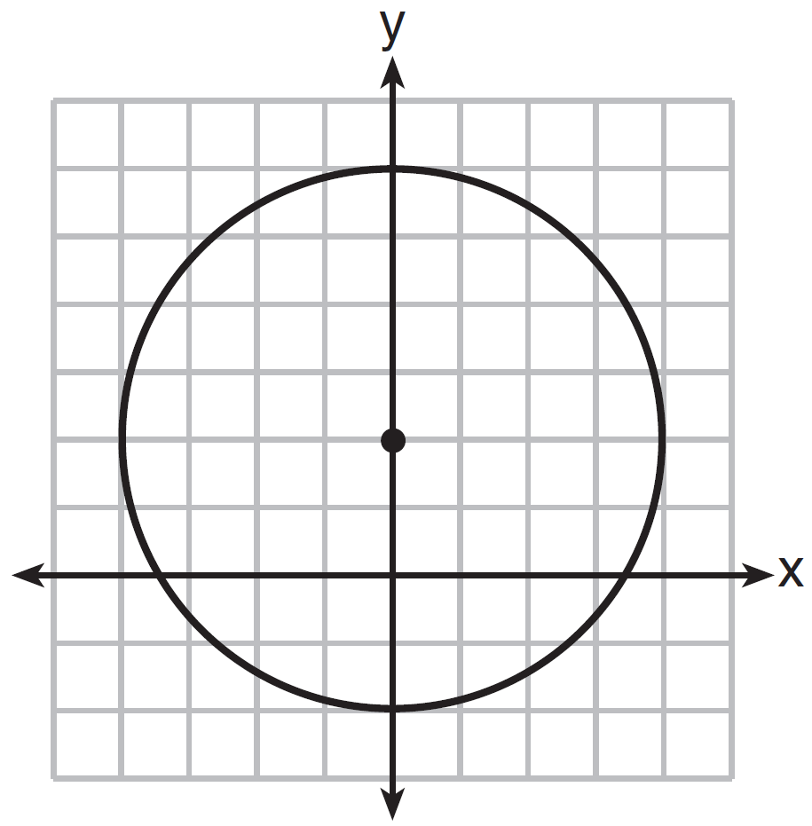
3) | 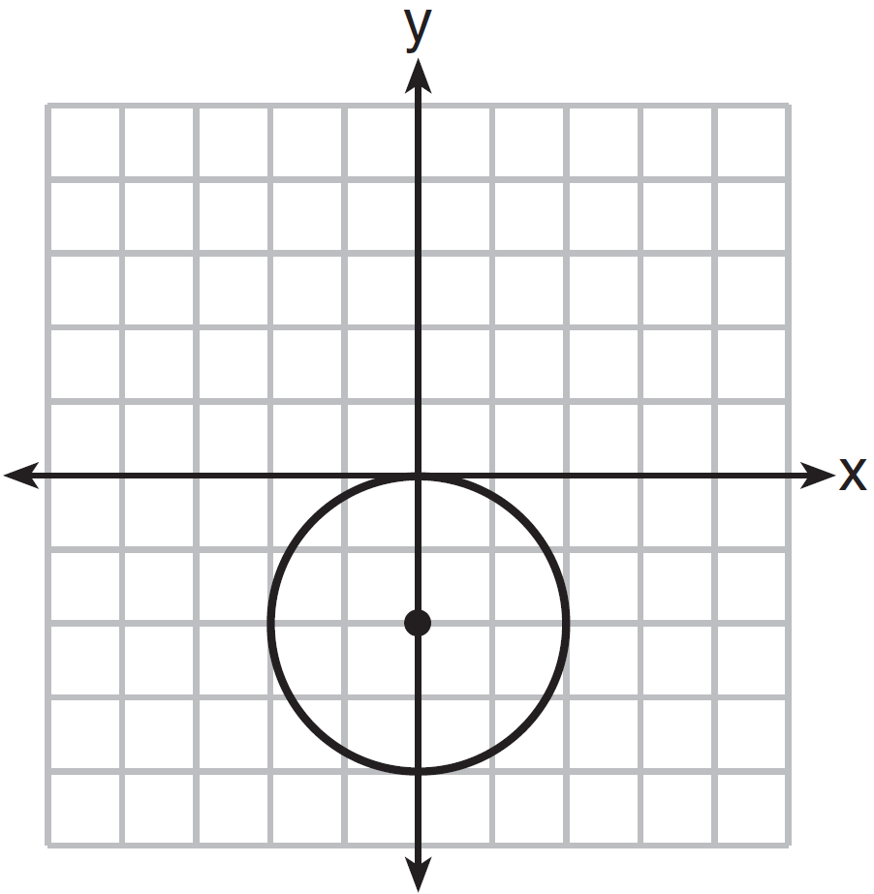
4) | 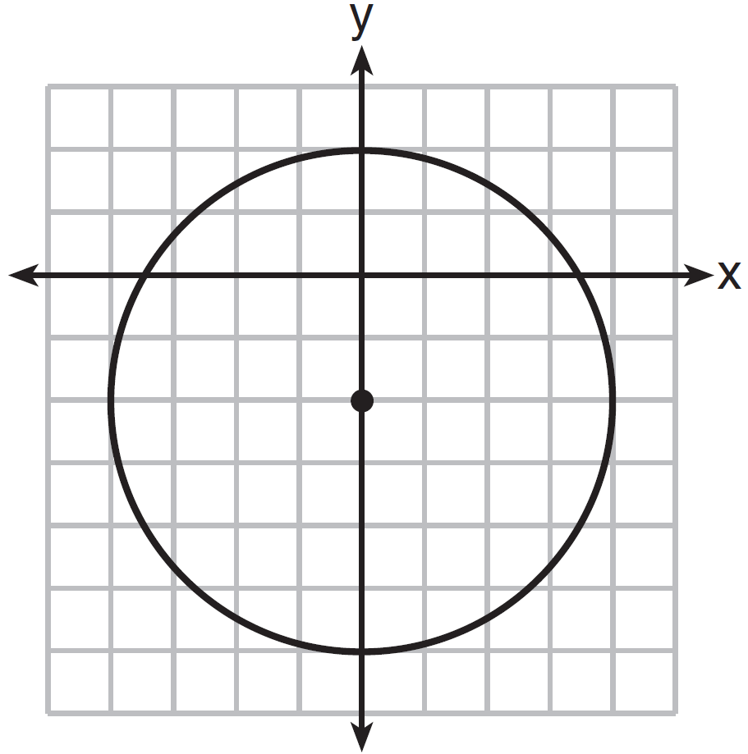

25 In the diagram below, and are tangent to circle B at points C and D, respectively, and , , and are drawn.

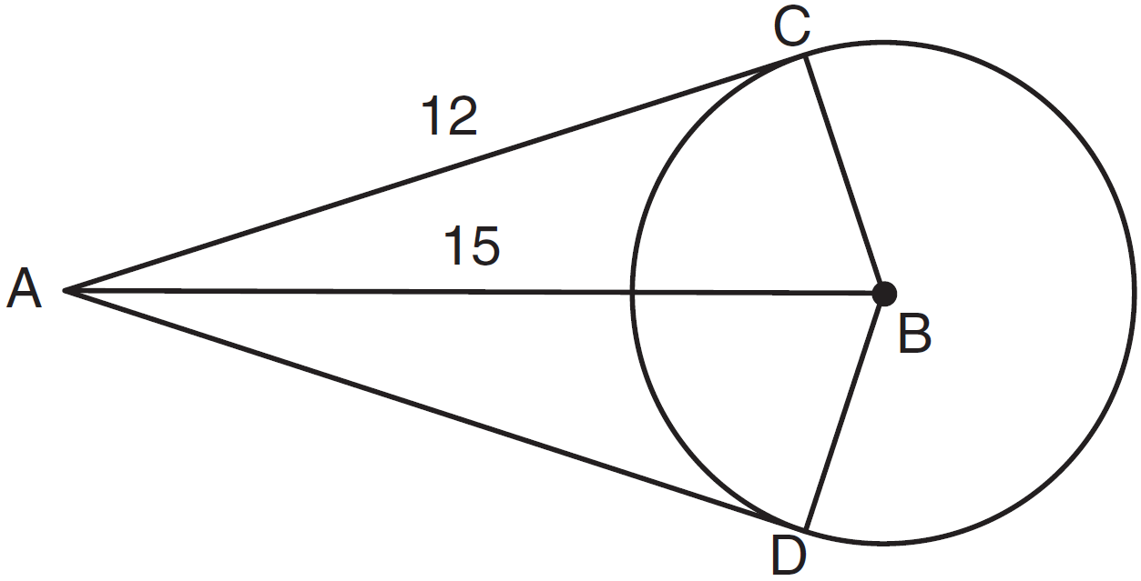

If and , what is the length of ?
1) | 5.5
2) | 9
3) | 12
4) | 18

26 Triangle ABC shown below is a right triangle with altitude drawn to the hypotenuse .

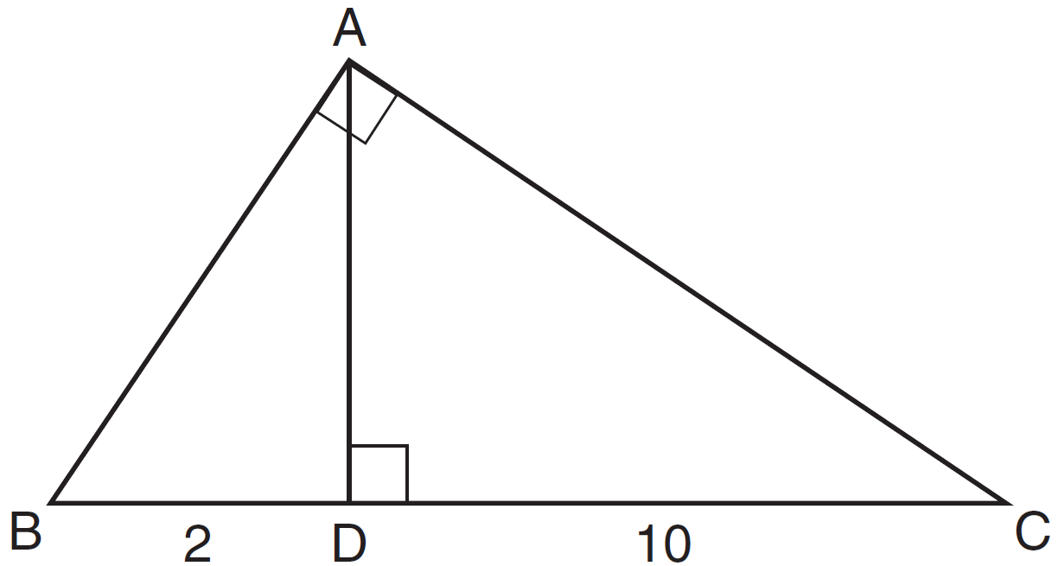

If and , what is the length of ?
1)
2)
3)
4)

27 Triangle ABC has vertices , , and . Which equation represents the perpendicular bisector of ?
1)
2)
3) | 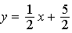
4) | 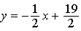

28 Chords and intersect at point E in a circle with center at O. If , , and , what is the length of ?
1) | 6
2) | 9
3) | 10
4) | 12

29 Triangle ABC has vertices , , and . State and label the coordinates of , the image of after a dilation of .

30 Using a compass and straightedge, construct the bisector of . [Leave all construction marks.]

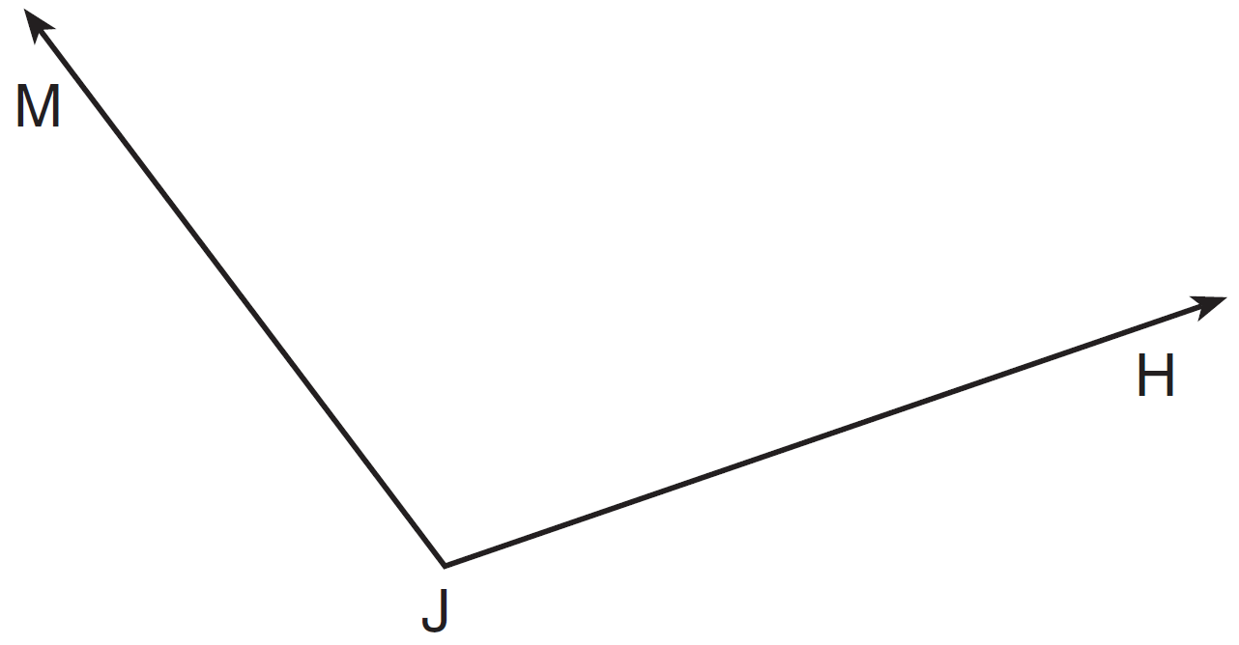

31 Find, in simplest radical form, the length of the line segment with endpoints whose coordinates are and .

32 In , the measure of angle A is fifteen less than twice the measure of angle B. The measure of angle C equals the sum of the measures of angle A and angle B. Determine the measure of angle B.

33 A circle has the equation . Find the coordinates of the center of the circle and the length of the circle's radius.

34 Two intersecting lines are shown in the diagram below. Sketch the locus of points that are equidistant from the two lines. Sketch the locus of points that are a given distance, d, from the point of intersection of the given lines. State the number of points that satisfy both conditions.

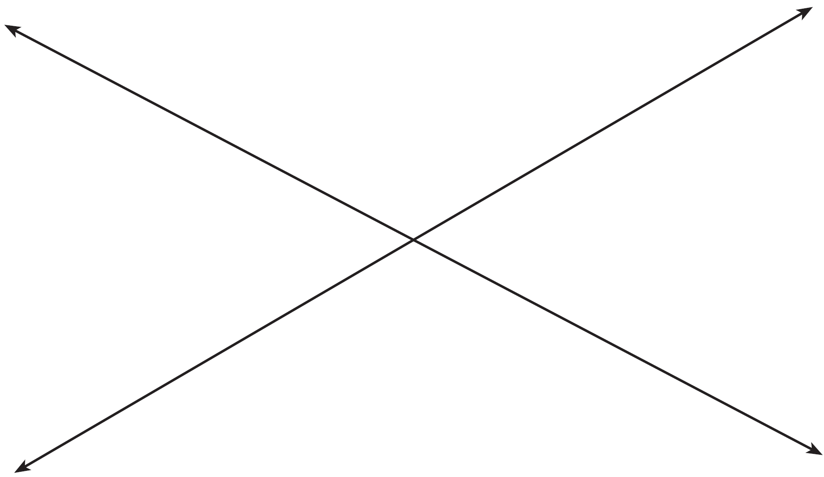

35 Given: , bisects ,
Prove:

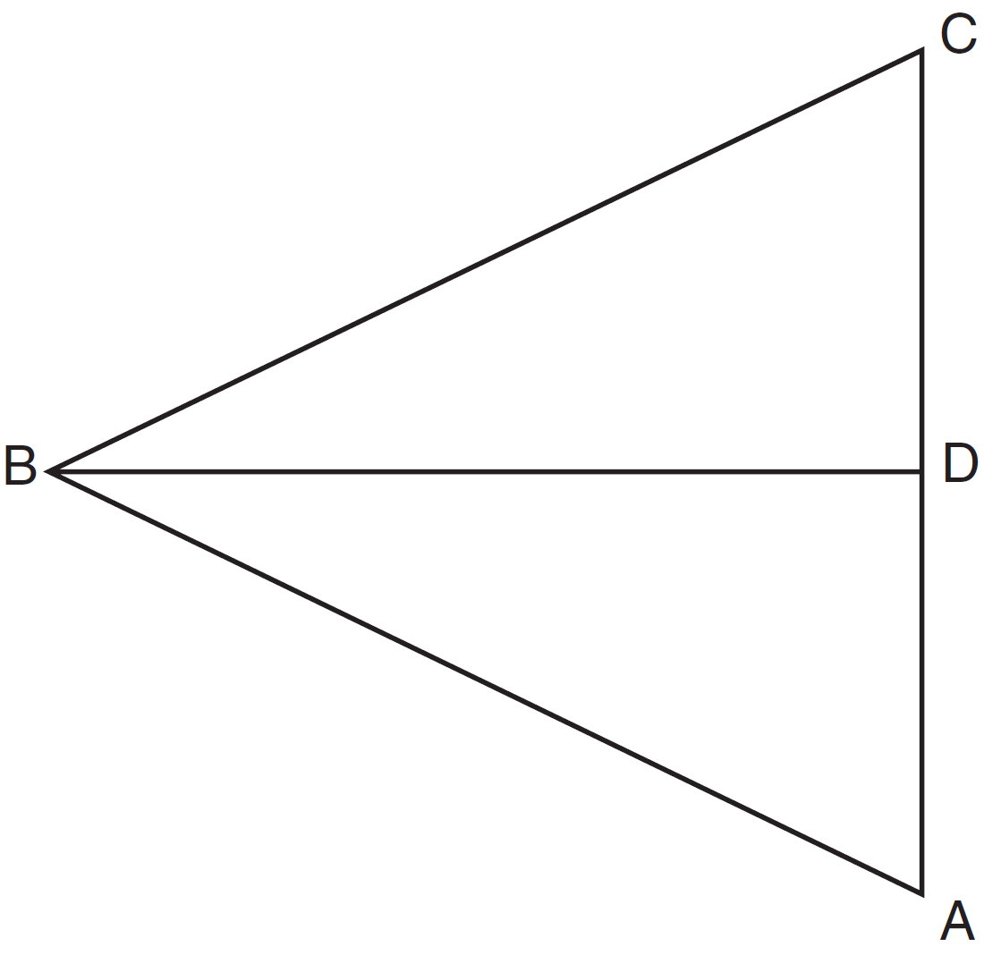

36 Quadrilateral MATH has coordinates , , , and . The image of quadrilateral MATH after the composition is quadrilateral . State and label the coordinates of . [The use of the set of axes below is optional.]

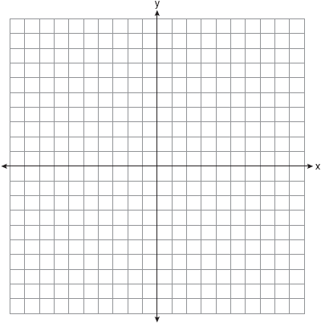

37 Trapezoid TRAP, with median , is shown in the diagram below. Solve algebraically for x and y.

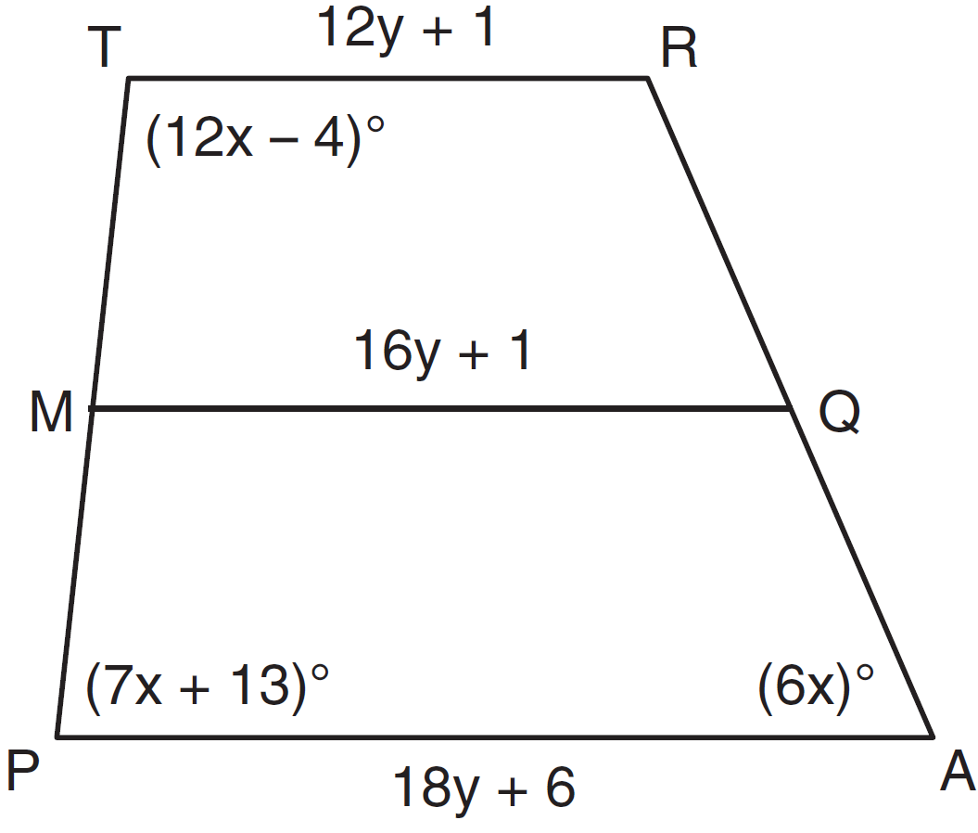

38 Quadrilateral ABCD with vertices , ,, and is graphed on the set of axes below. Quadrilateral MNPQ is formed by joining M, N, P, and Q, the midpoints of , , , and , respectively. Prove that quadrilateral MNPQ is a parallelogram. Prove that quadrilateral MNPQ is not a rhombus.

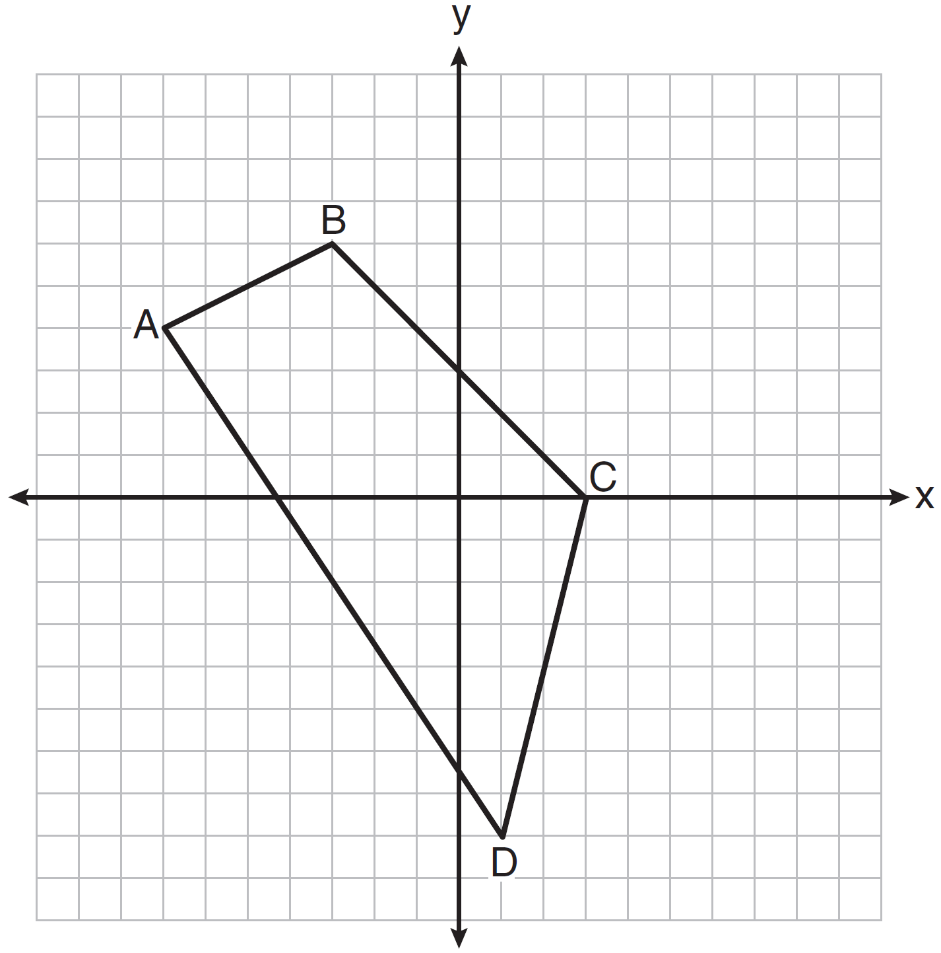
1 ANS: 2 PTS: 2 REF: 081301ge STA: G.G.24
TOP: Statements

2 ANS: 1
Parallel chords intercept congruent arcs. . 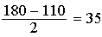.

PTS: 2 REF: 081302ge STA: G.G.52 TOP: Chords

3 ANS: 1 PTS: 2 REF: 081303ge STA: G.G.24
TOP: Negations

4 ANS: 4
Distance is preserved after a rotation.

PTS: 2 REF: 081304ge STA: G.G.55 TOP: Properties of Transformations

5 ANS: 4 PTS: 2 REF: 081305ge STA: G.G.71
TOP: Equations of Circles

6 ANS: 2 PTS: 2 REF: 081306ge STA: G.G.34
TOP: Angle Side Relationship

7 ANS: 3
The centroid divides each median into segments whose lengths are in the ratio 2 : 1.

PTS: 2 REF: 081307ge STA: G.G.43 TOP: Centroid

8 ANS: 4 PTS: 2 REF: 081308ge STA: G.G.49
TOP: Chords

9 ANS: 3 PTS: 2 REF: 081309ge STA: G.G.29
TOP: Triangle Congruency

10 ANS: 4
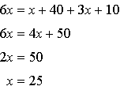.

PTS: 2 REF: 081310ge STA: G.G.32 TOP: Exterior Angle Theorem

11 ANS: 2 PTS: 2 REF: 081311ge STA: G.G.10
TOP: Solids

12 ANS: 3 PTS: 2 REF: 081312ge STA: G.G.72
TOP: Equations of Circles

13 ANS: 4 PTS: 2 REF: 081313ge STA: G.G.19
TOP: Constructions

14 ANS: 3
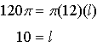

PTS: 2 REF: 081314ge STA: G.G.15 TOP: Volume and Lateral Area

15 ANS: 4
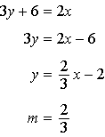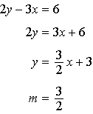

PTS: 2 REF: 081315ge STA: G.G.63 TOP: Parallel and Perpendicular Lines

16 ANS: 2 PTS: 2 REF: 081316ge STA: G.G.23
TOP: Locus

17 ANS: 3
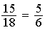

PTS: 2 REF: 081317ge STA: G.G.45 TOP: Similarity
KEY: perimeter and area

18 ANS: 4 PTS: 2 REF: 081318ge STA: G.G.26
TOP: Converse and Biconditional

19 ANS: 2
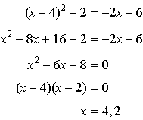. 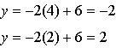

PTS: 2 REF: 081319ge STA: G.G.70 TOP: Quadratic-Linear Systems

20 ANS: 3 PTS: 2 REF: 081320ge STA: G.G.42
TOP: Midsegments

21 ANS: 1
If two prisms have equal heights and volume, the area of their bases is equal.

PTS: 2 REF: 081321ge STA: G.G.11 TOP: Volume

22 ANS: 4
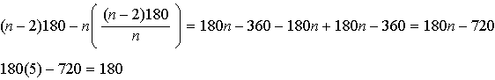.

PTS: 2 REF: 081322ge STA: G.G.37 TOP: Interior and Exterior Angles of Polygons

23 ANS: 1 PTS: 2 REF: 081323ge STA: G.G.9
TOP: Planes

24 ANS: 1 PTS: 2 REF: 081324ge STA: G.G.74
TOP: Graphing Circles

25 ANS: 2
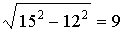

PTS: 2 REF: 081325ge STA: G.G.50 TOP: Tangents
KEY: point of tangency

26 ANS: 3
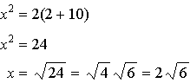

PTS: 2 REF: 081326ge STA: G.G.47 TOP: Similarity
KEY: leg

27 ANS: 3
midpoint: 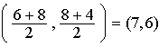. slope: 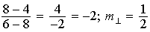. 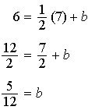

PTS: 2 REF: 081327ge STA: G.G.68 TOP: Perpendicular Bisector

28 ANS: 1
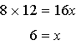

PTS: 2 REF: 081328ge STA: G.G.53 TOP: Segments Intercepted by Circle
KEY: two chords

29 ANS:

PTS: 2 REF: 081329ge STA: G.G.58 TOP: Dilations

30 ANS:
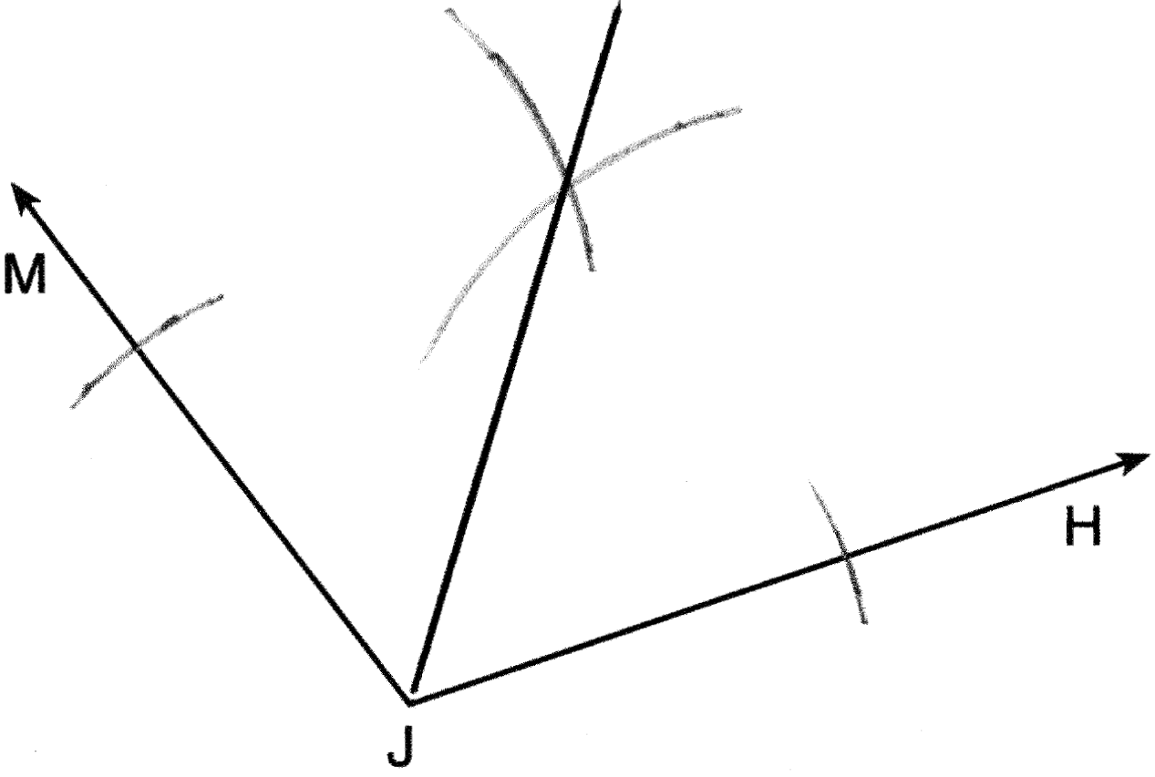

PTS: 2 REF: 081330ge STA: G.G.17 TOP: Constructions

31 ANS:

PTS: 2 REF: 081331ge STA: G.G.67 TOP: Distance

32 ANS:
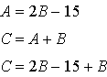. 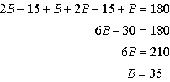

PTS: 2 REF: 081332ge STA: G.G.30 TOP: Interior and Exterior Angles of Triangles

33 ANS:
center: ; radius:

PTS: 2 REF: 081333ge STA: G.G.73 TOP: Equations of Circles

34 ANS:
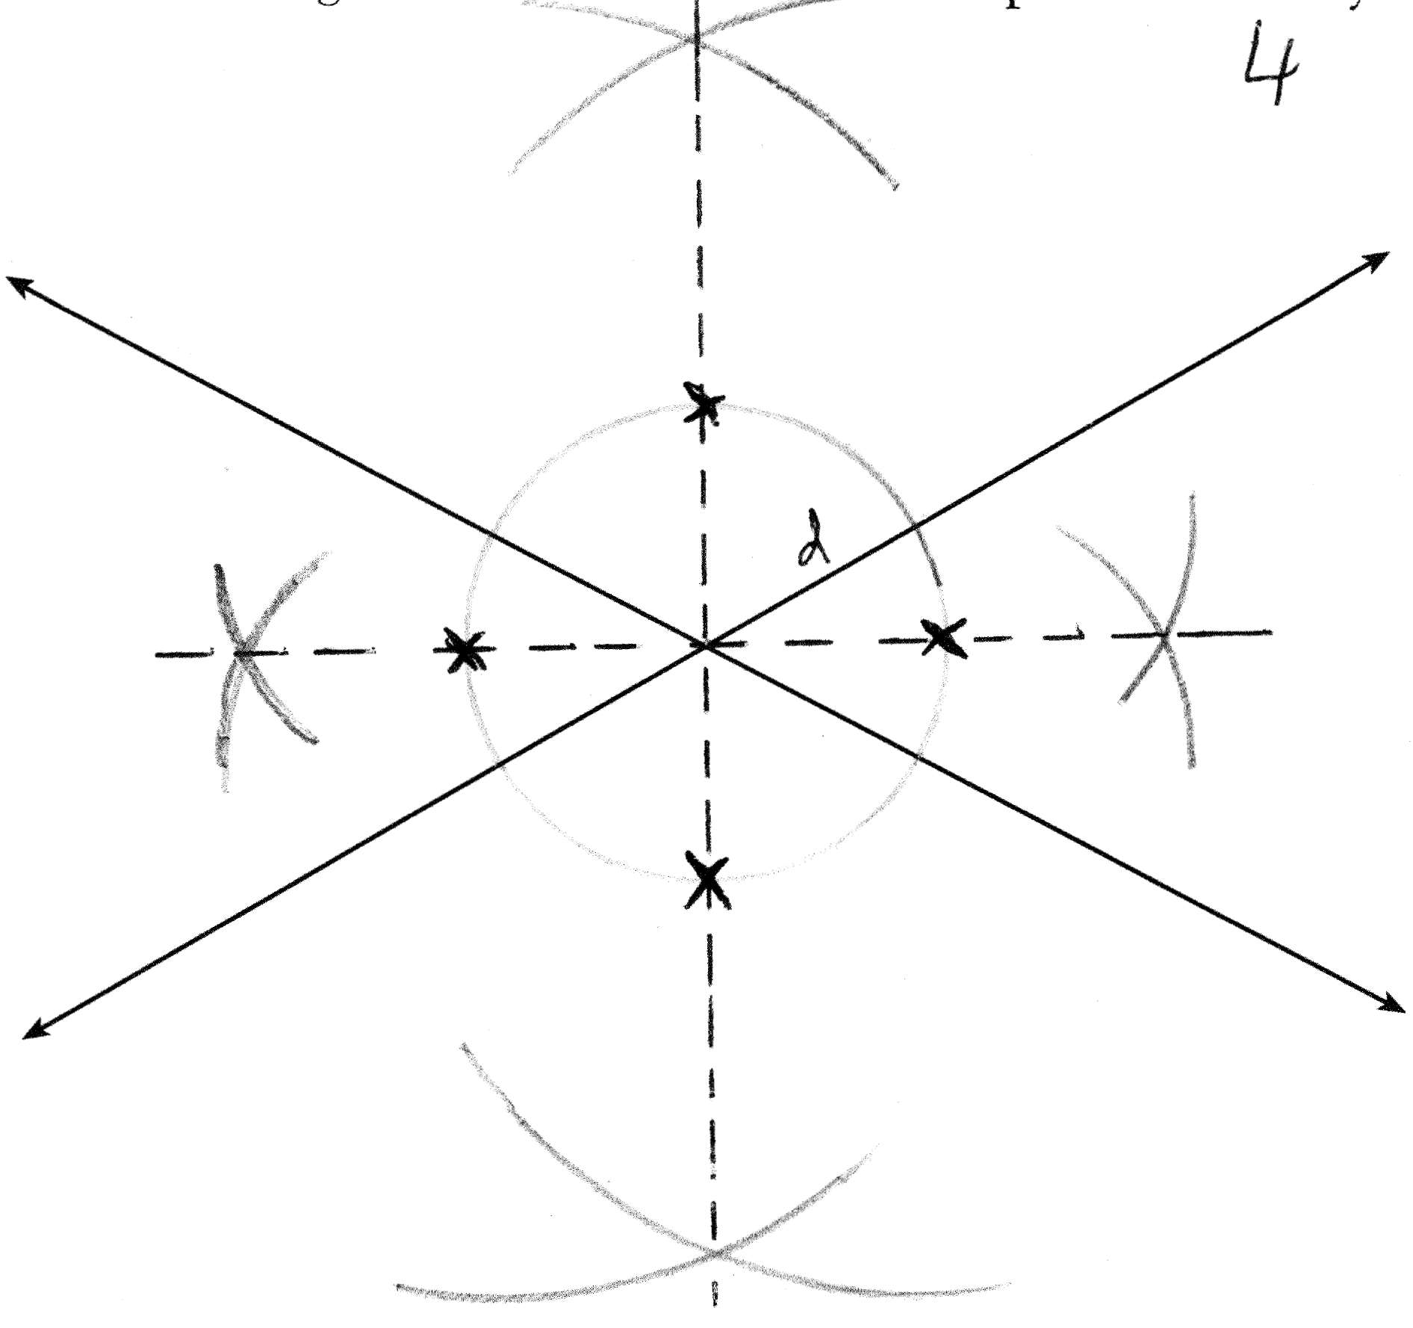

PTS: 2 REF: 081334ge STA: G.G.22 TOP: Locus

35 ANS:
, bisects , (Given). (Definition of angle bisector). (Reflexive property). and are right angles (Definition of perpendicular). (All right angles are congruent). (SAS). (CPCTC).

PTS: 4 REF: 081335ge STA: G.G.27 TOP: Triangle Proofs

36 ANS:
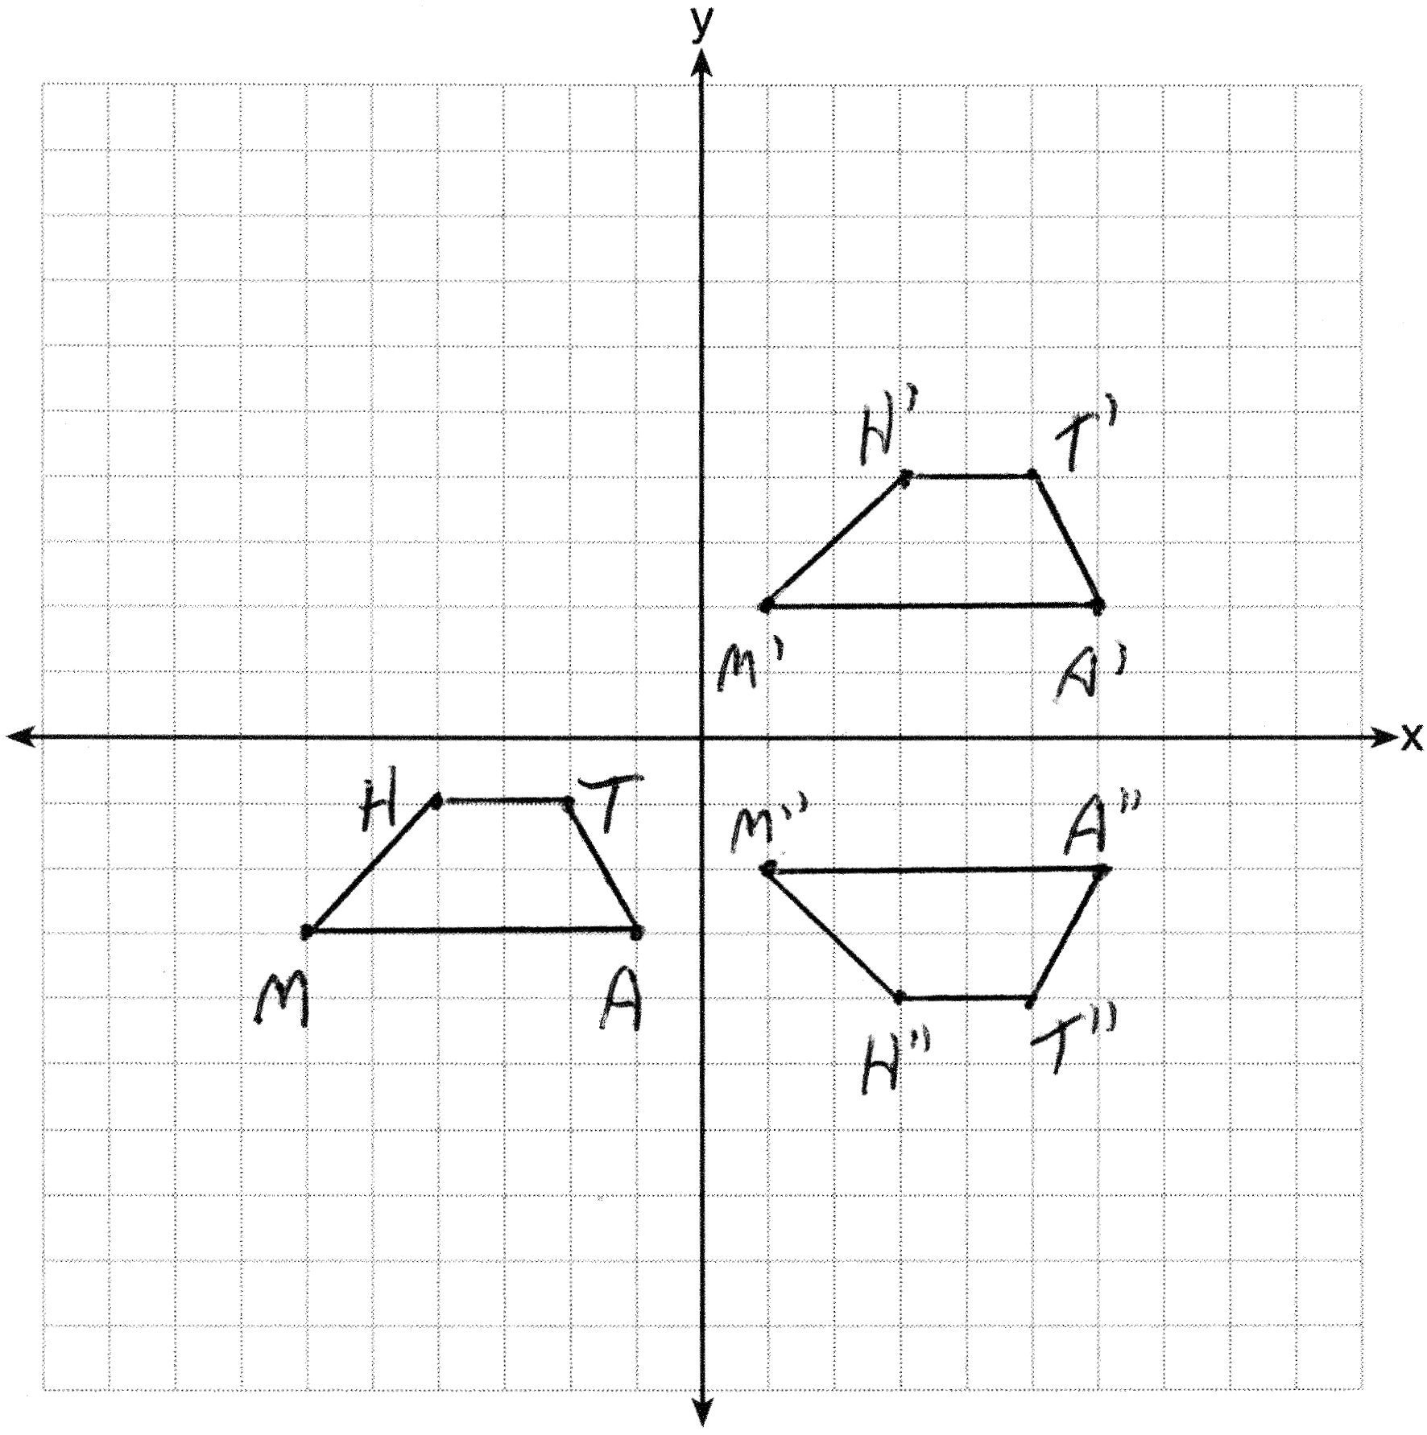

PTS: 4 REF: 081336ge STA: G.G.58 TOP: Compositions of Transformations
KEY: grids

37 ANS:
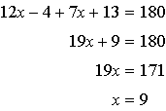. 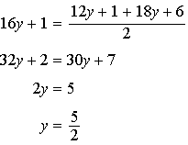

PTS: 4 REF: 081337ge STA: G.G.40 TOP: Trapezoids

38 ANS:
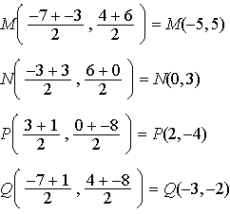. 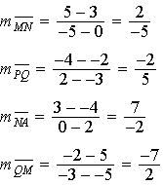. Since both opposite sides have equal slopes and are parallel, MNPQ is a parallelogram. 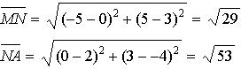. is not congruent to , so MNPQ is not a rhombus since not all sides are congruent. 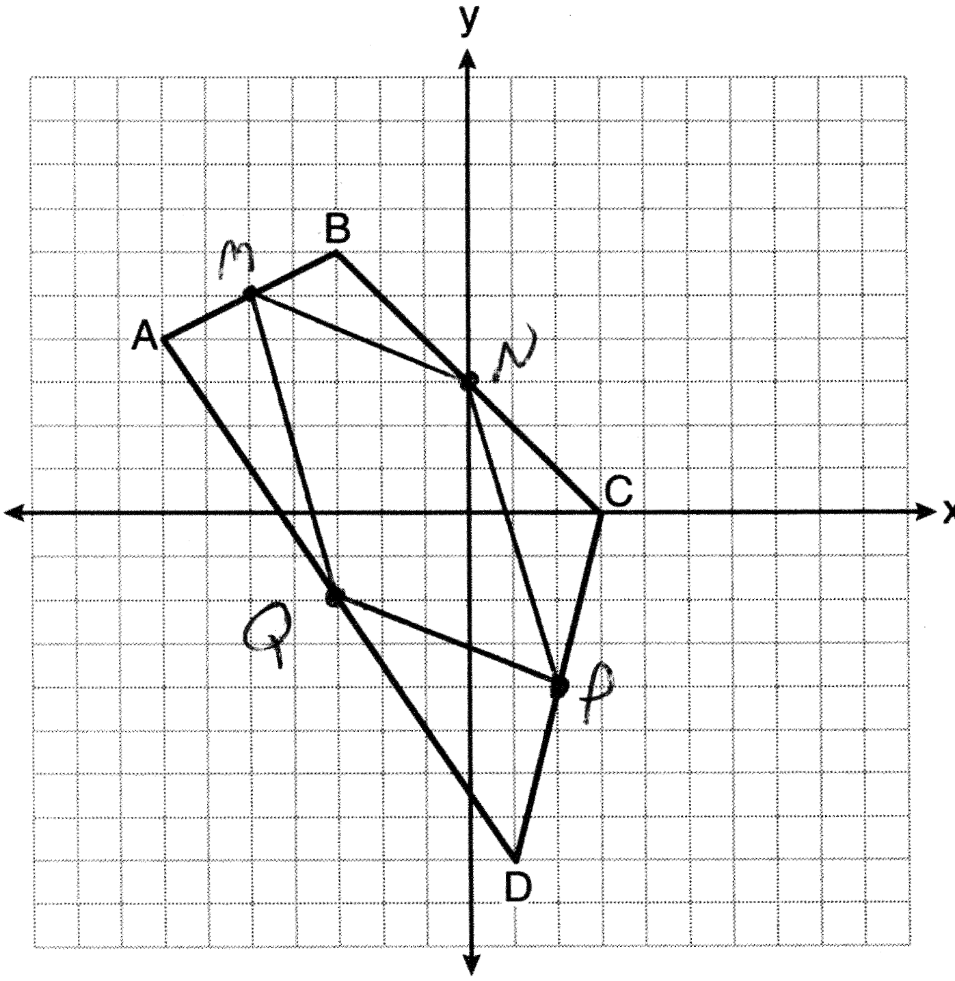

PTS: 6 REF: 081338ge STA: G.G.

