1 In the diagram below of circle O, chord is parallel to chord . Chord intersects at E and at F.

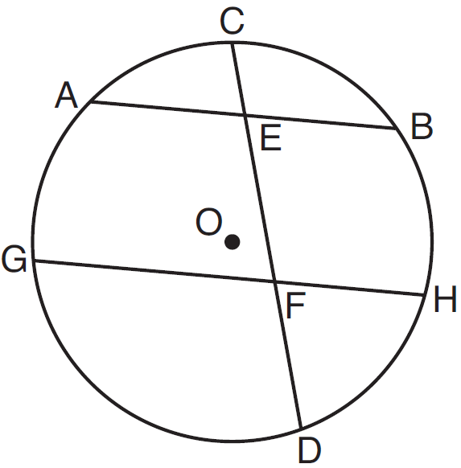

Which statement must always be true?
1)
2)
3)
4)

2 The vertices of parallelogram ABCD are , , , and . If ABCD is reflected over the x-axis, how many vertices remain invariant?
1) | 1
2) | 2
3) | 3
4) | 0

3 Point M is the midpoint of . If the coordinates of A are and the coordinates of M are , what are the coordinates of B?
1)
2)
3)
4)

4 When a dilation is performed on a hexagon, which property of the hexagon will not be preserved in its image?
1) | parallelism
2) | orientation
3) | length of sides
4) | measure of angles

5 As shown in the diagram below of , a compass is used to find points D and E, equidistant from point A. Next, the compass is used to find point F, equidistant from points D and E. Finally, a straightedge is used to draw . Then, point G, the intersection of and side of , is labeled.

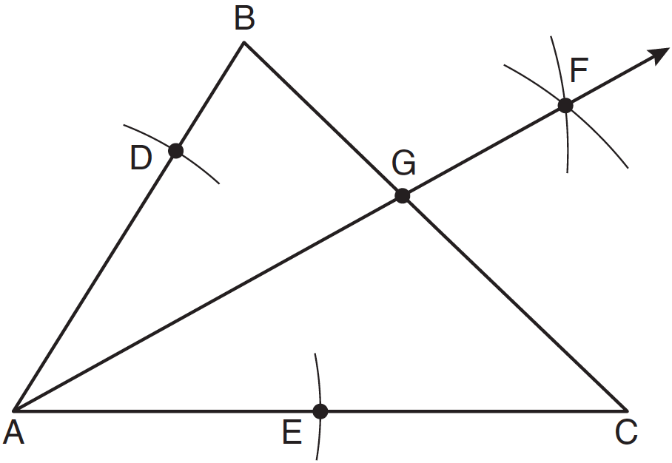
Which statement must be true?
1) | bisects side
2) | bisects
3)
4)

6 In the diagram of below, and . Line segment MS connects points M and S on the triangle, such that .

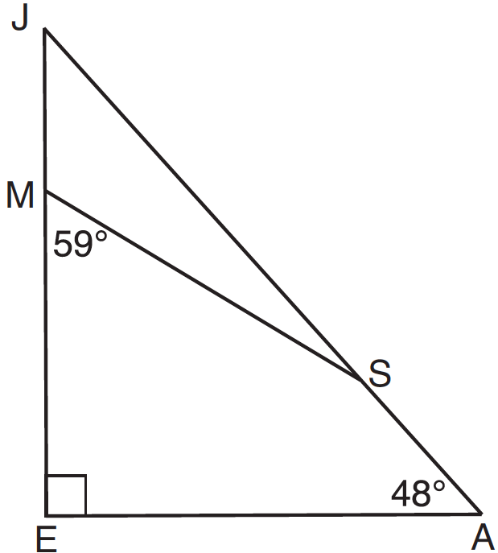

What is ?
1) | 163
2) | 121
3) | 42
4) | 17

7 In with shown in the diagram below, and are drawn.

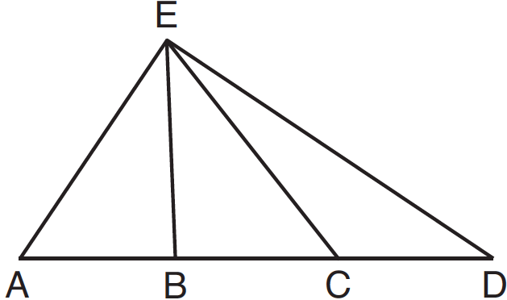

If , which statement could always be proven?
1)
2)
3)
4)

8 Given that ABCD is a parallelogram, a student wrote the proof below to show that a pair of its opposite angles are congruent.

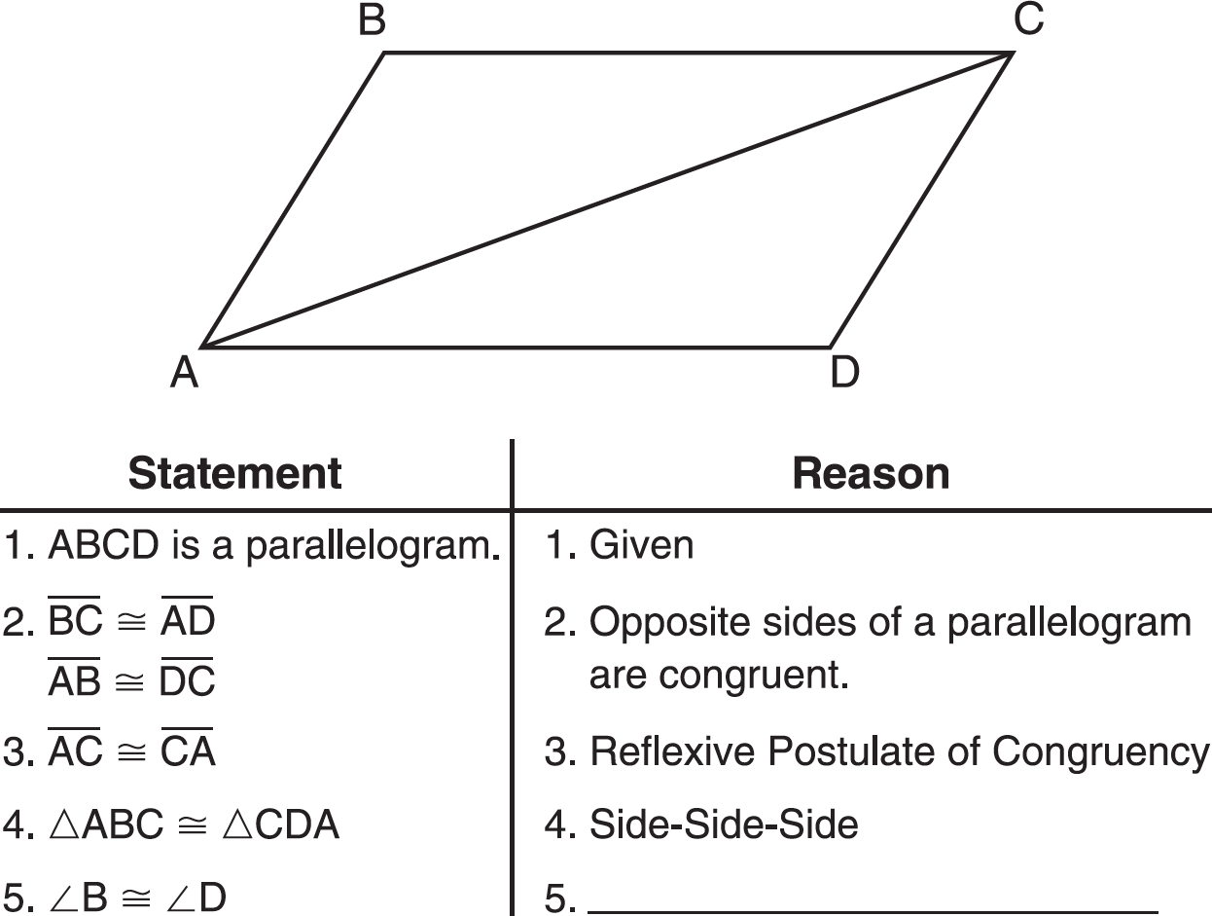

What is the reason justifying that ?
1) | Opposite angles in a quadrilateral are congruent.
2) | Parallel lines have congruent corresponding angles.
3) | Corresponding parts of congruent triangles are congruent.
4) | Alternate interior angles in congruent triangles are congruent.

9 The equation of a circle with its center at and a radius of 4 is
1)
2)
3)
4)

10 In the diagram below of and , and intersect at E, such that and .

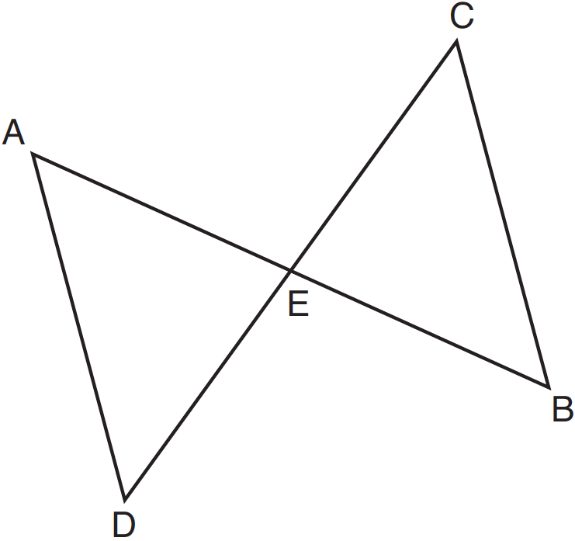

Triangle DAE can be proved congruent to triangle BCE by
1) | ASA
2) | SAS
3) | SSS
4) | HL

11 As shown in the diagram below, is contained in plane R, and are contained in plane S, and , , and intersect at A.

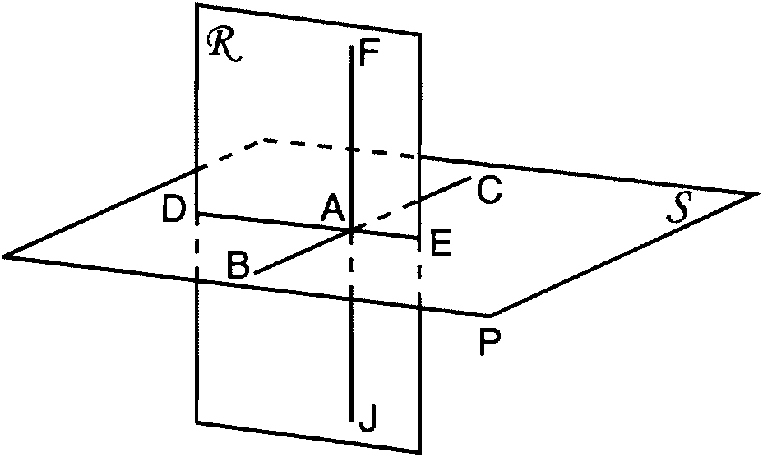

Which fact is sufficient to show that planes R and S are perpendicular?
1)
2)
3)
4)

12 What is an equation of the circle shown in the graph below?

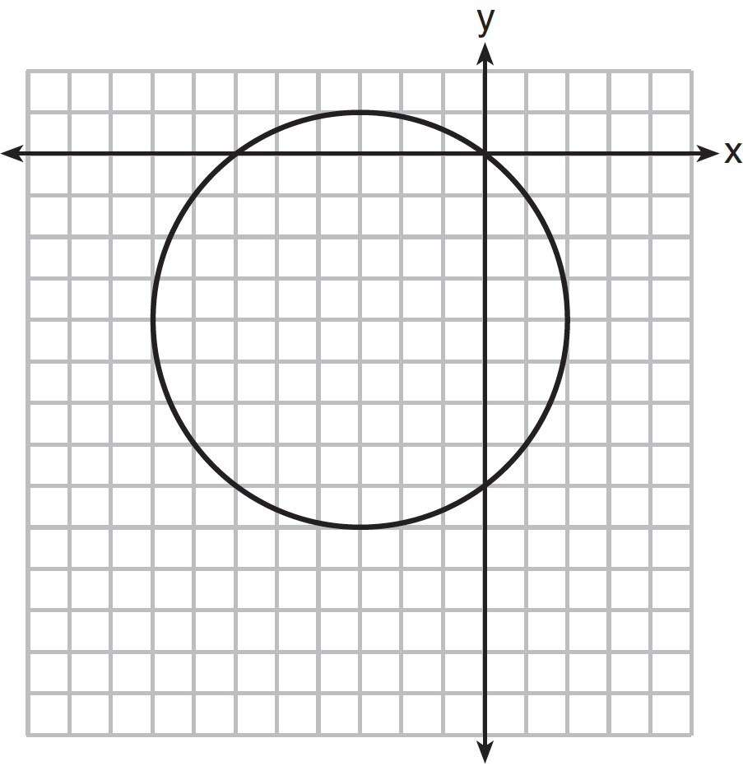
1)
2)
3)
4)

13 As shown in the diagram below, lines m and n are cut by transversal p.

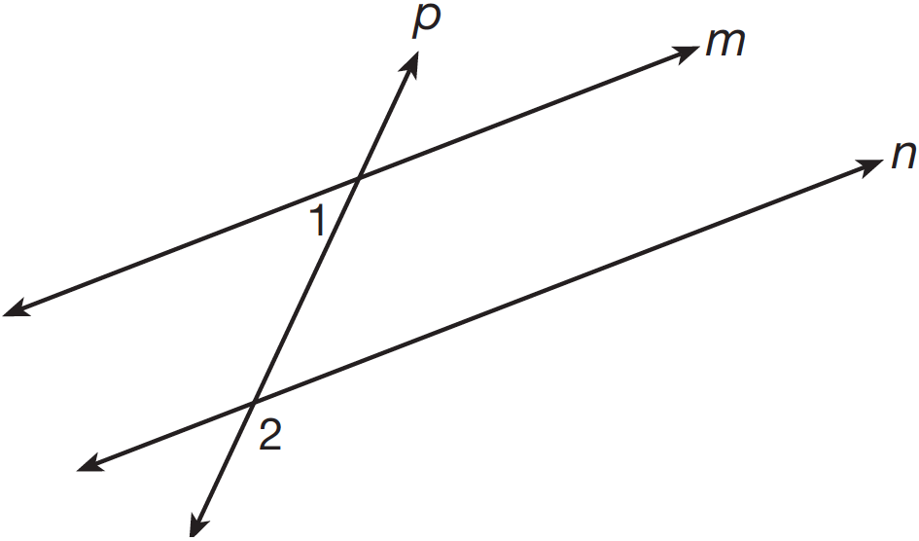

If and , lines m and n are parallel when x equals
1) | 1
2) | 6
3) | 13
4) | 17

14 The angle formed by the radius of a circle and a tangent to that circle has a measure of
1) | 45°
2) | 90°
3) | 135°
4) | 180°

15 A sphere is inscribed inside a cube with edges of 6 cm. In cubic centimeters, what is the volume of the sphere, in terms of ?
1) | 12π
2) | 36π
3) | 48π
4) | 288π

16 Scalene triangle ABC is similar to triangle DEF. Which statement is false?
1)
2)
3)
4)

17 Which equation represents a line that is parallel to the line whose equation is 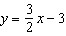 and passes through the point ?
1) | 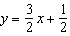
2) | 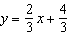
3) | 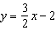
4) | 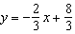

18 Lines a and b intersect at point P. Line c passes through P and is perpendicular to the plane containing lines a and b. Which statement must be true?
1) | Lines a, b, and c are coplanar.
2) | Line a is perpendicular to line b.
3) | Line c is perpendicular to both line a and line b.
4) | Line c is perpendicular to line a or line b, but not both.

19 As shown in the diagram of below, B is a point on and is drawn.

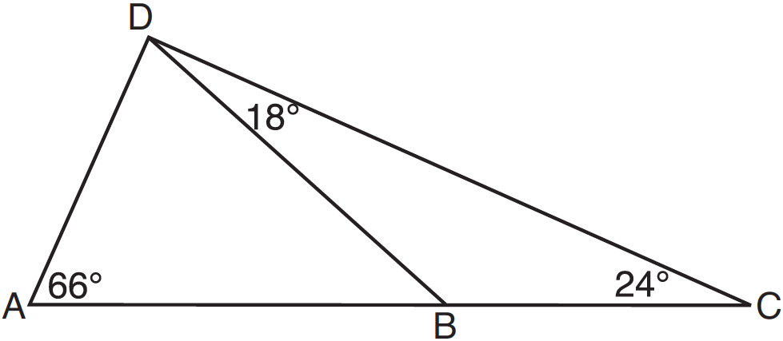

If , , and , what is the longest side of ?
1)
2)
3)
4)

20 In shown below, P is the centroid and .

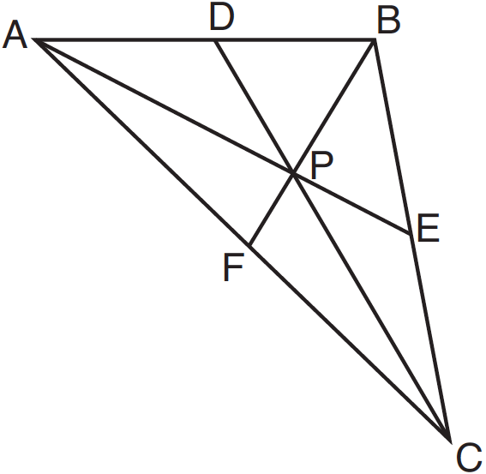

What is the length of ?
1) | 6
2) | 9
3) | 3
4) | 12

21 In the diagram below, is the median of trapezoid ABCD.

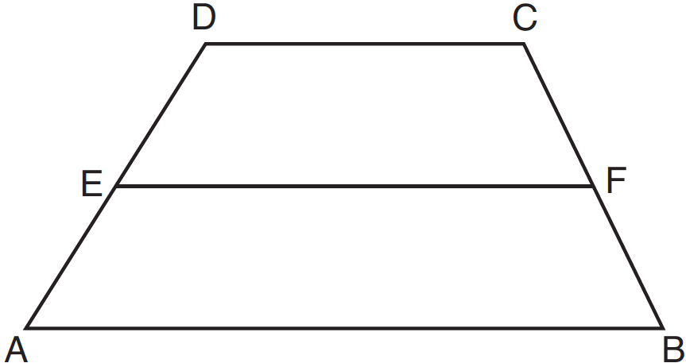

If , , and , what is the value of x?
1) | 5
2) | 2
3) | 7
4) | 8

22 In the diagram below of , , , and .

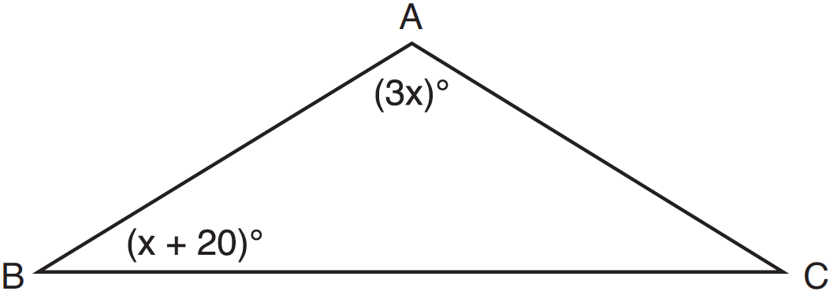

What is the value of x?
1) | 10
2) | 28
3) | 32
4) | 40

23 For which polygon does the sum of the measures of the interior angles equal the sum of the measures of the exterior angles?
1) | hexagon
2) | pentagon
3) | quadrilateral
4) | triangle

24 For a triangle, which two points of concurrence could be located outside the triangle?
1) | incenter and centroid
2) | centroid and orthocenter
3) | incenter and circumcenter
4) | circumcenter and orthocenter

25 The slope of line is . What is an equation of a line that is perpendicular to line ?
1) | 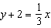
2)
3)
4)

26 Which type of triangle can be drawn using the points , , and ?
1) | scalene
2) | isosceles
3) | equilateral
4) | no triangle can be drawn

27 In the diagram below, joins the midpoints of two sides of .

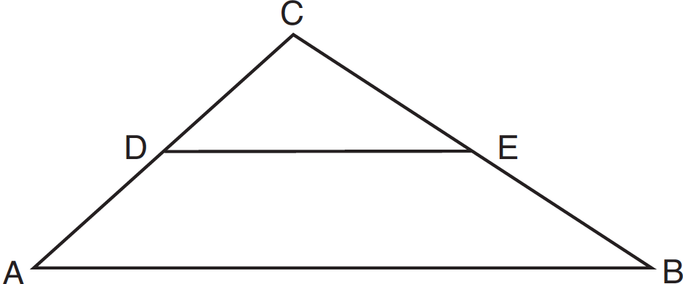

Which statement is not true?
1) | 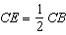
2) | 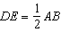
3) | area of 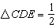 area of
4) | perimeter of perimeter of

28 Which equation represents the line that is perpendicular to and passes through the point ?
1) | 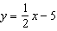
2) | 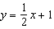
3)
4)

29 Write the negation of the statement “2 is a prime number,” and determine the truth value of the negation.

30 The coordinates of the vertices of are , , and . State the coordinates of , the image of after a rotation of 90º about the origin. [The use of the set of axes below is optional.]

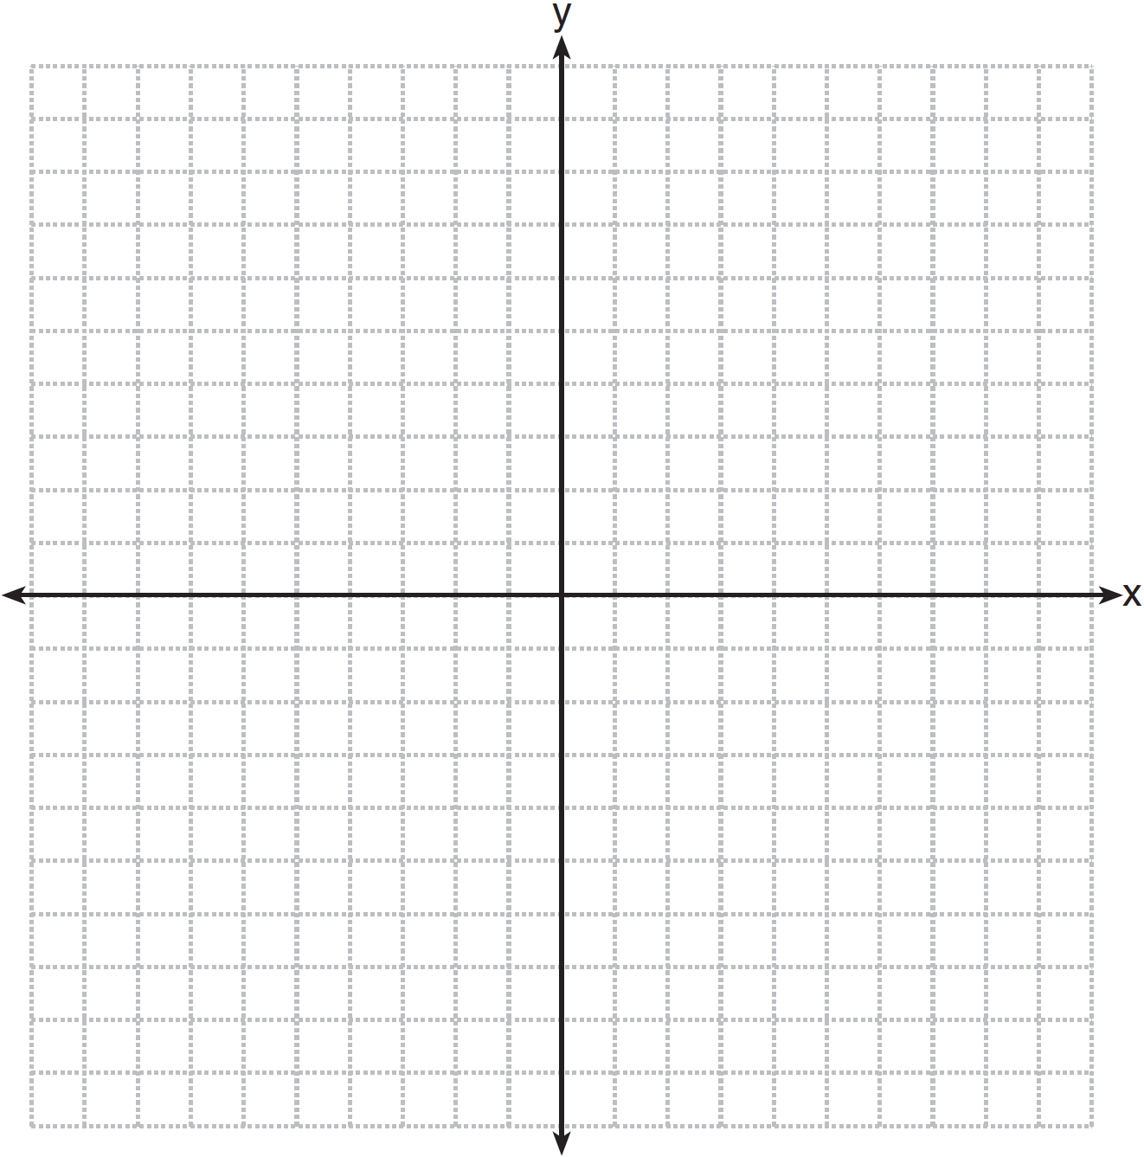

31 A cylinder has a height of 7 cm and a base with a diameter of 10 cm. Determine the volume, in cubic centimeters, of the cylinder in terms of .

32 The coordinates of the endpoints of are and . Find the length of in simplest radical form.

33 Using a compass and straightedge, construct a line perpendicular to through point P. [Leave all construction marks.]

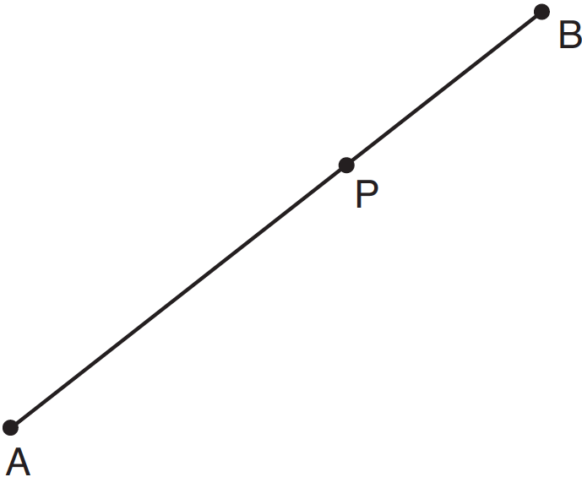

34 The graph below shows the locus of points equidistant from the x-axis and y-axis. On the same set of axes, graph the locus of points 3 units from the line . Label with an X all points that satisfy both conditions.

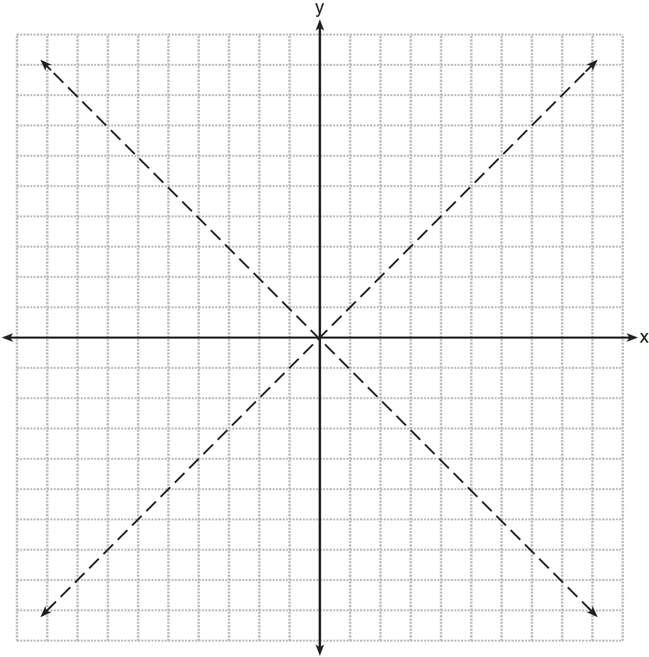

35 As shown in the diagram below, the diagonals of parallelogram QRST intersect at E. If , , and , determine TE algebraically.

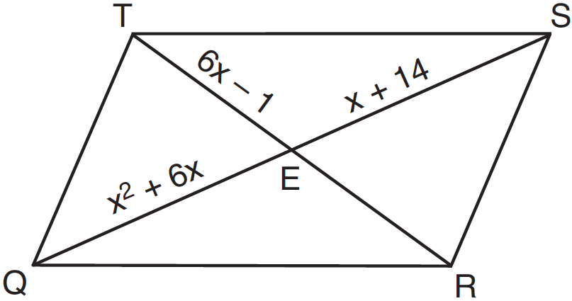

36 The vertices of are , , and . The image of after the composition is . State the coordinates of . [The use of the set of axes below is optional.]

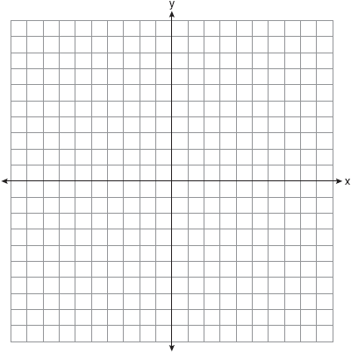

37 On the set of axes below, solve the following system of equations graphically and state the coordinates of all points in the solution.
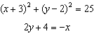

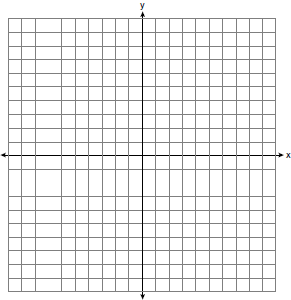

38 Chords and intersect at E in circle O, as shown in the diagram below. Secant and tangent are drawn to circle O from external point F and chord is drawn. The , , and the ratio of .

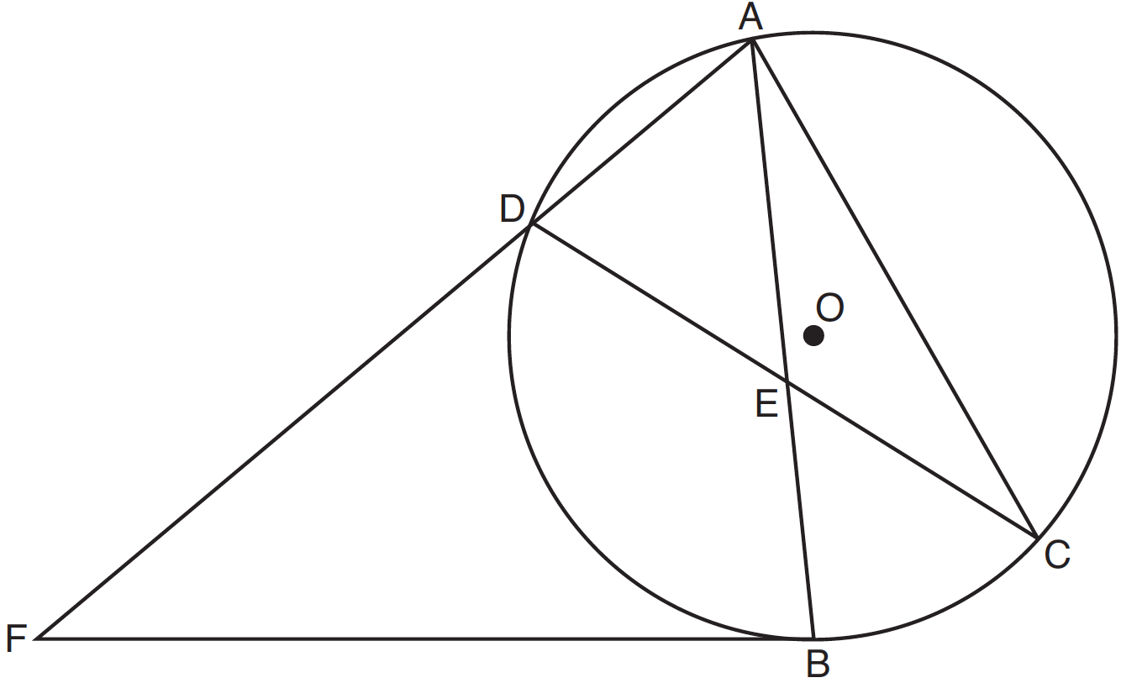

Determine . Determine . Determine .
1 ANS: 4
Parallel lines intercept congruent arcs.

PTS: 2 REF: 081201ge STA: G.G.52 TOP: Chords

2 ANS: 2 PTS: 2 REF: 081202ge STA: G.G.55
TOP: Properties of Transformations

3 ANS: 4
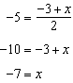. 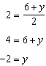

PTS: 2 REF: 081203ge STA: G.G.66 TOP: Midpoint

4 ANS: 3 PTS: 2 REF: 081204ge STA: G.G.59
TOP: Properties of Transformations

5 ANS: 2 PTS: 2 REF: 081205ge STA: G.G.17
TOP: Constructions

6 ANS: 4 PTS: 2 REF: 081206ge STA: G.G.30
TOP: Interior and Exterior Angles of Triangles

7 ANS: 1
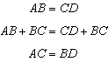

PTS: 2 REF: 081207ge STA: G.G.27 TOP: Line Proofs

8 ANS: 3 PTS: 2 REF: 081208ge STA: G.G.27
TOP: Quadrilateral Proofs

9 ANS: 3 PTS: 2 REF: 081209ge STA: G.G.71
TOP: Equations of Circles

10 ANS: 1
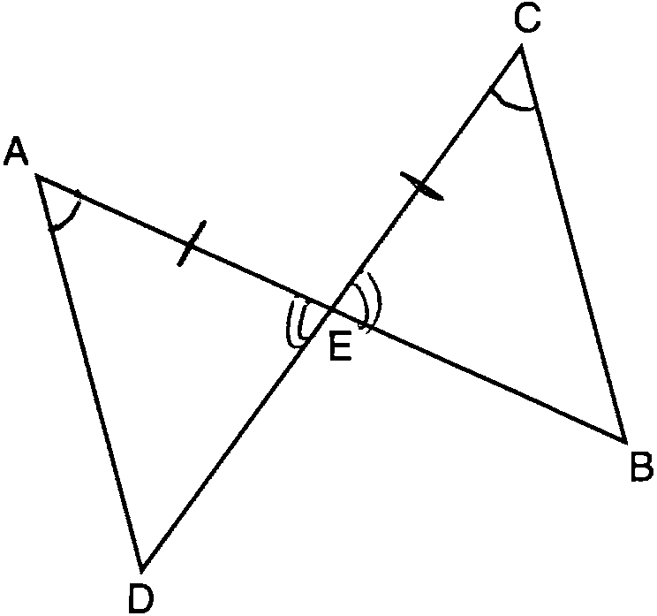

PTS: 2 REF: 081210ge STA: G.G.28 TOP: Triangle Congruency

11 ANS: 3
As originally administered, this question read, “Which fact is not sufficient to show that planes R and S are perpendicular?” The State Education Department stated that since a correct solution was not provided for Question 11, all students shall be awarded credit for this question.

PTS: 2 REF: 081211ge STA: G.G.5 TOP: Planes

12 ANS: 2 PTS: 2 REF: 081212ge STA: G.G.72
TOP: Equations of Circles

13 ANS: 3
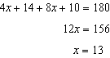

PTS: 2 REF: 081213ge STA: G.G.35 TOP: Parallel Lines and Transversals

14 ANS: 2 PTS: 2 REF: 081214ge STA: G.G.50
TOP: Tangents KEY: point of tangency

15 ANS: 2
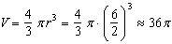

PTS: 2 REF: 081215ge STA: G.G.16 TOP: Volume and Surface Area

16 ANS: 4 PTS: 2 REF: 081216ge STA: G.G.45
TOP: Similarity KEY: basic

17 ANS: 1
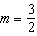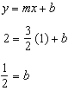

PTS: 2 REF: 081217ge STA: G.G.65 TOP: Parallel and Perpendicular Lines

18 ANS: 3 PTS: 2 REF: 081218ge STA: G.G.1
TOP: Planes

19 ANS: 1
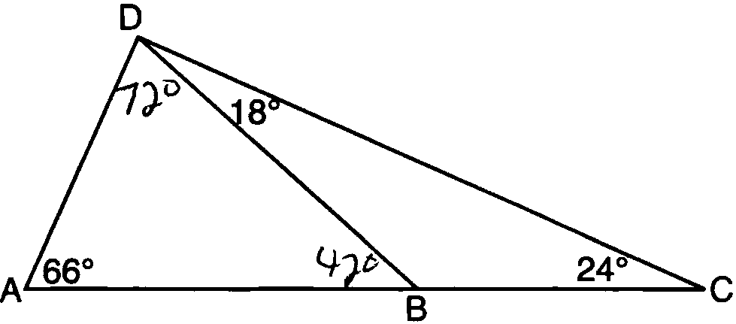

PTS: 2 REF: 081219ge STA: G.G.34 TOP: Angle Side Relationship

20 ANS: 4
The centroid divides each median into segments whose lengths are in the ratio 2 : 1.

PTS: 2 REF: 081220ge STA: G.G.43 TOP: Centroid

21 ANS: 1
The length of the midsegment of a trapezoid is the average of the lengths of its bases. 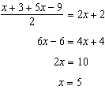.

PTS: 2 REF: 081221ge STA: G.G.40 TOP: Trapezoids

22 ANS: 2
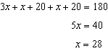

PTS: 2 REF: 081222ge STA: G.G.31 TOP: Isosceles Triangle Theorem

23 ANS: 3
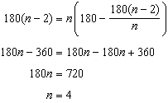

PTS: 2 REF: 081223ge STA: G.G.36 TOP: Interior and Exterior Angles of Polygons

24 ANS: 4 PTS: 2 REF: 081224ge STA: G.G.21
TOP: Centroid, Orthocenter, Incenter and Circumcenter

25 ANS: 3
The slope of is 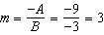, which is the opposite reciprocal of .

PTS: 2 REF: 081225ge STA: G.G.62 TOP: Parallel and Perpendicular Lines

26 ANS: 2 PTS: 2 REF: 081226ge STA: G.G.69
TOP: Triangles in the Coordinate Plane

27 ANS: 3 PTS: 2 REF: 081227ge STA: G.G.42
TOP: Midsegments

28 ANS: 3
The slope of is , which is the opposite reciprocal of . 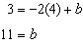

PTS: 2 REF: 081228ge STA: G.G.64 TOP: Parallel and Perpendicular Lines

29 ANS:
2 is not a prime number, false.

PTS: 2 REF: 081229ge STA: G.G.24 TOP: Negations

30 ANS:
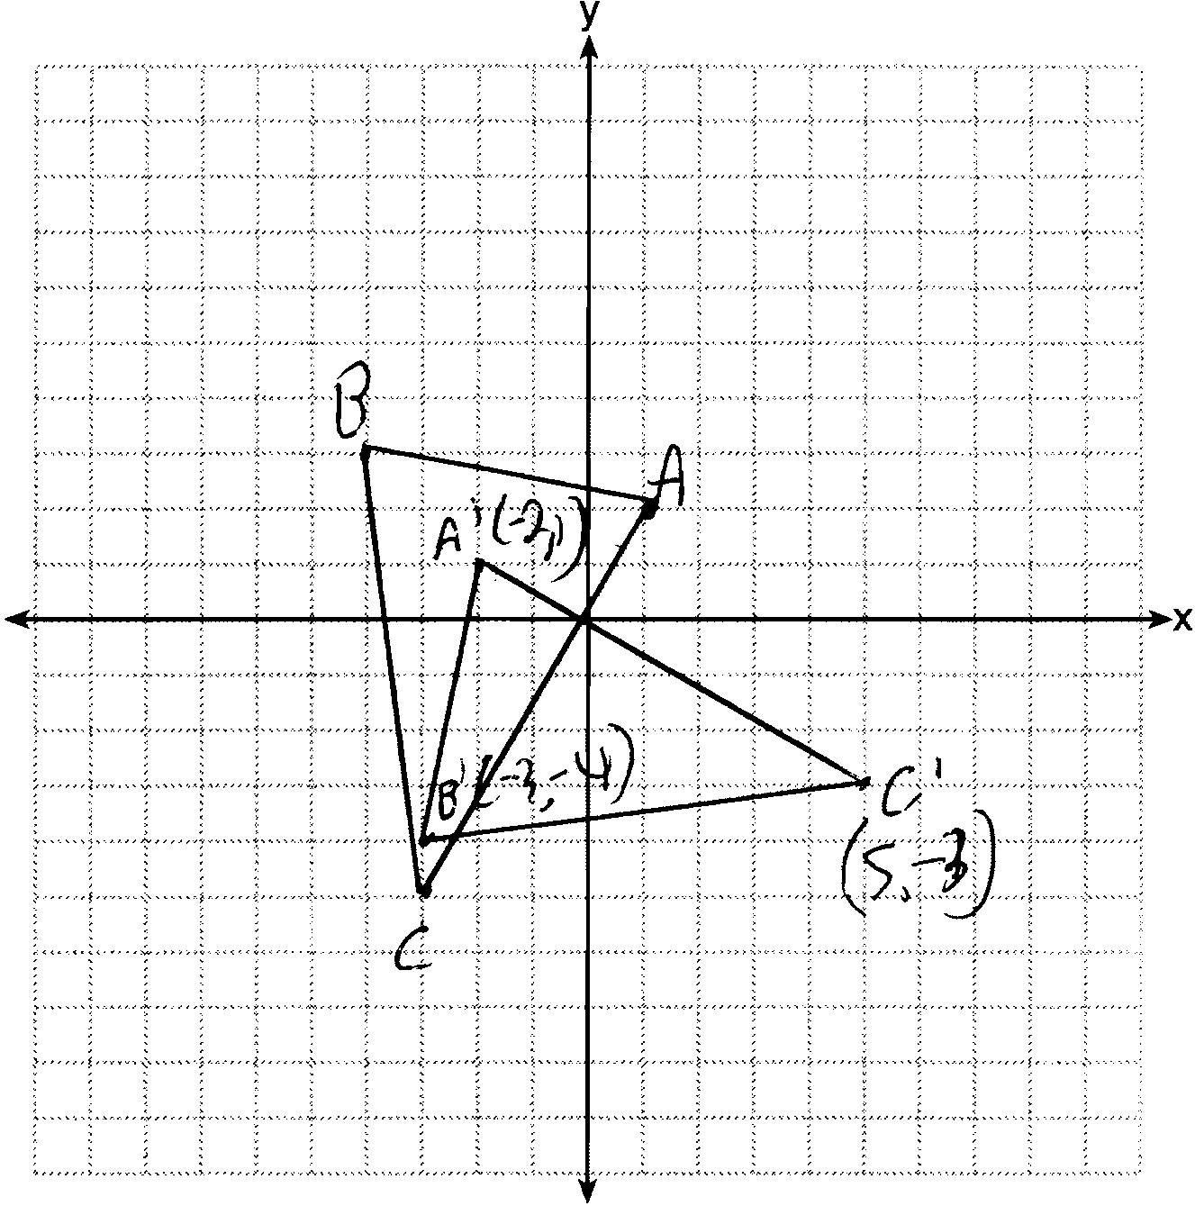 , , and

PTS: 2 REF: 081230ge STA: G.G.54 TOP: Rotations

31 ANS:

PTS: 2 REF: 081231ge STA: G.G.14 TOP: Volume and Lateral Area

32 ANS:
.

PTS: 2 REF: 081232ge STA: G.G.67 TOP: Distance

33 ANS:
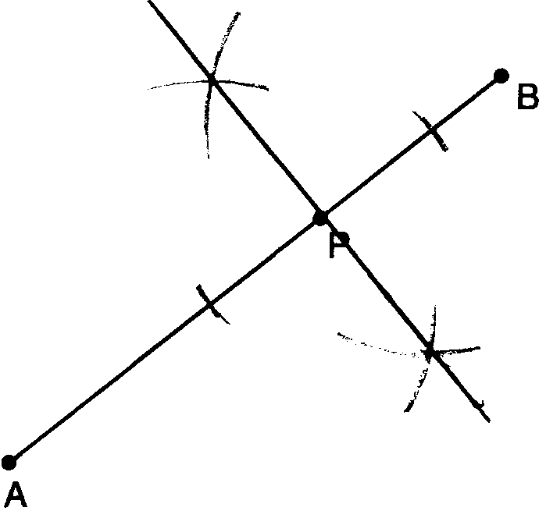

PTS: 2 REF: 081233ge STA: G.G.19 TOP: Constructions

34 ANS:
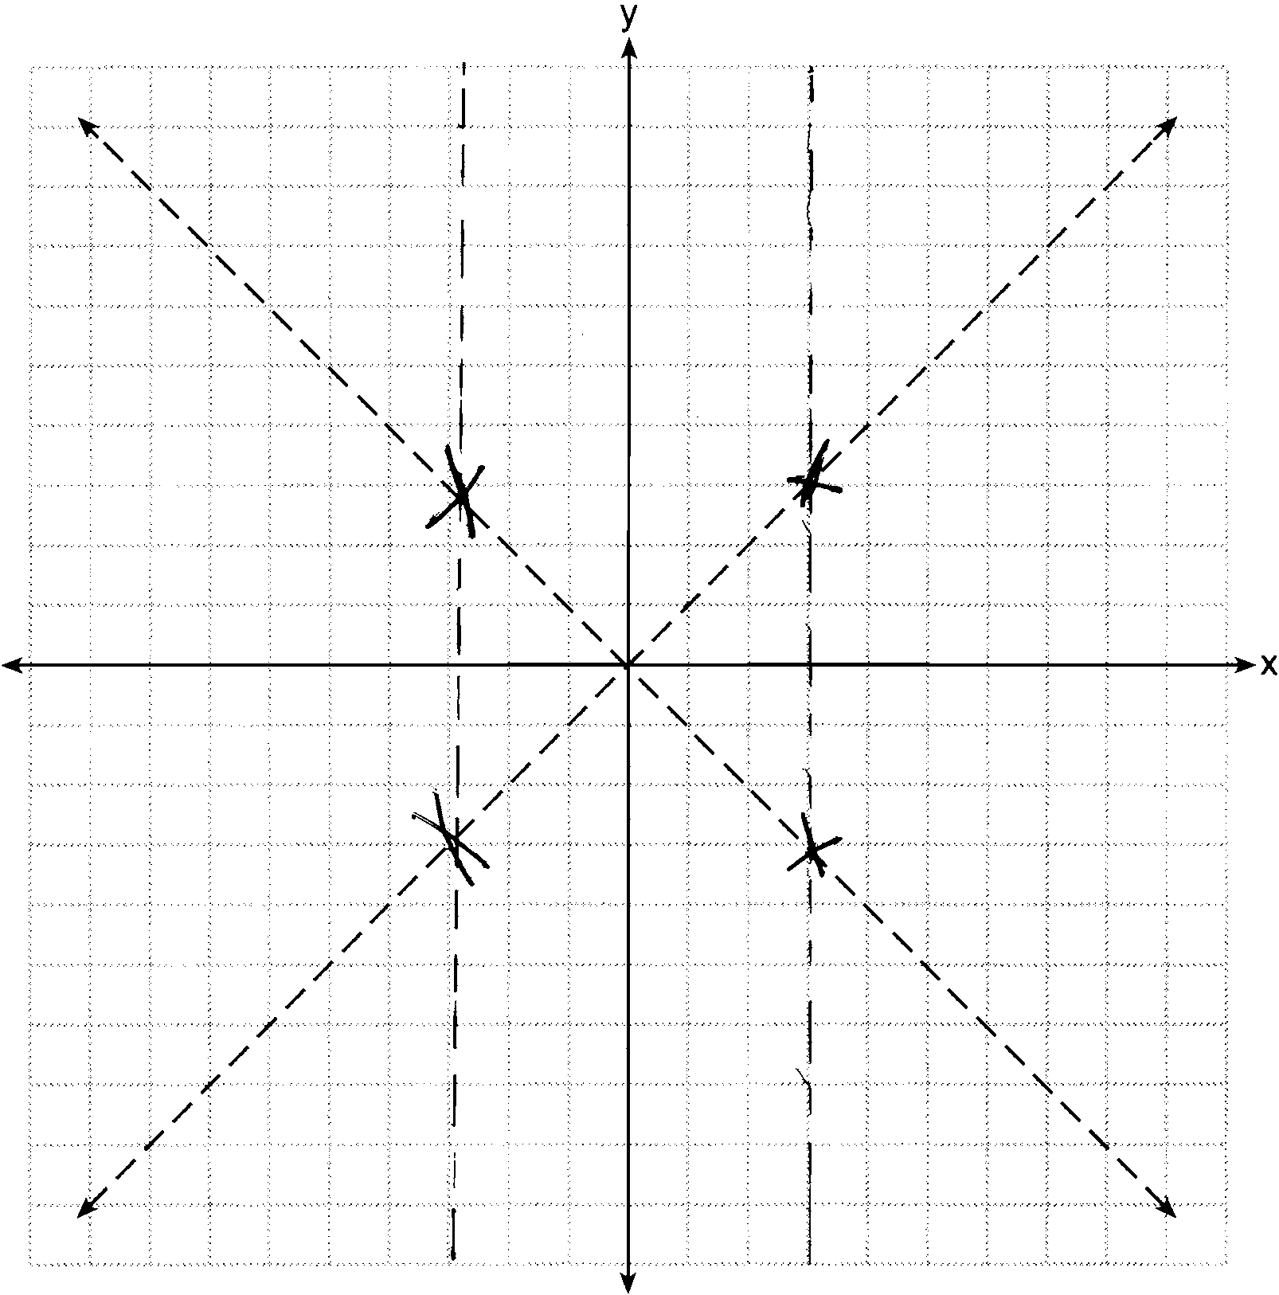

PTS: 2 REF: 081234ge STA: G.G.23 TOP: Locus

35 ANS:
11. 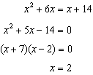.

PTS: 2 REF: 081235ge STA: G.G.38 TOP: Parallelograms

36 ANS:
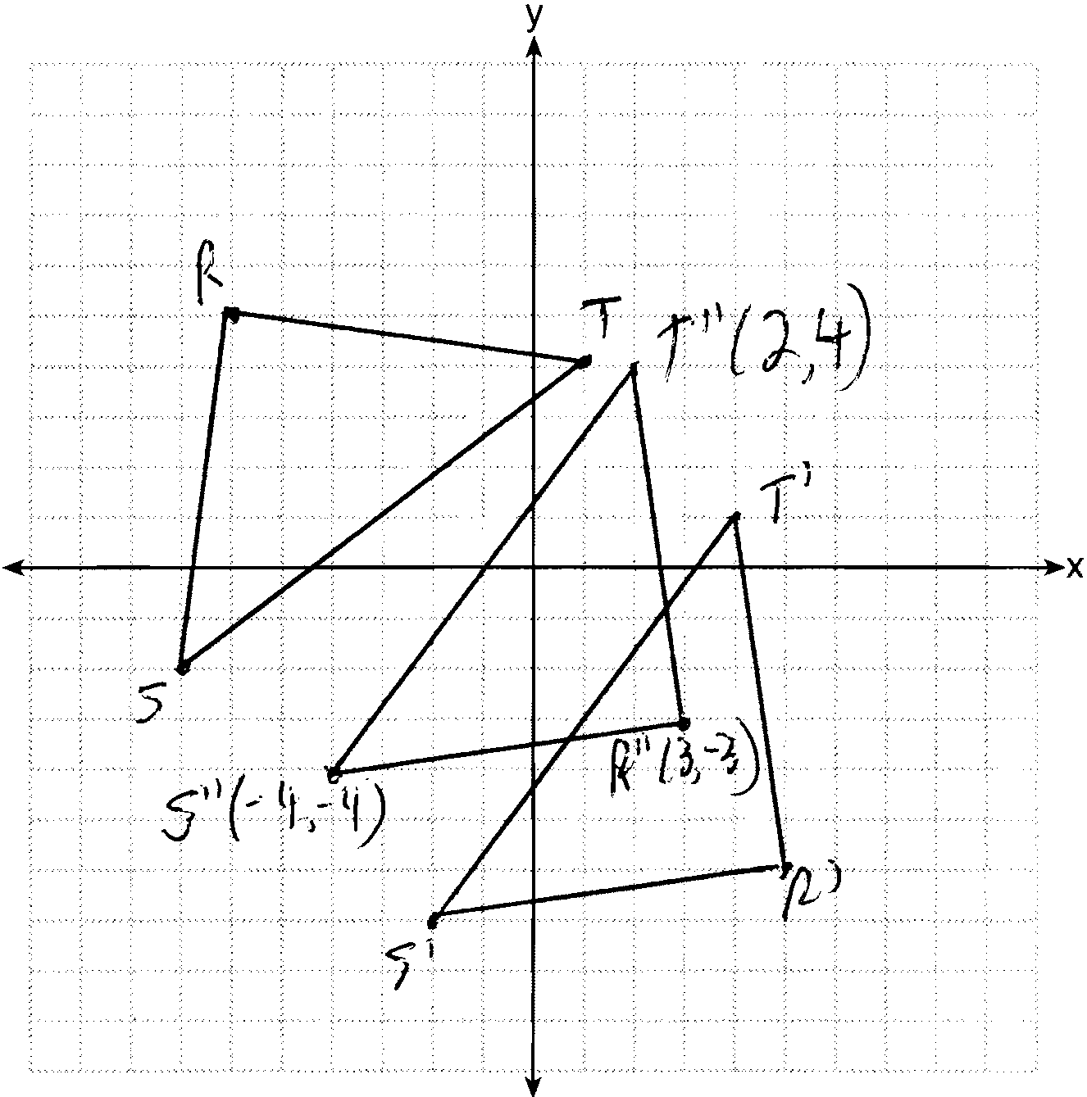

PTS: 4 REF: 081236ge STA: G.G.58 TOP: Compositions of Transformations
KEY: grids

37 ANS:
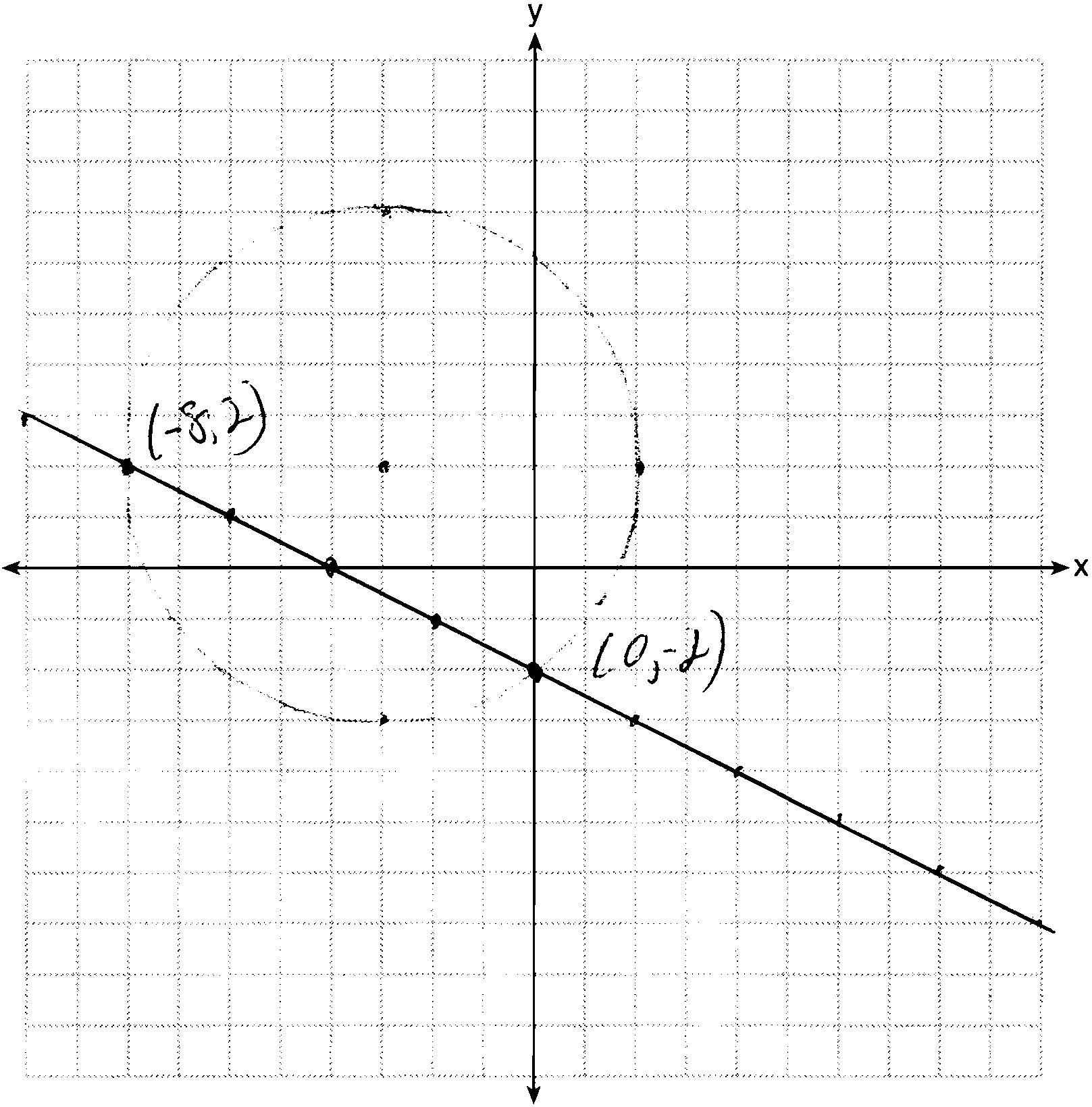

PTS: 4 REF: 081237ge STA: G.G.70 TOP: Quadratic-Linear Systems

38 ANS:
52, 40, 80. 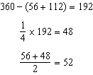. 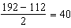. 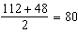

PTS: 6 REF: 081238ge STA: G.G.51 TOP: Arcs Determined by Angles
KEY: inscribed

