1 The statement "x is a multiple of 3, and x is an even integer" is true when x is equal to
1) | 9
2) | 8
3) | 3
4) | 6

2 In the diagram below, .

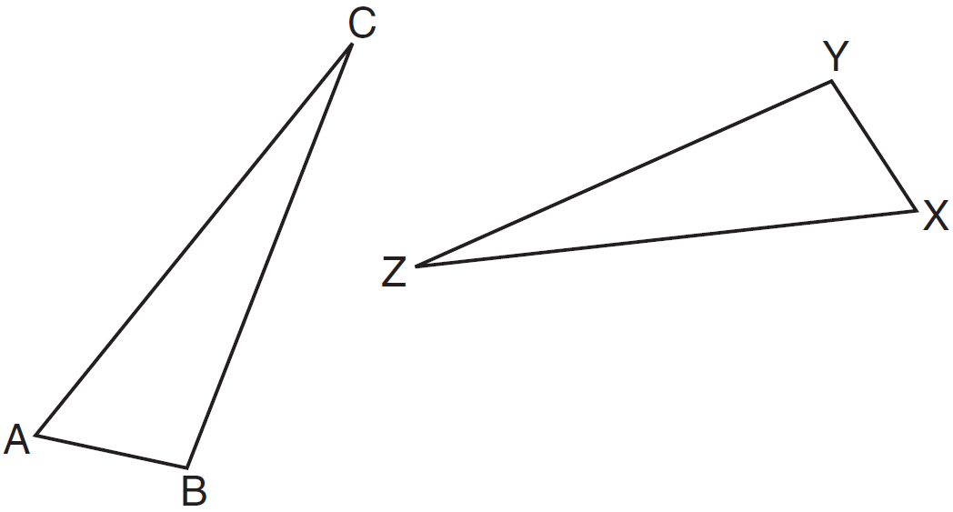

Which statement must be true?
1)
2)
3)
4)

3 In the diagram below of , , , , and .

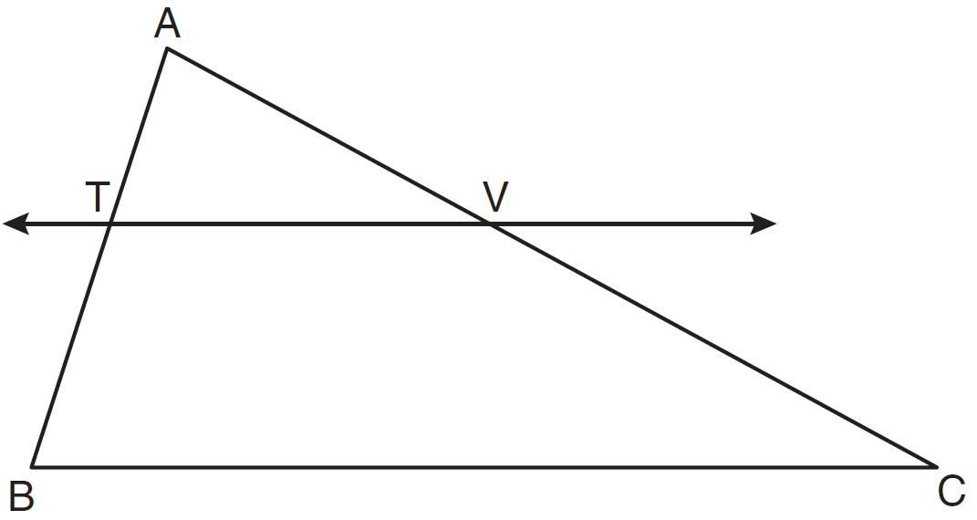

What is the length of ?
1)
2)
3) | 14
4) | 24

4 Pentagon PQRST has parallel to . After a translation of , which line segment is parallel to ?
1)
2)
3)
4)

5 In the diagram below of , is tangent to circle O at point A, , and .

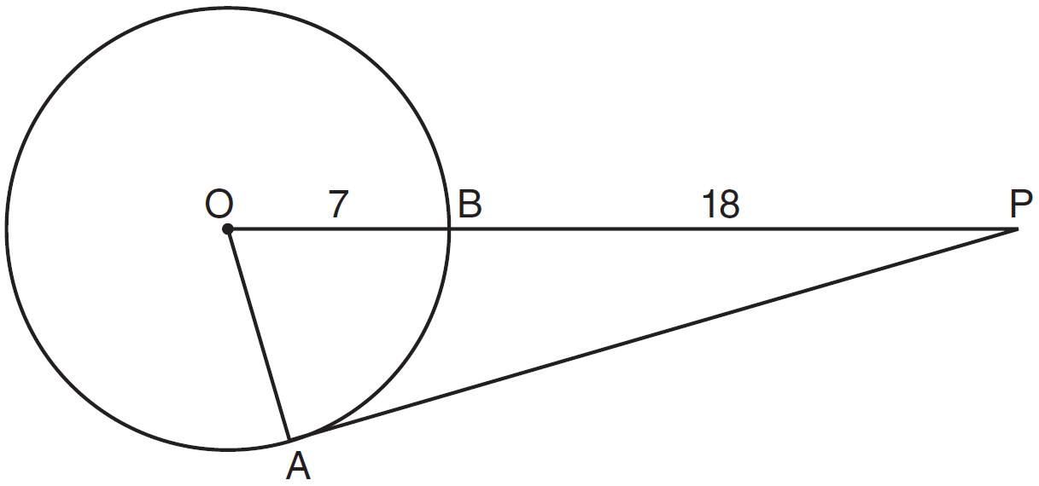

What is the length of ?
1) | 10
2) | 12
3) | 17
4) | 24

6 A straightedge and compass were used to create the construction below. Arc EF was drawn from point B, and arcs with equal radii were drawn from E and F.

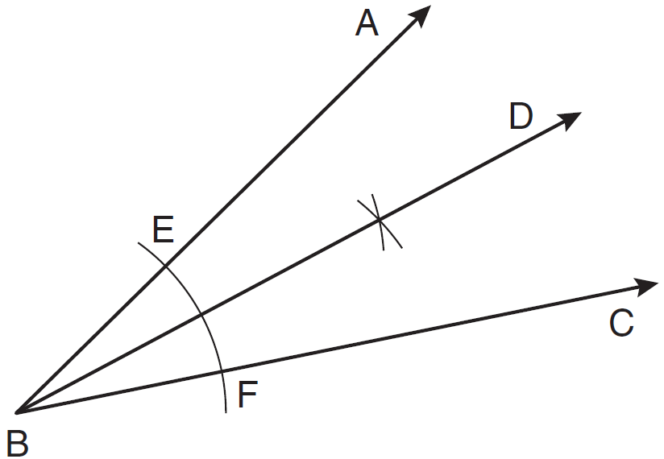

Which statement is false?
1)
2) | 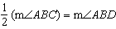
3)
4)

7 What is the length of the line segment whose endpoints are and ?
1) | 5
2)
3) | 10
4)

8 What is the image of the point after the transformation ?
1)
2)
3)
4)

9 In the diagram below, lines n and m are cut by transversals p and q.

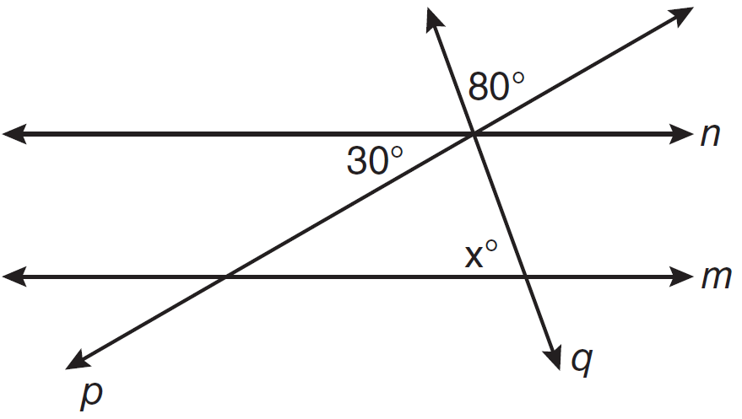

What value of x would make lines n and m parallel?
1) | 110
2) | 80
3) | 70
4) | 50

10 What is an equation of the circle with a radius of 5 and center at ?
1)
2)
3)
4)

11 In the diagram below of , side is extended to point A.

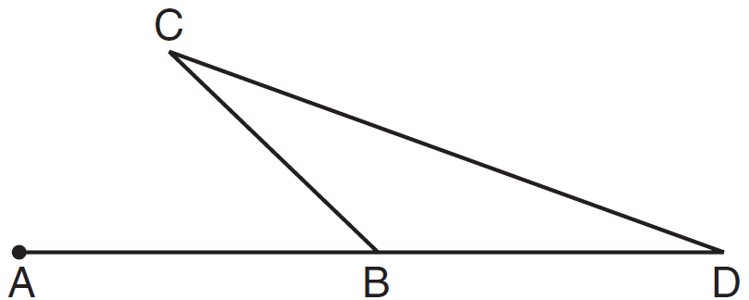

Which statement must be true?
1)
2)
3)
4)

12 Which equation represents the line parallel to the line whose equation is and passing through the point ?
1)
2)
3) | 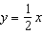
4) | 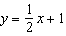

13 The coordinates of point A are . If point A' is the image of point A reflected over the line , the coordinates of A' are
1)
2)
3)
4)

14 As shown in the diagram below, bisects and .

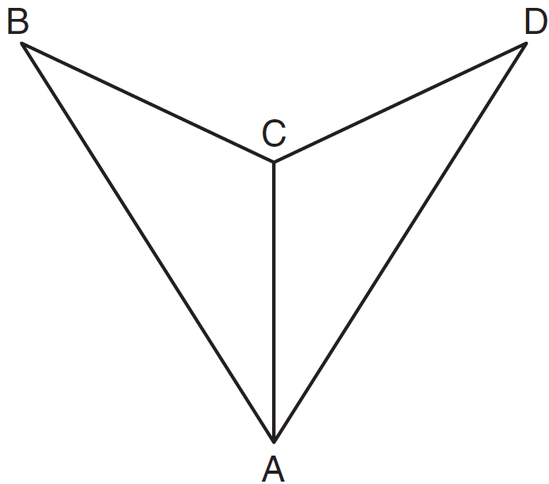

Which method could be used to prove ?
1) | SSS
2) | AAA
3) | SAS
4) | AAS

15 Segment AB is the diameter of circle M. The coordinates of A are . The coordinates of M are . What are the coordinates of B?
1)
2)
3)
4)

16 In the diagram below, is perpendicular to plane AEFG.

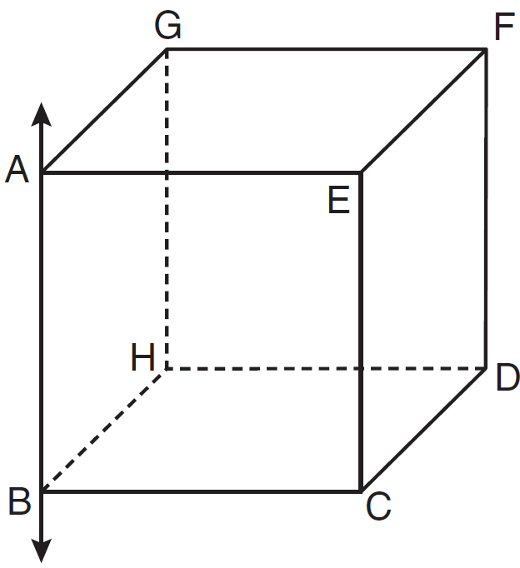

Which plane must be perpendicular to plane AEFG?
1) | ABCE
2) | BCDH
3) | CDFE
4) | HDFG

17 How many points are both 4 units from the origin and also 2 units from the line ?
1) | 1
2) | 2
3) | 3
4) | 4

18 When solved graphically, what is the solution to the following system of equations?
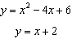
1)
2)
3) | and
4) | and

19 Triangle PQR has angles in the ratio of . Which type of triangle is ?
1) | acute
2) | isosceles
3) | obtuse
4) | right

20 Plane A is parallel to plane B. Plane C intersects plane A in line m and intersects plane B in line n. Lines m and n are
1) | intersecting
2) | parallel
3) | perpendicular
4) | skew

21 The diagonals of a quadrilateral are congruent but do not bisect each other. This quadrilateral is
1) | an isosceles trapezoid
2) | a parallelogram
3) | a rectangle
4) | a rhombus

22 What is the slope of a line that is perpendicular to the line represented by the equation ?
1)
2) | 2
3)
4)

23 A packing carton in the shape of a triangular prism is shown in the diagram below.

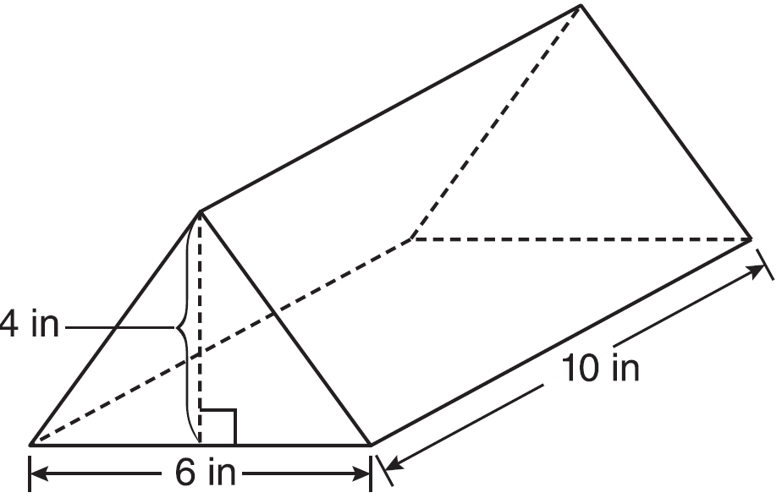

What is the volume, in cubic inches, of this carton?
1) | 20
2) | 60
3) | 120
4) | 240

24 In the diagram below of circle O, diameter is perpendicular to chord at point E, , and .

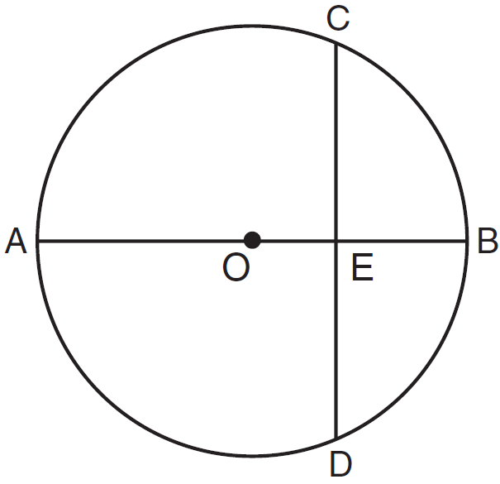

What is the length of ?
1)
2)
3)
4)

25 What is the measure of each interior angle of a regular hexagon?
1)
2)
3)
4)

26 Which equation represents the perpendicular bisector of whose endpoints are and ?
1)
2) | 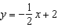
3) | 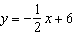
4)

27 As shown in the diagram below, a kite needs a vertical and a horizontal support bar attached at opposite corners. The upper edges of the kite are 7 inches, the side edges are x inches, and the vertical support bar is inches.

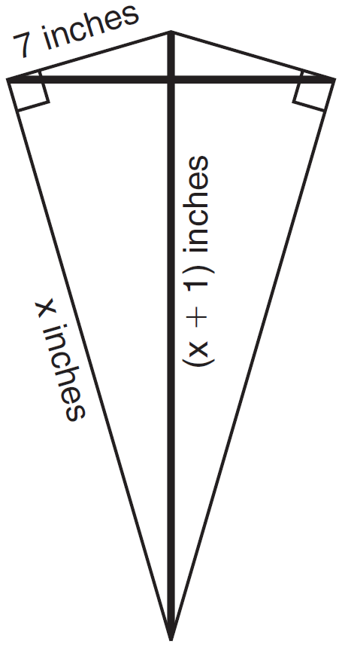

What is the measure, in inches, of the vertical support bar?
1) | 23
2) | 24
3) | 25
4) | 26

28 Given three distinct quadrilaterals, a square, a rectangle, and a rhombus, which quadrilaterals must have perpendicular diagonals?
1) | the rhombus, only
2) | the rectangle and the square
3) | the rhombus and the square
4) | the rectangle, the rhombus, and the square

29 In the diagram below, trapezoid ABCD, with bases and , is inscribed in circle O, with diameter . If , find .

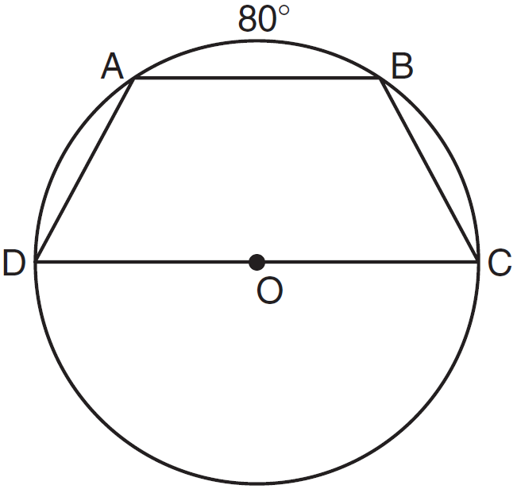

30 On the diagram of shown below, use a compass and straightedge to construct the perpendicular bisector of . [Leave all construction marks.]

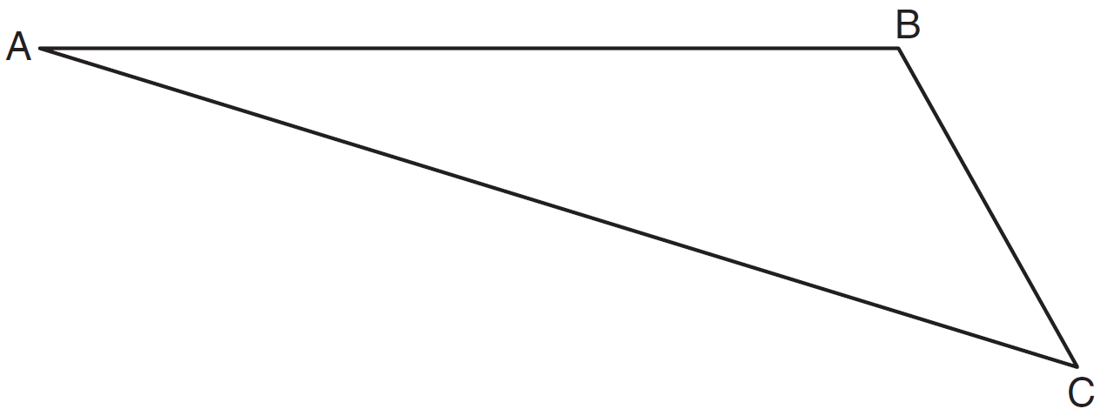

31 A sphere has a diameter of 18 meters. Find the volume of the sphere, in cubic meters, in terms of .

32 Write an equation of the circle graphed in the diagram below.

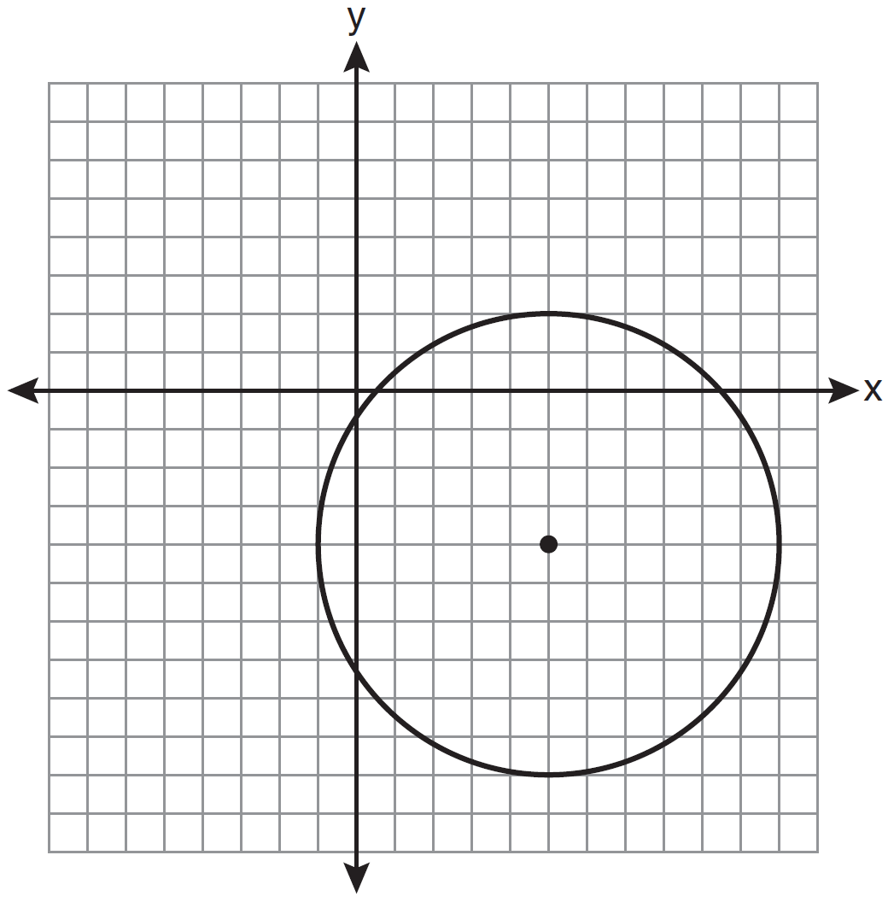

33 The diagram below shows , with , , and . Prove that is similar to .

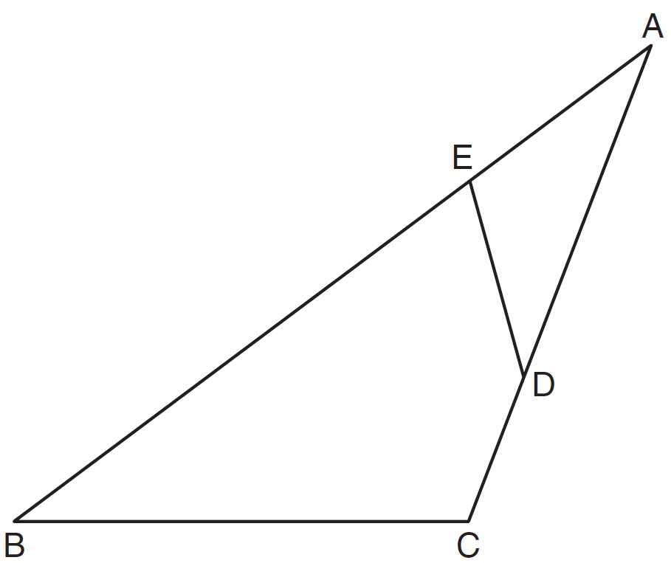

34 Triangle ABC has vertices , , and . Determine the point of intersection of the medians, and state its coordinates. [The use of the set of axes below is optional.]

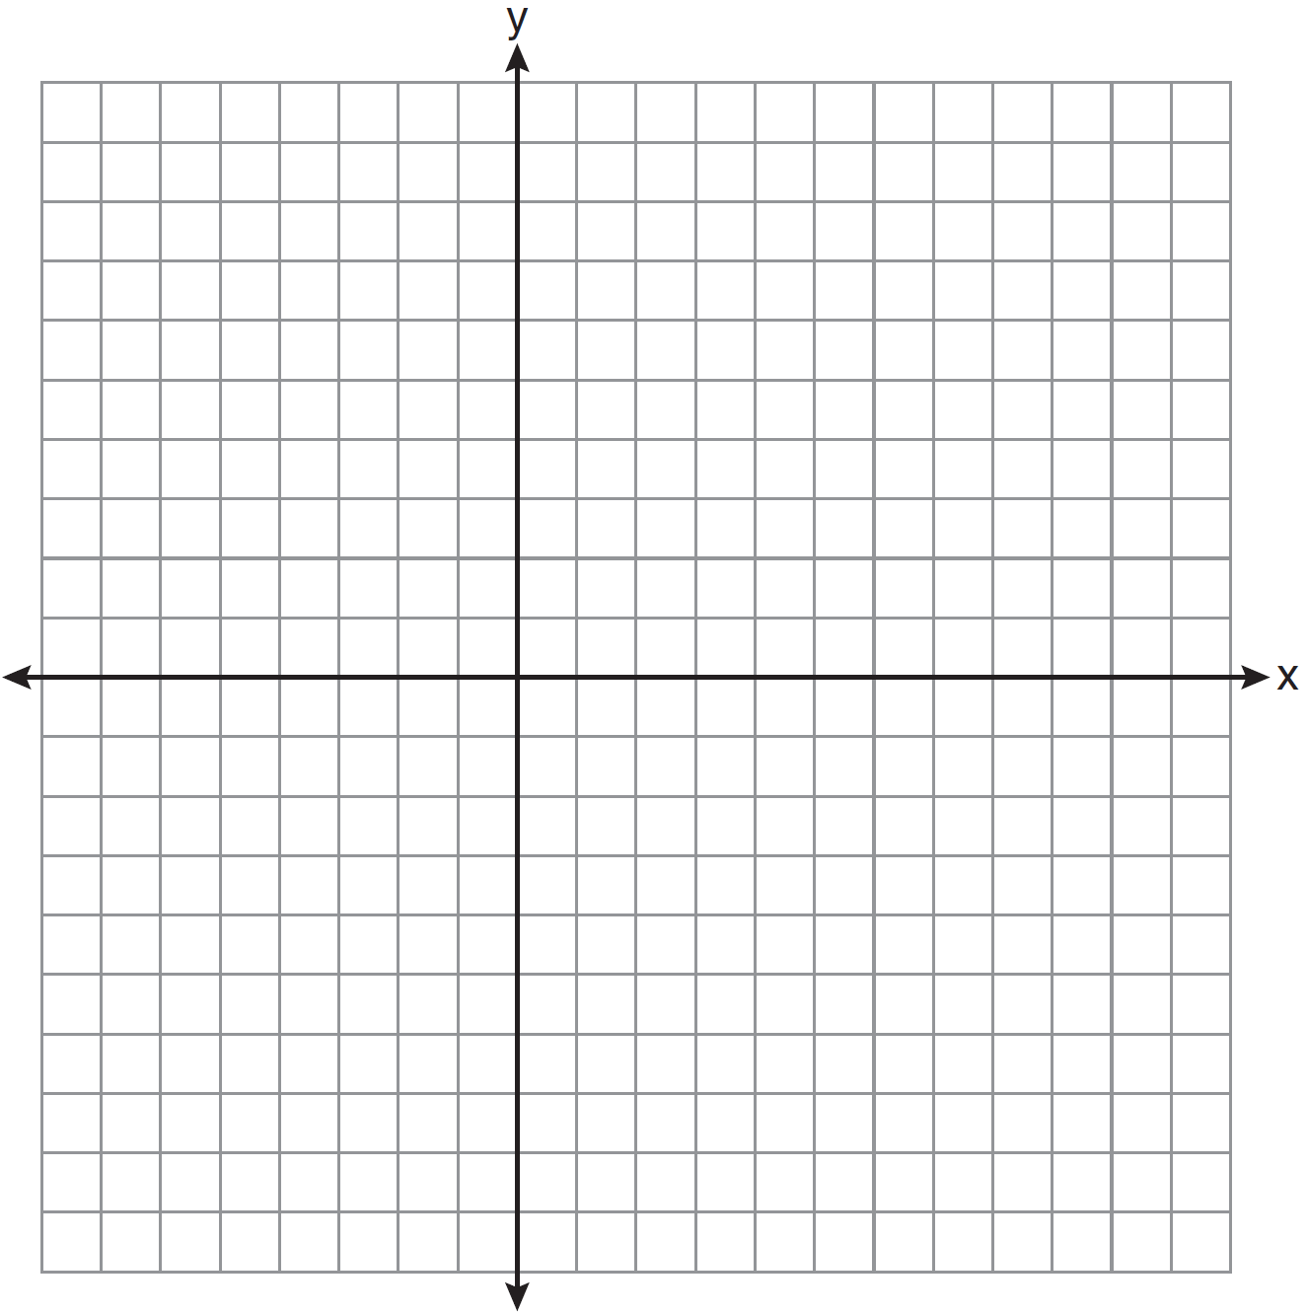

35 In the diagram below of , H is a point on , , , and . Determine whether is an isosceles triangle and justify your answer.

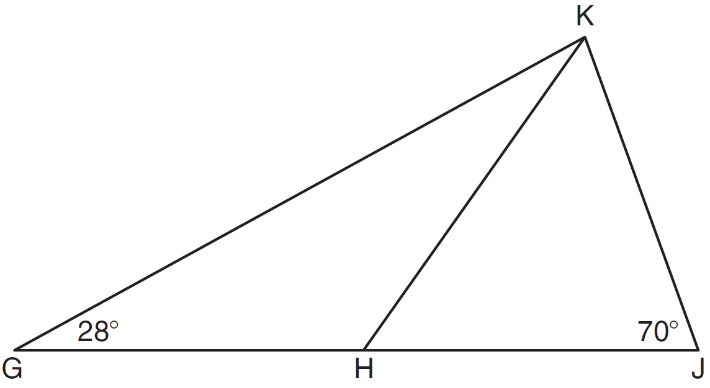

36 As shown on the set of axes below, has vertices , , and . Graph and state the coordinates of , the image of after the transformation .

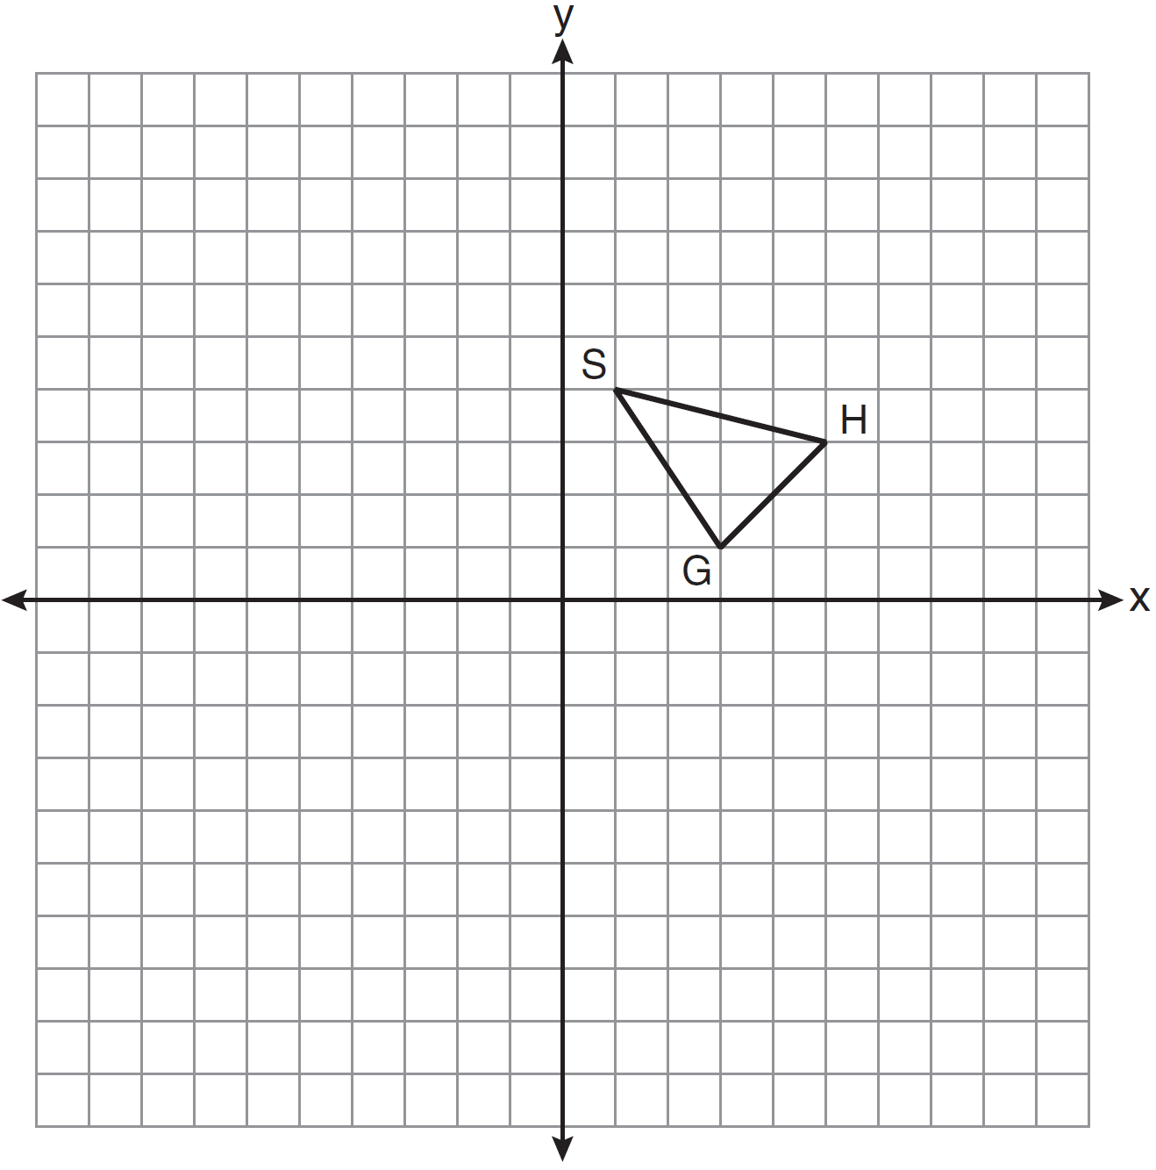

37 In the diagram below, , , , , and . Determine the length of . [Only an algebraic solution can receive full credit.]

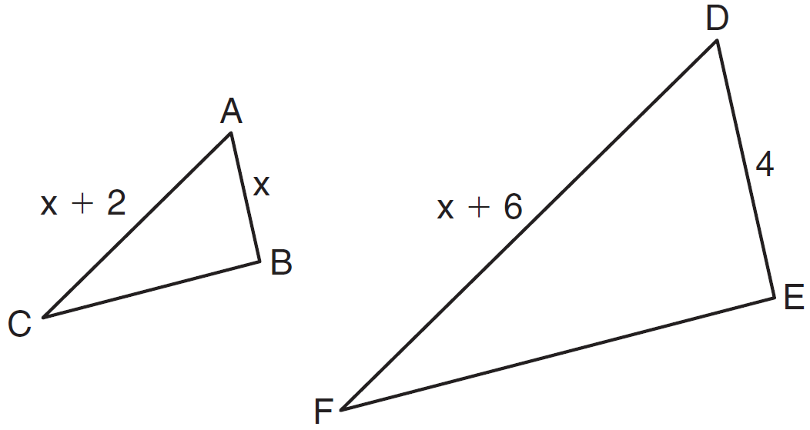

38 Given: with vertices , , and . has midpoint D, has midpoint E, and has midpoint F.
Prove: ADEF is a parallelogram
ADEF is not a rhombus
[The use of the grid is optional.]


1 ANS: 4 PTS: 2 REF: 081101ge STA: G.G.25
TOP: Compound Statements KEY: conjunction

2 ANS: 2 PTS: 2 REF: 081102ge STA: G.G.29
TOP: Triangle Congruency

3 ANS: 3
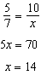

PTS: 2 REF: 081103ge STA: G.G.46 TOP: Side Splitter Theorem

4 ANS: 3 PTS: 2 REF: 081104ge STA: G.G.55
TOP: Properties of Transformations

5 ANS: 4

PTS: 2 REF: 081105ge STA: G.G.50 TOP: Tangents
KEY: point of tangency

6 ANS: 4 PTS: 2 REF: 081106ge STA: G.G.17
TOP: Constructions

7 ANS: 3

PTS: 2 REF: 081107ge STA: G.G.67 TOP: Distance
KEY: general

8 ANS: 2 PTS: 2 REF: 081108ge STA: G.G.54
TOP: Reflections KEY: basic

9 ANS: 3
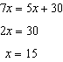

PTS: 2 REF: 081109ge STA: G.G.35 TOP: Parallel Lines and Transversals

10 ANS: 4 PTS: 2 REF: 081110ge STA: G.G.71
TOP: Equations of Circles

11 ANS: 3 PTS: 2 REF: 081111ge STA: G.G.32
TOP: Exterior Angle Theorem

12 ANS: 2
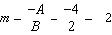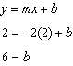

PTS: 2 REF: 081112ge STA: G.G.65 TOP: Parallel and Perpendicular Lines

13 ANS: 1 PTS: 2 REF: 081113ge STA: G.G.54
TOP: Reflections KEY: basic

14 ANS: 4
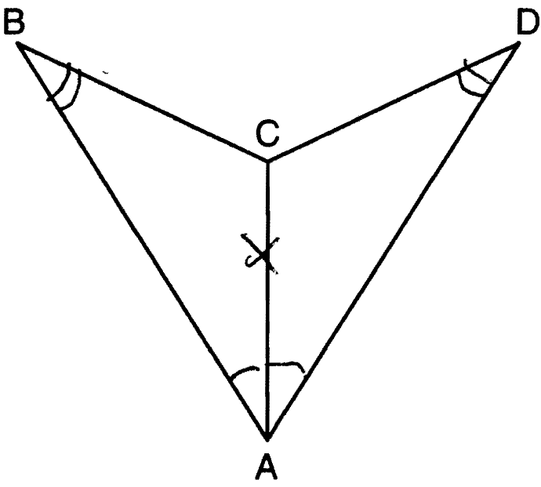

PTS: 2 REF: 081114ge STA: G.G.28 TOP: Triangle Congruency

15 ANS: 1
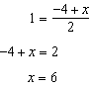. 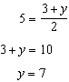.

PTS: 2 REF: 081115ge STA: G.G.66 TOP: Midpoint

16 ANS: 1 PTS: 2 REF: 081116ge STA: G.G.7
TOP: Planes

17 ANS: 2 PTS: 2 REF: 081117ge STA: G.G.23
TOP: Locus

18 ANS: 3
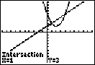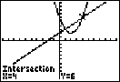

PTS: 2 REF: 081118ge STA: G.G.70 TOP: Quadratic-Linear Systems

19 ANS: 4
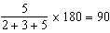

PTS: 2 REF: 081119ge STA: G.G.30 TOP: Interior and Exterior Angles of Triangles

20 ANS: 2 PTS: 2 REF: 081120ge STA: G.G.8
TOP: Planes

21 ANS: 1 PTS: 2 REF: 081121ge STA: G.G.39
TOP: Special Parallelograms

22 ANS: 2
The slope of is 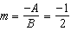. .

PTS: 2 REF: 081122ge STA: G.G.62 TOP: Parallel and Perpendicular Lines

23 ANS: 3 PTS: 2 REF: 081123ge STA: G.G.12
TOP: Volume

24 ANS: 4

PTS: 2 REF: 081124ge STA: G.G.49 TOP: Chords

25 ANS: 2
. 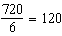.

PTS: 2 REF: 081125ge STA: G.G.37 TOP: Interior and Exterior Angles of Polygons

26 ANS: 1
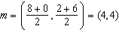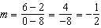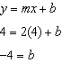

PTS: 2 REF: 081126ge STA: G.G.68 TOP: Perpendicular Bisector

27 ANS: 3
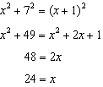

PTS: 2 REF: 081127ge STA: G.G.48 TOP: Pythagorean Theorem

28 ANS: 3 PTS: 2 REF: 081128ge STA: G.G.39
TOP: Special Parallelograms

29 ANS:
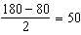

PTS: 2 REF: 081129ge STA: G.G.52 TOP: Chords

30 ANS:
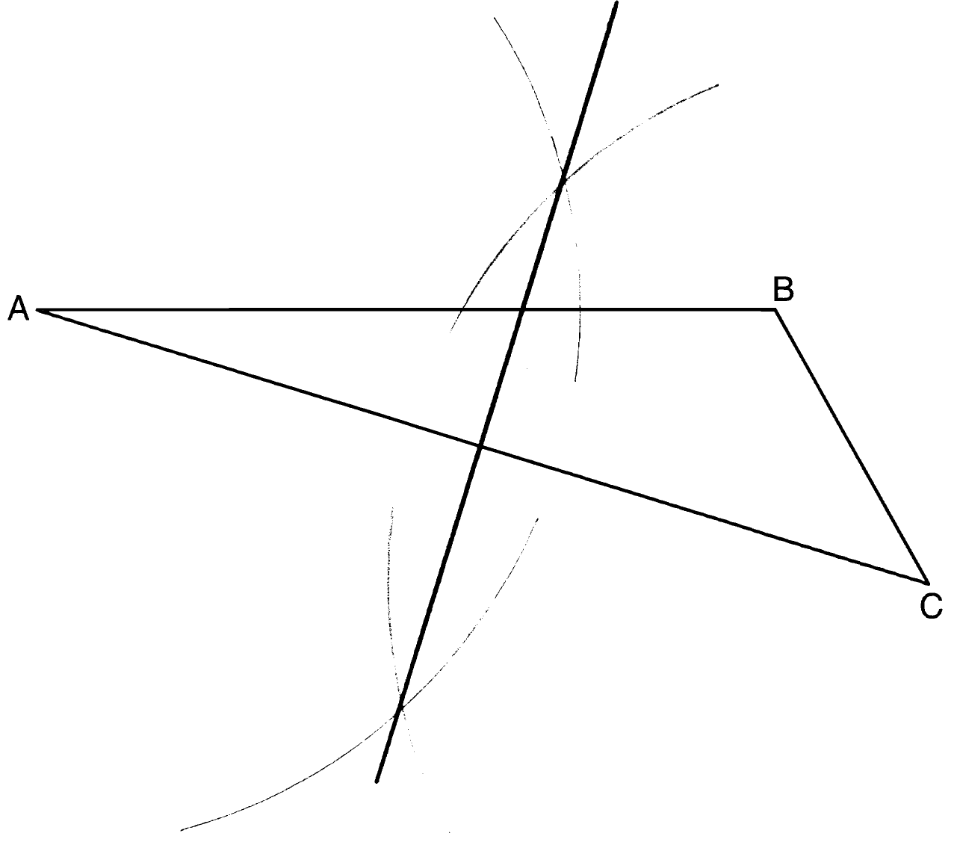

PTS: 2 REF: 081130ge STA: G.G.18 TOP: Constructions

31 ANS:
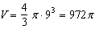

PTS: 2 REF: 081131ge STA: G.G.16 TOP: Volume and Surface Area

32 ANS:

PTS: 2 REF: 081132ge STA: G.G.72 TOP: Equations of Circles

33 ANS:
is given. because of the reflexive property. Therefore because of AA.

PTS: 2 REF: 081133ge STA: G.G.44 TOP: Similarity Proofs

34 ANS:
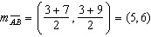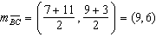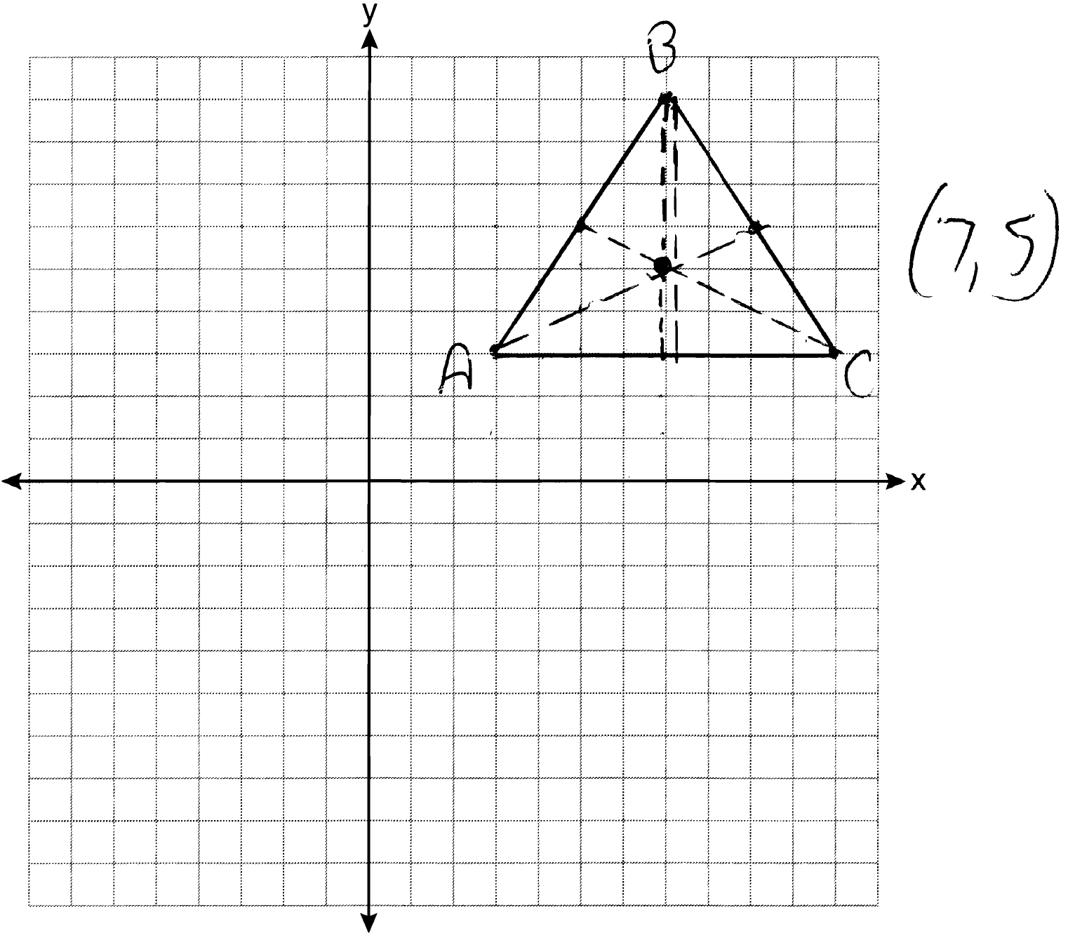

PTS: 2 REF: 081134ge STA: G.G.21
TOP: Centroid, Orthocenter, Incenter and Circumcenter

35 ANS:
No, is not congruent to . 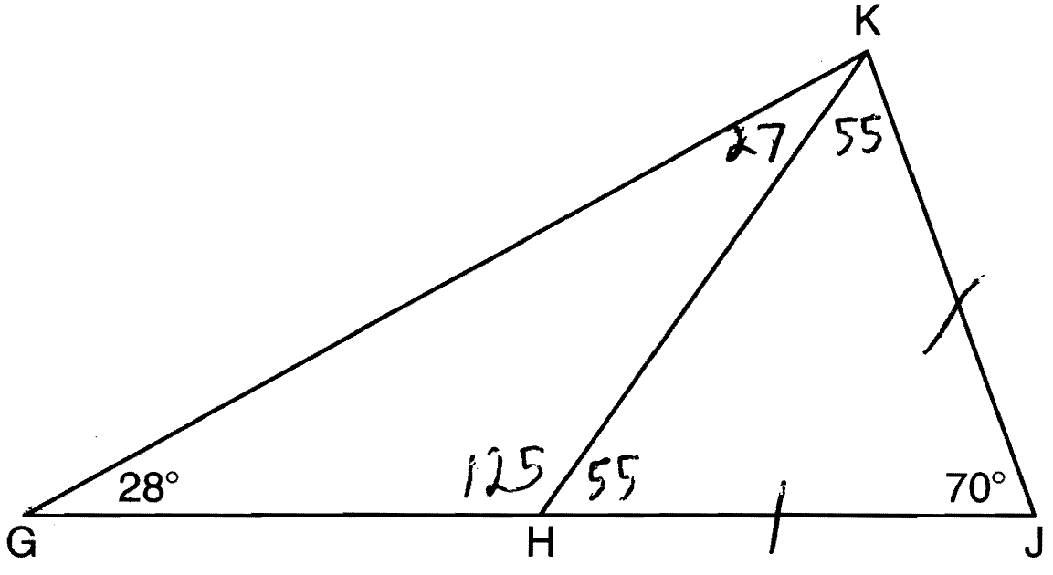

PTS: 2 REF: 081135ge STA: G.G.31 TOP: Isosceles Triangle Theorem

36 ANS:
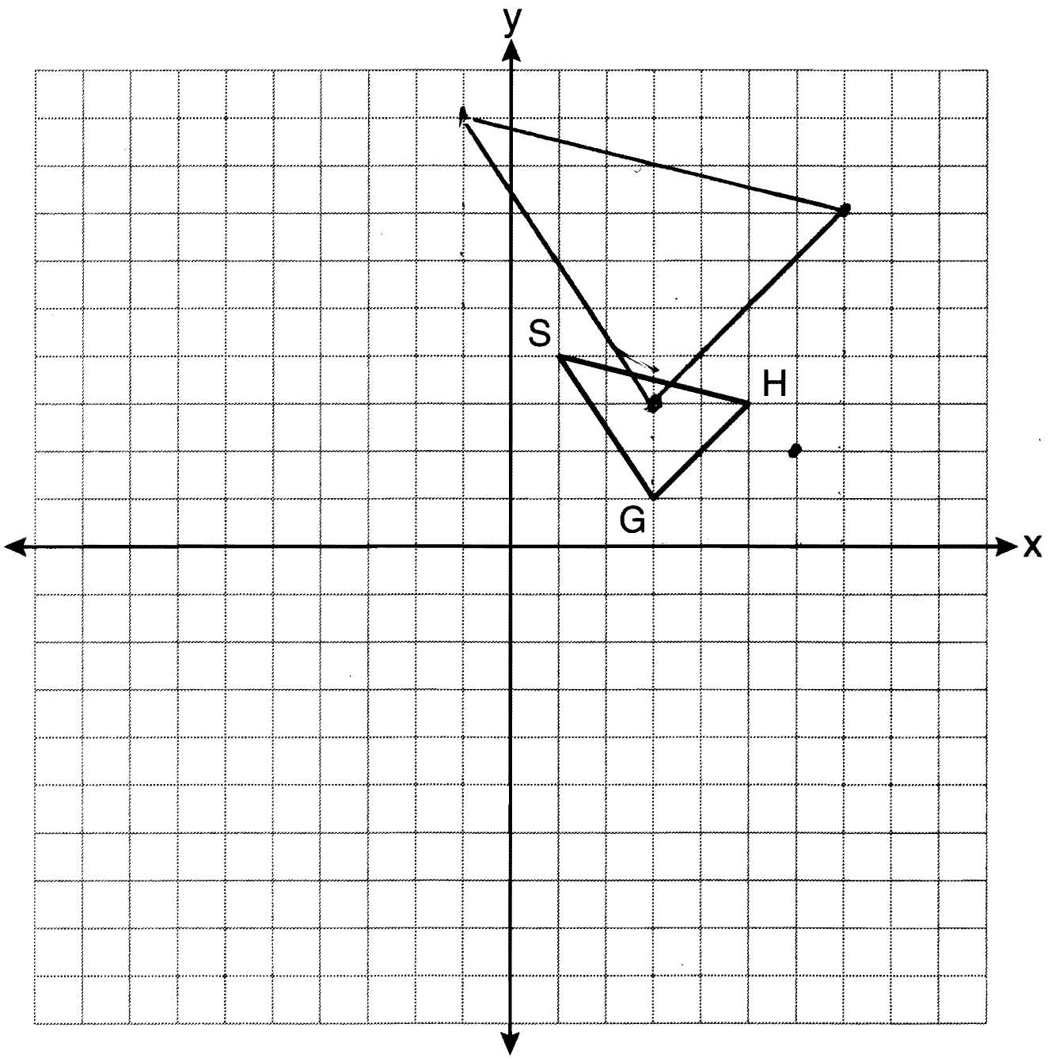

PTS: 4 REF: 081136ge STA: G.G.58 TOP: Compositions of Transformations

37 ANS:
2 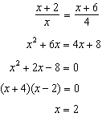

PTS: 4 REF: 081137ge STA: G.G.45 TOP: Similarity
KEY: basic

38 ANS:
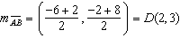 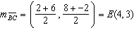 . To prove that ADEF is a parallelogram, show that both pairs of opposite sides of the parallelogram are parallel by showing the opposite sides have the same slope: 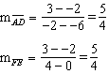 because all horizontal lines have the same slope. ADEF is not a rhombus because not all sides are congruent.

PTS: 6 REF: 081138ge STA: G.G.69 TOP: Quadrilaterals in the Coordinate Plane

