1 In the diagram below, .

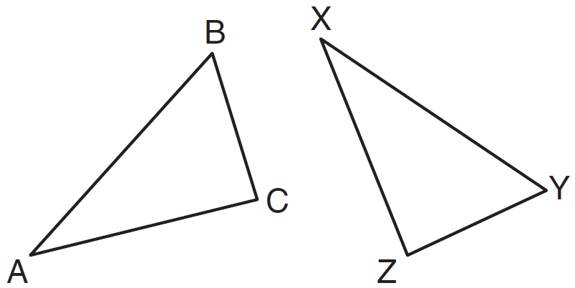

Which two statements identify corresponding congruent parts for these triangles?
1)
2)
3)
4)

2 A support beam between the floor and ceiling of a house forms a 90º angle with the floor. The builder wants to make sure that the floor and ceiling are parallel. Which angle should the support beam form with the ceiling?
1) | 45º
2) | 60º
3) | 90º
4) | 180º

3 In the diagram below, the vertices of are the midpoints of the sides of equilateral triangle ABC, and the perimeter of is 36 cm.

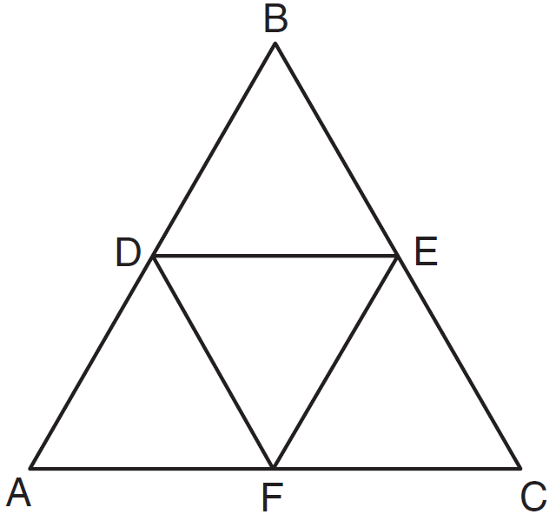

What is the length, in centimeters, of ?
1) | 6
2) | 12
3) | 18
4) | 4

4 What is the solution of the following system of equations?
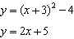
1)
2)
3)
4)

5 One step in a construction uses the endpoints of to create arcs with the same radii. The arcs intersect above and below the segment. What is the relationship of and the line connecting the points of intersection of these arcs?
1) | collinear
2) | congruent
3) | parallel
4) | perpendicular

6 If , , and , what is ?
1) | 30
2) | 50
3) | 80
4) | 100

7 In the diagram below of and , , and .

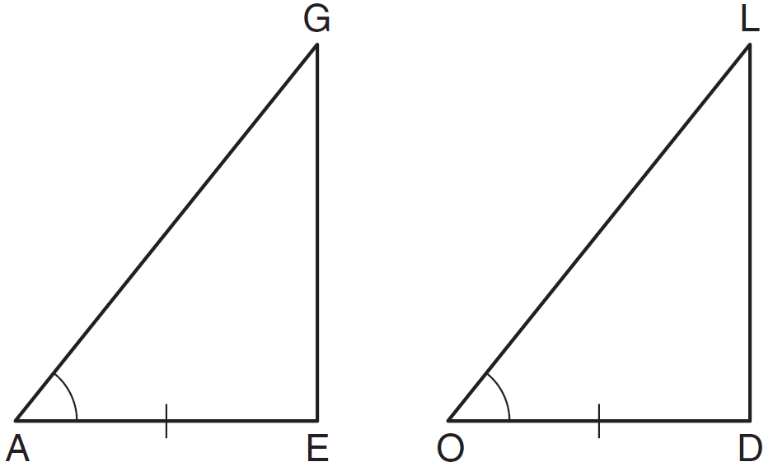

To prove that and are congruent by SAS, what other information is needed?
1)
2)
3)
4)

8 Point A is not contained in plane B. How many lines can be drawn through point A that will be perpendicular to plane B ?
1) | one
2) | two
3) | zero
4) | infinite

9 The equation of a circle is . What are the center and radius of the circle?
1) | center = ; radius = 4
2) | center = ; radius = 16
3) | center = ; radius = 4
4) | center = ; radius = 16

10 What is an equation of the line that passes through the point and is parallel to the line ?
1) | 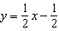
2) | 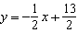
3)
4)

11 In , , , and . Which list has the angles of in order from smallest to largest?
1)
2)
3)
4)

12 Tangents and are drawn to circle O from an external point, P, and radii and are drawn. If , what is the measure of ?
1) | 140º
2) | 100º
3) | 70º
4) | 50º

13 What is the length of the line segment with endpoints and ?
1)
2)
3)
4)

14 The lines represented by the equations 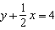 and are
1) | the same line
2) | parallel
3) | perpendicular
4) | neither parallel nor perpendicular

15 A transformation of a polygon that always preserves both length and orientation is
1) | dilation
2) | translation
3) | line reflection
4) | glide reflection

16 In which polygon does the sum of the measures of the interior angles equal the sum of the measures of the exterior angles?
1) | triangle
2) | hexagon
3) | octagon
4) | quadrilateral

17 In the diagram below of circle O, chords and intersect at E.

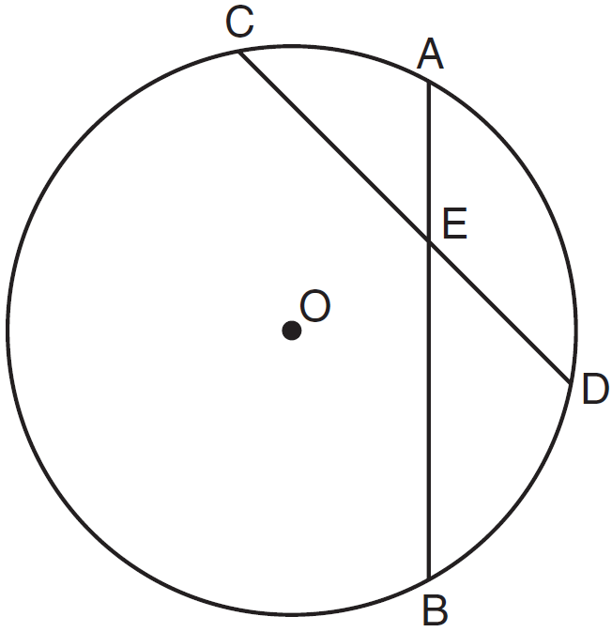

If , , and , what is the length of ?
1) | 15
2) | 12
3) | 6.7
4) | 2.4

18 In the diagram below of , medians , , and intersect at G.

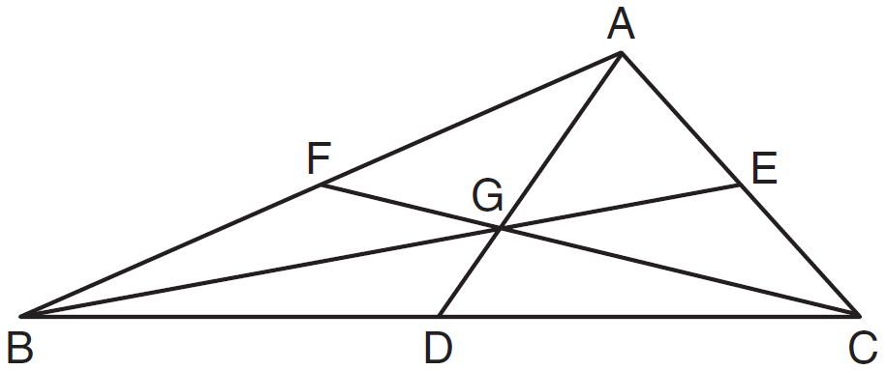

If , what is the length of ?
1) | 8
2) | 10
3) | 12
4) | 16

19 If a line segment has endpoints and , what are the coordinates of the midpoint of ?
1)
2)
3)
4)

20 If the surface area of a sphere is represented by , what is the volume in terms of ?
1)
2)
3)
4)

21 Which transformation of the line results in an image that is perpendicular to the given line?
1)
2)
3)
4)

22 In the diagram below of regular pentagon ABCDE, is drawn.

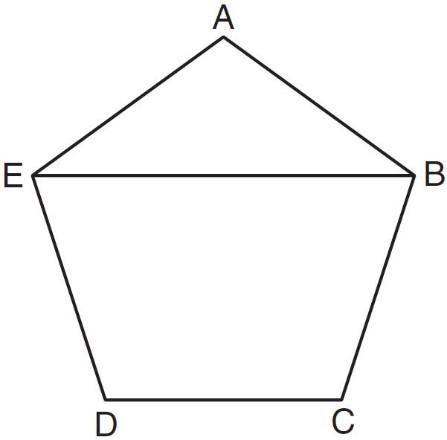

What is the measure of ?
1) | 36º
2) | 54º
3) | 72º
4) | 108º

23 is similar to . The ratio of the length of to the length of is . Which ratio is also equal to ?
1) | 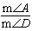
2) | 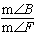
3) | 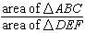
4) | 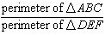

24 What is the slope of a line perpendicular to the line whose equation is ?
1)
2)
3)
4)

25 In the diagram below of circle C, , and .

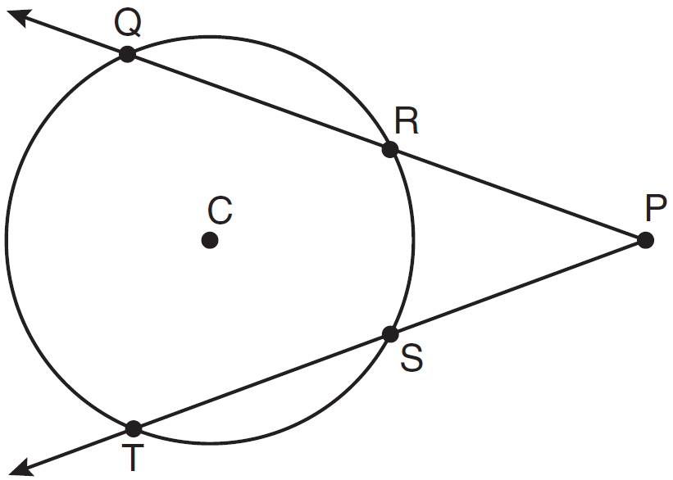

What is ?
1) | 50
2) | 60
3) | 90
4) | 110

26 Which statement is logically equivalent to "If it is warm, then I go swimming"
1) | If I go swimming, then it is warm.
2) | If it is warm, then I do not go swimming.
3) | If I do not go swimming, then it is not warm.
4) | If it is not warm, then I do not go swimming.

27 In the diagram below of , .

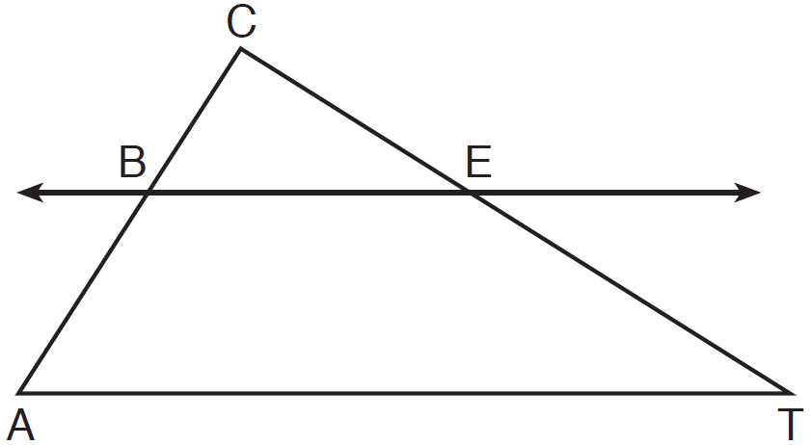

If , , and , what is the length of ?
1) | 5
2) | 14
3) | 20
4) | 26

28 Which geometric principle is used in the construction shown below?

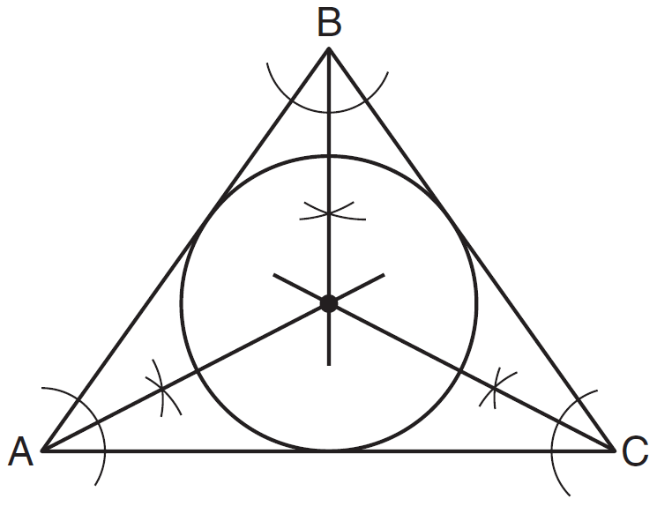
1) | The intersection of the angle bisectors of a triangle is the center of the inscribed circle.
2) | The intersection of the angle bisectors of a triangle is the center of the circumscribed circle.
3) | The intersection of the perpendicular bisectors of the sides of a triangle is the center of the inscribed circle.
4) | The intersection of the perpendicular bisectors of the sides of a triangle is the center of the circumscribed circle.

29 The diagram below shows isosceles trapezoid ABCD with and . If and , find .

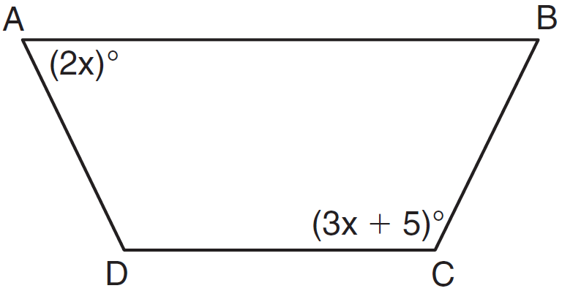

30 A right circular cone has a base with a radius of 15 cm, a vertical height of 20 cm, and a slant height of 25 cm. Find, in terms of' , the number of square centimeters in the lateral area of the cone.

31 In the diagram below of , side is extended through P to T, , , and . Find .

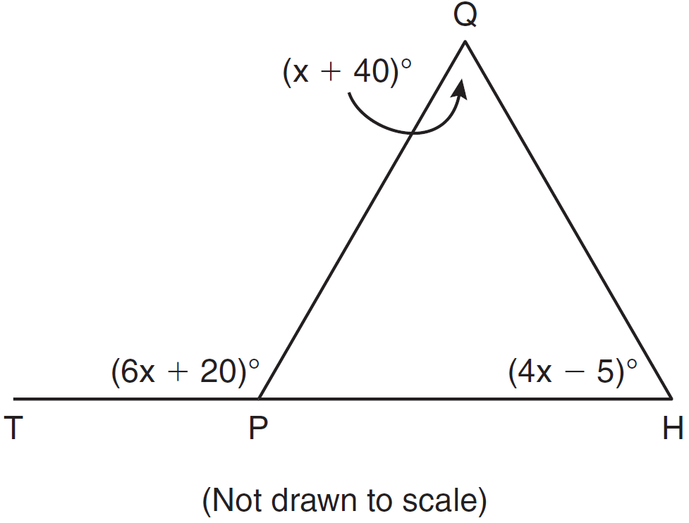

32 On the line segment below, use a compass and straightedge to construct equilateral triangle ABC. [Leave all construction marks.]

33 In the diagram below, car A is parked 7 miles from car B. Sketch the points that are 4 miles from car A and sketch the points that are 4 miles from car B. Label with an X all points that satisfy both conditions.



34 Write an equation for circle O shown on the graph below.

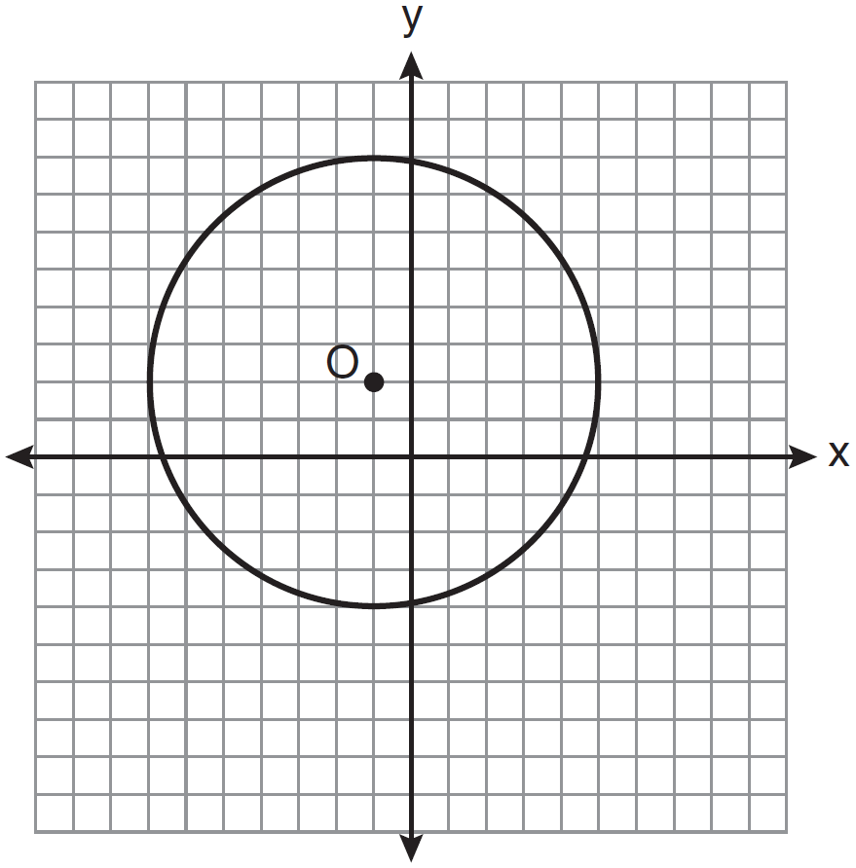

35 In the diagram below of quadrilateral ABCD with diagonal , , , , , and . Determine if is parallel to . Explain your reasoning.

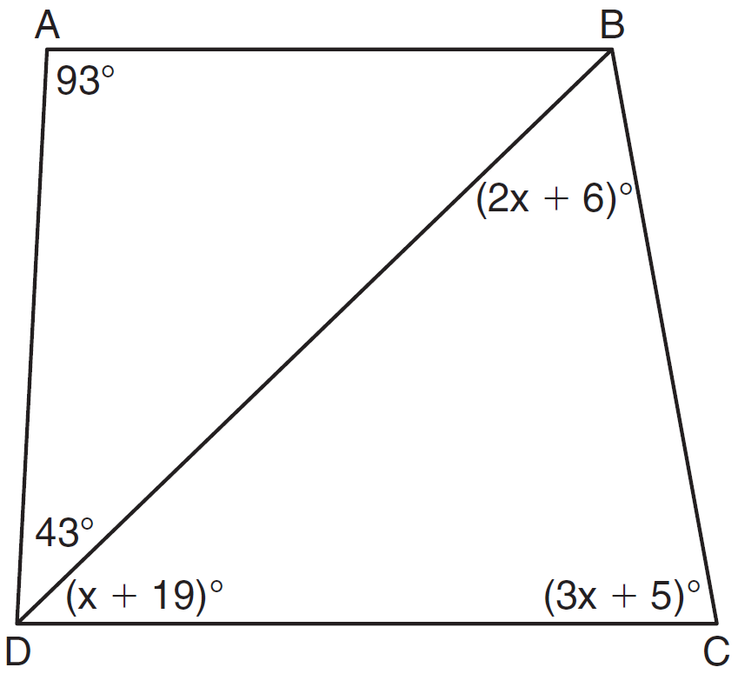

36 The coordinates of the vertices of , and . On the grid below, graph and label , the result of the composite transformation . State the coordinates of , , and .



37 In the diagram below, is a right triangle. The altitude, h, to the hypotenuse has been drawn. Determine the length of h.

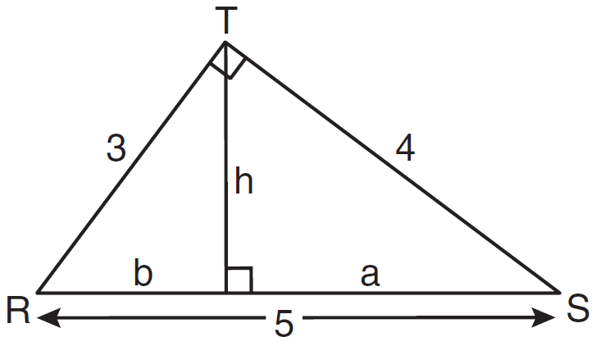

38 Given: Quadrilateral ABCD has vertices , , , and .
Prove: Quadrilateral ABCD is a parallelogram but is neither a rhombus nor a rectangle. [The use of the grid below is optional.]


1 ANS: 4
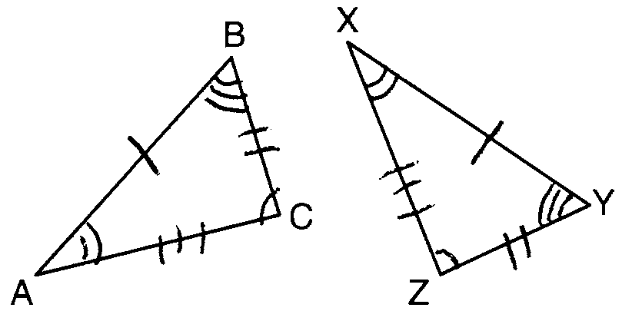

PTS: 2 REF: 081001ge STA: G.G.29 TOP: Triangle Congruency

2 ANS: 3 PTS: 2 REF: 081002ge STA: G.G.9
TOP: Planes

3 ANS: 1
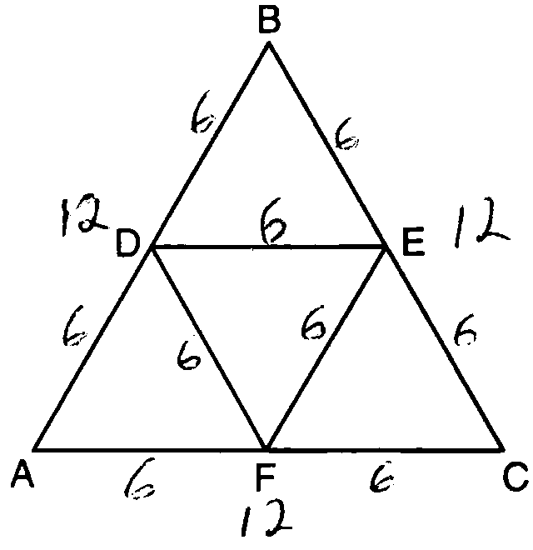

PTS: 2 REF: 081003ge STA: G.G.42 TOP: Midsegments

4 ANS: 3
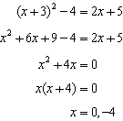

PTS: 2 REF: 081004ge STA: G.G.70 TOP: Quadratic-Linear Systems

5 ANS: 4 PTS: 2 REF: 081005ge STA: G.G.18
TOP: Constructions

6 ANS: 4

PTS: 2 REF: 081006ge STA: G.G.45 TOP: Similarity
KEY: basic

7 ANS: 2
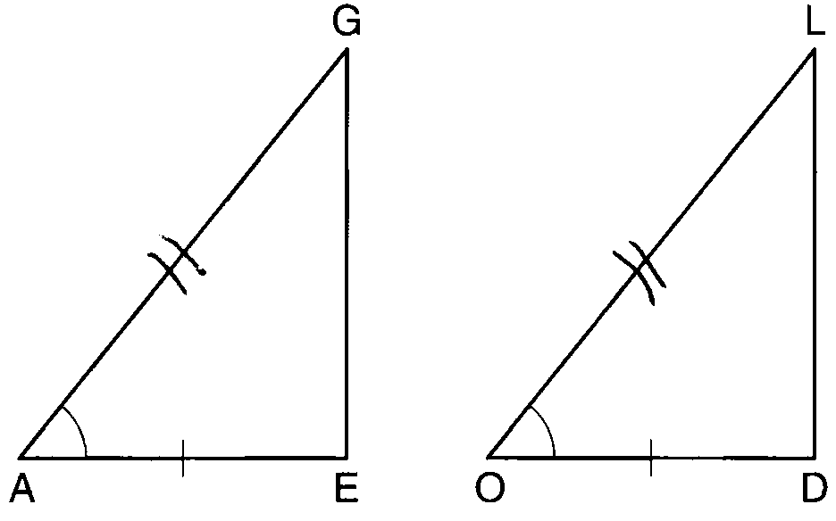

PTS: 2 REF: 081007ge STA: G.G.28 TOP: Triangle Congruency

8 ANS: 1 PTS: 2 REF: 081008ge STA: G.G.3
TOP: Planes

9 ANS: 1 PTS: 2 REF: 081009ge STA: G.G.73
TOP: Equations of Circles

10 ANS: 4
The slope of a line in standard form is , so the slope of this line is 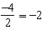. A parallel line would also have a slope of . Since the answers are in slope intercept form, find the y-intercept: 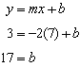

PTS: 2 REF: 081010ge STA: G.G.65 TOP: Parallel and Perpendicular Lines

11 ANS: 4
Longest side of a triangle is opposite the largest angle. Shortest side is opposite the smallest angle.

PTS: 2 REF: 081011ge STA: G.G.34 TOP: Angle Side Relationship

12 ANS: 1 PTS: 2 REF: 081012ge STA: G.G.50
TOP: Tangents KEY: two tangents

13 ANS: 4

PTS: 2 REF: 081013ge STA: G.G.67 TOP: Distance

14 ANS: 2
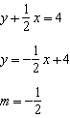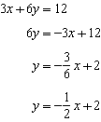

PTS: 2 REF: 081014ge STA: G.G.63 TOP: Parallel and Perpendicular Lines

15 ANS: 2 PTS: 2 REF: 081015ge STA: G.G.56
TOP: Identifying Transformations

16 ANS: 4
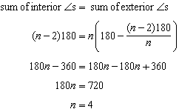

PTS: 2 REF: 081016ge STA: G.G.36 TOP: Interior and Exterior Angles of Polygons

17 ANS: 1
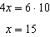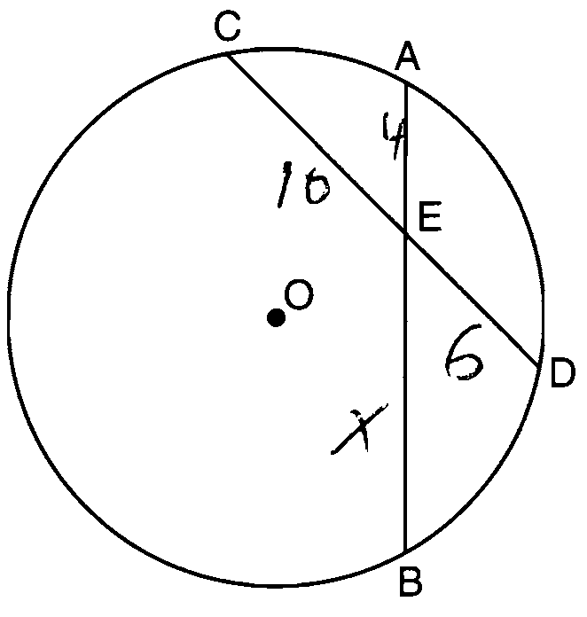

PTS: 2 REF: 081017ge STA: G.G.53 TOP: Segments Intercepted by Circle
KEY: two chords

18 ANS: 1
The centroid divides each median into segments whose lengths are in the ratio 2 : 1. 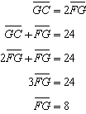

PTS: 2 REF: 081018ge STA: G.G.43 TOP: Centroid

19 ANS: 2
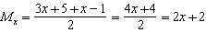. 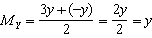.

PTS: 2 REF: 081019ge STA: G.G.66 TOP: Midpoint

20 ANS: 4
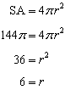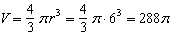

PTS: 2 REF: 081020ge STA: G.G.16 TOP: Volume and Surface Area

21 ANS: 3 PTS: 2 REF: 081021ge STA: G.G.57
TOP: Properties of Transformations

22 ANS: 1
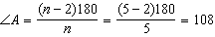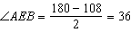

PTS: 2 REF: 081022ge STA: G.G.37 TOP: Interior and Exterior Angles of Polygons

23 ANS: 4 PTS: 2 REF: 081023ge STA: G.G.45
TOP: Similarity KEY: perimeter and area

24 ANS: 3
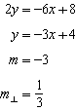 Perpendicular lines have slope the opposite and reciprocal of each other.

PTS: 2 REF: 081024ge STA: G.G.62 TOP: Parallel and Perpendicular Lines

25 ANS: 2
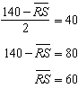

PTS: 2 REF: 081025ge STA: G.G.51 TOP: Arcs Determined by Angles
KEY: outside circle

26 ANS: 3 PTS: 2 REF: 081026ge STA: G.G.26
TOP: Contrapositive

27 ANS: 2
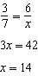

PTS: 2 REF: 081027ge STA: G.G.46 TOP: Side Splitter Theorem

28 ANS: 1 PTS: 2 REF: 081028ge STA: G.G.21
TOP: Centroid, Orthocenter, Incenter and Circumcenter

29 ANS:
70. 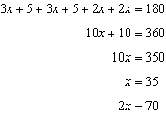

PTS: 2 REF: 081029ge STA: G.G.40 TOP: Trapezoids

30 ANS:

PTS: 2 REF: 081030ge STA: G.G.15 TOP: Volume and Lateral Area

31 ANS:
110. 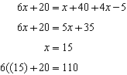

PTS: 2 REF: 081031ge STA: G.G.31 TOP: Isosceles Triangle Theorem

32 ANS:
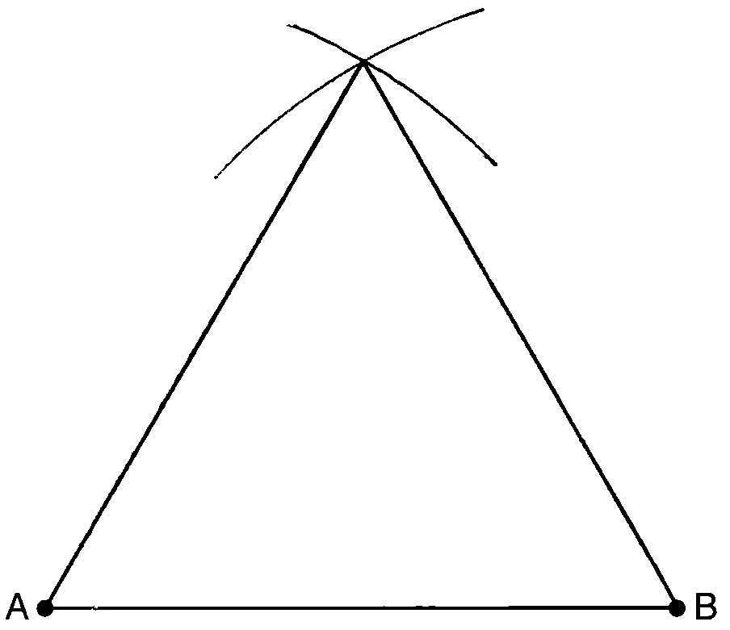

PTS: 2 REF: 081032ge STA: G.G.20 TOP: Constructions

33 ANS:
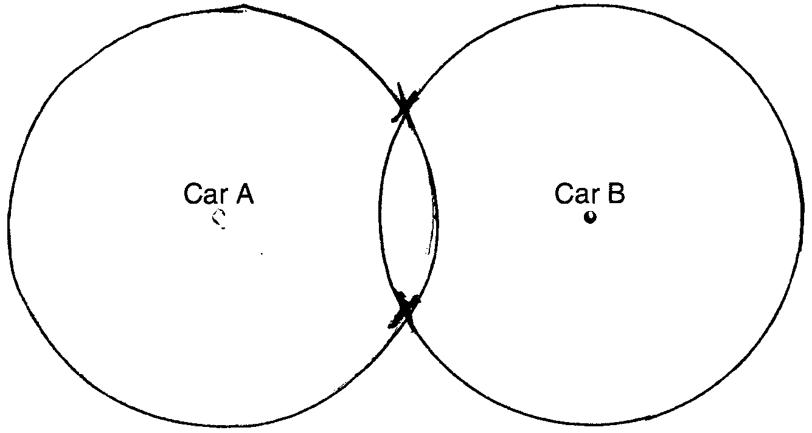

PTS: 2 REF: 081033ge STA: G.G.22 TOP: Locus

34 ANS:

PTS: 2 REF: 081034ge STA: G.G.72 TOP: Equations of Circles

35 ANS:
Yes, 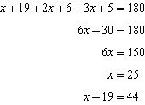. Because alternate interior angles and are congruent, is parallel to .

PTS: 4 REF: 081035ge STA: G.G.35 TOP: Parallel Lines and Transversals

36 ANS:
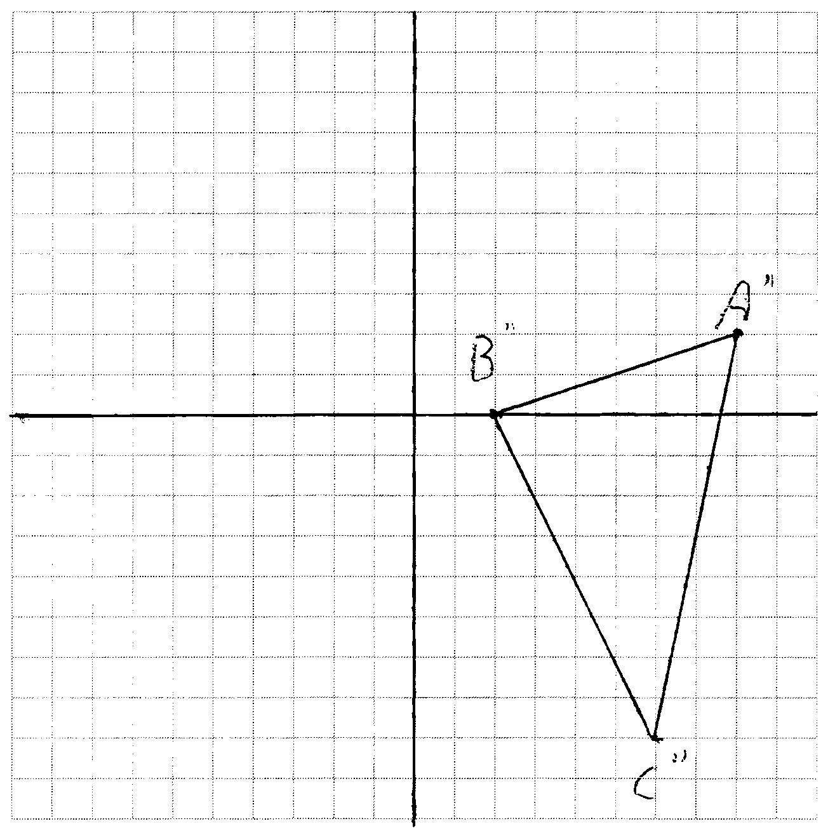

PTS: 4 REF: 081036ge STA: G.G.58 TOP: Compositions of Transformations

37 ANS:
2.4. 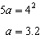 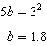 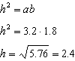

PTS: 4 REF: 081037ge STA: G.G.47 TOP: Similarity
KEY: altitude

38 ANS:
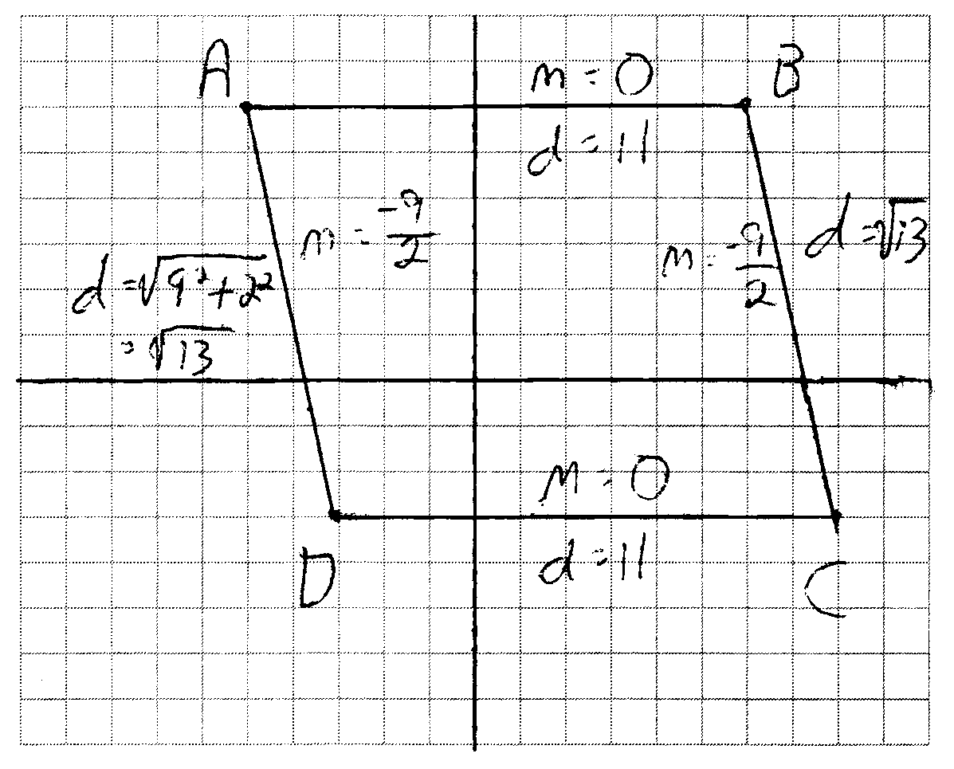 and because their slopes are equal. ABCD is a parallelogram because opposite side are parallel. ABCD is not a rhombus because all sides are not equal. because their slopes are not opposite reciprocals. ABCD is not a rectangle because is not a right angle.

PTS: 4 REF: 081038ge STA: G.G.69 TOP: Quadrilaterals in the Coordinate Plane

