1 Based on the diagram below, which statement is true?

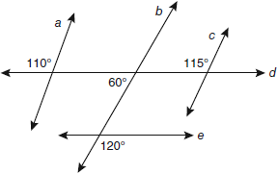
1)
2)
3)
4)

2 The diagram below shows the construction of the bisector of .

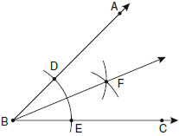

Which statement is not true?
1) | 
2) | 
3)
4)

3 In the diagram of below, . The measure of is 40°.

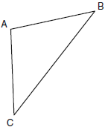

What is the measure of ?
1) | 40°
2) | 50°
3) | 70°
4) | 100°

4 In the diagram of circle O below, chord is parallel to diameter and .

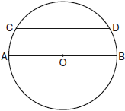

What is ?
1) | 150
2) | 120
3) | 100
4) | 60

5 In the diagram of trapezoid ABCD below, diagonals and intersect at E and .

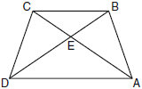

Which statement is true based on the given information?
1)
2)
3)
4)

6 Which transformation produces a figure similar but not congruent to the original figure?
1)
2)
3)
4)

7 In the diagram below of parallelogram ABCD with diagonals and , and .

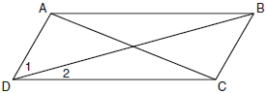

What is the measure of ?
1) | 15º
2) | 30º
3) | 45º
4) | 60º

8 On the set of axes below, Geoff drew rectangle ABCD. He will transform the rectangle by using the translation and then will reflect the translated rectangle over the x-axis.

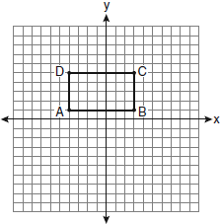

What will be the area of the rectangle after these transformations?
1) | exactly 28 square units
2) | less than 28 square units
3) | greater than 28 square units
4) | It cannot be determined from the information given.

9 What is the equation of a line that is parallel to the line whose equation is ?
1)
2)
3)
4)

10 The endpoints of are and . What are the coordinates of the midpoint of ?
1)
2)
3)
4)

11 What are the center and the radius of the circle whose equation is
1) | center = ; radius = 6
2) | center = ; radius = 6
3) | center = ; radius = 36
4) | center = ; radius = 36

12 Given the equations: 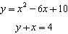
What is the solution to the given system of equations?
1)
2)
3)
4)

13 The diagonal is drawn in parallelogram ABCD. Which method can not be used to prove that ?
1) | SSS
2) | SAS
3) | SSA
4) | ASA

14 In the diagram below, line k is perpendicular to plane P at point T.

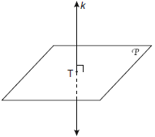

Which statement is true?
1) | Any point in plane P also will be on line k.
2) | Only one line in plane P will intersect line k.
3) | All planes that intersect plane P will pass through T.
4) | Any plane containing line k is perpendicular to plane P.

15 In the diagram below, which transformation was used to map to ?

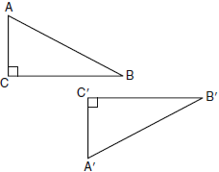
1) | dilation
2) | rotation
3) | reflection
4) | glide reflection

16 Which set of numbers represents the lengths of the sides of a triangle?
1)
2)
3)
4)

17 What is the slope of a line perpendicular to the line whose equation is 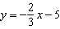?
1)
2)
3)
4)

18 A quadrilateral whose diagonals bisect each other and are perpendicular is a
1) | rhombus
2) | rectangle
3) | trapezoid
4) | parallelogram

19 If the endpoints of are and , what is the length of ?
1)
2) | 2
3)
4) | 8

20 In the diagram below of , D is the midpoint of , O is the midpoint of , and G is the midpoint of .

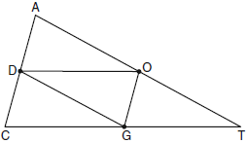

If , , and , what is the perimeter of parallelogram CDOG?
1) | 21
2) | 25
3) | 32
4) | 40

21 Which equation represents circle K shown in the graph below?

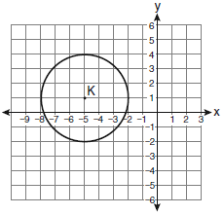
1)
2)
3)
4)

22 In the diagram below of right triangle ACB, altitude is drawn to hypotenuse .

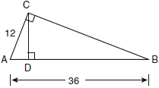

If and , what is the length of ?
1) | 32
2) | 6
3) | 3
4) | 4

23 In the diagram of circle O below, chord intersects chord at E, , , , and .

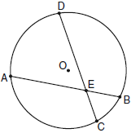

What is the value of x?
1) | 1
2) | 3.6
3) | 5
4) | 10.25

24 What is the negation of the statement “Squares are parallelograms”?
1) | Parallelograms are squares.
2) | Parallelograms are not squares.
3) | It is not the case that squares are parallelograms.
4) | It is not the case that parallelograms are squares.

25 The diagram below shows the construction of the center of the circle circumscribed about .

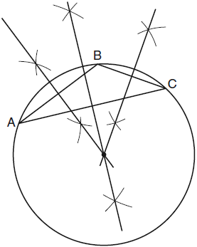

This construction represents how to find the intersection of
1) | the angle bisectors of
2) | the medians to the sides of
3) | the altitudes to the sides of
4) | the perpendicular bisectors of the sides of

26 A right circular cylinder has a volume of 1,000 cubic inches and a height of 8 inches. What is the radius of the cylinder to the nearest tenth of an inch?
1) | 6.3
2) | 11.2
3) | 19.8
4) | 39.8

27 If two different lines are perpendicular to the same plane, they are
1) | collinear
2) | coplanar
3) | congruent
4) | consecutive

28 How many common tangent lines can be drawn to the two externally tangent circles shown below?

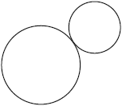
1) | 1
2) | 2
3) | 3
4) | 4

29 In the diagram below of isosceles trapezoid DEFG, , , , , and . Find the value of x.

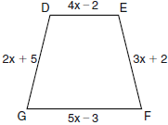

30 A regular pyramid with a square base is shown in the diagram below.

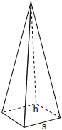

A side, s, of the base of the pyramid is 12 meters, and the height, h, is 42 meters. What is the volume of the pyramid in cubic meters?

31 Write an equation of the line that passes through the point and is parallel to the line whose equation is .

32 Using a compass and straightedge, construct the angle bisector of shown below. [Leave all construction marks.]

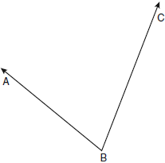

33 The degree measures of the angles of are represented by x, 3x, and . Find the value of x.

34 In the diagram below of with side extended through D, and . Which side of is the longest side? Justify your answer.

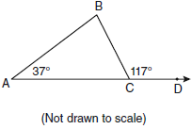

35 Write an equation of the perpendicular bisector of the line segment whose endpoints are and . [The use of the grid below is optional]



36 On the set of axes below, sketch the points that are 5 units from the origin and sketch the points that are 2 units from the line . Label with an X all points that satisfy both conditions.

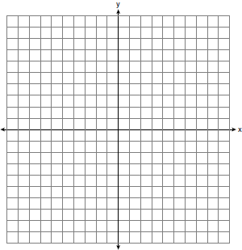

37 Triangle DEG has the coordinates , , and . Triangle DEG is rotated 90° about the origin to form . On the grid below, graph and label and . State the coordinates of the vertices D', E', and G'. Justify that this transformation preserves distance.

38 Given: Quadrilateral ABCD, diagonal , , , ,
Prove: ABCD is a parallelogram.

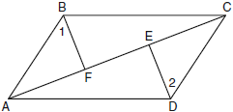
1 ANS: 4
The marked 60º angle and the angle above it are on the same straight line and supplementary. This unmarked supplementary angle is 120º. Because the unmarked 120º angle and the marked 120º angle are alternate exterior angles and congruent, .

PTS: 2 REF: 080901ge STA: G.G.35 TOP: Parallel Lines and Transversals

2 ANS: 3 PTS: 2 REF: 080902ge STA: G.G.17
TOP: Constructions

3 ANS: 4

PTS: 2 REF: 080903ge STA: G.G.31 TOP: Isosceles Triangle Theorem

4 ANS: 2
Parallel chords intercept congruent arcs. . .

PTS: 2 REF: 080904ge STA: G.G.52 TOP: Chords

5 ANS: 4 PTS: 2 REF: 080905ge STA: G.G.29
TOP: Triangle Congruency

6 ANS: 2
A dilation affects distance, not angle measure.

PTS: 2 REF: 080906ge STA: G.G.60 TOP: Identifying Transformations

7 ANS: 1
and are supplementary adjacent angles of a parallelogram. .

PTS: 2 REF: 080907ge STA: G.G.38 TOP: Parallelograms

8 ANS: 1
Translations and reflections do not affect distance.

PTS: 2 REF: 080908ge STA: G.G.59 TOP: Properties of Transformations

9 ANS: 3
The slope of is 1. The slope of is 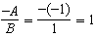.

PTS: 2 REF: 080909ge STA: G.G.63 TOP: Parallel and Perpendicular Lines

10 ANS: 2
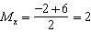. 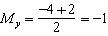

PTS: 2 REF: 080910ge STA: G.G.66 TOP: Midpoint

11 ANS: 1 PTS: 2 REF: 080911ge STA: G.G.73
TOP: Equations of Circles

12 ANS: 4
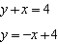. 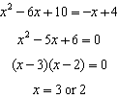. 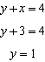. 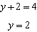 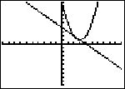

PTS: 2 REF: 080912ge STA: G.G.70 TOP: Quadratic-Linear Systems

13 ANS: 3 PTS: 2 REF: 080913ge STA: G.G.28
TOP: Triangle Congruency

14 ANS: 4 PTS: 2 REF: 080914ge STA: G.G.7
TOP: Planes

15 ANS: 4 PTS: 2 REF: 080915ge STA: G.G.56
TOP: Identifying Transformations

16 ANS: 2

PTS: 2 REF: 080916ge STA: G.G.33 TOP: Triangle Inequality Theorem

17 ANS: 4
The slope of is . Perpendicular lines have slope that are opposite reciprocals.

PTS: 2 REF: 080917ge STA: G.G.62 TOP: Parallel and Perpendicular Lines

18 ANS: 1 PTS: 2 REF: 080918ge STA: G.G.41
TOP: Special Quadrilaterals

19 ANS: 1
.

PTS: 2 REF: 080919ge STA: G.G.67 TOP: Distance

20 ANS: 3
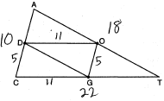

PTS: 2 REF: 080920ge STA: G.G.42 TOP: Midsegments

21 ANS: 2 PTS: 2 REF: 080921ge STA: G.G.72
TOP: Equations of Circles

22 ANS: 4
Let . 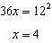

PTS: 2 REF: 080922ge STA: G.G.47 TOP: Similarity
KEY: leg

23 ANS: 2
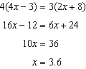

PTS: 2 REF: 080923ge STA: G.G.53 TOP: Segments Intercepted by Circle
KEY: two chords

24 ANS: 3 PTS: 2 REF: 080924ge STA: G.G.24
TOP: Negations

25 ANS: 4 PTS: 2 REF: 080925ge STA: G.G.21
TOP: Centroid, Orthocenter, Incenter and Circumcenter

26 ANS: 1
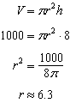

PTS: 2 REF: 080926ge STA: G.G.14 TOP: Volume and Lateral Area

27 ANS: 2 PTS: 2 REF: 080927ge STA: G.G.4
TOP: Planes

28 ANS: 3 PTS: 2 REF: 080928ge STA: G.G.50
TOP: Tangents KEY: common tangency

29 ANS:
3. The non-parallel sides of an isosceles trapezoid are congruent. 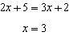

PTS: 2 REF: 080929ge STA: G.G.40 TOP: Trapezoids

30 ANS:
2016. 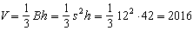

PTS: 2 REF: 080930ge STA: G.G.13 TOP: Volume

31 ANS:
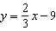. The slope of is 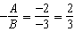. 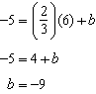

PTS: 2 REF: 080931ge STA: G.G.65 TOP: Parallel and Perpendicular Lines

32 ANS:
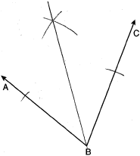

PTS: 2 REF: 080932ge STA: G.G.17 TOP: Constructions

33 ANS:
26. 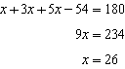

PTS: 2 REF: 080933ge STA: G.G.30 TOP: Interior and Exterior Angles of Triangles

34 ANS:
. and . is the longest side as it is opposite the largest angle.

PTS: 2 REF: 080934ge STA: G.G.34 TOP: Angle Side Relationship

35 ANS:
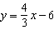. 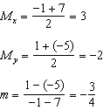 The perpendicular bisector goes through and has a slope of . 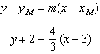. 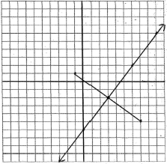

PTS: 4 REF: 080935ge STA: G.G.68 TOP: Perpendicular Bisector

36 ANS:
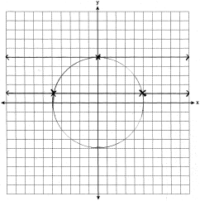

PTS: 4 REF: 080936ge STA: G.G.23 TOP: Locus

37 ANS:
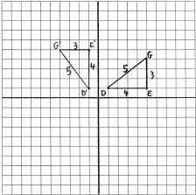 , ,

PTS: 4 REF: 080937ge STA: G.G.55 TOP: Properties of Transformations

38 ANS:
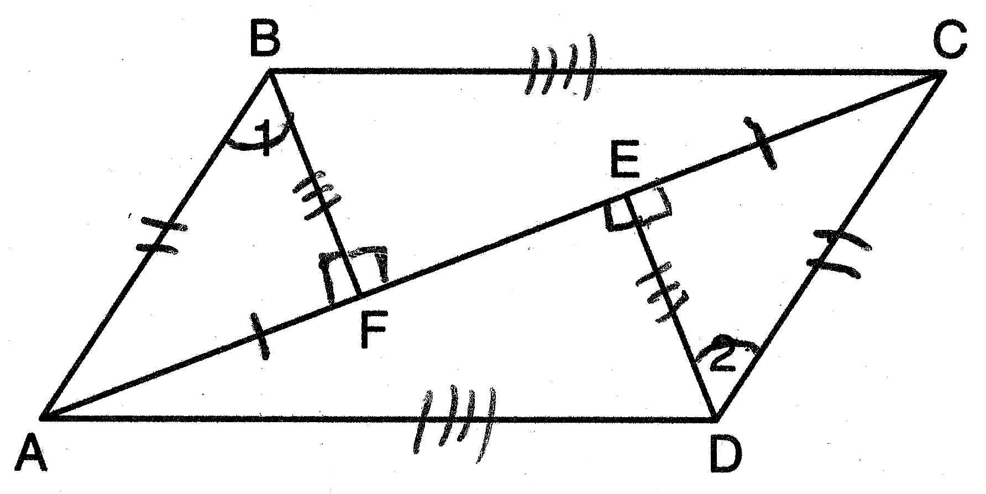 (Reflexive Property); (Line Segment Subtraction Theorem); (Substitution); (All right angles are congruent); (AAS); and (CPCTC); (All right angles are congruent); (SAS); (CPCTC); ABCD is a parallelogram (opposite sides of quadrilateral ABCD are congruent)

PTS: 6 REF: 080938ge STA: G.G.27 TOP: Quadrilateral Proofs

