1 Quadrilateral ABCD undergoes a transformation, producing quadrilateral . For which transformation would the area of not be equal to the area of ABCD?
1) | a rotation of 90° about the origin
2) | a reflection over the y-axis
3) | a dilation by a scale factor of 2
4) | a translation defined by

2 The diameter of a sphere is 12 inches. What is the volume of the sphere to the nearest cubic inch?
1) | 288
2) | 452
3) | 905
4) | 7,238

3 A right rectangular prism is shown in the diagram below.

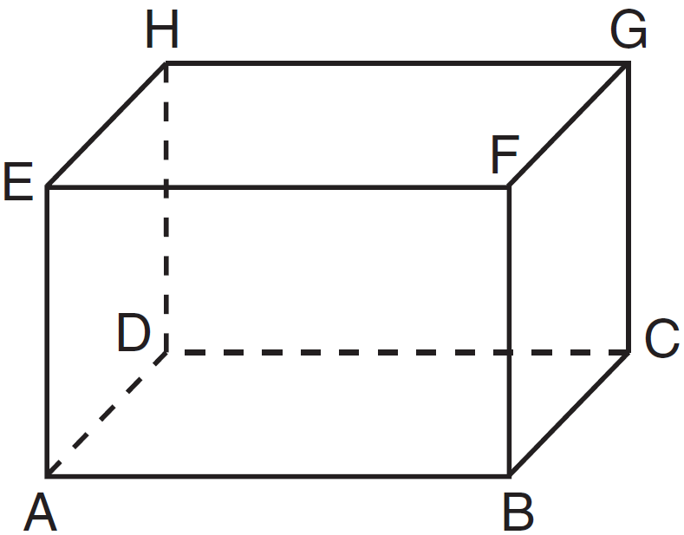

Which line segments are coplanar?
1) | and
2) | and
3) | and
4) | and

4 What are the coordinates of the image of point under the translation ?
1)
2)
3)
4)

5 Point M is the midpoint of . If the coordinates of M are and the coordinates of A are , what are the coordinates of B?
1)
2)
3)
4)

6 In the diagram below, is an altitude of right triangle PQR, , and .

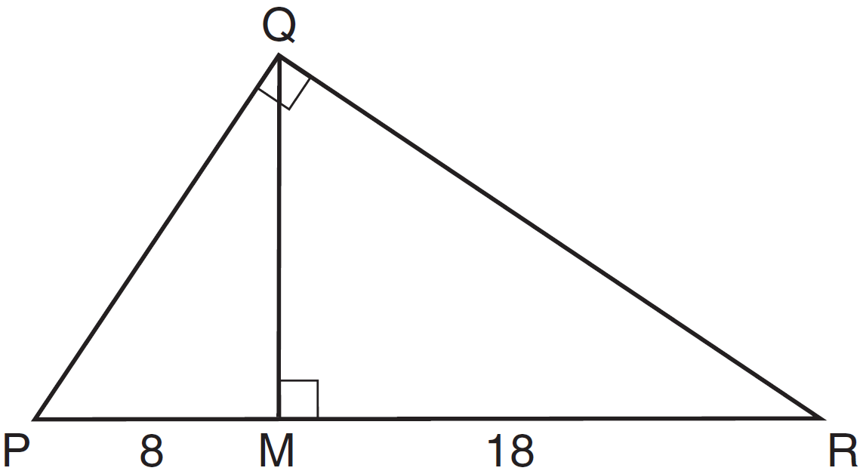

What is the length of ?
1) | 20
2) | 16
3) | 12
4) | 10

7 What is an equation of the line that passes through the point and is perpendicular to the line whose equation is ?
1) | 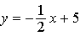
2) | 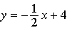
3)
4)

8 In all isosceles triangles, the exterior angle of a base angle must always be
1) | a right angle
2) | an acute angle
3) | an obtuse angle
4) | equal to the vertex angle

9 If is the image of after the transformation , which statement is false?
1)
2)
3)
4)

10 Which equation represents the circle shown in the graph below?

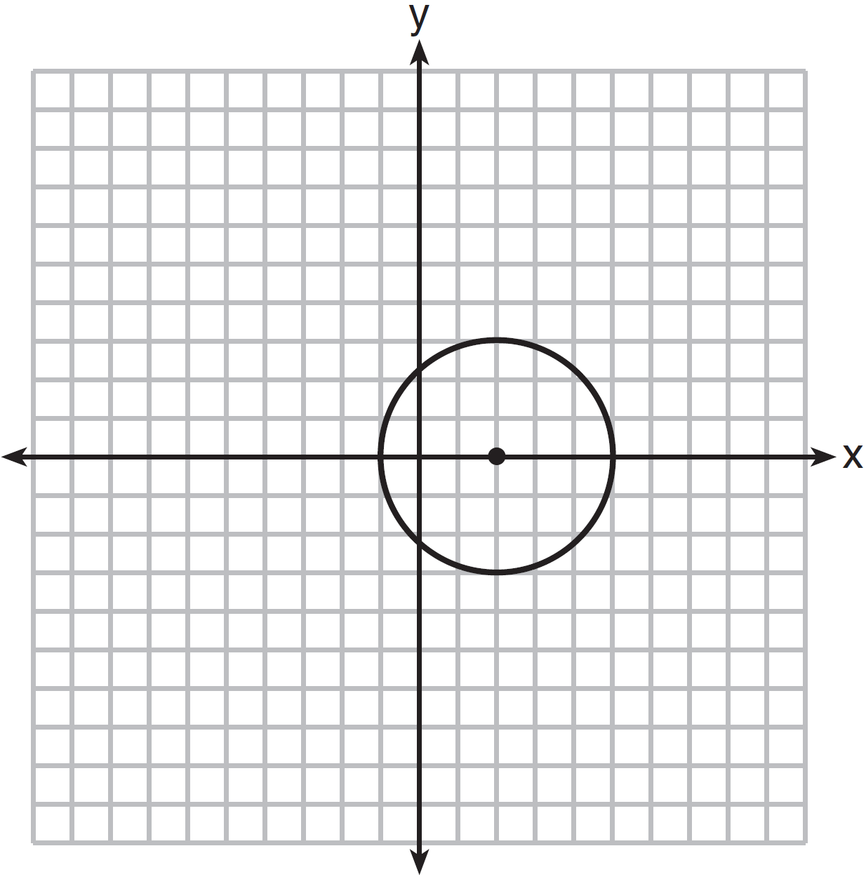
1)
2)
3)
4)

11 In quadrilateral ABCD, each diagonal bisects opposite angles. If , then ABCD must be a
1) | rectangle
2) | trapezoid
3) | rhombus
4) | square

12 Which diagram illustrates a correct construction of an altitude of ?
1) | 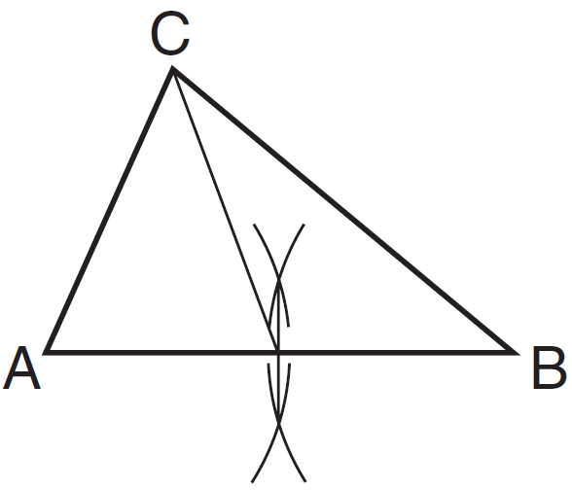
2) | 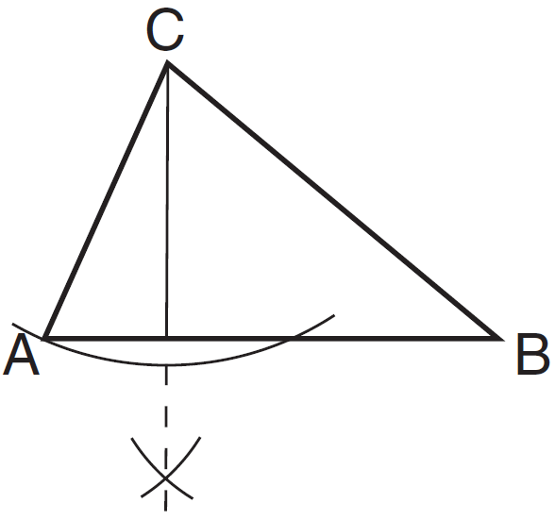
3) | 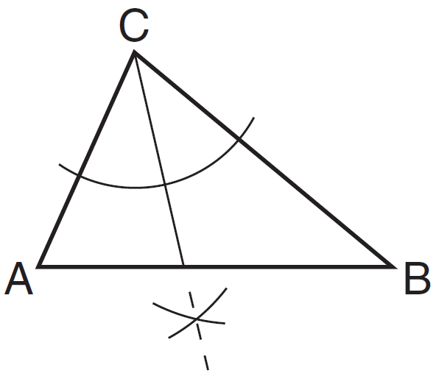
4) | 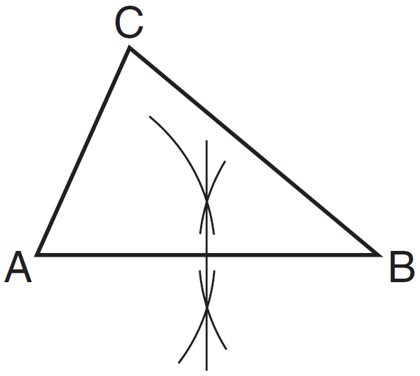

13 From external point A, two tangents to circle O are drawn. The points of tangency are B and C. Chord is drawn to form . If , what is ?
1) | 33
2) | 48
3) | 57
4) | 66

14 Point A lies on plane P. How many distinct lines passing through point A are perpendicular to plane P?
1) | 1
2) | 2
3) | 0
4) | infinite

15 Students made four statements about a circle.
A: The coordinates of its center are .
B: The coordinates of its center are .
C: The length of its radius is .
D: The length of its radius is 25.
If the equation of the circle is , which statements are correct?
1) | A and C
2) | A and D
3) | B and C
4) | B and D

16 Points A, B, C, and D are located on circle O, forming trapezoid ABCD with . Which statement must be true?
1)
2)
3)
4)

17 If , which statement is not always true?
1)
2)
3) | 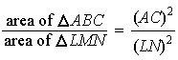
4) | 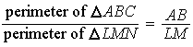

18 The equations of lines k, m, and n are given below.
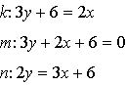
Which statement is true?
1)
2)
3)
4)

19 A regular polygon with an exterior angle of 40° is a
1) | pentagon
2) | hexagon
3) | nonagon
4) | decagon

20 In shown below, L is the midpoint of , M is the midpoint of , and N is the midpoint of .

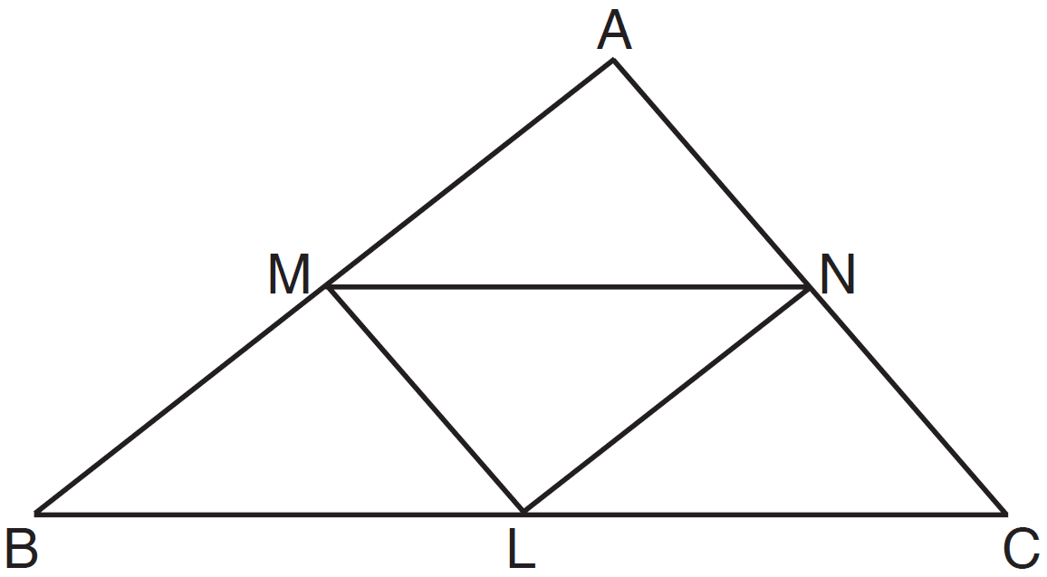

If , , and , the perimeter of trapezoid BMNC is
1) | 26
2) | 28
3) | 30
4) | 35

21 The sum of the interior angles of a regular polygon is 720°. How many sides does the polygon have?
1) | 8
2) | 6
3) | 5
4) | 4

22 In the prism shown below, and .

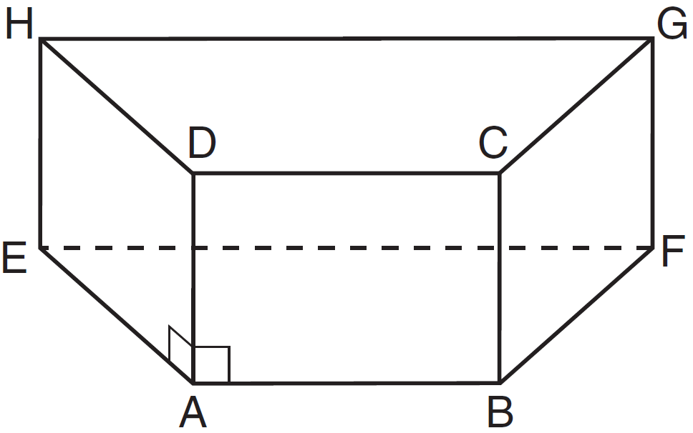

Which plane is perpendicular to ?
1) | HEA
2) | BAD
3) | EAB
4) | EHG

23 In , and is greater than . The lengths of the sides of in order from smallest to largest are
1) | , ,
2) | , ,
3) | , ,
4) | , ,

24 Which equation represents a circle whose center is the origin and that passes through the point ?
1)
2)
3)
4)

25 The lengths of two sides of a triangle are 7 and 11. Which inequality represents all possible values for x, the length of the third side of the triangle?
1)
2)
3)
4)

26 Which statement is the inverse of “If , then ”?
1) | If , then .
2) | If , then .
3) | If , then .
4) | If , then .

27 In the diagram below of , medians , , and intersect at O.

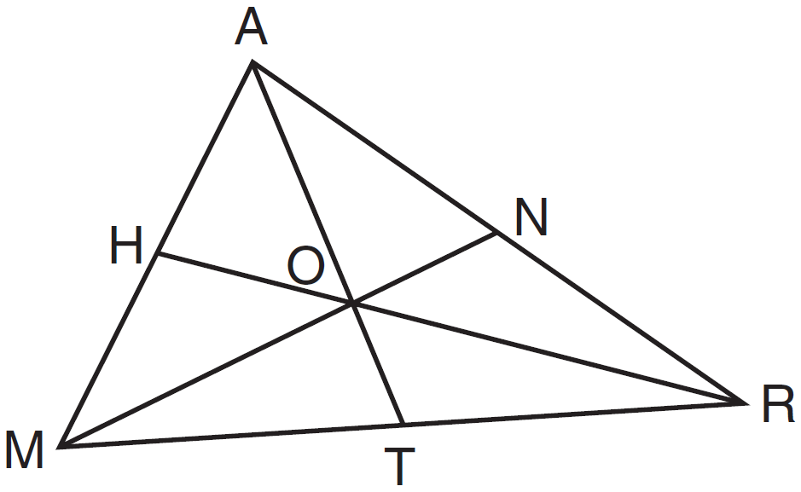

If , what is the length of ?
1) | 30
2) | 25
3) | 20
4) | 15

28 What is an equation of the line that passes through the point and is parallel to the line whose equation is 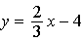?
1)
2)
3)
4)

29 The measures of the angles of a triangle are in the ratio . Determine the measure, in degrees, of the smallest angle of the triangle.

30 Triangle ABC has vertices , , and . The image of after the transformation is . State and label the coordinates of . [The use of the set of axes below is optional.]

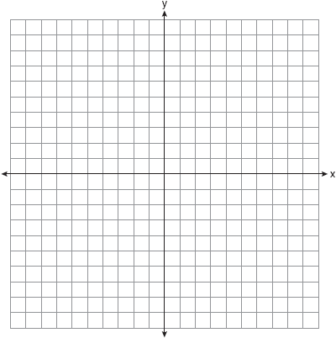

31 As shown in the diagram below, a right circular cone has a height of 12 and a radius of 5.

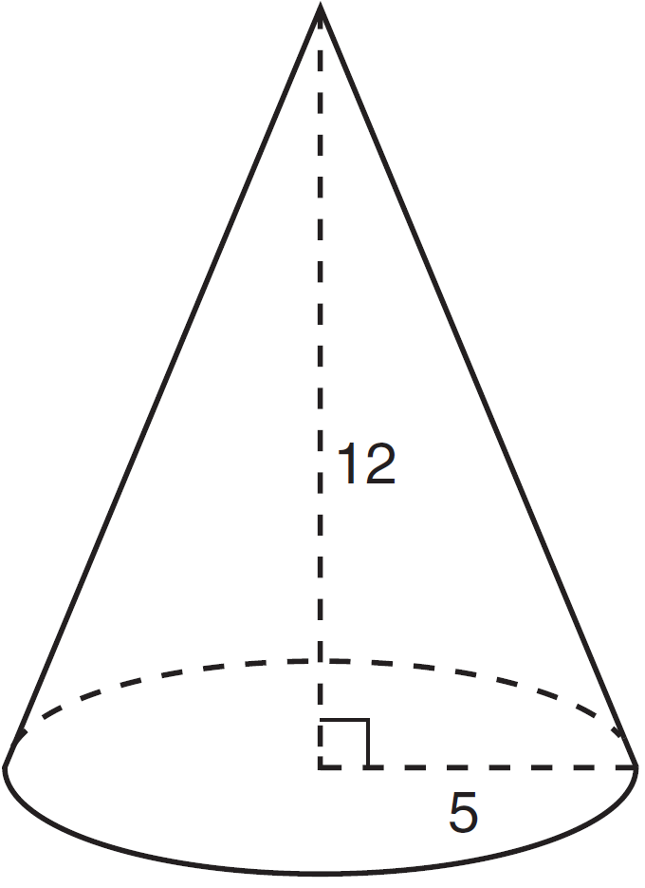

Determine, in terms of , the lateral area of the right circular cone.

32 Using a compass and straightedge, locate the midpoint of by construction. [Leave all construction marks.]

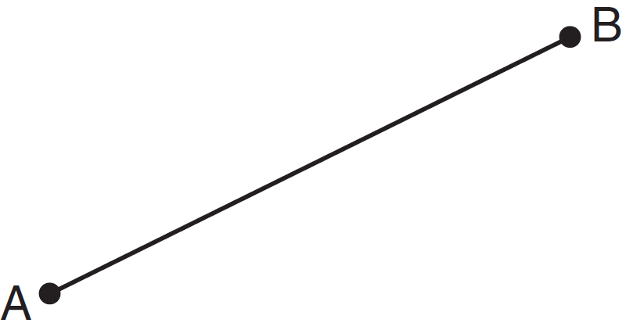

33 The coordinates of the endpoints of are and . Find the length of in simplest radical form.

34 In the diagram below, point B is the incenter of , and , , and are drawn.

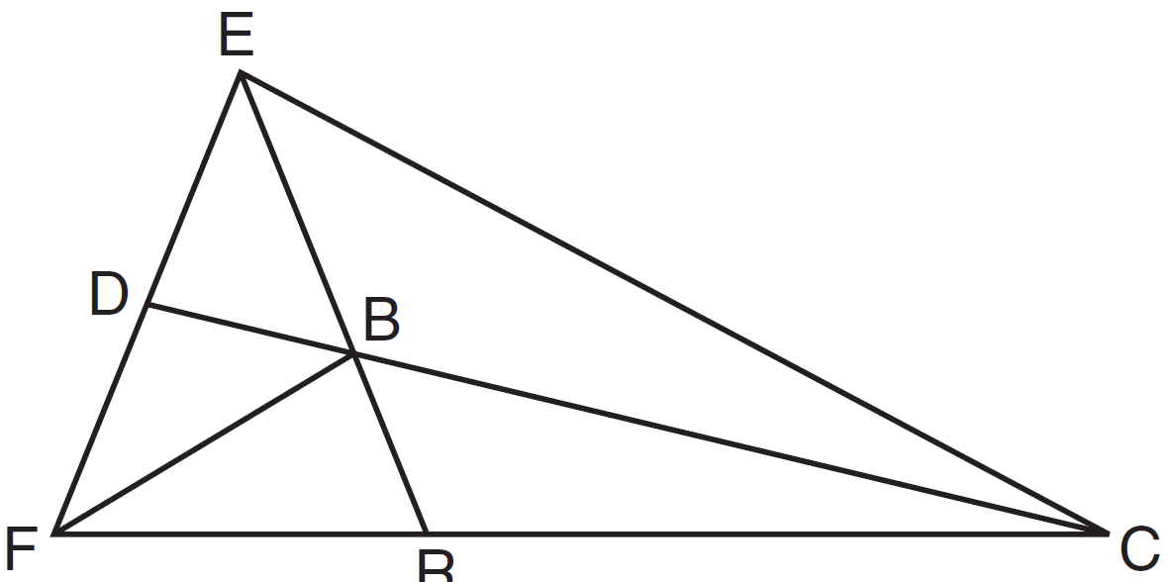

If and , determine and state .

35 Solve the following system of equations graphically. State the coordinates of all points in the solution.
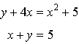

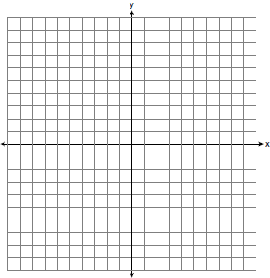

36 In parallelogram ABCD, with diagonal drawn, , , , and . Determine .

37 Point P is 5 units from line j. Sketch the locus of points that are 3 units from line j and also sketch the locus of points that are 8 units from P. Label with an X all points that satisfy both conditions.
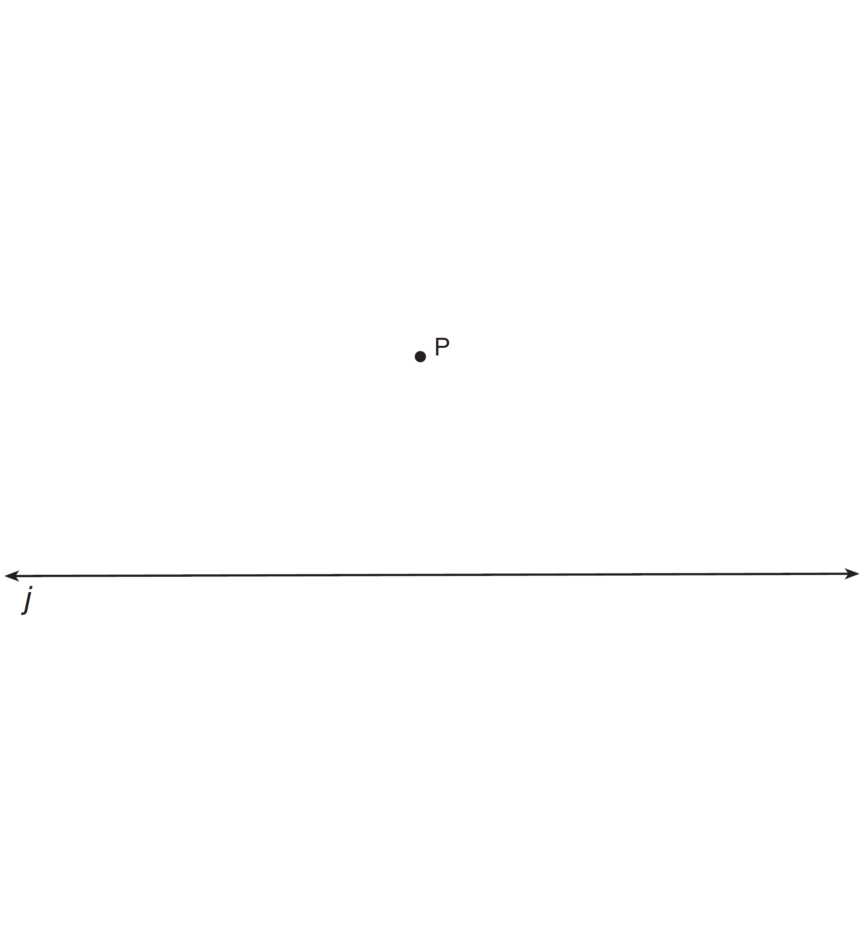

38 The diagram below shows square ABCD where E and F are points on such that , and segments AF and DE are drawn. Prove that .

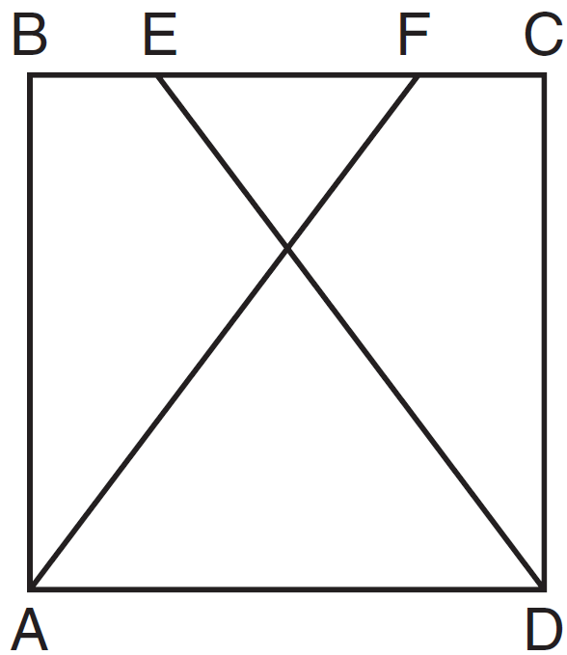

1 ANS: 3 PTS: 2 REF: 061501ge STA: G.G.61
TOP: Analytical Representations of Transformations

2 ANS: 3
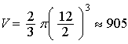

PTS: 2 REF: 061502ge STA: G.G.16 TOP: Volume and Surface Area

3 ANS: 4 PTS: 2 REF: 061503ge STA: G.G.10
TOP: Solids

4 ANS: 1

PTS: 2 REF: 061504ge STA: G.G.61
TOP: Analytical Representations of Transformations

5 ANS: 2
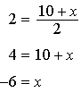. 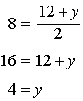

PTS: 2 REF: 061505ge STA: G.G.66 TOP: Midpoint

6 ANS: 3
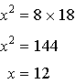

PTS: 2 REF: 061506ge STA: G.G.47 TOP: Similarity
KEY: altitude

7 ANS: 1
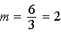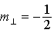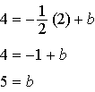

PTS: 2 REF: 061507ge STA: G.G.64 TOP: Parallel and Perpendicular Lines

8 ANS: 3 PTS: 2 REF: 061508ge STA: G.G.32
TOP: Exterior Angle Theorem

9 ANS: 2 PTS: 2 REF: 061509ge STA: G.G.55
TOP: Properties of Transformations

10 ANS: 1 PTS: 2 REF: 061510ge STA: G.G.72
TOP: Equations of Circles

11 ANS: 3

Diagonals of rectangles and trapezoids do not bisect opposite angles. if ABCD is a square.

PTS: 2 REF: 061511ge STA: G.G.39 TOP: Special Parallelograms

12 ANS: 2 PTS: 2 REF: 061512ge STA: G.G.19
TOP: Constructions

13 ANS: 2

PTS: 2 REF: 061513ge STA: G.G.50 TOP: Tangents
KEY: two tangents

14 ANS: 1 PTS: 2 REF: 061514ge STA: G.G.3
TOP: Planes

15 ANS: 3
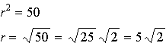

PTS: 2 REF: 061515ge STA: G.G.73 TOP: Equations of Circles

16 ANS: 2 PTS: 2 REF: 061516ge STA: G.G.52
TOP: Chords

17 ANS: 1 PTS: 2 REF: 061517ge STA: G.G.45
TOP: Similarity KEY: perimeter and area

18 ANS: 4
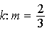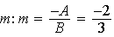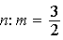

PTS: 2 REF: 061518ge STA: G.G.63 TOP: Parallel and Perpendicular Lines

19 ANS: 3
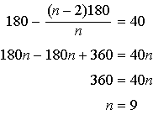

PTS: 2 REF: 061519ge STA: G.G.37 TOP: Interior and Exterior Angles of Polygons

20 ANS: 4
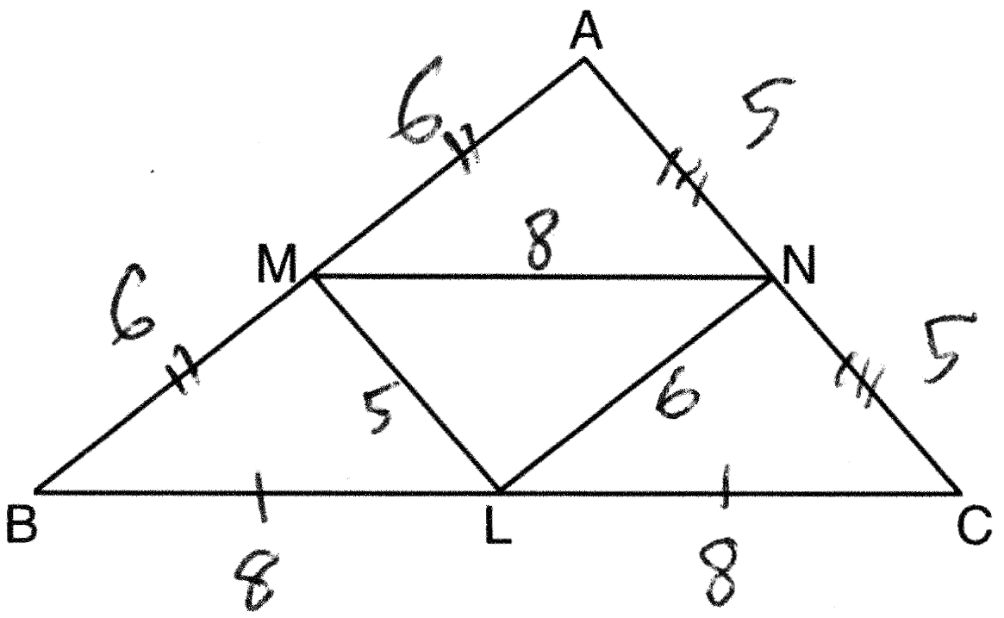

PTS: 2 REF: 061520ge STA: G.G.42 TOP: Midsegments

21 ANS: 2
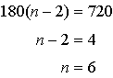

PTS: 2 REF: 061521ge STA: G.G.37 TOP: Interior and Exterior Angles of Polygons

22 ANS: 3 PTS: 2 REF: 061522ge STA: G.G.1
TOP: Planes

23 ANS: 1 PTS: 2 REF: 061523ge STA: G.G.34
TOP: Angle Side Relationship

24 ANS: 2 PTS: 2 REF: 061524ge STA: G.G.71
TOP: Equations of Circles

25 ANS: 4

PTS: 2 REF: 061525ge STA: G.G.33 TOP: Triangle Inequality Theorem

26 ANS: 3 PTS: 2 REF: 061526ge STA: G.G.26
TOP: Inverse

27 ANS: 1 PTS: 2 REF: 061527ge STA: G.G.43
TOP: Centroid

28 ANS: 4
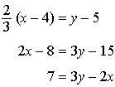

PTS: 2 REF: 061528ge STA: G.G.65 TOP: Parallel and Perpendicular Lines

29 ANS:
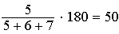

PTS: 2 REF: 061529ge STA: G.G.30 TOP: Interior and Exterior Angles of Triangles

30 ANS:
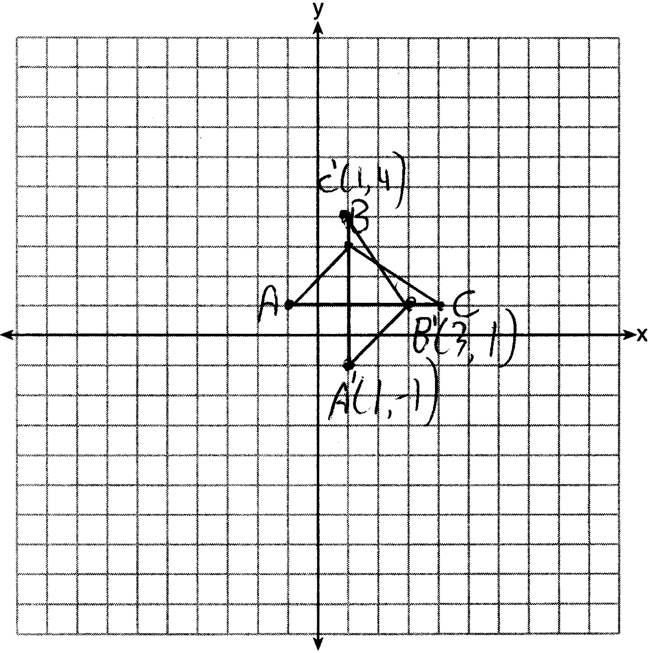

PTS: 2 REF: 061530ge STA: G.G.54 TOP: Reflections
KEY: grids

31 ANS:
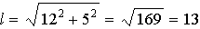

PTS: 2 REF: 061531ge STA: G.G.15 TOP: Volume and Lateral Area

32 ANS:
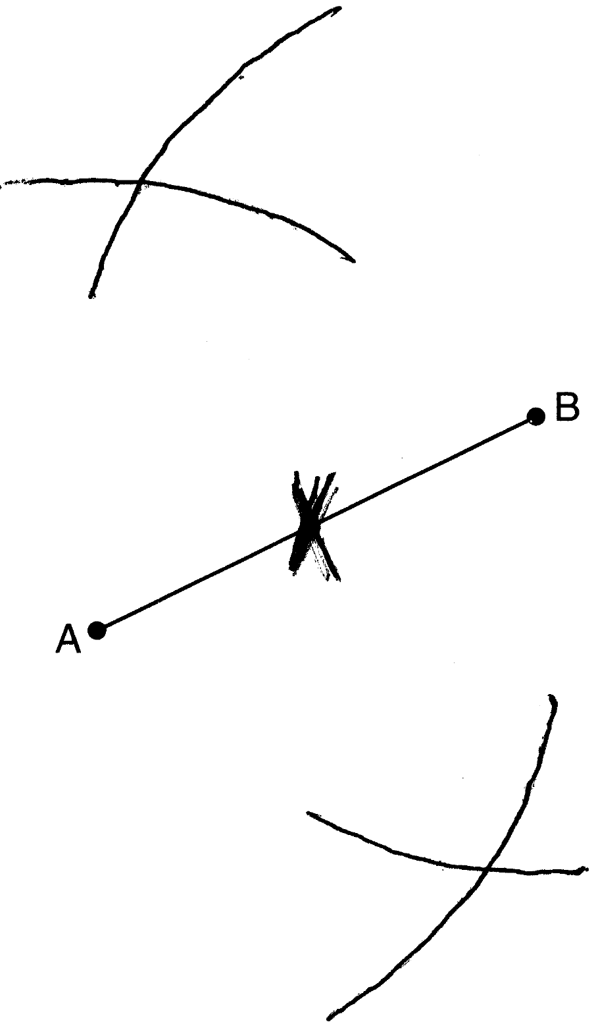

PTS: 2 REF: 061532ge STA: G.G.18 TOP: Constructions

33 ANS:
.

PTS: 2 REF: 061533ge STA: G.G.67 TOP: Distance

34 ANS:
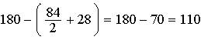

PTS: 2 REF: 061534ge STA: G.G.21
TOP: Centroid, Orthocenter, Incenter and Circumcenter

35 ANS:
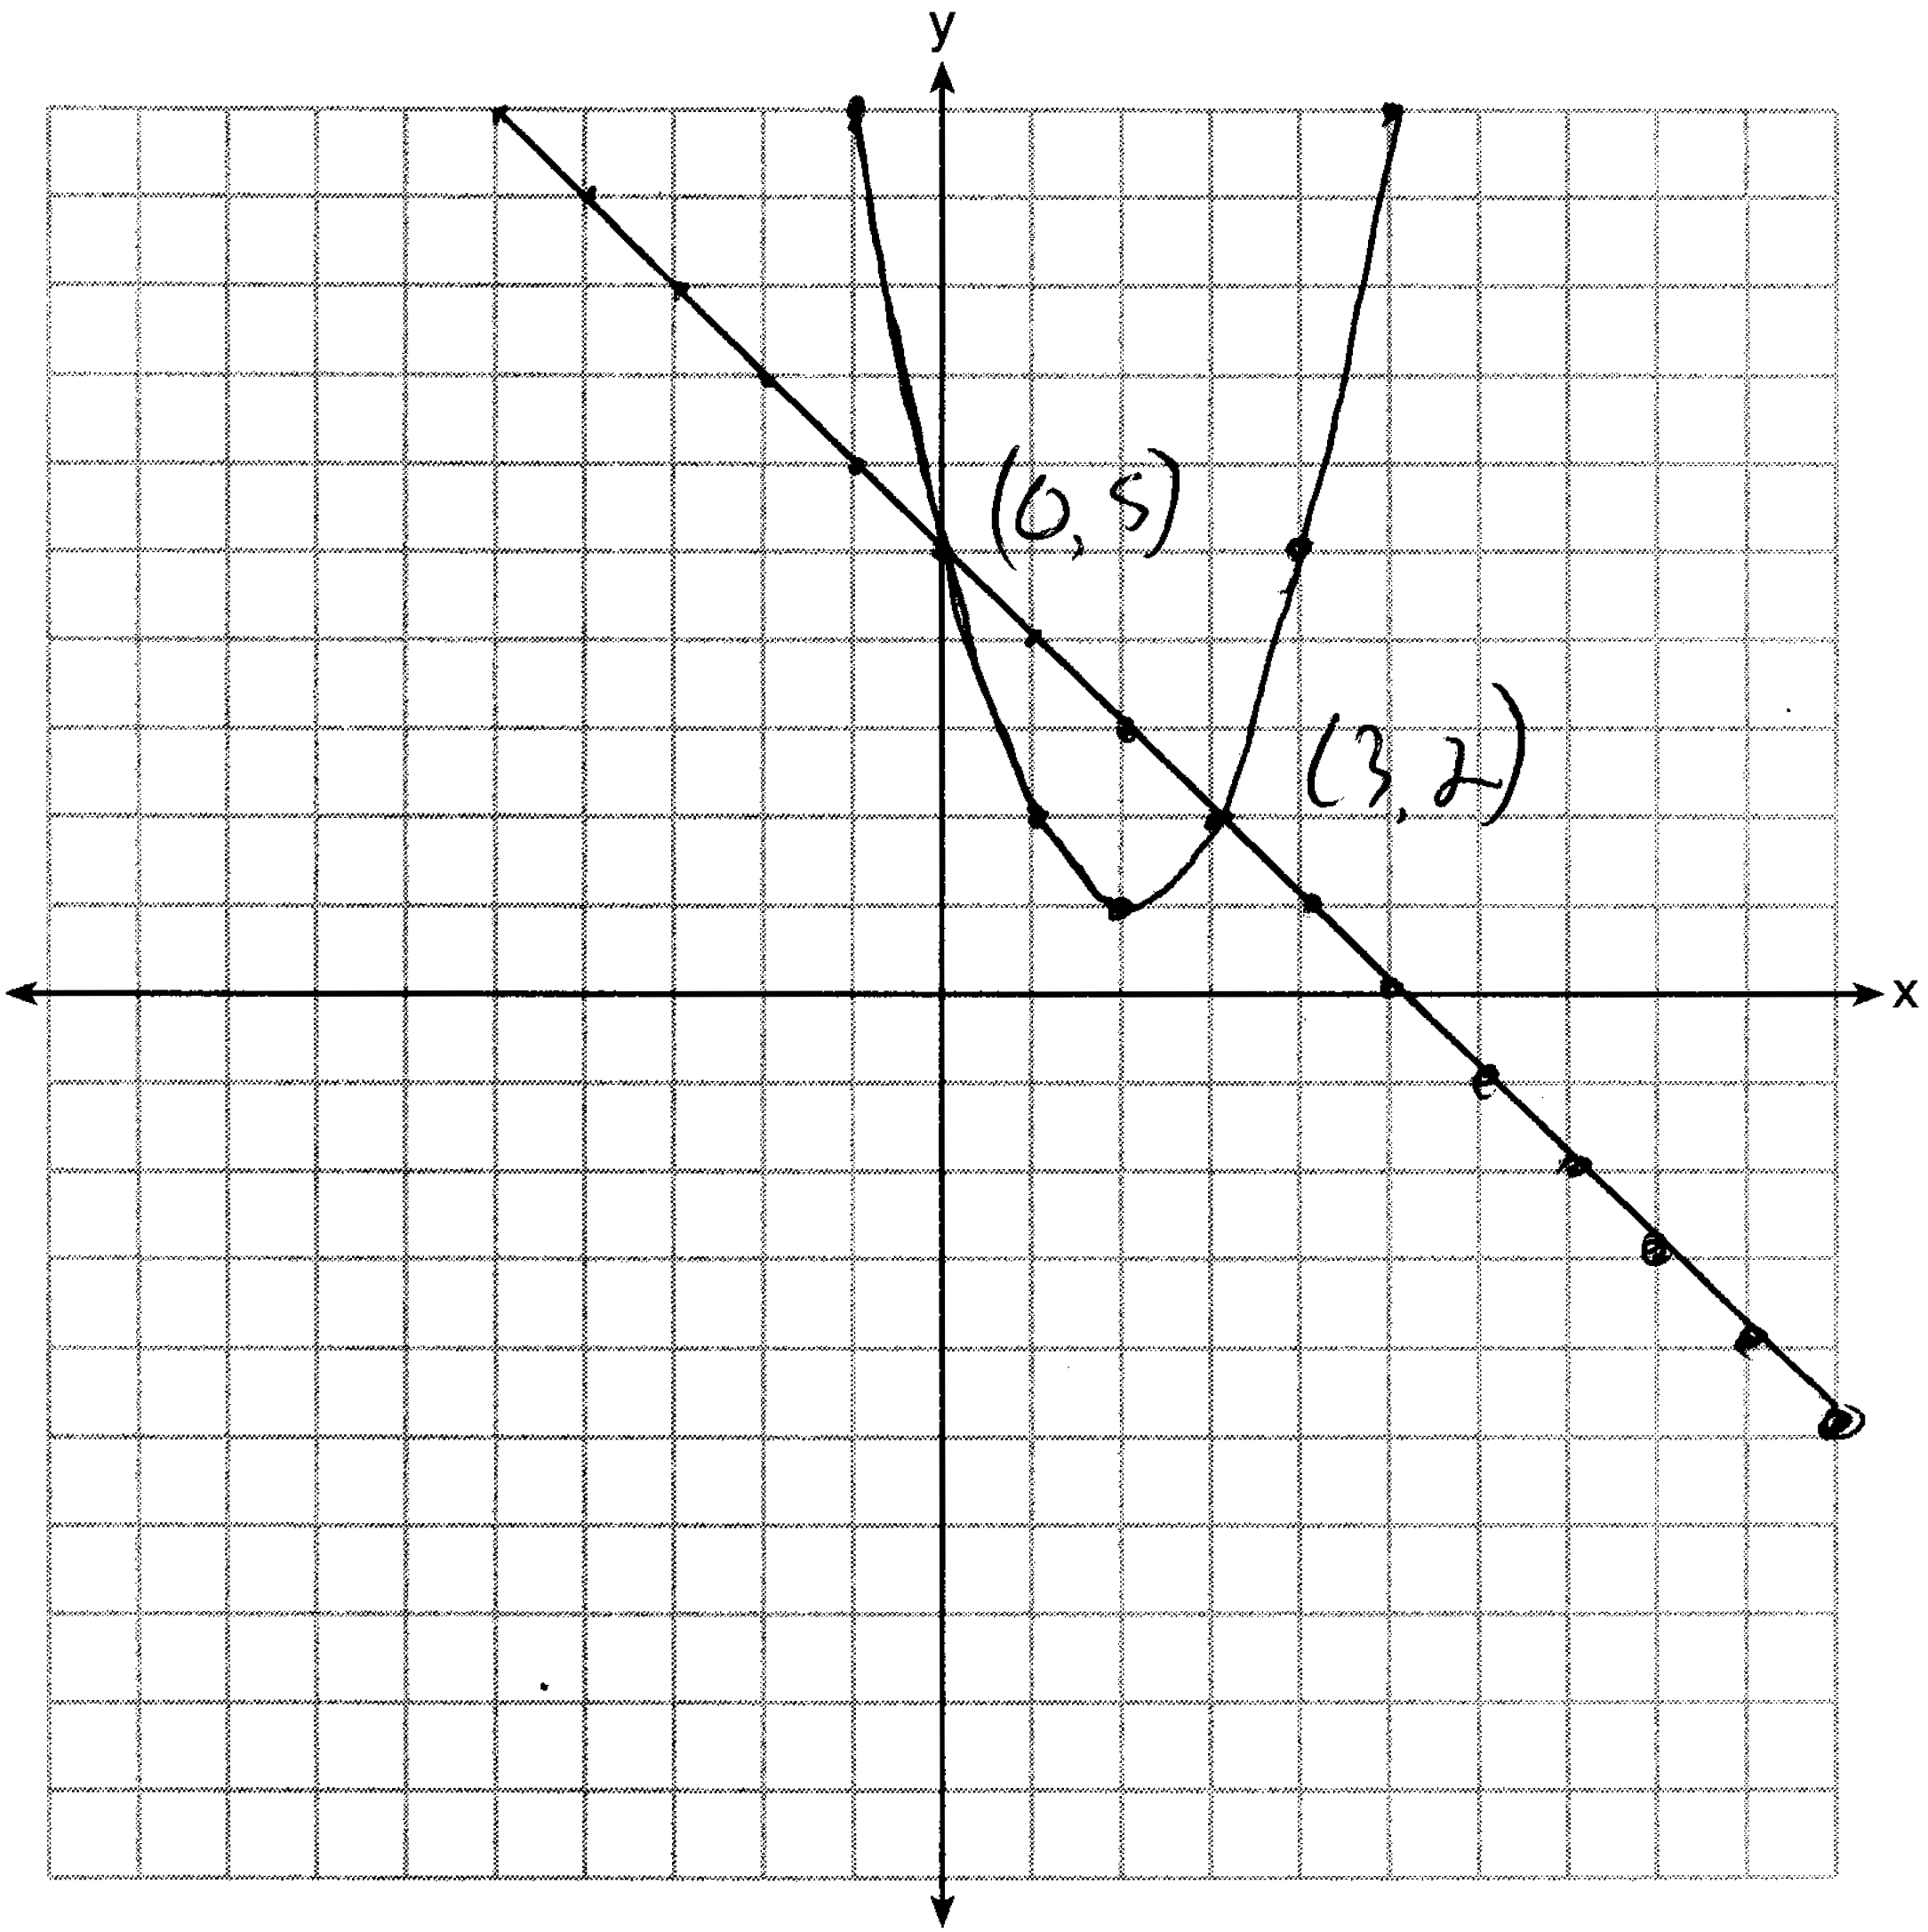

PTS: 4 REF: 061535ge STA: G.G.70 TOP: Quadratic-Linear Systems

36 ANS:
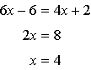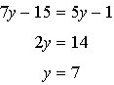

PTS: 4 REF: 061536ge STA: G.G.38 TOP: Parallelograms

37 ANS:
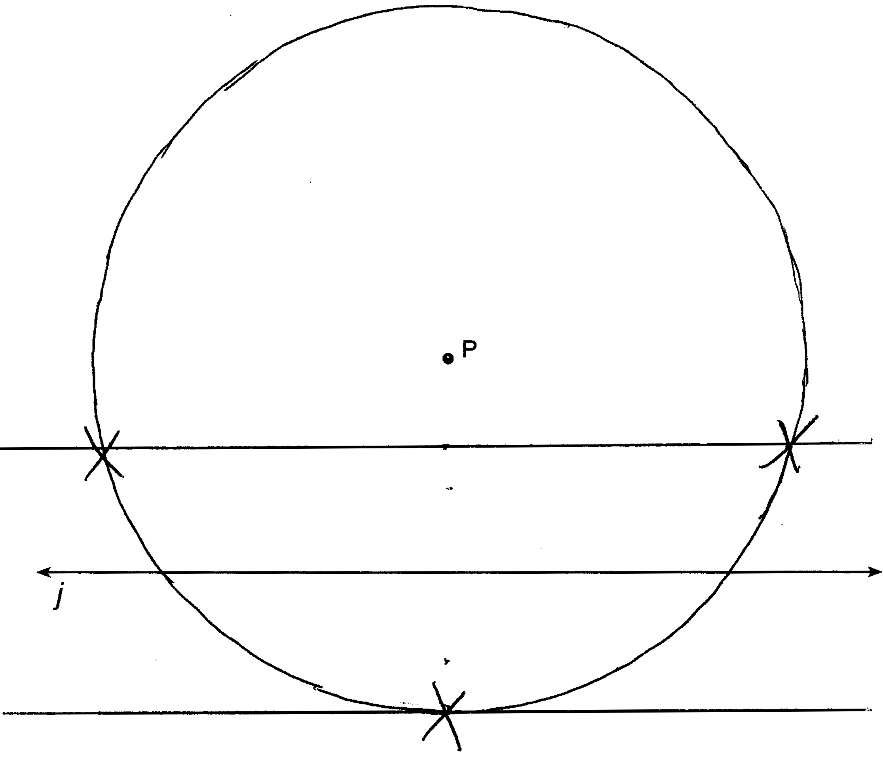

PTS: 4 REF: 061537ge STA: G.G.22 TOP: Locus

38 ANS:
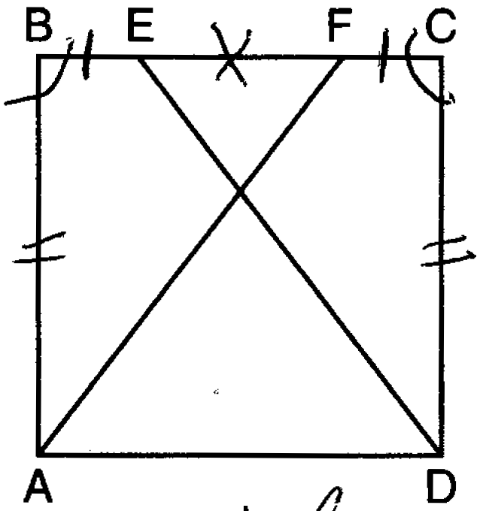 Square ABCD; E and F are points on such that ; and drawn (Given). (All sides of a square are congruent). (All angles of a square are equiangular). (Reflexive property). (Additive property of line segments). (Angle addition). (SAS). (CPCTC).

PTS: 6 REF: 061538ge STA: G.G.27 TOP: Quadrilateral Proofs

