1 Plane P is parallel to plane Q. If plane P is perpendicular to line , then plane Q
1) | contains line
2) | is parallel to line
3) | is perpendicular to line
4) | intersects, but is not perpendicular to line

2 In the diagram below, quadrilateral ABCD has vertices , , , and .

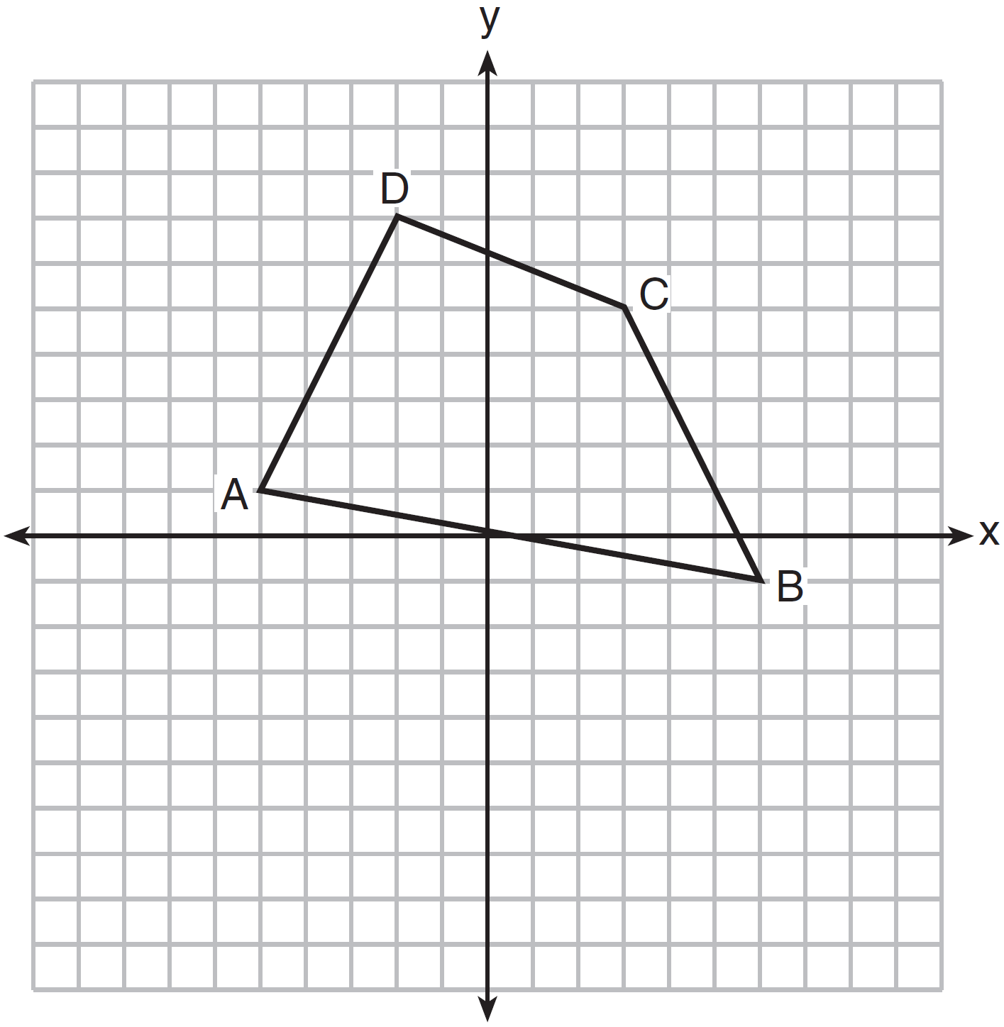

What are the coordinates of the midpoint of diagonal ?
1)
2)
3)
4)

3 In the diagram below, transversal intersects and at V and W, respectively.

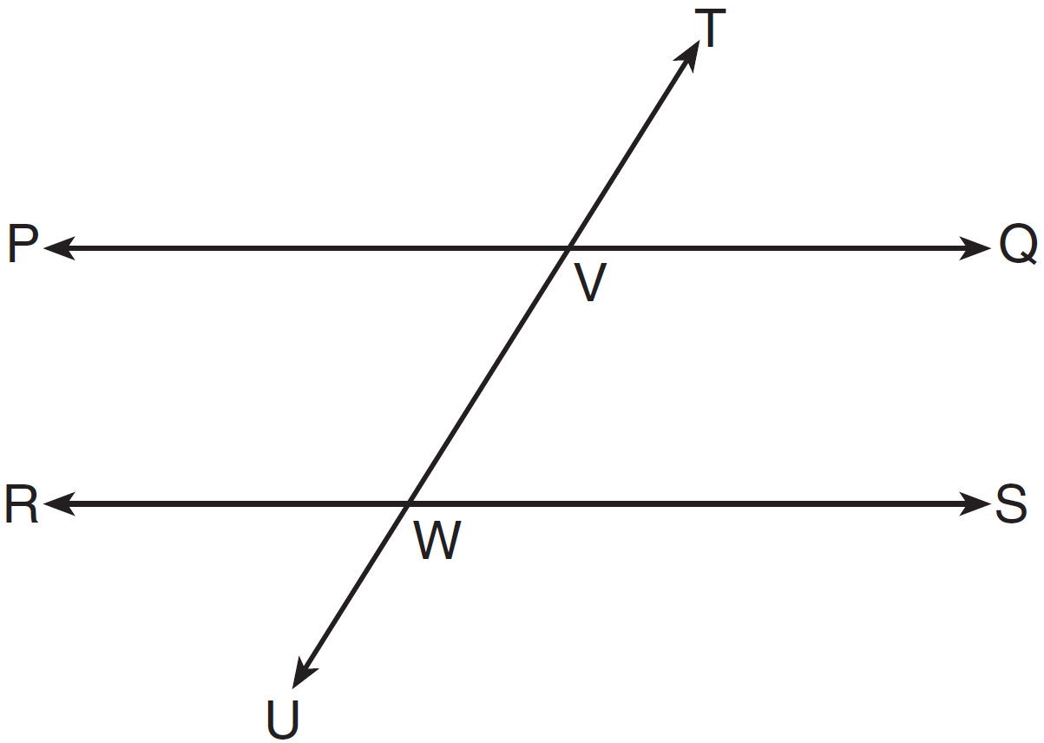

If and , for which value of x is 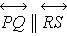?
1) | 6
2) | 16
3) | 24
4) | 28

4 The measures of the angles of a triangle are in the ratio . In degrees, the measure of the largest angle of the triangle is
1) | 20
2) | 40
3) | 80
4) | 100

5 The diameter of the base of a right circular cylinder is 6 cm and its height is 15 cm. In square centimeters, the lateral area of the cylinder is
1) | 180
2) | 135
3) | 90
4) | 45

6 When the system of equations and is graphed on a set of axes, what is the total number of points of intersection?
1) | 1
2) | 2
3) | 3
4) | 0

7 The vertex angle of an isosceles triangle measures 15 degrees more than one of its base angles. How many degrees are there in a base angle of the triangle?
1) | 50
2) | 55
3) | 65
4) | 70

8 Circle O is graphed on the set of axes below. Which equation represents circle O?

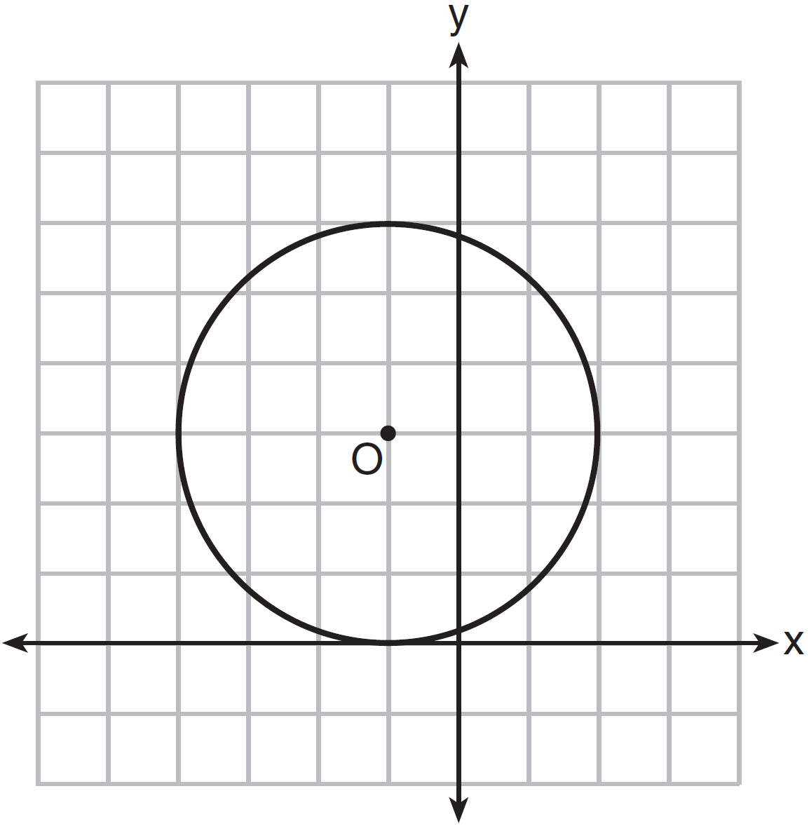
1)
2)
3)
4)

9 In the diagram of the circle shown below, chords and intersect at Q, and chords and are parallel.

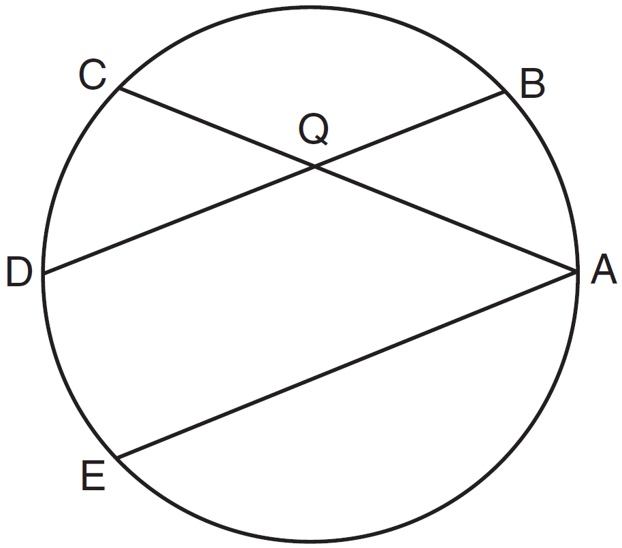

Which statement must always be true?
1)
2)
3)
4)

10 In the diagram below, .

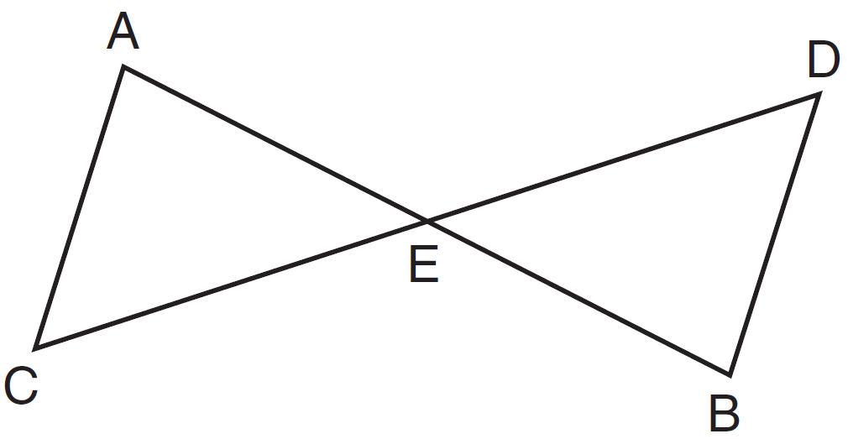

Which statement is not always true?
1)
2)
3)
4)

11 What is the length of with and ?
1)
2) | 40
3)
4)

12 What are the truth values of the statement “Two is prime” and its negation?
1) | The statement is false and its negation is true.
2) | The statement is false and its negation is false.
3) | The statement is true and its negation is true.
4) | The statement is true and its negation is false.

13 A regular polygon has an exterior angle that measures 45°. How many sides does the polygon have?
1) | 10
2) | 8
3) | 6
4) | 4

14 In rhombus ABCD, with diagonals and , .

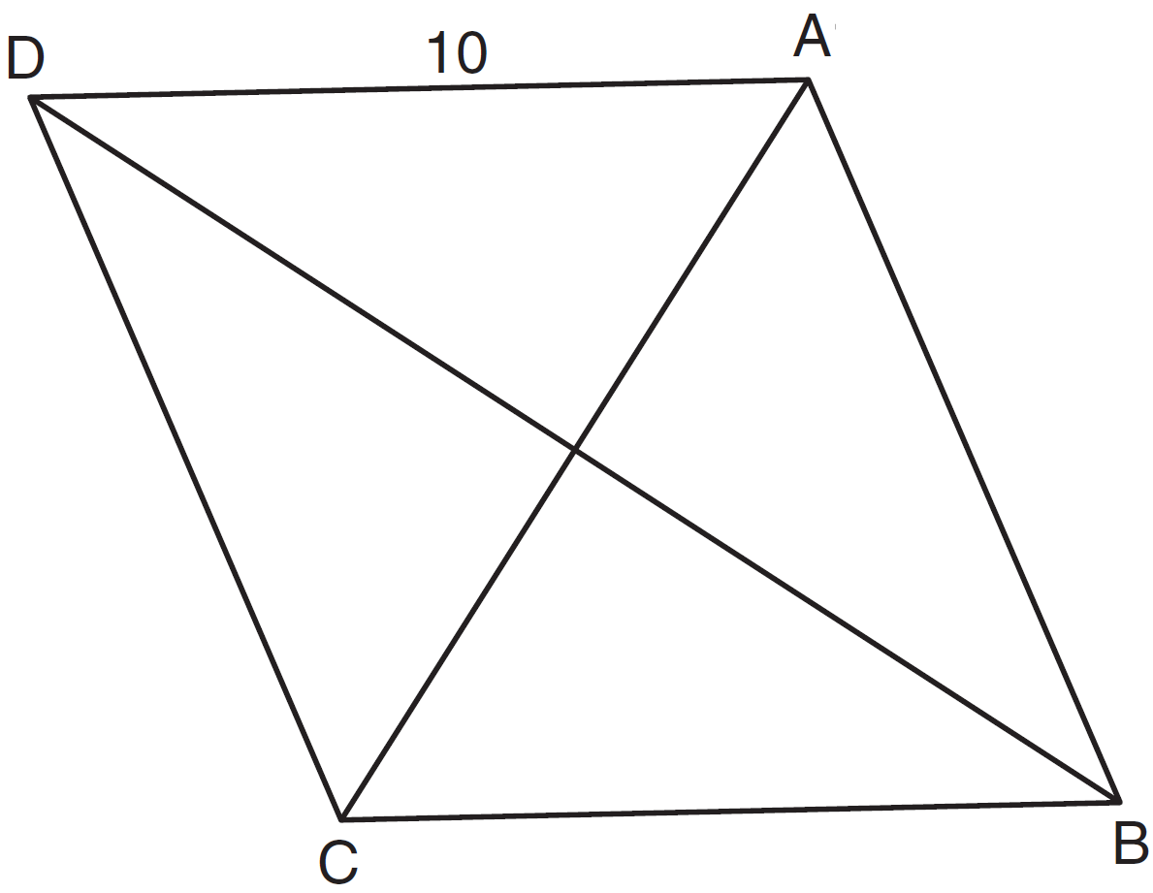

If the length of diagonal is 12, what is the length of ?
1) | 8
2) | 16
3)
4)

15 If the surface area of a sphere is 144 square centimeters, what is the length of the diameter of the sphere, in centimeters?
1) | 36
2) | 18
3) | 12
4) | 6

16 Which numbers could represent the lengths of the sides of a triangle?
1)
2)
3)
4)

17 The equation of a line is . What is the slope of the line perpendicular to the given line?
1)
2)
3)
4)

18 In the diagram below, point K is in plane P.

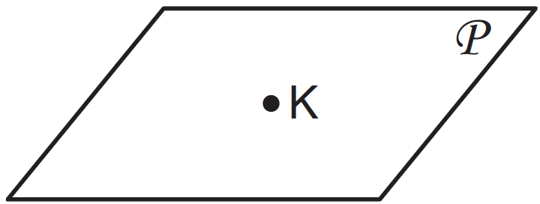

How many lines can be drawn through K, perpendicular to plane P ?
1) | 1
2) | 2
3) | 0
4) | an infinite number

19 In the diagram below, and are bases of trapezoid ABCD.

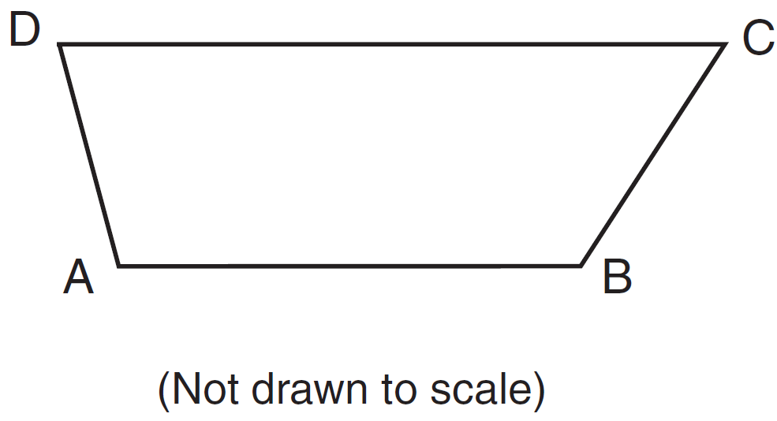

If and , what is ?
1) | 57
2) | 75
3) | 105
4) | 123

20 What is the equation of a line passing through the point and parallel to the line whose equation is ?
1) | 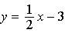
2) | 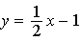
3)
4)

21 The image of rhombus VWXY preserves which properties under the transformation ?
1) | parallelism, only
2) | orientation, only
3) | both parallelism and orientation
4) | neither parallelism nor orientation

22 The equation of a circle is . The coordinates of its center and the length of its radius are
1) | and 4
2) | and 4
3) | and
4) | and

23 Which statement has the same truth value as the statement “If a quadrilateral is a square, then it is a rectangle”?
1) | If a quadrilateral is a rectangle, then it is a square.
2) | If a quadrilateral is a rectangle, then it is not a square.
3) | If a quadrilateral is not a square, then it is not a rectangle.
4) | If a quadrilateral is not a rectangle, then it is not a square.

24 The three medians of a triangle intersect at a point. Which measurements could represent the segments of one of the medians?
1) | 2 and 3
2) | 3 and 4.5
3) | 3 and 6
4) | 3 and 9

25 In the diagram of shown below, is extended to S, , , and .

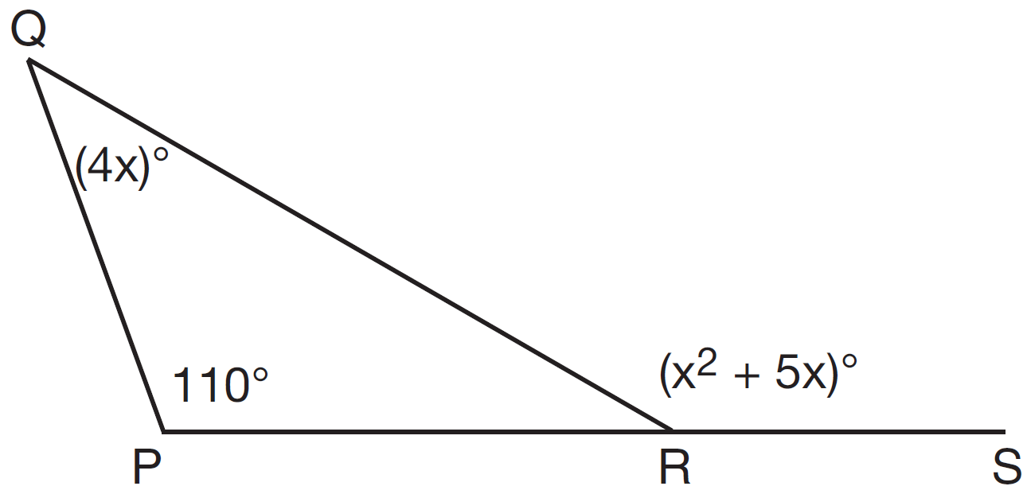

What is ?
1) | 44
2) | 40
3) | 11
4) | 10

26 Triangle PQT with is shown below.

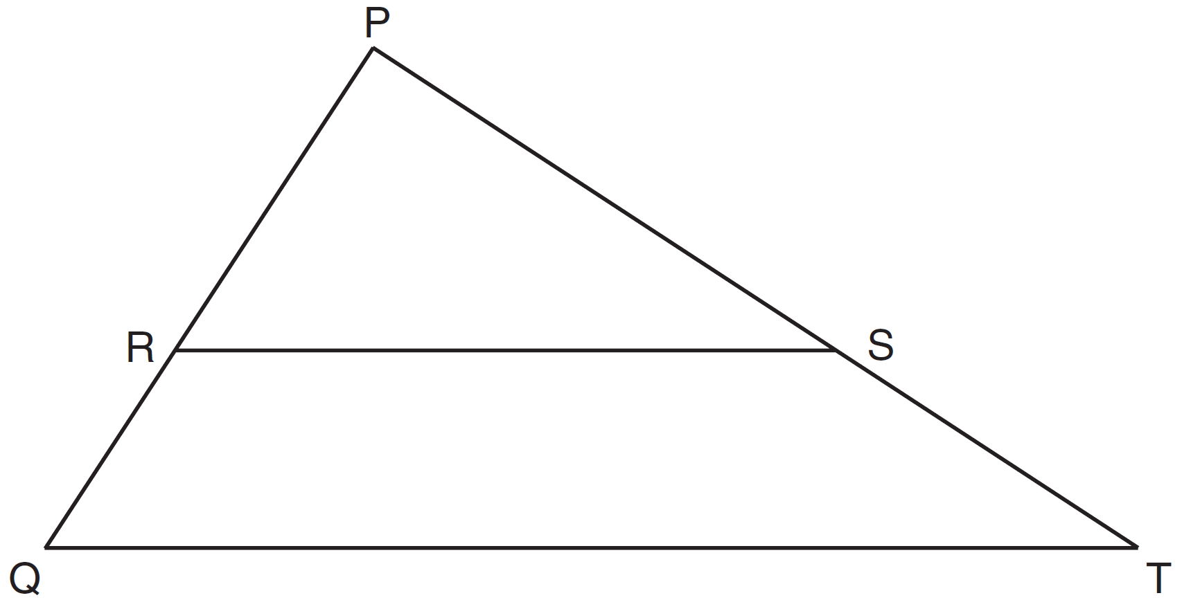

If , , and , what is the length of ?
1) | 14
2) | 17
3) | 35
4) | 38

27 In the diagram of below, .

Which reasons can be used to prove ?
1) | reflexive property and addition postulate
2) | reflexive property and subtraction postulate
3) | transitive property and addition postulate
4) | transitive property and subtraction postulate

28 The coordinates of the endpoints of the diameter of a circle are and . What is the equation of the circle?
1)
2)
3)
4)

29 The coordinates of the endpoints of are and . Under the transformation , the image of is . State the coordinates of points and .

30 As shown in the diagram below, is a diagonal of trapezoid STAR, , , , and .

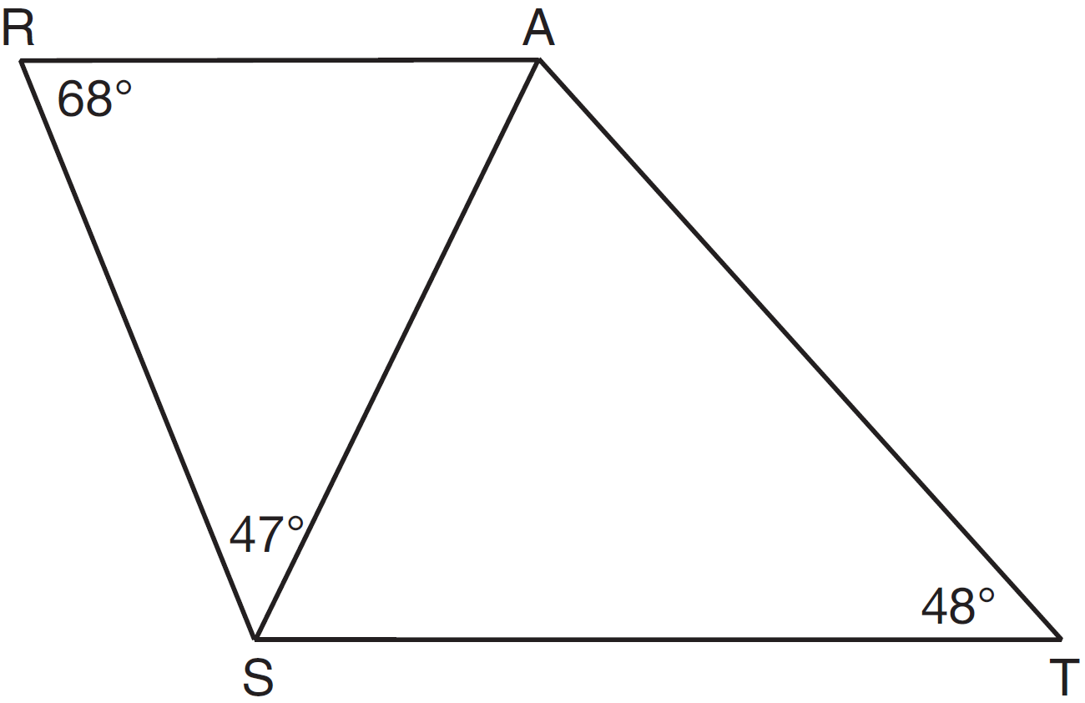

Determine and state the longest side of .

31 In right triangle ABC shown below, altitude is drawn to hypotenuse .

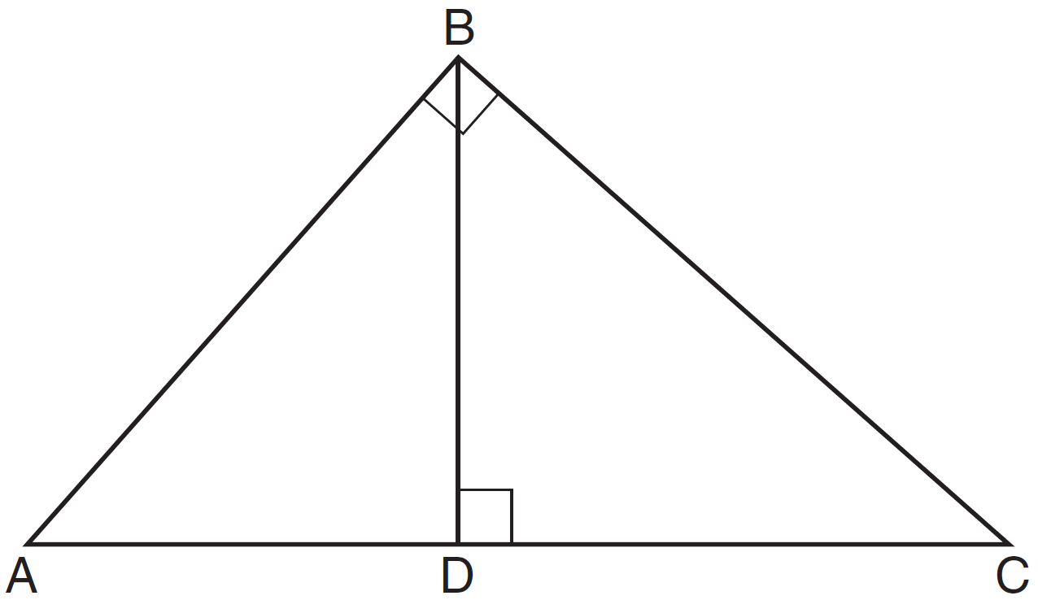

If and , determine and state the length of .

32 Two prisms with equal altitudes have equal volumes. The base of one prism is a square with a side length of 5 inches. The base of the second prism is a rectangle with a side length of 10 inches. Determine and state, in inches, the measure of the width of the rectangle.

33 As shown in the diagram below, and tangents and are drawn from external point B to circle O. Radii and are drawn.

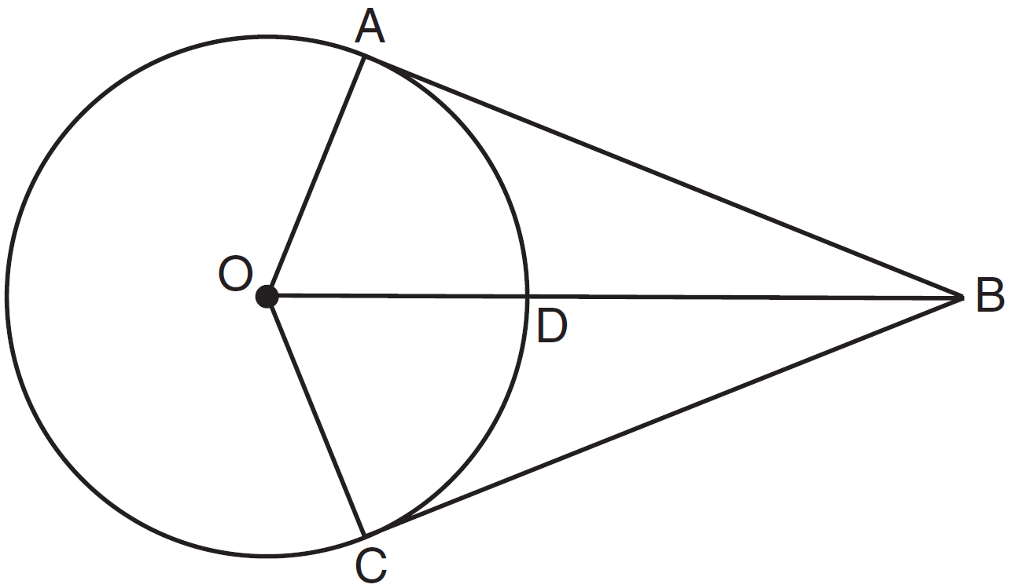

If and , determine and state the length of .

34 Triangle RST is similar to with inches and inches. If the area of is 27 square inches, determine and state the area of , in square inches.

35 The graph below shows , the image of after it was reflected over the y-axis. Graph and label , the pre-image of . Graph and label , the image of after it is reflected through the origin. State a single transformation that will map onto .

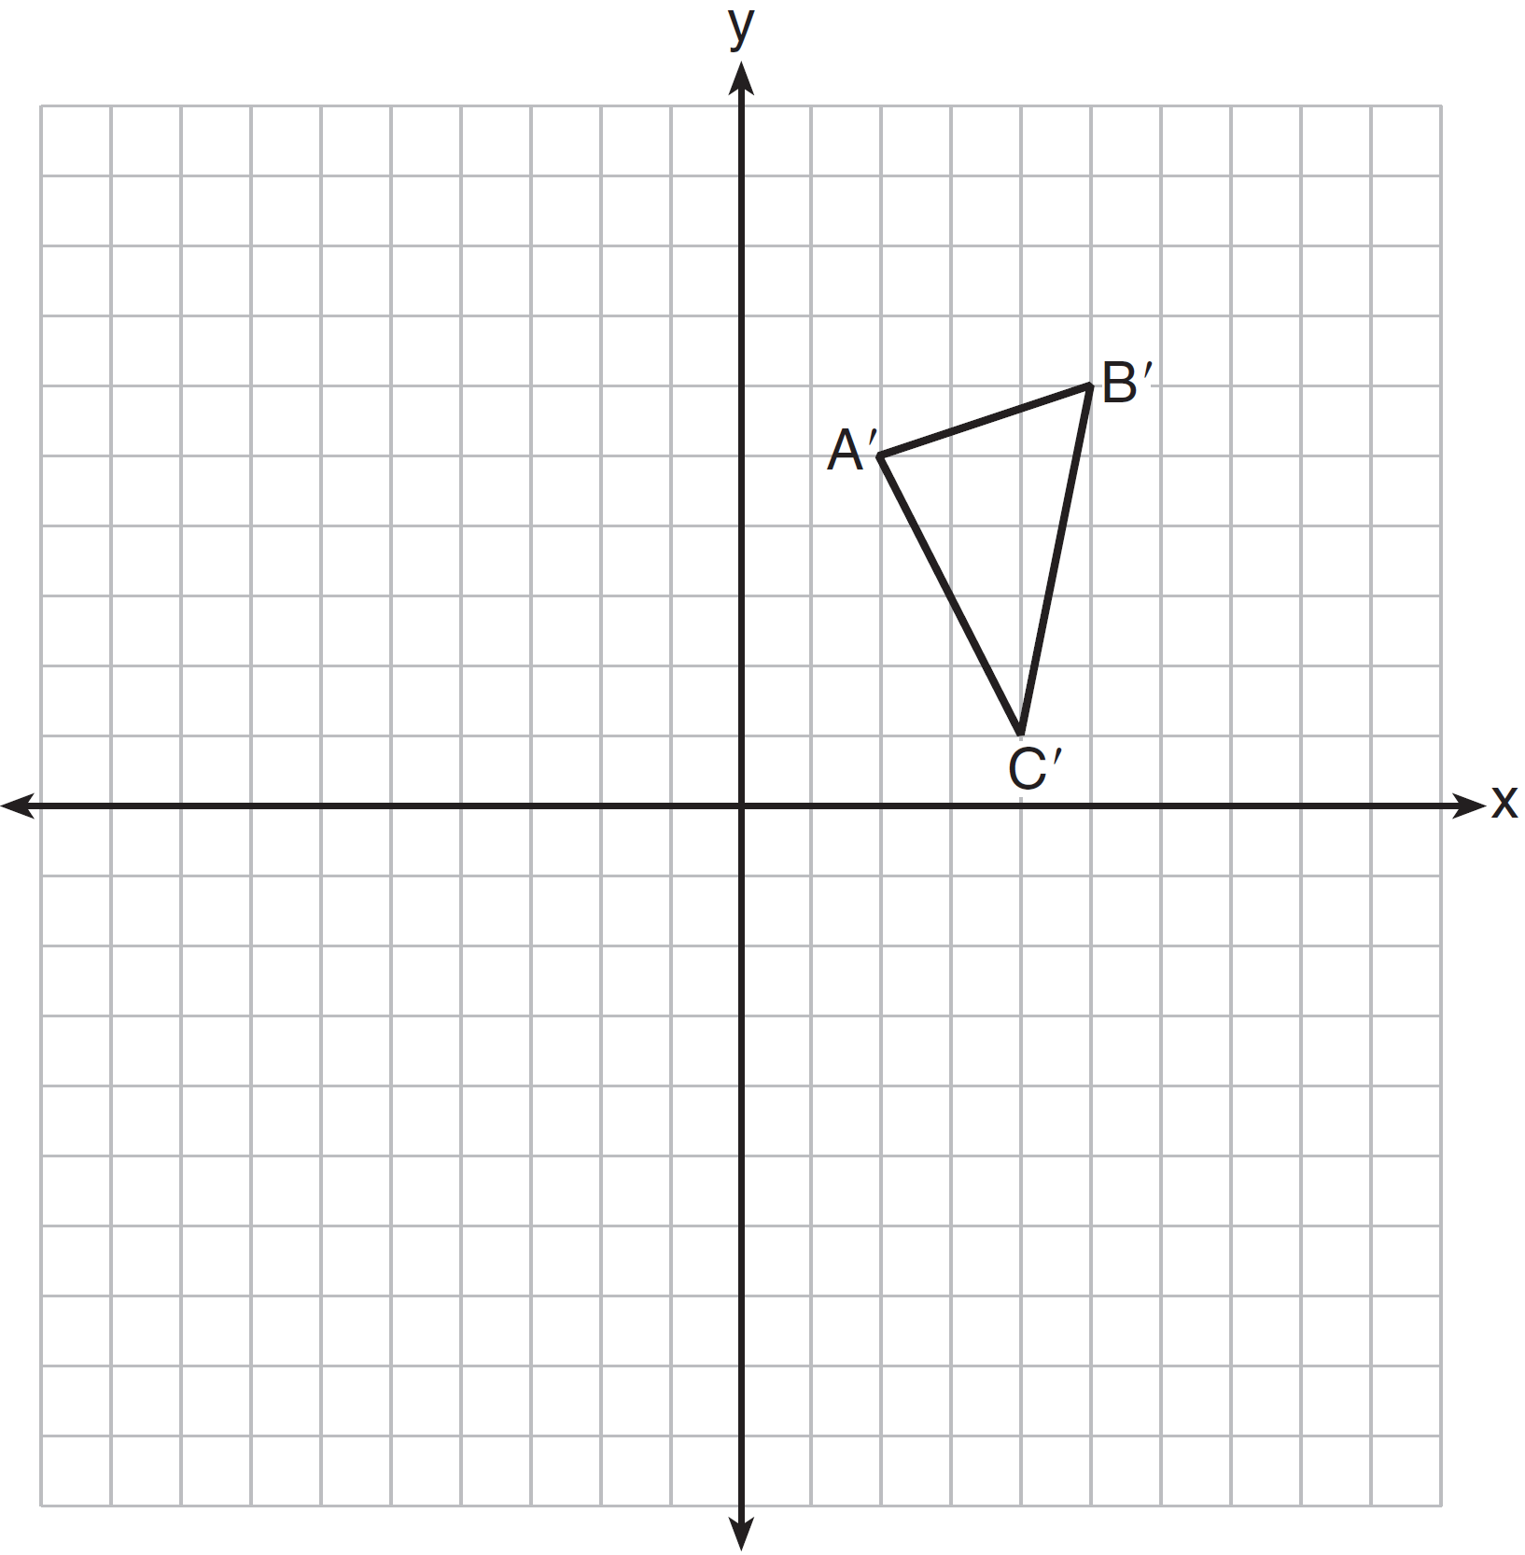

36 On the set of axes below, sketch the locus of points 2 units from the x-axis and sketch the locus of points 6 units from the point . Label with an X all points that satisfy both conditions.

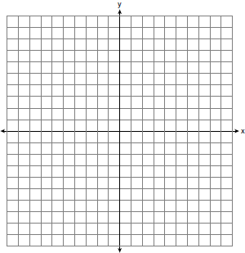

37 Using a compass and straightedge, construct an equilateral triangle with as a side. Using this triangle, construct a 30° angle with its vertex at A. [Leave all construction marks.]

38 The vertices of quadrilateral JKLM have coordinates , , , and . Prove that JKLM is a parallelogram. Prove that JKLM is not a rhombus. [The use of the set of axes below is optional.]

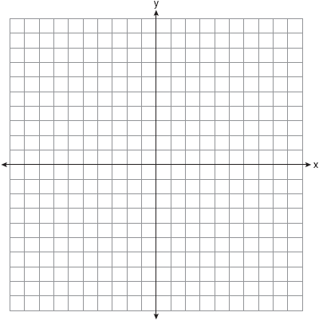
1 ANS: 3 PTS: 2 REF: 061401ge STA: G.G.9
TOP: Planes

2 ANS: 1
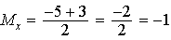. 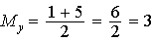.

PTS: 2 REF: 061402ge STA: G.G.66 TOP: Midpoint

3 ANS: 2
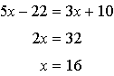

PTS: 2 REF: 061403ge STA: G.G.35 TOP: Parallel Lines and Transversals

4 ANS: 3
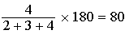

PTS: 2 REF: 061404ge STA: G.G.30 TOP: Interior and Exterior Angles of Triangles

5 ANS: 3
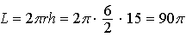

PTS: 2 REF: 061405ge STA: G.G.14 TOP: Volume and Lateral Area

6 ANS: 2
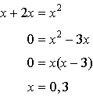

PTS: 2 REF: 061406ge STA: G.G.70 TOP: Quadratic-Linear Systems

7 ANS: 2
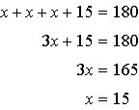

PTS: 2 REF: 061407ge STA: G.G.31 TOP: Isosceles Triangle Theorem

8 ANS: 1 PTS: 2 REF: 061408ge STA: G.G.72
TOP: Equations of Circles

9 ANS: 3
Parallel lines intercept congruent arcs.

PTS: 2 REF: 061409ge STA: G.G.52 TOP: Chords

10 ANS: 4 PTS: 2 REF: 061410ge STA: G.G.29
TOP: Triangle Congruency

11 ANS: 3

PTS: 2 REF: 061411ge STA: G.G.67 TOP: Distance
KEY: general

12 ANS: 4 PTS: 2 REF: 061412ge STA: G.G.24
TOP: Negations

13 ANS: 2
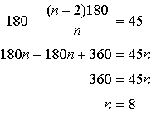.

PTS: 2 REF: 061413ge STA: G.G.37 TOP: Interior and Exterior Angles of Polygons

14 ANS: 2
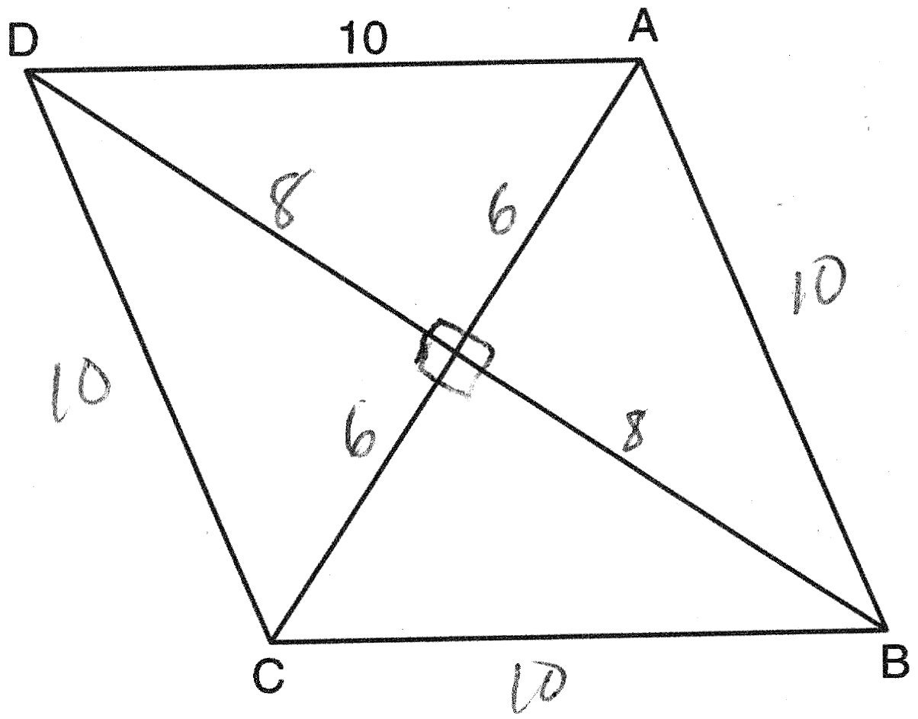

PTS: 2 REF: 061414ge STA: G.G.39 TOP: Special Parallelograms

15 ANS: 3
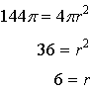

PTS: 2 REF: 061415ge STA: G.G.16 TOP: Volume and Surface Area

16 ANS: 4

PTS: 2 REF: 061416ge STA: G.G.33 TOP: Triangle Inequality Theorem

17 ANS: 2
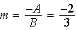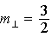

PTS: 2 REF: 061417ge STA: G.G.62 TOP: Parallel and Perpendicular Lines

18 ANS: 1 PTS: 2 REF: 061418ge STA: G.G.3
TOP: Planes

19 ANS: 1

PTS: 2 REF: 061419ge STA: G.G.40 TOP: Trapezoids

20 ANS: 1
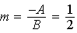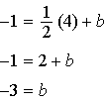

PTS: 2 REF: 061420ge STA: G.G.65 TOP: Parallel and Perpendicular Lines

21 ANS: 3 PTS: 2 REF: 061421ge STA: G.G.55
TOP: Properties of Transformations

22 ANS: 4 PTS: 2 REF: 061422ge STA: G.G.73
TOP: Equations of Circles

23 ANS: 4 PTS: 2 REF: 061423ge STA: G.G.25
TOP: Compound Statements KEY: conditional

24 ANS: 3 PTS: 2 REF: 061424ge STA: G.G.43
TOP: Centroid

25 ANS: 2
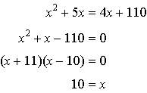

PTS: 2 REF: 061425ge STA: G.G.32 TOP: Exterior Angle Theorem

26 ANS: 3
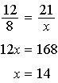

PTS: 2 REF: 061426ge STA: G.G.46 TOP: Side Splitter Theorem

27 ANS: 2 PTS: 2 REF: 061427ge STA: G.G.27
TOP: Line Proofs

28 ANS: 1
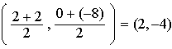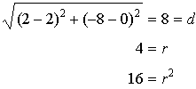

PTS: 2 REF: 061428ge STA: G.G.71 TOP: Equations of Circles

29 ANS:
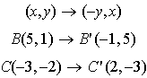

PTS: 2 REF: 061429ge STA: G.G.54 TOP: Rotations

30 ANS:
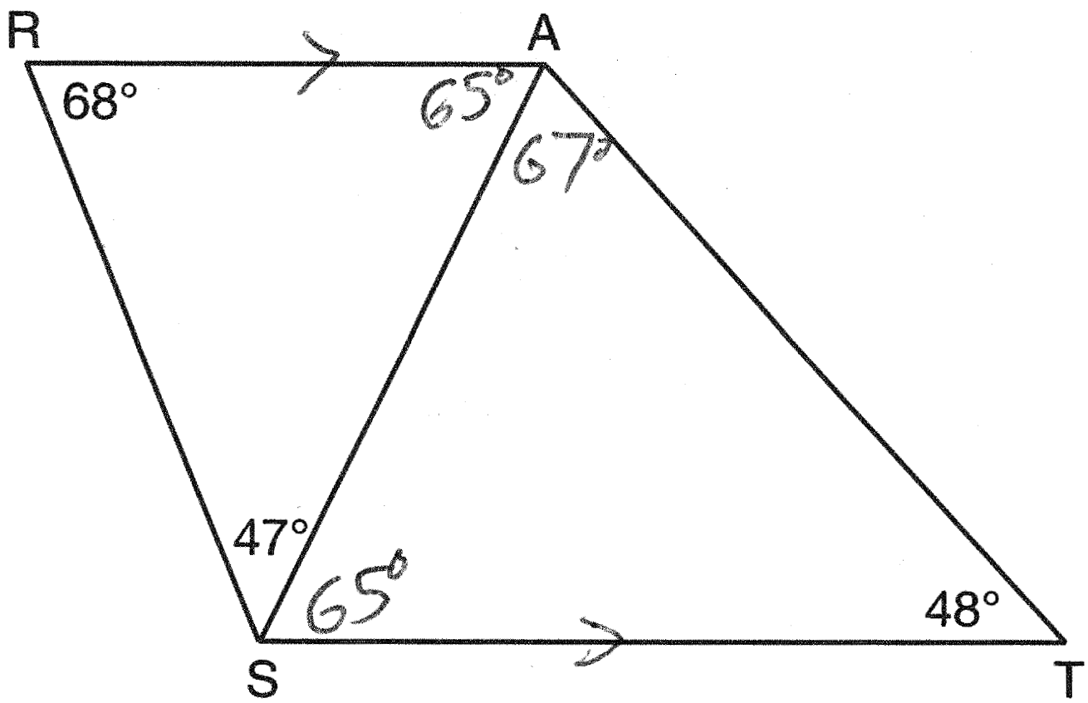

PTS: 2 REF: 061430ge STA: G.G.34 TOP: Angle Side Relationship

31 ANS:
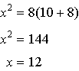

PTS: 2 REF: 061431ge STA: G.G.47 TOP: Similarity
KEY: leg

32 ANS:
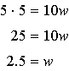

PTS: 2 REF: 061432ge STA: G.G.11 TOP: Volume

33 ANS:
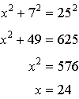

PTS: 2 REF: 061433ge STA: G.G.50 TOP: Tangents
KEY: point of tangency

34 ANS:
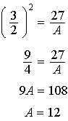

PTS: 2 REF: 061434ge STA: G.G.45 TOP: Similarity
KEY: perimeter and area

35 ANS:
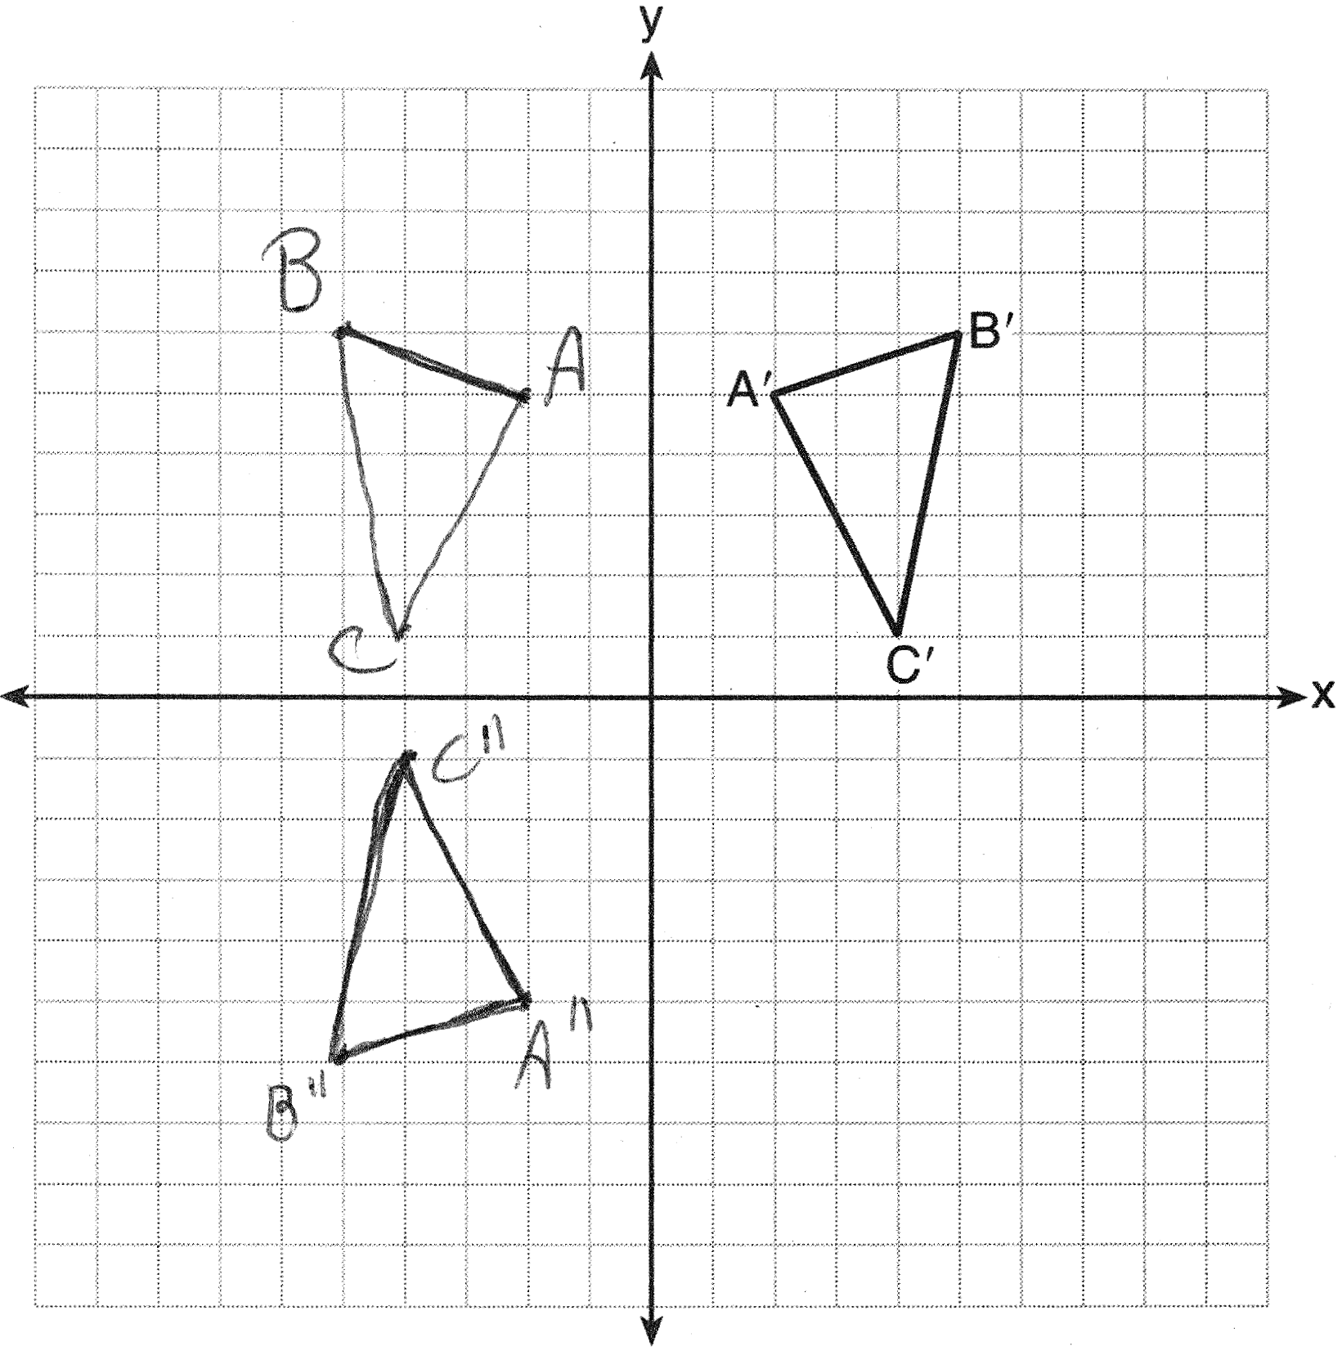

PTS: 4 REF: 061435ge STA: G.G.58 TOP: Compositions of Transformations
KEY: grids

36 ANS:
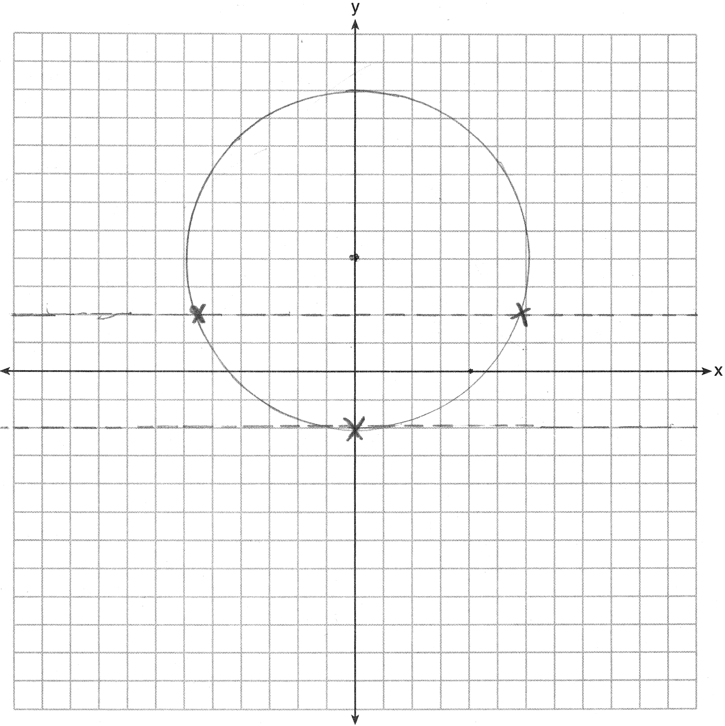

PTS: 4 REF: 061436ge STA: G.G.23 TOP: Locus

37 ANS:
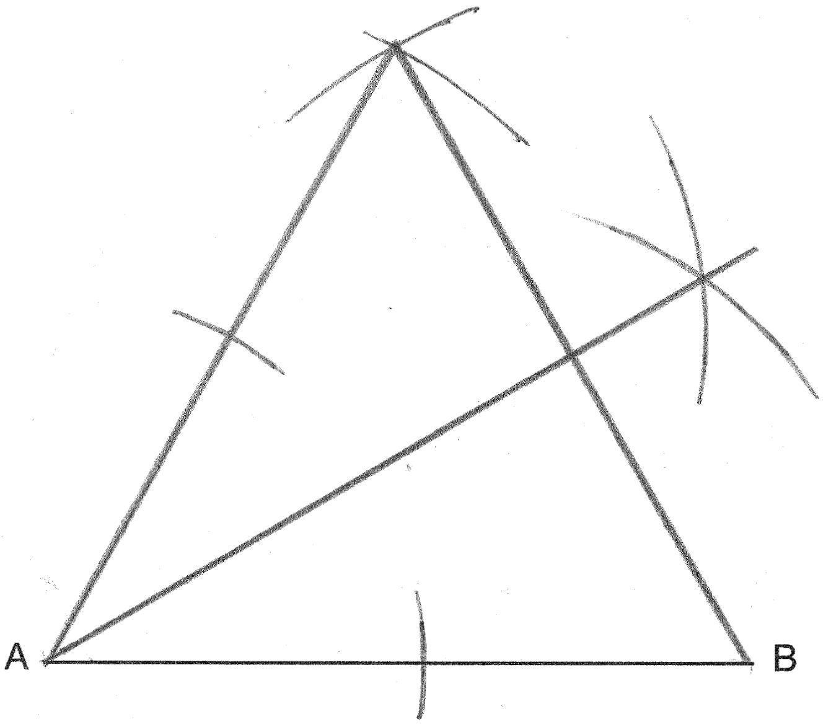

PTS: 4 REF: 061437ge STA: G.G.17 TOP: Constructions

38 ANS:
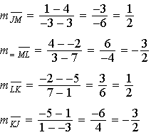 Since both opposite sides have equal slopes and are parallel, JKLM is a parallelogram. 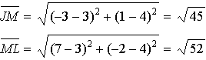. is not congruent to , so JKLM is not a rhombus since not all sides are congruent.

PTS: 6 REF: 061438ge STA: G.G.69 TOP: Quadrilaterals in the Coordinate Plane

