1 In trapezoid RSTV with bases and , diagonals and intersect at Q.

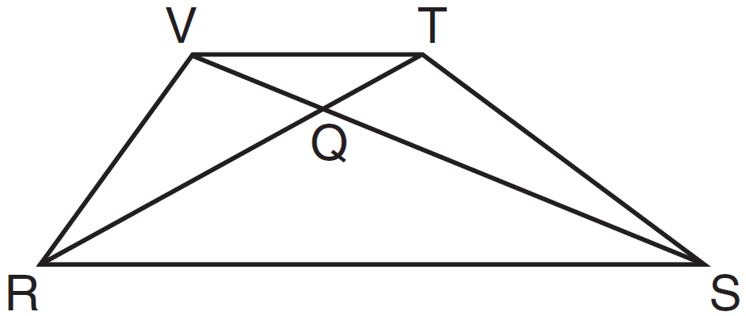

If trapezoid RSTV is not isosceles, which triangle is equal in area to ?
1)
2)
3)
4)

2 In the diagram below, .

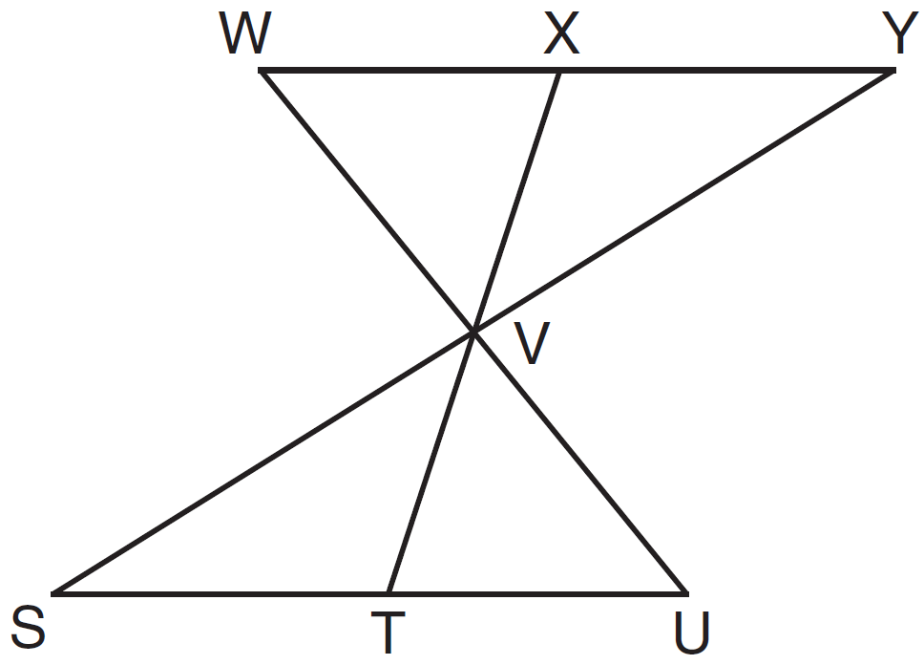

Which statement can not be proven?
1)
2)
3)
4)

3 In a park, two straight paths intersect. The city wants to install lampposts that are both equidistant from each path and also 15 feet from the intersection of the paths. How many lampposts are needed?
1) | 1
2) | 2
3) | 3
4) | 4

4 What are the coordinates of , the image of , after a rotation of 180º about the origin?
1)
2)
3)
4)

5 Based on the construction below, which conclusion is not always true?

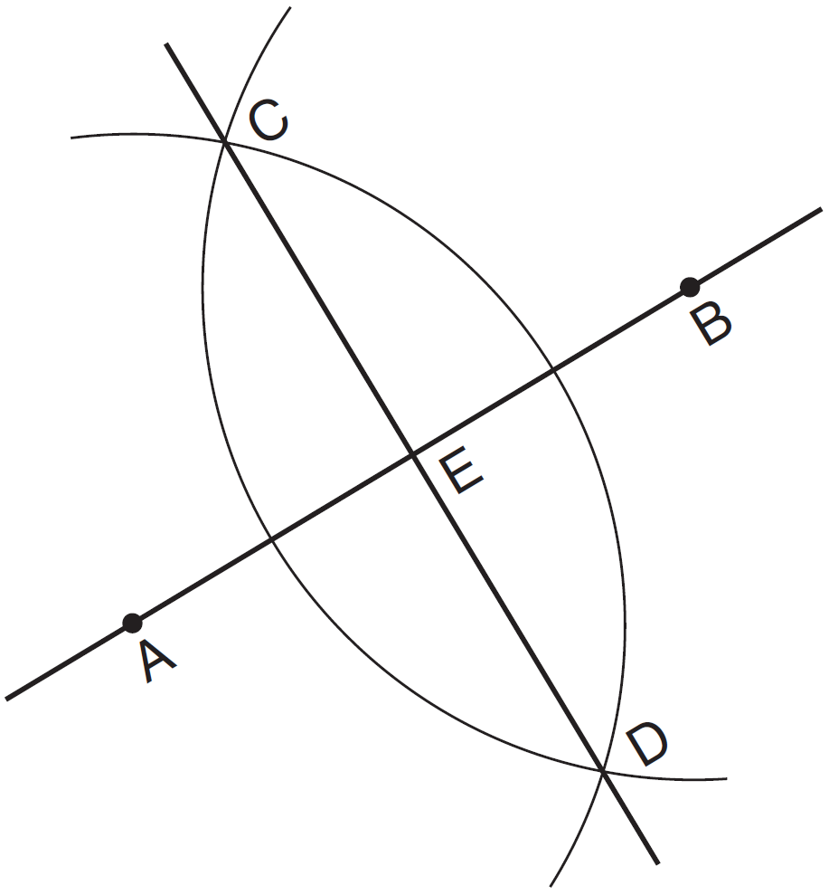
1)
2)
3)
4)

6 Which equation represents the circle whose center is and that passes through the point ?
1)
2)
3)
4)

7 As shown in the diagram below, when right triangle DAB is reflected over the x-axis, its image is triangle DCB.

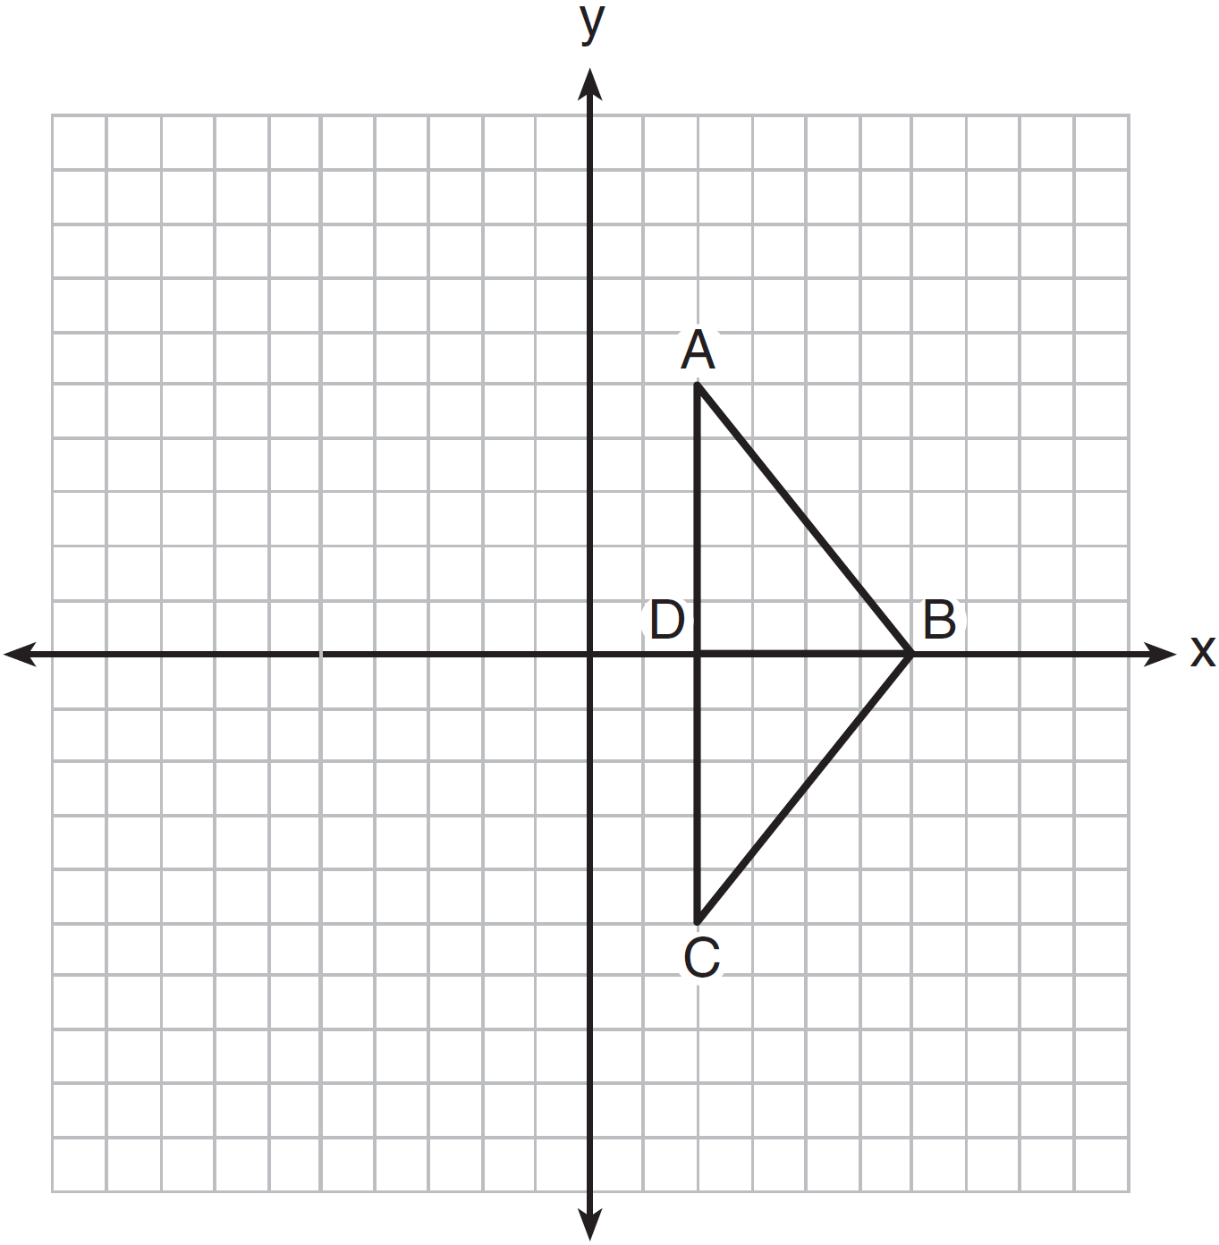

Which statement justifies why ?
1) | Distance is preserved under reflection.
2) | Orientation is preserved under reflection.
3) | Points on the line of reflection remain invariant.
4) | Right angles remain congruent under reflection.

8 In , , , and . Which type of triangle is ?
1) | right
2) | scalene
3) | isosceles
4) | equilateral

9 What is the equation for circle O shown in the graph below?

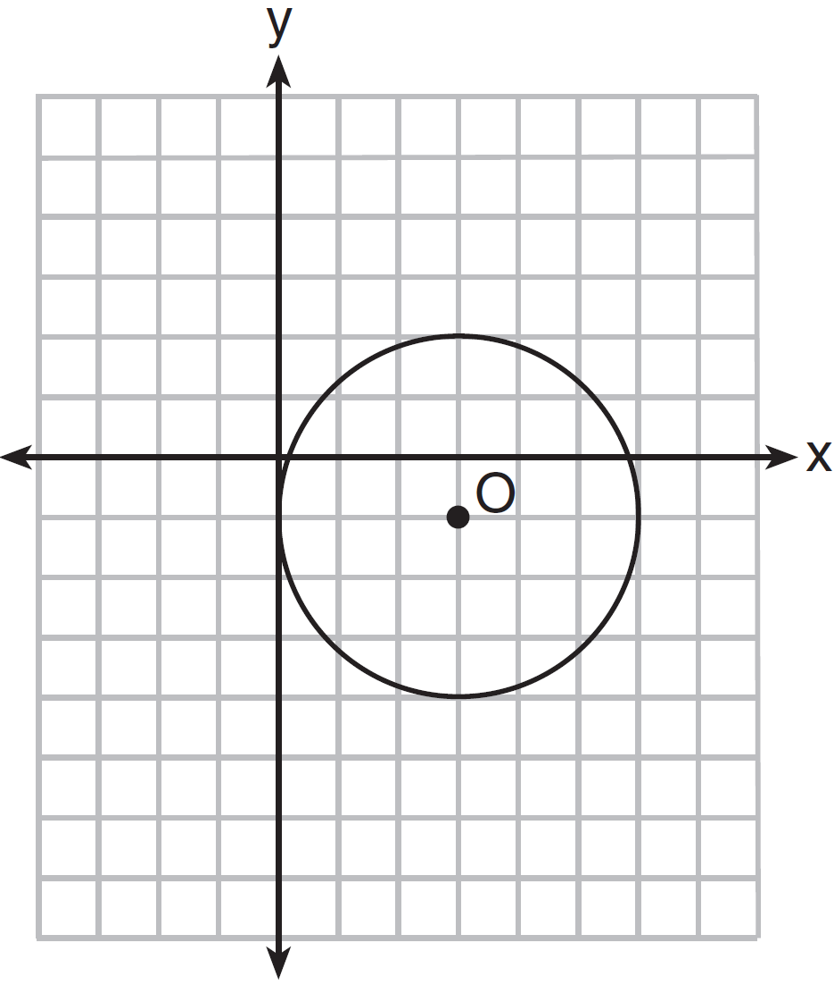
1)
2)
3)
4)

10 Point A is on line m. How many distinct planes will be perpendicular to line m and pass through point A?
1) | one
2) | two
3) | zero
4) | infinite

11 In , D is the midpoint of and E is the midpoint of . If and , what is the value of x?

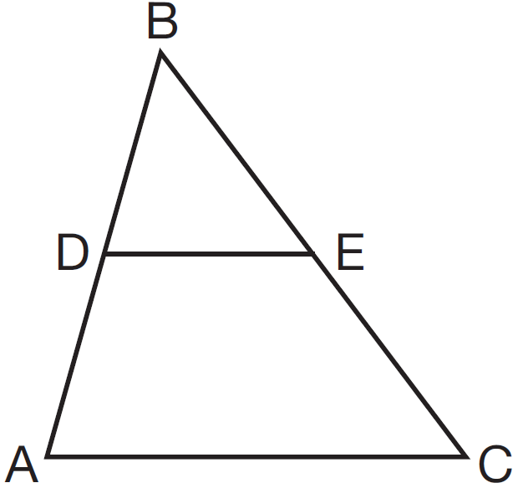
1) | 6
2) | 7
3) | 9
4) | 12

12 What are the coordinates of the center of a circle if the endpoints of its diameter are and ?
1)
2)
3)
4)

13 Which graph could be used to find the solution to the following system of equations?
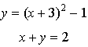
1) | 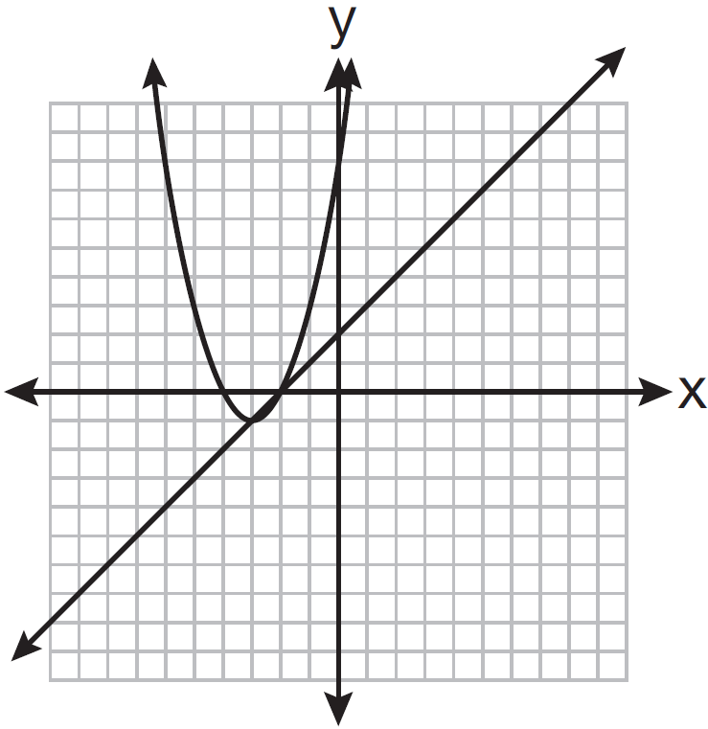
2) | 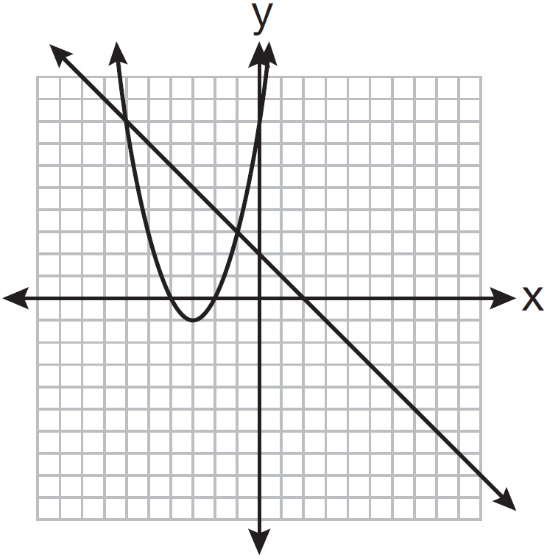
3) | 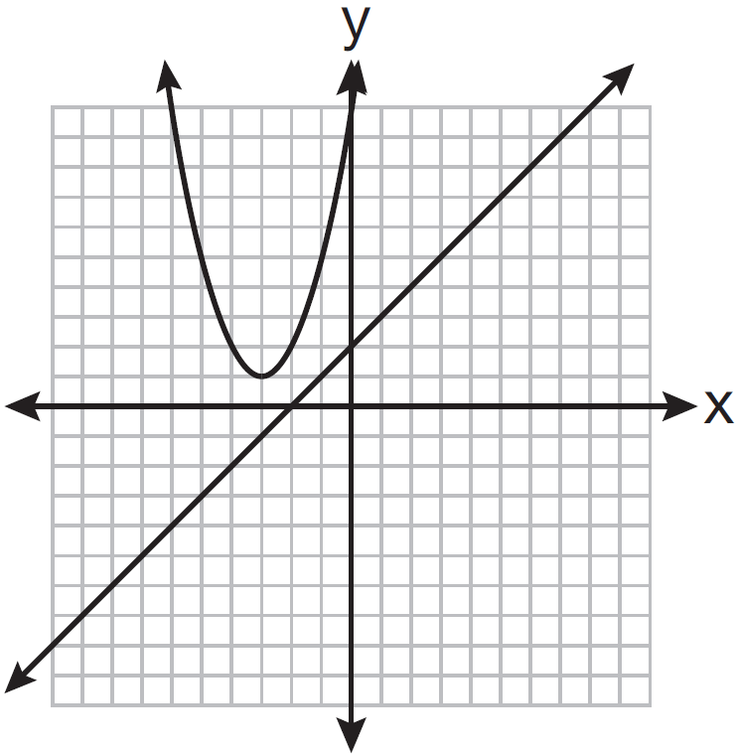
4) | 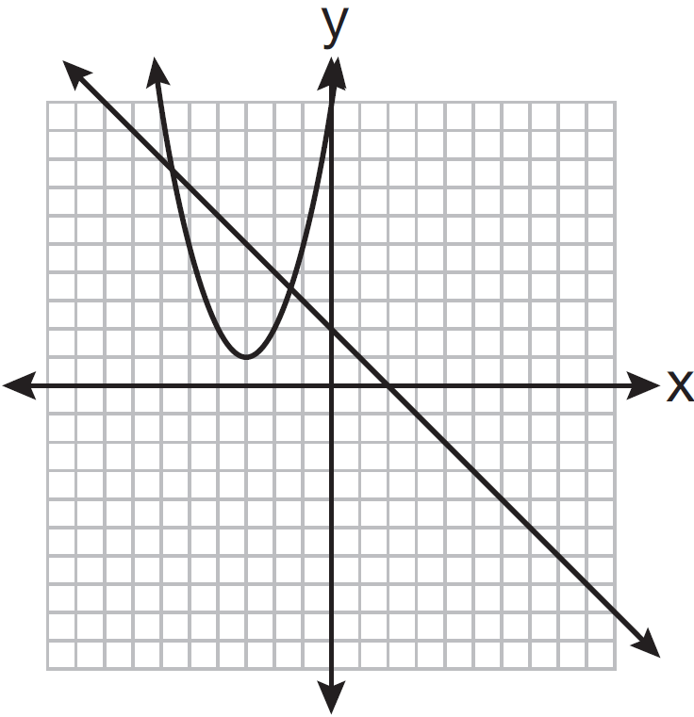

14 What is the converse of “If an angle measures 90 degrees, then it is a right angle”?
1) | If an angle is a right angle, then it measures 90 degrees.
2) | An angle is a right angle if it measures 90 degrees.
3) | If an angle is not a right angle, then it does not measure 90 degrees.
4) | If an angle does not measure 90 degrees, then it is not a right angle.

15 As shown in the diagram below, a right pyramid has a square base, ABCD, and is the slant height.

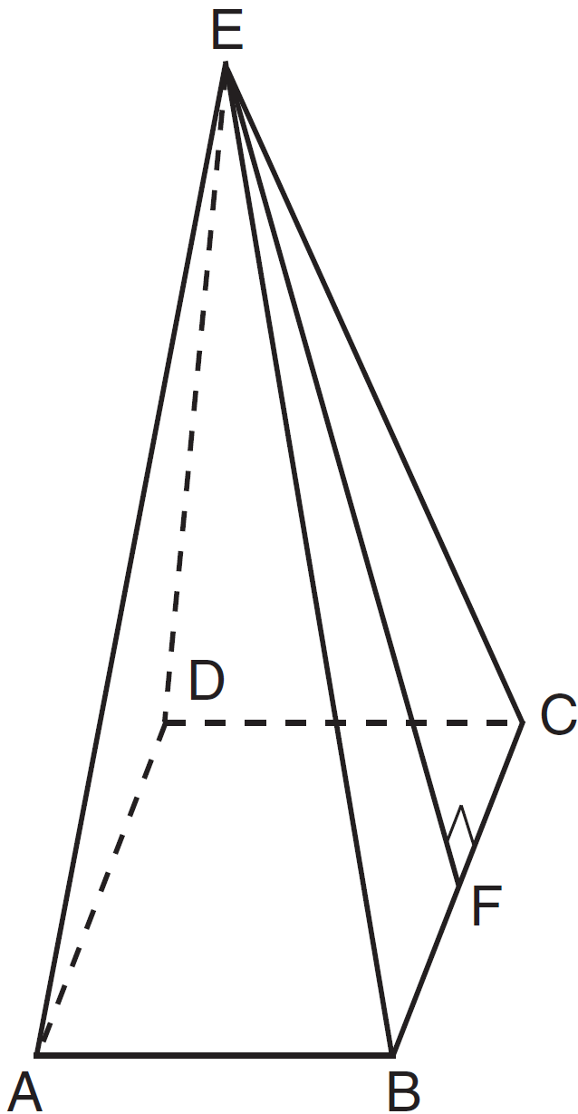

Which statement is not true?
1)
2)
3)
4) | is isosceles

16 What is the equation of a line passing through the point and parallel to the line whose equation is ?
1) | 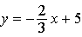
2) | 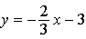
3) | 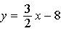
4) | 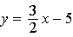

17 The volume of a sphere is approximately 44.6022 cubic centimeters. What is the radius of the sphere, to the nearest tenth of a centimeter?
1) | 2.2
2) | 3.3
3) | 4.4
4) | 4.7

18 Points and lie on . Points and lie on . Which statement is true?
1) | 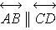
2) | 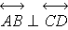
3) | and are the same line.
4) | and intersect, but are not perpendicular.

19 Which set of equations represents two circles that have the same center?
1) | and
2) | and
3) | and
4) | and

20 Transversal intersects and , as shown in the diagram below.

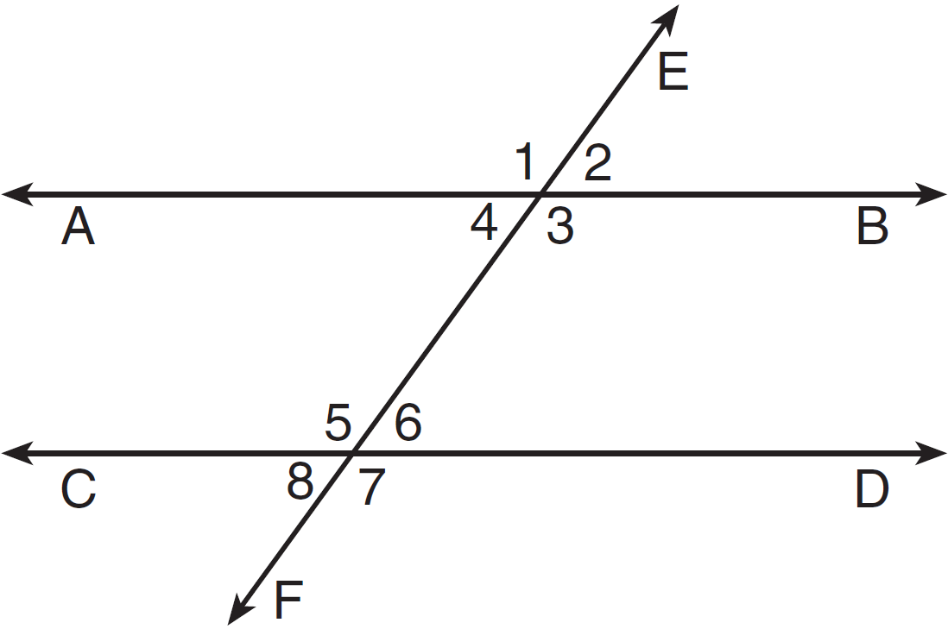

Which statement could always be used to prove ?
1)
2)
3) | and are supplementary
4) | and are supplementary

21 In , , , and . Which inequality is true?
1)
2)
3)
4)

22 Circle O with and is shown in the diagram below.

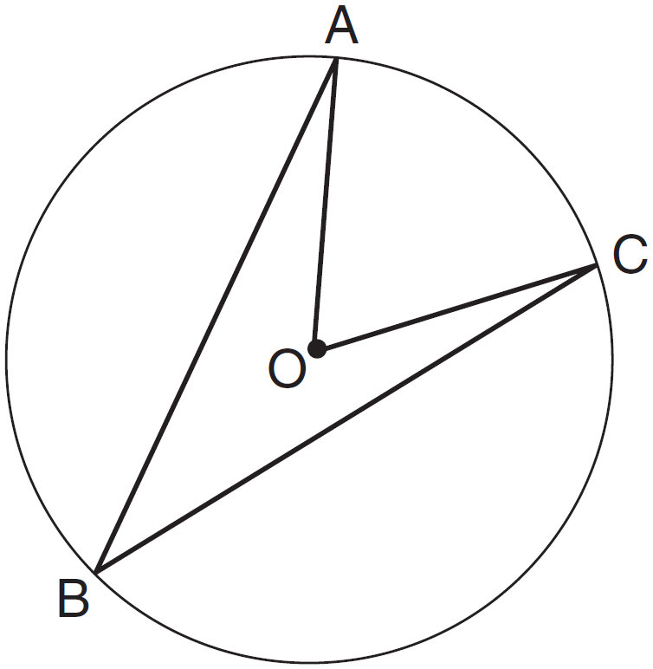

What is the ratio of to ?
1)
2)
3)
4)

23 A rectangular prism has a base with a length of 25, a width of 9, and a height of 12. A second prism has a square base with a side of 15. If the volumes of the two prisms are equal, what is the height of the second prism?
1) | 6
2) | 8
3) | 12
4) | 15

24 In triangles ABC and DEF, , , , , and . Which method could be used to prove ?
1) | AA
2) | SAS
3) | SSS
4) | ASA

25 Which graph represents a circle whose equation is ?
1) | 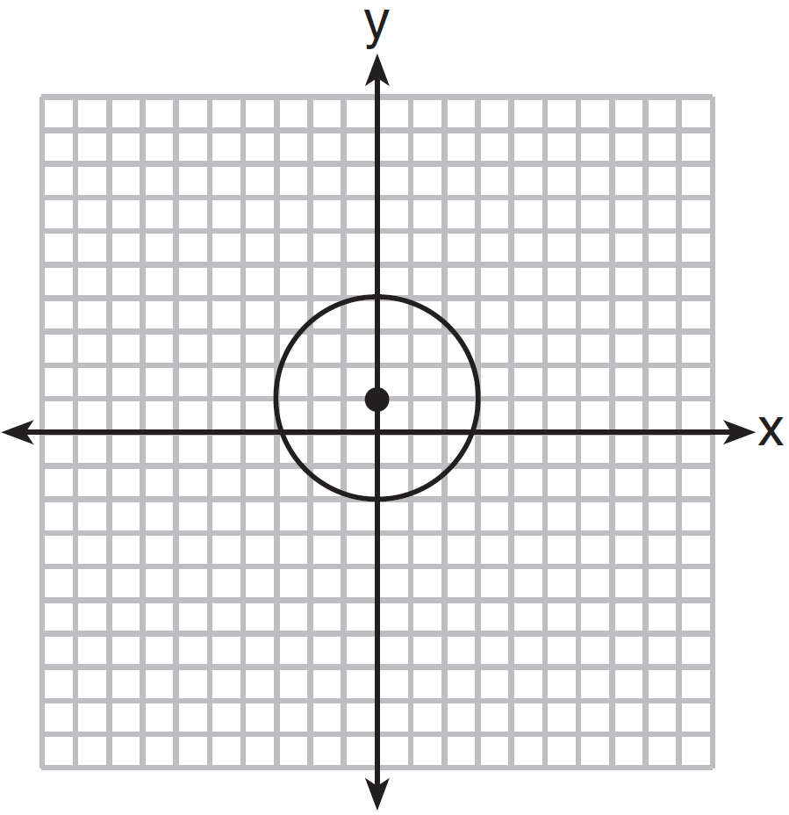
2) | 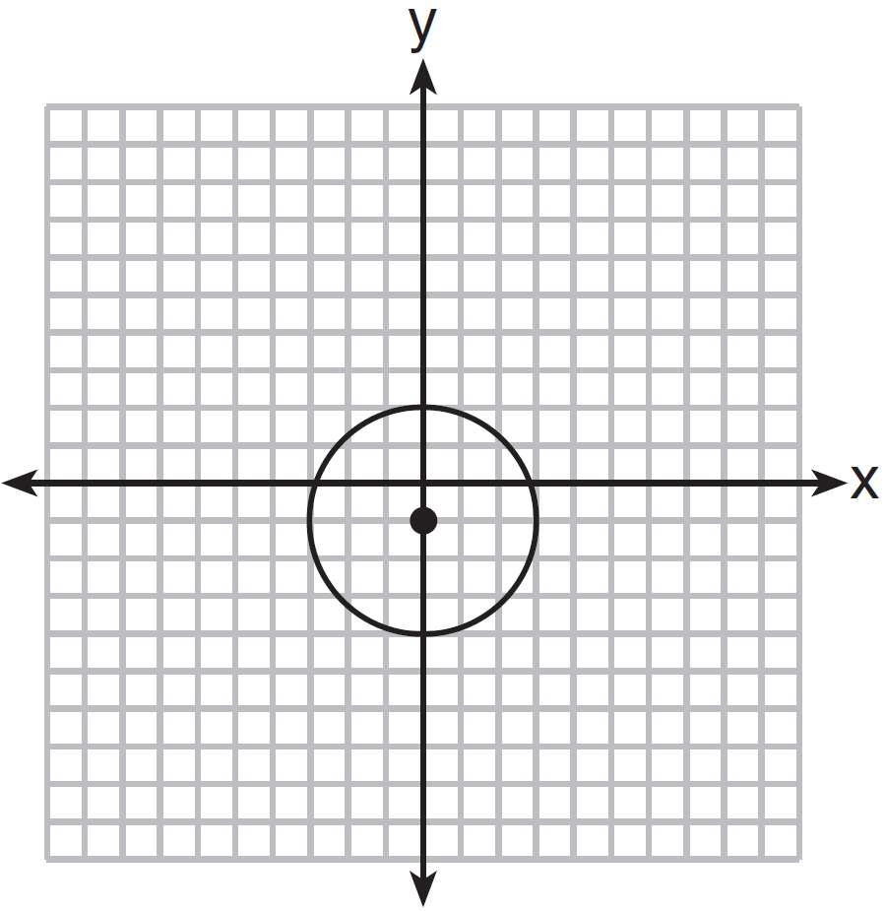
3) | 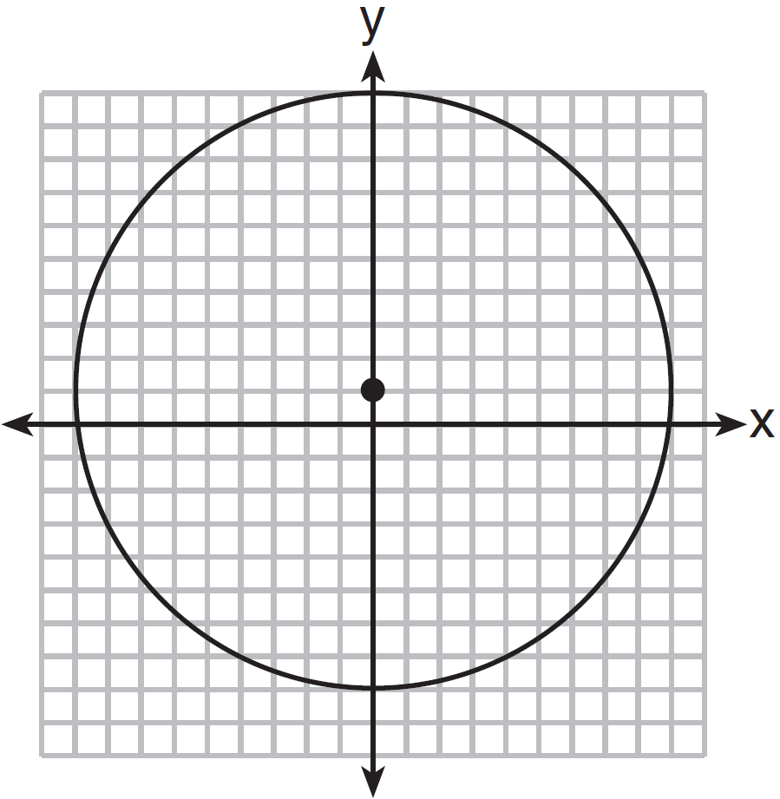
4) | 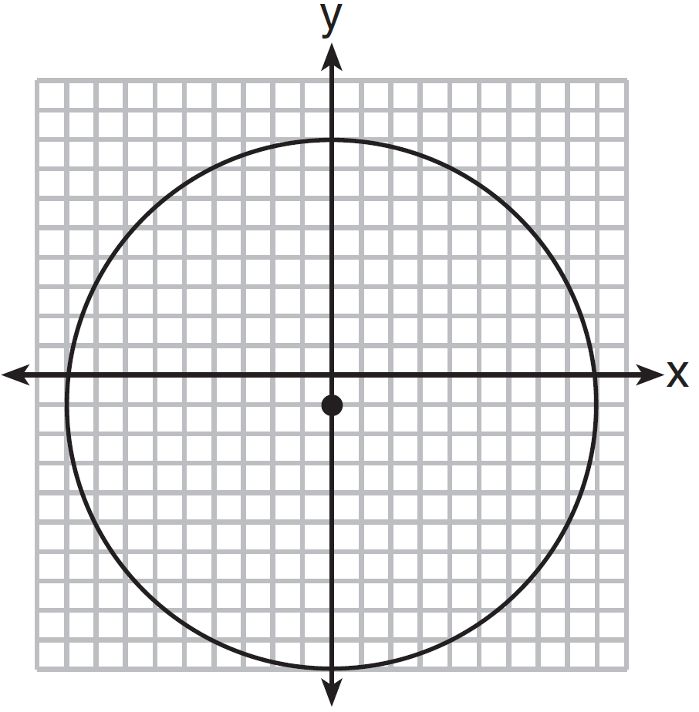

26 What is the perimeter of a rhombus whose diagonals are 16 and 30?
1) | 92
2) | 68
3) | 60
4) | 17

27 In right triangle ABC shown in the diagram below, altitude is drawn to hypotenuse , , and .

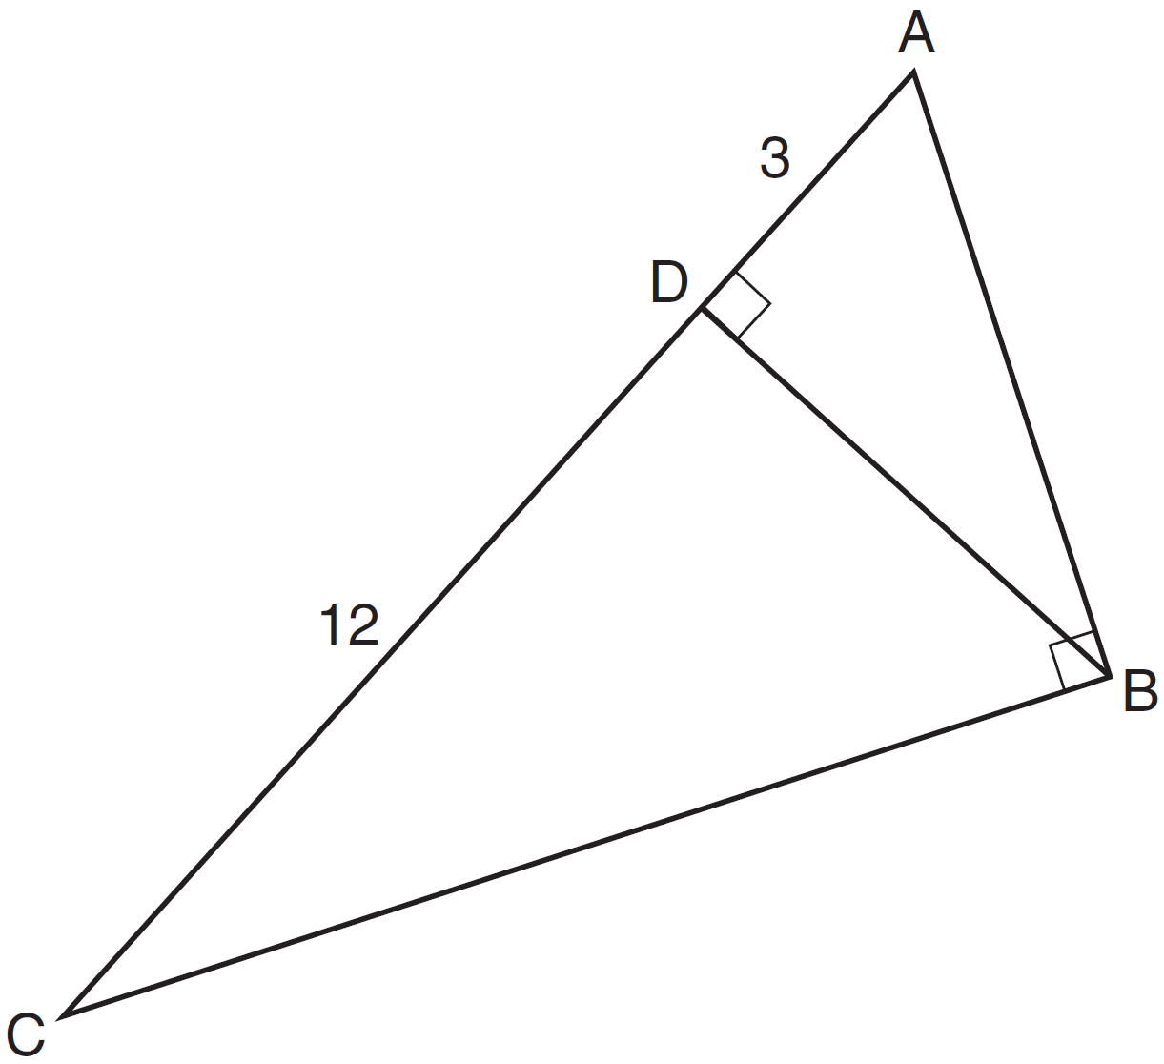

What is the length of ?
1)
2) | 6
3)
4) | 9

28 Secants and are drawn to circle O from an external point, J. If , , and , what is the length of ?
1) | 16
2) | 12
3) | 10
4) | 8

29 A right circular cylinder has a height of 7 inches and the base has a diameter of 6 inches. Determine the lateral area, in square inches, of the cylinder in terms of .

30 Determine, in degrees, the measure of each interior angle of a regular octagon.

31 Triangle ABC has vertices at , , and . Find the length of in simplest radical form.

32 On the ray drawn below, using a compass and straightedge, construct an equilateral triangle with a vertex at R. The length of a side of the triangle must be equal to a length of the diagonal of rectangle ABCD.

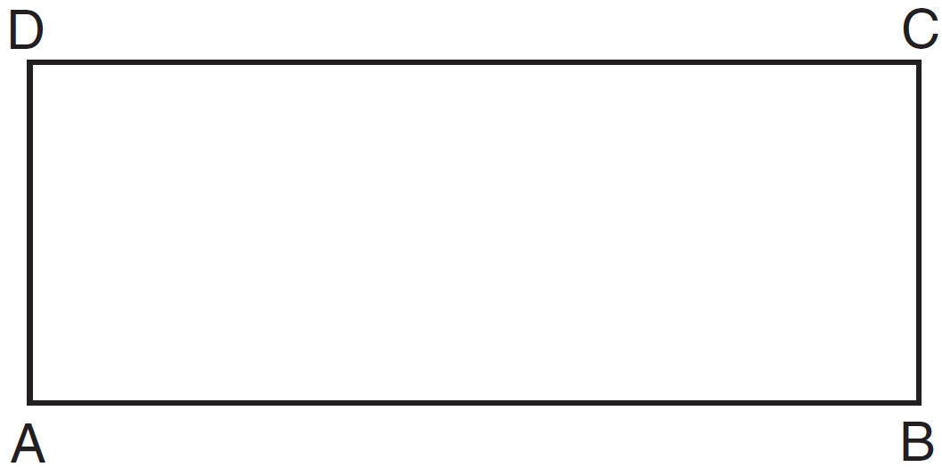

33 On the set of axes below, graph the locus of points 4 units from the x-axis and equidistant from the points whose coordinates are and . Mark with an X all points that satisfy both conditions.

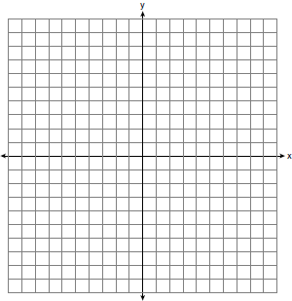

34 The coordinates of two vertices of square ABCD are and . Determine the slope of side .

35 The coordinates of the vertices of parallelogram SWAN are , , , and . State and label the coordinates of parallelogram , the image of SWAN after the transformation 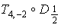. [The use of the set of axes below is optional.]

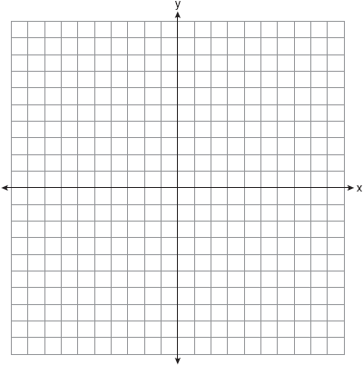

36 In circle O shown below, chords and and radius are drawn, such that , , , , , and .

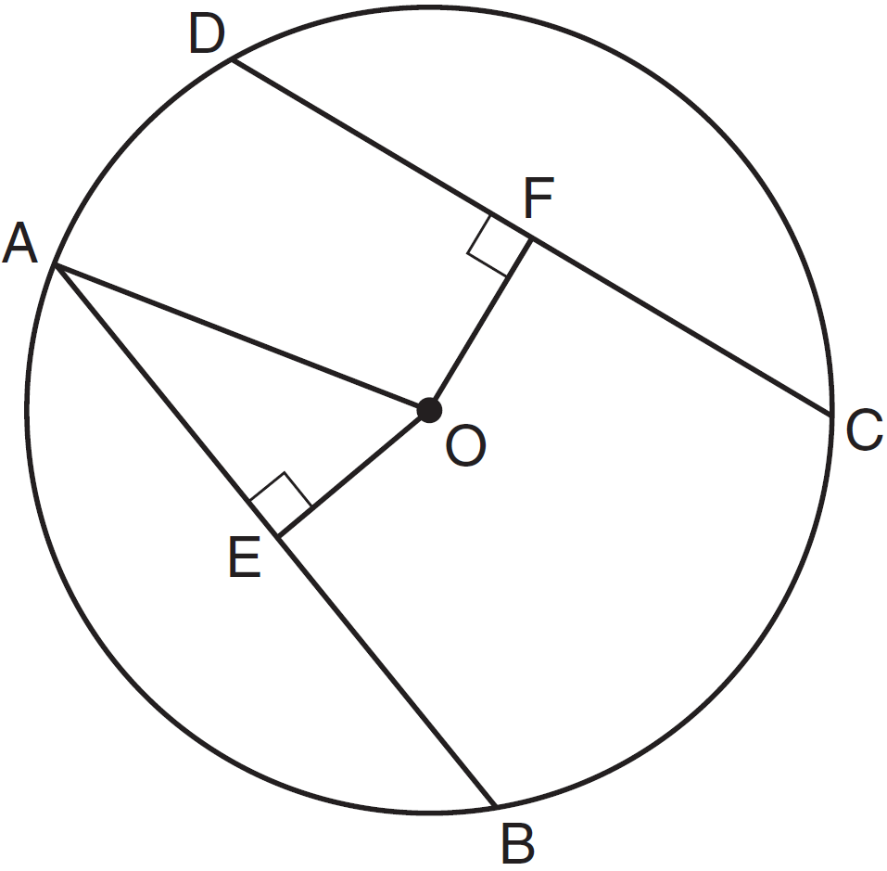

Determine the length of . Determine the length of .

37 If , , , and , find . [Only an algebraic solution can receive full credit.]

38 In the diagram of below, and medians and are drawn.
Prove:

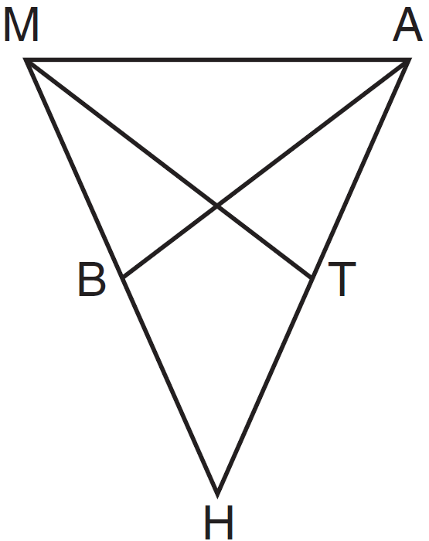
1 ANS: 2
Isosceles or not, and have a common base, and since and are bases, congruent altitudes.

PTS: 2 REF: 061301ge STA: G.G.40 TOP: Trapezoids

2 ANS: 2
(1) is true because of vertical angles. (3) and (4) are true because CPCTC.

PTS: 2 REF: 061302ge STA: G.G.29 TOP: Triangle Congruency

3 ANS: 4 PTS: 2 REF: 061303ge STA: G.G.22
TOP: Locus

4 ANS: 4

PTS: 2 REF: 061304ge STA: G.G.54 TOP: Rotations

5 ANS: 2 PTS: 2 REF: 061305ge STA: G.G.18
TOP: Constructions

6 ANS: 3 PTS: 2 REF: 061306ge STA: G.G.71
TOP: Equations of Circles

7 ANS: 1 PTS: 2 REF: 061307ge STA: G.G.55
TOP: Properties of Transformations

8 ANS: 3
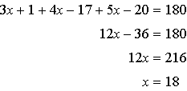. 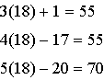

PTS: 2 REF: 061308ge STA: G.G.30 TOP: Interior and Exterior Angles of Triangles

9 ANS: 3 PTS: 2 REF: 061309ge STA: G.G.72
TOP: Equations of Circles

10 ANS: 1 PTS: 2 REF: 061310ge STA: G.G.2
TOP: Planes

11 ANS: 3
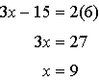

PTS: 2 REF: 061311ge STA: G.G.42 TOP: Midsegments

12 ANS: 2
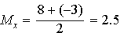. 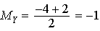.

PTS: 2 REF: 061312ge STA: G.G.66 TOP: Midpoint

13 ANS: 2 PTS: 2 REF: 061313ge STA: G.G.70
TOP: Quadratic-Linear Systems

14 ANS: 1 PTS: 2 REF: 061314ge STA: G.G.26
TOP: Converse and Biconditional

15 ANS: 2 PTS: 2 REF: 061315ge STA: G.G.13
TOP: Solids

16 ANS: 3
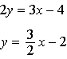. 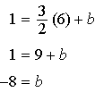

PTS: 2 REF: 061316ge STA: G.G.65 TOP: Parallel and Perpendicular Lines

17 ANS: 1
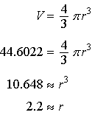

PTS: 2 REF: 061317ge STA: G.G.16 TOP: Volume and Surface Area

18 ANS: 4
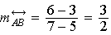. 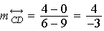

PTS: 2 REF: 061318ge STA: G.G.63 TOP: Parallel and Perpendicular Lines

19 ANS: 4 PTS: 2 REF: 061319ge STA: G.G.73
TOP: Equations of Circles

20 ANS: 3 PTS: 2 REF: 061320ge STA: G.G.35
TOP: Parallel Lines and Transversals

21 ANS: 2 PTS: 2 REF: 061321ge STA: G.G.34
TOP: Angle Side Relationship

22 ANS: 2 PTS: 2 REF: 061322ge STA: G.G.51
TOP: Arcs Determined by Angles KEY: inscribed

23 ANS: 3
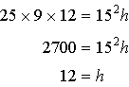

PTS: 2 REF: 061323ge STA: G.G.11 TOP: Volume

24 ANS: 2 PTS: 2 REF: 061324ge STA: G.G.44
TOP: Similarity Proofs

25 ANS: 1 PTS: 2 REF: 061325ge STA: G.G.74
TOP: Graphing Circles

26 ANS: 2
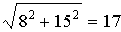

PTS: 2 REF: 061326ge STA: G.G.39 TOP: Special Parallelograms

27 ANS: 3
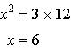. 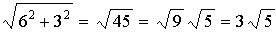

PTS: 2 REF: 061327ge STA: G.G.47 TOP: Similarity
KEY: altitude

28 ANS: 1
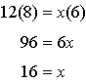

PTS: 2 REF: 061328ge STA: G.G.53 TOP: Segments Intercepted by Circle
KEY: two secants

29 ANS:

PTS: 2 REF: 061329ge STA: G.G.14 TOP: Volume and Lateral Area

30 ANS:
. 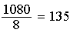.

PTS: 2 REF: 061330ge STA: G.G.37 TOP: Interior and Exterior Angles of Polygons

31 ANS:

PTS: 2 REF: 061331ge STA: G.G.69 TOP: Triangles in the Coordinate Plane

32 ANS:
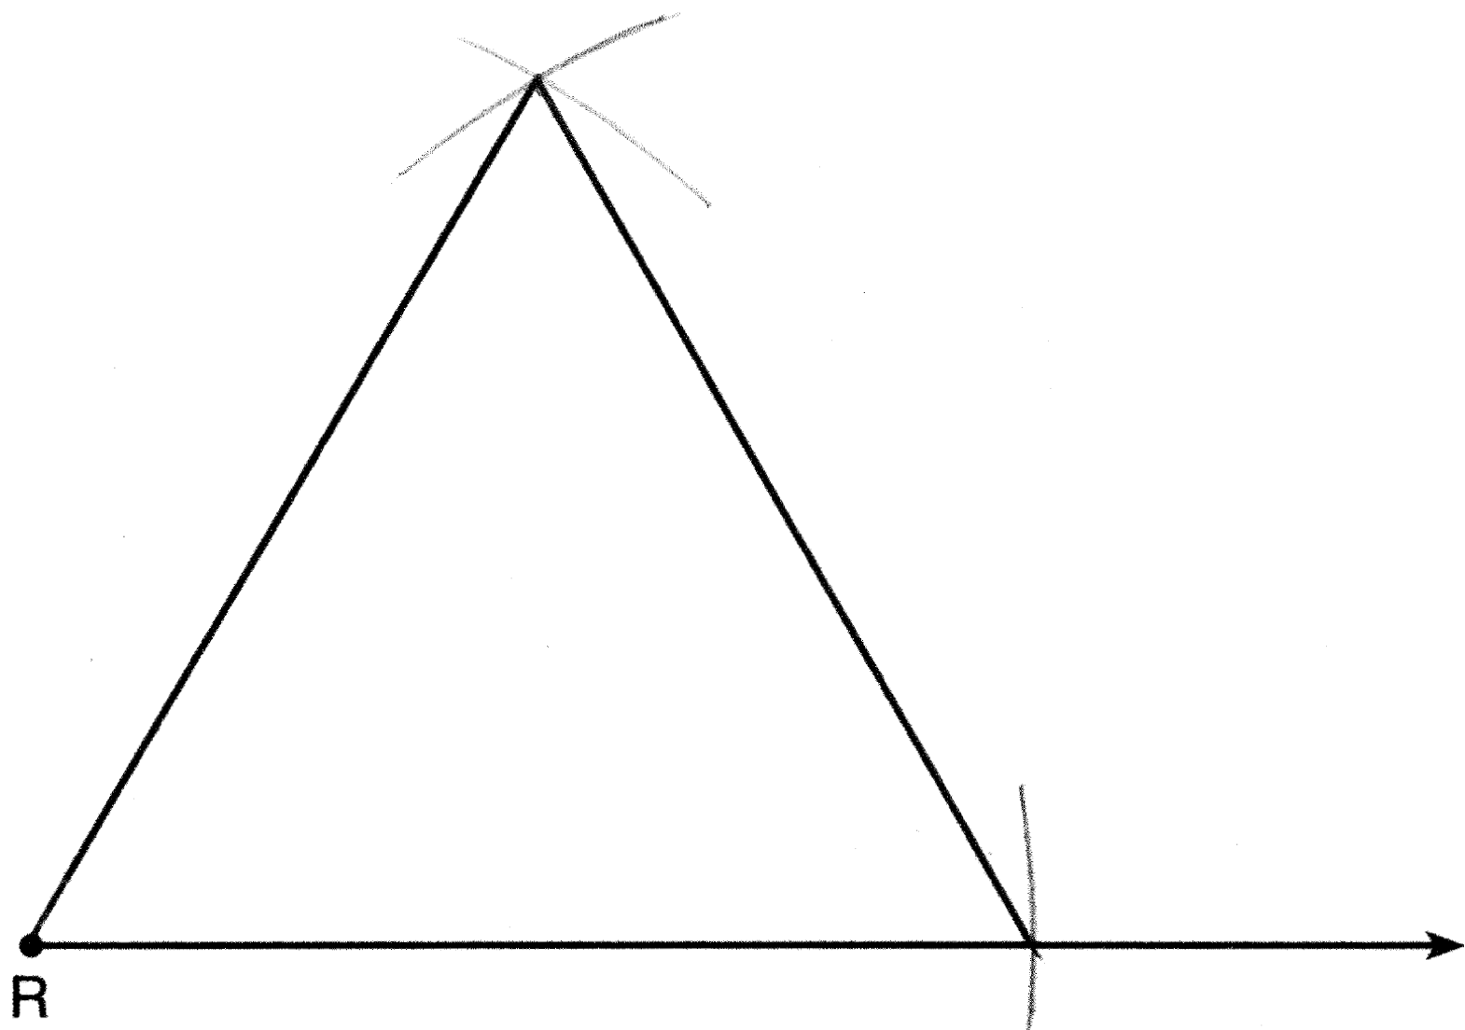

PTS: 2 REF: 061332ge STA: G.G.20 TOP: Constructions

33 ANS:
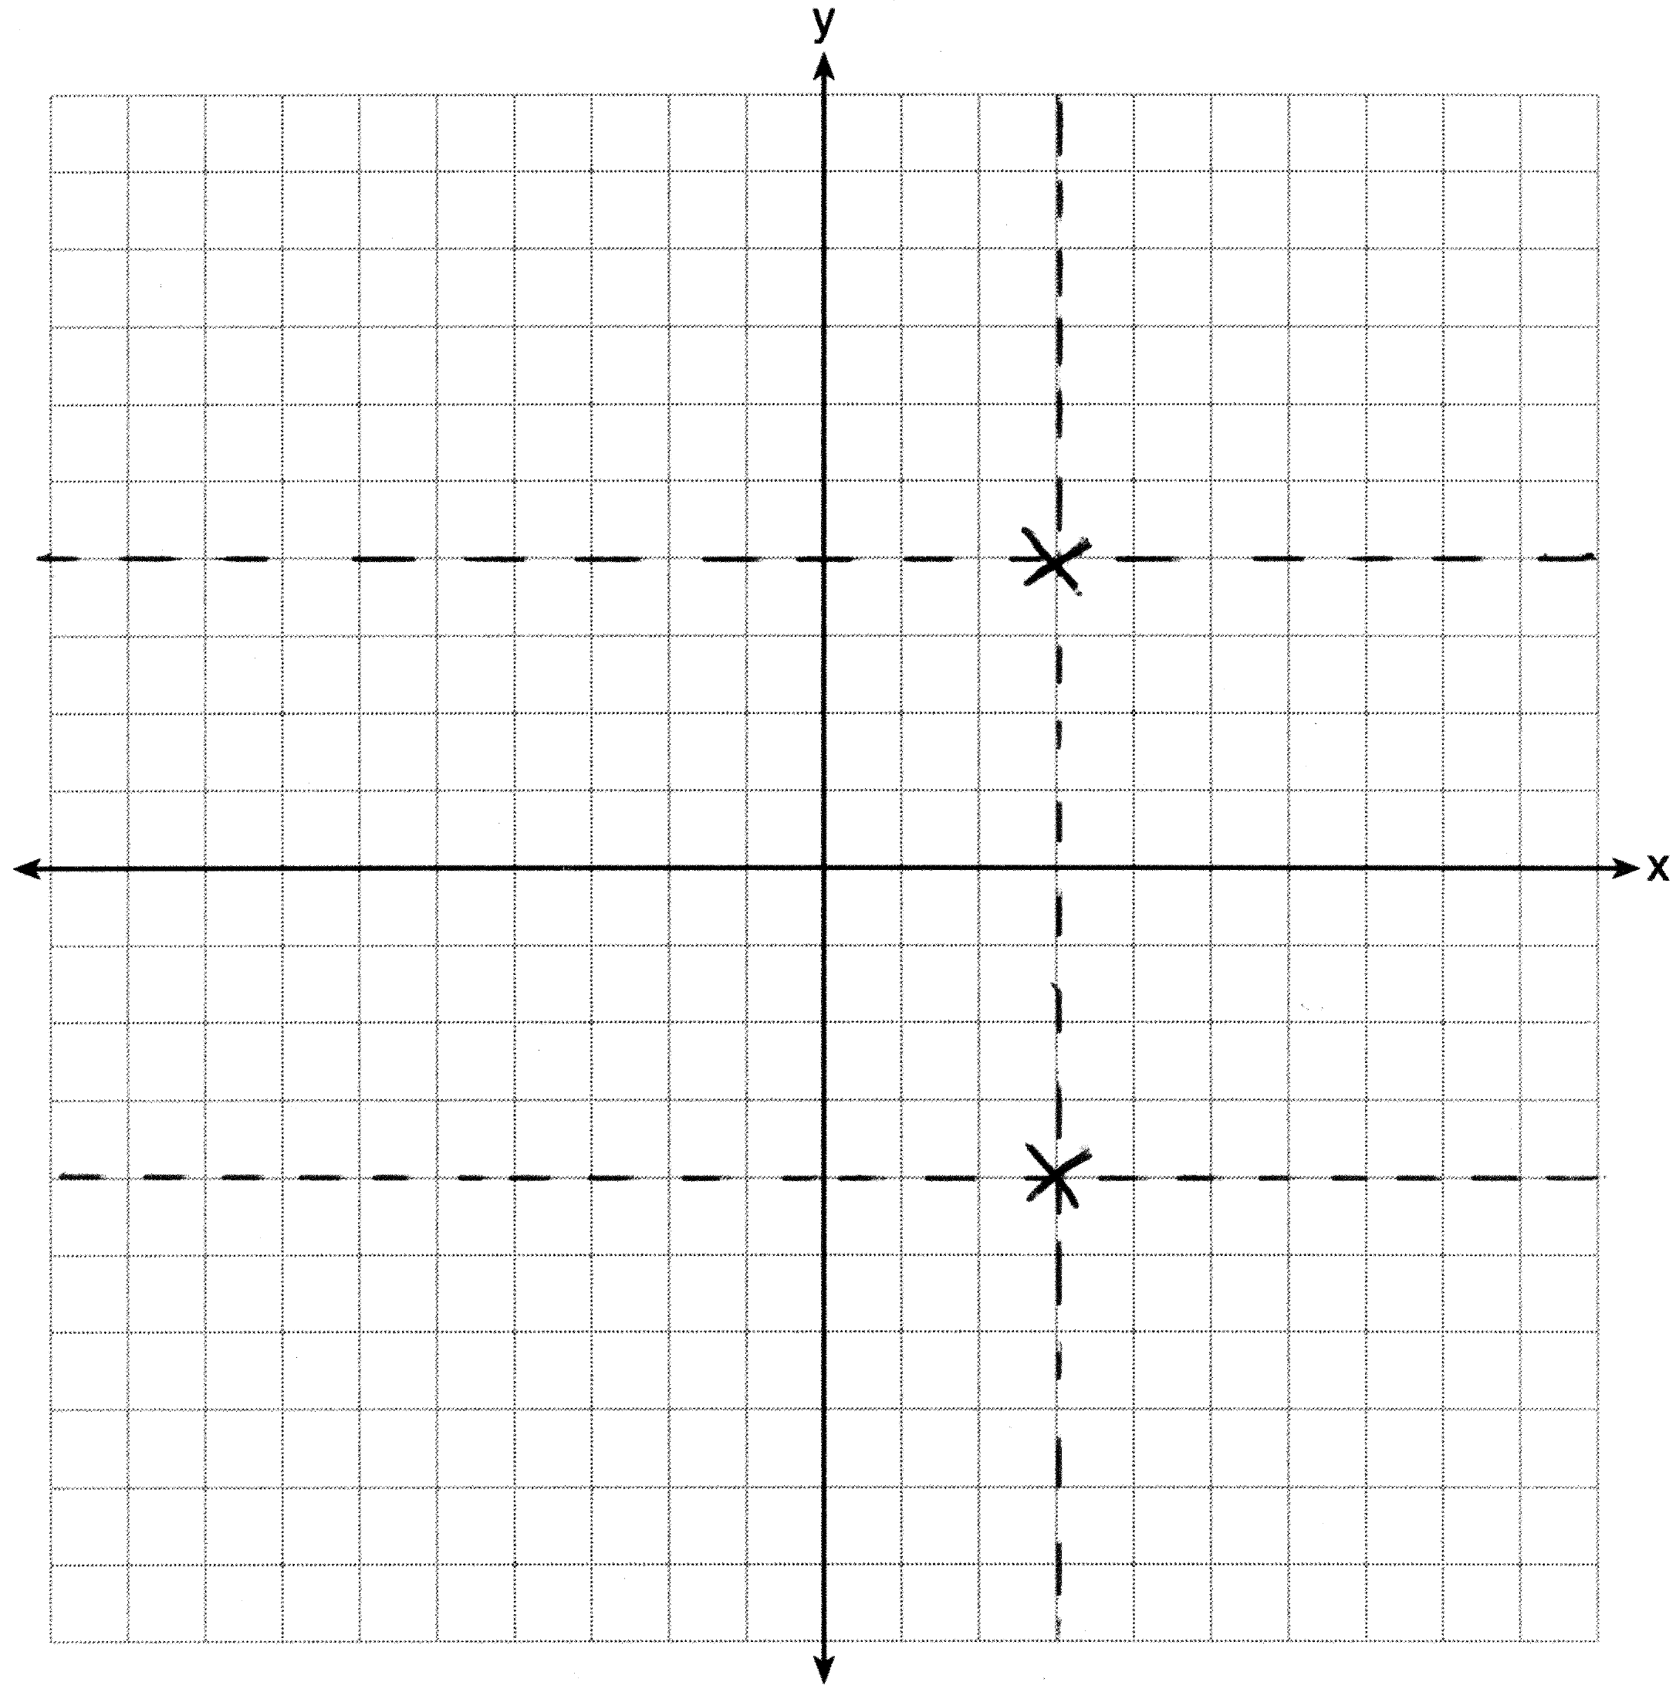

PTS: 2 REF: 061333ge STA: G.G.23 TOP: Locus

34 ANS:
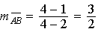. 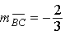

PTS: 4 REF: 061334ge STA: G.G.69 TOP: Quadrilaterals in the Coordinate Plane

35 ANS:
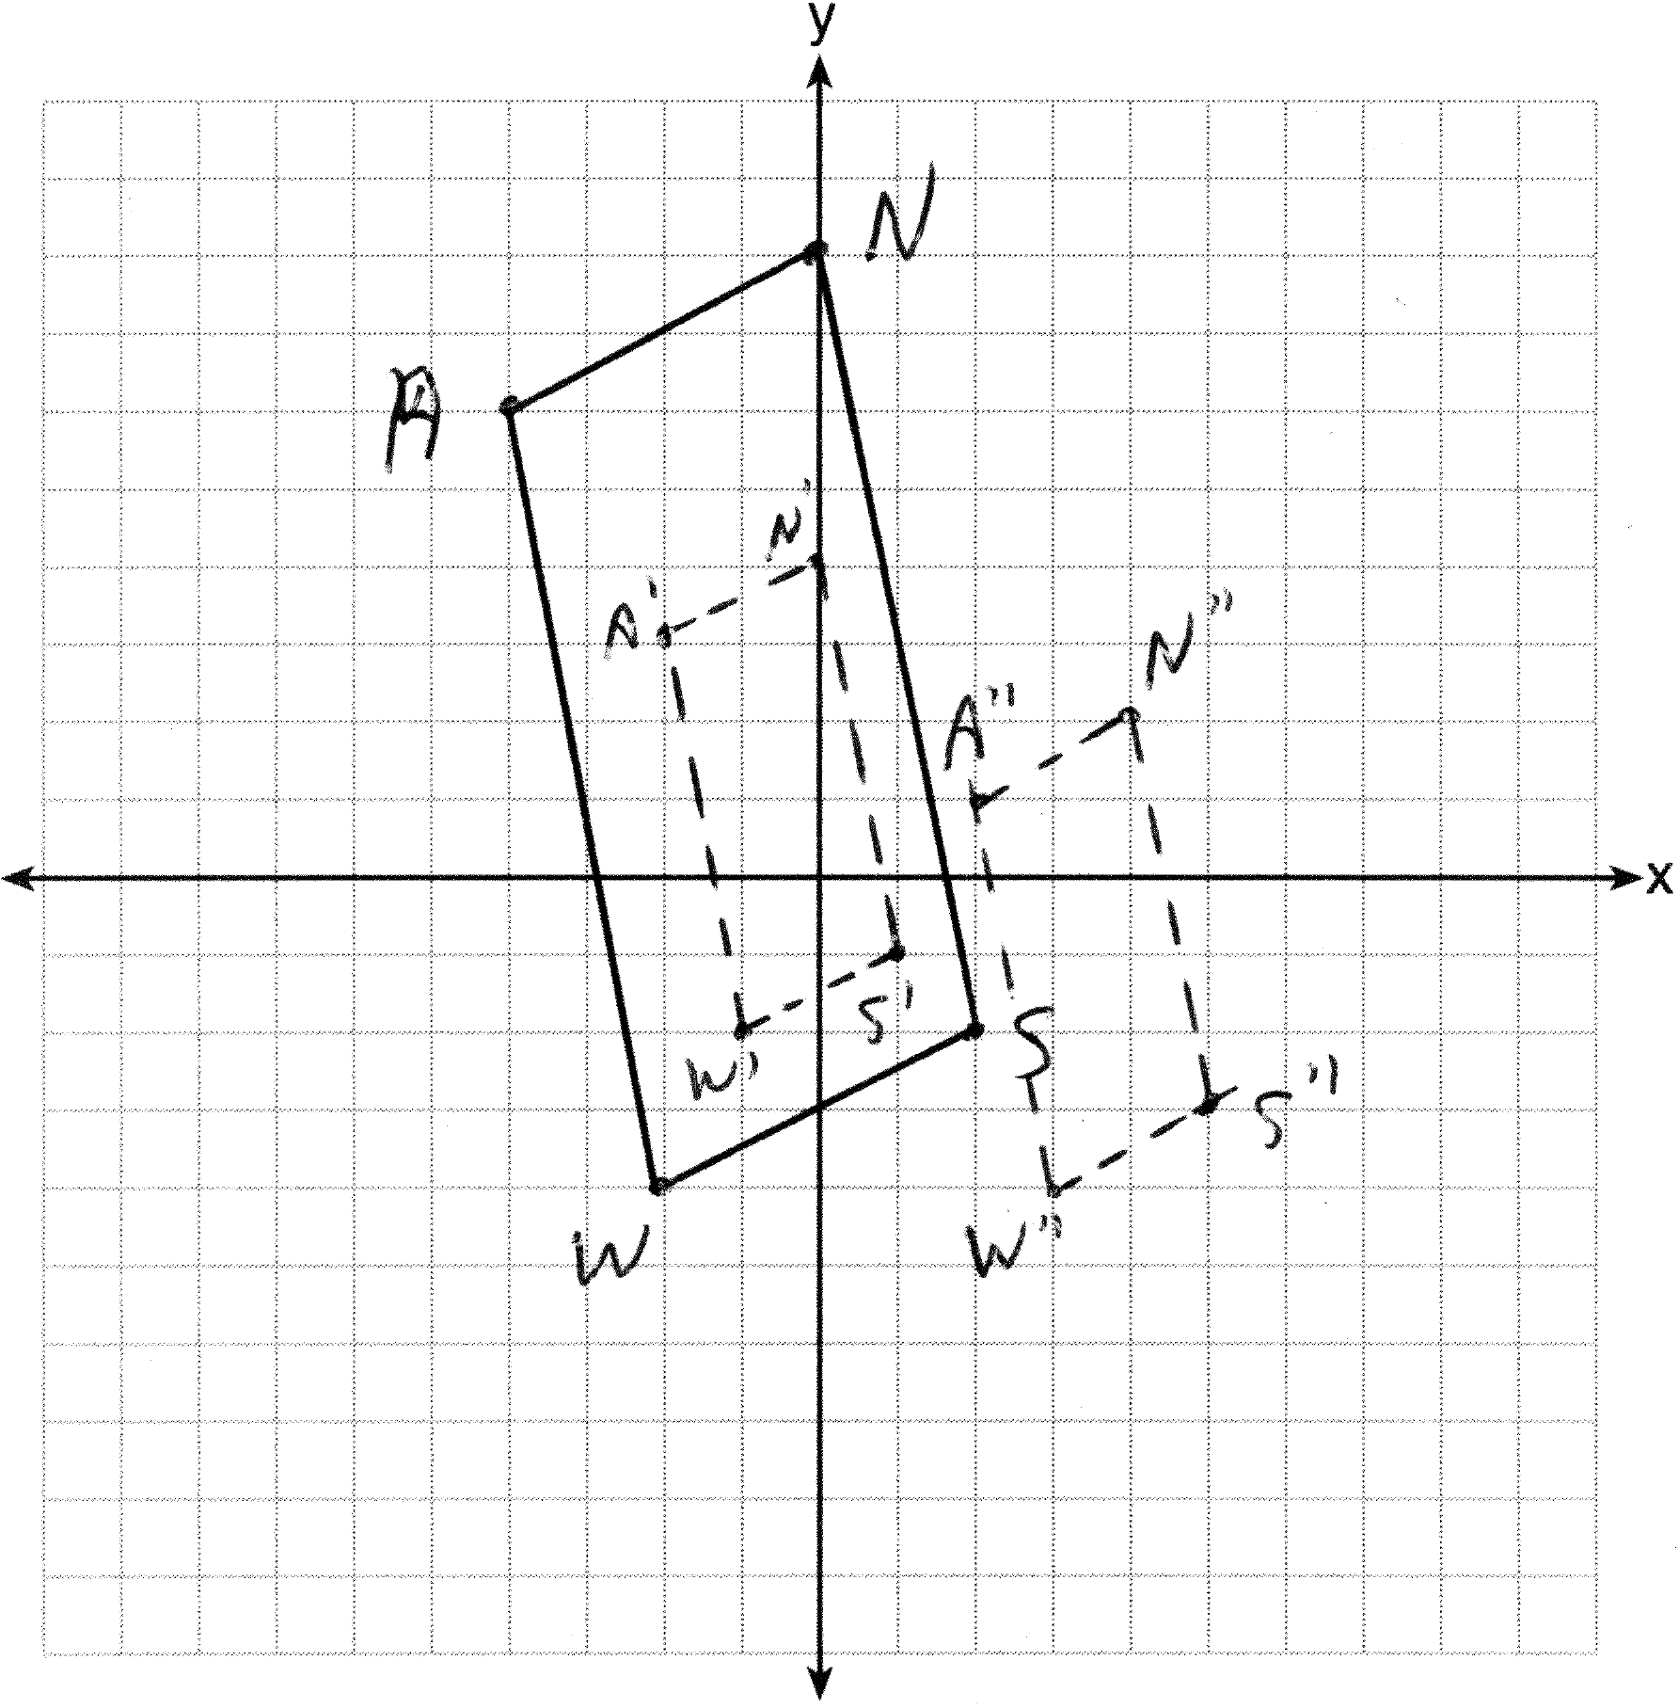 , , , and

PTS: 4 REF: 061335ge STA: G.G.58 TOP: Compositions of Transformations
KEY: grids

36 ANS:
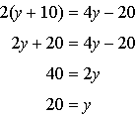. . 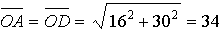

PTS: 4 REF: 061336ge STA: G.G.49 TOP: Chords

37 ANS:
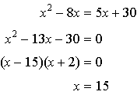.

PTS: 4 REF: 061337ge STA: G.G.45 TOP: Similarity
KEY: basic

38 ANS:
, and medians and are given. (reflexive property). is an isosceles triangle (definition of isosceles triangle). (isosceles triangle theorem). B is the midpoint of and T is the midpoint of (definition of median). 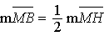 and 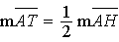 (definition of midpoint). (multiplication postulate). (SAS). (CPCTC).

PTS: 6 REF: 061338ge STA: G.G.27 TOP: Triangle Proofs

