1 Triangle ABC is graphed on the set of axes below.

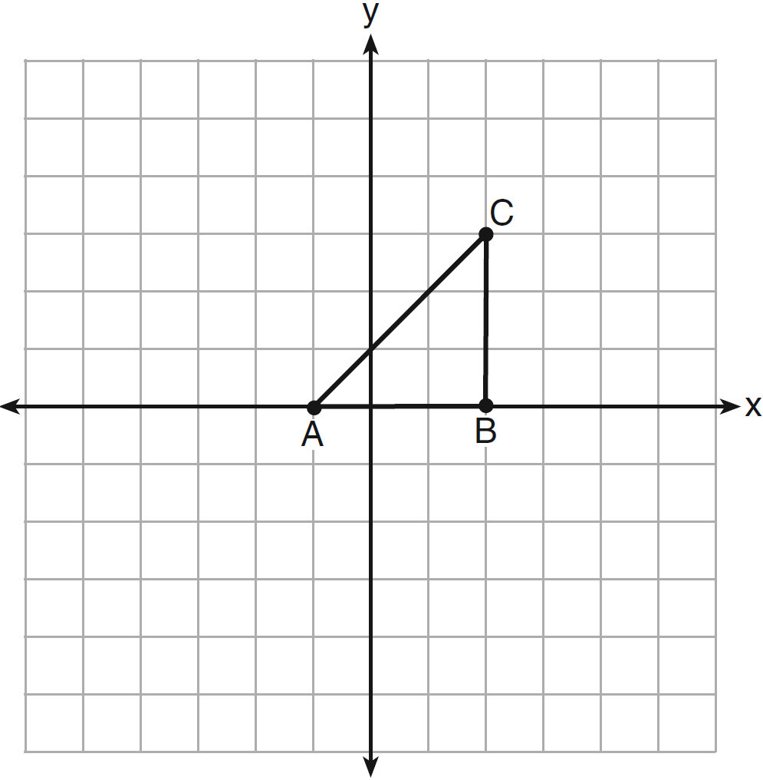

Which transformation produces an image that is similar to, but not congruent to, ?
1)
2)
3)
4)

2 A student wrote the sentence “4 is an odd integer.” What is the negation of this sentence and the truth value of the negation?
1) | 3 is an odd integer; true
2) | 4 is not an odd integer; true
3) | 4 is not an even integer; false
4) | 4 is an even integer; false

3 As shown in the diagram below, intersects planes P, Q, and R.

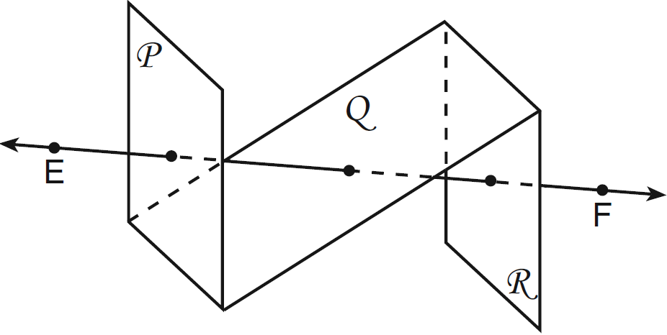

If is perpendicular to planes P and R, which statement must be true?
1) | Plane P is perpendicular to plane Q.
2) | Plane R is perpendicular to plane P.
3) | Plane P is parallel to plane Q.
4) | Plane R is parallel to plane P.

4 In the diagram below, LATE is an isosceles trapezoid with , , , and . Altitudes and are drawn.

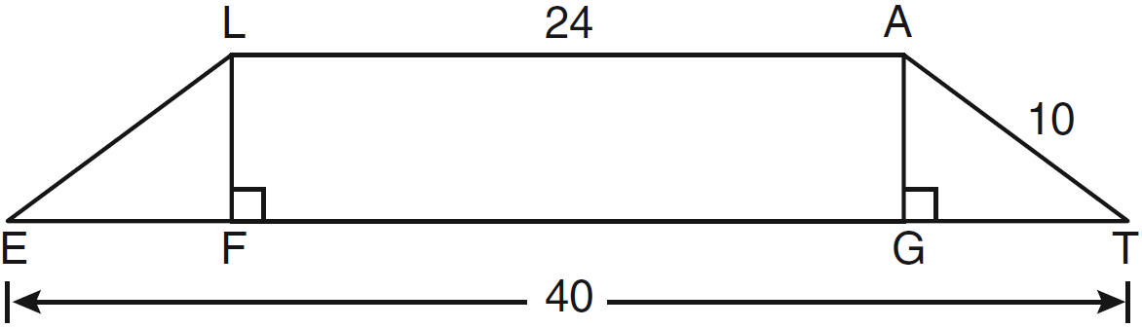

What is the length of ?
1) | 6
2) | 8
3) | 3
4) | 4

5 In the diagram below of circle O, diameter is parallel to chord .

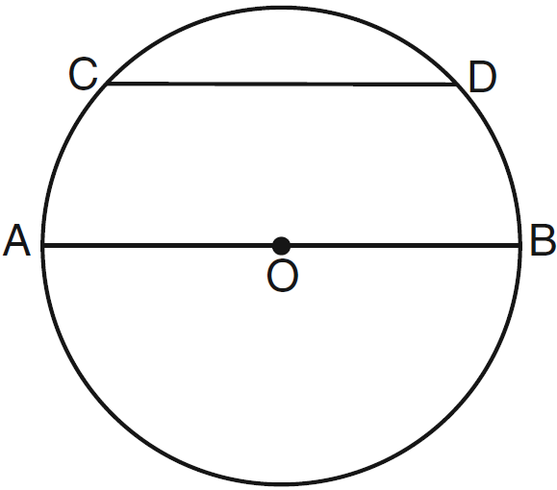

If , what is ?
1) | 110
2) | 70
3) | 55
4) | 35

6 In the diagram below of , .

Using this information, it could be proven that
1)
2)
3)
4)

7 The diameter of a sphere is 15 inches. What is the volume of the sphere, to the nearest tenth of a cubic inch?
1) | 706.9
2) | 1767.1
3) | 2827.4
4) | 14,137.2

8 The diagram below shows the construction of through point P parallel to .

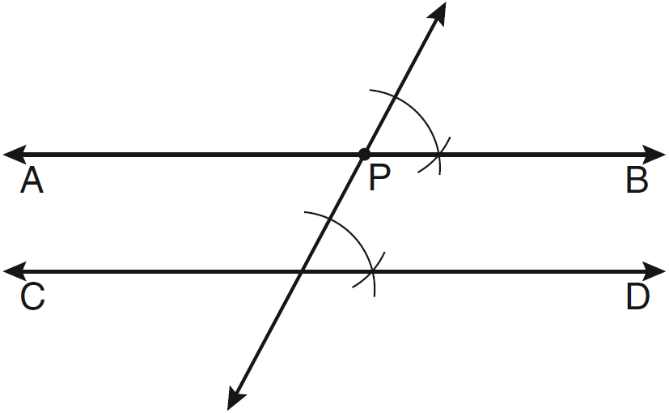

Which theorem justifies this method of construction?
1) | If two lines in a plane are perpendicular to a transversal at different points, then the lines are parallel.
2) | If two lines in a plane are cut by a transversal to form congruent corresponding angles, then the lines are parallel.
3) | If two lines in a plane are cut by a transversal to form congruent alternate interior angles, then the lines are parallel.
4) | If two lines in a plane are cut by a transversal to form congruent alternate exterior angles, then the lines are parallel.

9 Parallelogram ABCD has coordinates , , , and . What are the coordinates of E, the intersection of diagonals and ?
1)
2)
3)
4)

10 What is the equation of a circle whose center is 4 units above the origin in the coordinate plane and whose radius is 6?
1)
2)
3)
4)

11 In the diagram of shown below, D is the midpoint of , E is the midpoint of , and F is the midpoint of .

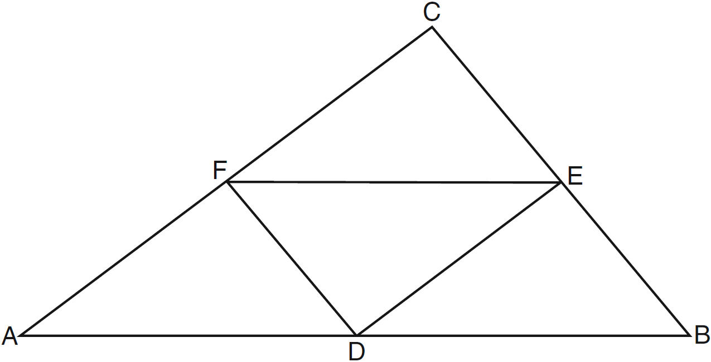

If , , and , what is the perimeter of trapezoid ABEF?
1) | 24
2) | 36
3) | 40
4) | 44

12 In the diagram below, is isosceles with .

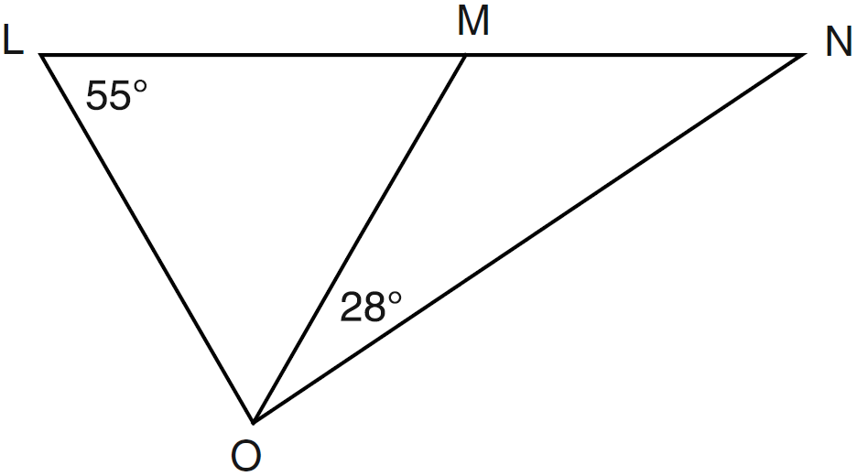

If and , what is ?
1) | 27
2) | 28
3) | 42
4) | 70

13 If is contained in plane P, and is perpendicular to plane R, which statement is true?
1) | is parallel to plane R.
2) | Plane P is parallel to plane R.
3) | is perpendicular to plane P.
4) | Plane P is perpendicular to plane R.

14 In the diagram below of , , , and .

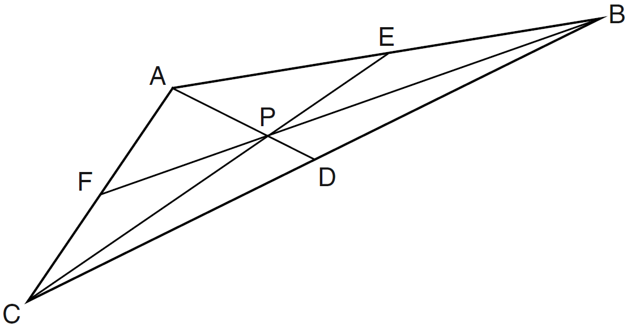

Point P must be the
1) | centroid
2) | circumcenter
3) | incenter
4) | orthocenter

15 What is the equation of the line that passes through the point and is perpendicular to the line ?
1)
2) | 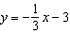
3)
4) | 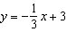

16 In the diagram of shown below, .

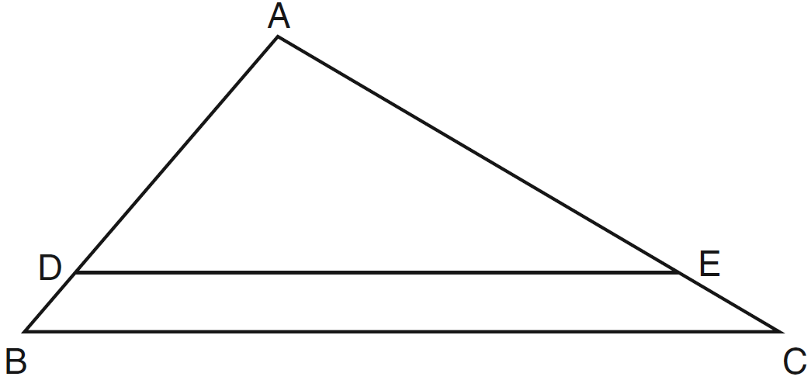

If , , and , what is the length of ?
1) | 6
2) | 2
3) | 3
4) | 15

17 What is the length of with endpoints and ?
1)
2)
3)
4)

18 The sum of the interior angles of a polygon of n sides is
1) | 360
2)
3)
4) | 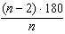

19 What is the slope of a line perpendicular to the line whose equation is ?
1)
2)
3) | 10
4)

20 Which graph represents a circle whose equation is ?
1) | 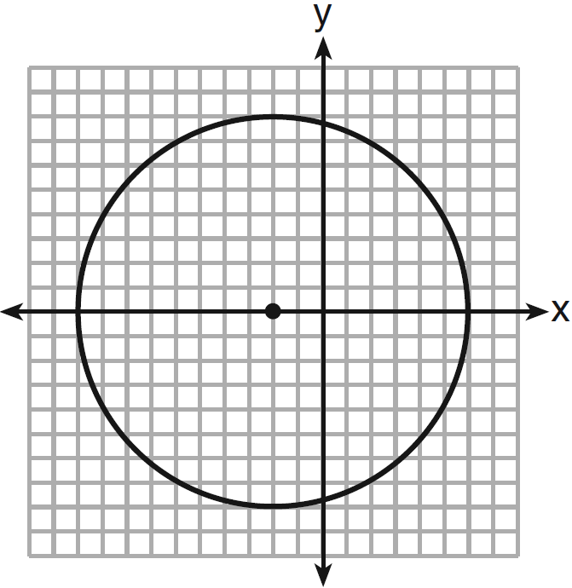
2) | 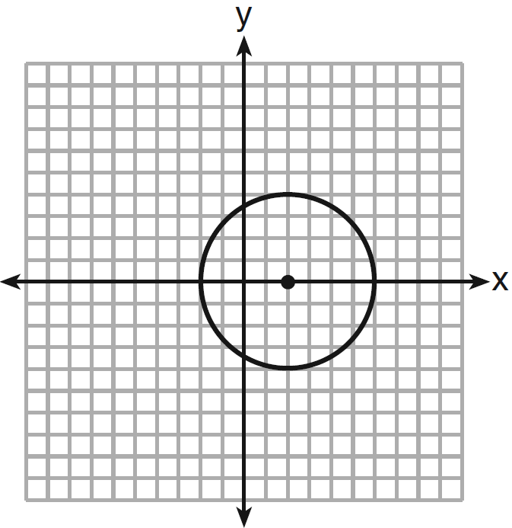
3) | 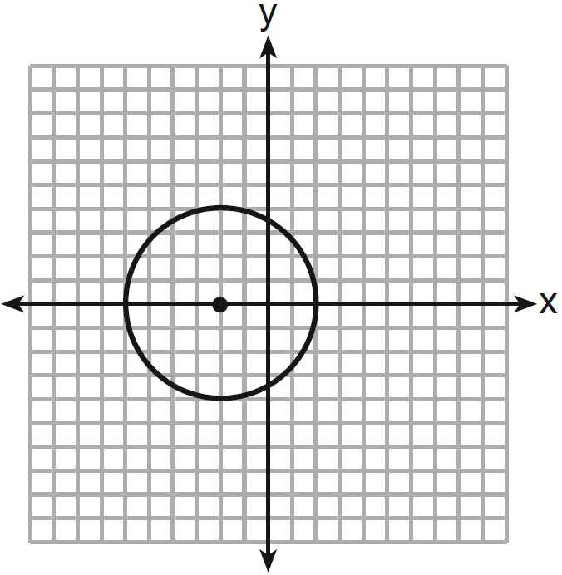
4) | 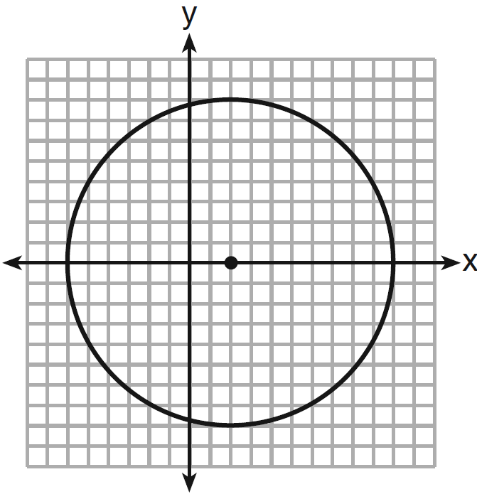

21 In circle O shown below, diameter is perpendicular to chord at E.

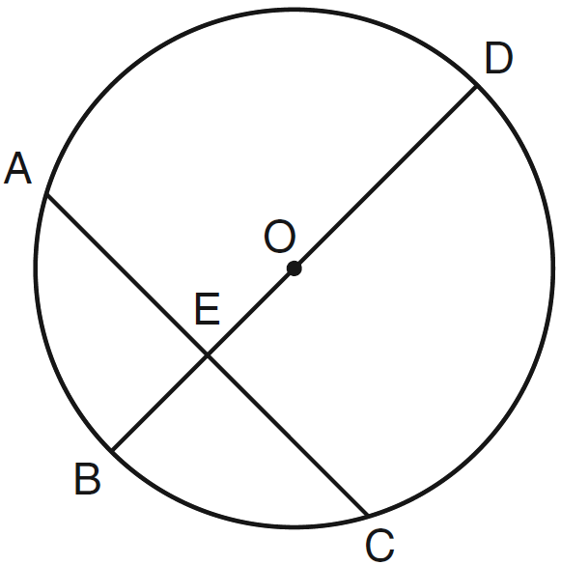

If , , and , what is the length of ?
1) | 8
2) | 9
3) | 16
4) | 25

22 In parallelogram ABCD shown below, diagonals and intersect at E.

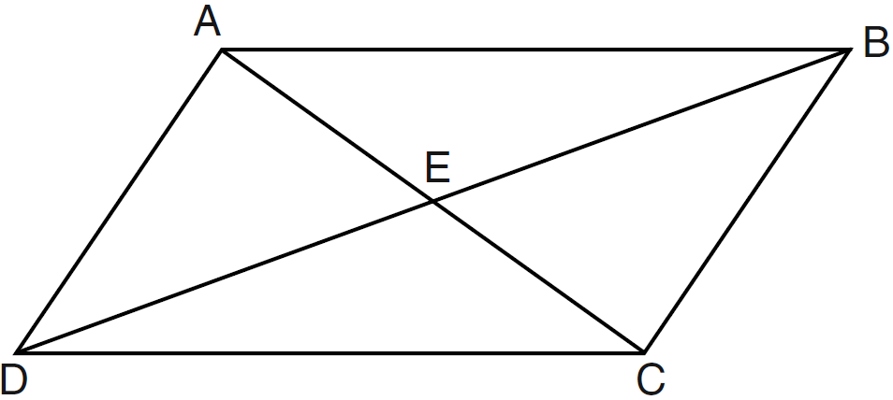

Which statement must be true?
1)
2)
3)
4)

23 Which equation of a circle will have a graph that lies entirely in the first quadrant?
1)
2)
3)
4)

24 In the diagram below, .

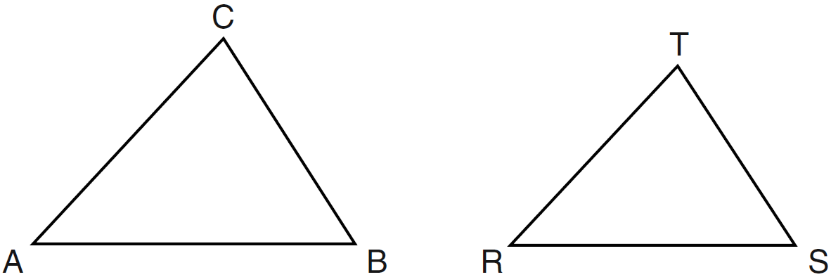

Which statement is not true?
1)
2) | 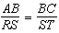
3) | 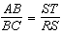
4) | 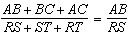

25 In the diagram below of , is extended to D.

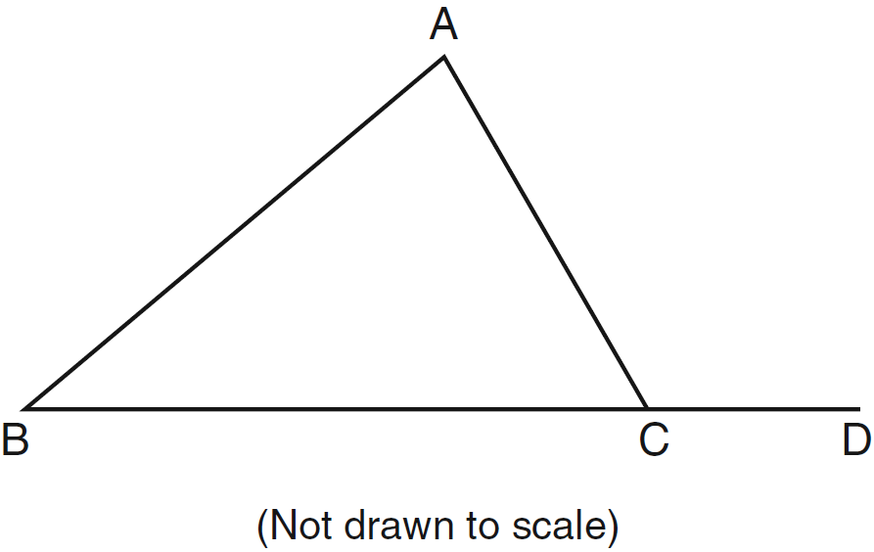

If , , and , what is the value of x?
1) | 10
2) | 2
3) | 3
4) | 15

26 An equation of the line that passes through and is parallel to the line is
1) | 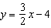
2) | 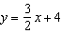
3) | 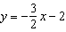
4) | 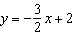

27 The graph below shows and its image, , after a transformation.

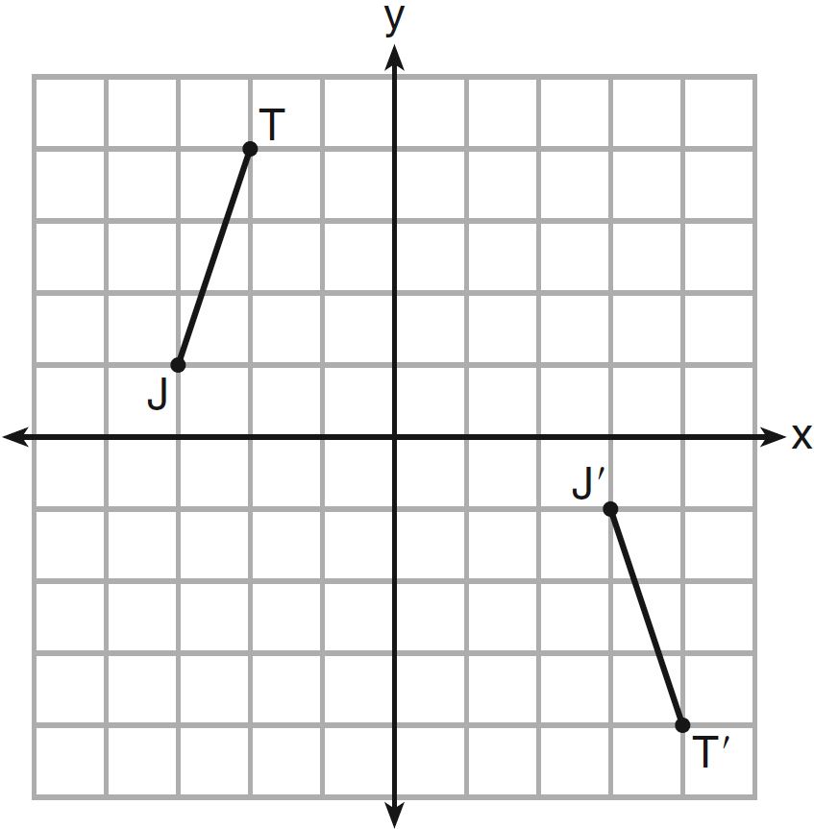

Which transformation would map onto ?
1) | translation
2) | glide reflection
3) | rotation centered at the origin
4) | reflection through the origin

28 Which reason could be used to prove that a parallelogram is a rhombus?
1) | Diagonals are congruent.
2) | Opposite sides are parallel.
3) | Diagonals are perpendicular.
4) | Opposite angles are congruent.

29 Triangle TAP has coordinates , , and . On the set of axes below, graph and label , the image of after the translation .

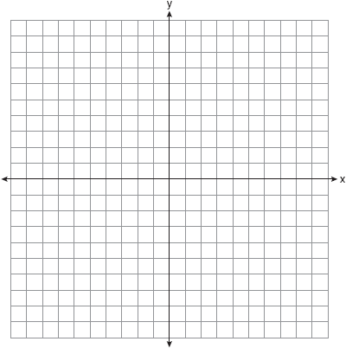

30 In the diagram below, and at R.

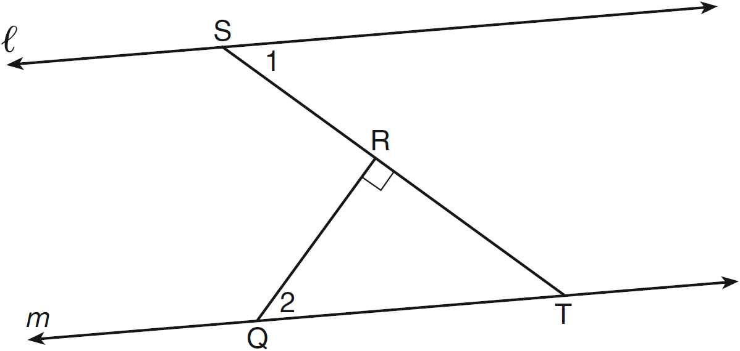

If , find .

31 Two lines are represented by the equations and . Determine whether these lines are parallel, perpendicular, or neither. Justify your answer.

32 Using a compass and straightedge, construct the bisector of . [Leave all construction marks.]

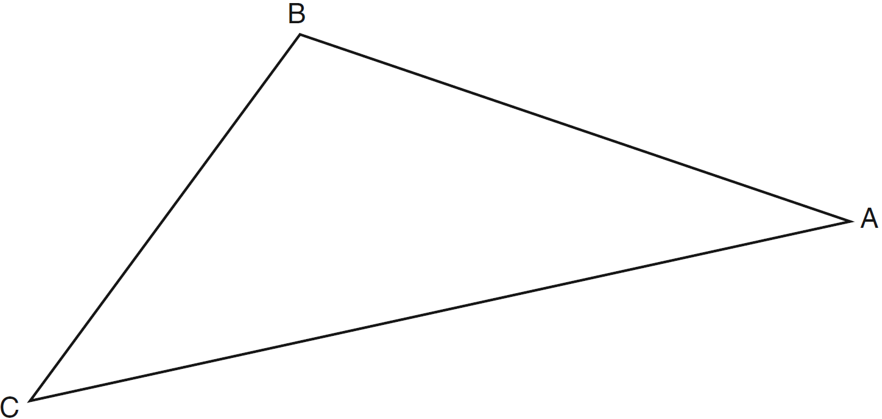

33 The cylindrical tank shown in the diagram below is to be painted. The tank is open at the top, and the bottom does not need to be painted. Only the outside needs to be painted. Each can of paint covers 600 square feet. How many cans of paint must be purchased to complete the job?

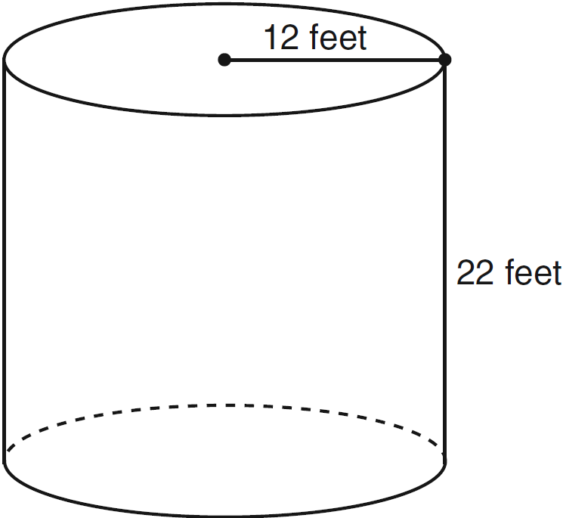

34 On the set of axes below, graph the locus of points that are 4 units from the line and the locus of points that are 5 units from the point . Label with an X all points that satisfy both conditions.

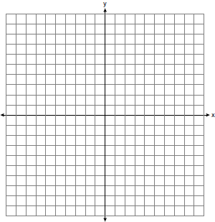

35 Given: bisects at E.
Prove:

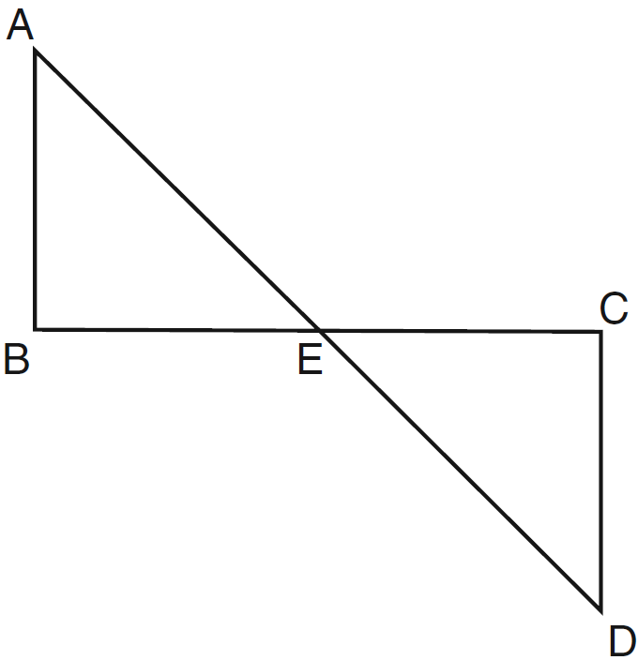

36 The coordinates of trapezoid ABCD are , , , and . Trapezoid is the image after the composition is performed on trapezoid ABCD. State the coordinates of trapezoid . [The use of the set of axes below is optional.]

37 In the diagram below of circle O, chords and intersect at M. Secant and tangent are drawn to circle O. The length of is two more than the length of , , , and .

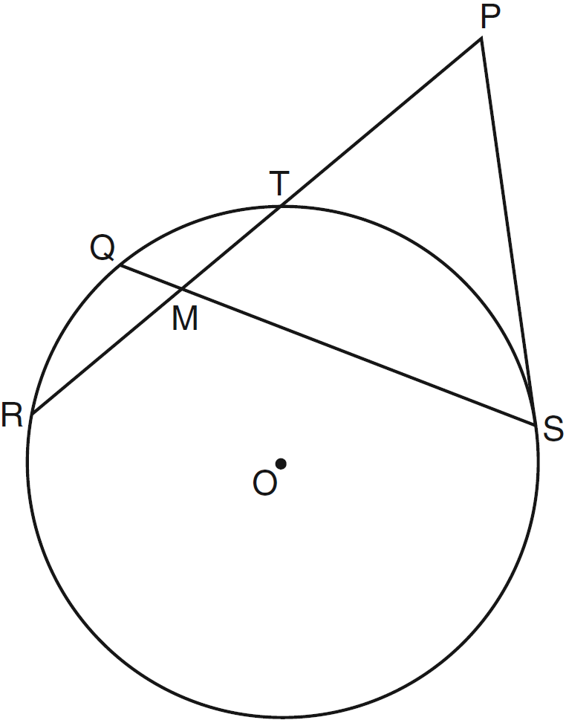

Find the length of . Find the length of .

38 On the set of axes below, solve the system of equations graphically and state the coordinates of all points in the solution.
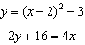

1 ANS: 2 PTS: 2 REF: 061201ge STA: G.G.59
TOP: Properties of Transformations

2 ANS: 2 PTS: 2 REF: 061202ge STA: G.G.24
TOP: Negations

3 ANS: 4 PTS: 2 REF: 061203ge STA: G.G.9
TOP: Planes

4 ANS: 1
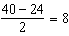. . 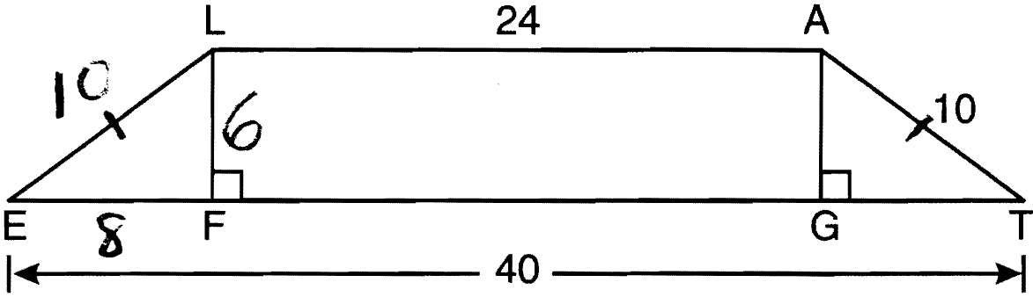

PTS: 2 REF: 061204ge STA: G.G.40 TOP: Trapezoids

5 ANS: 3
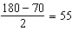

PTS: 2 REF: 061205ge STA: G.G.52 TOP: Chords

6 ANS: 2
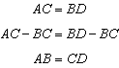

PTS: 2 REF: 061206ge STA: G.G.27 TOP: Line Proofs

7 ANS: 2
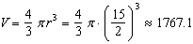

PTS: 2 REF: 061207ge STA: G.G.16 TOP: Volume and Surface Area

8 ANS: 2 PTS: 2 REF: 061208ge STA: G.G.19
TOP: Constructions

9 ANS: 1
The diagonals of a parallelogram intersect at their midpoints. 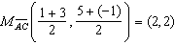

PTS: 2 REF: 061209ge STA: G.G.69 TOP: Quadrilaterals in the Coordinate Plane

10 ANS: 3 PTS: 2 REF: 061210ge STA: G.G.71
TOP: Equations of Circles

11 ANS: 4
. 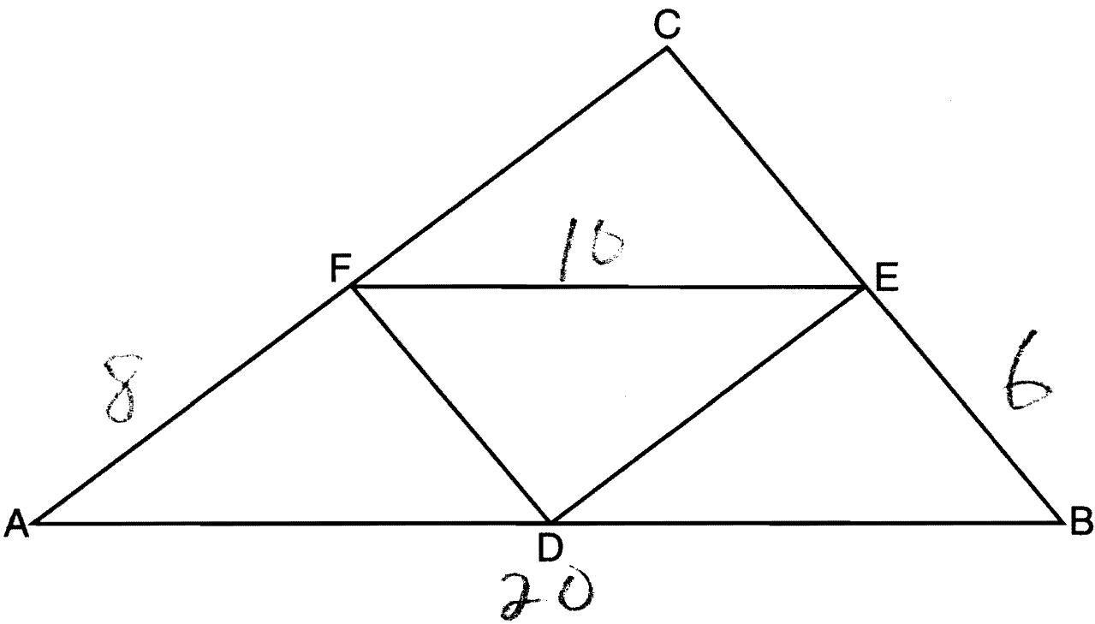

PTS: 2 REF: 061211ge STA: G.G.42 TOP: Midsegments

12 ANS: 1
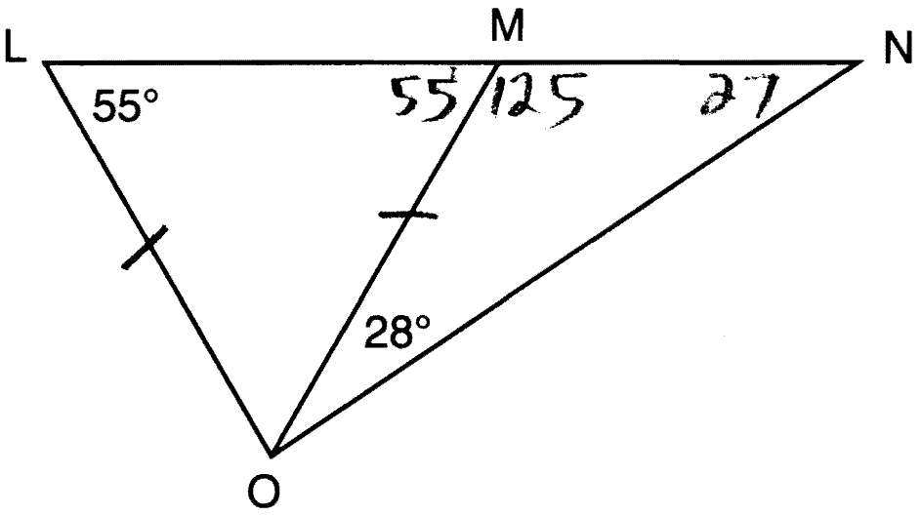

PTS: 2 REF: 061211ge STA: G.G.31 TOP: Isosceles Triangle Theorem

13 ANS: 4 PTS: 2 REF: 061213ge STA: G.G.5
TOP: Planes

14 ANS: 1 PTS: 2 REF: 061214ge STA: G.G.21
TOP: Centroid, Orthocenter, Incenter and Circumcenter

15 ANS: 4
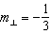. 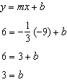

PTS: 2 REF: 061215ge STA: G.G.64 TOP: Parallel and Perpendicular Lines

16 ANS: 3
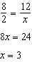. 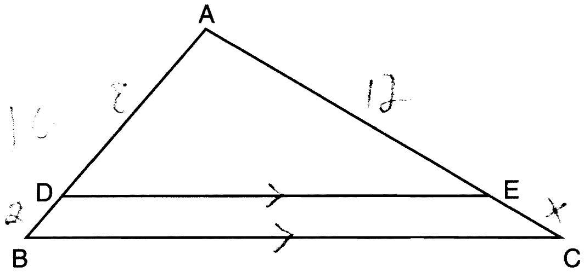

PTS: 2 REF: 061216ge STA: G.G.46 TOP: Side Splitter Theorem

17 ANS: 3

PTS: 2 REF: 061217ge STA: G.G.67 TOP: Distance
KEY: general

18 ANS: 3 PTS: 2 REF: 061218ge STA: G.G.36
TOP: Interior and Exterior Angles of Polygons

19 ANS: 2
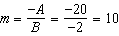. 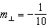

PTS: 2 REF: 061219ge STA: G.G.62 TOP: Parallel and Perpendicular Lines

20 ANS: 3 PTS: 2 REF: 061220ge STA: G.G.74
TOP: Graphing Circles

21 ANS: 2
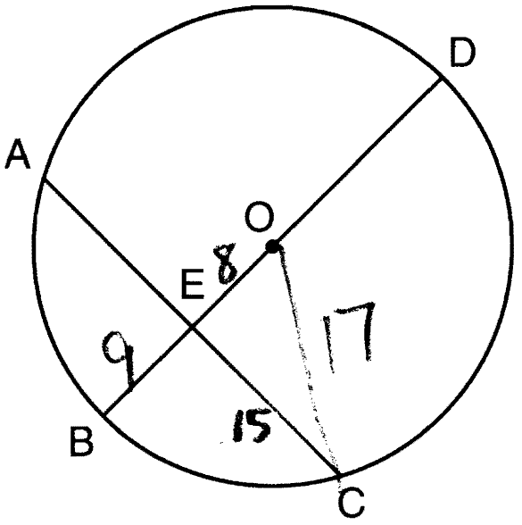 .

PTS: 2 REF: 061221ge STA: G.G.49 TOP: Chords

22 ANS: 3
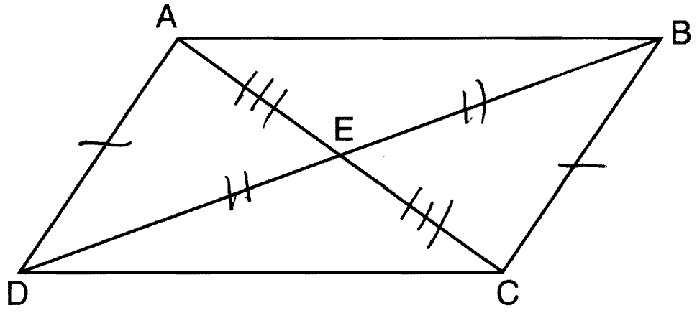. Opposite sides of a parallelogram are congruent and the diagonals of a parallelogram bisect each other.

PTS: 2 REF: 061222ge STA: G.G.28 TOP: Triangle Congruency

23 ANS: 1 PTS: 2 REF: 061223ge STA: G.G.73
TOP: Equations of Circles

24 ANS: 3 PTS: 2 REF: 061224ge STA: G.G.45
TOP: Similarity KEY: basic

25 ANS: 4
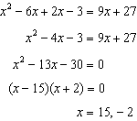

PTS: 2 REF: 061225ge STA: G.G.32 TOP: Exterior Angle Theorem

26 ANS: 4
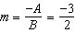. 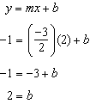

PTS: 2 REF: 061226ge STA: G.G.65 TOP: Parallel and Perpendicular Lines

27 ANS: 2 PTS: 2 REF: 061227ge STA: G.G.56
TOP: Identifying Transformations

28 ANS: 3 PTS: 2 REF: 061228ge STA: G.G.39
TOP: Special Parallelograms

29 ANS:
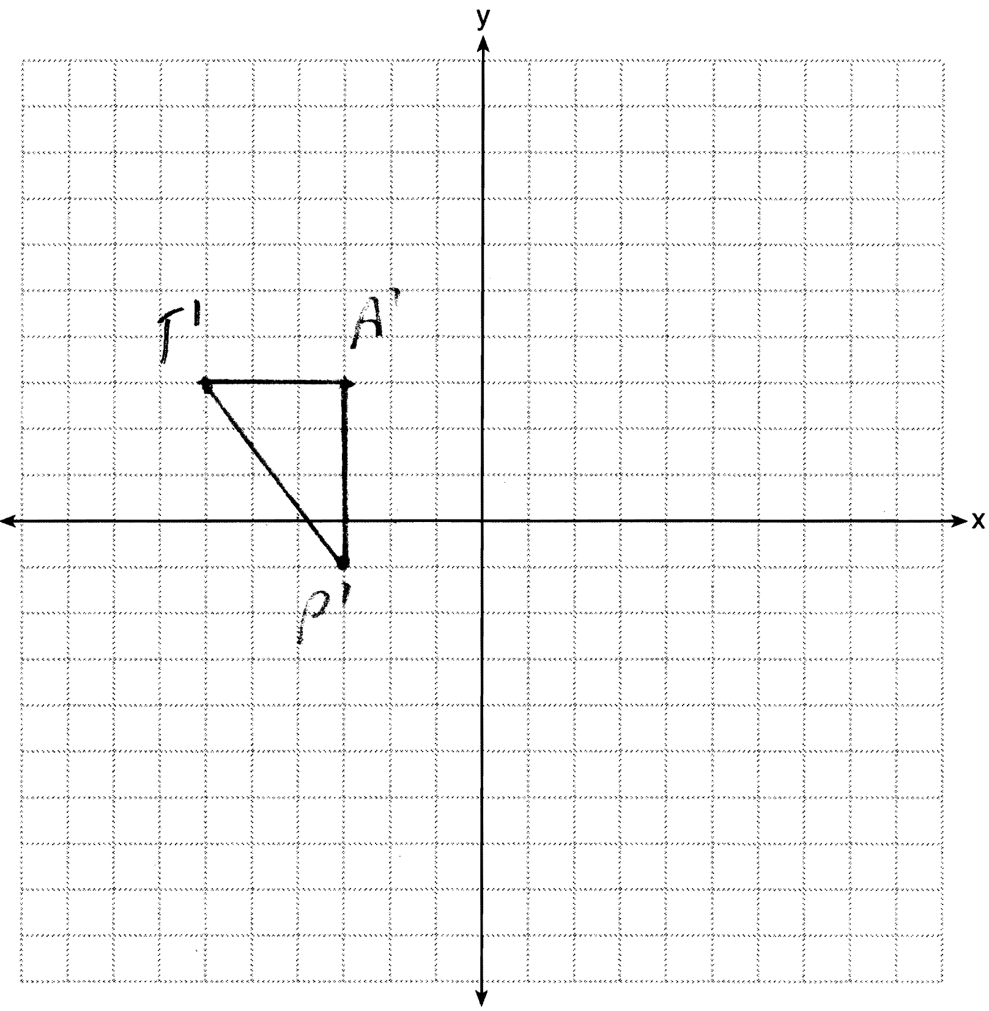

PTS: 2 REF: 061229ge STA: G.G.61
TOP: Analytical Representations of Transformations

30 ANS:

PTS: 2 REF: 061230ge STA: G.G.35 TOP: Parallel Lines and Transversals

31 ANS:
The slope of is 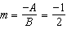. The slope of is 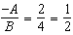. Since the slopes are neither equal nor opposite reciprocals, the lines are neither parallel nor perpendicular.

PTS: 2 REF: 061231ge STA: G.G.63 TOP: Parallel and Perpendicular Lines

32 ANS:
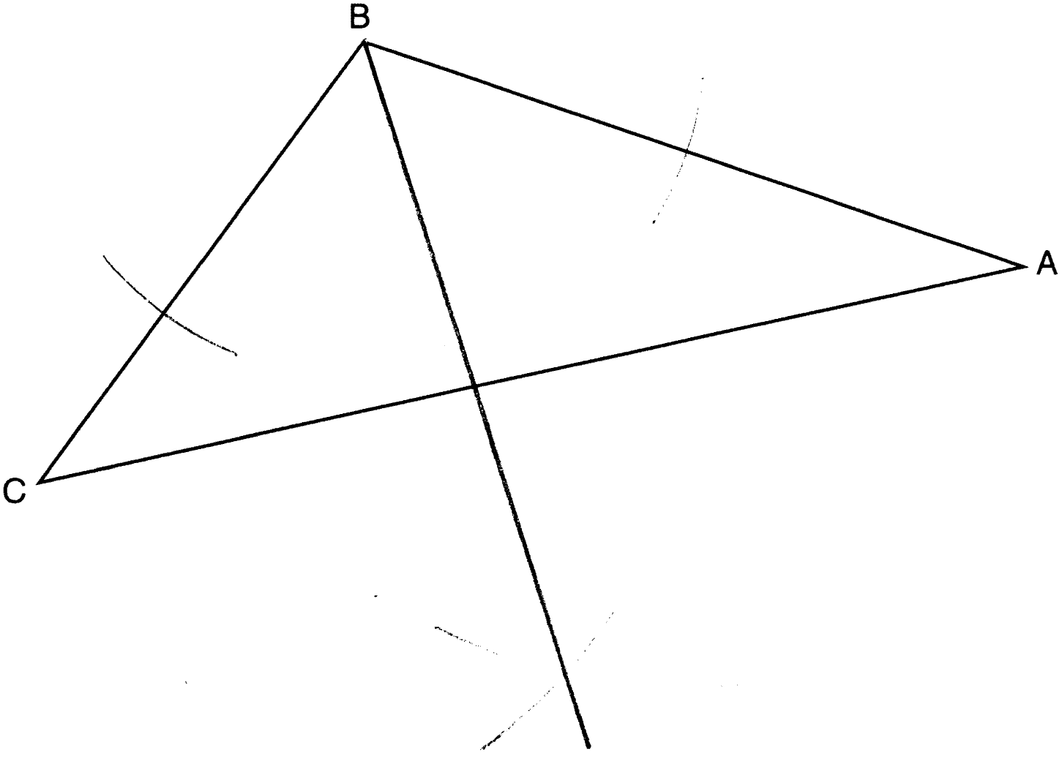

PTS: 2 REF: 061232ge STA: G.G.17 TOP: Constructions

33 ANS:
. 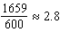. 3 cans are needed.

PTS: 2 REF: 061233ge STA: G.G.14 TOP: Volume and Lateral Area

34 ANS:
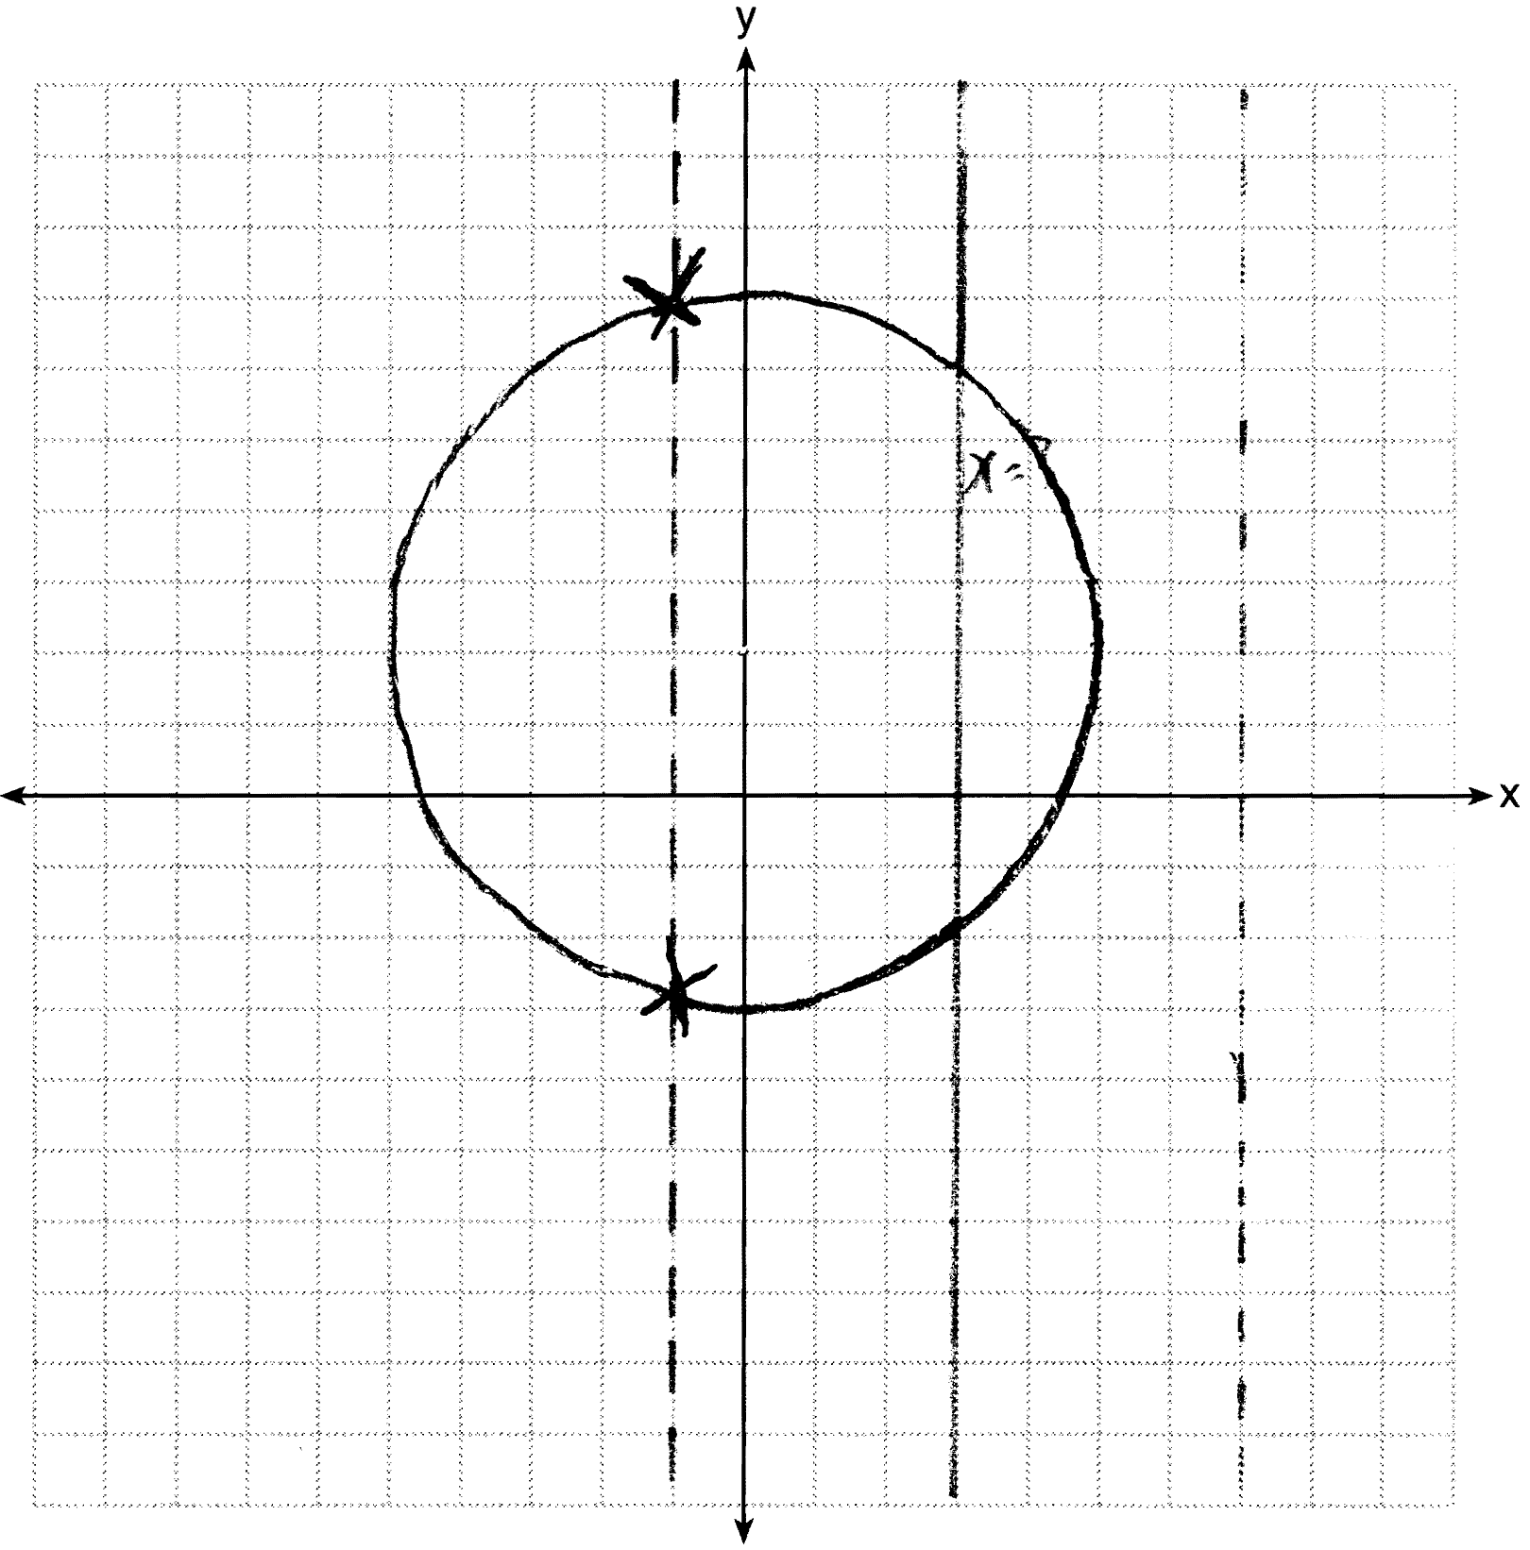

PTS: 2 REF: 061234ge STA: G.G.23 TOP: Locus

35 ANS:
and are right angles because perpendicular lines form right angles. because all right angles are congruent. because vertical angles are congruent. because of ASA. because CPCTC.

PTS: 4 REF: 061235ge STA: G.G.27 TOP: Triangle Proofs

36 ANS:
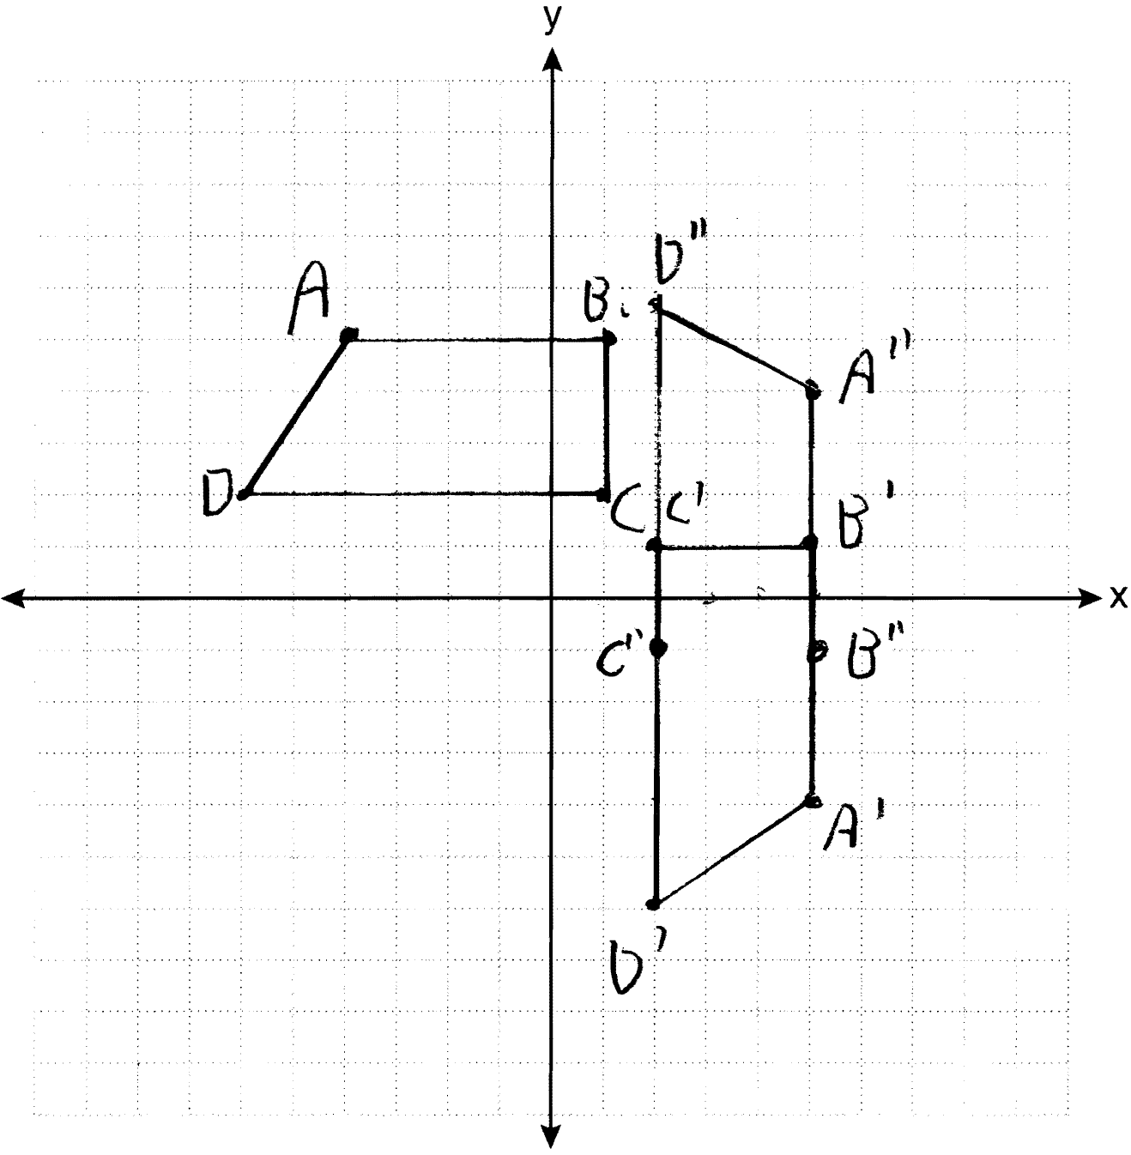 ;

PTS: 4 REF: 061236ge STA: G.G.58 TOP: Compositions of Transformations
KEY: grids

37 ANS:
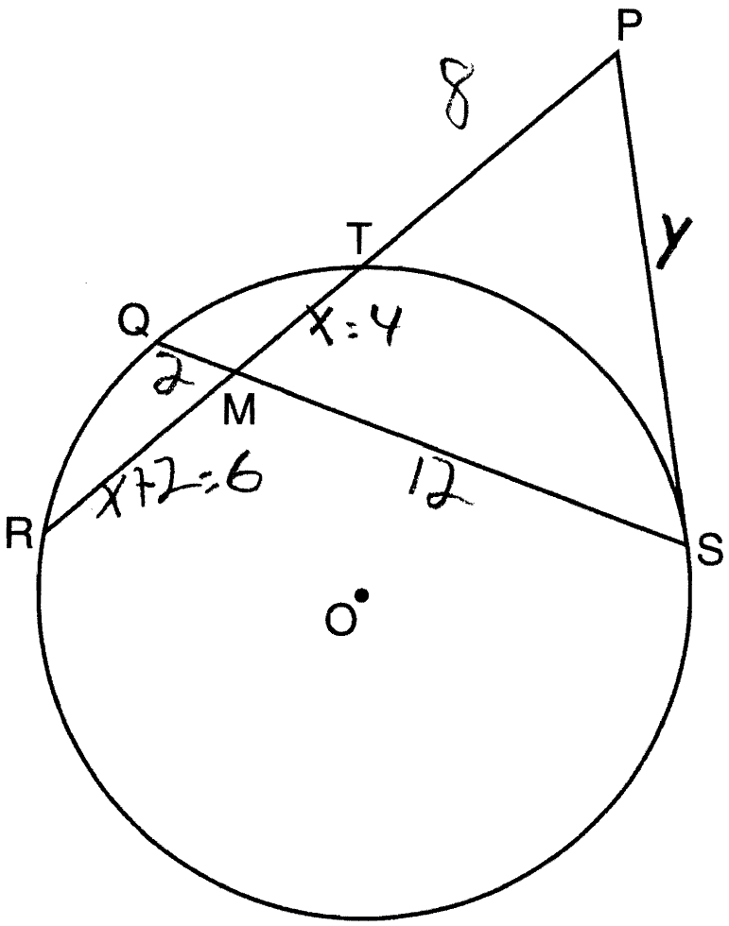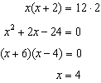. . 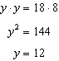

PTS: 4 REF: 061237ge STA: G.G.53 TOP: Segments Intercepted by Circle
KEY: tangent and secant

38 ANS:
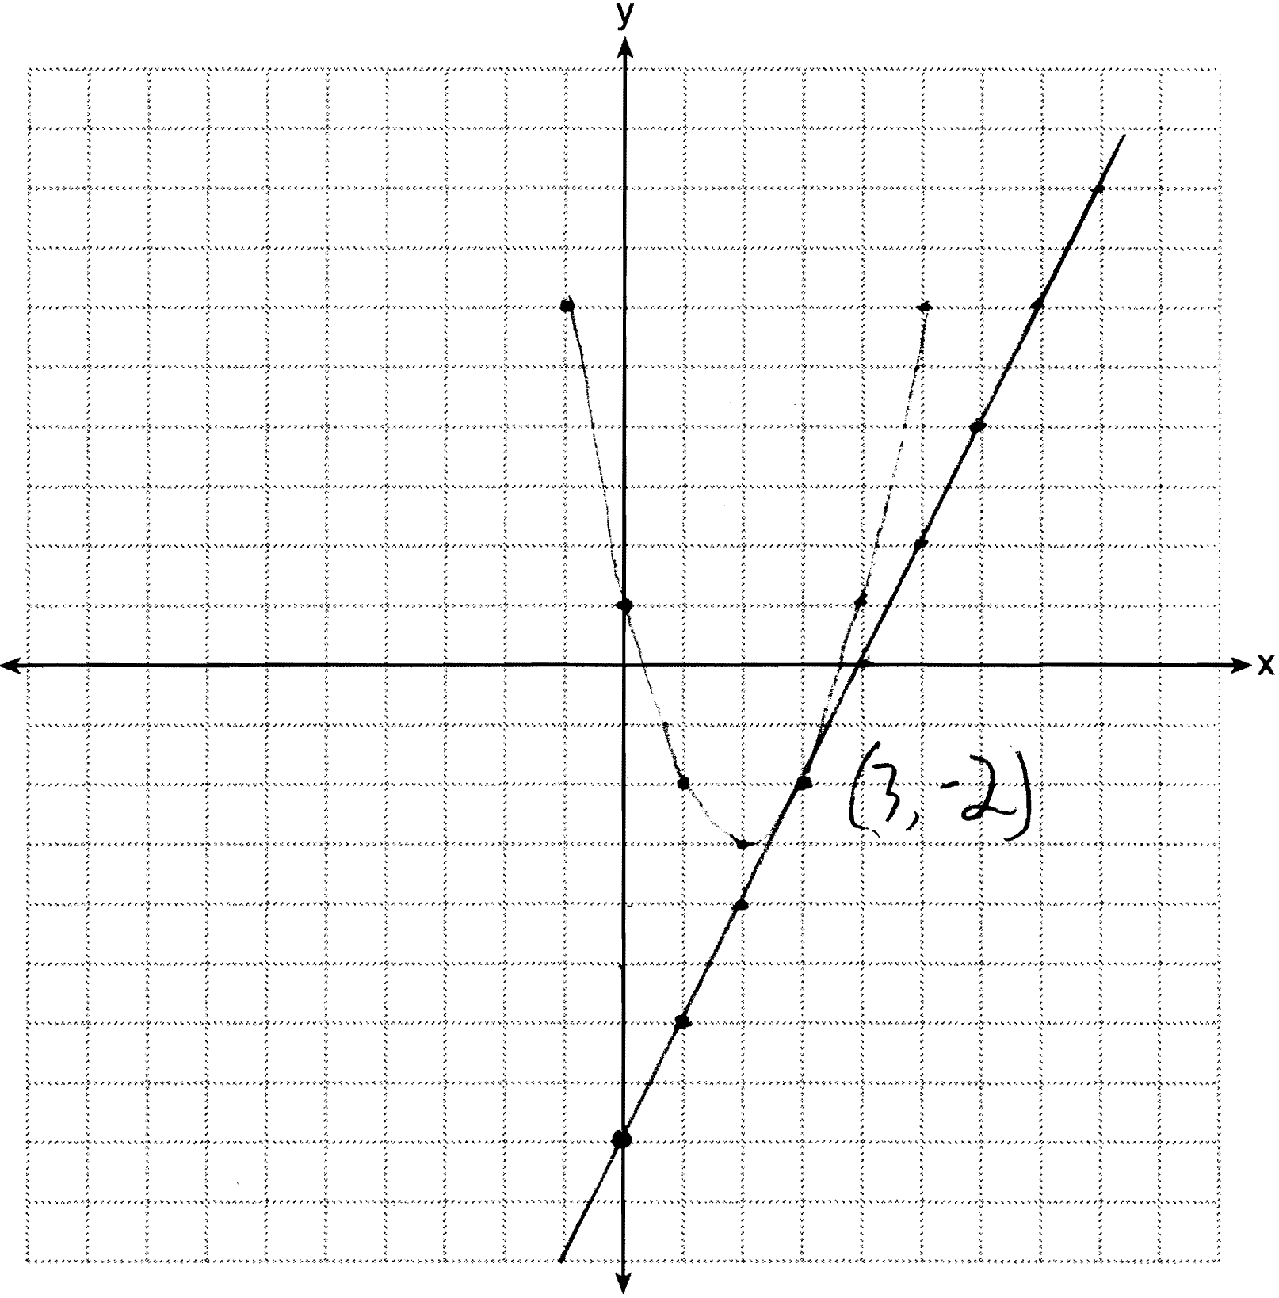

PTS: 6 REF: 061238ge STA: G.G.70 TOP: Quadratic-Linear Systems

