1 Line segment AB is shown in the diagram below.

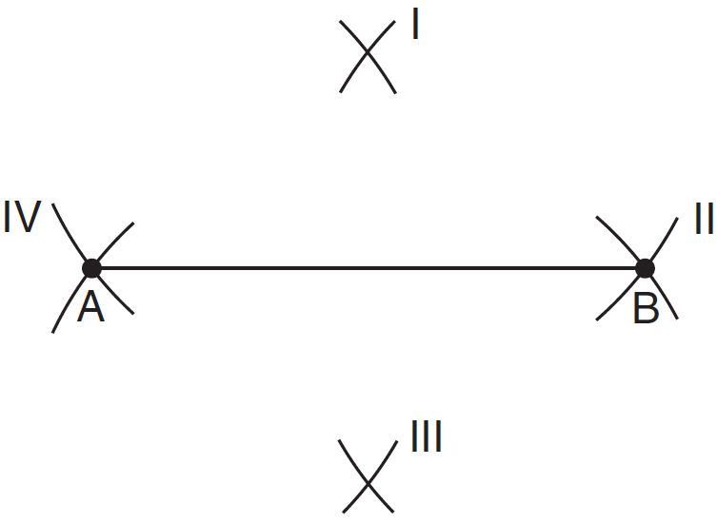

Which two sets of construction marks, labeled I, II, III, and IV, are part of the construction of the perpendicular bisector of line segment AB?
1) | I and II
2) | I and III
3) | II and III
4) | II and IV

2 If , which statement is always true?
1)
2)
3)
4)

3 In the diagram below, is a transformation of , and is a transformation of .

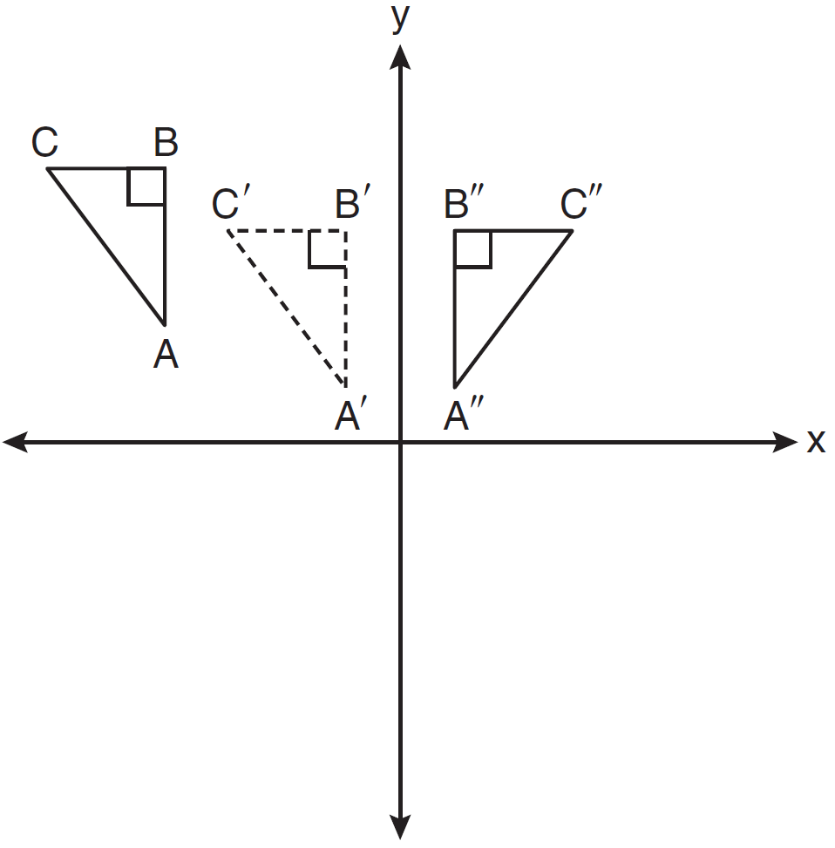

The composite transformation of to is an example of a
1) | reflection followed by a rotation
2) | reflection followed by a translation
3) | translation followed by a rotation
4) | translation followed by a reflection

4 In the diagram below of , medians , , and intersect at G. The length of is 12 cm.

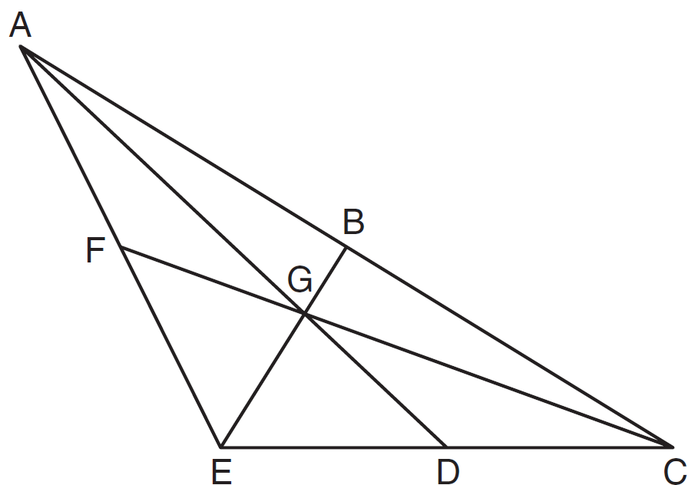

What is the length, in centimeters, of ?
1) | 24
2) | 12
3) | 6
4) | 4

5 In the diagram below of circle O, is parallel to .

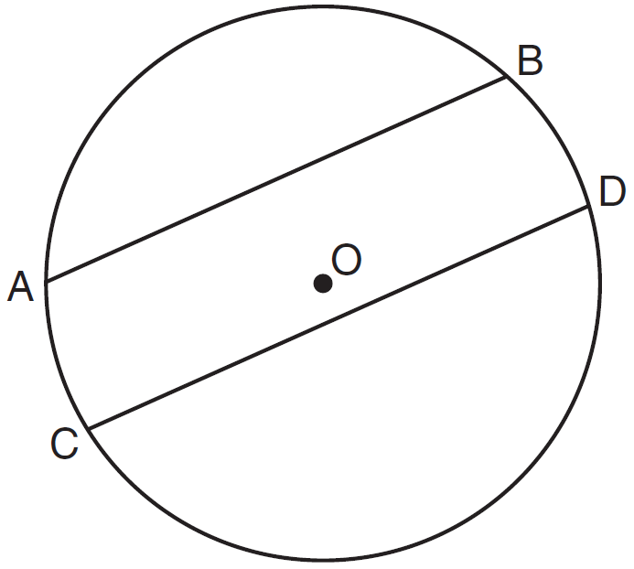

Which statement must be true?
1)
2)
3)
4)

6 In the diagram below, line p intersects line m and line n.

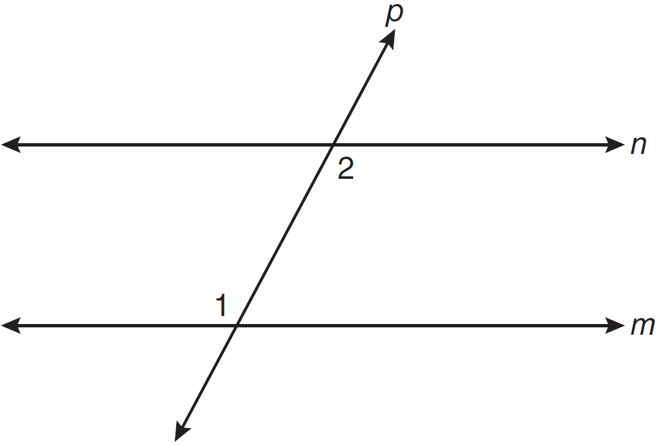

If and , lines m and n are parallel when x equals
1) | 12.5
2) | 15
3) | 87.5
4) | 105

7 In the diagram of below, , , and is extended through N.

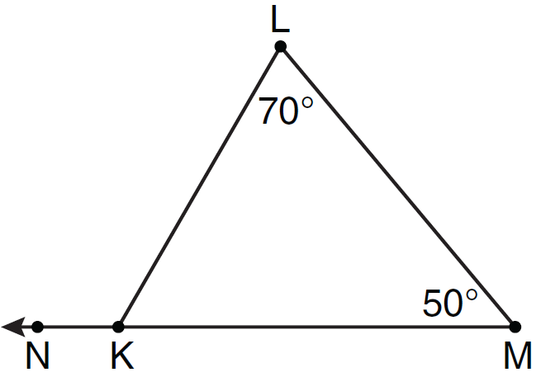

What is the measure of ?
1) | 60º
2) | 120º
3) | 180º
4) | 300º

8 If two distinct planes, A and B, are perpendicular to line c, then which statement is true?
1) | Planes A and B are parallel to each other.
2) | Planes A and B are perpendicular to each other.
3) | The intersection of planes A and B is a line parallel to line c.
4) | The intersection of planes A and B is a line perpendicular to line c.

9 What is the length of the line segment whose endpoints are and ?
1)
2)
3)
4)

10 What is an equation of circle O shown in the graph below?

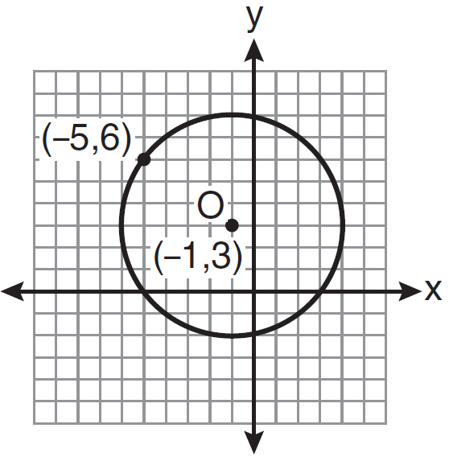
1)
2)
3)
4)

11 In the diagram below, parallelogram ABCD has diagonals and that intersect at point E.

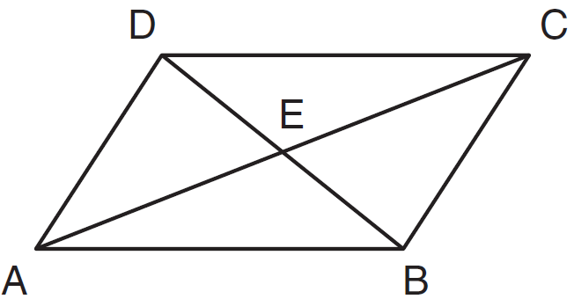

Which expression is not always true?
1)
2)
3)
4)

12 The volume, in cubic centimeters, of a sphere whose diameter is 6 centimeters is
1)
2)
3)
4)

13 The equation of line k is 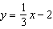. The equation of line m is . Lines k and m are
1) | parallel
2) | perpendicular
3) | the same line
4) | neither parallel nor perpendicular

14 What are the center and the radius of the circle whose equation is ?
1) | and 16
2) | and 16
3) | and 4
4) | and 4

15 Triangle ABC has vertices , , and . The triangle may be classified as
1) | equilateral
2) | isosceles
3) | right
4) | scalene

16 In rhombus ABCD, the diagonals and intersect at E. If and , what is the length of ?
1) | 7
2) | 10
3) | 13
4) | 17

17 In the diagram below of circle O, is tangent to circle O at A, and is a secant with points B and C on the circle.

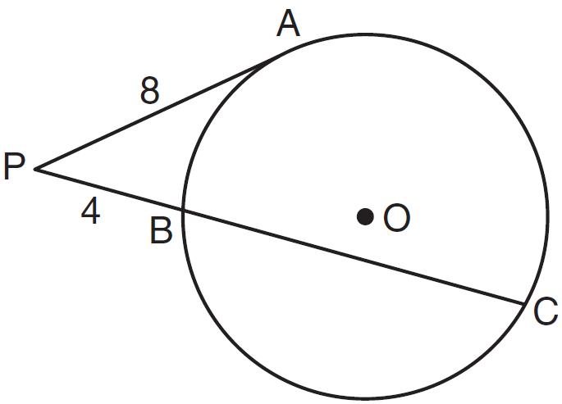

If and , what is the length of ?
1) | 20
2) | 16
3) | 15
4) | 12

18 Lines m and n intersect at point A. Line k is perpendicular to both lines m and n at point A. Which statement must be true?
1) | Lines m, n, and k are in the same plane.
2) | Lines m and n are in two different planes.
3) | Lines m and n are perpendicular to each other.
4) | Line k is perpendicular to the plane containing lines m and n.

19 In , , , and . Which statement is true?
1)
2)
3)
4)

20 As shown in the diagram below, , , , , and .

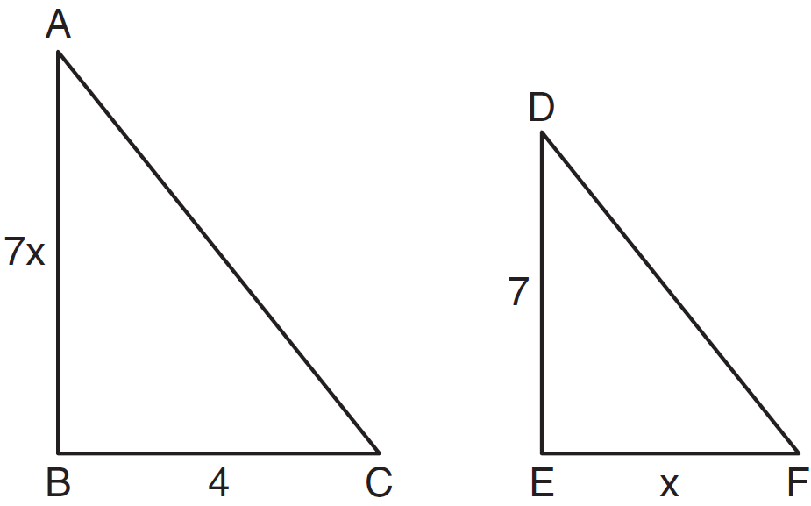

What is the length of ?
1) | 28
2) | 2
3) | 14
4) | 4

21 A man wants to place a new bird bath in his yard so that it is 30 feet from a fence, f, and also 10 feet from a light pole, P. As shown in the diagram below, the light pole is 35 feet away from the fence.

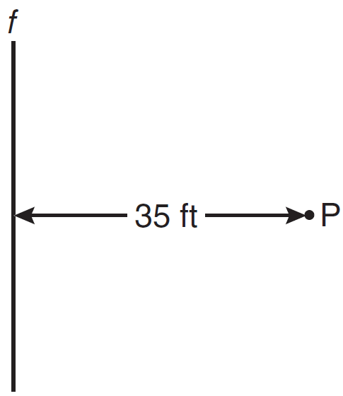

How many locations are possible for the bird bath?
1) | 1
2) | 2
3) | 3
4) | 0

22 As shown on the graph below, is the image of under a single transformation.

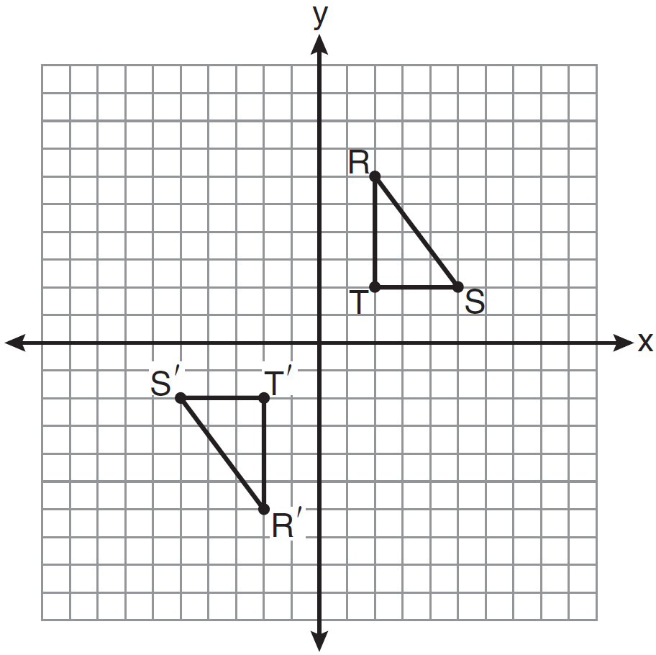

Which transformation does this graph represent?
1) | glide reflection
2) | line reflection
3) | rotation
4) | translation

23 Which line is parallel to the line whose equation is and also passes through the point ?
1)
2)
3)
4)

24 If the vertex angles of two isosceles triangles are congruent, then the triangles must be
1) | acute
2) | congruent
3) | right
4) | similar

25 Which quadrilateral has diagonals that always bisect its angles and also bisect each other?
1) | rhombus
2) | rectangle
3) | parallelogram
4) | isosceles trapezoid

26 When is dilated by a scale factor of 2, its image is . Which statement is true?
1)
2)
3) | perimeter of = perimeter of
4) | 2(area of ) = area of

27 What is the slope of a line that is perpendicular to the line whose equation is ?
1)
2)
3)
4)

28 In the diagram below of right triangle ABC, altitude is drawn to hypotenuse , , and .

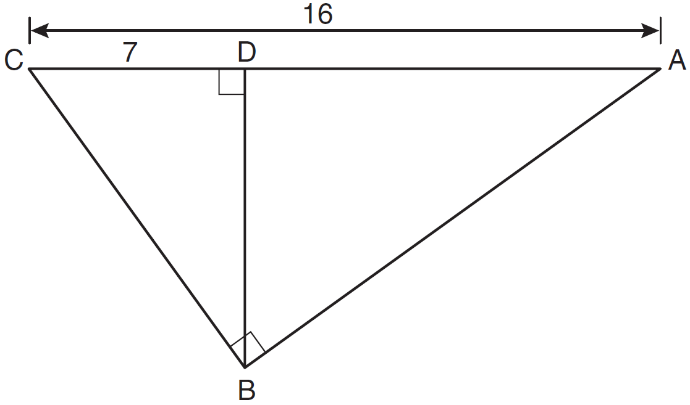

What is the length of ?
1)
2)
3)
4) | 12

29 Given the true statement, "The medians of a triangle are concurrent," write the negation of the statement and give the truth value for the negation.

30 Using a compass and straightedge, on the diagram below of , construct an equilateral triangle with as one side. [Leave all construction marks.]

31 The Parkside Packing Company needs a rectangular shipping box. The box must have a length of 11 inches and a width of 8 inches. Find, to the nearest tenth of an inch, the minimum height of the box such that the volume is at least 800 cubic inches.

32 A pentagon is drawn on the set of axes below. If the pentagon is reflected over the y-axis, determine if this transformation is an isometry. Justify your answer. [The use of the set of axes is optional.]

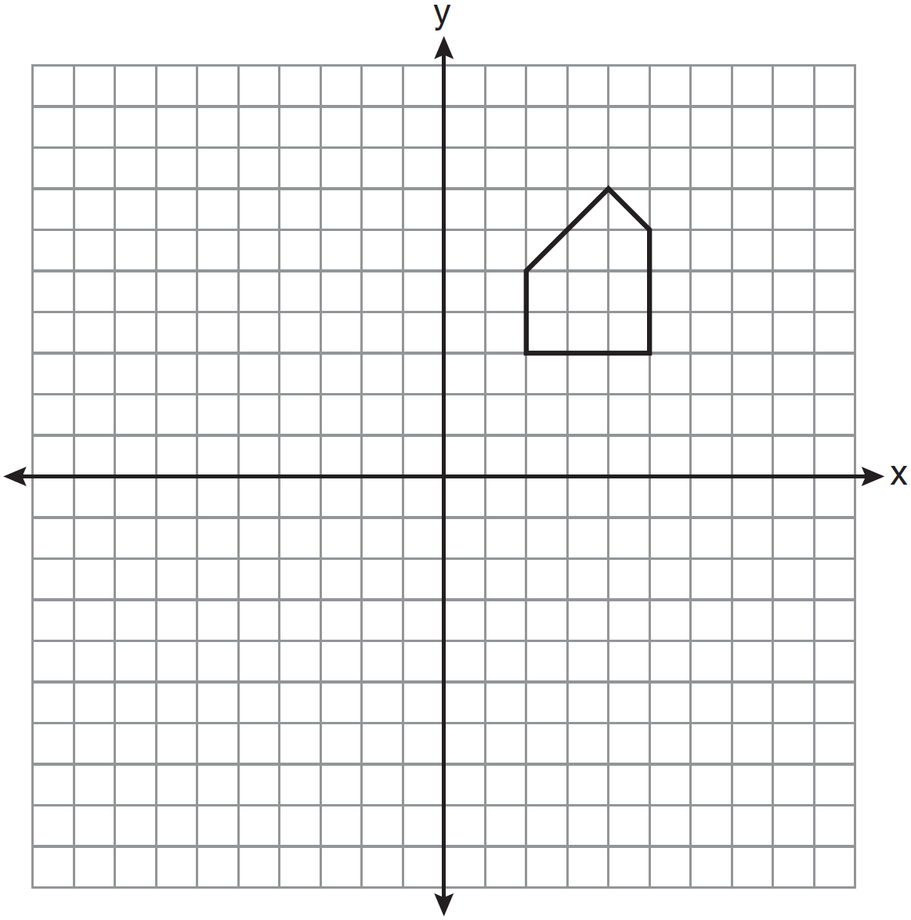

33 In the diagram below of , D is a point on , E is a point on , , inches, inches, and inches. Find, to the nearest tenth of an inch, the length of .

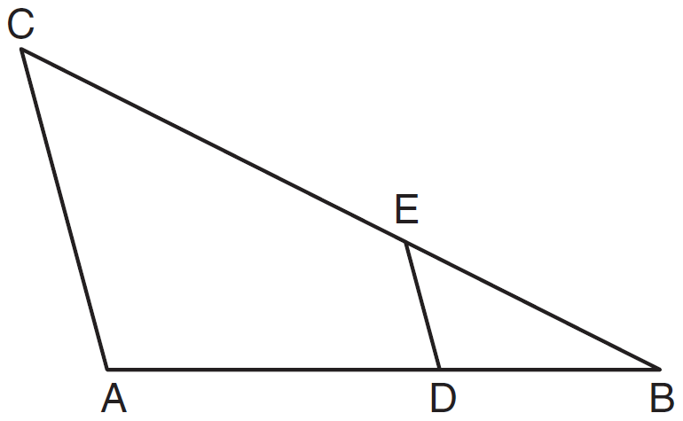

34 In circle O, diameter has endpoints and . Find the coordinates of point O, in terms of a and b. Express your answer in simplest form.

35 On the set of coordinate axes below, graph the locus of points that are equidistant from the lines and and also graph the locus of points that are 3 units from the y-axis. State the coordinates of all points that satisfy both conditions.

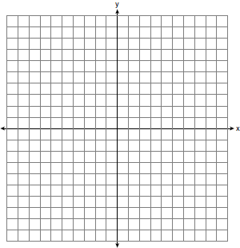

36 In the diagram below, tangent and secant are drawn to circle O. The ratio is . Find .

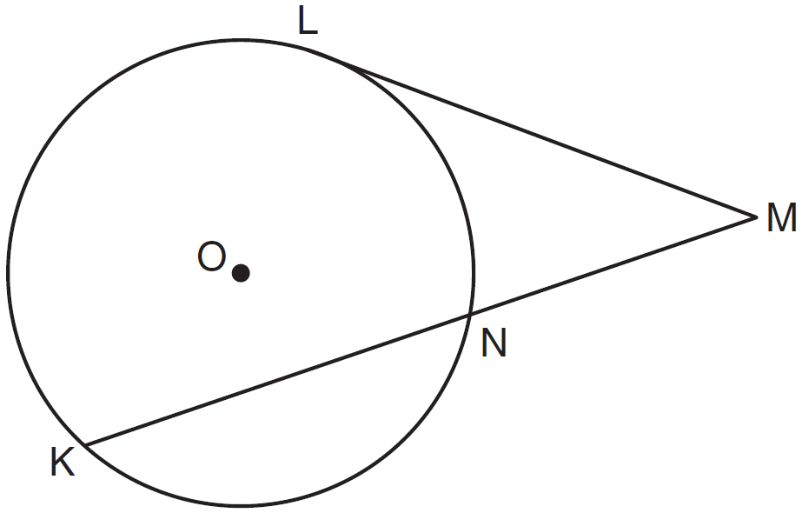

37 Solve the following system of equations graphically.
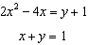

38 In the diagram below, and are tangent to circle O, and are radii, and intersects the circle at C. Prove:

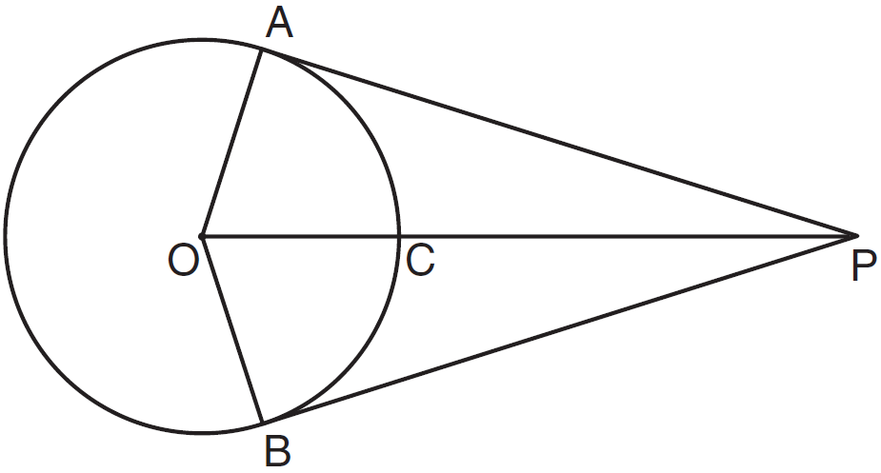
1 ANS: 2 PTS: 2 REF: 061101ge STA: G.G.18
TOP: Constructions

2 ANS: 3 PTS: 2 REF: 061102ge STA: G.G.29
TOP: Triangle Congruency

3 ANS: 4 PTS: 2 REF: 061103ge STA: G.G.60
TOP: Identifying Transformations

4 ANS: 1 PTS: 2 REF: 061104ge STA: G.G.43
TOP: Centroid

5 ANS: 1
Parallel lines intercept congruent arcs.

PTS: 2 REF: 061105ge STA: G.G.52 TOP: Chords

6 ANS: 2
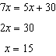

PTS: 2 REF: 061106ge STA: G.G.35 TOP: Parallel Lines and Transversals

7 ANS: 2 PTS: 2 REF: 061107ge STA: G.G.32
TOP: Exterior Angle Theorem

8 ANS: 1 PTS: 2 REF: 061108ge STA: G.G.9
TOP: Planes

9 ANS: 2

PTS: 2 REF: 061109ge STA: G.G.67 TOP: Distance
KEY: general

10 ANS: 1 PTS: 2 REF: 061110ge STA: G.G.72
TOP: Equations of Circles

11 ANS: 3 PTS: 2 REF: 061111ge STA: G.G.38
TOP: Parallelograms

12 ANS: 2
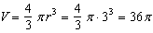

PTS: 2 REF: 061112ge STA: G.G.16 TOP: Volume and Surface Area

13 ANS: 1 PTS: 2 REF: 061113ge STA: G.G.63
TOP: Parallel and Perpendicular Lines

14 ANS: 4 PTS: 2 REF: 061114ge STA: G.G.73
TOP: Equations of Circles

15 ANS: 2 PTS: 2 REF: 061115ge STA: G.G.69
TOP: Triangles in the Coordinate Plane

16 ANS: 3

PTS: 2 REF: 061116ge STA: G.G.39 TOP: Special Parallelograms

17 ANS: 4
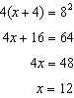

PTS: 2 REF: 061117ge STA: G.G.53 TOP: Segments Intercepted by Circle
KEY: tangent and secant

18 ANS: 4 PTS: 2 REF: 061118ge STA: G.G.1
TOP: Planes

19 ANS: 1
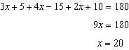. . .

PTS: 2 REF: 061119ge STA: G.G.30 TOP: Interior and Exterior Angles of Triangles

20 ANS: 3
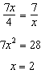.

PTS: 2 REF: 061120ge STA: G.G.45 TOP: Similarity
KEY: basic

21 ANS: 2 PTS: 2 REF: 061121ge STA: G.G.22
TOP: Locus

22 ANS: 3 PTS: 2 REF: 061122ge STA: G.G.56
TOP: Identifying Transformations

23 ANS: 2
The slope of a line in standard form is , so the slope of this line is . A parallel line would also have a slope of . Since the answers are in standard form, use the point-slope formula. 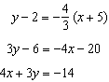

PTS: 2 REF: 061123ge STA: G.G.65 TOP: Parallel and Perpendicular Lines

24 ANS: 4 PTS: 2 REF: 061124ge STA: G.G.31
TOP: Isosceles Triangle Theorem

25 ANS: 1 PTS: 2 REF: 061125ge STA: G.G.39
TOP: Special Parallelograms

26 ANS: 2 PTS: 2 REF: 061126ge STA: G.G.59
TOP: Properties of Transformations

27 ANS: 4
The slope of is 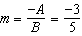. 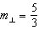.
PTS: 2 REF: 061127ge STA: G.G.62 TOP: Parallel and Perpendicular Lines

28 ANS: 1
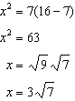

PTS: 2 REF: 061128ge STA: G.G.47 TOP: Similarity
KEY: altitude

29 ANS:
The medians of a triangle are not concurrent. False.
PTS: 2 REF: 061129ge STA: G.G.24 TOP: Negations

30 ANS:
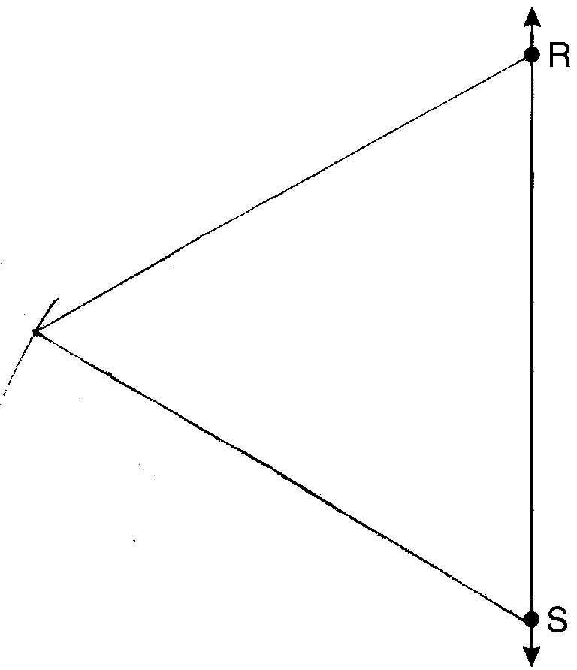

PTS: 2 REF: 061130ge STA: G.G.20 TOP: Constructions

31 ANS:
9.1. 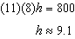
PTS: 2 REF: 061131ge STA: G.G.12 TOP: Volume

32 ANS:
Yes. A reflection is an isometry.
PTS: 2 REF: 061132ge STA: G.G.55 TOP: Properties of Transformations

33 ANS:
16.7. 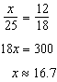
PTS: 2 REF: 061133ge STA: G.G.46 TOP: Side Splitter Theorem

34 ANS:
. 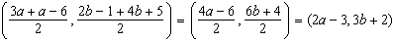
PTS: 2 REF: 061134ge STA: G.G.66 TOP: Midpoint

35 ANS:
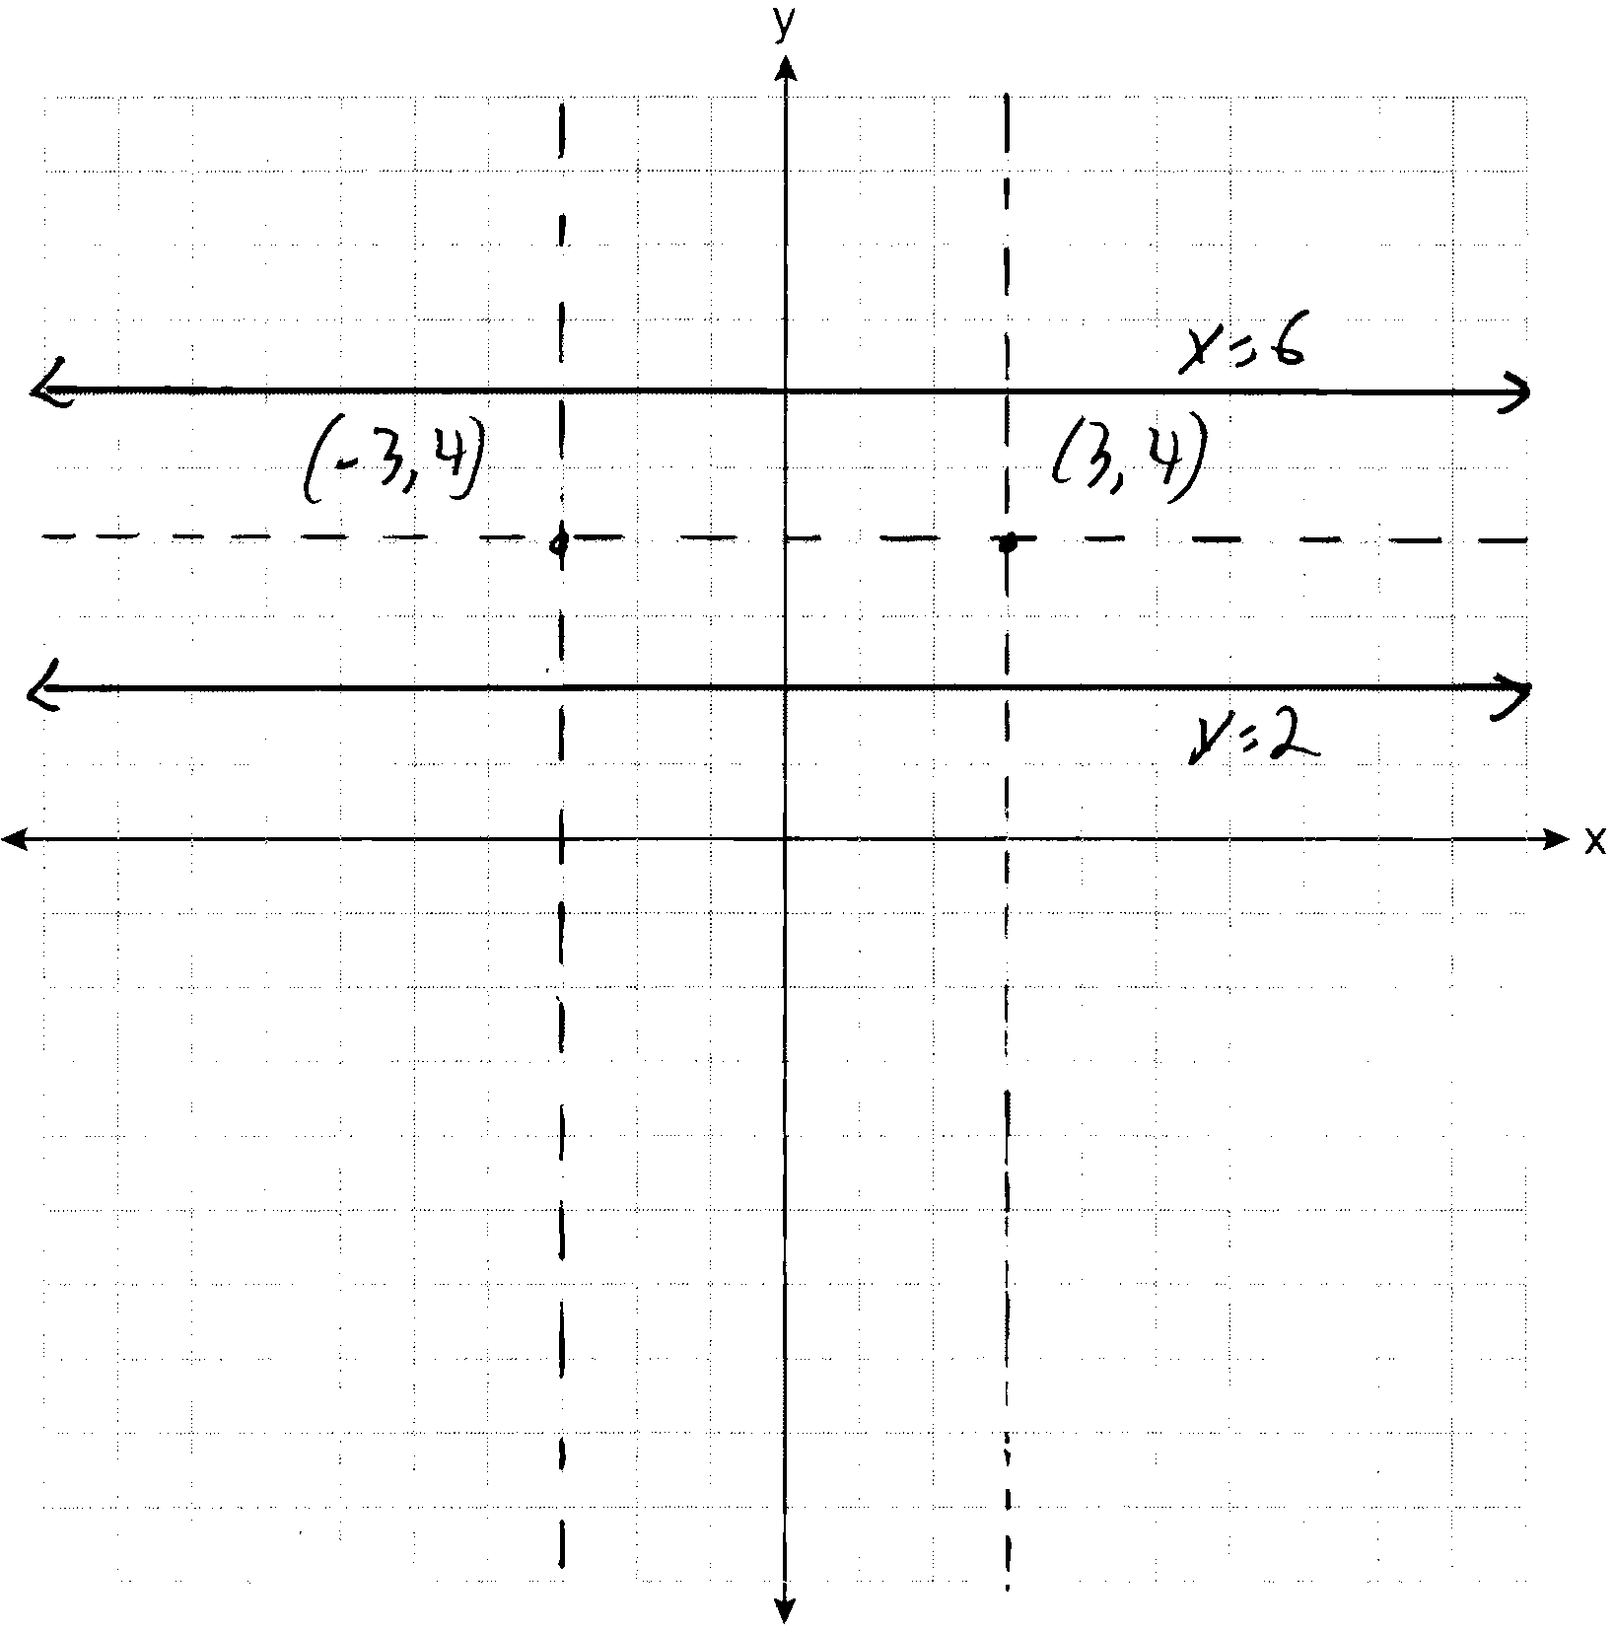
PTS: 4 REF: 061135ge STA: G.G.23 TOP: Locus

36 ANS:
30. 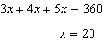. . 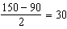
PTS: 4 REF: 061136ge STA: G.G.51 TOP: Arcs Determined by Angles
KEY: outside circle

37 ANS:
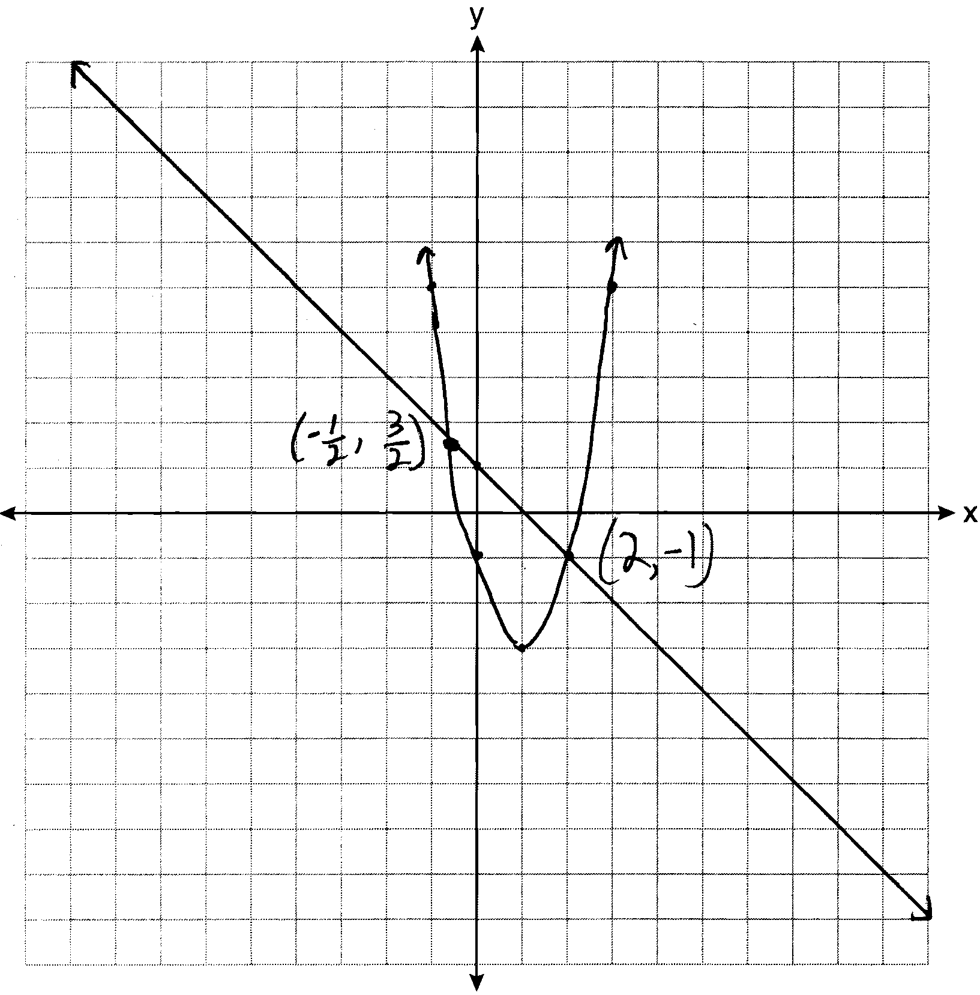
PTS: 4 REF: 061137ge STA: G.G.70 TOP: Quadratic-Linear Systems

38 ANS:
because all radii are equal. because of the reflexive property. and because tangents to a circle are perpendicular to a radius at a point on a circle. and are right angles because of the definition of perpendicular. because all right angles are congruent. because of HL. because of CPCTC.
PTS: 6 REF: 061138ge STA: G.G.27 TOP: Circle Proofs

