1 In the diagram below of circle O, , and .

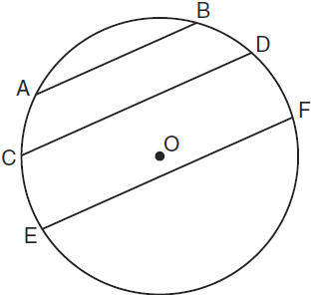

Which statement must be true?
1)
2)
3)
4)

2 What is the negation of the statement “I am not going to eat ice cream”?
1) | I like ice cream.
2) | I am going to eat ice cream.
3) | If I eat ice cream, then I like ice cream.
4) | If I don’t like ice cream, then I don’t eat ice cream.

3 The diagram below shows a right pentagonal prism.

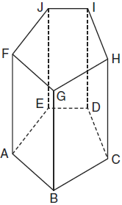

Which statement is always true?
1)
2)
3)
4)

4 In isosceles triangle ABC, . Which statement will always be true?
1)
2)
3)
4)

5 The rectangle ABCD shown in the diagram below will be reflected across the x-axis.

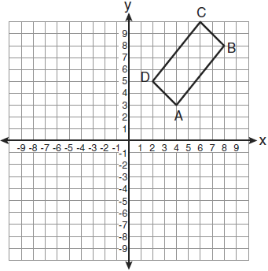

What will not be preserved?
1) | slope of
2) | parallelism of and
3) | length of
4) | measure of

6 A right circular cylinder has an altitude of 11 feet and a radius of 5 feet. What is the lateral area, in square feet, of the cylinder, to the nearest tenth?
1) | 172.7
2) | 172.8
3) | 345.4
4) | 345.6

7 A transversal intersects two lines. Which condition would always make the two lines parallel?
1) | Vertical angles are congruent.
2) | Alternate interior angles are congruent.
3) | Corresponding angles are supplementary.
4) | Same-side interior angles are complementary.

8 If the diagonals of a quadrilateral do not bisect each other, then the quadrilateral could be a
1) | rectangle
2) | rhombus
3) | square
4) | trapezoid

9 What is the converse of the statement "If Bob does his homework, then George gets candy"?
1) | If George gets candy, then Bob does his homework.
2) | Bob does his homework if and only if George gets candy.
3) | If George does not get candy, then Bob does not do his homework.
4) | If Bob does not do his homework, then George does not get candy.

10 In , , , and . Which statement about the angles of must be true?
1)
2)
3)
4)

11 Given: 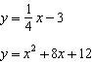
In which quadrant will the graphs of the given equations intersect?
1) | I
2) | II
3) | III
4) | IV

12 Which diagram shows the construction of an equilateral triangle?
1) | 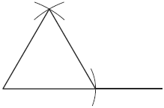
2) | 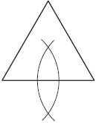
3) | 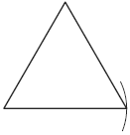
4) | 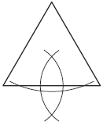

13 Line segment AB is tangent to circle O at A. Which type of triangle is always formed when points A, B, and O are connected?
1) | right
2) | obtuse
3) | scalene
4) | isosceles

14 What is an equation for the circle shown in the graph below?

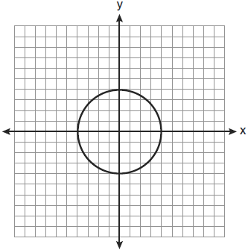
1)
2)
3)
4)

15 Which transformation can map the letter S onto itself?
1) | glide reflection
2) | translation
3) | line reflection
4) | rotation

16 In isosceles trapezoid ABCD, . If , , and , what is the length of the altitude of the trapezoid?
1) | 10
2) | 12
3) | 15
4) | 16

17 In plane P, lines m and n intersect at point A. If line k is perpendicular to line m and line n at point A, then line k is
1) | contained in plane P
2) | parallel to plane P
3) | perpendicular to plane P
4) | skew to plane P

18 The diagram below shows and .

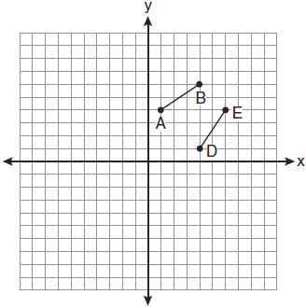

Which transformation will move onto such that point D is the image of point A and point E is the image of point B?
1)
2)
3)
4)

19 In the diagram below of circle O, chords and intersect at point B, such that and .

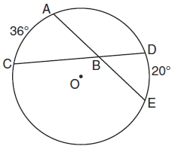

What is ?
1) | 56
2) | 36
3) | 28
4) | 8

20 The diagram below shows the construction of a line through point P perpendicular to line m.

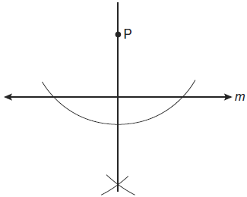

Which statement is demonstrated by this construction?
1) | If a line is parallel to a line that is perpendicular to a third line, then the line is also perpendicular to the third line.
2) | The set of points equidistant from the endpoints of a line segment is the perpendicular bisector of the segment.
3) | Two lines are perpendicular if they are equidistant from a given point.
4) | Two lines are perpendicular if they intersect to form a vertical line.

21 What is the length, to the nearest tenth, of the line segment joining the points and ?
1) | 141.4
2) | 150.5
3) | 151.9
4) | 158.1

22 What is the slope of a line perpendicular to the line whose equation is ?
1)
2)
3) | 3
4)

23 In the diagram below of circle O, secant intersects circle O at D, secant intersects circle O at E, , , and .

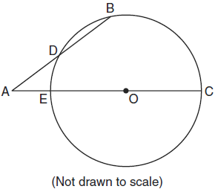

What is the length of ?
1) | 4.5
2) | 7
3) | 9
4) | 14

24 The diagram below shows a pennant in the shape of an isosceles triangle. The equal sides each measure 13, the altitude is , and the base is 2x.

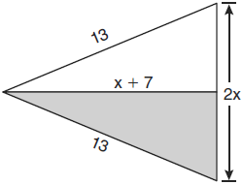

What is the length of the base?
1) | 5
2) | 10
3) | 12
4) | 24

25 In the diagram below of , is the bisector of , is the bisector of , and is drawn.

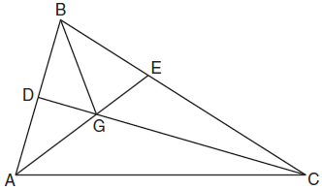

Which statement must be true?
1)
2)
3)
4)

26 In the diagram below of circle O, chords and intersect at E.

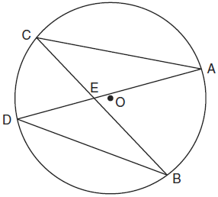

Which relationship must be true?
1)
2)
3)
4)

27 Two lines are represented by the equations 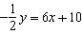 and . For which value of m will the lines be parallel?
1)
2)
3) | 3
4) | 12

28 The coordinates of the vertices of parallelogram ABCD are , , , and . The slopes of which line segments could be calculated to show that ABCD is a rectangle?
1) | and
2) | and
3) | and
4) | and

29 Tim is going to paint a wooden sphere that has a diameter of 12 inches. Find the surface area of the sphere, to the nearest square inch.

30 In the diagram below of , is a midsegment of , , , and . Find the perimeter of .

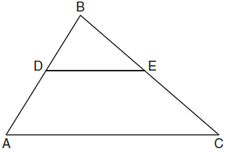

31 In right , and is 12 degrees less than twice . Find .

32 Triangle XYZ, shown in the diagram below, is reflected over the line . State the coordinates of , the image of .

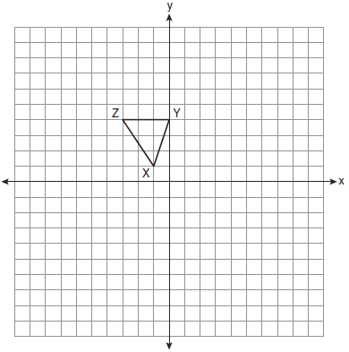

33 Two lines, and , are parallel and 10 inches apart. Sketch the locus of all points that are equidistant from and and 7 inches from point R. Label with an X each point that satisfies both conditions.

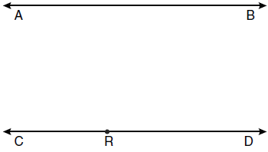

34 The base of a pyramid is a rectangle with a width of 6 cm and a length of 8 cm. Find, in centimeters, the height of the pyramid if the volume is .

35 Given: Quadrilateral ABCD with , , and diagonal is drawn
Prove:

36 Find an equation of the line passing through the point and perpendicular to the line whose equation is .

37 Write an equation of the circle whose diameter has endpoints and . [The use of the grid below is optional.]

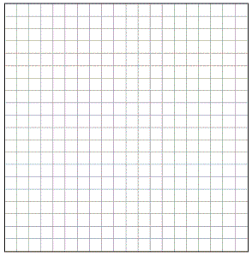

38 In the diagram below, quadrilateral STAR is a rhombus with diagonals and intersecting at E. , , , , , , and . Find SR, RT, and .

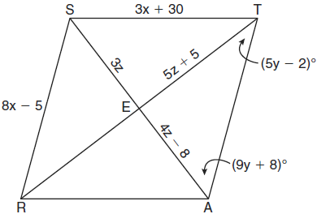
1 ANS: 1
Parallel lines intercept congruent arcs.

PTS: 2 REF: 061001ge STA: G.G.52 TOP: Chords

2 ANS: 2 PTS: 2 REF: 061002ge STA: G.G.24
TOP: Negations

3 ANS: 4 PTS: 2 REF: 061003ge STA: G.G.10
TOP: Solids

4 ANS: 3 PTS: 2 REF: 061004ge STA: G.G.31
TOP: Isosceles Triangle Theorem

5 ANS: 1 PTS: 2 REF: 061005ge STA: G.G.55
TOP: Properties of Transformations

6 ANS: 4

PTS: 2 REF: 061006ge STA: G.G.14 TOP: Volume and Lateral Area

7 ANS: 2 PTS: 2 REF: 061007ge STA: G.G.35
TOP: Parallel Lines and Transversals

8 ANS: 4 PTS: 2 REF: 061008ge STA: G.G.40
TOP: Trapezoids

9 ANS: 1 PTS: 2 REF: 061009ge STA: G.G.26
TOP: Converse

10 ANS: 1 PTS: 2 REF: 061010ge STA: G.G.34
TOP: Angle Side Relationship

11 ANS: 3
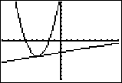

PTS: 2 REF: 061011ge STA: G.G.70 TOP: Quadratic-Linear Systems

12 ANS: 1 PTS: 2 REF: 061012ge STA: G.G.20
TOP: Constructions

13 ANS: 1 PTS: 2 REF: 061013ge STA: G.G.50
TOP: Tangents KEY: point of tangency

14 ANS: 4
The radius is 4. .

PTS: 2 REF: 061014ge STA: G.G.72 TOP: Equations of Circles

15 ANS: 4 PTS: 2 REF: 061015ge STA: G.G.56
TOP: Identifying Transformations

16 ANS: 3
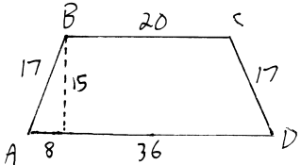 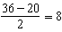.

PTS: 2 REF: 061016ge STA: G.G.40 TOP: Trapezoids

17 ANS: 3 PTS: 2 REF: 061017ge STA: G.G.1
TOP: Planes

18 ANS: 4 PTS: 2 REF: 061018ge STA: G.G.56
TOP: Identifying Transformations

19 ANS: 3
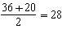

PTS: 2 REF: 061019ge STA: G.G.51 TOP: Arcs Determined by Angles
KEY: inside circle

20 ANS: 2 PTS: 2 REF: 061020ge STA: G.G.19
TOP: Constructions

21 ANS: 4

PTS: 2 REF: 061021ge STA: G.G.67 TOP: Distance

22 ANS: 2 PTS: 2 REF: 061022ge STA: G.G.62
TOP: Parallel and Perpendicular Lines

23 ANS: 2
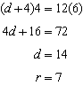

PTS: 2 REF: 061023ge STA: G.G.53 TOP: Segments Intercepted by Circle
KEY: two secants

24 ANS: 2
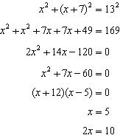

PTS: 2 REF: 061024ge STA: G.G.48 TOP: Pythagorean Theorem

25 ANS: 4
is also an angle bisector since it intersects the concurrence of and

PTS: 2 REF: 061025ge STA: G.G.21
KEY: Centroid, Orthocenter, Incenter and Circumcenter

26 ANS: 2
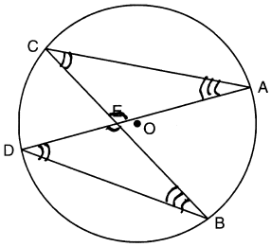

PTS: 2 REF: 061026ge STA: G.G.51 TOP: Arcs Determined by Angles
KEY: inscribed

27 ANS: 1
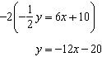

PTS: 2 REF: 061027ge STA: G.G.63 TOP: Parallel and Perpendicular Lines

28 ANS: 2
Adjacent sides of a rectangle are perpendicular and have opposite and reciprocal slopes.

PTS: 2 REF: 061028ge STA: G.G.69 TOP: Quadrilaterals in the Coordinate Plane

29 ANS:
452.

PTS: 2 REF: 061029ge STA: G.G.16 TOP: Volume and Surface Area

30 ANS:
37. Since is a midsegment, .

PTS: 2 REF: 061030ge STA: G.G.42 TOP: Midsegments

31 ANS:
34. 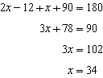

PTS: 2 REF: 061031ge STA: G.G.30 TOP: Interior and Exterior Angles of Triangles

32 ANS:
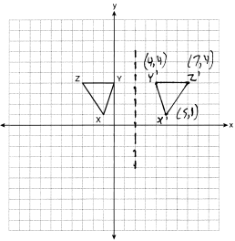

PTS: 2 REF: 061032ge STA: G.G.54 TOP: Reflections
KEY: grids

33 ANS:
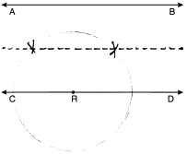

PTS: 2 REF: 061033ge STA: G.G.22 TOP: Locus

34 ANS:
18. 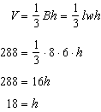

PTS: 2 REF: 061034ge STA: G.G.13 TOP: Volume

35 ANS:
(Reflexive Property); (SSS); (CPCTC). 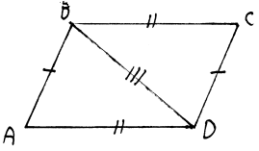

PTS: 4 REF: 061035ge STA: G.G.27 TOP: Quadrilateral Proofs

36 ANS:
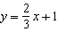. 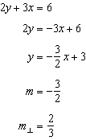. 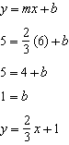

PTS: 4 REF: 061036ge STA: G.G.64 TOP: Parallel and Perpendicular Lines

37 ANS:
Midpoint: 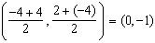. Distance: 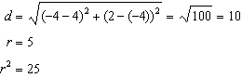
PTS: 4 REF: 061037ge STA: G.G.71 TOP: Equations of Circles

38 ANS:
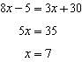. 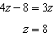. 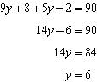. 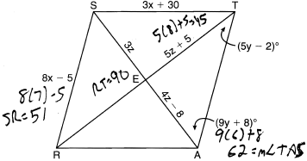
PTS: 6 REF: 061038ge STA: G.G.39 TOP: Special Parallelograms

