1 Juliann plans on drawing , where the measure of can range from 50° to 60° and the measure of can range from 90° to 100°. Given these conditions, what is the correct range of measures possible for ?
1) | 20° to 40°
2) | 30° to 50°
3) | 80° to 90°
4) | 120° to 130°

2 In the diagram of and below, , , and .

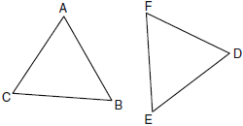

Which method can be used to prove ?
1) | SSS
2) | SAS
3) | ASA
4) | HL

3 In the diagram below, under which transformation will be the image of ?

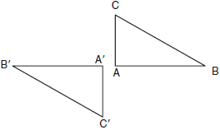

1) | rotation
2) | dilation
3) | translation
4) | glide reflection

4 The lateral faces of a regular pyramid are composed of
1) | squares
2) | rectangles
3) | congruent right triangles
4) | congruent isosceles triangles

5 Point A is located at . The point is reflected in the x-axis. Its image is located at
1)
2)
3)
4)

6 In the diagram of circle O below, chords and are parallel, and is a diameter of the circle.

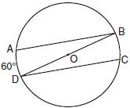

If , what is ?
1) | 20
2) | 30
3) | 60
4) | 120

7 What is an equation of the line that passes through the point and is perpendicular to the line whose equation is 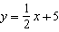?
1)
2)
3)
4)

8 After a composition of transformations, the coordinates , , and become , , and , as shown on the set of axes below.

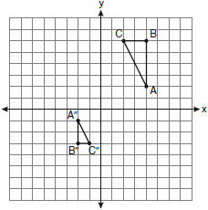

Which composition of transformations was used?
1)
2)
3)
4)

9 In an equilateral triangle, what is the difference between the sum of the exterior angles and the sum of the interior angles?
1) | 180°
2) | 120°
3) | 90°
4) | 60°

10 What is an equation of a circle with its center at and a radius of 4?
1)
2)
3)
4)

11 In , , , and . Which expression correctly relates the lengths of the sides of this triangle?
1)
2)
3)
4)

12 In a coordinate plane, how many points are both 5 units from the origin and 2 units from the x-axis?
1) | 1
2) | 2
3) | 3
4) | 4

13 What is the contrapositive of the statement, “If I am tall, then I will bump my head”?
1) | If I bump my head, then I am tall.
2) | If I do not bump my head, then I am tall.
3) | If I am tall, then I will not bump my head.
4) | If I do not bump my head, then I am not tall.

14 In the diagram of below, Jose found centroid P by constructing the three medians. He measured and found it to be 6 inches.

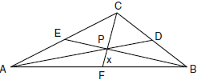

If , which equation can be used to find x?
1)
2)
3)
4) | 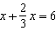

15 In the diagram below, the length of the legs and of right triangle ABC are 6 cm and 8 cm, respectively. Altitude is drawn to the hypotenuse of .

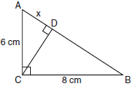

What is the length of to the nearest tenth of a centimeter?
1) | 3.6
2) | 6.0
3) | 6.4
4) | 4.0

16 In the diagram below, tangent and secant are drawn to circle O from an external point A, , and .

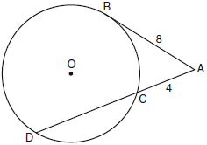

What is the length of ?
1) | 16
2) | 13
3) | 12
4) | 10

17 In the diagram of and below, and intersect at C, and .

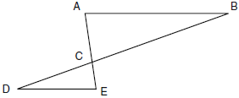

Which method can be used to show that must be similar to ?
1) | SAS
2) | AA
3) | SSS
4) | HL

18 Point P is on line m. What is the total number of planes that are perpendicular to line m and pass through point P?
1) | 1
2) | 2
3) | 0
4) | infinite

19 Square LMNO is shown in the diagram below.

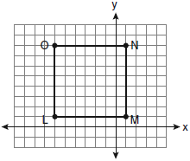

What are the coordinates of the midpoint of diagonal ?
1) | 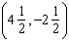
2) | 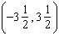
3) | 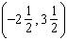
4) | 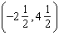

20 Which graph represents a circle with the equation ?

1) | 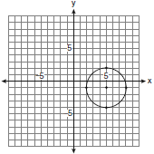
2) | 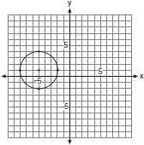
3) | 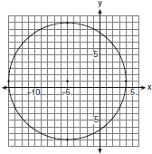
4) | 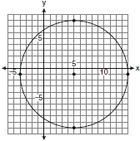

21 In the diagram below, a right circular cone has a diameter of 8 inches and a height of 12 inches.

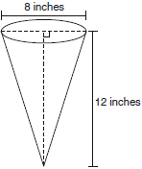

What is the volume of the cone to the nearest cubic inch?
1) | 201
2) | 481
3) | 603
4) | 804

22 A circle is represented by the equation . What are the coordinates of the center of the circle and the length of the radius?
1)
2)
3)
4)

23 Given the system of equations: 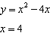
The number of points of intersection is
1) | 1
2) | 2
3) | 3
4) | 0

24 Side of is extended through Q to point T. Which statement is not always true?
1)
2)
3)
4)

25 Which illustration shows the correct construction of an angle bisector?
1) | 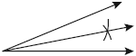
2) | 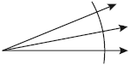
3) | 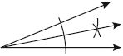
4) | 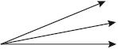

26 Which equation represents a line perpendicular to the line whose equation is ?
1)
2)
3)
4)

27 In , point D is on , and point E is on such that . If , , and , what is the length of ?
1) | 8
2) | 9
3) | 10.5
4) | 13.5

28 In three-dimensional space, two planes are parallel and a third plane intersects both of the parallel planes. The intersection of the planes is a
1) | plane
2) | point
3) | pair of parallel lines
4) | pair of intersecting lines

29 In the diagram of below, , , and . Find the perimeter of the triangle formed by connecting the midpoints of the sides of .

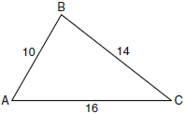

30 Using a compass and straightedge, construct a line that passes through point P and is perpendicular to line m. [Leave all construction marks.]

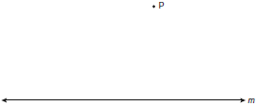

- Find an equation of the line passing through the point and parallel to the line whose equation is .

32 The length of is 3 inches. On the diagram below, sketch the points that are equidistant from A and B and sketch the points that are 2 inches from A. Label with an X all points that satisfy both conditions.

33 Given: Two is an even integer or three is an even integer.
Determine the truth value of this disjunction. Justify your answer.

34 In the diagram below, , , and . Determine the value of x.

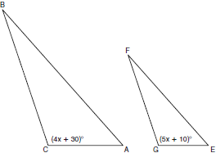

35 In the diagram below, circles X and Y have two tangents drawn to them from external point T. The points of tangency are C, A, S, and E. The ratio of TA to AC is . If , find the length of .

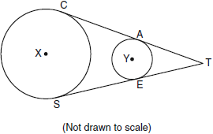

36 Triangle ABC has coordinates , , and . Find the perimeter of the triangle. Express your answer in simplest radical form. [The use of the grid below is optional.]



37 The coordinates of the vertices of parallelogram ABCD are , , , and . State the coordinates of the vertices of parallelogram that result from the transformation . [The use of the set of axes below is optional. ]

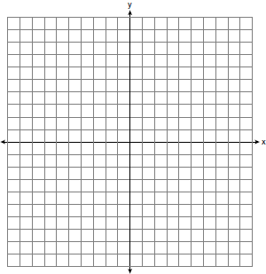

38 Given: and , C is the midpoint of and
Prove:

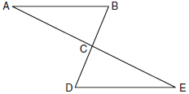
1 ANS: 1
If is at minimum (50°) and is at minimum (90°), is at maximum of 40° (180° - (50° + 90°)). If is at maximum (60°) and is at maximum (100°), is at minimum of 20° (180° - (60° + 100°)).

PTS: 2 REF: 060901ge STA: G.G.30 TOP: Interior and Exterior Angles of Triangles

2 ANS: 3
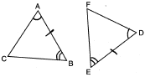

PTS: 2 REF: 060902ge STA: G.G.28 TOP: Triangle Congruency

3 ANS: 1 PTS: 2 REF: 060903ge STA: G.G.56
TOP: Identifying Transformations

4 ANS: 4 PTS: 2 REF: 060904ge STA: G.G.13
TOP: Solids

5 ANS: 3 PTS: 2 REF: 060905ge STA: G.G.54
TOP: Reflections KEY: basic

6 ANS: 2
Parallel chords intercept congruent arcs. . 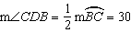.

PTS: 2 REF: 060906ge STA: G.G.52 TOP: Chords

7 ANS: 2
The slope of is . The slope of a perpendicular line is . 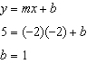.

PTS: 2 REF: 060907ge STA: G.G.64 TOP: Parallel and Perpendicular Lines

8 ANS: 3 PTS: 2 REF: 060908ge STA: G.G.60
TOP: Identifying Transformations

9 ANS: 1
In an equilateral triangle, each interior angle is 60° and each exterior angle is 120° (180° - 120°). The sum of the three interior angles is 180° and the sum of the three exterior angles is 360°.

PTS: 2 REF: 060909ge STA: G.G.30 TOP: Interior and Exterior Angles of Triangles

10 ANS: 2 PTS: 2 REF: 060910ge STA: G.G.71
TOP: Equations of Circles

11 ANS: 2
Longest side of a triangle is opposite the largest angle. Shortest side is opposite the smallest angle.

PTS: 2 REF: 060911ge STA: G.G.34 TOP: Angle Side Relationship

12 ANS: 4 PTS: 2 REF: 060912ge STA: G.G.23
TOP: Locus

13 ANS: 4 PTS: 2 REF: 060913ge STA: G.G.26
TOP: Conditional Statements

14 ANS: 2
The centroid divides each median into segments whose lengths are in the ratio 2 : 1.

PTS: 2 REF: 060914ge STA: G.G.43 TOP: Centroid

15 ANS: 1
since is a 6-8-10 triangle. 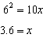

PTS: 2 REF: 060915ge STA: G.G.47 TOP: Similarity
KEY: leg

16 ANS: 3
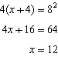

PTS: 2 REF: 060916ge STA: G.G.53 TOP: Segments Intercepted by Circle
KEY: tangent and secant

17 ANS: 2
and are congruent vertical angles and . 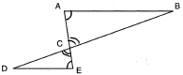

PTS: 2 REF: 060917ge STA: G.G.44 TOP: Similarity Proofs

18 ANS: 1 PTS: 2 REF: 060918ge STA: G.G.2
TOP: Planes

19 ANS: 4
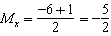. 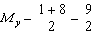.

PTS: 2 REF: 060919ge STA: G.G.66 TOP: Midpoint

20 ANS: 1 PTS: 2 REF: 060920ge STA: G.G.74
TOP: Graphing Circles

21 ANS: 1
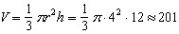

PTS: 2 REF: 060921ge STA: G.G.15 TOP: Volume and Lateral Area

22 ANS: 4 PTS: 2 REF: 060922ge STA: G.G.73
TOP: Equations of Circles

23 ANS: 1
. is the only intersection. 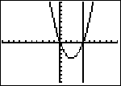

PTS: 2 REF: 060923ge STA: G.G.70 TOP: Quadratic-Linear Systems

24 ANS: 4
(4) is not true if is obtuse.

PTS: 2 REF: 060924ge STA: G.G.32 TOP: Exterior Angle Theorem

25 ANS: 3 PTS: 2 REF: 060925ge STA: G.G.17
TOP: Constructions

26 ANS: 2
The slope of is 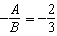. The slope of a perpendicular line is . Rewritten in slope intercept form, (2) becomes 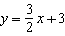.

PTS: 2 REF: 060926ge STA: G.G.63 TOP: Parallel and Perpendicular Lines

27 ANS: 4
. 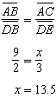

PTS: 2 REF: 060927ge STA: G.G.46 TOP: Side Splitter Theorem

28 ANS: 3 PTS: 2 REF: 060928ge STA: G.G.8
TOP: Planes

29 ANS:
20. The sides of the triangle formed by connecting the midpoints are half the sides of the original triangle. . 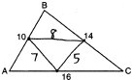

PTS: 2 REF: 060929ge STA: G.G.42 TOP: Midsegments

30 ANS:
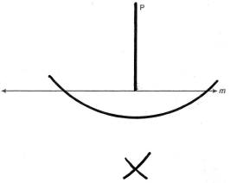

PTS: 2 REF: 060930ge STA: G.G.19 TOP: Constructions

31 ANS:
. The slope of is 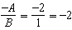. 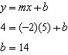.

PTS: 2 REF: 060931ge STA: G.G.65 TOP: Parallel and Perpendicular Lines

32 ANS:
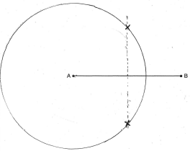

PTS: 2 REF: 060932ge STA: G.G.22 TOP: Locus

33 ANS:
True. The first statement is true and the second statement is false. In a disjunction, if either statement is true, the disjunction is true.

PTS: 2 REF: 060933ge STA: G.G.25 TOP: Compound Statements
KEY: disjunction

34 ANS:
20. 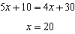

PTS: 2 REF: 060934ge STA: G.G.45 TOP: Similarity
KEY: basic

35 ANS:
18. If the ratio of TA to AC is 1:3, the ratio of TE to ES is also 1:3. 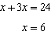. .

PTS: 4 REF: 060935ge STA: G.G.50 TOP: Tangents
KEY: common tangency

36 ANS:
. 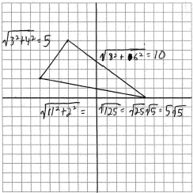

PTS: 4 REF: 060936ge STA: G.G.69 TOP: Triangles in the Coordinate Plane

37 ANS:
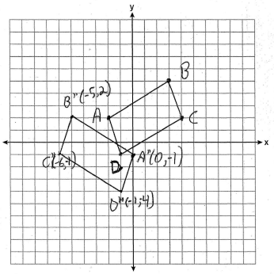

PTS: 4 REF: 060937ge STA: G.G.54 TOP: Compositions of Transformations
KEY: grids

38 ANS:
and because of the definition of midpoint. because of vertical angles. because of SAS. because of CPCTC. is a transversal intersecting and . Therefore because and are congruent alternate interior angles. 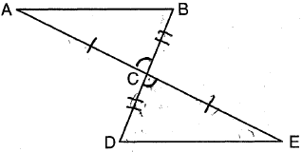

PTS: 6 REF: 060938ge STA: G.G.27 TOP: Triangle Proofs

