1 What is the solution of the system of equations graphed below?
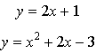

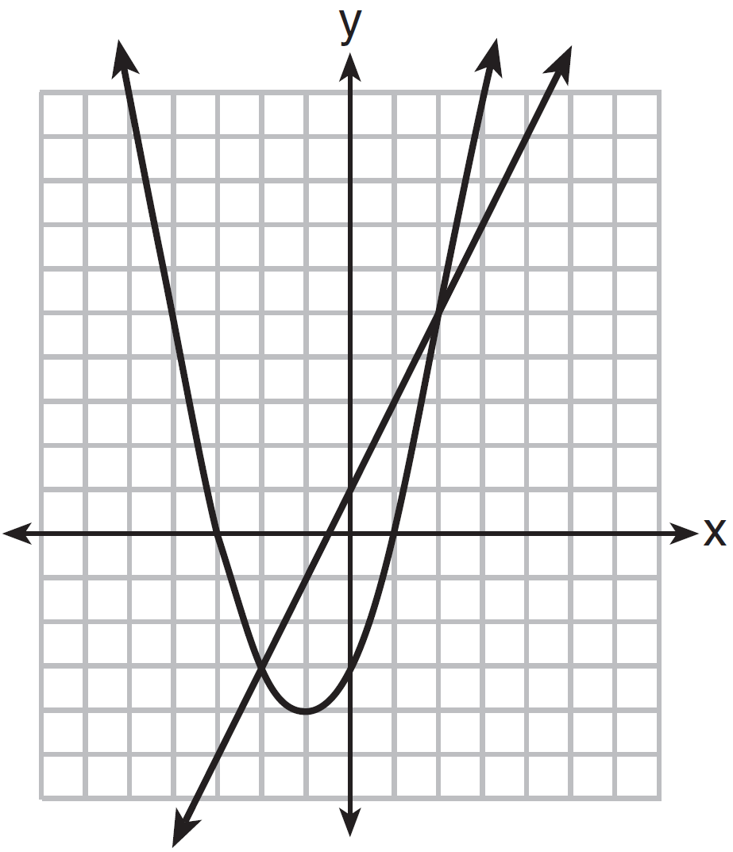
1)
2)
3) | and
4) | and

2 What are the coordinates of the midpoint of the line segment with endpoints and ?
1)
2)
3)
4)

3 As shown in the diagram below, when hexagon ABCDEF is reflected over line m, the image is hexagon A'B'C'D'E'F'.

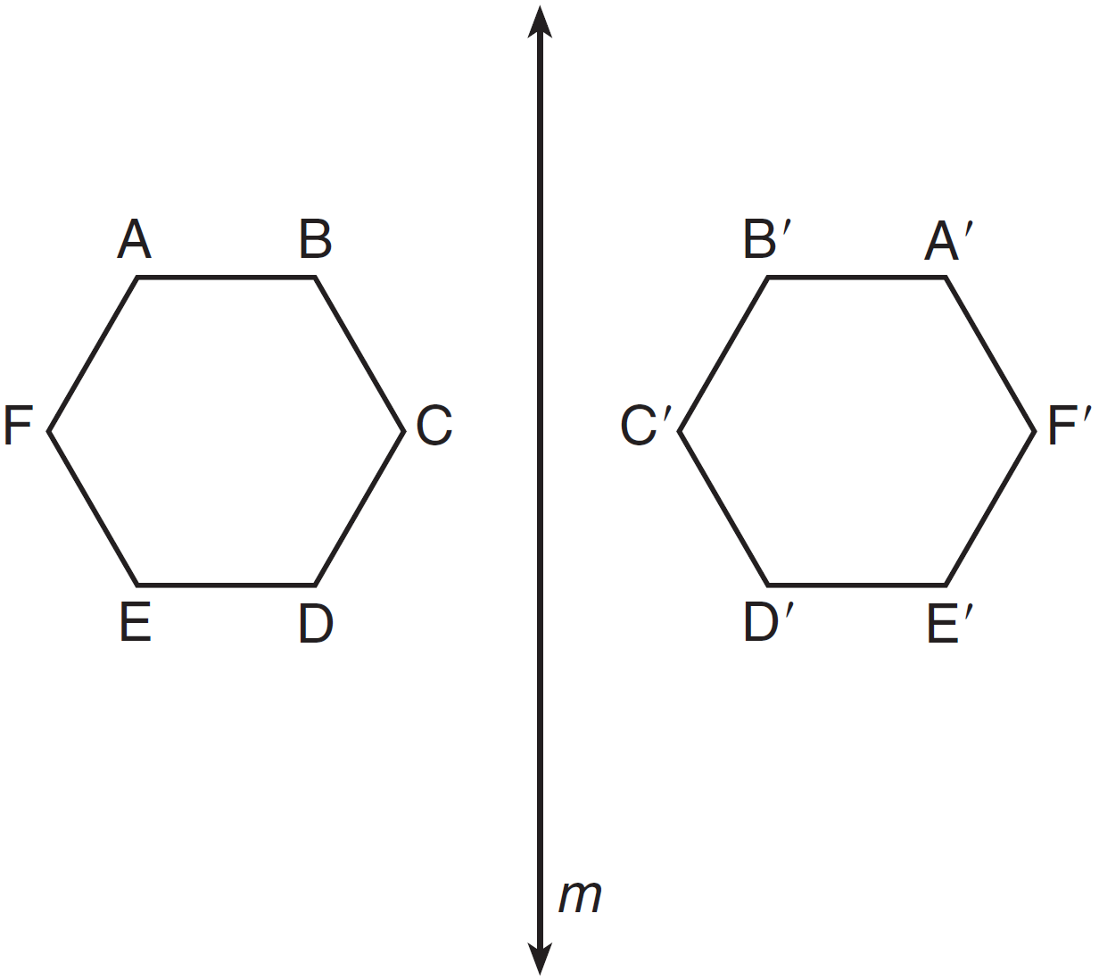

Under this transformation, which property is not preserved?
1) | area
2) | distance
3) | orientation
4) | angle measure

4 In the diagram of below, is drawn to side .

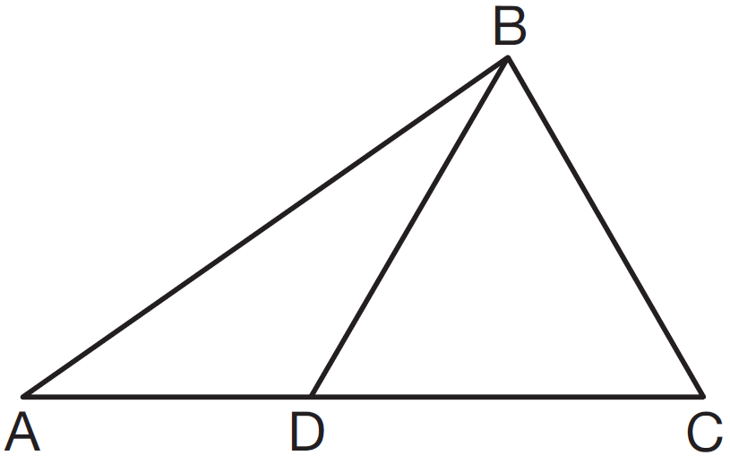

If , , and , which type of triangle is ?
1) | equilateral
2) | scalene
3) | obtuse
4) | right

5 In the diagram below of rhombus ABCD, the diagonals and intersect at E.

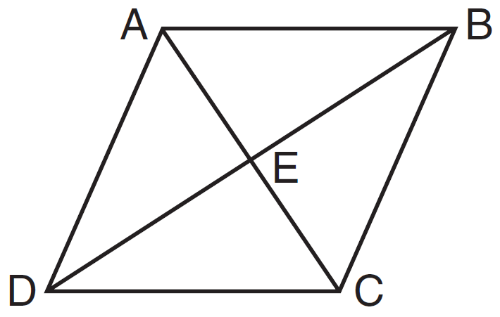

If and , what is the length of one side of rhombus ABCD?
1) | 15
2) | 18
3) | 24
4) | 30

6 What are the truth values of the statement "Opposite angles of a trapezoid are always congruent" and its negation?
1) | The statement is true and its negation is true.
2) | The statement is true and its negation is false.
3) | The statement is false and its negation is true.
4) | The statement is false and its negation is false.

7 What is the length of a line segment whose endpoints have coordinates and ?
1) | 5
2) | 25
3)
4)

8 In the diagram below of isosceles , the measure of vertex angle B is 80°. If extends to point D, what is ?

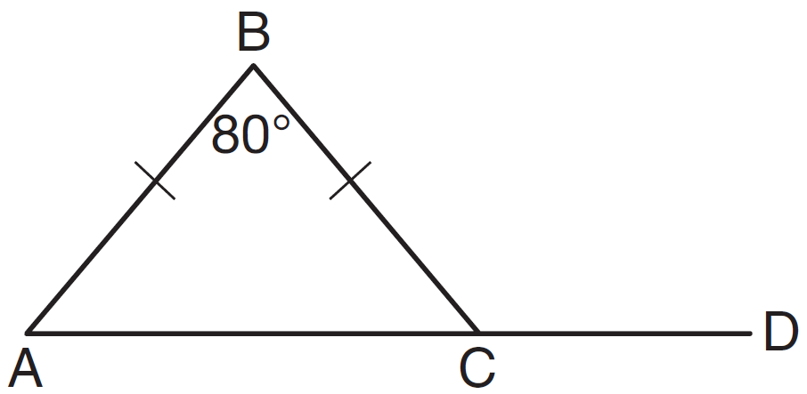
1) | 50
2) | 80
3) | 100
4) | 130

9 A student used a compass and a straightedge to construct in as shown below.

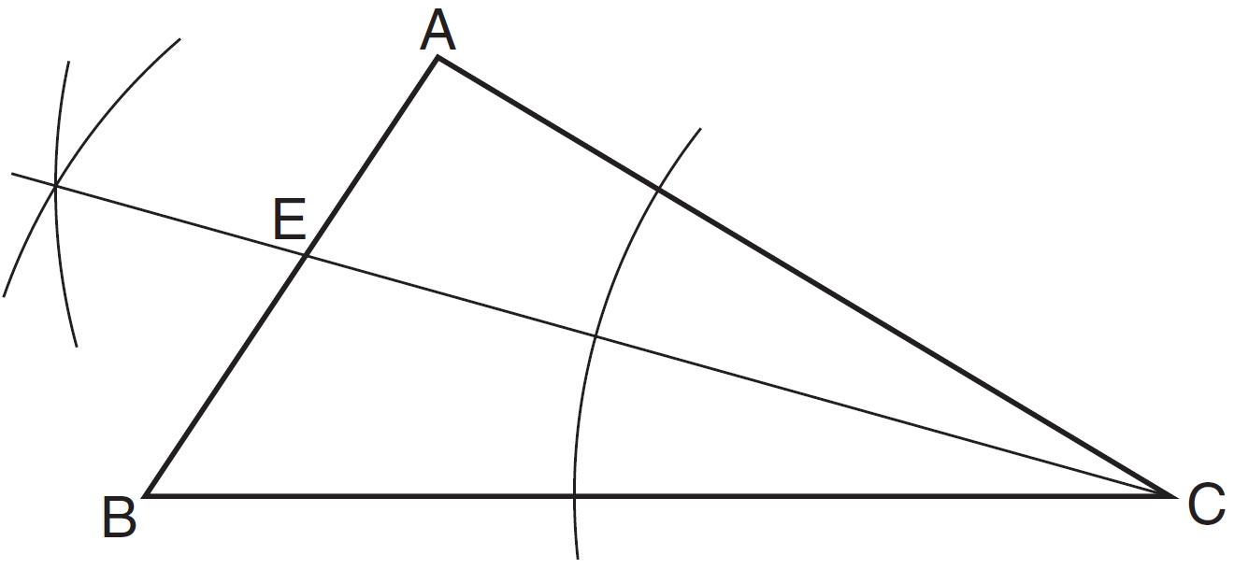

Which statement must always be true for this construction?
1)
2)
3)
4)

10 In , , , and . Which statement is true?
1)
2)
3)
4)

11 A circle whose center has coordinates passes through the origin. What is the equation of the circle?
1)
2)
3)
4)

12 Point W is located in plane R . How many distinct lines passing through point W are perpendicular to plane R ?
1) | one
2) | two
3) | zero
4) | infinite

13 In the diagram below, line is parallel to line m, and line w is a transversal.

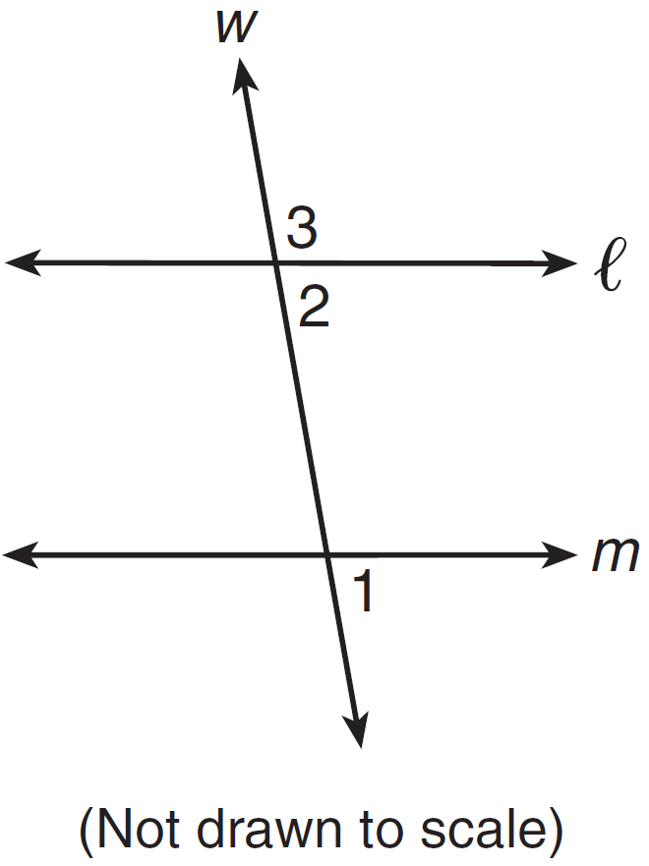

If and , what is ?
1) | 19
2) | 23
3) | 74
4) | 86

14 The diagram below is a graph of circle O.

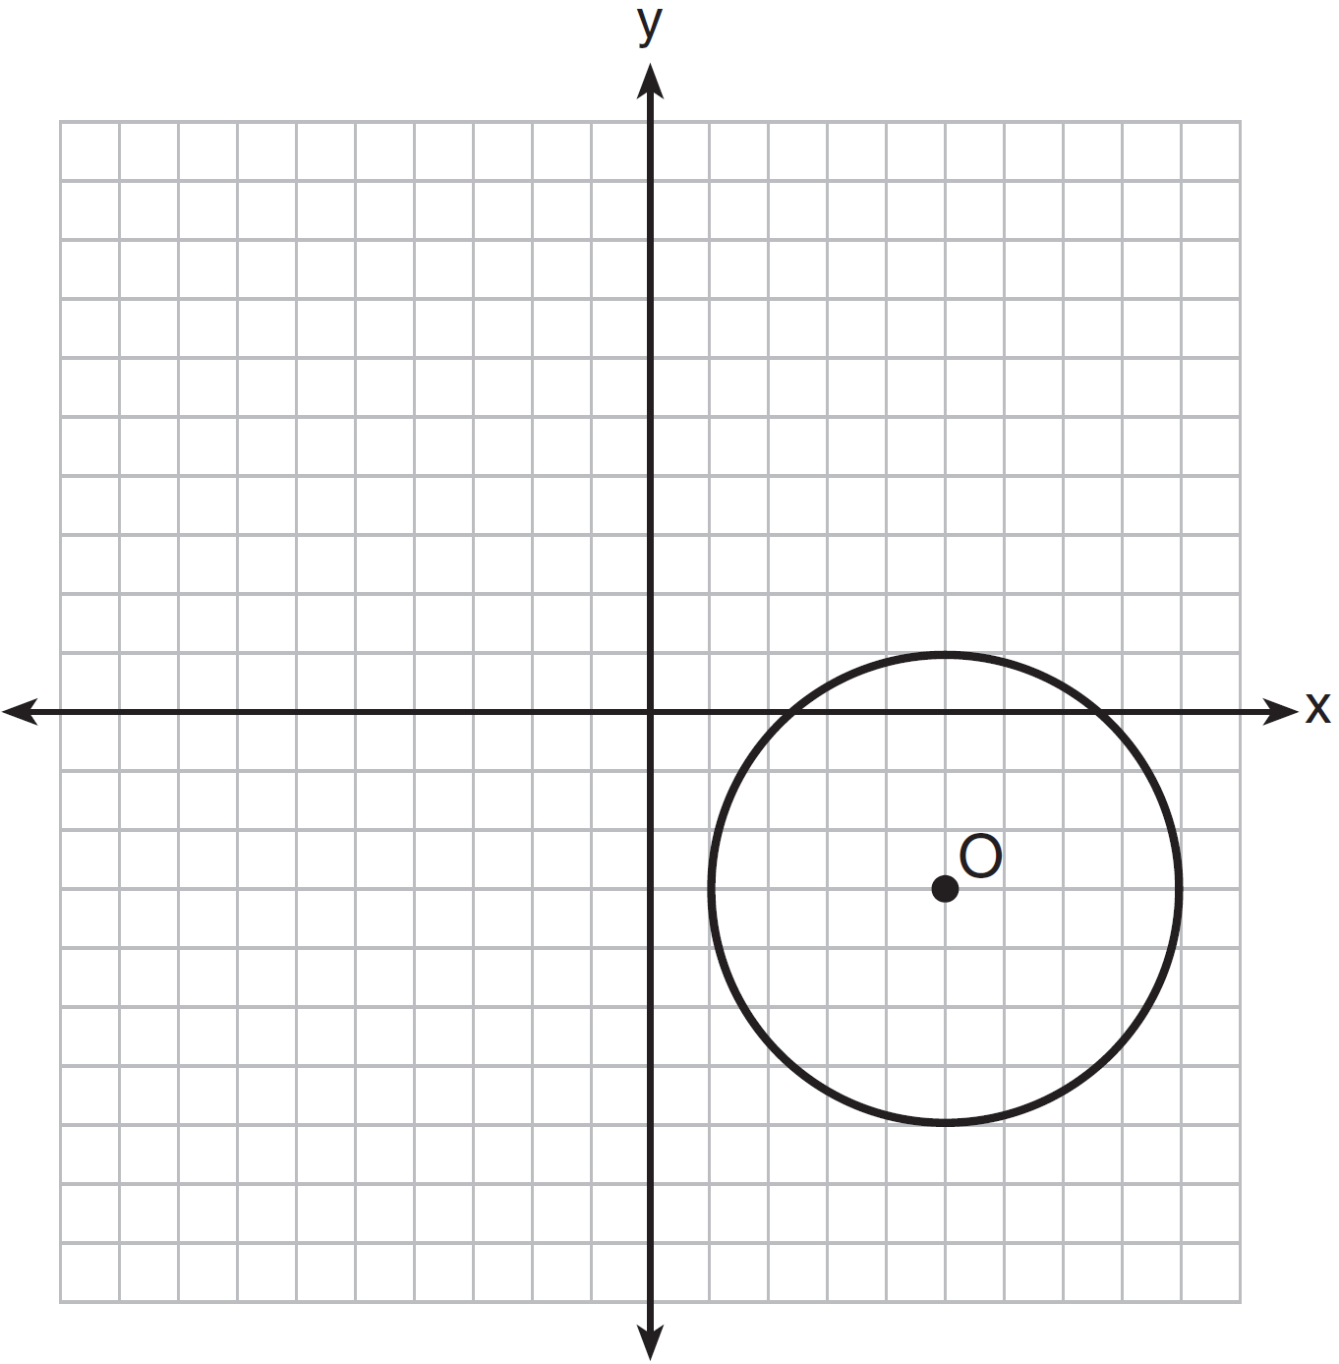

Which equation represents circle O?
1)
2)
3)
4)

15 In isosceles trapezoid QRST shown below, and are bases.

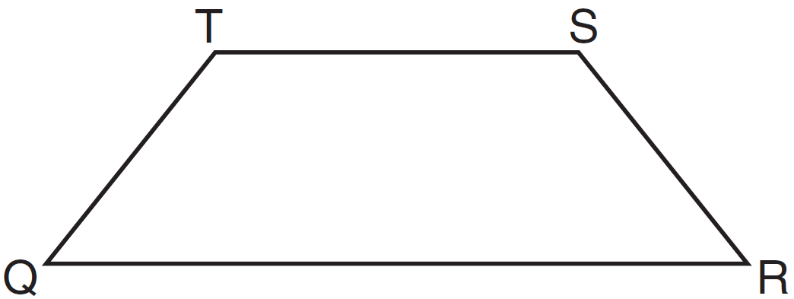

If and , what is ?
1) | 83
2) | 48
3) | 16
4) | 9

16 Triangle ABC is graphed on the set of axes below.

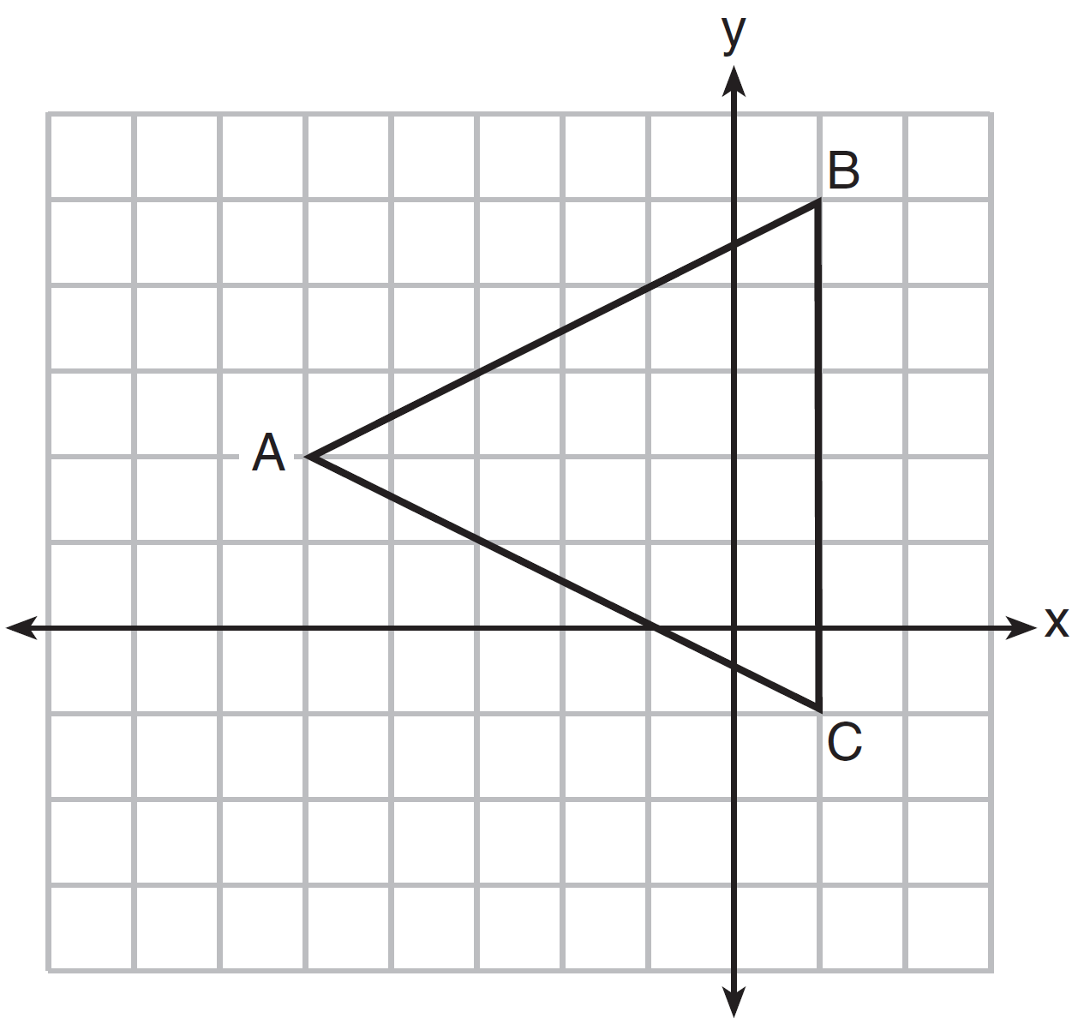

What are the coordinates of the point of intersection of the medians of ?
1)
2)
3)
4)

17 Given the statement, "If a number has exactly two factors, it is a prime number," what is the contrapositive of this statement?
1) | If a number does not have exactly two factors, then it is not a prime number.
2) | If a number is not a prime number, then it does not have exactly two factors.
3) | If a number is a prime number, then it has exactly two factors.
4) | A number is a prime number if it has exactly two factors.

18 Which graph represents a circle whose equation is ?
1) | 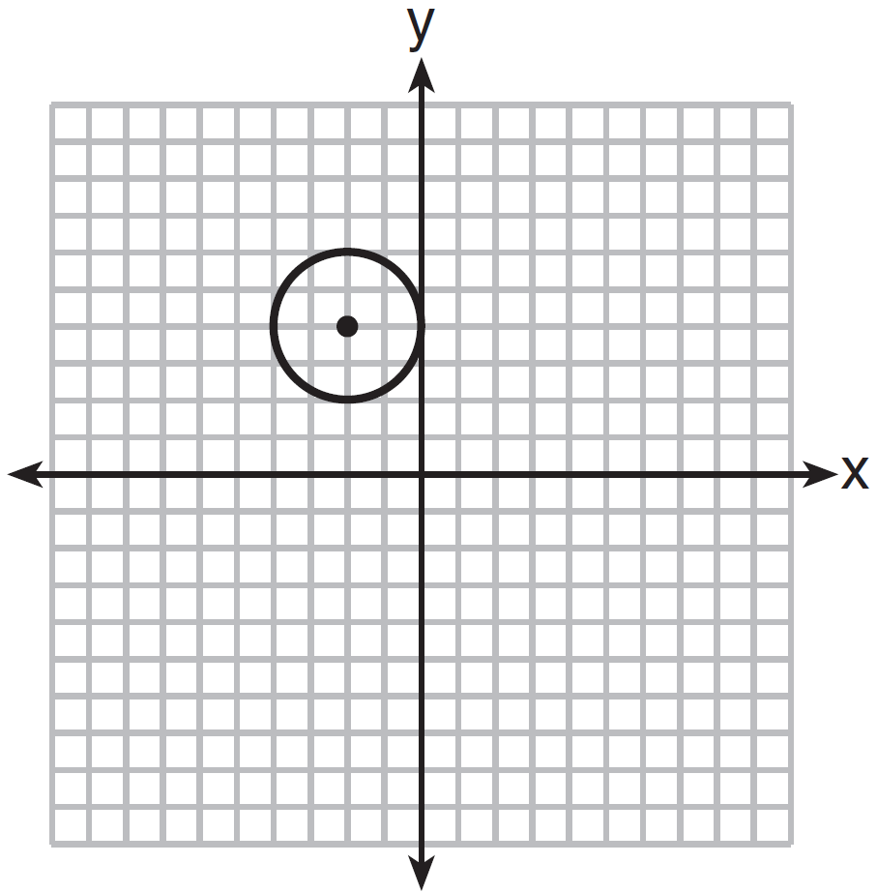
2) | 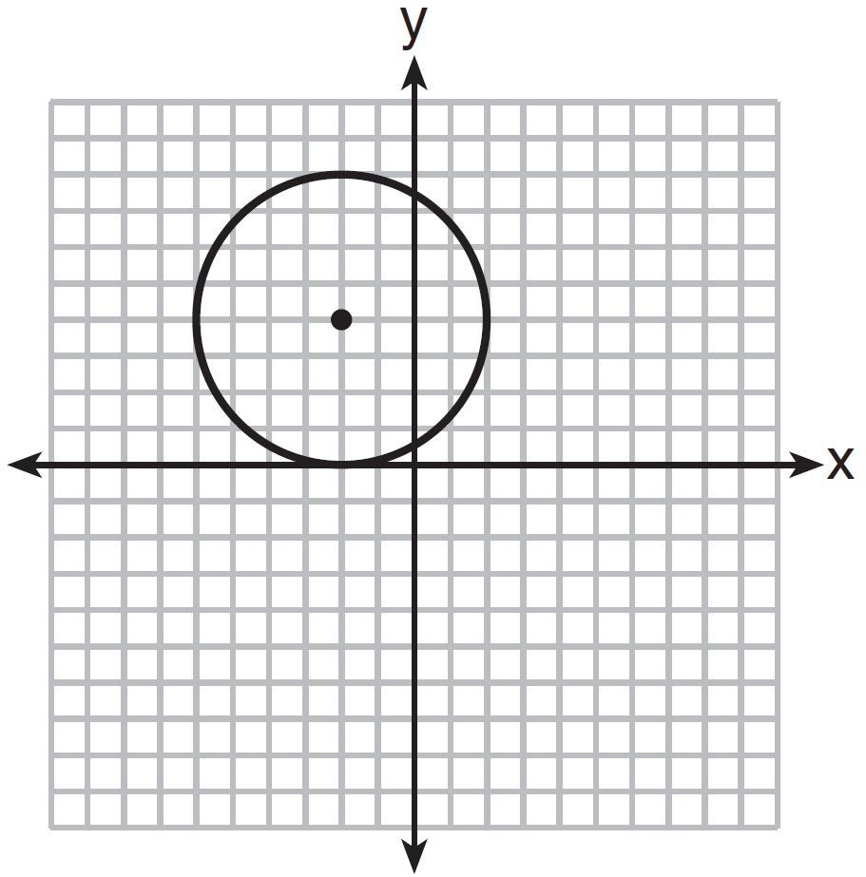
3) | 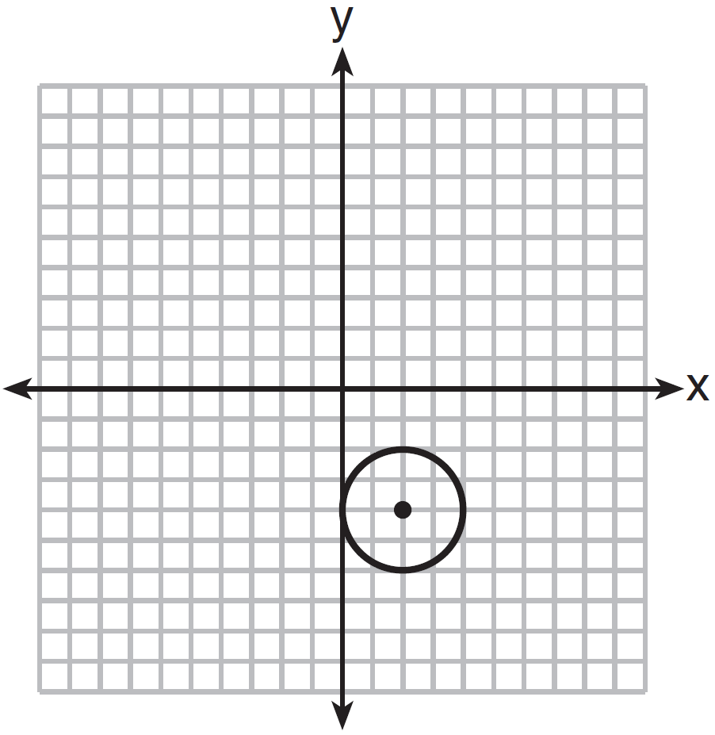
4) | 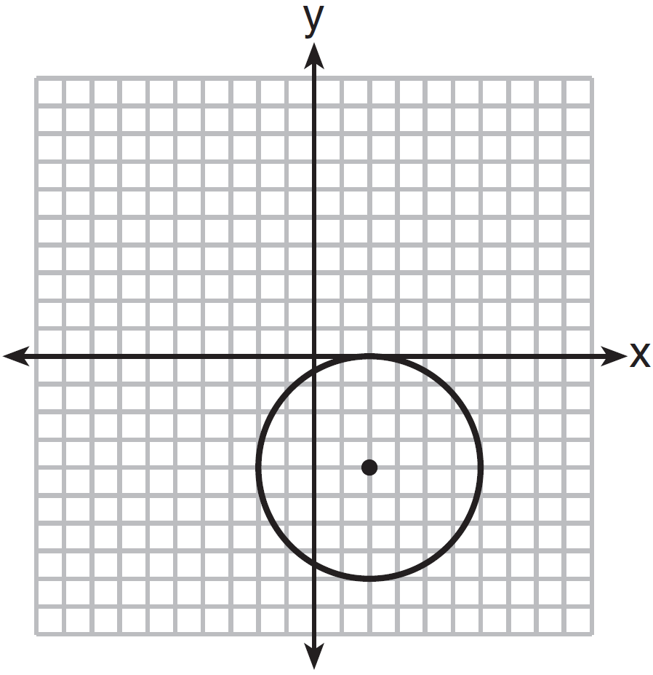

19 If two sides of a triangle have lengths of 4 and 10, the third side could be
1) | 8
2) | 2
3) | 16
4) | 4

20 The lines represented by the equations and 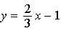 are
1) | parallel
2) | the same line
3) | perpendicular
4) | intersecting, but not perpendicular

21 In the diagram of below, .

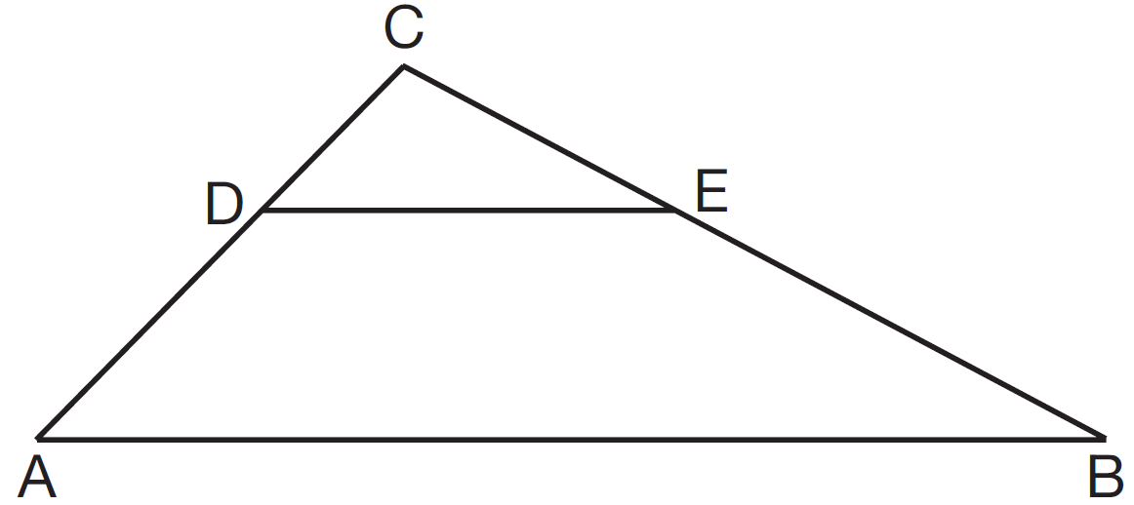

If , , , and , what is the length of ?
1) | 10
2) | 8
3) | 6
4) | 4

22 Parallelogram ABCD with diagonals and intersecting at E is shown below.

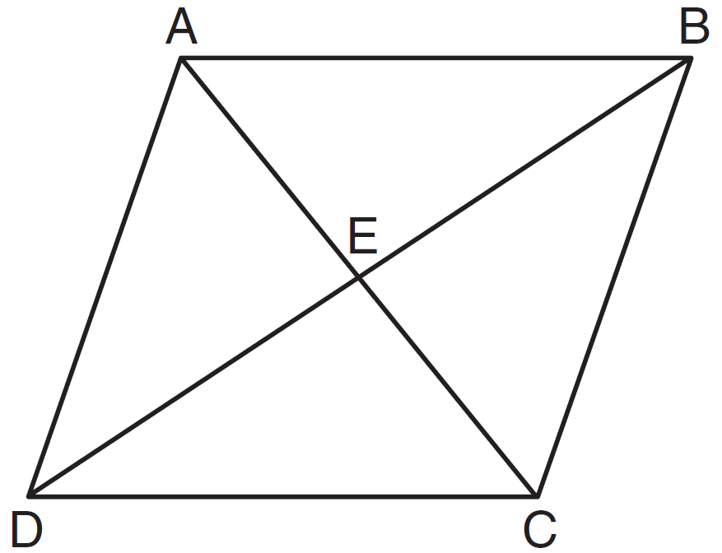

Which statement must be true?
1)
2)
3)
4)

23 In the diagram below of circle O, .

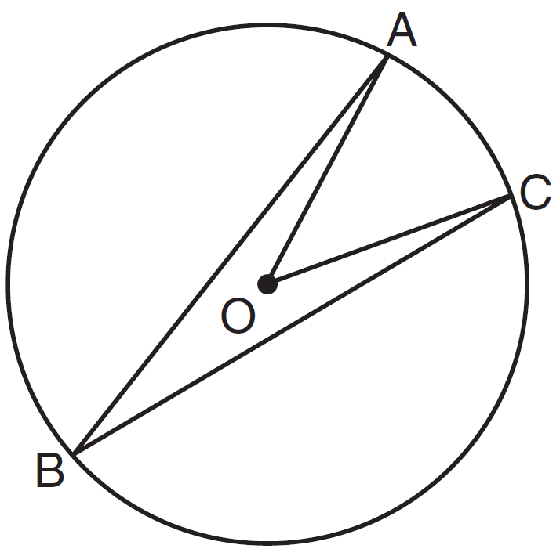

What is the ?
1) | 12
2) | 24
3) | 48
4) | 60

24 Triangle is the image of after a dilation of 2. Which statement is true?
1)
2)
3)
4) | 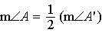

25 In the diagram of the circle below, , , and .

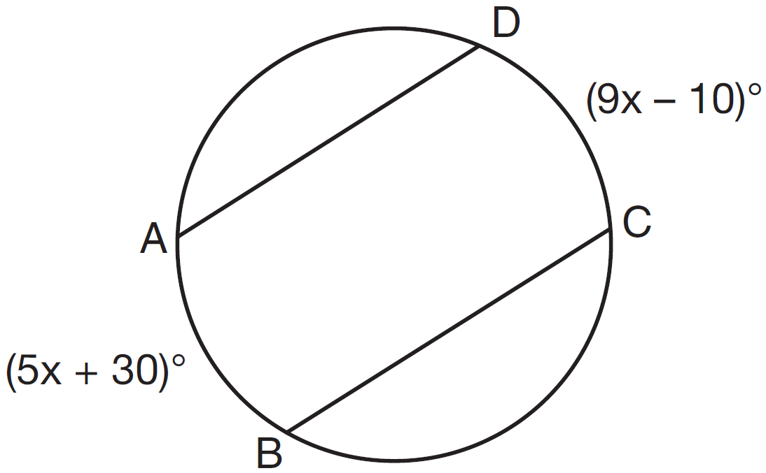

What is ?
1) | 5
2) | 10
3) | 55
4) | 80

26 The bases of a prism are right trapezoids, as shown in the diagram below.

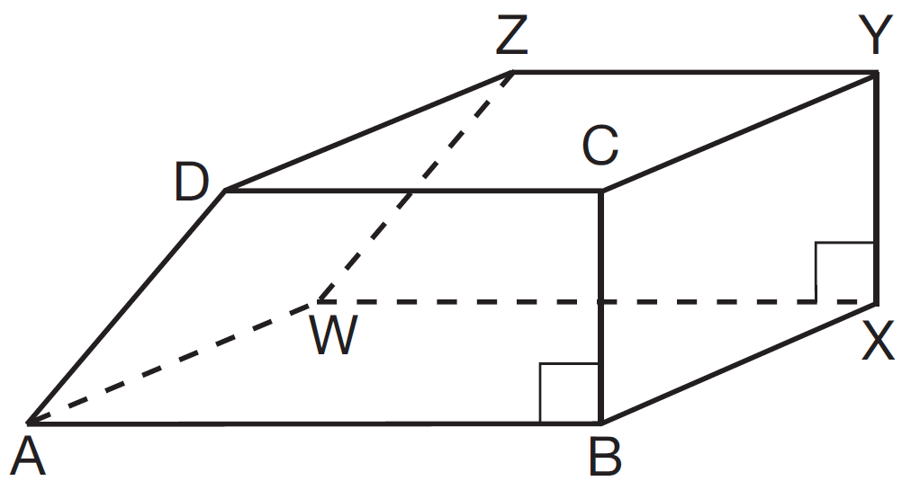

Which two edges do not lie in the same plane?
1) | and
2) | and
3) | and
4) | and

27 In the diagram below, is the image of under which single transformation?

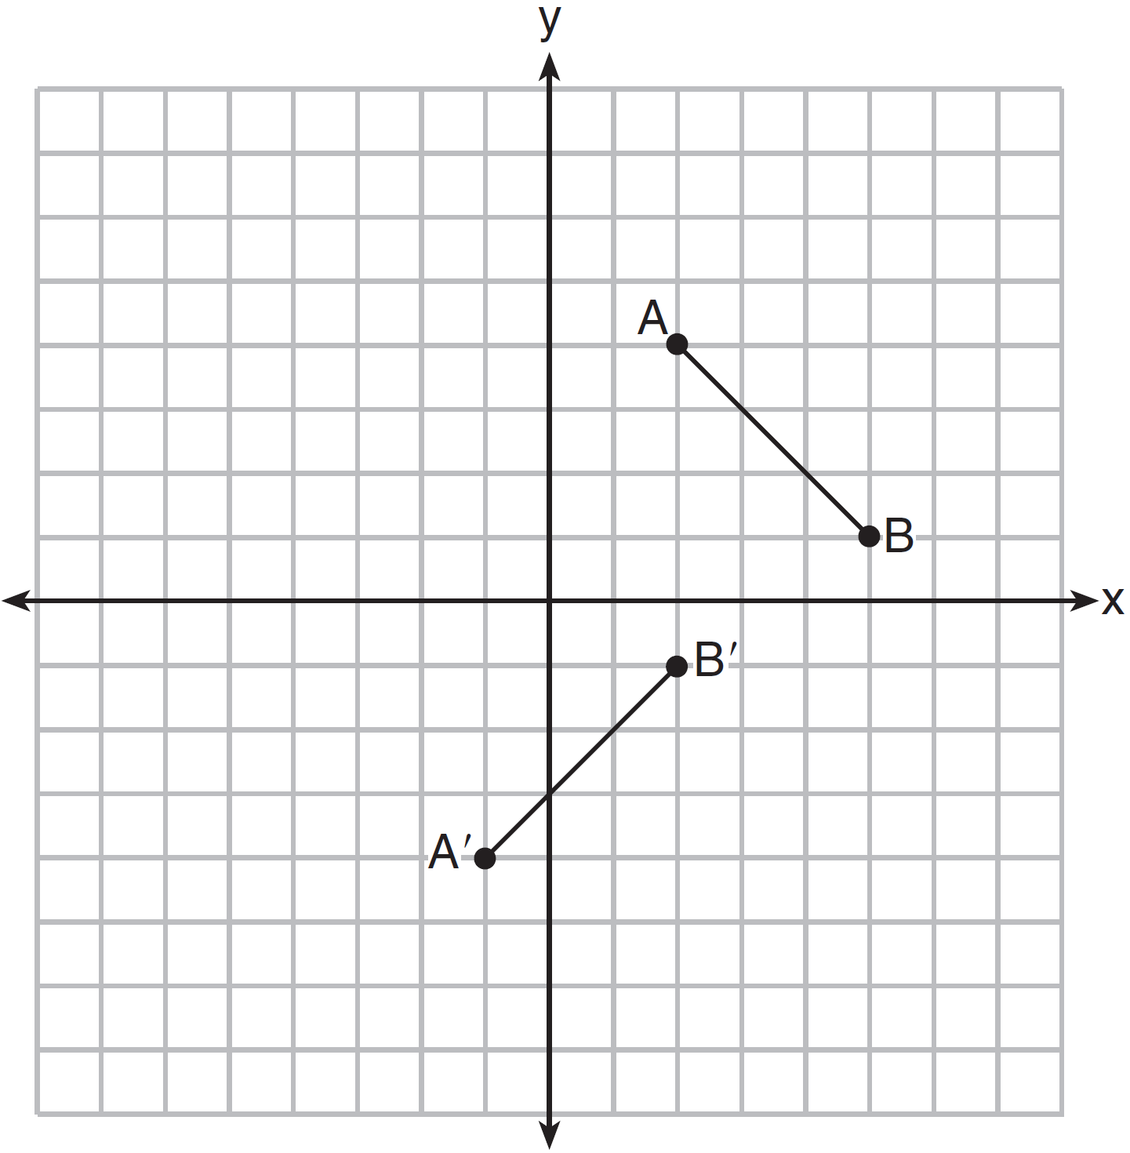
1) | dilation
2) | rotation
3) | translation
4) | glide reflection

28 For which diagram is the statement not always true??
1) | 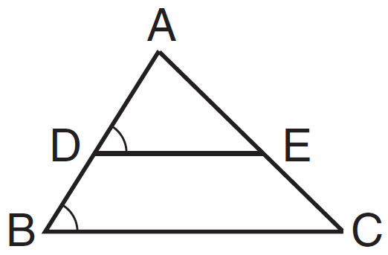
2) | 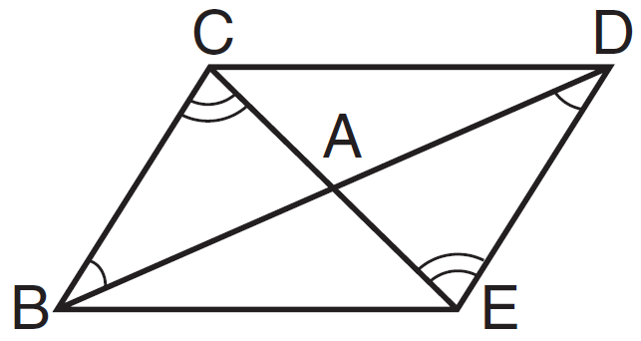
3) | 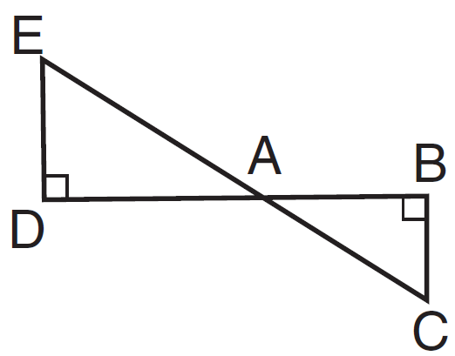
4) | 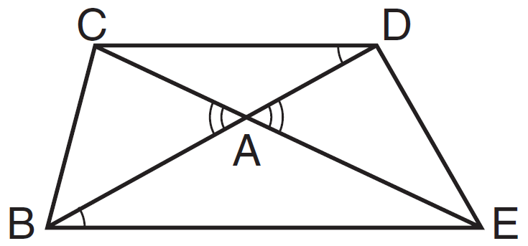

29 Given: and intersect at point C
and are drawn
Prove:

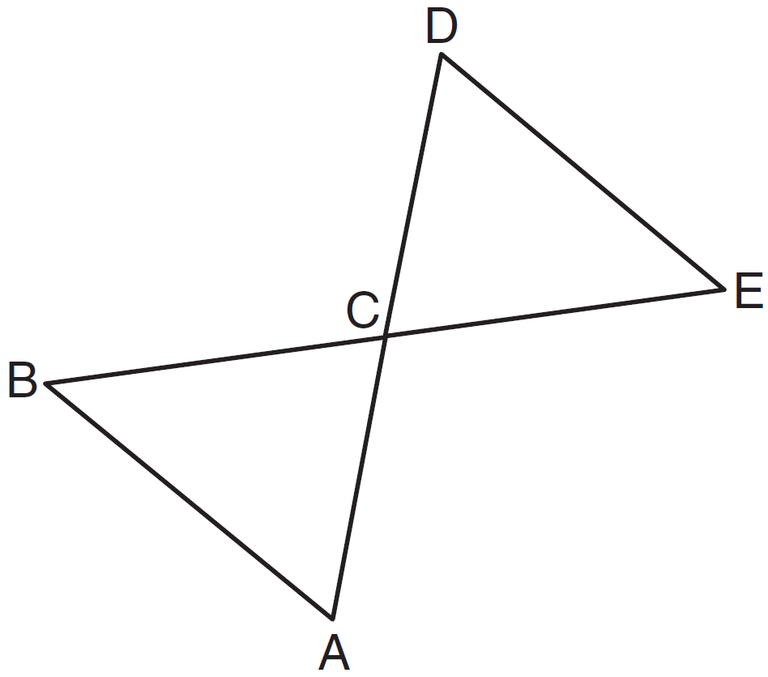

30 Using a compass and straightedge, construct the perpendicular bisector of side in shown below. [Leave all construction marks.]

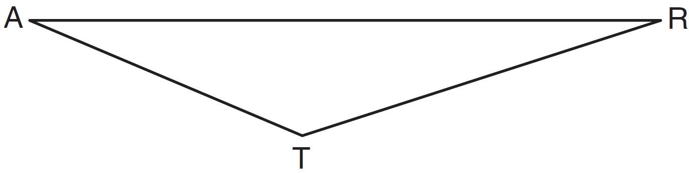

31 Determine and state the measure, in degrees, of an interior angle of a regular decagon.

32 Write an equation of a line that is parallel to the line whose equation is and that passes through the point .

33 In the diagram below, secants and are drawn to a circle from point P.

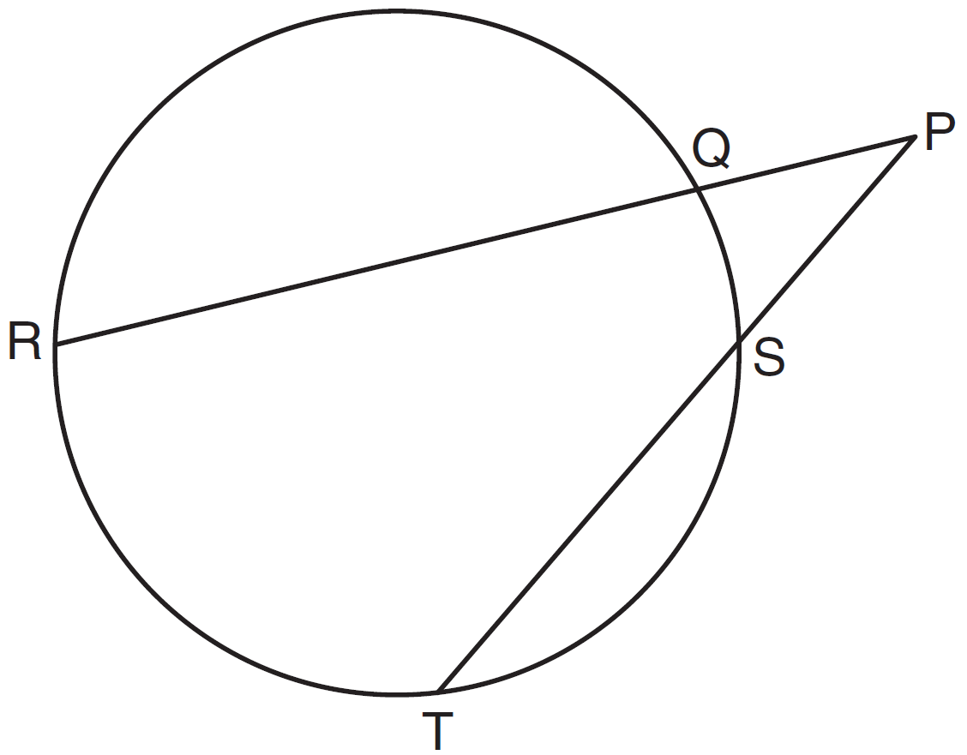

If , , and , determine and state the length of .

34 The slope of is 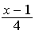 and the slope of is . If , determine and state the value of x.

35 Quadrilateral HYPE has vertices , , , and . State and label the coordinates of the vertices of H"Y"P"E" after the composition of transformations . [The use of the set of axes below is optional.]

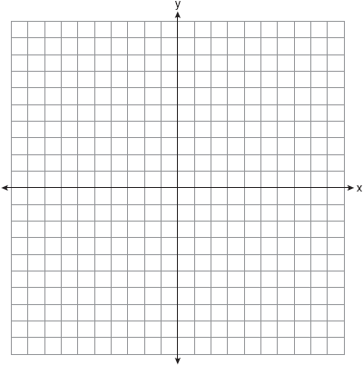

36 On the set of axes below, graph two horizontal lines whose y-intercepts are and , respectively. Graph the locus of points equidistant from these horizontal lines. Graph the locus of points 3 units from the y-axis. State the coordinates of the points that satisfy both loci.

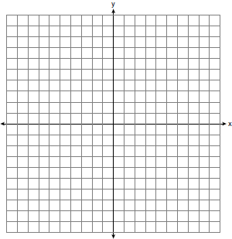

37 In the diagram below, a right circular cone with a radius of 3 inches has a slant height of 5 inches, and a right cylinder with a radius of 4 inches has a height of 6 inches.

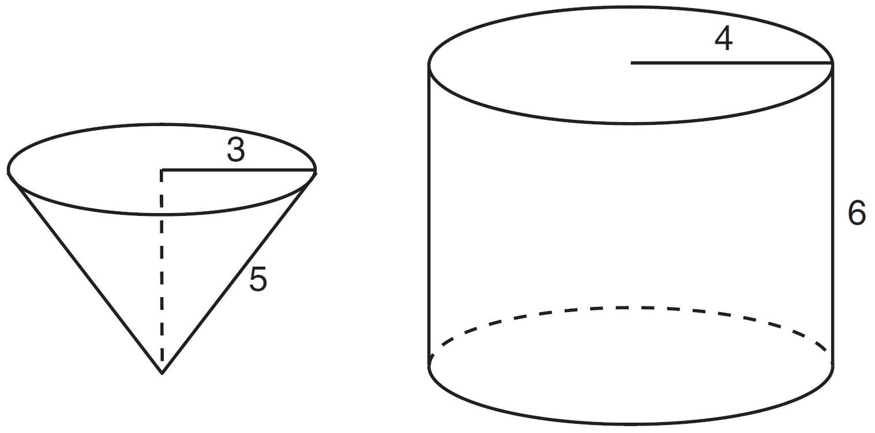

Determine and state the number of full cones of water needed to completely fill the cylinder with water.

38 In the diagram below, right triangle RSU is inscribed in circle O, and is the altitude drawn to hypotenuse . The length of is 16 more than the length of and . Find the length of . Find, in simplest radical form, the length of .

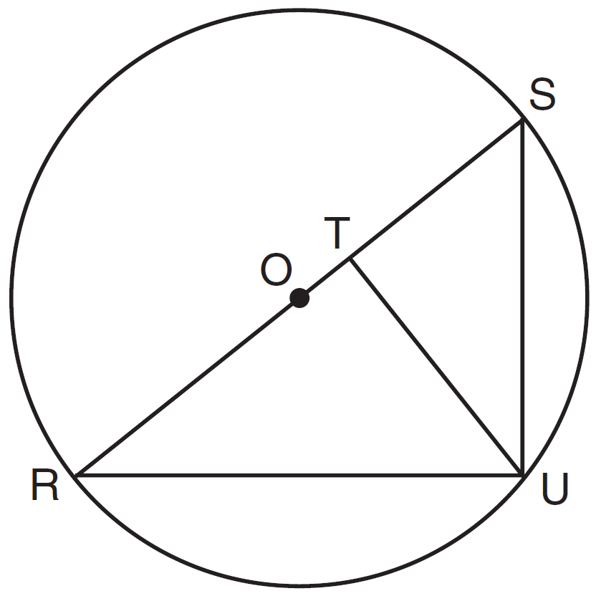
1 ANS: 4 PTS: 2 REF: 011501ge STA: G.G.70
TOP: Quadratic-Linear Systems

2 ANS: 4
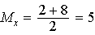. 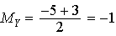.

PTS: 2 REF: 011502ge STA: G.G.66 TOP: Midpoint
KEY: general

3 ANS: 3 PTS: 2 REF: 011503ge STA: G.G.55
TOP: Properties of Transformations

4 ANS: 1
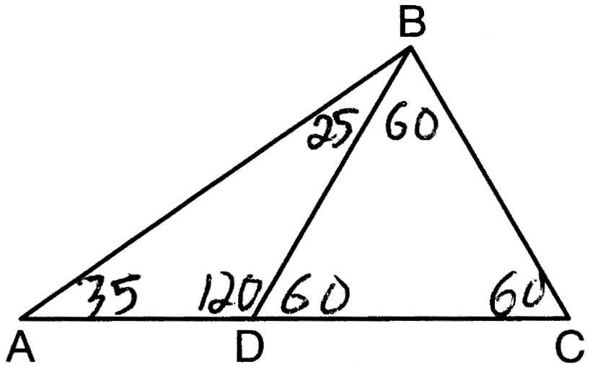

PTS: 2 REF: 011504ge STA: G.G.30 TOP: Interior and Exterior Angles of Triangles

5 ANS: 1
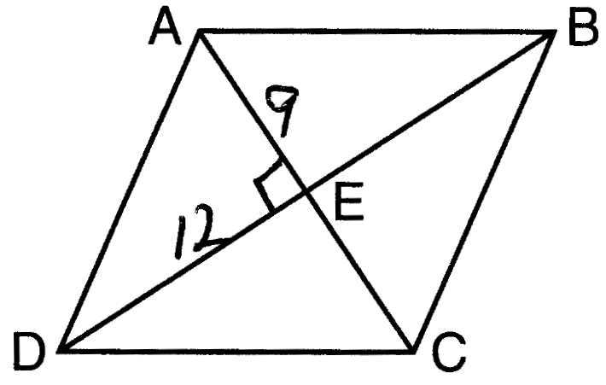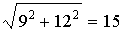

PTS: 2 REF: 011505ge STA: G.G.39 TOP: Special Parallelograms

6 ANS: 3 PTS: 2 REF: 011506ge STA: G.G.24
TOP: Negations

7 ANS: 1
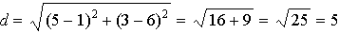

PTS: 2 REF: 011507ge STA: G.G.67 TOP: Distance
KEY: general

8 ANS: 4
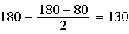

PTS: 2 REF: 011508ge STA: G.G.31 TOP: Isosceles Triangle Theorem

9 ANS: 2 PTS: 2 REF: 011509ge STA: G.G.17
TOP: Constructions

10 ANS: 2 PTS: 2 REF: 011510ge STA: G.G.34
TOP: Angle Side Relationship

11 ANS: 2 PTS: 2 REF: 011511ge STA: G.G.71
TOP: Equations of Circles

12 ANS: 1 PTS: 2 REF: 011512ge STA: G.G.3
TOP: Planes

13 ANS: 4
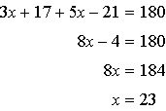

PTS: 2 REF: 011513ge STA: G.G.35 TOP: Parallel Lines and Transversals

14 ANS: 3 PTS: 2 REF: 011514ge STA: G.G.72
TOP: Equations of Circles

15 ANS: 2
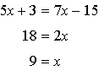

PTS: 2 REF: 011515ge STA: G.G.40 TOP: Trapezoids

16 ANS: 1
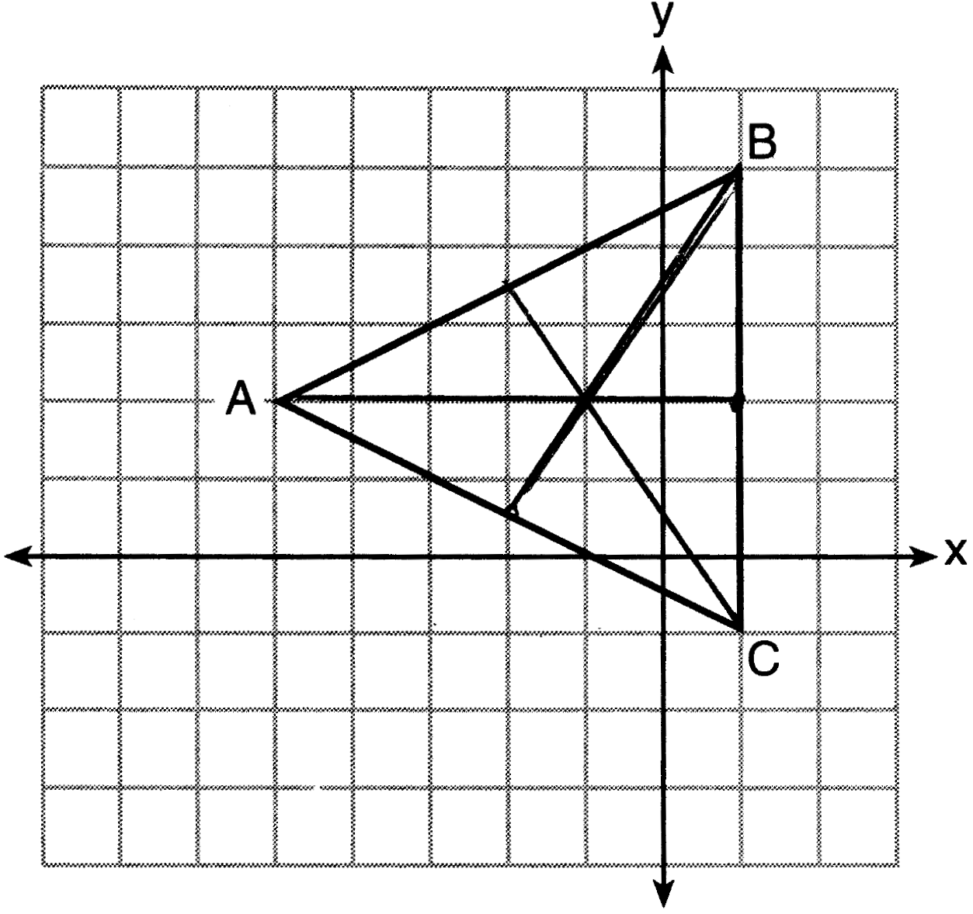

PTS: 2 REF: 011516ge STA: G.G.21
TOP: Centroid, Orthocenter, Incenter and Circumcenter

17 ANS: 2 PTS: 2 REF: 011517ge STA: G.G.26
TOP: Contrapositive

18 ANS: 3 PTS: 2 REF: 011518ge STA: G.G.74
TOP: Graphing Circles

19 ANS: 1
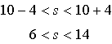

PTS: 2 REF: 011519ge STA: G.G.33 TOP: Triangle Inequality Theorem

20 ANS: 4
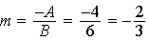

PTS: 2 REF: 011520ge STA: G.G.63 TOP: Parallel and Perpendicular Lines

21 ANS: 3
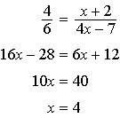

PTS: 2 REF: 011521ge STA: G.G.46 TOP: Side Splitter Theorem

22 ANS: 2 PTS: 2 REF: 011522ge STA: G.G.38
TOP: Parallelograms

23 ANS: 3 PTS: 2 REF: 011523ge STA: G.G.51
TOP: Arcs Determined by Angles KEY: inscribed

24 ANS: 3 PTS: 2 REF: 011524ge STA: G.G.58
TOP: Dilations

25 ANS: 4
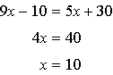

PTS: 2 REF: 011525ge STA: G.G.52 TOP: Chords

26 ANS: 1 PTS: 2 REF: 011526ge STA: G.G.10
TOP: Solids

27 ANS: 4
(2) rotation is also a correct response

PTS: 2 REF: 011527ge STA: G.G.56 TOP: Identifying Transformations

28 ANS: 4 PTS: 2 REF: 011528ge STA: G.G.44
TOP: Similarity Proofs

29 ANS:
and intersect at point C, , , and are drawn (Given). (Vertical Angles). (SAS).

PTS: 2 REF: 011529ge STA: G.G.27 TOP: Triangle Proofs

30 ANS:
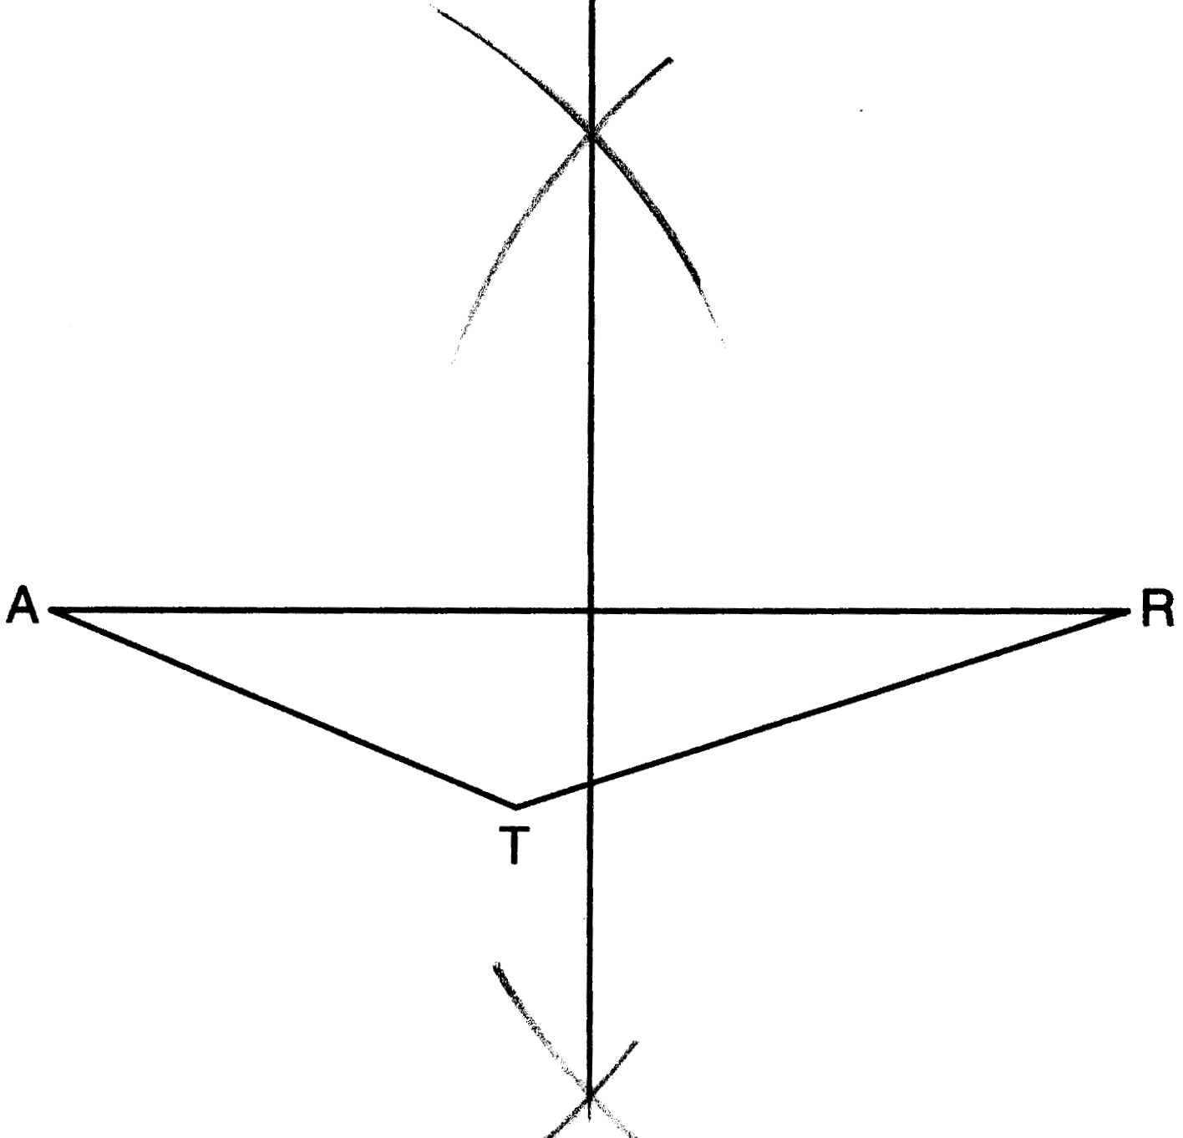

PTS: 2 REF: 011530ge STA: G.G.18 TOP: Constructions

31 ANS:
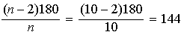

PTS: 2 REF: 011531ge STA: G.G.37 TOP: Interior and Exterior Angles of Polygons

32 ANS:
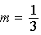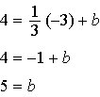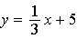

PTS: 2 REF: 011532ge STA: G.G.65 TOP: Parallel and Perpendicular Lines

33 ANS:
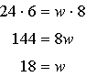

PTS: 2 REF: 011533ge STA: G.G.53 TOP: Segments Intercepted by Circle
KEY: two secants

34 ANS:
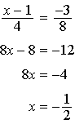

PTS: 2 REF: 011534ge STA: G.G.62 TOP: Parallel and Perpendicular Lines

35 ANS:
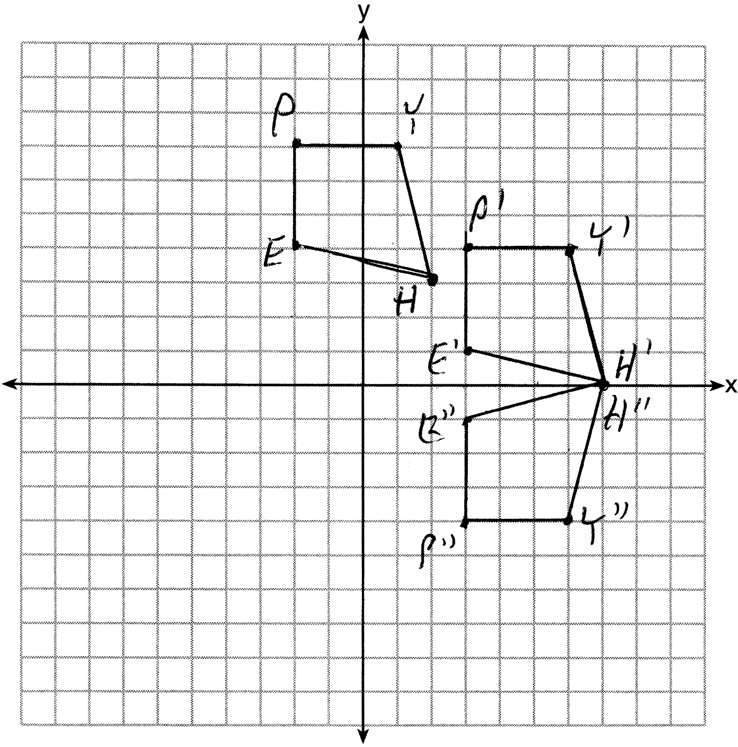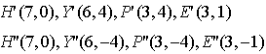

PTS: 4 REF: 011535ge STA: G.G.58 TOP: Compositions of Transformations
KEY: grids

36 ANS:
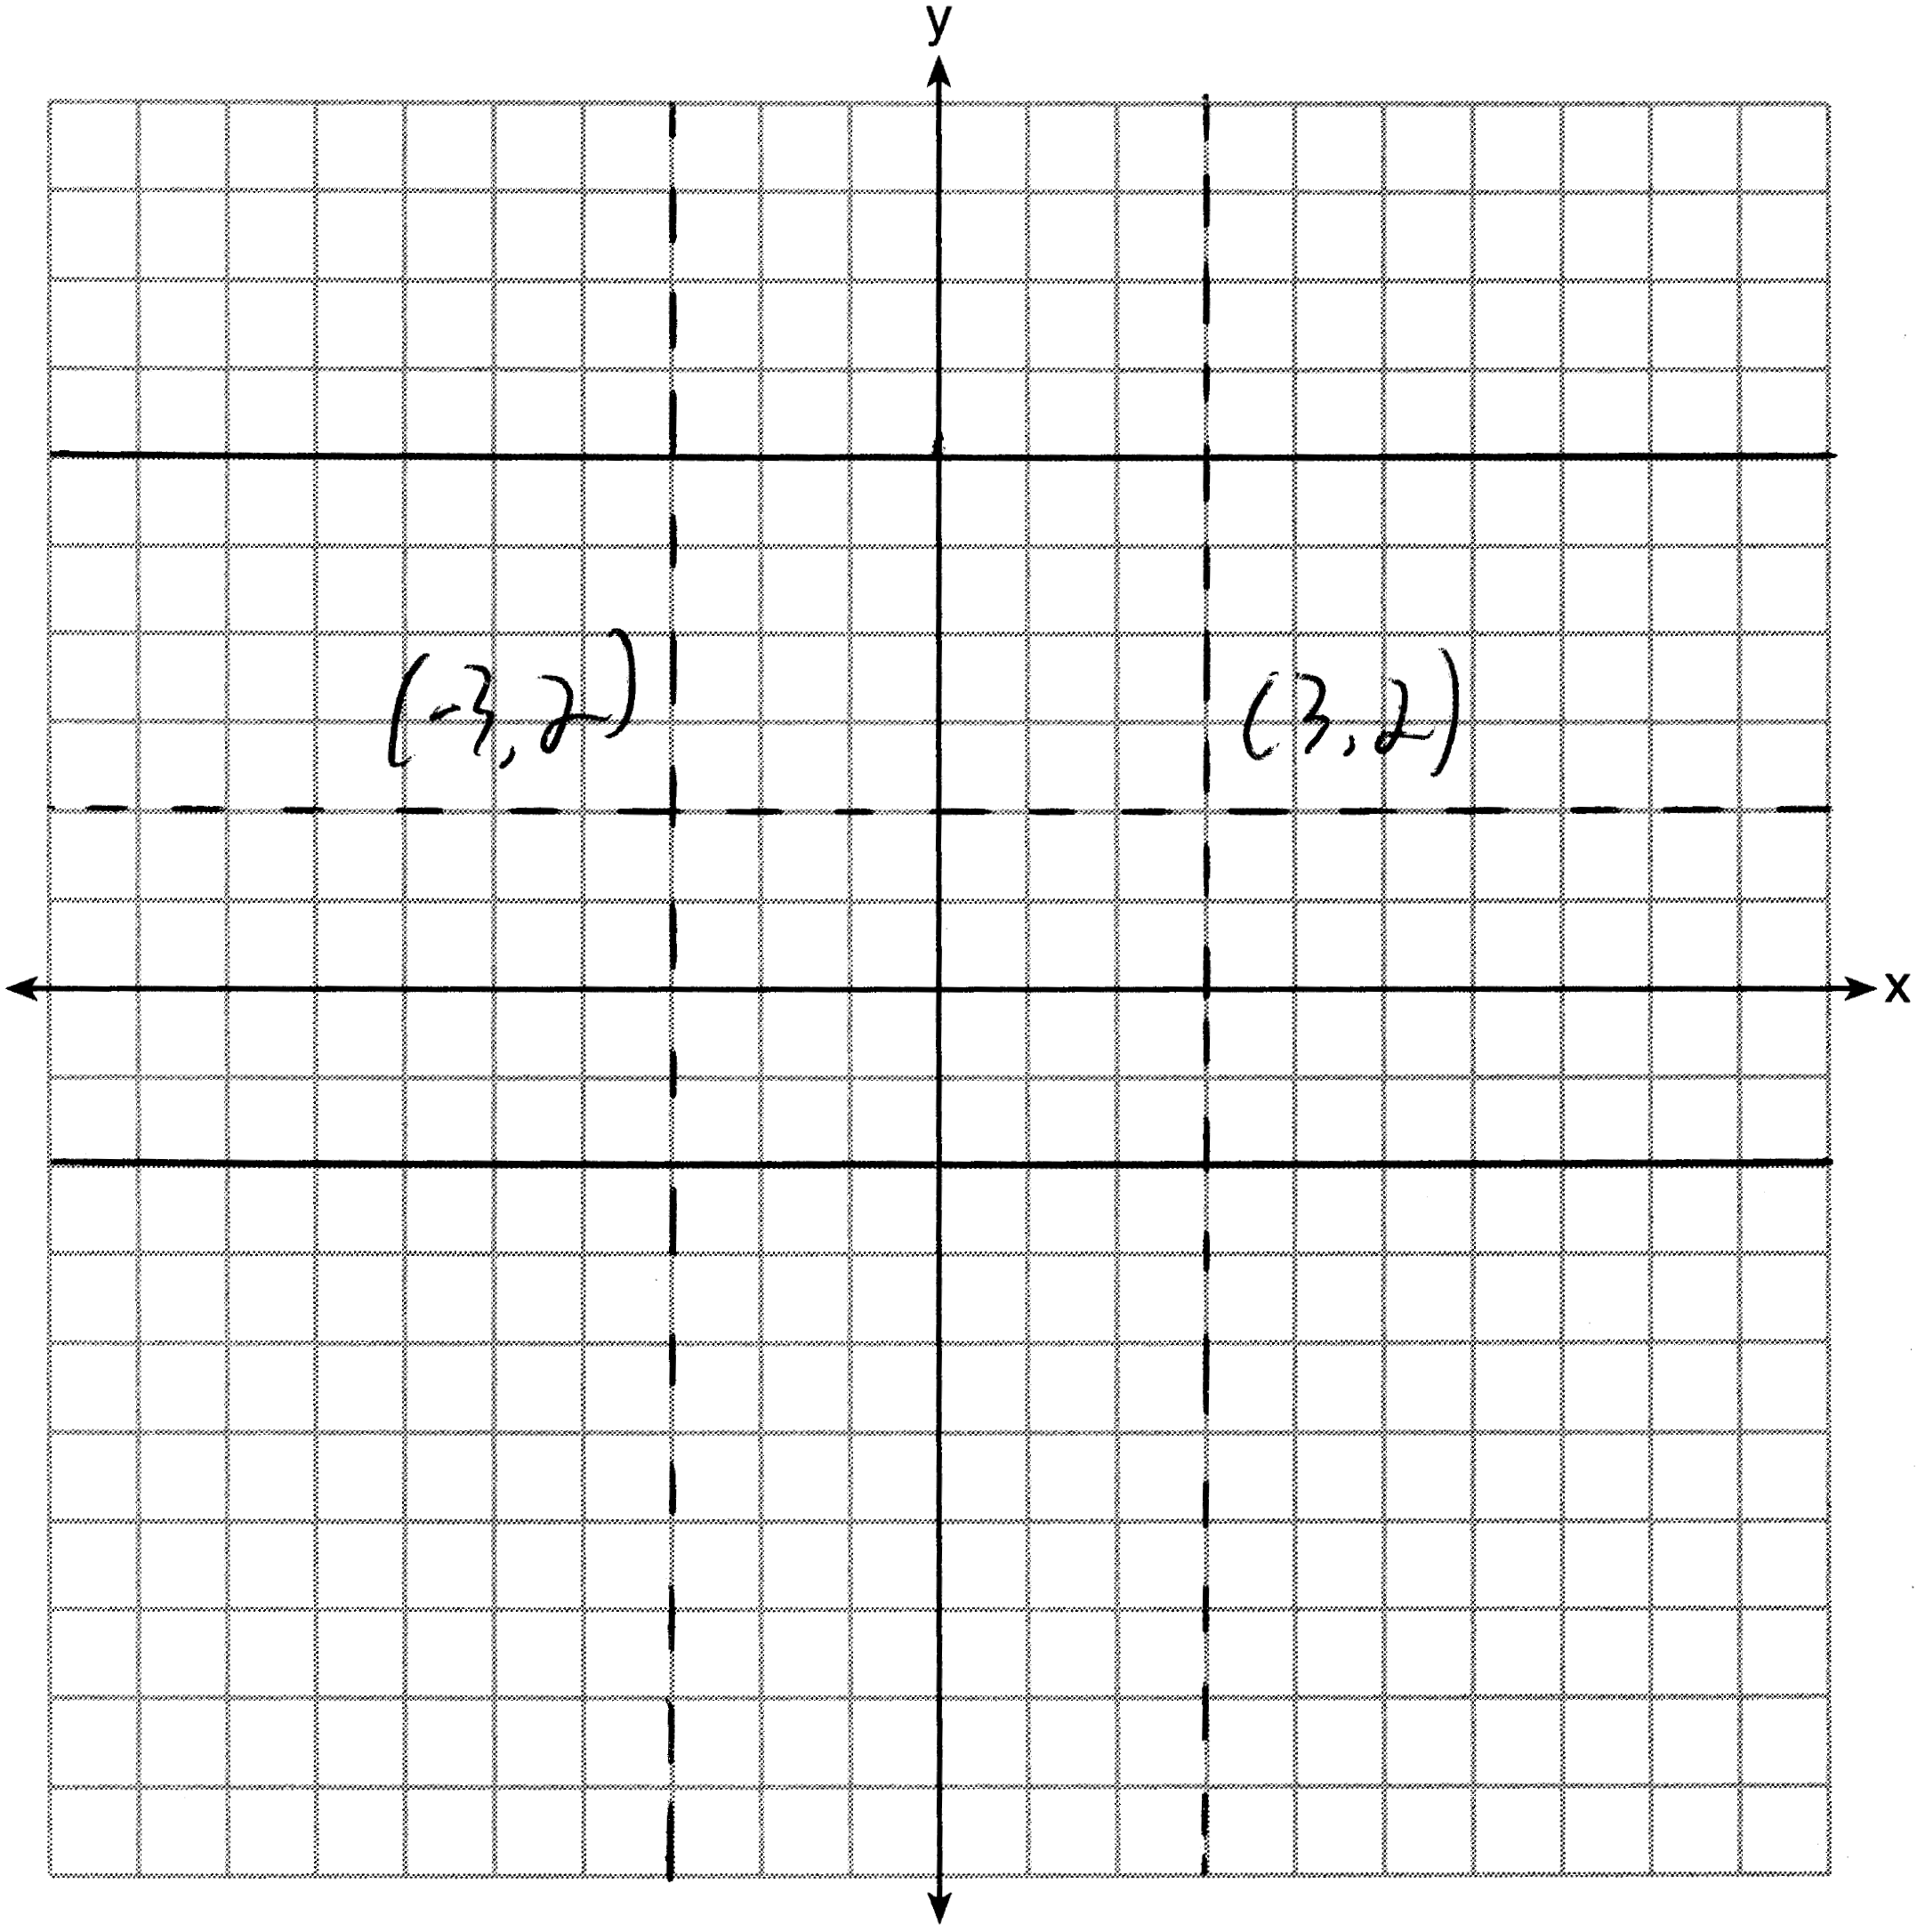

PTS: 4 REF: 011536ge STA: G.G.23 TOP: Locus

37 ANS:
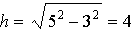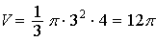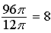

PTS: 4 REF: 011537ge STA: G.G.15 TOP: Volume and Lateral Area

38 ANS:
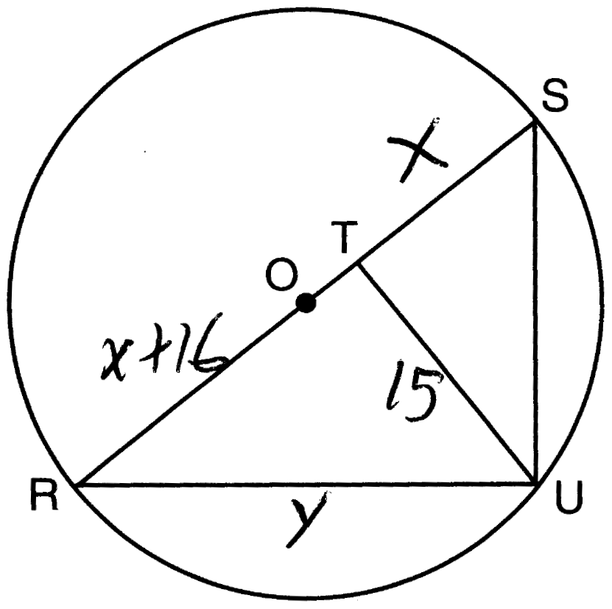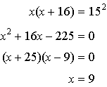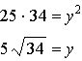

PTS: 6 REF: 011538ge STA: G.G.47 TOP: Similarity
KEY: leg

