1 The midpoint of is . If the coordinates of A are , what are the coordinates of B?
1)
2)
3)
4)

2 Which diagram shows the construction of a 45° angle?
1) | 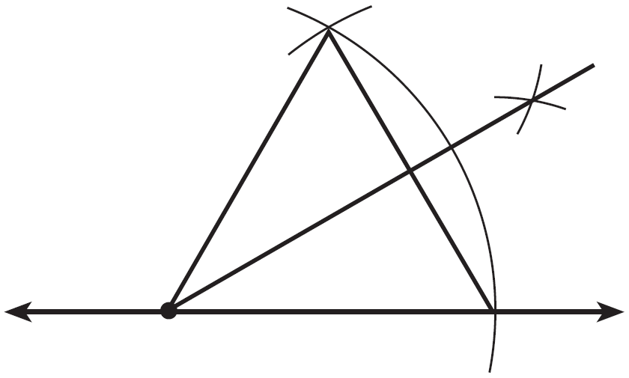
2) | 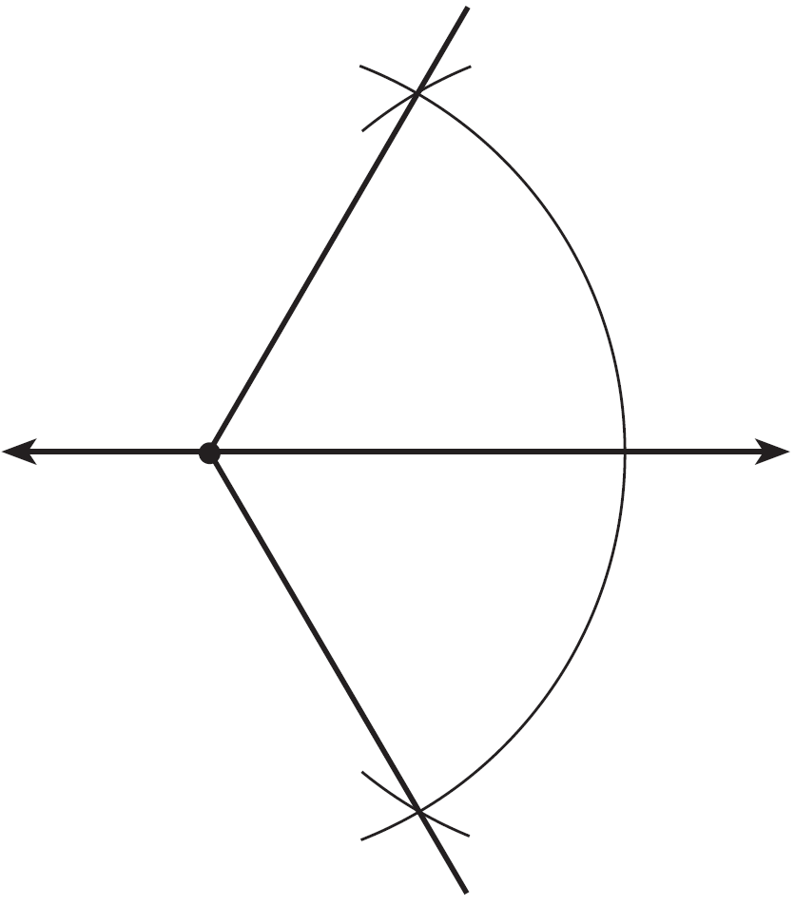
3) | 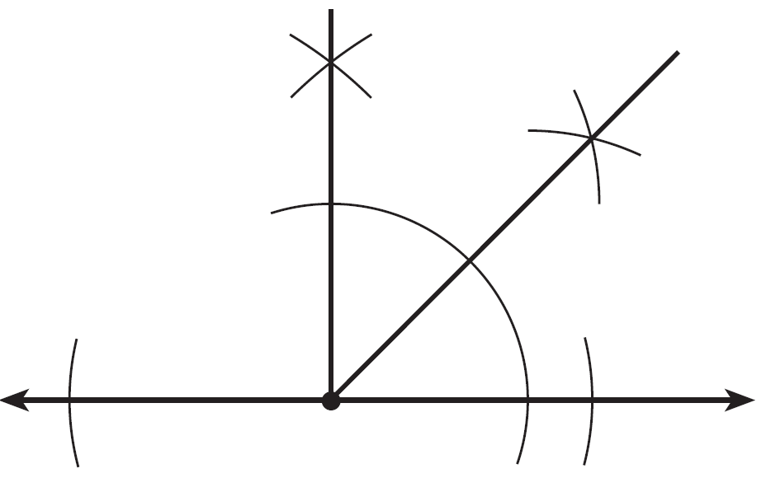
4) | 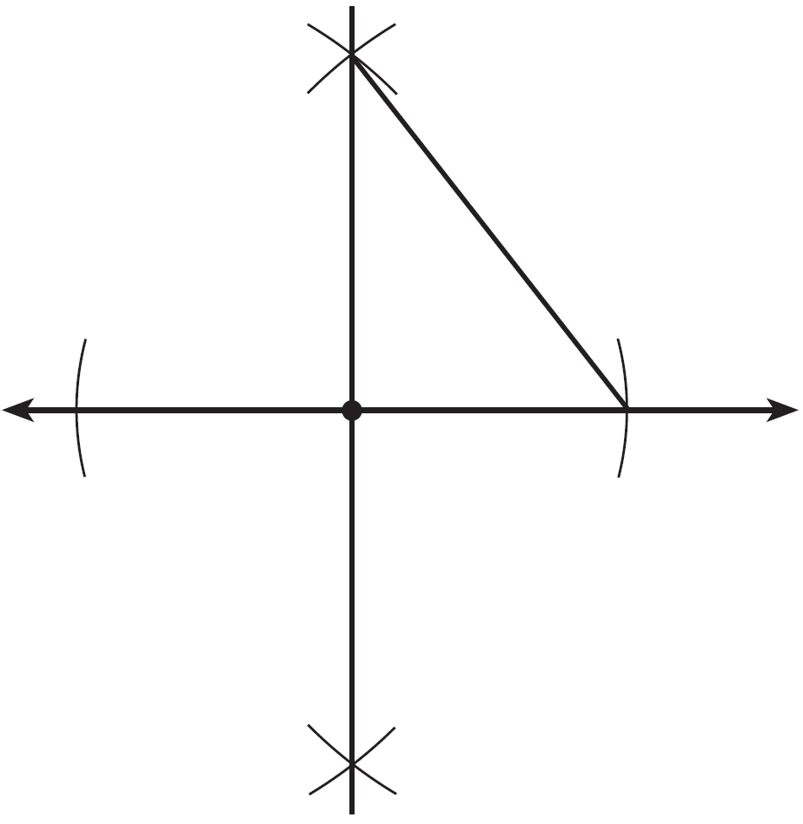

3 What are the coordinates of the center and the length of the radius of the circle whose equation is ?
1) | and 16
2) | and 16
3) | and 4
4) | and 4

4 If distinct planes R and S are both perpendicular to line , which statement must always be true?
1) | Plane R is parallel to plane S.
2) | Plane R is perpendicular to plane S.
3) | Planes R and S and line are all parallel.
4) | The intersection of planes R and S is perpendicular to line .

5 If and its image, , are graphed on a set of axes, under each transformation except
1)
2)
3)
4)

6 A rectangular right prism is shown in the diagram below.

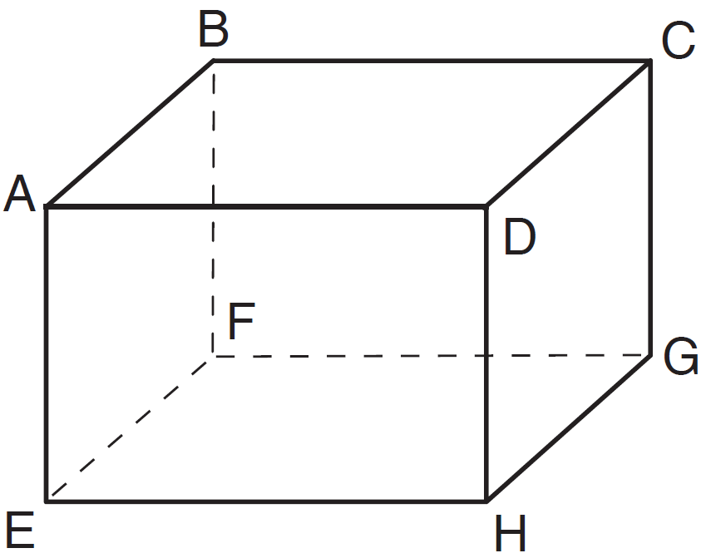

Which pair of edges are not coplanar?
1) | and
2) | and
3) | and
4) | and

7 How many points in the coordinate plane are 3 units from the origin and also equidistant from both the x-axis and the y-axis?
1) | 1
2) | 2
3) | 8
4) | 4

8 As shown below, the medians of intersect at D.

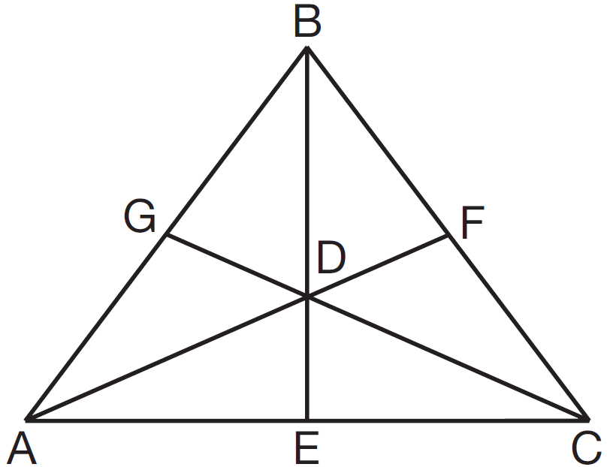

If the length of is 12, what is the length of ?
1) | 8
2) | 9
3) | 3
4) | 4

9 The solution of the system of equations and is
1) | and
2) | and
3) | and
4) | and

10 Line passes through the point and is parallel to line k whose equation is . An equation of line is
1) | 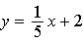
2)
3) | 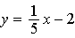
4)

11 In the diagram below of quadrilateral ABCD, E and F are points on and , respectively, , and .

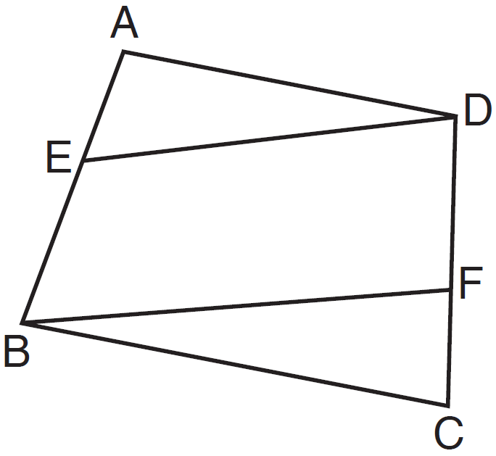

Which conclusion can be proven?
1)
2)
3)
4)

12 In the diagram below, four pairs of triangles are shown. Congruent corresponding parts are labeled in each pair.

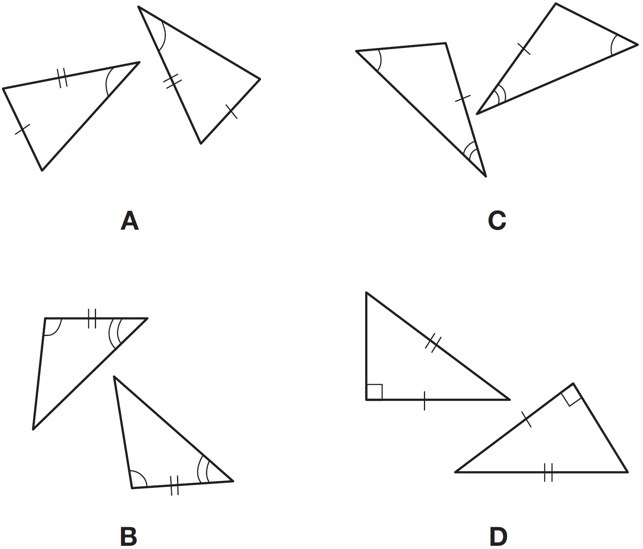

Using only the information given in the diagrams, which pair of triangles can not be proven congruent?
1) | A
2) | B
3) | C
4) | D

13 In shown below, L is the midpoint of , M is the midpoint of , and N is the midpoint of .

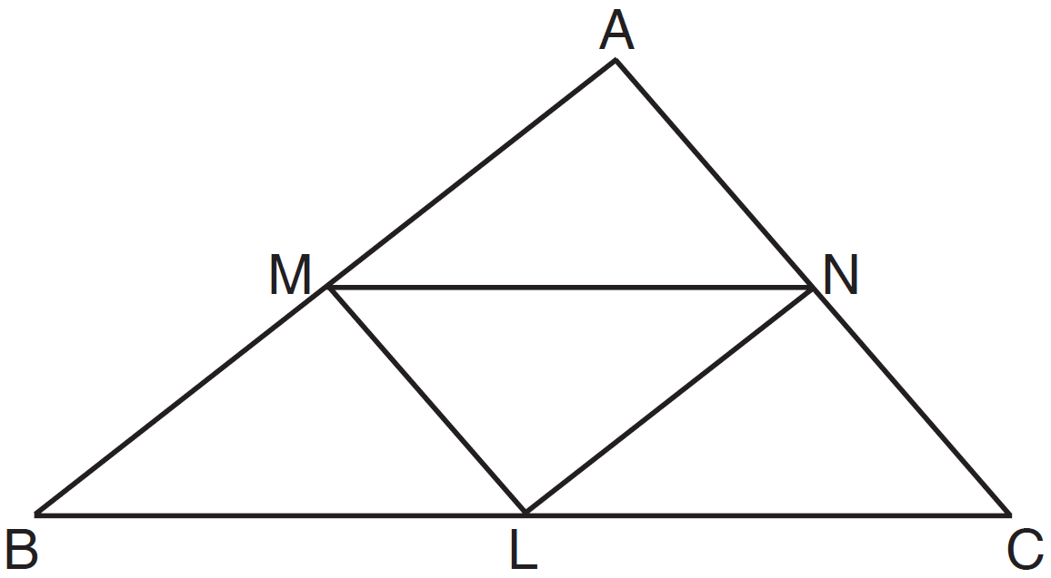

If , , and , the perimeter of trapezoid BMNC is
1) | 35
2) | 31
3) | 28
4) | 26

14 In the diagram below, 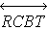 and are shown with and .

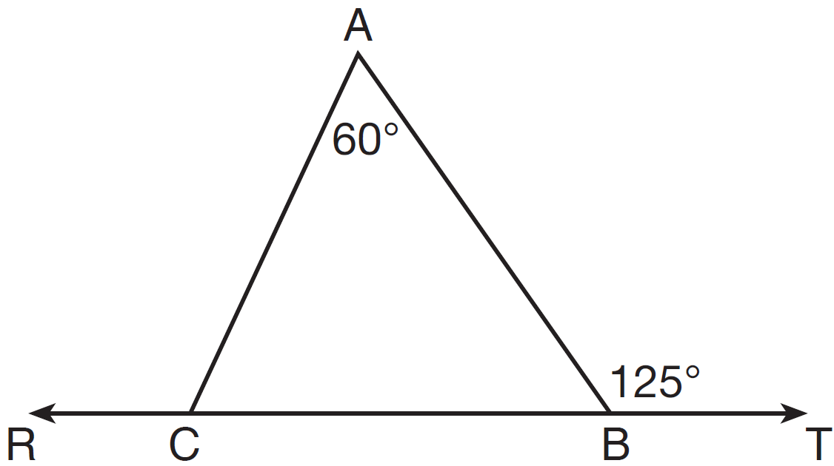

What is ?
1) | 125
2) | 115
3) | 65
4) | 55

15 Which equation represents circle O shown in the graph below?

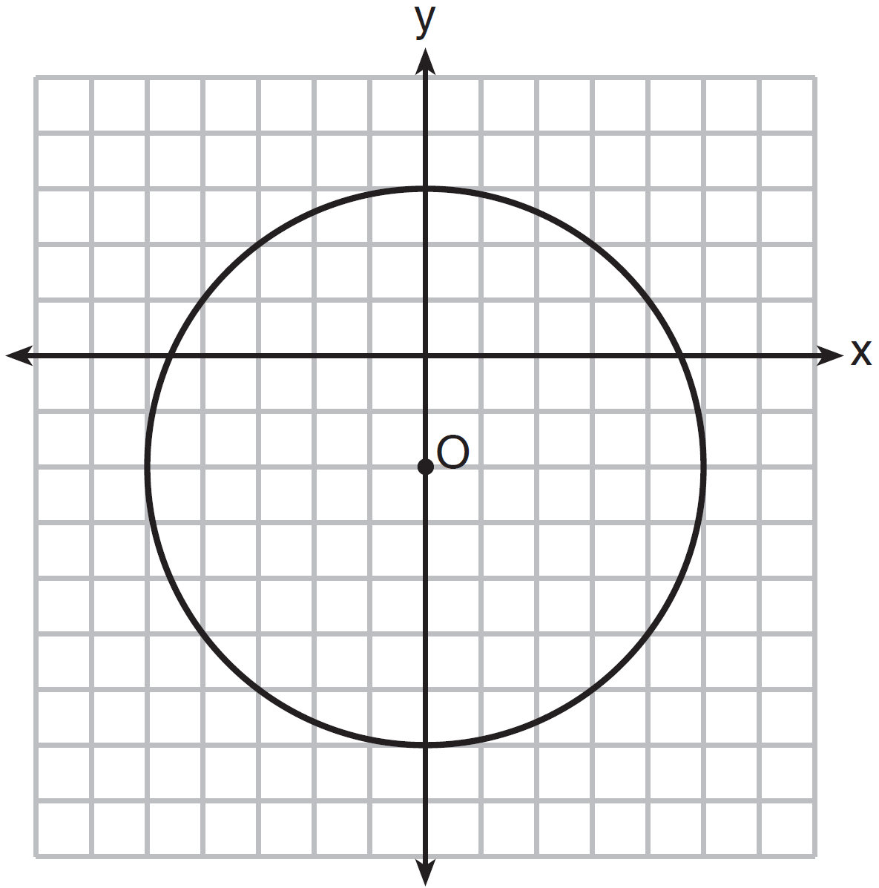
1)
2)
3)
4)

16 For which measures of the sides of is angle B the largest angle of the triangle?
1)
2)
3)
4)

17 What is the measure of the largest exterior angle that any regular polygon can have?
1) | 60º
2) | 90º
3) | 120º
4) | 360º

18 As shown in the diagram below, a landscaper uses a cylindrical lawn roller on a lawn. The roller has a radius of 9 inches and a width of 42 inches.

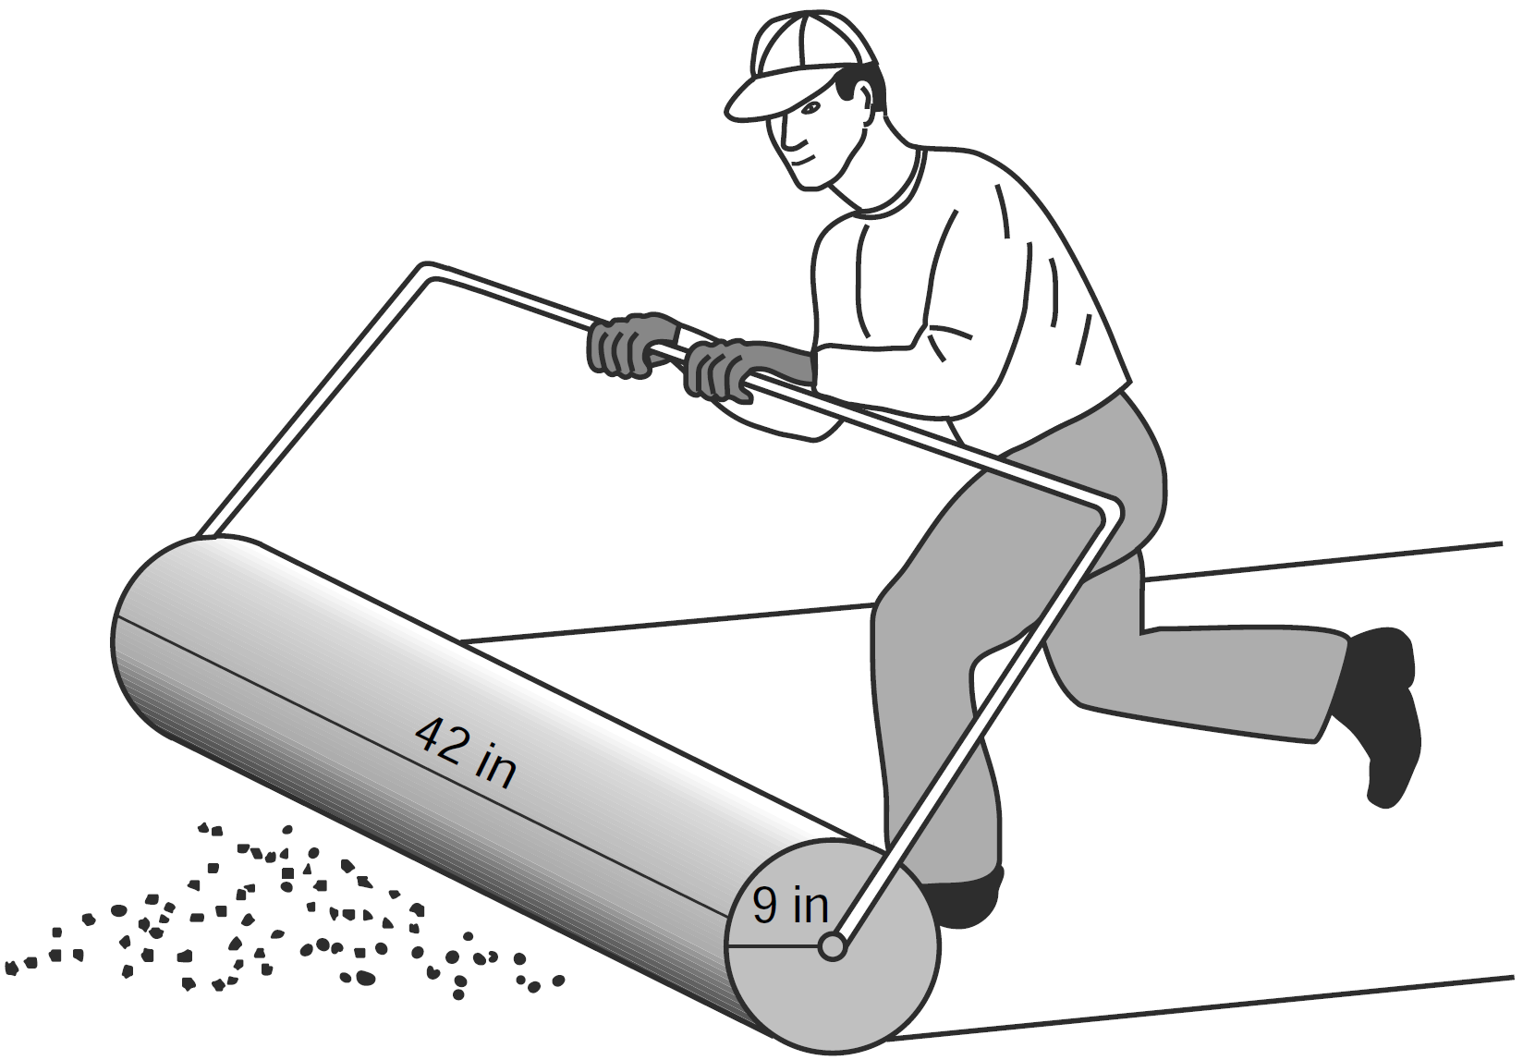

To the nearest square inch, the area the roller covers in one complete rotation is
1) | 2,374
2) | 2,375
3) | 10,682
4) | 10,688

19 In the diagram below, and are tangent to circle O at A and B, respectively, from external point C.

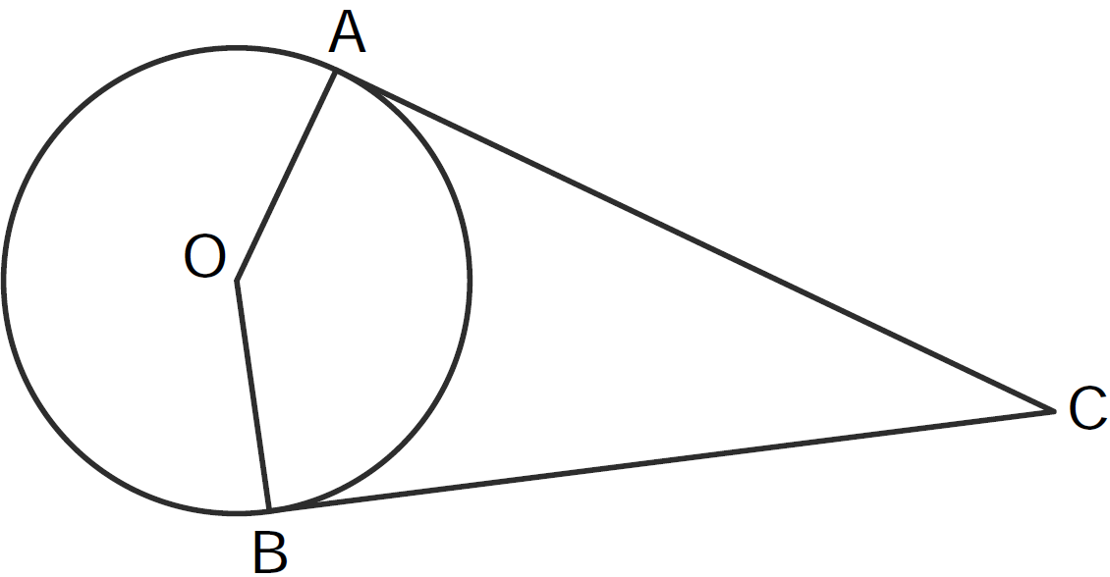

If , what is ?
1) | 71
2) | 104
3) | 142
4) | 161

20 What is the perimeter of a square whose diagonal is ?
1) | 18
2) | 12
3) | 9
4) | 6

21 The coordinates of point P are . What are the coordinates of the image of P after about the origin?
1)
2)
3)
4)

22 Lines p and q are intersected by line r, as shown below.

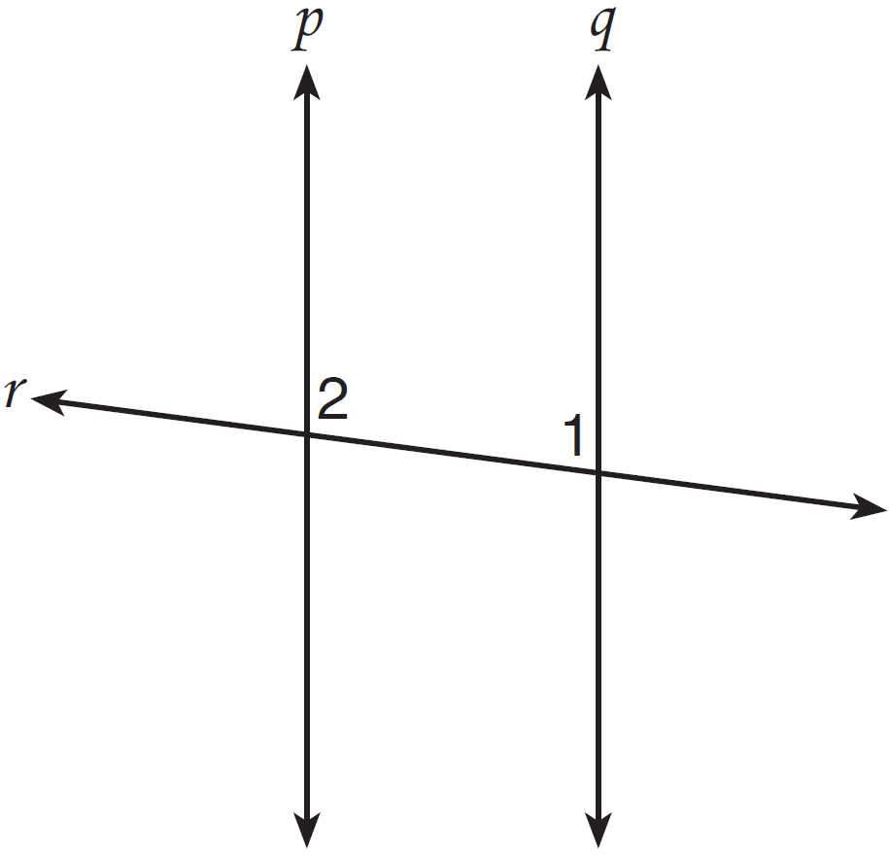

If and , for which value of x would ?
1) | 17
2) | 24
3) | 83
4) | 97

23 What is the equation of the circle with its center at and that passes through the point ?
1)
2)
3)
4)

24 In the diagram below, diameter bisects chord at point E in circle F.

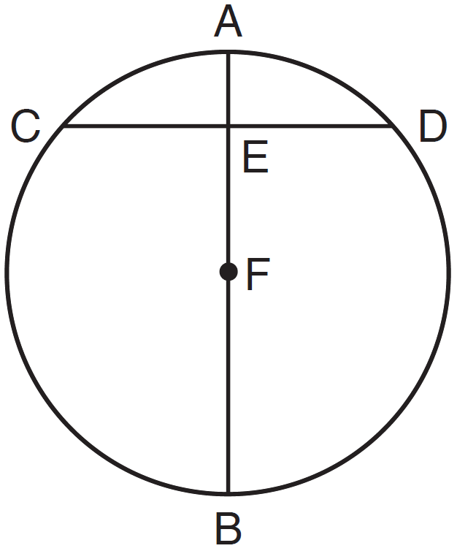

If and , then the length of is
1) | 7
2) | 8
3) | 15
4) | 16

25 Which quadrilateral does not always have congruent diagonals?
1) | isosceles trapezoid
2) | rectangle
3) | rhombus
4) | square

26 A circle with the equation does not include points in Quadrant
1) | I
2) | II
3) | III
4) | IV

27 Trapezoid QRST is graphed on the set of axes below.

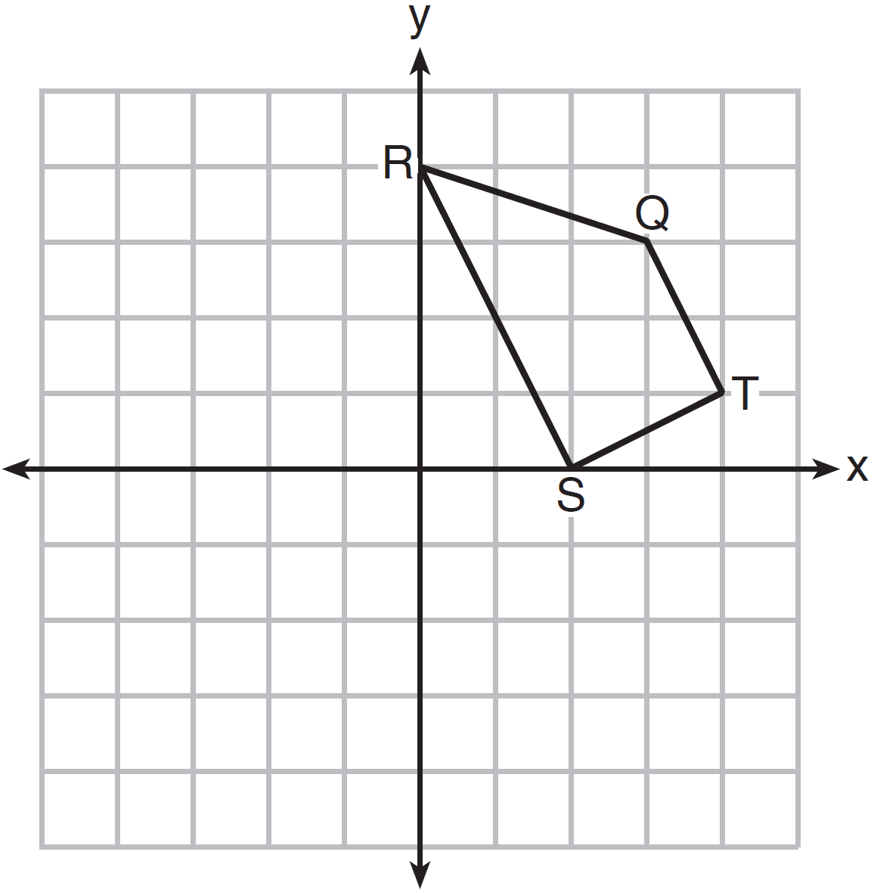

Under which transformation will there be no invariant points?
1)
2)
3)
4)

28 How many common tangent lines can be drawn to the circles shown below?

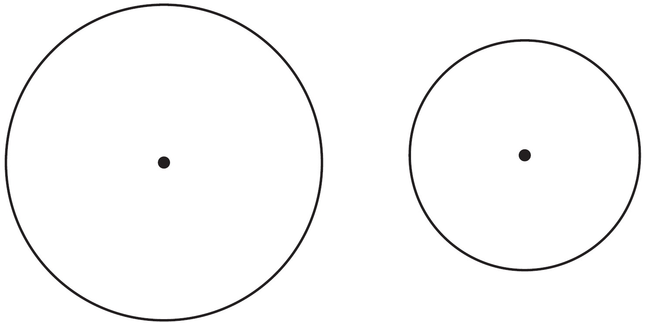
1) | 1
2) | 2
3) | 3
4) | 4

29 The diameter of a sphere is 5 inches. Determine and state the surface area of the sphere, to the nearest hundredth of a square inch.

30 Using a compass and straightedge, construct the perpendicular bisector of . [Leave all construction marks.]

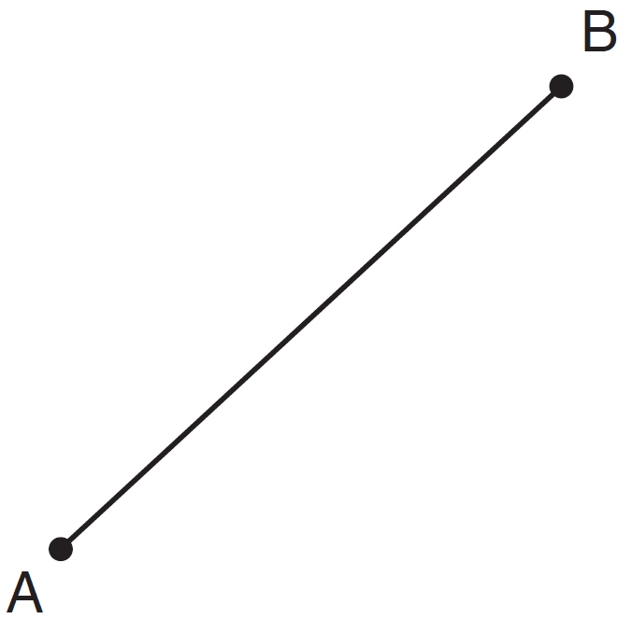

31 The endpoints of are and . Determine and state the length of in simplest radical form.

32 A right prism has a square base with an area of 12 square meters. The volume of the prism is 84 cubic meters. Determine and state the height of the prism, in meters.

33 State whether the lines represented by the equations 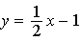 and 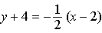 are parallel, perpendicular, or neither. Explain your answer.

34 A tree, T, is 6 meters from a row of corn, c, as represented in the diagram below. A farmer wants to place a scarecrow 2 meters from the row of corn and also 5 meters from the tree. Sketch both loci. Indicate, with an X, all possible locations for the scarecrow.

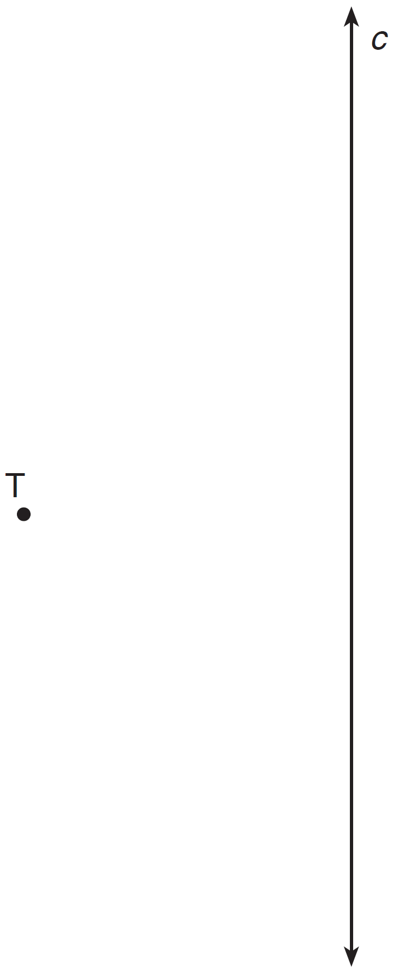

35 In the diagram of shown below, is drawn from vertex B to point A on , such that .

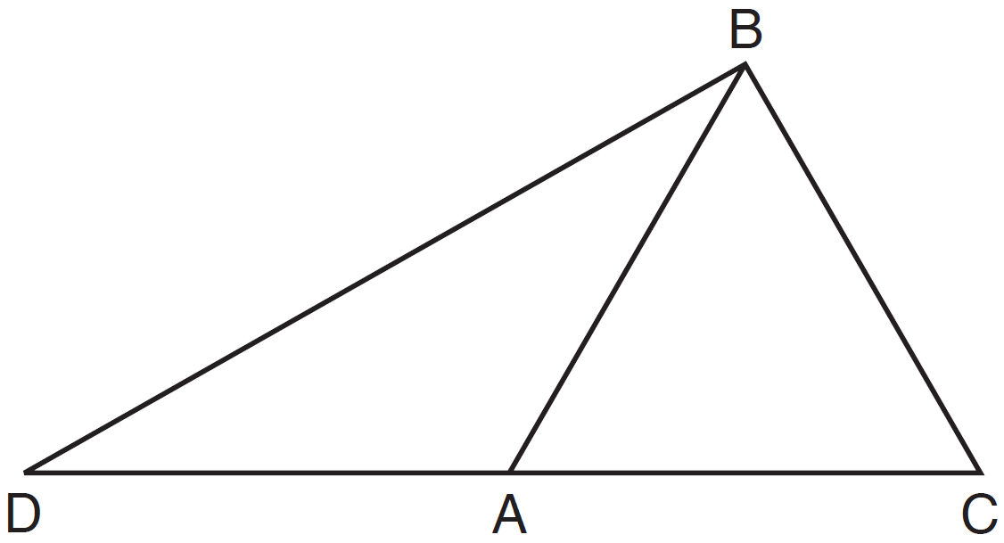

In , , , and . In , and . [Only algebraic solutions can receive full credit.] Find . Find . Find the length of . Find the length of .

36 The coordinates of the vertices of are , , and . State and label the coordinates of the vertices of , the image of after the composition of transformations . [The use of the set of axes below is optional.]

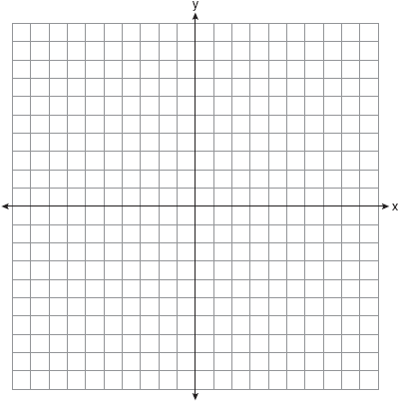

37 In right triangle ABC below, is the altitude to hypotenuse . If and the ratio of AD to AB is 1:5, determine and state the length of . [Only an algebraic solution can receive full credit.]

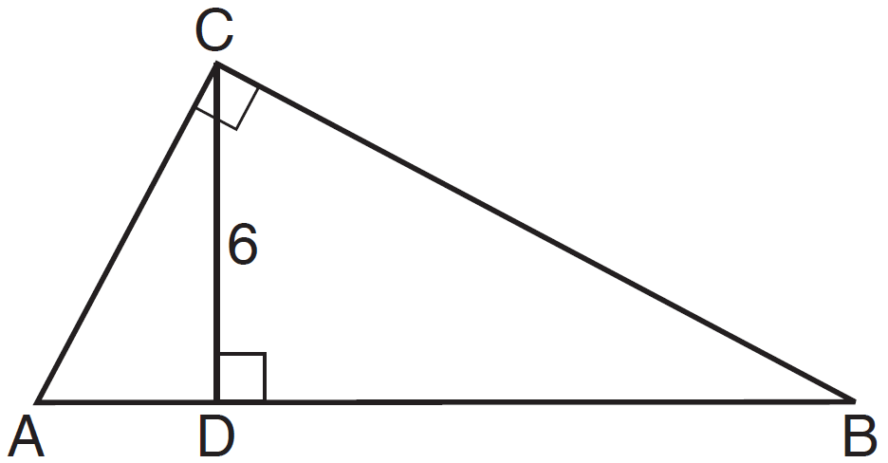

38 In the diagram of circle O below, diameter , chord , tangent , and secant are drawn.

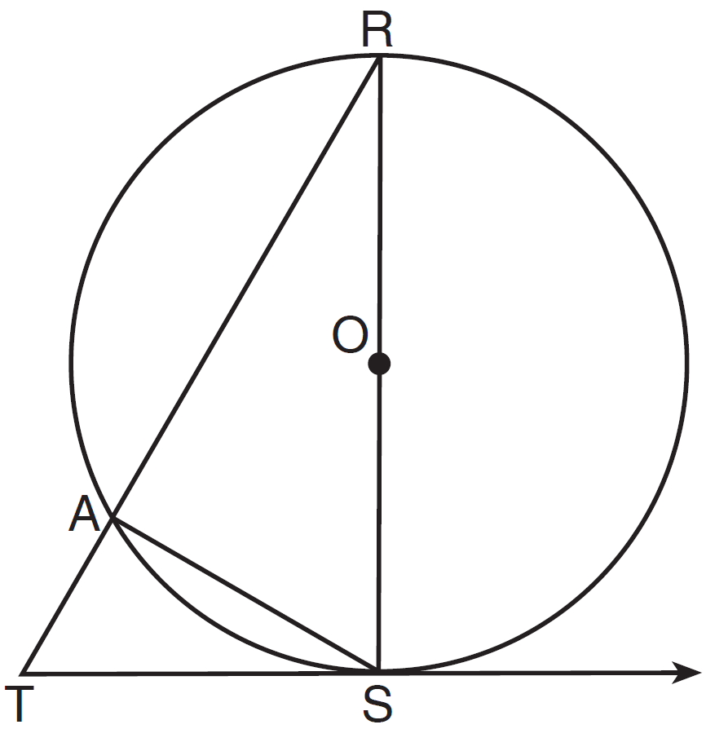

Complete the following proof to show

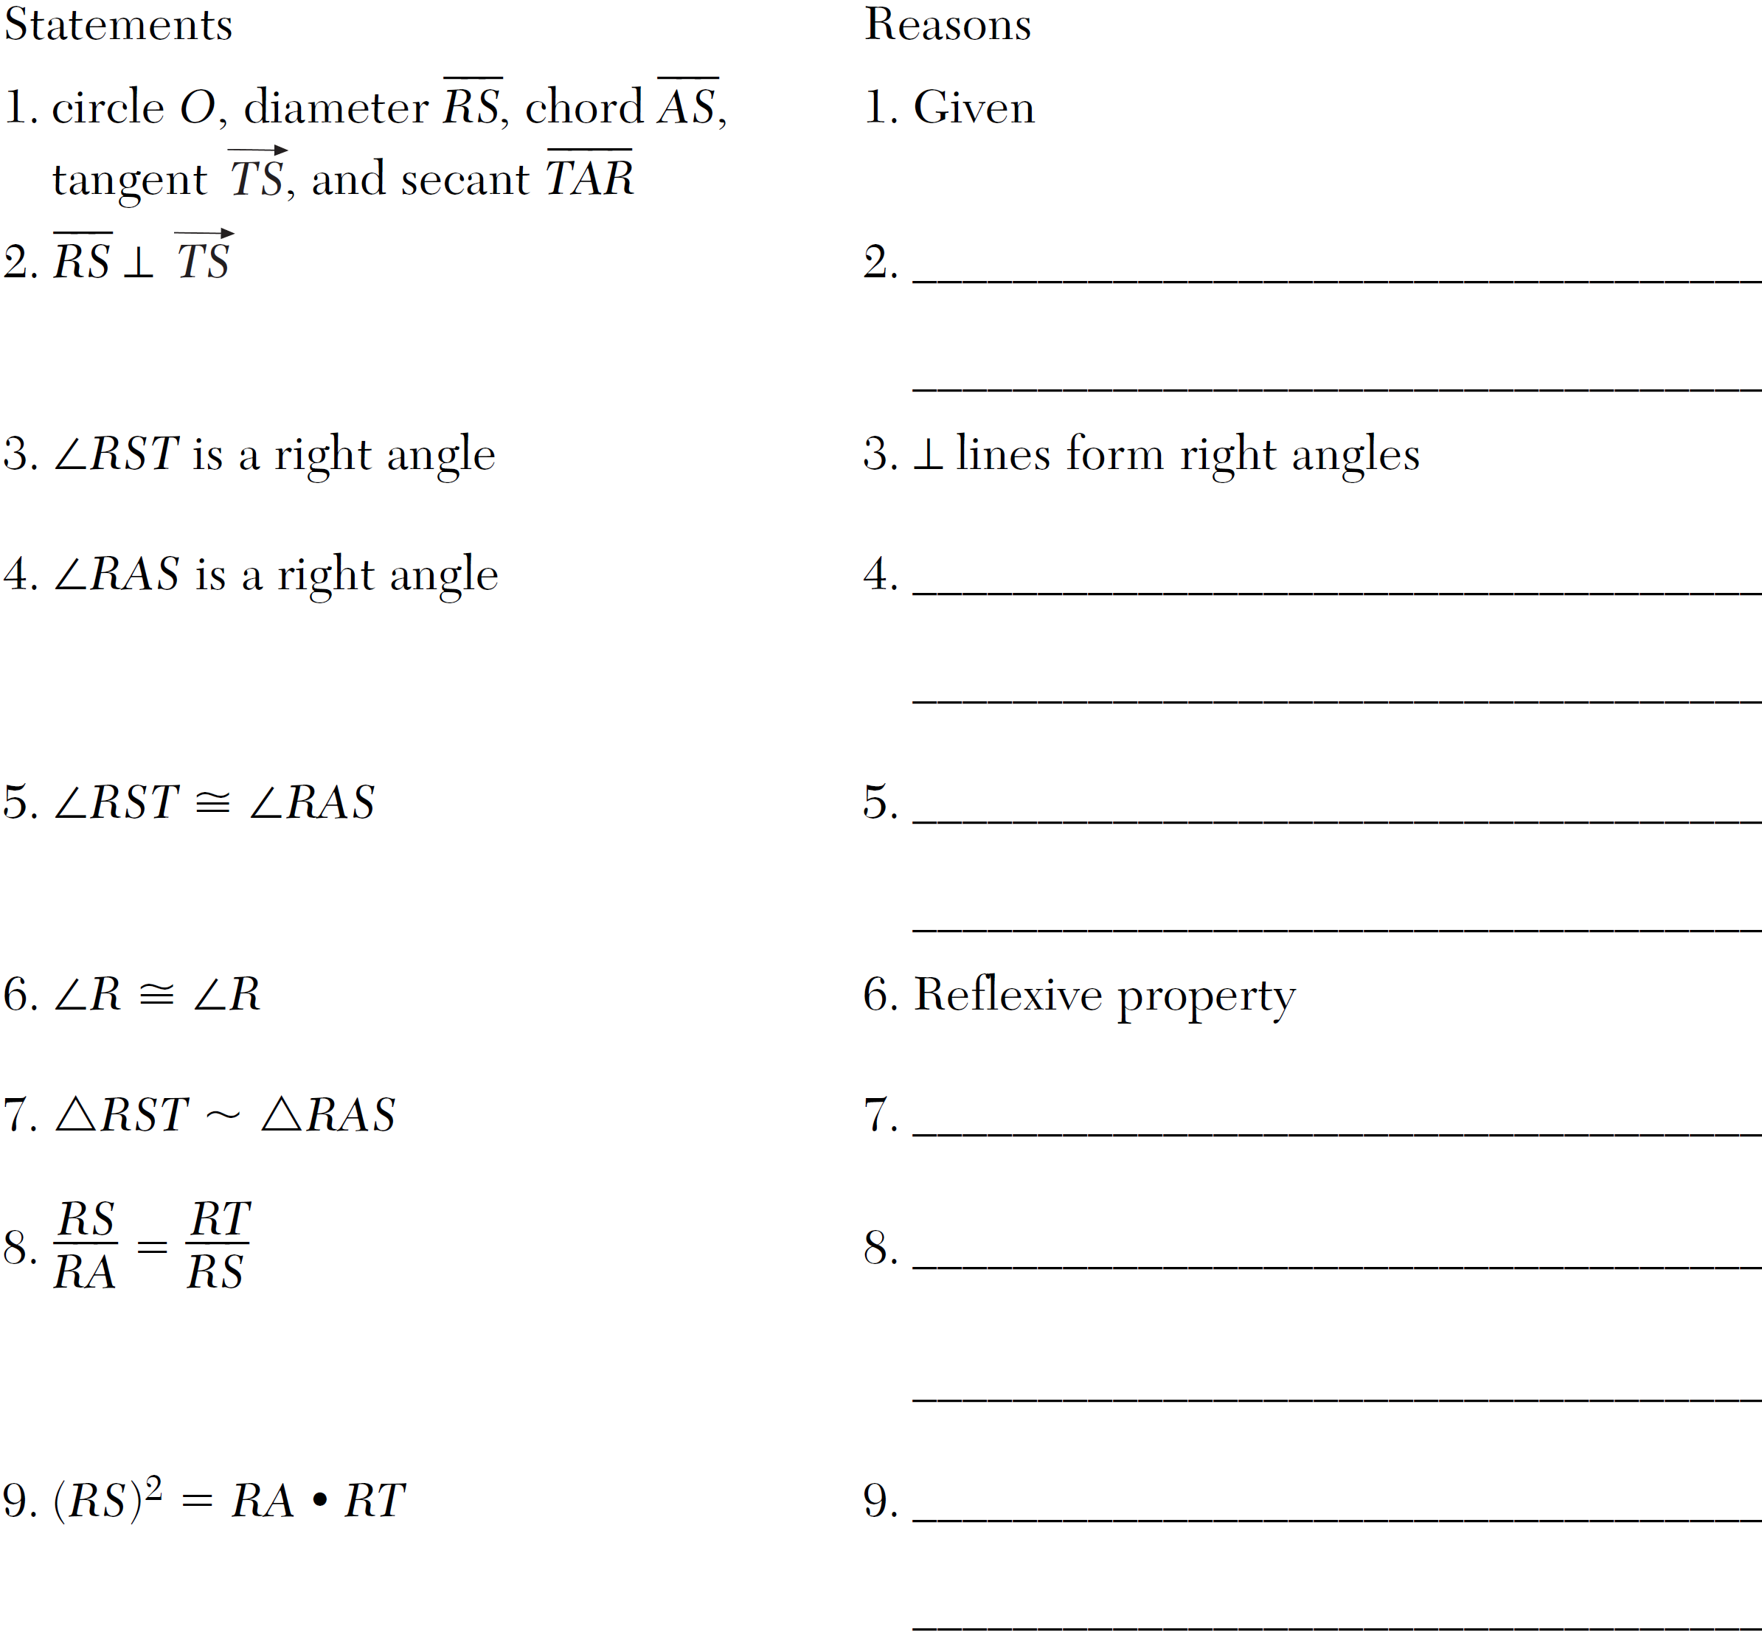
1 ANS: 2
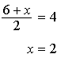. 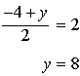
PTS: 2 REF: 011401ge STA: G.G.66 TOP: Midpoint

2 ANS: 3 PTS: 2 REF: 011402ge STA: G.G.17
TOP: Constructions

3 ANS: 4 PTS: 2 REF: 011403ge STA: G.G.73
TOP: Equations of Circles

4 ANS: 1 PTS: 2 REF: 011404ge STA: G.G.9
TOP: Planes

5 ANS: 1 PTS: 2 REF: 011405ge STA: G.G.59
TOP: Properties of Transformations

6 ANS: 4 PTS: 2 REF: 011406ge STA: G.G.10
TOP: Solids

7 ANS: 4 PTS: 2 REF: 011407ge STA: G.G.23
TOP: Locus

8 ANS: 1
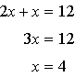.
PTS: 2 REF: 011408ge STA: G.G.43 TOP: Centroid

9 ANS: 2
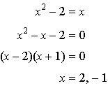
PTS: 2 REF: 011409ge STA: G.G.70 TOP: Quadratic-Linear Systems

10 ANS: 2
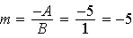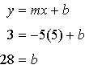

PTS: 2 REF: 011410ge STA: G.G.65 TOP: Parallel and Perpendicular Lines

11 ANS: 2 PTS: 2 REF: 011411ge STA: G.G.27
TOP: Quadrilateral Proofs

12 ANS: 1 PTS: 2 REF: 011412ge STA: G.G.28
TOP: Triangle Congruency

13 ANS: 1
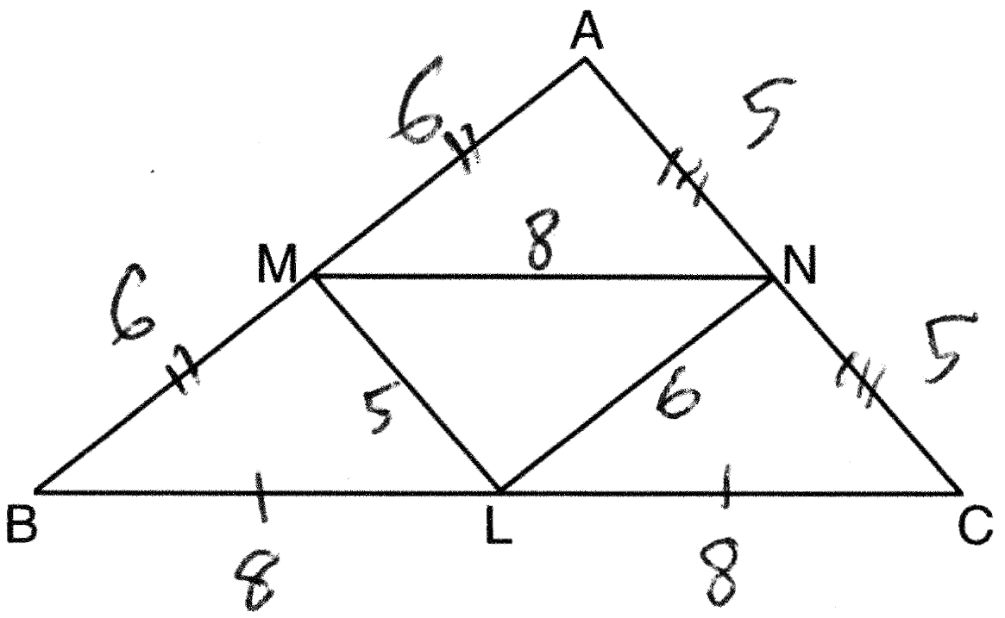

PTS: 2 REF: 011413ge STA: G.G.42 TOP: Midsegments

14 ANS: 2
, so
PTS: 2 REF: 011414ge STA: G.G.32 TOP: Exterior Angle Theorem

15 ANS: 4 PTS: 2 REF: 011415ge STA: G.G.72
TOP: Equations of Circles

16 ANS: 1 PTS: 2 REF: 011416ge STA: G.G.34
TOP: Angle Side Relationship

17 ANS: 3
The regular polygon with the smallest interior angle is an equilateral triangle, with 60º.
PTS: 2 REF: 011417ge STA: G.G.37 TOP: Interior and Exterior Angles of Polygons

18 ANS: 2
PTS: 2 REF: 011418ge STA: G.G.14 TOP: Volume and Lateral Area

19 ANS: 3
PTS: 2 REF: 011419ge STA: G.G.50 TOP: Tangents
KEY: two tangents

20 ANS: 2
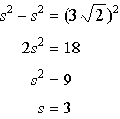
PTS: 2 REF: 011420ge STA: G.G.39 TOP: Special Parallelograms

21 ANS: 4 PTS: 2 REF: 011421ge STA: G.G.54
TOP: Rotations

22 ANS: 1
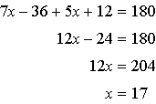

PTS: 2 REF: 011422ge STA: G.G.35 TOP: Parallel Lines and Transversals

23 ANS: 1 PTS: 2 REF: 011423ge STA: G.G.71
TOP: Equations of Circles

24 ANS: 2
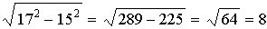
PTS: 2 REF: 011424ge STA: G.G.49 TOP: Chords

25 ANS: 3 PTS: 2 REF: 011425ge STA: G.G.39
TOP: Special Parallelograms

26 ANS: 4 PTS: 2 REF: 011426ge STA: G.G.73
TOP: Equations of Circles

27 ANS: 3 PTS: 2 REF: 011427ge STA: G.G.56
TOP: Identifying Transformations

28 ANS: 4 PTS: 2 REF: 011428ge STA: G.G.50
TOP: Tangents KEY: common tangency

29 ANS:
PTS: 2 REF: 011429ge STA: G.G.16 TOP: Volume and Surface Area

30 ANS:
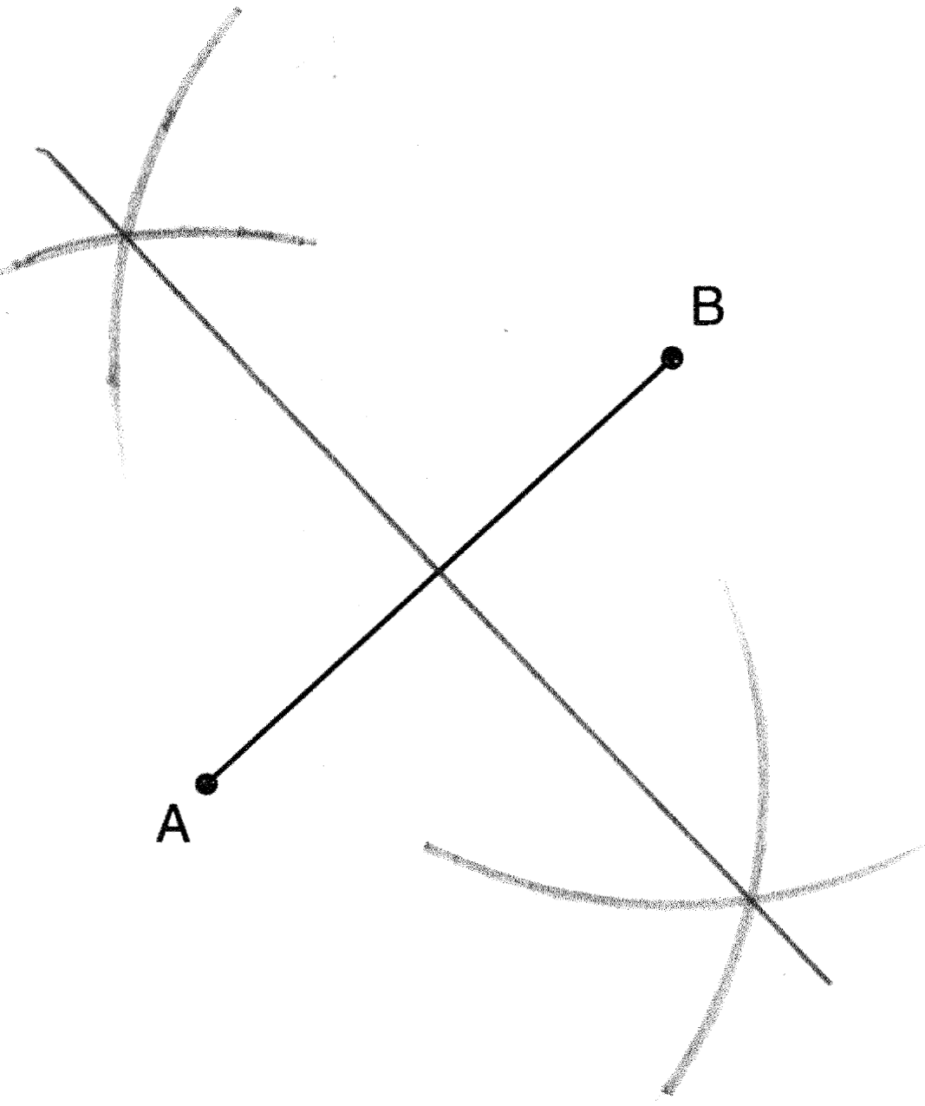
PTS: 2 REF: 011430ge STA: G.G.18 TOP: Constructions

31 ANS:
.
PTS: 2 REF: 011431ge STA: G.G.67 TOP: Distance

32 ANS:
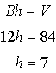
PTS: 2 REF: 011432ge STA: G.G.12 TOP: Volume

33 ANS:
Neither. The slope of is . The slope of is . The slopes are neither the same nor opposite reciprocals.
PTS: 2 REF: 011433ge STA: G.G.63 TOP: Parallel and Perpendicular Lines

34 ANS:
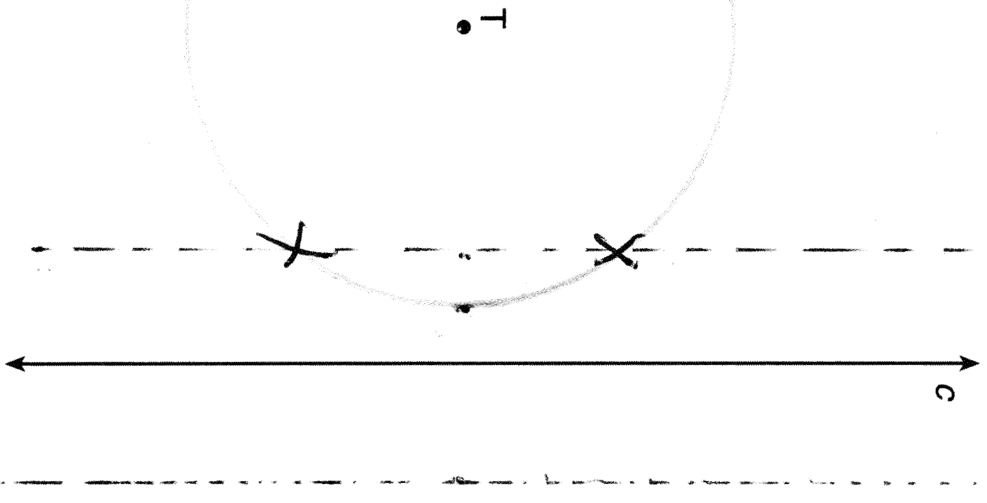
PTS: 2 REF: 011434ge STA: G.G.22 TOP: Locus

35 ANS:
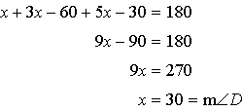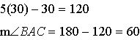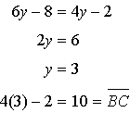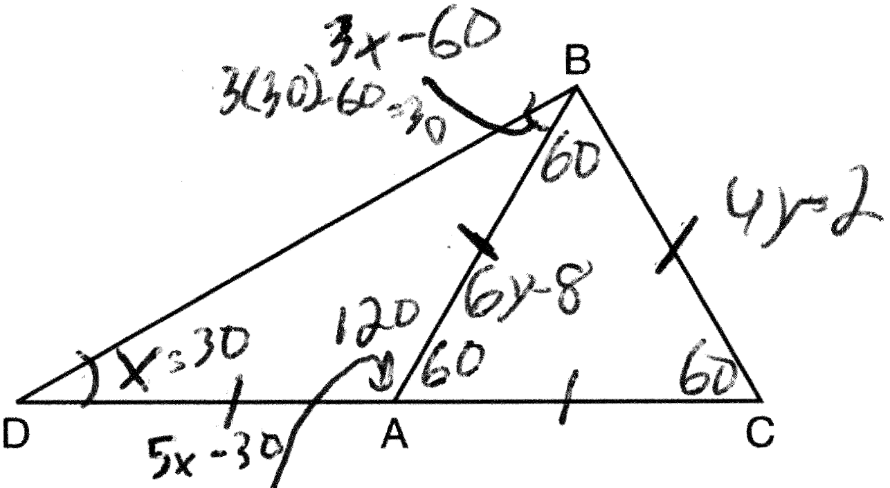
PTS: 3 REF: 011435ge STA: G.G.31 TOP: Isosceles Triangle Theorem

36 ANS:
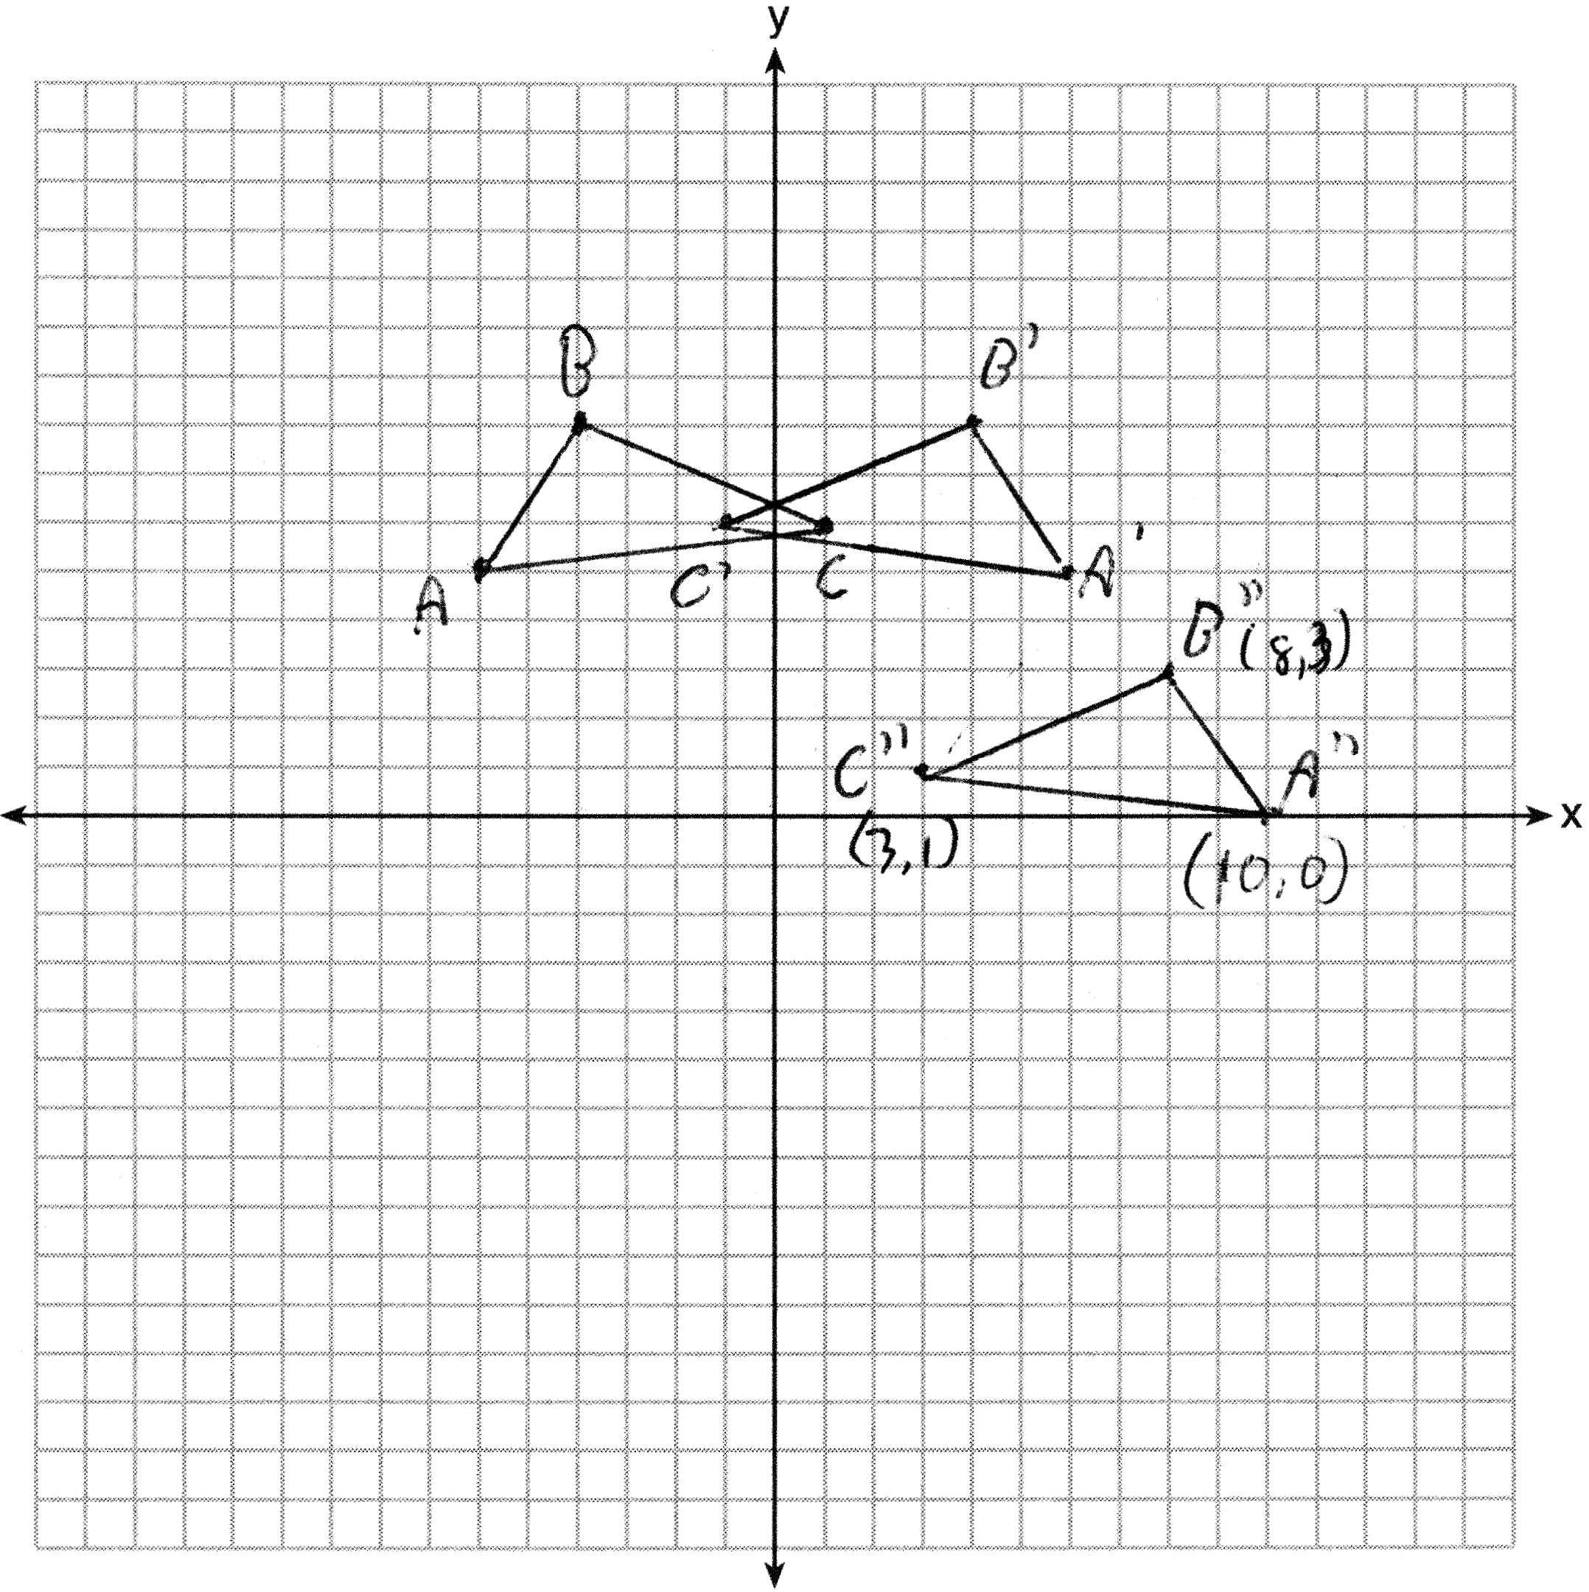
PTS: 3 REF: 011436ge STA: G.G.58 TOP: Compositions of Transformations
KEY: grids

37 ANS:
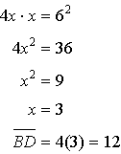
PTS: 4 REF: 011437ge STA: G.G.47 TOP: Similarity
KEY: leg

38 ANS:
2. The diameter of a circle is to a tangent at the point of tangency. 4. An angle inscribed in a semicircle is a right angle. 5. All right angles are congruent. 7. AA. 8. Corresponding sides of congruent triangles are in proportion. 9. The product of the means equals the product of the extremes.
PTS: 6 REF: 011438ge STA: G.G.27 TOP: Circle Proofs

