1 If and is the shortest side of , what is the shortest side of ?
1)
2)
3)
4)

2 In circle O shown in the diagram below, chords and are parallel.

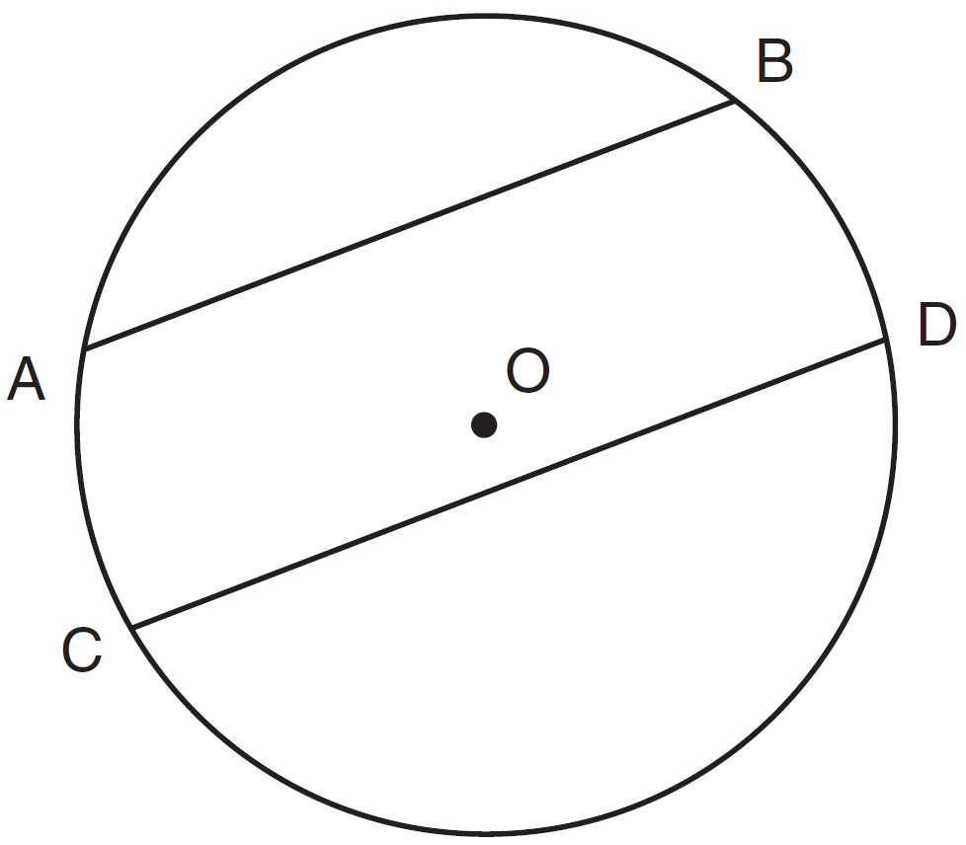

If and , what is ?
1) | 38
2) | 44
3) | 88
4) | 96

3 As shown in the diagram below, is a median of .

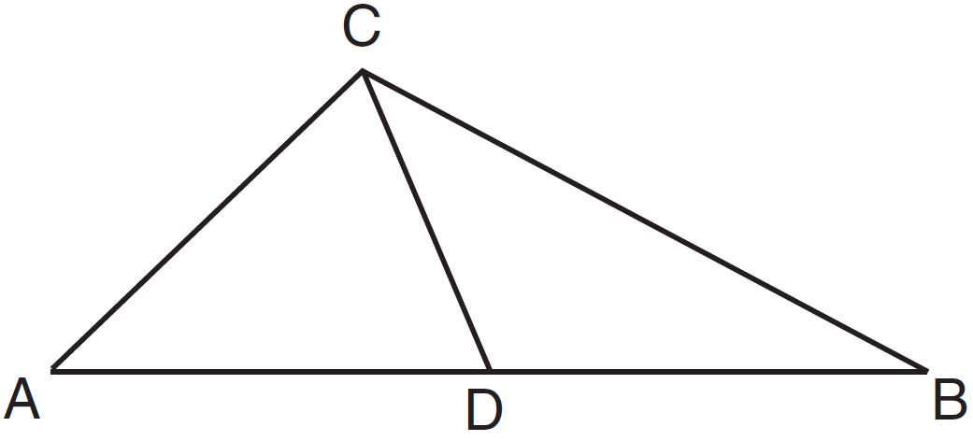

Which statement is always true?
1)
2)
3)
4)

4 In the diagram below, under which transformation is the image of ?

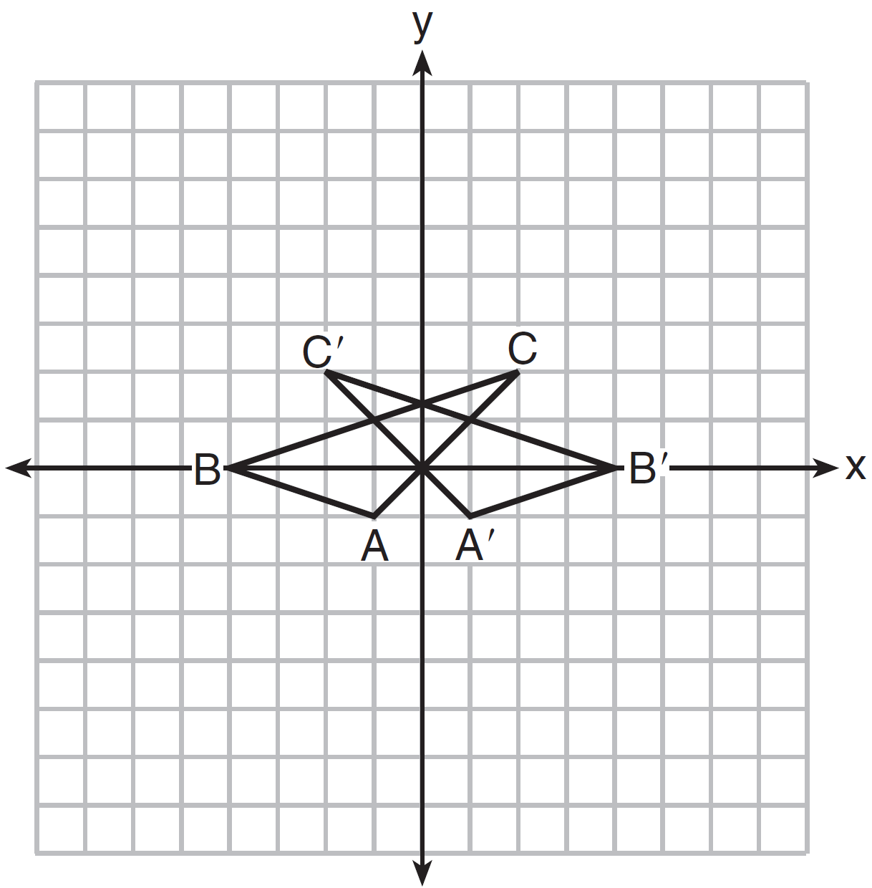
1)
2)
3)
4)

5 Line segment AB is a diameter of circle O whose center has coordinates . What are the coordinates of point B if the coordinates of point A are ?
1)
2)
3)
4)

6 Plane A and plane B are two distinct planes that are both perpendicular to line . Which statement about planes A and B is true?
1) | Planes A and B have a common edge, which forms a line.
2) | Planes A and B are perpendicular to each other.
3) | Planes A and B intersect each other at exactly one point.
4) | Planes A and B are parallel to each other.

7 Triangle ABC is similar to triangle DEF. The lengths of the sides of are 5, 8, and 11. What is the length of the shortest side of if its perimeter is 60?
1) | 10
2) | 12.5
3) | 20
4) | 27.5

8 In the diagram below of right triangle ABC, altitude is drawn to hypotenuse .

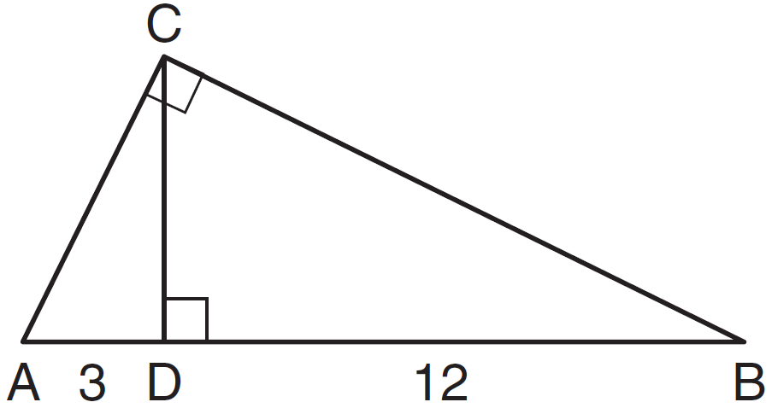

If and , what is the length of altitude ?
1) | 6
2)
3) | 3
4)

9 The diagram below shows the construction of an equilateral triangle.

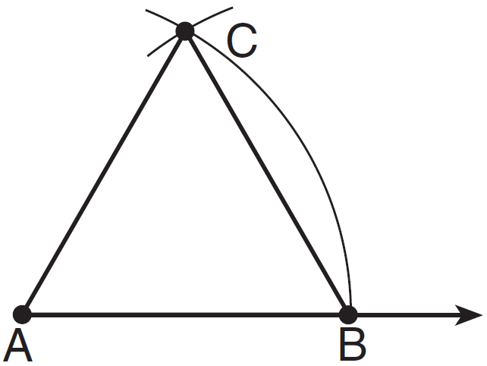

Which statement justifies this construction?
1)
2)
3)
4)

10 What is the slope of the line perpendicular to the line represented by the equation ?
1)
2) | 2
3)
4)

11 Triangle ABC is shown in the diagram below.

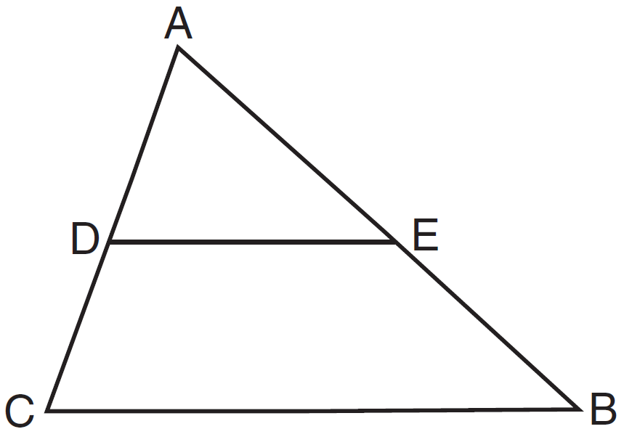

If joins the midpoints of and , which statement is not true?
1) | 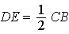
2)
3) | 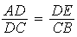
4)

12 The equations and are graphed on a set of axes. What is the solution of this system?
1)
2)
3)
4)

13 Square ABCD has vertices , , , and . What is the length of a side of the square?
1)
2)
3)
4)

14 The diagram below shows , with 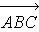, , and .

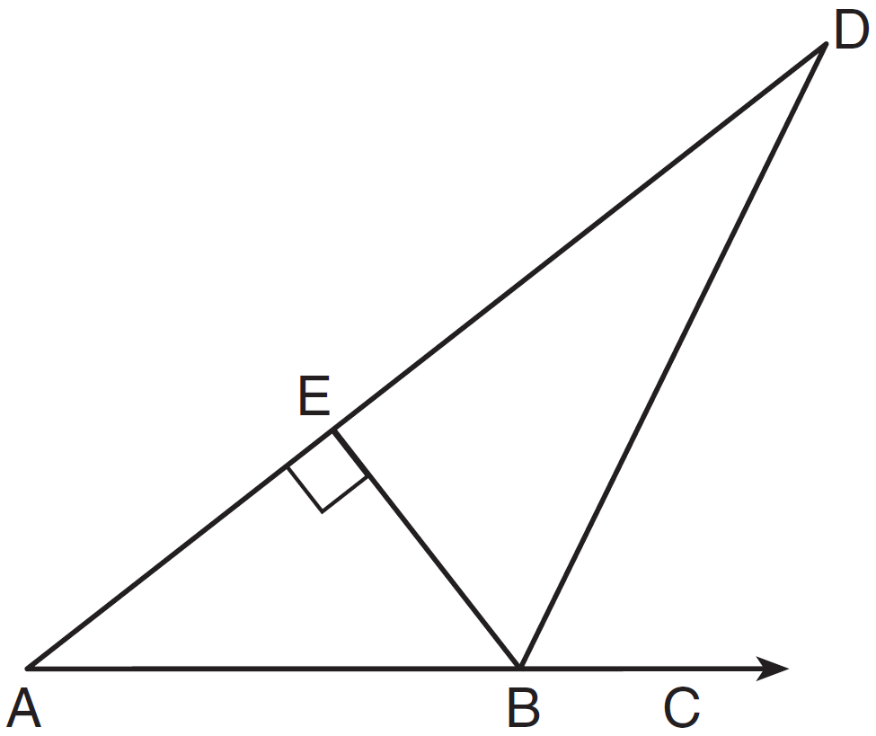

If , what is ?
1) | 26
2) | 38
3) | 52
4) | 64

15 As shown in the diagram below, and intersect at point A and is perpendicular to both and at A.

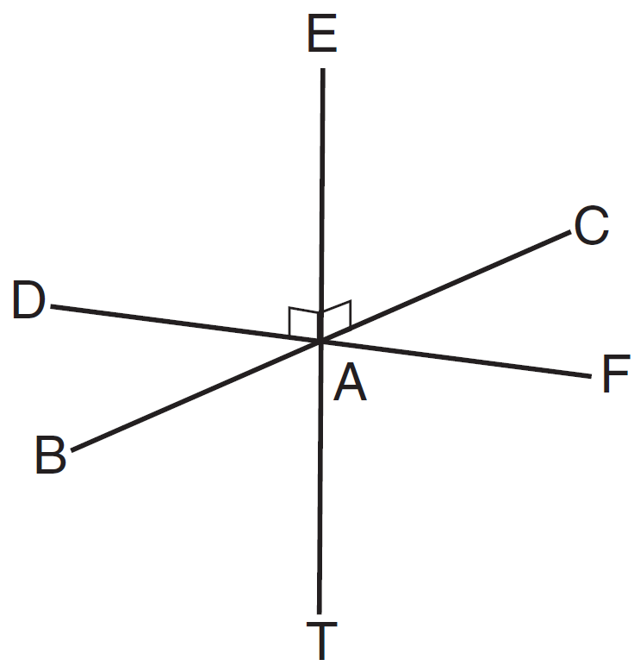

Which statement is not true?
1) | is perpendicular to plane BAD.
2) | is perpendicular to plane FAB.
3) | is perpendicular to plane CAD.
4) | is perpendicular to plane BAT.

16 Which set of numbers could not represent the lengths of the sides of a right triangle?
1)
2)
3)
4)

17 How many points are 5 units from a line and also equidistant from two points on the line?
1) | 1
2) | 2
3) | 3
4) | 0

18 The equation of a circle is . What are the coordinates of the center of this circle and the length of its radius?
1) | and 16
2) | and 16
3) | and
4) | and

19 The equation of a line is 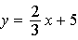. What is an equation of the line that is perpendicular to the given line and that passes through the point ?
1) | 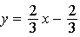
2) | 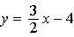
3) | 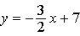
4) | 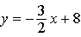

20 Consider the relationship between the two statements below.
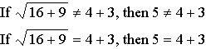
These statements are
1) | inverses
2) | converses
3) | contrapositives
4) | biconditionals

21 In the diagram of trapezoid ABCD below, , , , and .

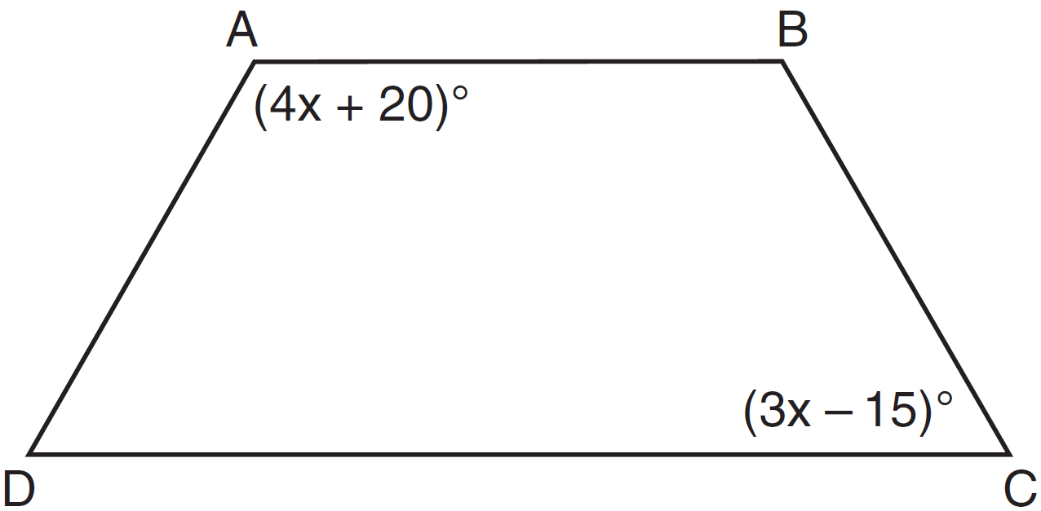

What is ?
1) | 25
2) | 35
3) | 60
4) | 90

22 In circle R shown below, diameter is perpendicular to chord at point L.

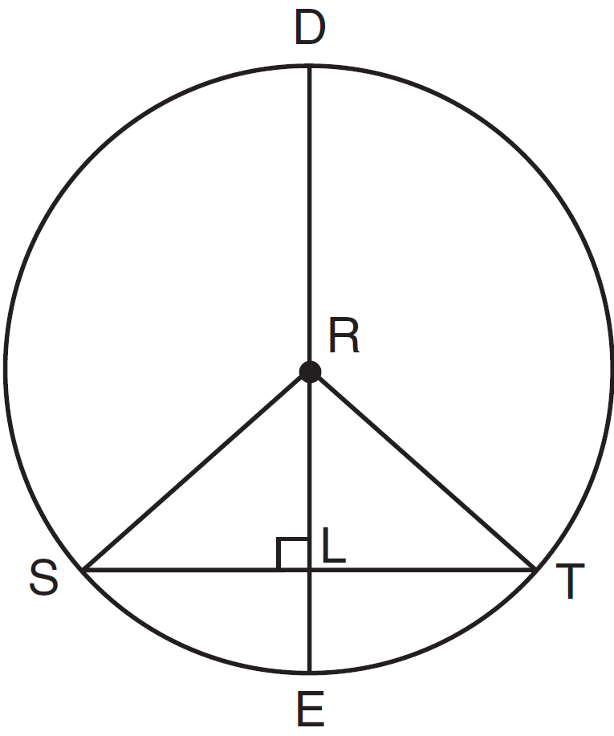

Which statement is not always true?
1)
2)
3)
4)

23 Which equation represents circle A shown in the diagram below?

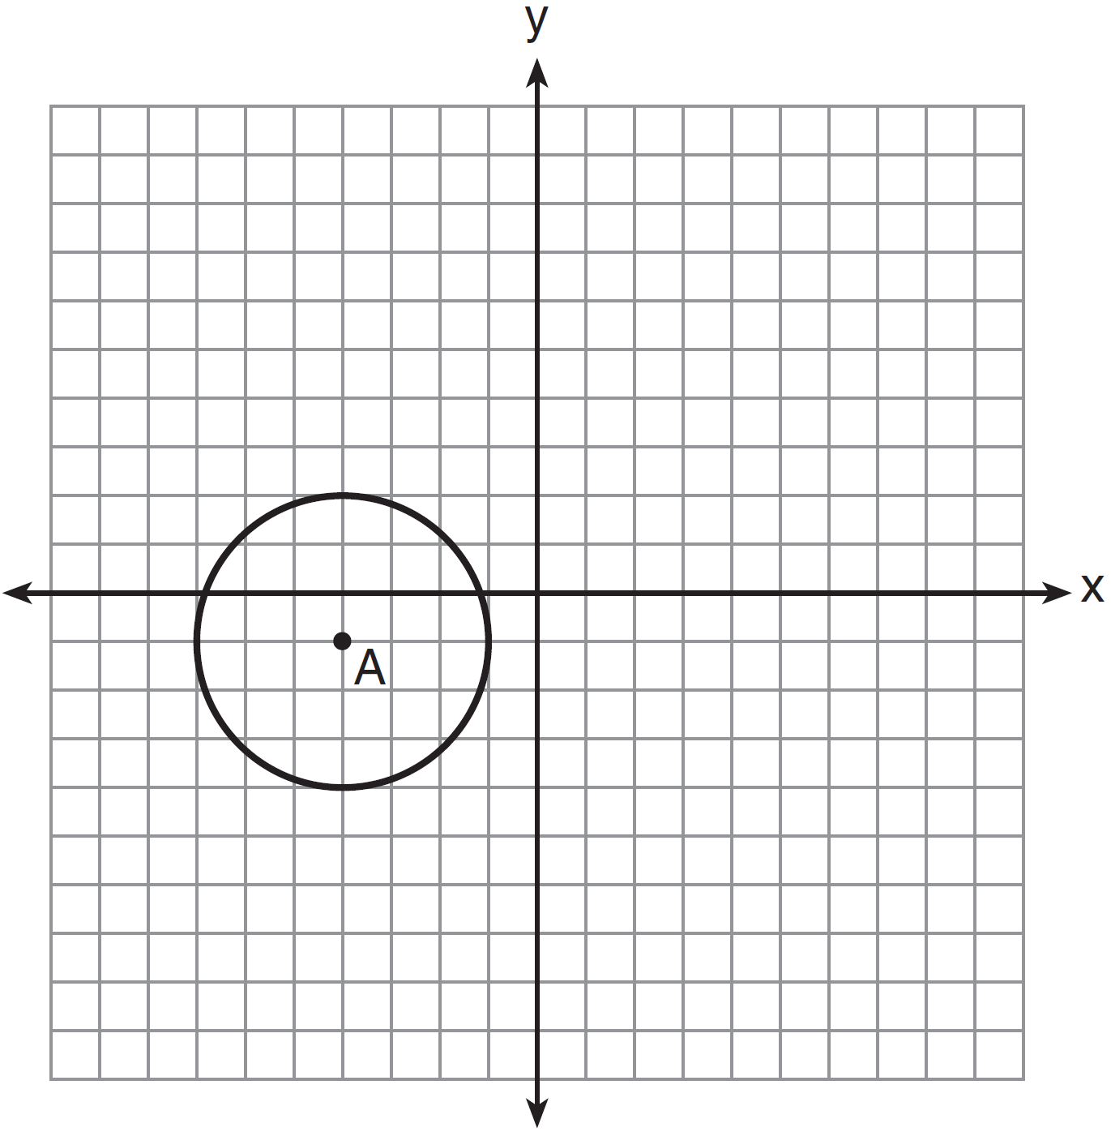
1)
2)
3)
4)

24 Which equation represents a line that is parallel to the line whose equation is ?
1) | 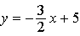
2) | 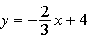
3) | 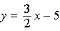
4) | 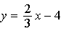

25 In the diagram below of circle O, and are secants.

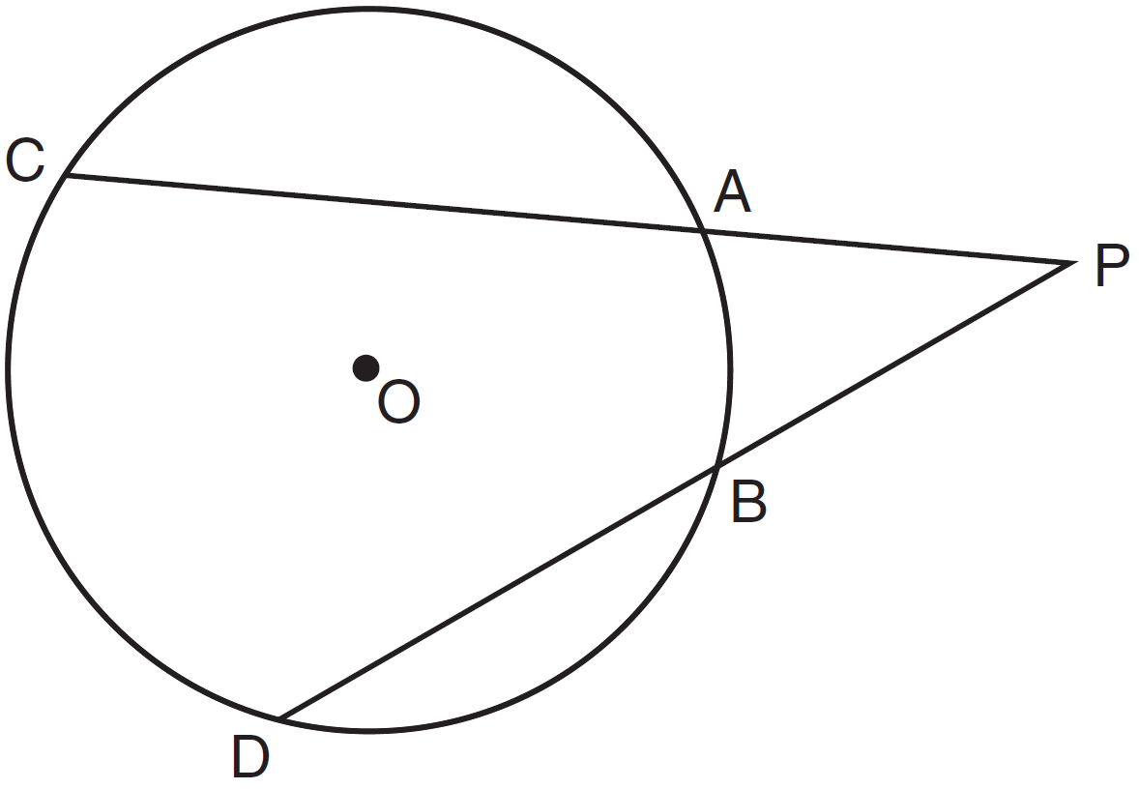

If and , what is the degree measure of ?
1) | 25
2) | 35
3) | 45
4) | 50

26 The measure of an interior angle of a regular polygon is 120°. How many sides does the polygon have?
1) | 5
2) | 6
3) | 3
4) | 4

27 As shown in the diagram of rectangle ABCD below, diagonals and intersect at E.

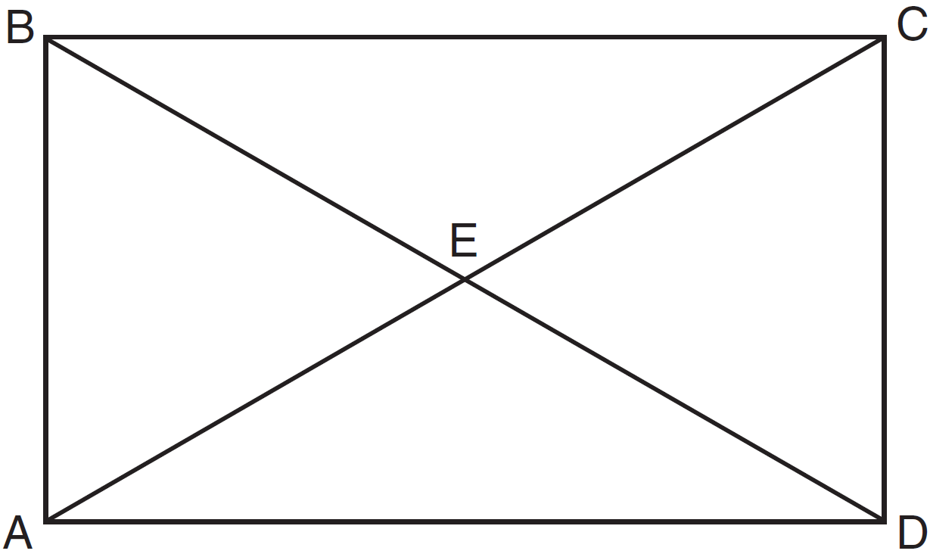

If and , then the length of is
1) | 6
2) | 10
3) | 12
4) | 24

28 If the vertices of are , , and , then is classified as
1) | right
2) | scalene
3) | isosceles
4) | equilateral

29 After the transformation , the image of is . If and , find the value of x.

30 In the diagram below, circles A and B are tangent at point C and is drawn. Sketch all common tangent lines.

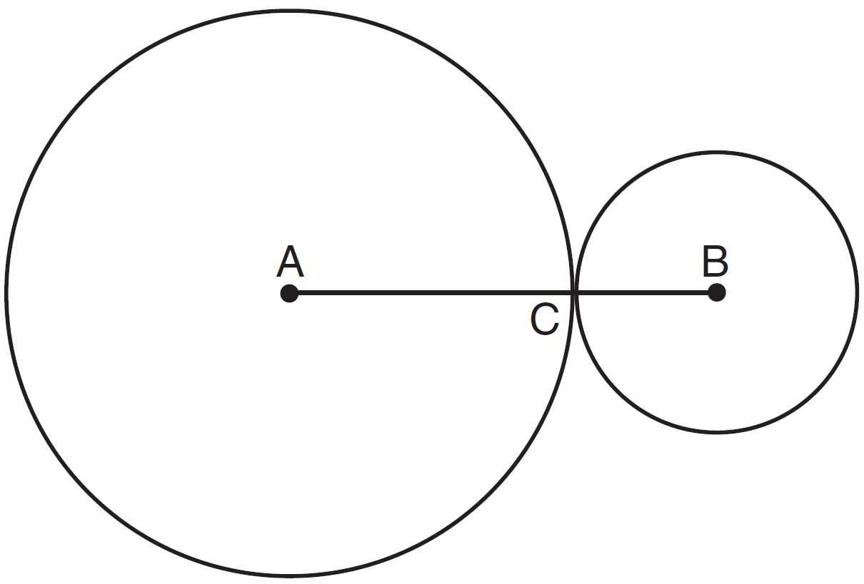

31 On the set of axes below, graph the locus of points 4 units from and the locus of points 3 units from the origin. Label with an X any points that satisfy both conditions.

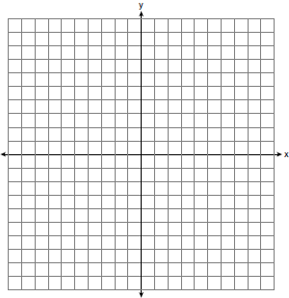

32 Write an equation of a circle whose center is and whose diameter is 10.

33 Using a compass and straightedge, construct a line perpendicular to line through point P. [Leave all construction marks.]

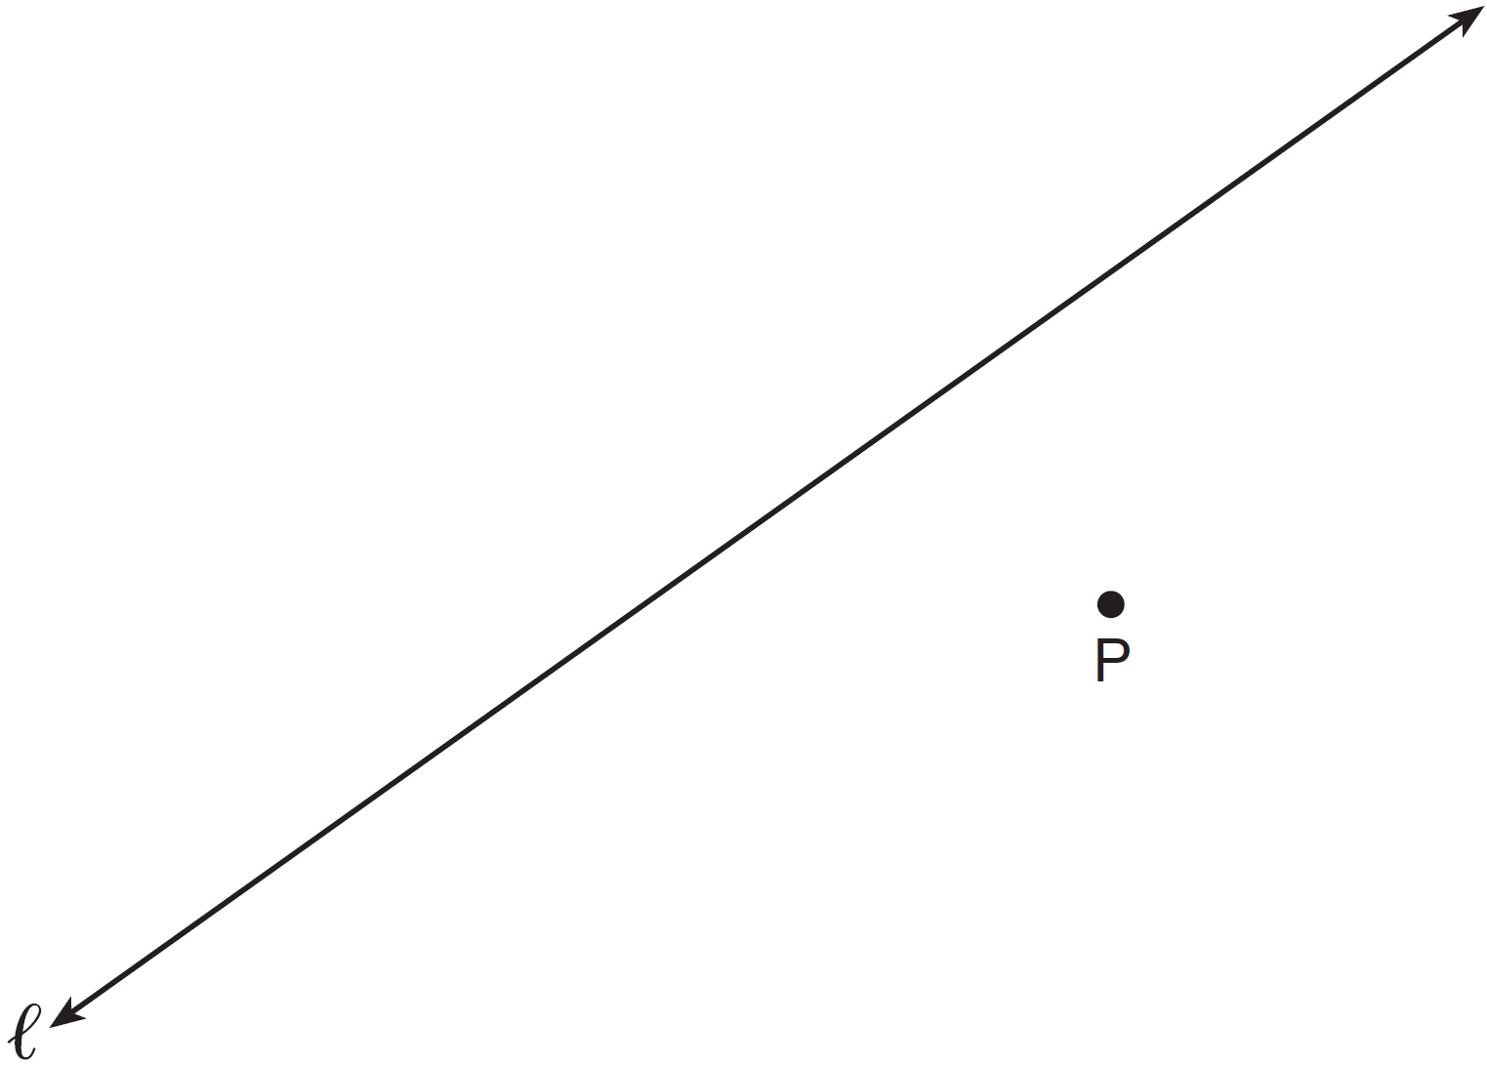

34 Write an equation of the line that is the perpendicular bisector of the line segment having endpoints and . [The use of the grid below is optional]

35 A right circular cylinder with a height of 5 cm has a base with a diameter of 6 cm. Find the lateral area of the cylinder to the nearest hundredth of a square centimeter. Find the volume of the cylinder to the nearest hundredth of a cubic centimeter.

36 Triangle ABC has vertices , and . State and label the coordinates of the vertices of , the image of , following the composite transformation . [The use of the set of axes below is optional.]

37 In , , , and . Determine the longest side of .

38 The diagram below shows rectangle ABCD with points E and F on side . Segments and intersect at G, and . Prove:

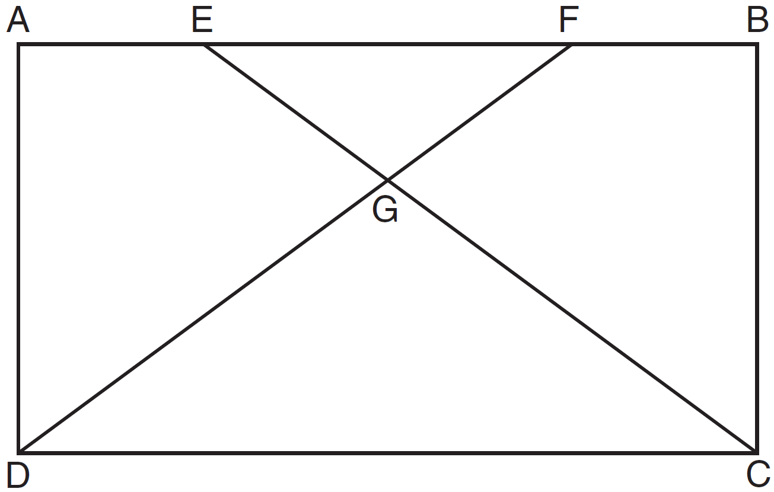

1 ANS: 1 PTS: 2 REF: 011301ge STA: G.G.29
TOP: Triangle Congruency

2 ANS: 2
Parallel chords intercept congruent arcs. 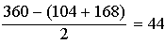
PTS: 2 REF: 011302ge STA: G.G.52 TOP: Chords

3 ANS: 1 PTS: 2 REF: 011303ge STA: G.G.24
TOP: Statements

4 ANS: 3 PTS: 2 REF: 011304ge STA: G.G.56
TOP: Identifying Transformations

5 ANS: 3
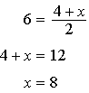. 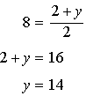.
PTS: 2 REF: 011305ge STA: G.G.66 TOP: Midpoint

6 ANS: 4 PTS: 2 REF: 011306ge STA: G.G.9
TOP: Planes

7 ANS: 2
Perimeter of is . 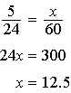
PTS: 2 REF: 011307ge STA: G.G.45 TOP: Similarity
KEY: perimeter and area

8 ANS: 1
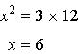
PTS: 2 REF: 011308ge STA: G.G.47 TOP: Similarity
KEY: altitude

9 ANS: 3 PTS: 2 REF: 011309ge STA: G.G.20
TOP: Constructions

10 ANS: 2
The slope of is 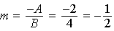. .
PTS: 2 REF: 011310ge STA: G.G.62 TOP: Parallel and Perpendicular Lines

11 ANS: 3 PTS: 2 REF: 011311ge STA: G.G.42
TOP: Midsegments

12 ANS: 3
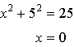
PTS: 2 REF: 011312ge STA: G.G.70 TOP: Quadratic-Linear Systems

13 ANS: 2
PTS: 2 REF: 011313ge STA: G.G.69 TOP: Quadrilaterals in the Coordinate Plane

14 ANS: 1
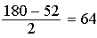.
PTS: 2 REF: 011314ge STA: G.G.30 TOP: Interior and Exterior Angles of Triangles

15 ANS: 4 PTS: 2 REF: 011315ge STA: G.G.1
TOP: Planes

16 ANS: 2
PTS: 2 REF: 011316ge STA: G.G.48 TOP: Pythagorean Theorem

17 ANS: 2 PTS: 2 REF: 011317ge STA: G.G.22
TOP: Locus

18 ANS: 4 PTS: 2 REF: 011318ge STA: G.G.73
TOP: Equations of Circles

19 ANS: 4
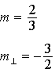. 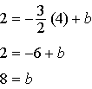
PTS: 2 REF: 011319ge STA: G.G.64 TOP: Parallel and Perpendicular Lines

20 ANS: 1 PTS: 2 REF: 011320ge STA: G.G.26
TOP: Conditional Statements

21 ANS: 3
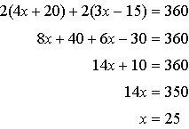.
PTS: 2 REF: 011321ge STA: G.G.40 TOP: Trapezoids

22 ANS: 3 PTS: 2 REF: 011322ge STA: G.G.49
TOP: Chords

23 ANS: 4 PTS: 2 REF: 011323ge STA: G.G.72
TOP: Equations of Circles

24 ANS: 3
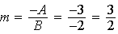
PTS: 2 REF: 011324ge STA: G.G.63 TOP: Parallel and Perpendicular Lines

25 ANS: 1
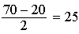
PTS: 2 REF: 011325ge STA: G.G.51 TOP: Arcs Determined by Angles
KEY: outside circle

26 ANS: 2
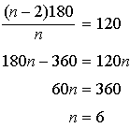.
PTS: 2 REF: 011326ge STA: G.G.37 TOP: Interior and Exterior Angles of Polygons

27 ANS: 4
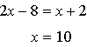. .
PTS: 2 REF: 011327ge STA: G.G.39 TOP: Special Parallelograms

28 ANS: 3
. 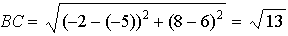. 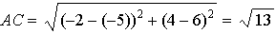
PTS: 2 REF: 011328ge STA: G.G.69 TOP: Triangles in the Coordinate Plane

29 ANS:
Distance is preserved after the reflection. 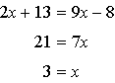
PTS: 2 REF: 011329ge STA: G.G.55 TOP: Properties of Transformations

30 ANS:
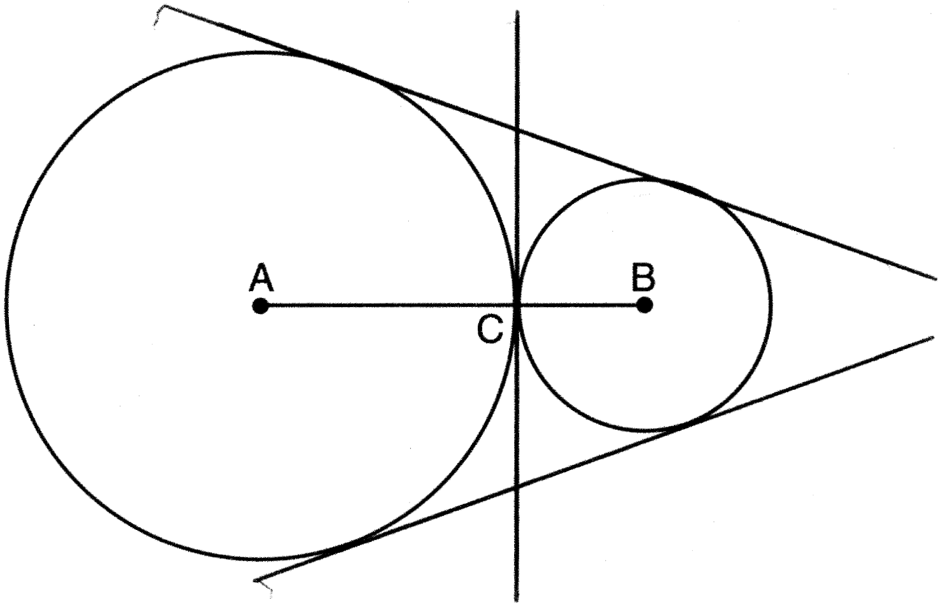
PTS: 2 REF: 011330ge STA: G.G.50 TOP: Tangents
KEY: common tangency

31 ANS:
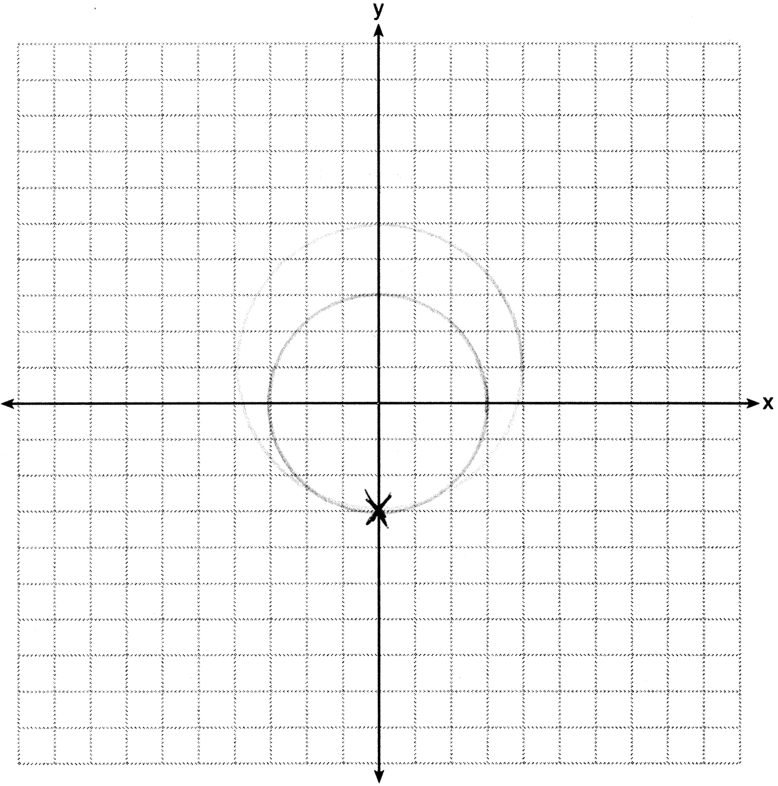
PTS: 2 REF: 011331ge STA: G.G.23 TOP: Locus

32 ANS:
If , then .
PTS: 2 REF: 011332ge STA: G.G.71 TOP: Equations of Circles

33 ANS:
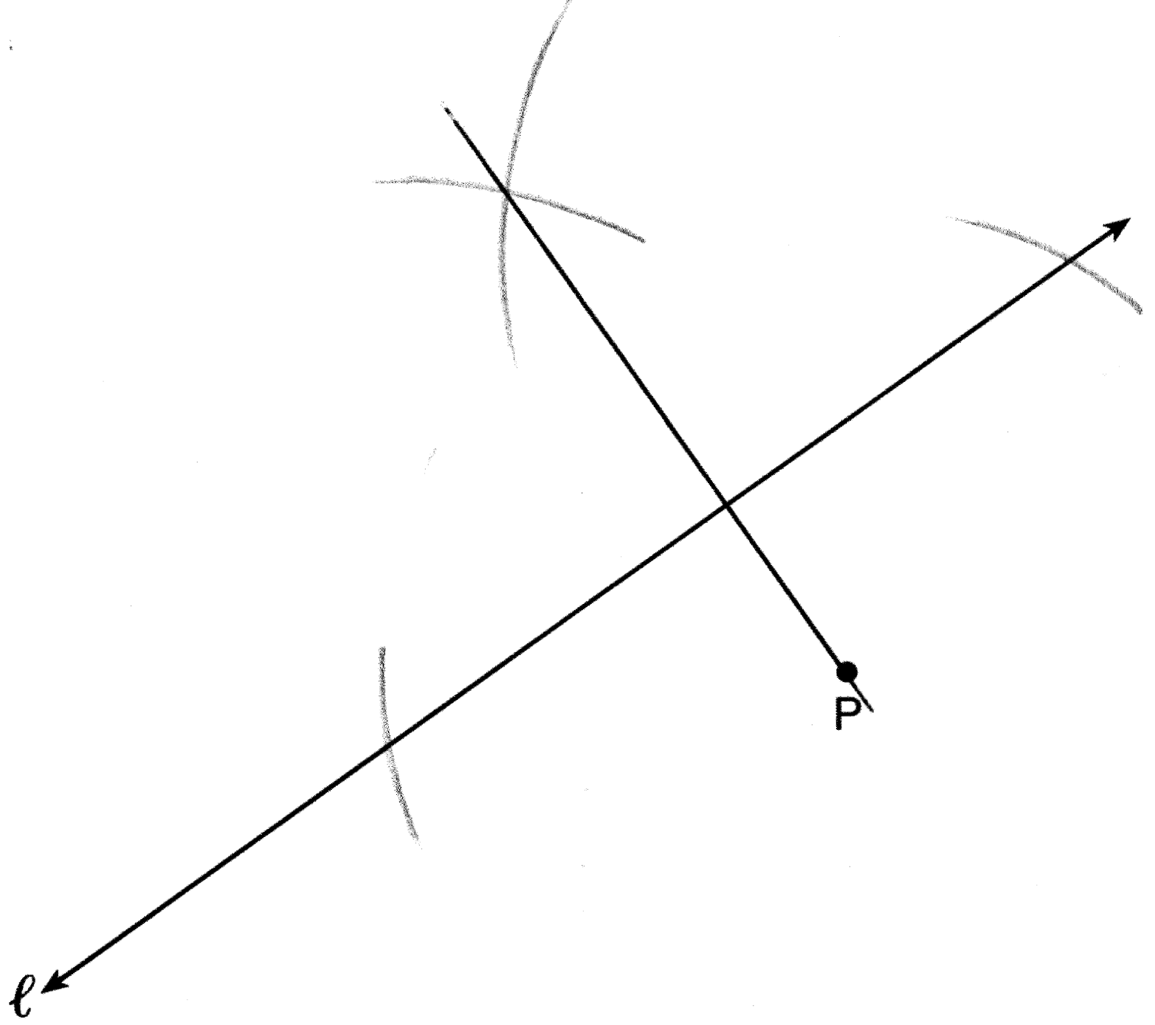
PTS: 2 REF: 011333ge STA: G.G.19 TOP: Constructions

34 ANS:
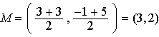. . 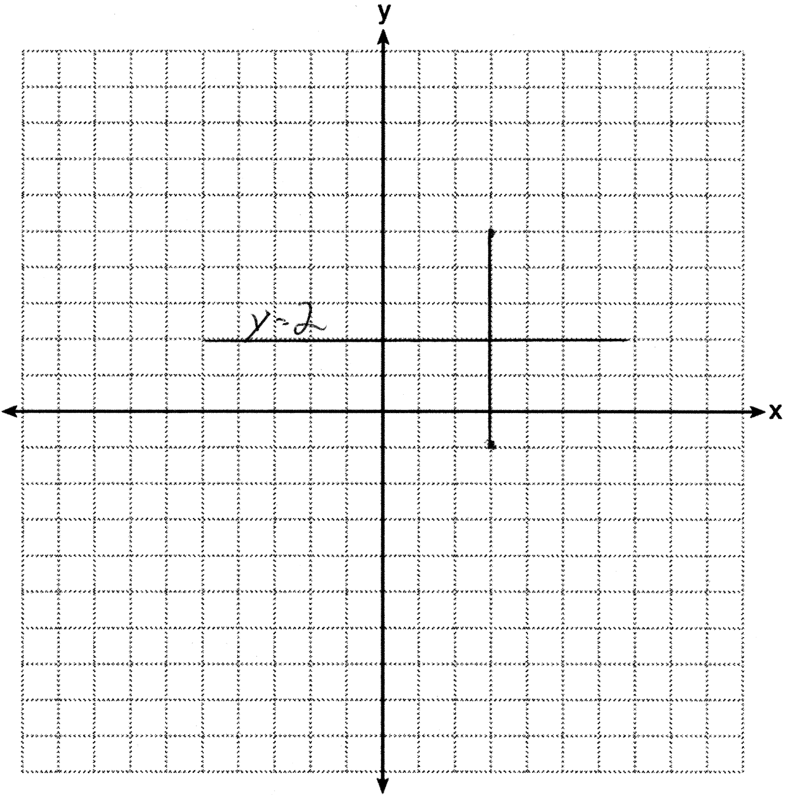
PTS: 2 REF: 011334ge STA: G.G.68 TOP: Perpendicular Bisector

35 ANS:
.
PTS: 4 REF: 011335ge STA: G.G.14 TOP: Volume and Lateral Area

36 ANS:
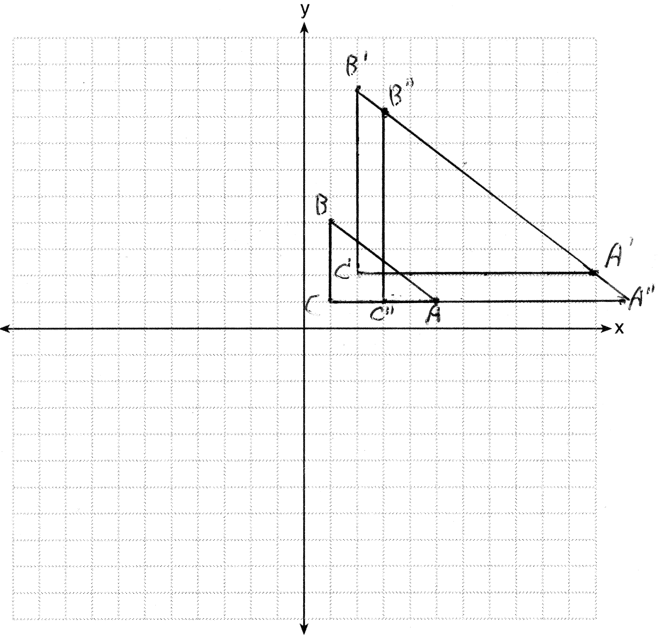
PTS: 4 REF: 011336ge STA: G.G.58 TOP: Compositions of Transformations

37 ANS:
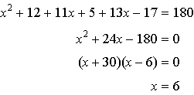. 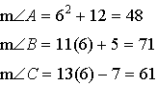. is the largest angle, so in the longest side.
PTS: 4 REF: 011337ge STA: G.G.34 TOP: Angle Side Relationship

38 ANS:
Rectangle ABCD with points E and F on side , segments and intersect at G, and are given. because opposite sides of a rectangle are congruent. and are right angles and congruent because all angles of a rectangle are right and congruent. by ASA. per CPCTC. under the Reflexive Property. using the Subtraction Property of Segments. because of the Definition of Segments.
PTS: 6 REF: 011338ge STA: G.G.27

