1 Line n intersects lines l and m, forming the angles shown in the diagram below.

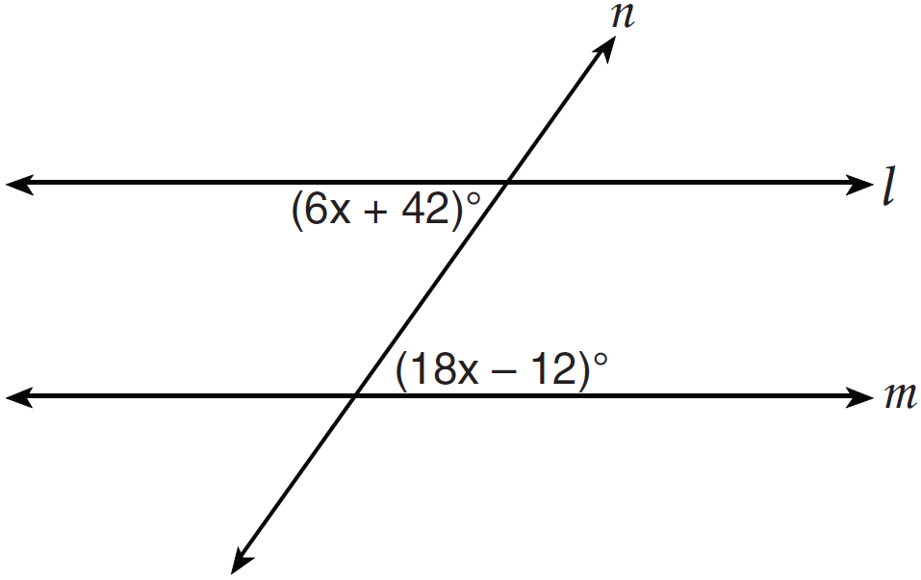

Which value of x would prove ?
1) | 2.5
2) | 4.5
3) | 6.25
4) | 8.75

2 In a given triangle, the point of intersection of the three medians is the same as the point of intersection of the three altitudes. Which classification of the triangle is correct?
1) | scalene triangle
2) | isosceles triangle
3) | equilateral triangle
4) | right isosceles triangle

3 A circle has the equation . What are the coordinates of its center and the length of its radius?
1) | and 6
2) | and 6
3) | and 36
4) | and 36

4 In the diagram below, MATH is a rhombus with diagonals and .

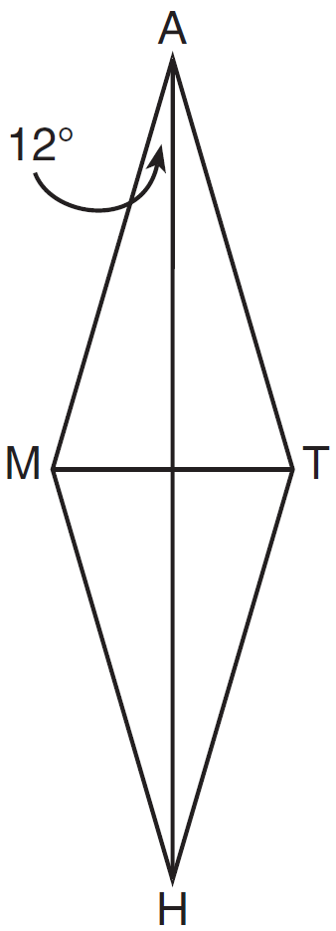

If , what is ?
1) | 12
2) | 78
3) | 84
4) | 156

5 A line segment has endpoints and . What is the length of the segment?
1) | 5
2) | 7
3) | 16
4) | 25

6 In , and an exterior angle at vertex H has a measure of 104. What is ?
1) | 34
2) | 62
3) | 76
4) | 146

7 Which diagram represents a correct construction of equilateral , given side ?
1) | 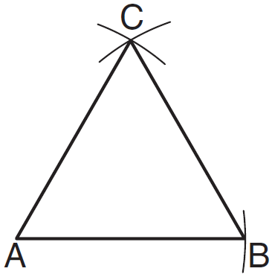
2) | 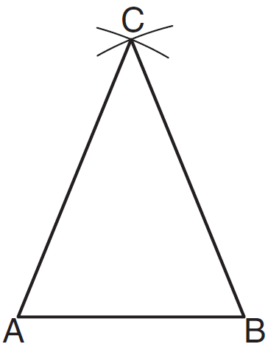
3) | 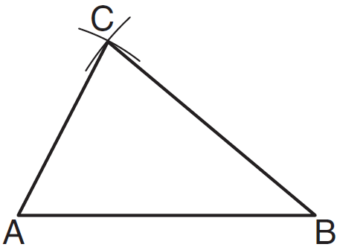
4) | 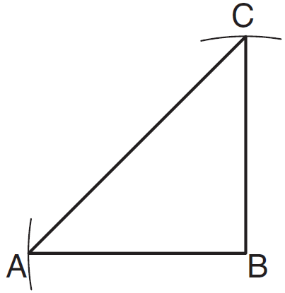

8 In the diagram below, is circumscribed about circle O and the sides of are tangent to the circle at points D, E, and F.

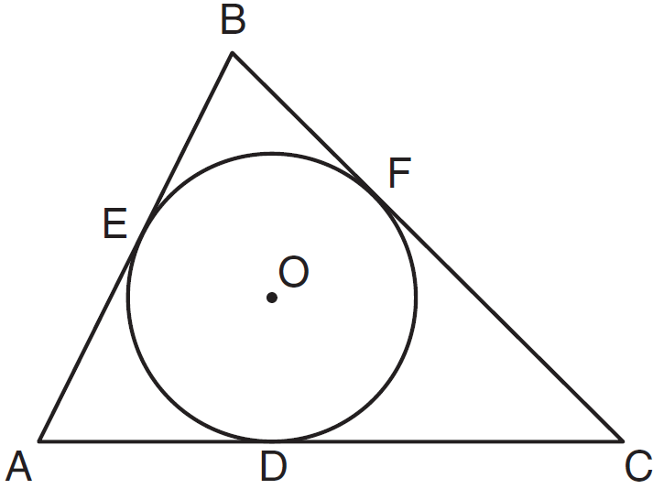

If , , and , what is the length of ?
1) | 8
2) | 15
3) | 23
4) | 27

9 In and , 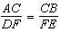. Which additional information would prove ?
1)
2)
3)
4)

10 The angles of triangle ABC are in the ratio of . What is the measure of the smallest angle?
1) | 12º
2) | 24º
3) | 36º
4) | 72º

11 When a quadrilateral is reflected over the line , which geometric relationship is not preserved?
1) | congruence
2) | orientation
3) | parallelism
4) | perpendicularity

12 Which equation represents circle O with center and radius 9?
1)
2)
3)
4)

13 Which statement is the negation of “Two is a prime number” and what is the truth value of the negation?
1) | Two is not a prime number; false
2) | Two is not a prime number; true
3) | A prime number is two; false
4) | A prime number is two; true

14 In the diagram below of circle O, chords and intersect at E.

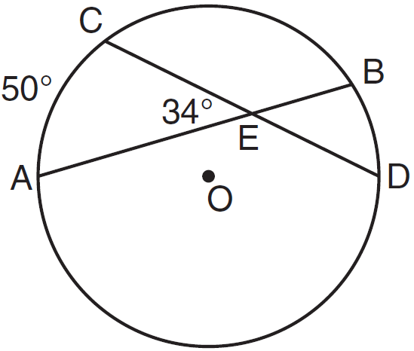

If and , what is ?
1) | 16
2) | 18
3) | 68
4) | 118

15 The volume of a rectangular prism is 144 cubic inches. The height of the prism is 8 inches. Which measurements, in inches, could be the dimensions of the base?
1) | 3.3 by 5.5
2) | 2.5 by 7.2
3) | 12 by 8
4) | 9 by 9

16 The diagram below shows a pair of congruent triangles, with and .

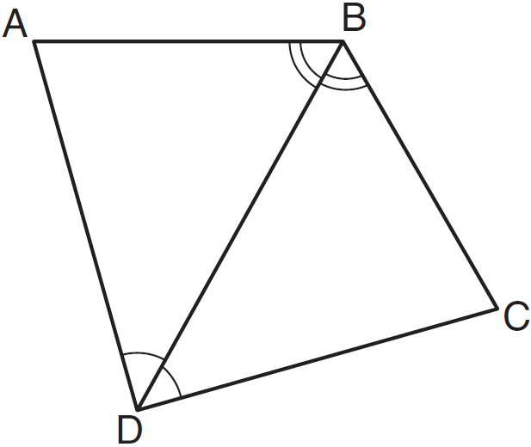

Which statement must be true?
1)
2)
3)
4)

17 What is an equation of the line that is perpendicular to the line whose equation is 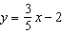 and that passes through the point ?
1) | 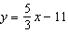
2) | 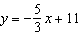
3) | 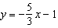
4) | 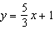

18 Point A lies in plane B. How many lines can be drawn perpendicular to plane B through point A?
1) | one
2) | two
3) | zero
4) | infinite

19 In the diagram below of isosceles trapezoid ABCD, , , and .

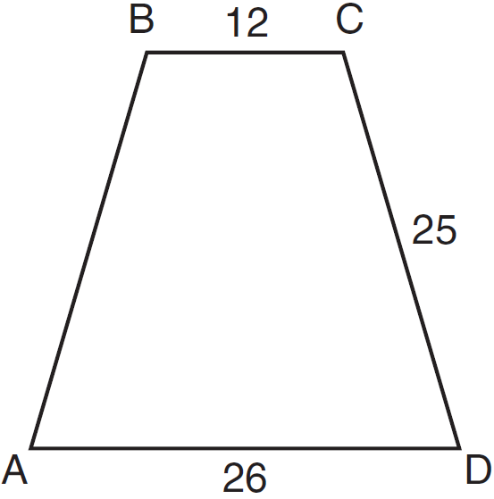

What is the length of an altitude of the trapezoid?
1) | 7
2) | 14
3) | 19
4) | 24

20 What is an equation of circle O shown in the graph below?

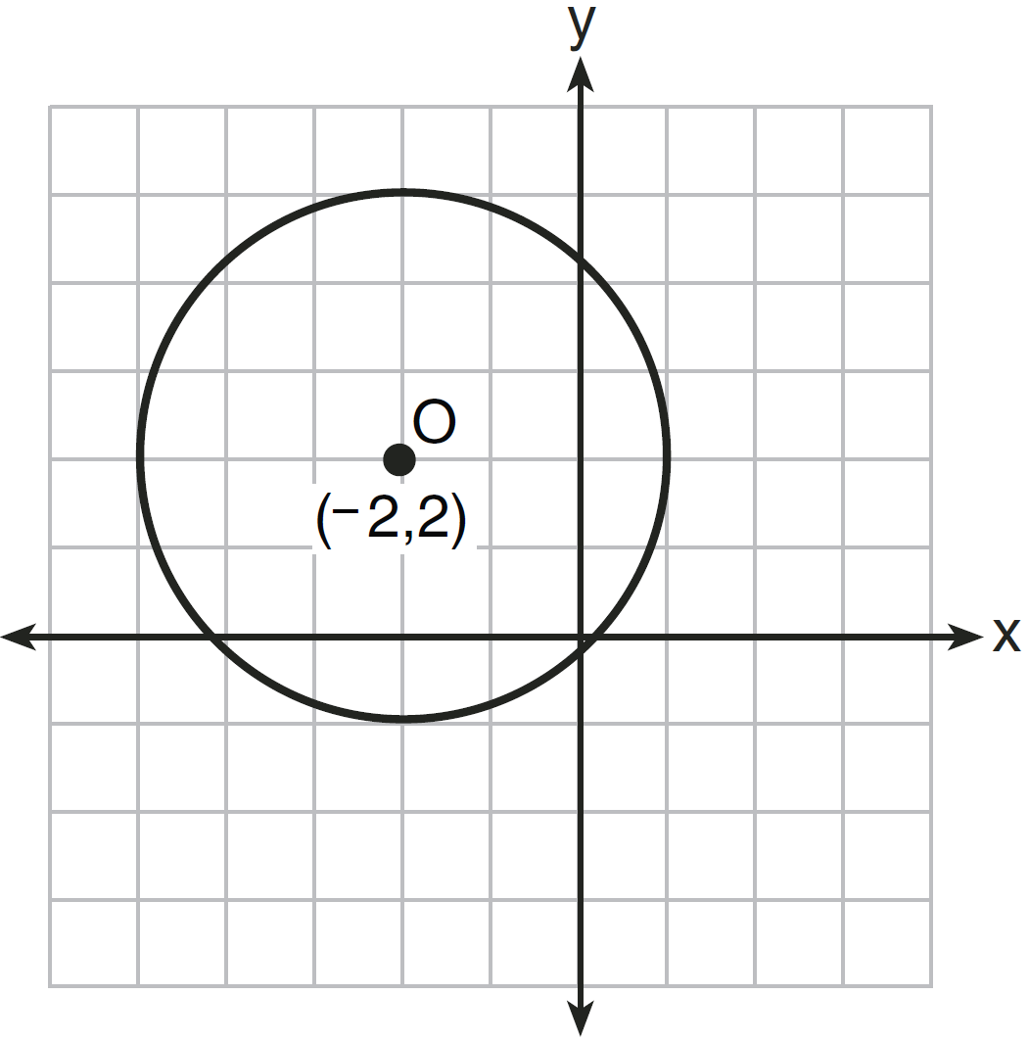
1)
2)
3)
4)

21 The diagram below represents a rectangular solid.

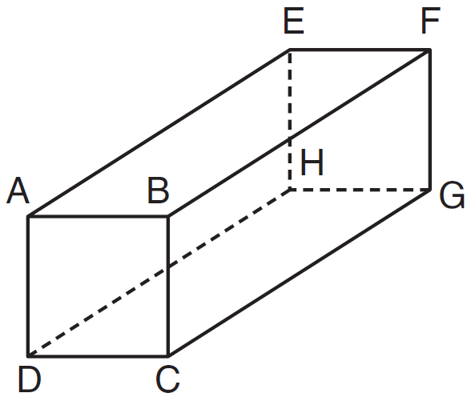

Which statement must be true?
1) | and are coplanar
2) | and are coplanar
3) | and are skew
4) | and are skew

22 In , and . Which inequality is true?
1)
2)
3)
4)

23 The number of degrees in the sum of the interior angles of a pentagon is
1) | 72
2) | 360
3) | 540
4) | 720

24 What is the equation of a line passing through and parallel to the line represented by the equation ?
1) | 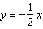
2) | 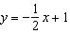
3)
4)

25 The coordinates of the endpoints of are and . The equation of the perpendicular bisector of is
1)
2)
3)
4)

26 In the diagram below, point P is the centroid of .

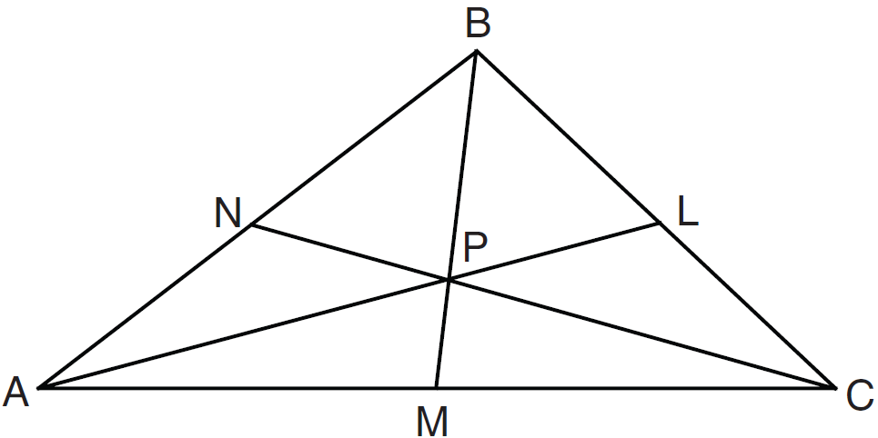

If and , what is the length of ?
1) | 9
2) | 2
3) | 18
4) | 27

27 In , is a right angle and is drawn perpendicular to hypotenuse . If , , and , what is the length of ?
1) | 9
2) | 12
3) | 3
4) | 15

28 In , feet and feet. Which inequality represents all possible values for the length of , in feet?
1)
2)
3)
4)

29 In the diagram below, two parallel lines intersect circle O at points A, B, C, and D, with and . Find .

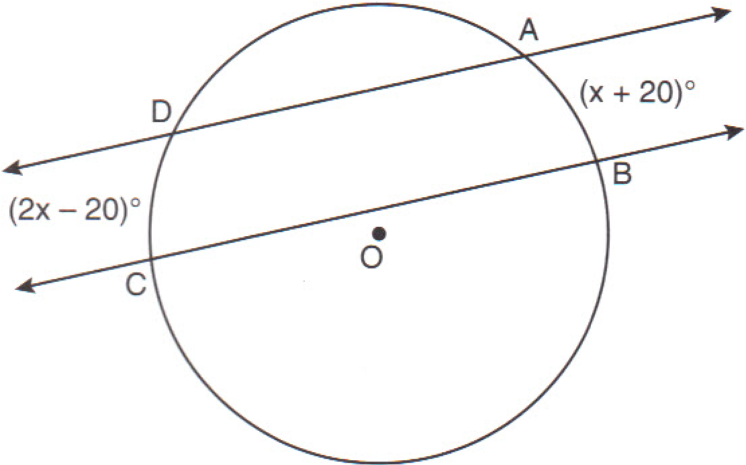

30 In the diagram below, point M is located on . Sketch the locus of points that are 1 unit from and the locus of points 2 units from point M. Label with an X all points that satisfy both conditions.

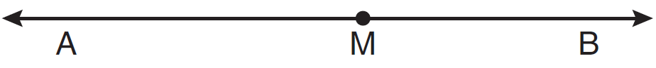

31 Determine whether the two lines represented by the equations and are parallel, perpendicular, or neither. Justify your response.

32 The coordinates of the vertices of are , , and . Triangle is the image of after a rotation of 90° about the origin. State the coordinates of the vertices of . [The use of the set of axes below is optional.]

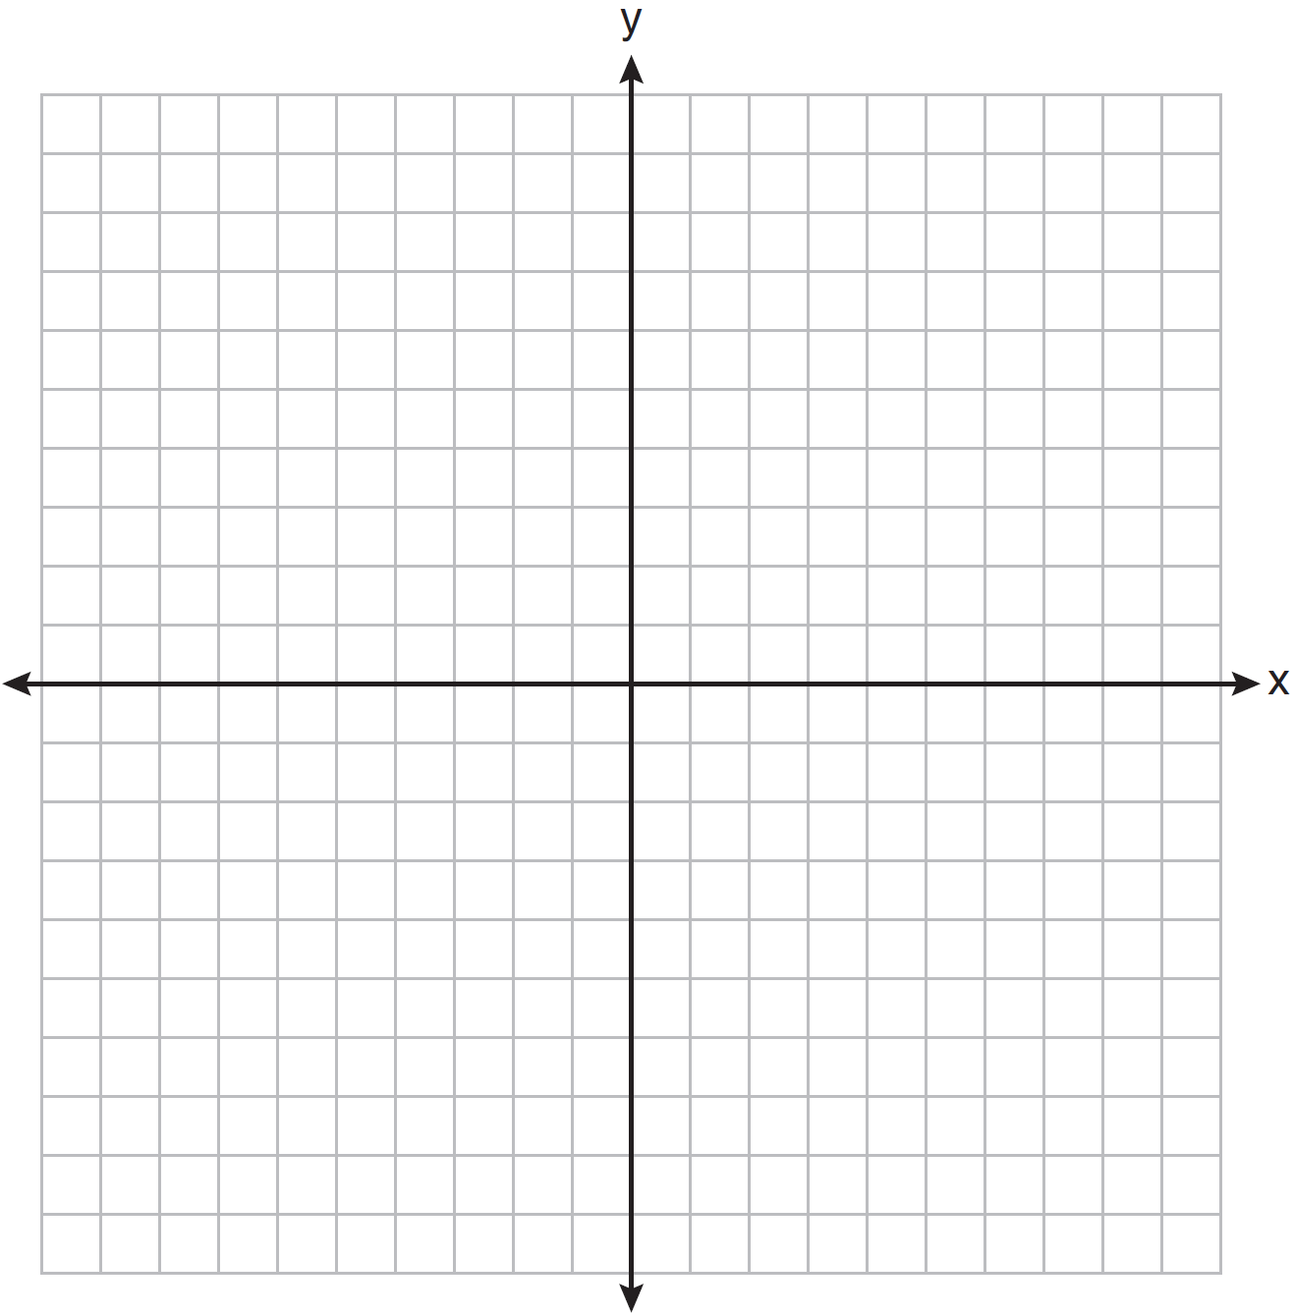

33 On the diagram below, use a compass and straightedge to construct the bisector of . [Leave all construction marks.]
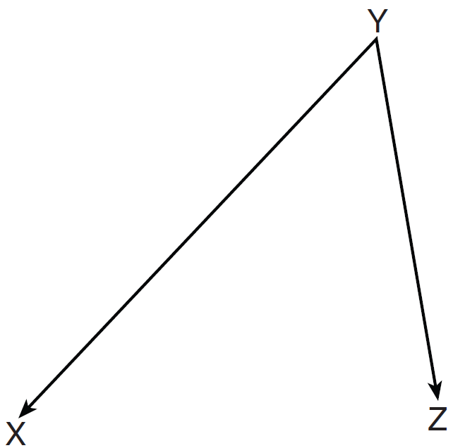

34 In the diagram below of circle O, diameter is perpendicular to chord at E. If and , find the length of .

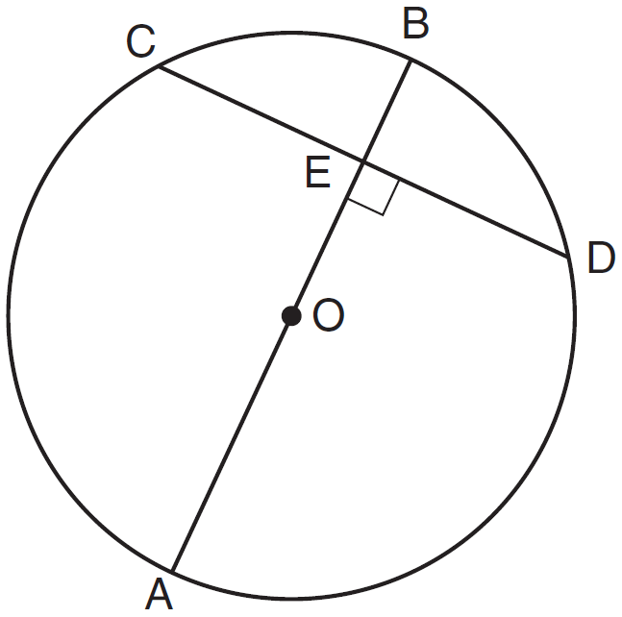

35 Triangle ABC has coordinates , , and . Triangle is the image of under . On the set of axes below, graph and label and its image, . Determine the relationship between the area of and the area of . Justify your response.

36 A paint can is in the shape of a right circular cylinder. The volume of the paint can is 600 cubic inches and its altitude is 12 inches. Find the radius, in inches, of the base of the paint can. Express the answer in simplest radical form. Find, to the nearest tenth of a square inch, the lateral area of the paint can.

37 Triangle HKL has vertices , , and . The midpoint of is M and the midpoint of is N. Determine and state the coordinates of points M and N. Justify the statement: is parallel to . [The use of the set of axes below is optional.]

38 In the diagram below of quadrilateral ABCD, and . Line segments AC, DB, and FG intersect at E.
Prove:

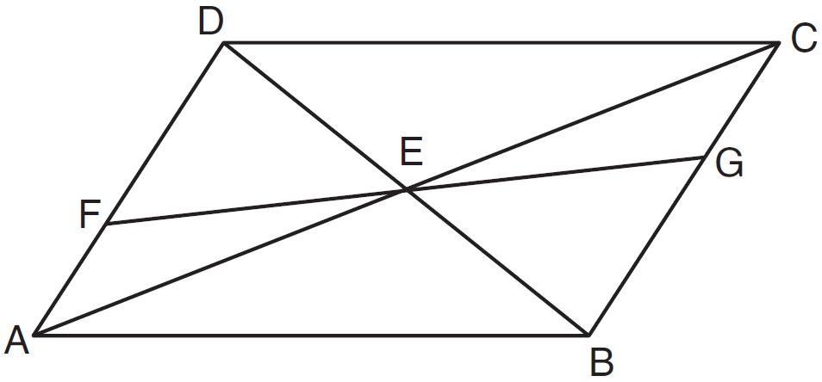
1 ANS: 2
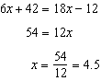

PTS: 2 REF: 011201ge STA: G.G.35 TOP: Parallel Lines and Transversals

2 ANS: 3 PTS: 2 REF: 011202ge STA: G.G.21
TOP: Centroid, Orthocenter, Incenter and Circumcenter

3 ANS: 2 PTS: 2 REF: 011203ge STA: G.G.73
TOP: Equations of Circles

4 ANS: 2
The diagonals of a rhombus are perpendicular.

PTS: 2 REF: 011204ge STA: G.G.39 TOP: Special Parallelograms

5 ANS: 1

PTS: 2 REF: 011205ge STA: G.G.67 TOP: Distance
KEY: general

6 ANS: 2 PTS: 2 REF: 011206ge STA: G.G.32
TOP: Exterior Angle Theorem

7 ANS: 1 PTS: 2 REF: 011207ge STA: G.G.20
TOP: Constructions

8 ANS: 4 PTS: 2 REF: 011208ge STA: G.G.53
TOP: Segments Intercepted by Circle KEY: two tangents

9 ANS: 3 PTS: 2 REF: 011209ge STA: G.G.44
TOP: Similarity Proofs

10 ANS: 3
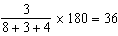

PTS: 2 REF: 011210ge STA: G.G.30 TOP: Interior and Exterior Angles of Triangles

11 ANS: 2 PTS: 2 REF: 011211ge STA: G.G.55
TOP: Properties of Transformations

12 ANS: 4 PTS: 2 REF: 011212ge STA: G.G.71
TOP: Equations of Circles

13 ANS: 1 PTS: 2 REF: 011213ge STA: G.G.24
TOP: Negations

14 ANS: 2
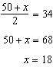

PTS: 2 REF: 011214ge STA: G.G.51 TOP: Arcs Determined by Angles
KEY: inside circle

15 ANS: 2 PTS: 2 REF: 011215ge STA: G.G.12
TOP: Volume

16 ANS: 4 PTS: 2 REF: 011216ge STA: G.G.29
TOP: Triangle Congruency

17 ANS: 3 PTS: 2 REF: 011217ge STA: G.G.64
TOP: Parallel and Perpendicular Lines

18 ANS: 1 PTS: 2 REF: 011218ge STA: G.G.3
TOP: Planes

19 ANS: 4
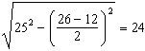

PTS: 2 REF: 011219ge STA: G.G.40 TOP: Trapezoids

20 ANS: 1 PTS: 2 REF: 011220ge STA: G.G.72
TOP: Equations of Circles

21 ANS: 1 PTS: 2 REF: 011221ge STA: G.G.10
TOP: Solids

22 ANS: 4 PTS: 2 REF: 011222ge STA: G.G.34
TOP: Angle Side Relationship

23 ANS: 3

PTS: 2 REF: 011223ge STA: G.G.36 TOP: Interior and Exterior Angles of Polygons

24 ANS: 3
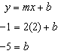

PTS: 2 REF: 011224ge STA: G.G.65 TOP: Parallel and Perpendicular Lines

25 ANS: 4
is a vertical line, so its perpendicular bisector is a horizontal line through the midpoint of , which is .

PTS: 2 REF: 011225ge STA: G.G.68 TOP: Perpendicular Bisector

26 ANS: 1
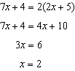.
PTS: 2 REF: 011226ge STA: G.G.43 TOP: Centroid

27 ANS: 4
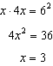.
PTS: 2 REF: 011227ge STA: G.G.47 TOP: Similarity
KEY: leg

28 ANS: 2

PTS: 2 REF: 011228ge STA: G.G.33 TOP: Triangle Inequality Theorem

29 ANS:
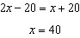.
PTS: 2 REF: 011229ge STA: G.G.52 TOP: Chords

30 ANS:
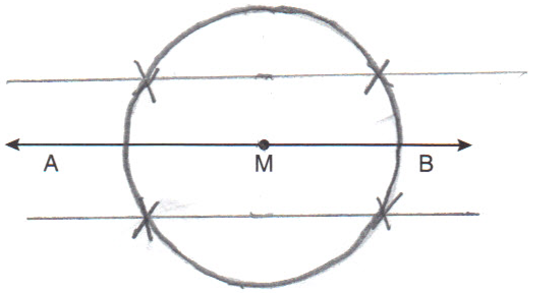
PTS: 2 REF: 011230ge STA: G.G.22 TOP: Locus

31 ANS:
The slope of is 2. The slope of is 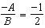. Since the slopes are opposite reciprocals, the lines are perpendicular.
PTS: 2 REF: 011231ge STA: G.G.63 TOP: Parallel and Perpendicular Lines

32 ANS:
, , and .
PTS: 2 REF: 011232ge STA: G.G.54 TOP: Rotations

33 ANS:
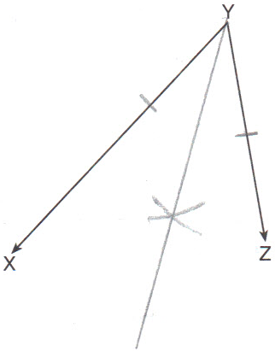
PTS: 2 REF: 011233ge STA: G.G.17 TOP: Constructions

34 ANS:
.
PTS: 2 REF: 011234ge STA: G.G.49 TOP: Chords

35 ANS:
. The areas are equal because translations preserve distance. 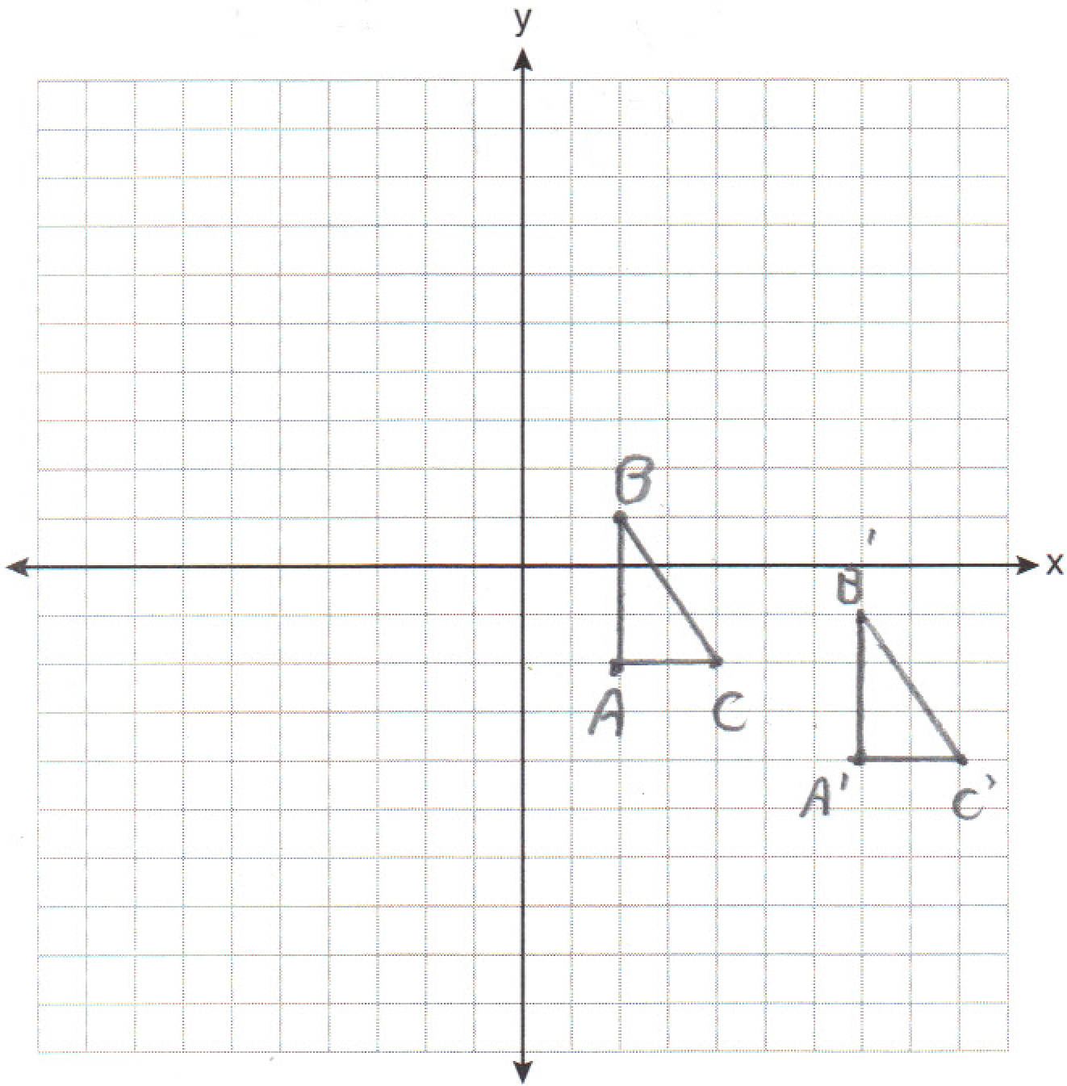
PTS: 4 REF: 011235ge STA: G.G.55 TOP: Properties of Transformations

36 ANS:
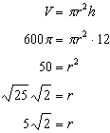.
PTS: 4 REF: 011236ge STA: G.G.14 TOP: Volume and Lateral Area

37 ANS:
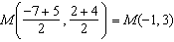. 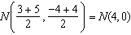. is a midsegment. 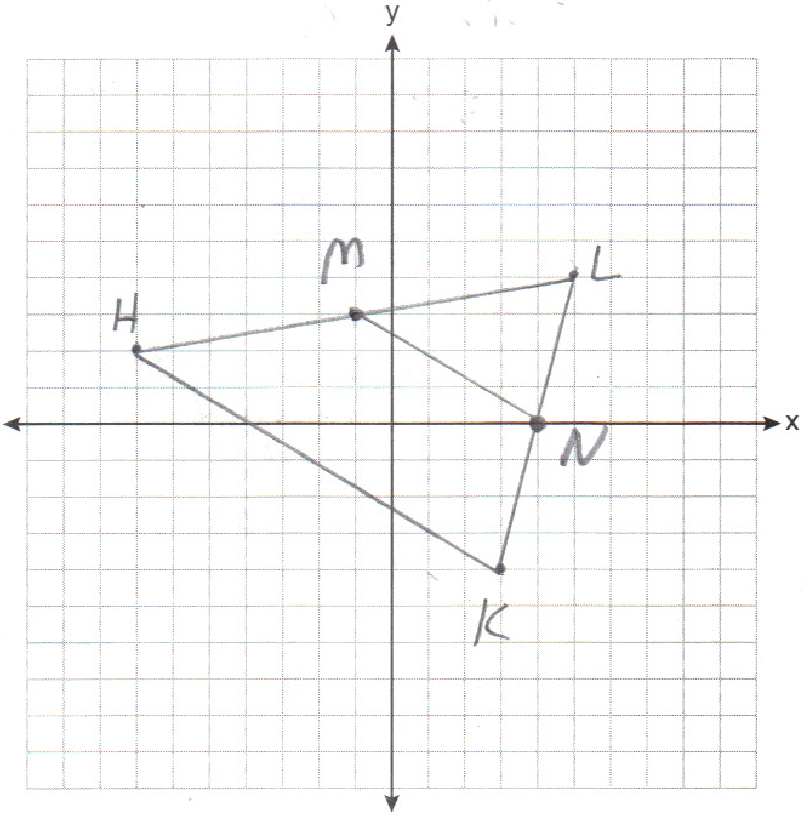
PTS: 4 REF: 011237ge STA: G.G.42 TOP: Midsegments

38 ANS:
Quadrilateral ABCD, and are given. because if two lines are cut by a transversal so that a pair of alternate interior angles are congruent, the lines are parallel. ABCD is a parallelogram because if one pair of opposite sides of a quadrilateral are both congruent and parallel, the quadrilateral is a parallelogram. because the diagonals of a parallelogram bisect each other. as vertical angles. by ASA.
PTS: 6 REF: 011238ge STA: G.G.27 TOP: Quadrilateral Proofs

