1 In the diagram below, , , and are tangents to circle O at points F, E, and D, respectively, , , and .

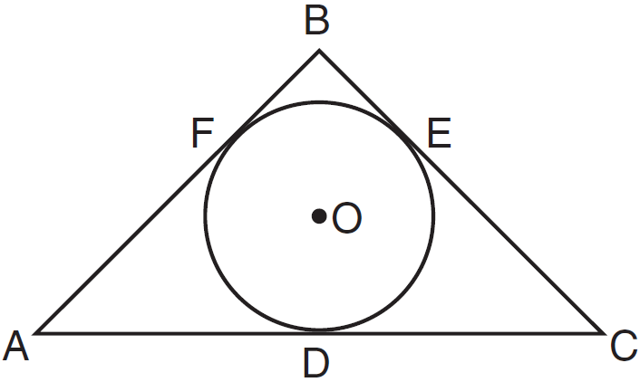

What is the perimeter of ?
1) | 15
2) | 25
3) | 30
4) | 60

2 Quadrilateral MNOP is a trapezoid with . If is the image of MNOP after a reflection over the x-axis, which two sides of quadrilateral are parallel?
1) | and
2) | and
3) | and
4) | and

3 In the diagram below of , D is the midpoint of , and E is the midpoint of .

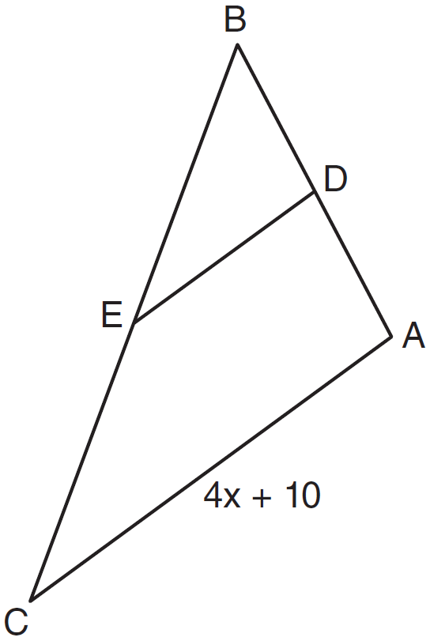

If , which expression represents DE?
1)
2)
3)
4)

4 Which statement is true about every parallelogram?
1) | All four sides are congruent.
2) | The interior angles are all congruent.
3) | Two pairs of opposite sides are congruent.
4) | The diagonals are perpendicular to each other.

5 The diagram below shows a rectangular prism.

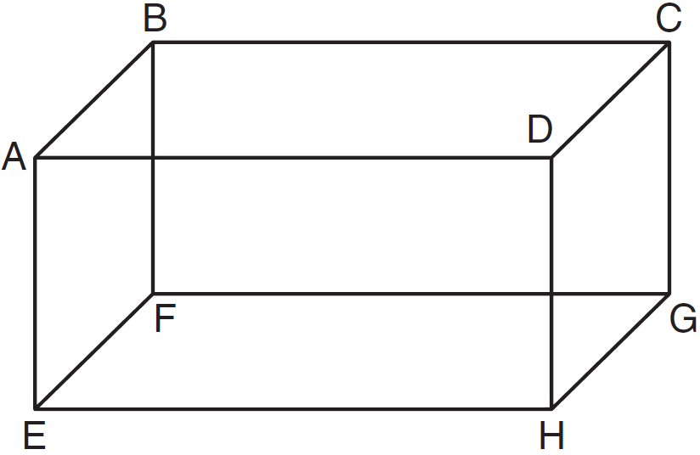

Which pair of edges are segments of lines that are coplanar?
1) | and
2) | and
3) | and
4) | and

6 A line segment has endpoints and . What are the coordinates of the midpoint of ?
1)
2)
3)
4)

7 What is the image of the point under the translation ?
1)
2)
3)
4)

8 When writing a geometric proof, which angle relationship could be used alone to justify that two angles are congruent?
1) | supplementary angles
2) | linear pair of angles
3) | adjacent angles
4) | vertical angles

9 Plane R is perpendicular to line k and plane D is perpendicular to line k. Which statement is correct?
1) | Plane R is perpendicular to plane D.
2) | Plane R is parallel to plane D.
3) | Plane R intersects plane D.
4) | Plane R bisects plane D.

10 The vertices of the triangle in the diagram below are , , and .

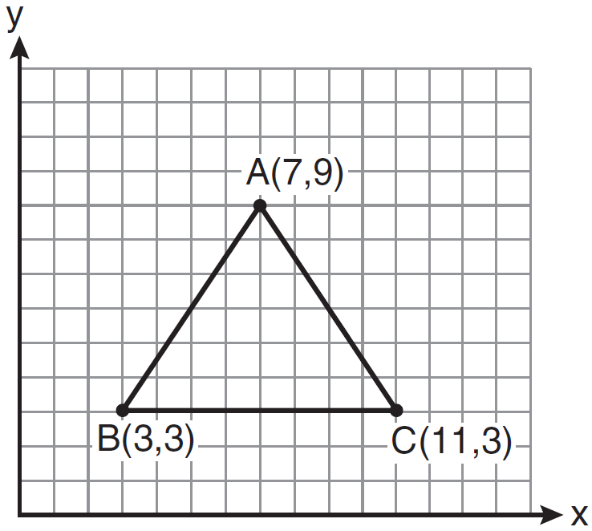

What are the coordinates of the centroid of ?
1)
2)
3)
4)

11 Which set of numbers does not represent the sides of a right triangle?
1)
2)
3)
4)

12 In the diagram below of rhombus ABCD, .

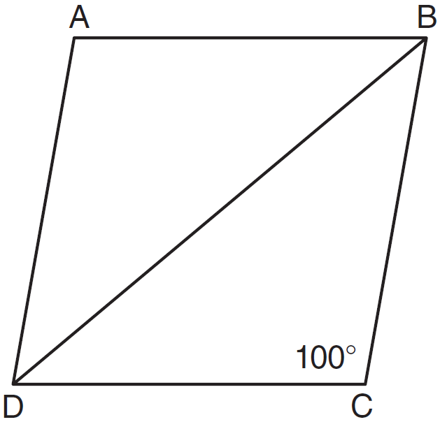

What is ?
1) | 40
2) | 45
3) | 50
4) | 80

13 In the diagram below of circle O, radius is 5 cm. Chord is 8 cm and is perpendicular to at point P.

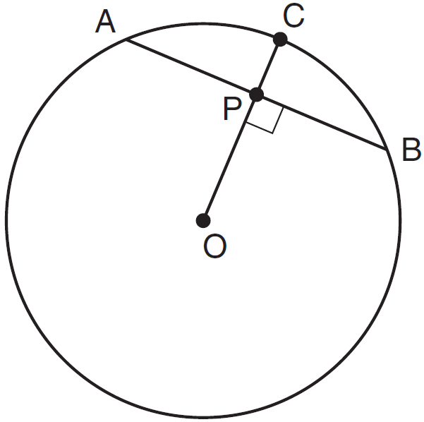

What is the length of , in centimeters?
1) | 8
2) | 2
3) | 3
4) | 4

14 What is an equation of the line that passes through the point and is parallel to the line whose equation is 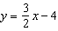?
1) | 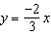
2) | 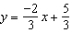
3) | 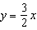
4) | 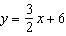

15 In scalene triangle ABC, and . What is the order of the sides in length, from longest to shortest?
1) | , ,
2) | , ,
3) | , ,
4) | , ,

16 What is an equation of a circle with center and radius 4?
1)
2)
3)
4)

17 What is the volume, in cubic centimeters, of a cylinder that has a height of 15 cm and a diameter of 12 cm?
1)
2)
3)
4)

18 Which compound statement is true?
1) | A triangle has three sides and a quadrilateral has five sides.
2) | A triangle has three sides if and only if a quadrilateral has five sides.
3) | If a triangle has three sides, then a quadrilateral has five sides.
4) | A triangle has three sides or a quadrilateral has five sides.

19 The two lines represented by the equations below are graphed on a coordinate plane.
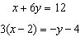
Which statement best describes the two lines?
1) | The lines are parallel.
2) | The lines are the same line.
3) | The lines are perpendicular.
4) | The lines intersect at an angle other than 90°.

20 Which diagram shows the construction of the perpendicular bisector of ?
1) | 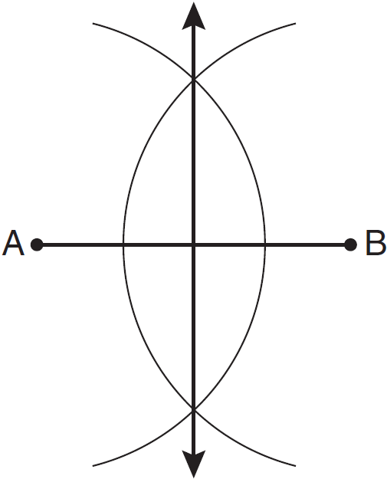
2) | 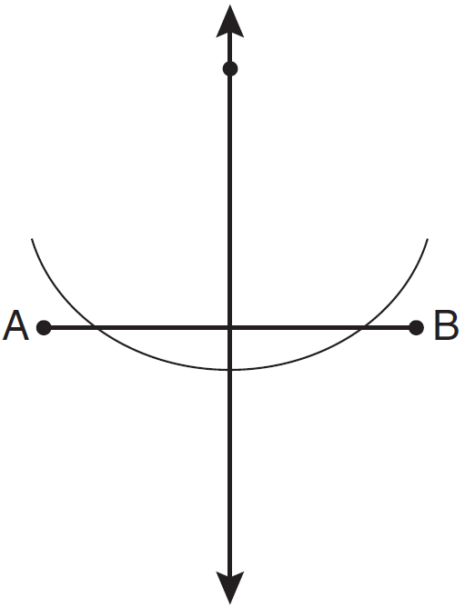
3) | 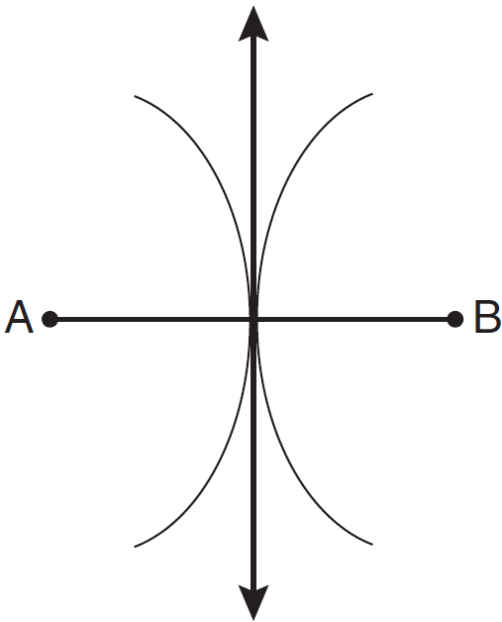
4) | 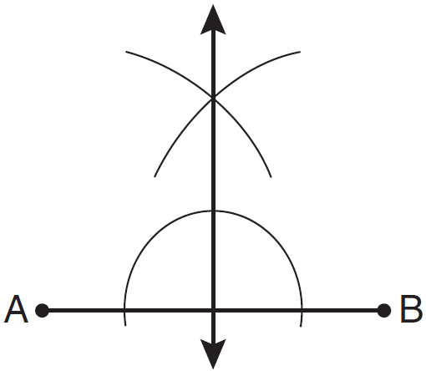

21 In circle O, a diameter has endpoints and . What is the length of the diameter?
1)
2)
3)
4)

22 In the diagram of quadrilateral ABCD, , , and diagonal is drawn.

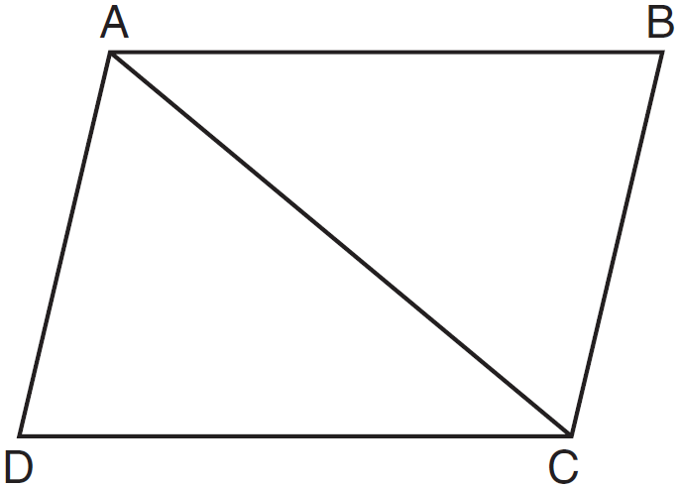

Which method can be used to prove is congruent to ?
1) | AAS
2) | SSA
3) | SAS
4) | SSS

23 In the diagram below of right triangle ABC, is the altitude to hypotenuse , , and .

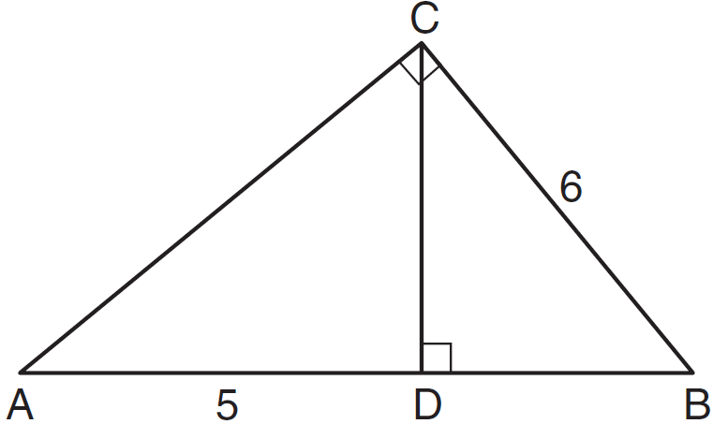

What is the length of ?
1) | 5
2) | 9
3) | 3
4) | 4

24 In the diagram below, quadrilateral JUMP is inscribed in a circle..

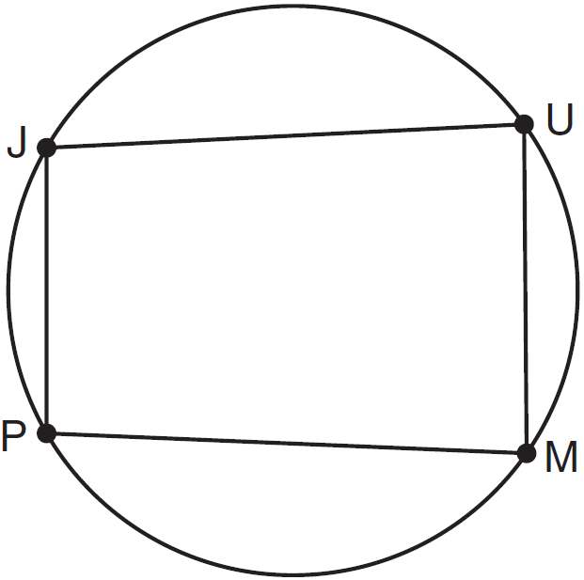

Opposite angles J and M must be
1) | right
2) | complementary
3) | congruent
4) | supplementary

25 Which graph represents a circle with the equation ?
1) | 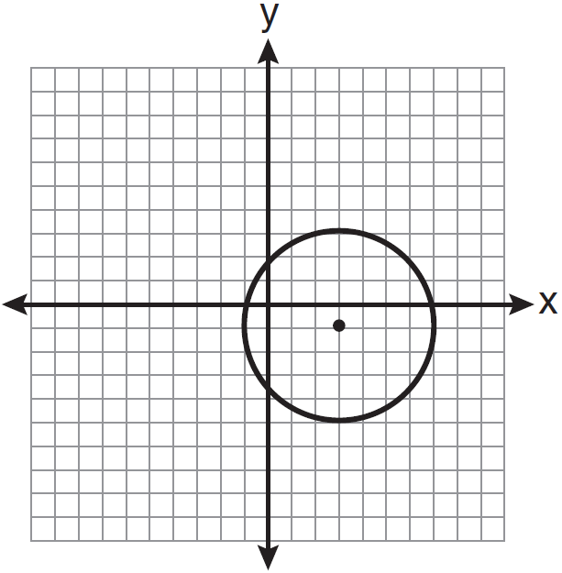
2) | 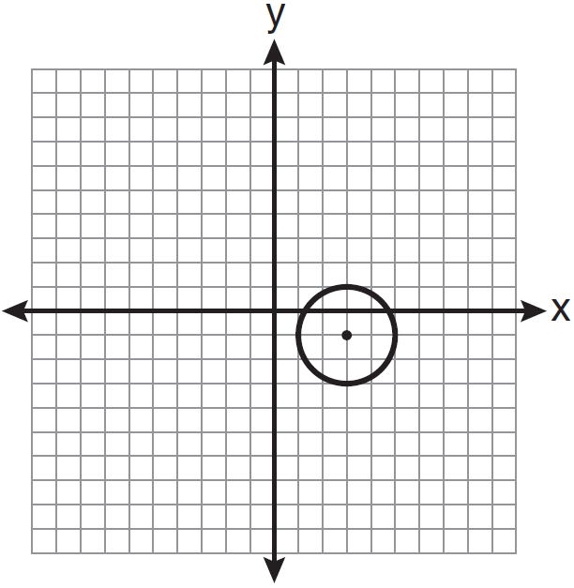
3) | 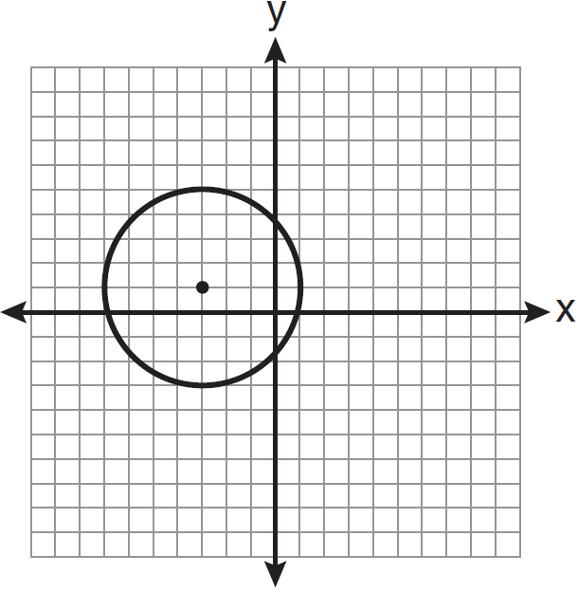
4) | 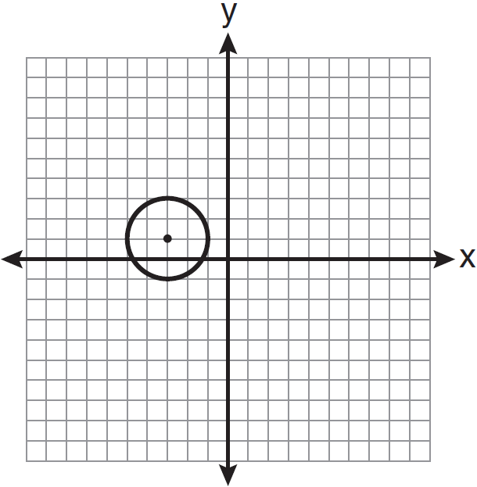

26 The point is rotated 90º about the origin and then dilated by a scale factor of 4. What are the coordinates of the resulting image?
1)
2) | (12,-8)
3)
4)

27 In the diagram below of , side is extended to point D, , , and .

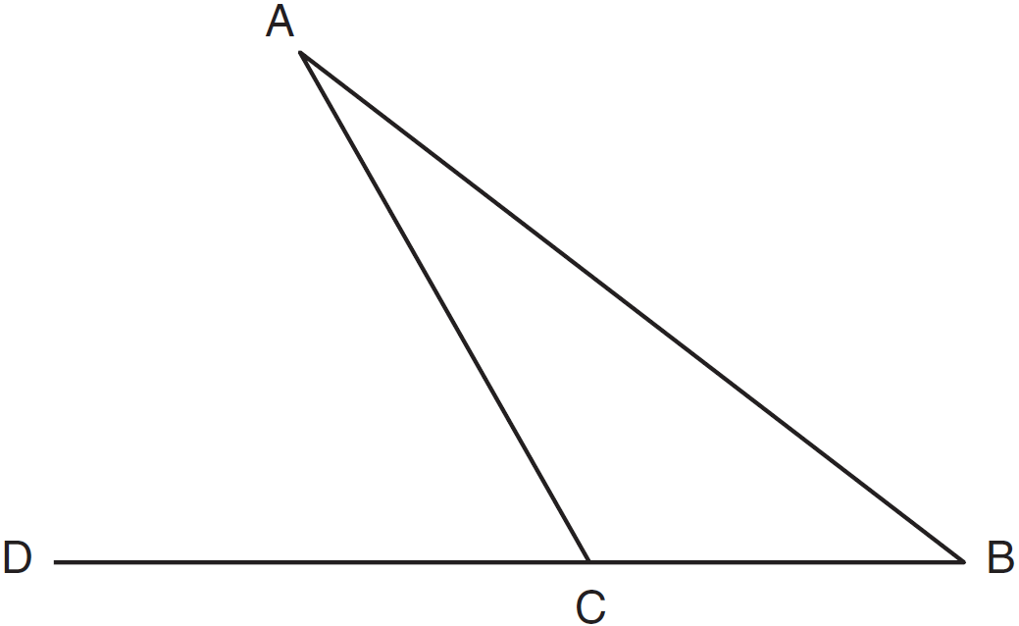

What is ?
1) | 5
2) | 20
3) | 25
4) | 55

28 Point P lies on line m. Point P is also included in distinct planes Q, R, S, and T. At most, how many of these planes could be perpendicular to line m?
1) | 1
2) | 2
3) | 3
4) | 4

29 In the diagram below of , B is a point on such that is an equilateral triangle, and is an isosceles triangle with . Find .

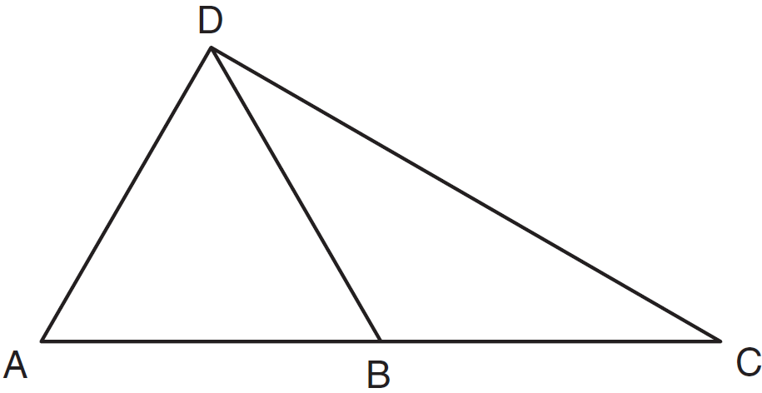

30 Triangle ABC has vertices , , and . Find the coordinates of the vertices of , the image of after the transformation . [The use of the grid is optional.]



31 Find, in degrees, the measures of both an interior angle and an exterior angle of a regular pentagon.

32 In the diagram below of circle O, chord bisects chord at E. If and , find the length of in simplest radical form.

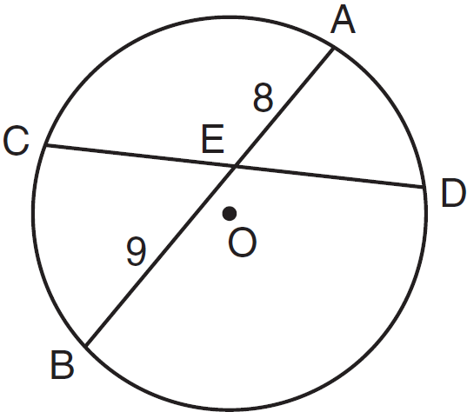

33 On the diagram below, use a compass and straightedge to construct the bisector of . [Leave all construction marks.]

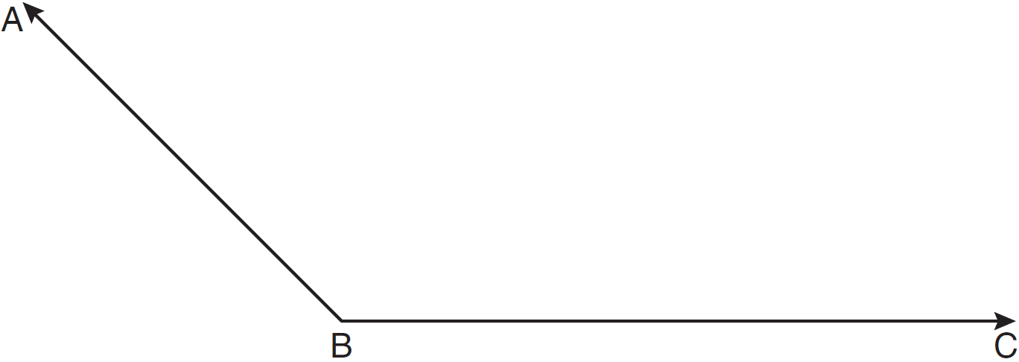

34 Find the slope of a line perpendicular to the line whose equation is .

35 On the set of axes below, graph the locus of points that are four units from the point . On the same set of axes, graph the locus of points that are two units from the line . State the coordinates of all points that satisfy both conditions.

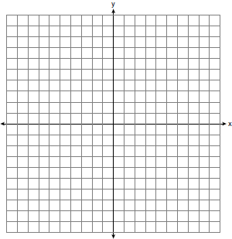

36 In the diagram below, , , , and . Prove that .

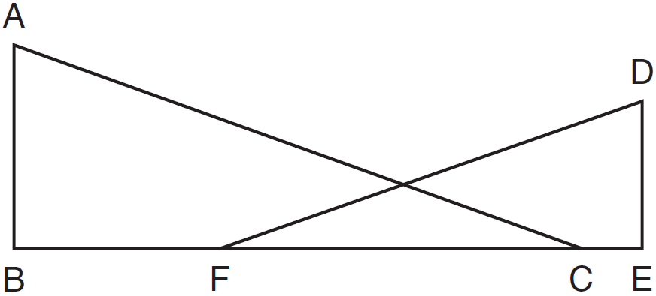

37 In the diagram below of , B is a point on and C is a point on such that , , , , and . Find the length of .

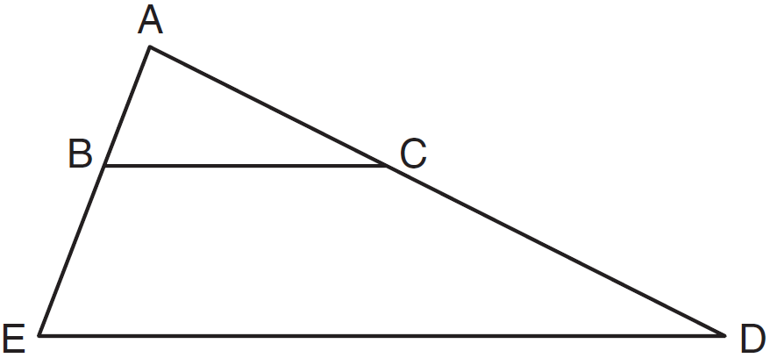

38 Quadrilateral MATH has coordinates , , , and . Prove that quadrilateral MATH is a rhombus and prove that it is not a square. [The use of the grid is optional.]


1 ANS: 3
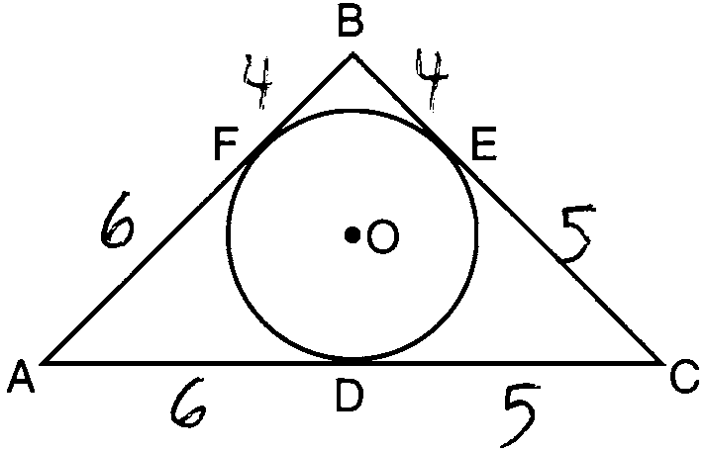

PTS: 2 REF: 011101ge STA: G.G.53 TOP: Segments Intercepted by Circle
KEY: two tangents

2 ANS: 1 PTS: 2 REF: 011102ge STA: G.G.55
TOP: Properties of Transformations

3 ANS: 2
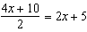

PTS: 2 REF: 011103ge STA: G.G.42 TOP: Midsegments

4 ANS: 3 PTS: 2 REF: 011104ge STA: G.G.38
TOP: Parallelograms

5 ANS: 3 PTS: 2 REF: 011105ge STA: G.G.10
TOP: Solids

6 ANS: 2
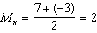. 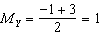.

PTS: 2 REF: 011106ge STA: G.G.66 TOP: Midpoint

7 ANS: 3

PTS: 2 REF: 011107ge STA: G.G.54 TOP: Translations

8 ANS: 4 PTS: 2 REF: 011108ge STA: G.G.27
TOP: Angle Proofs

9 ANS: 2 PTS: 2 REF: 011109ge STA: G.G.9
TOP: Planes

10 ANS: 3 PTS: 2 REF: 011110ge STA: G.G.21
KEY: Centroid, Orthocenter, Incenter and Circumcenter

11 ANS: 3

PTS: 2 REF: 011111ge STA: G.G.48 TOP: Pythagorean Theorem

12 ANS: 1 PTS: 2 REF: 011112ge STA: G.G.39
TOP: Special Parallelograms

13 ANS: 3
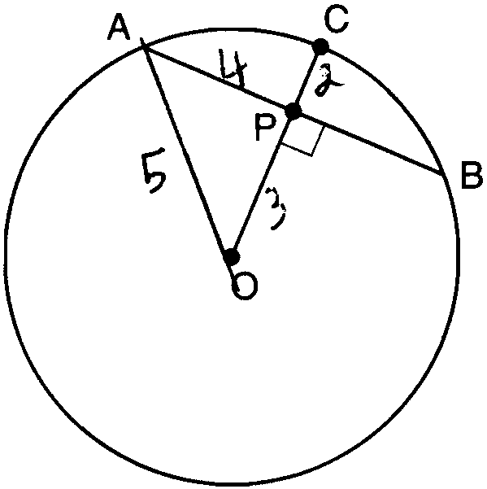

PTS: 2 REF: 011112ge STA: G.G.49 TOP: Chords

14 ANS: 4
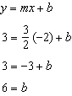

PTS: 2 REF: 011114ge STA: G.G.65 TOP: Parallel and Perpendicular Lines

15 ANS: 4

PTS: 2 REF: 011115ge STA: G.G.34 TOP: Angle Side Relationship

16 ANS: 3 PTS: 2 REF: 011116ge STA: G.G.71
TOP: Equations of Circles

17 ANS: 2

PTS: 2 REF: 011117ge STA: G.G.14 TOP: Volume and Lateral Area

18 ANS: 4 PTS: 2 REF: 011118ge STA: G.G.25
TOP: Compound Statements KEY: general

19 ANS: 4
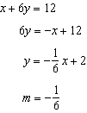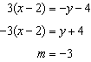

PTS: 2 REF: 011119ge STA: G.G.63 TOP: Parallel and Perpendicular Lines

20 ANS: 1 PTS: 2 REF: 011120ge STA: G.G.18
TOP: Constructions

21 ANS: 4

PTS: 2 REF: 011121ge STA: G.G.67 TOP: Distance
KEY: general

22 ANS: 1 PTS: 2 REF: 011122GE STA: G.G.28
TOP: Triangle Congruency

23 ANS: 4
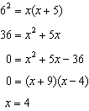

PTS: 2 REF: 011123ge STA: G.G.47 TOP: Similarity
KEY: leg

24 ANS: 4 PTS: 2 REF: 011124ge STA: G.G.51
TOP: Arcs Determined by Angles KEY: inscribed

25 ANS: 2 PTS: 2 REF: 011125ge STA: G.G.74
TOP: Graphing Circles

26 ANS: 3

PTS: 2 REF: 011126ge STA: G.G.54 TOP: Compositions of Transformations
KEY: basic

27 ANS: 3
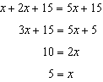

PTS: 2 REF: 011127ge STA: G.G.32 TOP: Exterior Angle Theorem

28 ANS: 1 PTS: 2 REF: 011128ge STA: G.G.2
TOP: Planes

29 ANS:
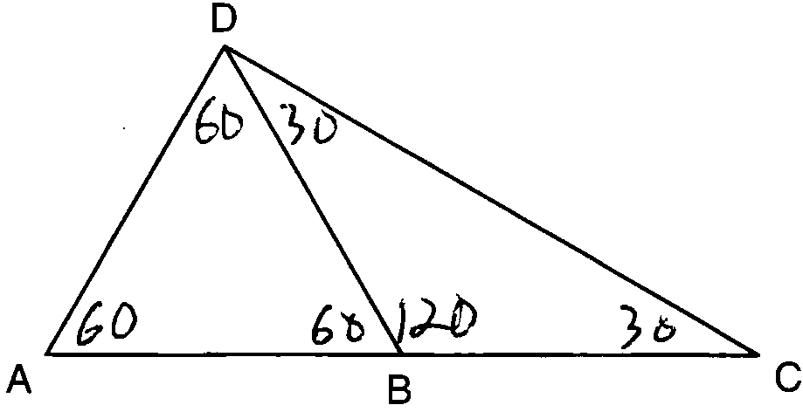

PTS: 2 REF: 011129ge STA: G.G.31 TOP: Isosceles Triangle Theorem

30 ANS:
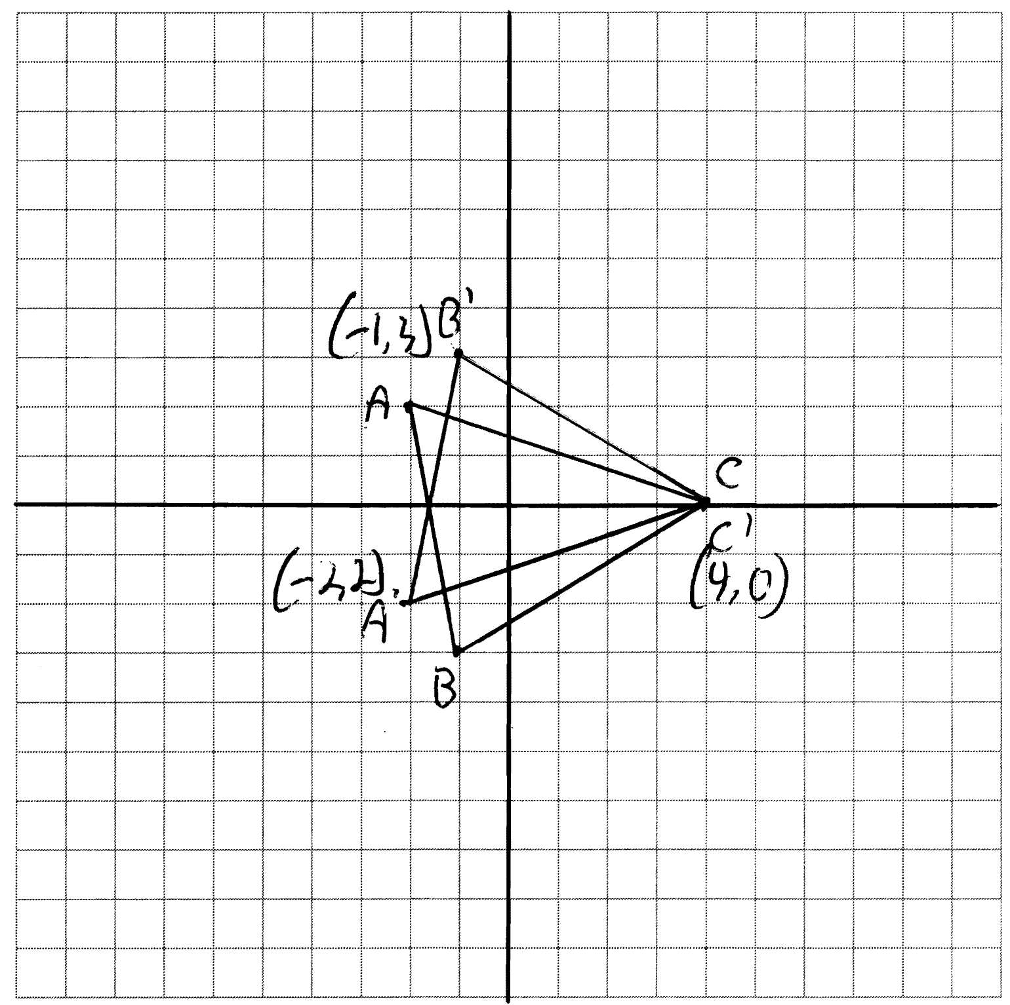

PTS: 2 REF: 011130ge STA: G.G.54 TOP: Reflections
KEY: grids

31 ANS:
. 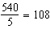 interior. exterior

PTS: 2 REF: 011131ge STA: G.G.37 TOP: Interior and Exterior Angles of Polygons

32 ANS:
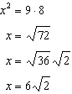

PTS: 2 REF: 011132ge STA: G.G.53 TOP: Segments Intercepted by Circle
KEY: two chords

33 ANS:
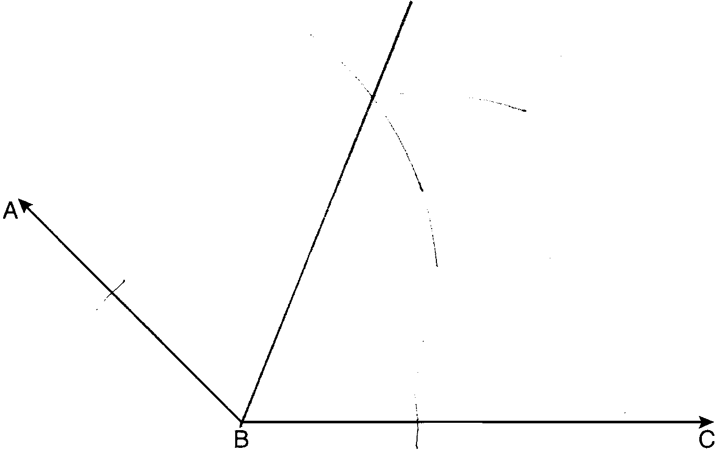

PTS: 2 REF: 011133ge STA: G.G.17 TOP: Constructions

34 ANS:
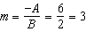. 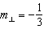.

PTS: 2 REF: 011134ge STA: G.G.62 TOP: Parallel and Perpendicular Lines

35 ANS:
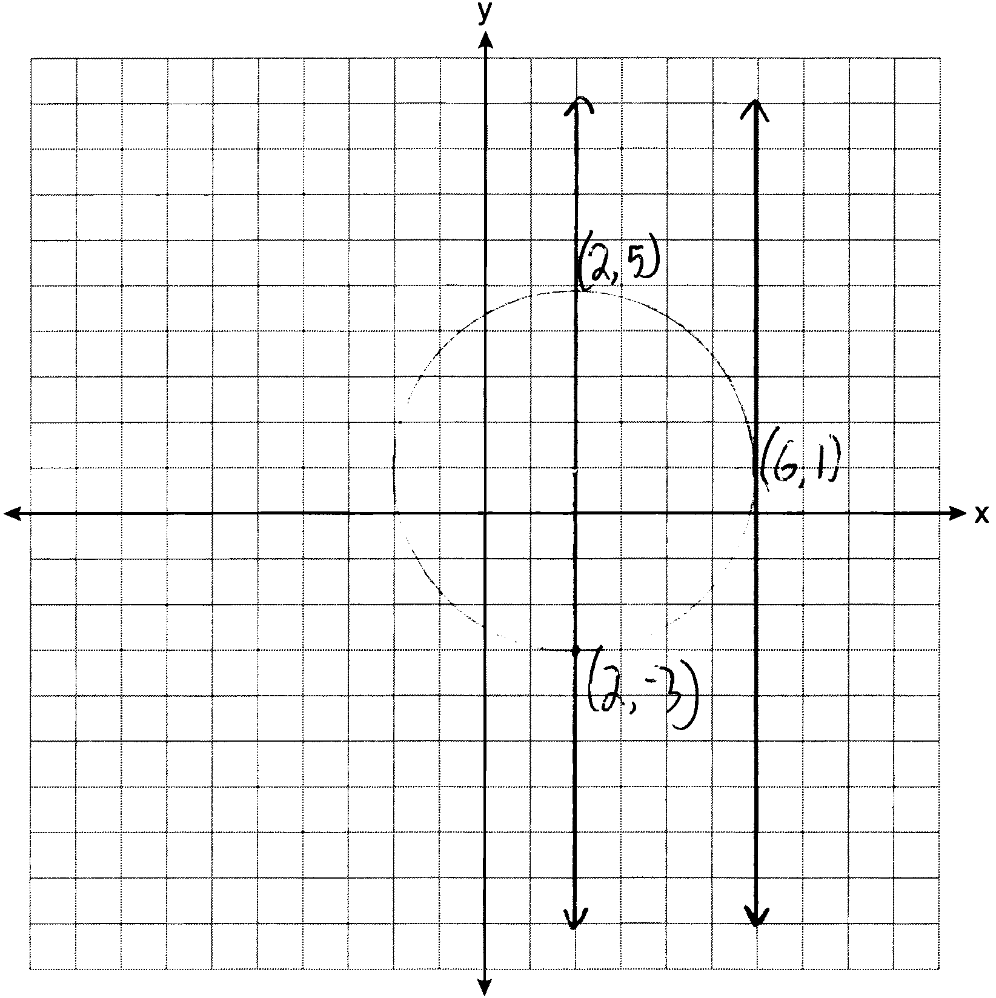

PTS: 4 REF: 011135ge STA: G.G.23 TOP: Locus

36 ANS:
and are right angles because of the definition of perpendicular lines. because all right angles are congruent. and are supplementary and and are supplementary because of the definition of supplementary angles. because angles supplementary to congruent angles are congruent. because of AA.

PTS: 4 REF: 011136ge STA: G.G.44 TOP: Similarity Proofs

37 ANS:
32. 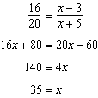.

PTS: 4 REF: 011137ge STA: G.G.46 TOP: Side Splitter Theorem

38 ANS:
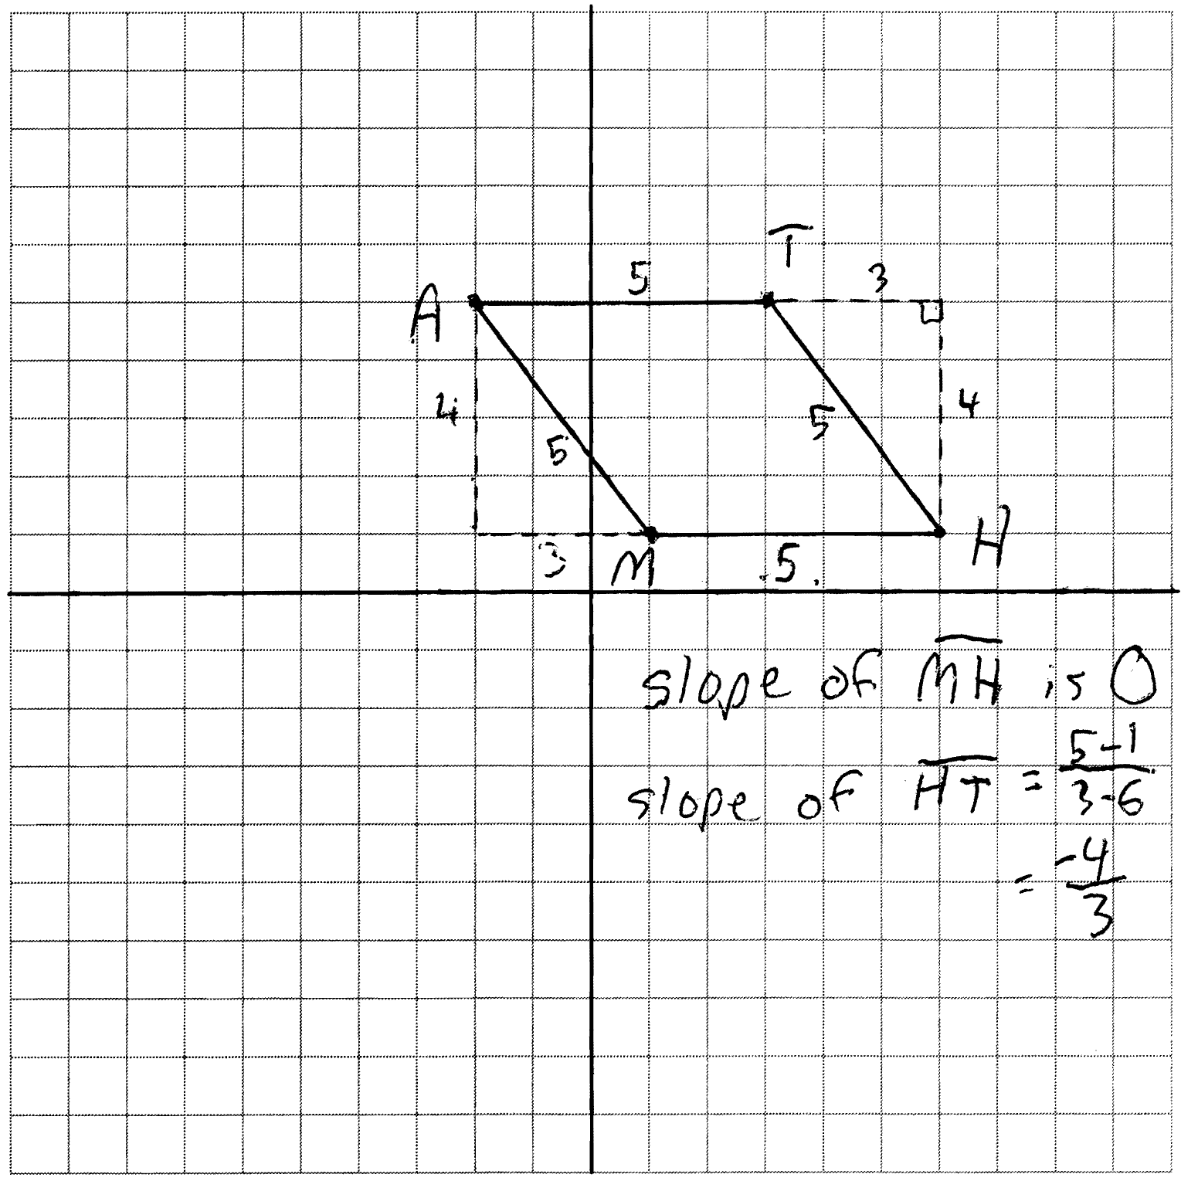 The length of each side of quadrilateral is 5. Since each side is congruent, quadrilateral MATH is a rhombus. The slope of is 0 and the slope of is . Since the slopes are not negative reciprocals, the sides are not perpendicular and do not form rights angles. Since adjacent sides are not perpendicular, quadrilateral MATH is not a square.

PTS: 6 REF: 011138ge STA: G.G.69 TOP: Quadrilaterals in the Coordinate Plane

