1 In the diagram below of trapezoid RSUT, , X is the midpoint of , and V is the midpoint of .

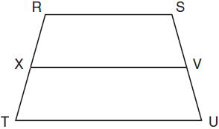

If and , what is the length of ?
1) | 37
2) | 58
3) | 74
4) | 118

2 In , , , and . What is the value of x?
1) | 29
2) | 31
3) | 59
4) | 61

3 Which expression best describes the transformation shown in the diagram below?

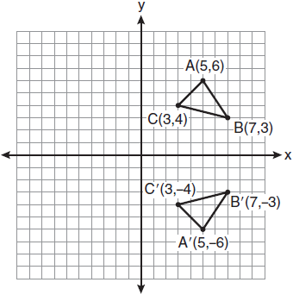
1) | same orientation; reflection
2) | opposite orientation; reflection
3) | same orientation; translation
4) | opposite orientation; translation

4 Based on the construction below, which statement must be true?

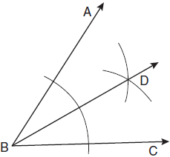
1) | 
2)
3)
4) | 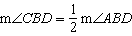

5 In the diagram below, is inscribed in circle P. The distances from the center of circle P to each side of the triangle are shown.

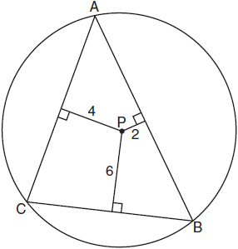

Which statement about the sides of the triangle is true?
1)
2)
3)
4)

6 Which transformation is not always an isometry?
1) | rotation
2) | dilation
3) | reflection
4) | translation

7 In , . An altitude is drawn from B to and intersects at D. Which conclusion is not always true?
1)
2)
3)
4)

8 In the diagram below, tangent and secant are drawn to circle O from external point P.

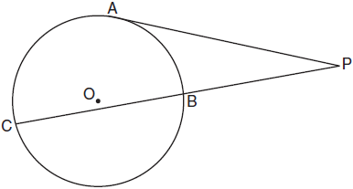

If and , what is the length of ?
1) | 20
2) | 9
3) | 8
4) | 6

9 Which geometric principle is used to justify the construction below?

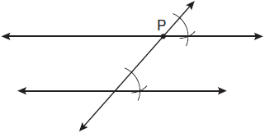
1) | A line perpendicular to one of two parallel lines is perpendicular to the other.
2) | Two lines are perpendicular if they intersect to form congruent adjacent angles.
3) | When two lines are intersected by a transversal and alternate interior angles are congruent, the lines are parallel.
4) | When two lines are intersected by a transversal and the corresponding angles are congruent, the lines are parallel.

10 Which equation represents the circle whose center is and whose radius is 5?
1)
2)
3)
4)

11 Towns A and B are 16 miles apart. How many points are 10 miles from town A and 12 miles from town B?
1) | 1
2) | 2
3) | 3
4) | 0

12 Lines j and k intersect at point P. Line m is drawn so that it is perpendicular to lines j and k at point P. Which statement is correct?
1) | Lines j and k are in perpendicular planes.
2) | Line m is in the same plane as lines j and k.
3) | Line m is parallel to the plane containing lines j and k.
4) | Line m is perpendicular to the plane containing lines j and k.

13 In the diagram below of parallelogram STUV, , , and .

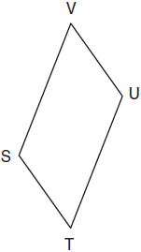

What is the length of ?
1) | 5
2) | 2
3) | 7
4) | 4

14 Which equation represents a line parallel to the line whose equation is ?
1)
2)
3)
4)

15 In the diagram below of circle O, chords and intersect at E, , and .

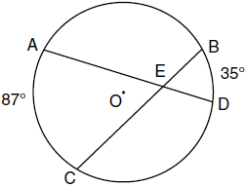

What is the degree measure of ?
1) | 87
2) | 61
3) | 43.5
4) | 26

16 In the diagram below of , , , and .

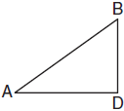

What is the length of ?
1)
2)
3)
4)

17 What is the distance between the points and ?
1)
2)
3)
4)

18 What is an equation of the line that contains the point and is perpendicular to the line whose equation is ?
1)
2)
3) | 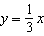
4) | 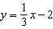

19 In the diagram below, and intersect at T, is drawn, and .

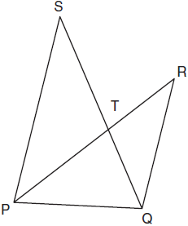

What technique can be used to prove that ?
1) | SAS
2) | SSS
3) | ASA
4) | AA

20 The equation of a circle is . Which diagram is the graph of the circle?
1) | 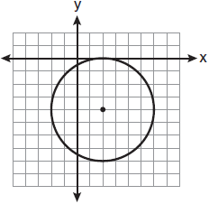
2) | 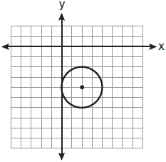
3) | 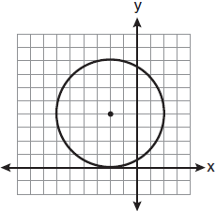
4) | 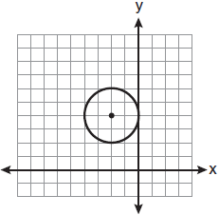

21 In the diagram below, is shown with extended through point D.

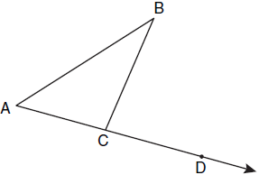

If , , and , what is the value of x?
1) | 12
2) | 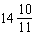
3) | 16
4)

22 Given such that 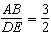. Which statement is not true?
1) | 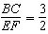
2) | 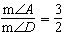
3) | 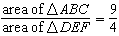
4) | 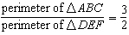

23 The pentagon in the diagram below is formed by five rays.

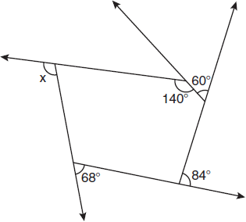

What is the degree measure of angle x?
1) | 72
2) | 96
3) | 108
4) | 112

24 Through a given point, P, on a plane, how many lines can be drawn that are perpendicular to that plane?
1) | 1
2) | 2
3) | more than 2
4) | none

25 What is the slope of a line that is perpendicular to the line whose equation is ?
1)
2)
3)
4)

26 What is the image of point after the composition of transformations defined by ?
1)
2)
3)
4)

27 Which expression represents the volume, in cubic centimeters, of the cylinder represented in the diagram below?

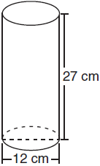
1)
2)
3)
4)

28 What is the inverse of the statement “If two triangles are not similar, their corresponding angles are not congruent”?
1) | If two triangles are similar, their corresponding angles are not congruent.
2) | If corresponding angles of two triangles are not congruent, the triangles are not similar.
3) | If two triangles are similar, their corresponding angles are congruent.
4) | If corresponding angles of two triangles are congruent, the triangles are similar.

29 In , and . Find .

30 Tim has a rectangular prism with a length of 10 centimeters, a width of 2 centimeters, and an unknown height. He needs to build another rectangular prism with a length of 5 centimeters and the same height as the original prism. The volume of the two prisms will be the same. Find the width, in centimeters, of the new prism.

31 In the diagram below of circle C, is a diameter, and and are points on a coordinate plane. Find and state the coordinates of point R.

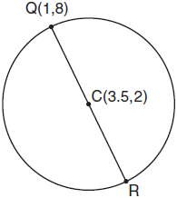

32 Using a compass and straightedge, and below, construct an equilateral triangle with all sides congruent to . [Leave all construction marks.]

33 In the diagram below of , E is a point on and B is a point on , such that . If , , and , find the length of .

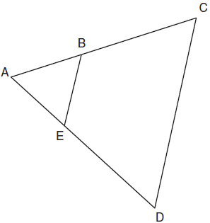

34 In the diagram below of , medians , , and intersect at D, and . Find the length of .

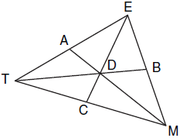

35 In , and . The transformation is performed on to form . Find . Justify your answer. Find the length of . Justify your answer.

36 Given: JKLM is a parallelogram.
Prove: JKLM is a rhombus.

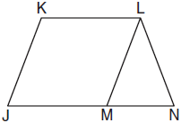

37 On the grid below, graph the points that are equidistant from both the x and y axes and the points that are 5 units from the origin. Label with an X all points that satisfy both conditions.



38 On the set of axes below, solve the following system of equations graphically for all values of x and y.
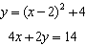

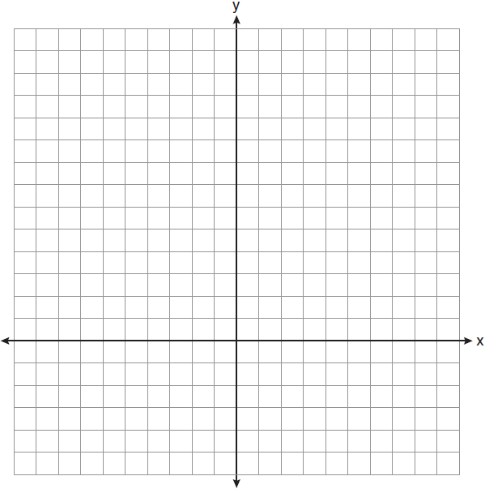
1 ANS: 2
The length of the midsegment of a trapezoid is the average of the lengths of its bases. 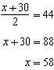.

PTS: 2 REF: 011001ge STA: G.G.40 TOP: Trapezoids

2 ANS: 1
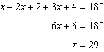

PTS: 2 REF: 011002ge STA: G.G.30 TOP: Interior and Exterior Angles of Triangles

3 ANS: 2 PTS: 2 REF: 011003ge STA: G.G.55
TOP: Properties of Transformations

4 ANS: 2 PTS: 2 REF: 011004ge STA: G.G.17
TOP: Constructions

5 ANS: 1
The closer a chord is to the center of a circle, the longer the chord.

PTS: 2 REF: 011005ge STA: G.G.49 TOP: Chords

6 ANS: 2 PTS: 2 REF: 011006ge STA: G.G.56
TOP: Isometries

7 ANS: 3 PTS: 2 REF: 011007ge STA: G.G.31
TOP: Isosceles Triangle Theorem

8 ANS: 4
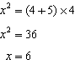

PTS: 2 REF: 011008ge STA: G.G.53 TOP: Segments Intercepted by Circle
KEY: tangent and secant

9 ANS: 4 PTS: 2 REF: 011009ge STA: G.G.19
TOP: Constructions

10 ANS: 3 PTS: 2 REF: 011010ge STA: G.G.71
TOP: Equations of Circles

11 ANS: 2 PTS: 2 REF: 011011ge STA: G.G.22
TOP: Locus

12 ANS: 4 PTS: 2 REF: 011012ge STA: G.G.1
TOP: Planes

13 ANS: 1
Opposite sides of a parallelogram are congruent. 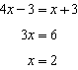. .

PTS: 2 REF: 011013ge STA: G.G.38 TOP: Parallelograms

14 ANS: 3
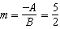. 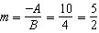

PTS: 2 REF: 011014ge STA: G.G.63 TOP: Parallel and Perpendicular Lines

15 ANS: 2
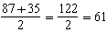

PTS: 2 REF: 011015ge STA: G.G.51 TOP: Arcs Determined by Angles
KEY: inside circle

16 ANS: 1
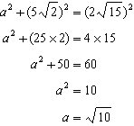

PTS: 2 REF: 011016ge STA: G.G.48 TOP: Pythagorean Theorem

17 ANS: 4

PTS: 2 REF: 011017ge STA: G.G.67 TOP: Distance

18 ANS: 4
The slope of is . The perpendicular slope is . 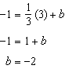

PTS: 2 REF: 011018ge STA: G.G.64 TOP: Parallel and Perpendicular Lines

19 ANS: 4 PTS: 2 REF: 011019ge STA: G.G.44
TOP: Similarity Proofs

20 ANS: 2 PTS: 2 REF: 011020ge STA: G.G.74
TOP: Graphing Circles

21 ANS: 1
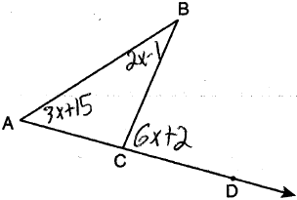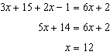

PTS: 2 REF: 011021ge STA: G.G.32 TOP: Exterior Angle Theorem

22 ANS: 2
Because the triangles are similar, 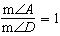

PTS: 2 REF: 011022ge STA: G.G.45 TOP: Similarity
KEY: perimeter and area

23 ANS: 3
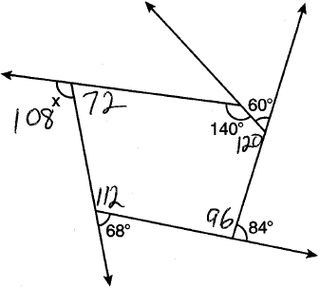. The sum of the interior angles of a pentagon is .

PTS: 2 REF: 011023ge STA: G.G.36 TOP: Interior and Exterior Angles of Polygons

24 ANS: 1 PTS: 2 REF: 011024ge STA: G.G.3
TOP: Planes

25 ANS: 3
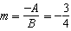

PTS: 2 REF: 011025ge STA: G.G.62 TOP: Parallel and Perpendicular Lines

26 ANS: 1

PTS: 2 REF: 011026ge STA: G.G.54 TOP: Compositions of Transformations
KEY: basic

27 ANS: 3

PTS: 2 REF: 011027ge STA: G.G.14 TOP: Volume and Lateral Area

28 ANS: 3 PTS: 2 REF: 011028ge STA: G.G.26
TOP: Conditional Statements

29 ANS:
67. 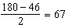

PTS: 2 REF: 011029ge STA: G.G.31 TOP: Isosceles Triangle Theorem

30 ANS:
4. 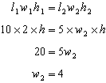

PTS: 2 REF: 011030ge STA: G.G.11 TOP: Volume

31 ANS:
. 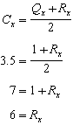. 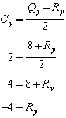.

PTS: 2 REF: 011031ge STA: G.G.66 TOP: Midpoint

32 ANS:
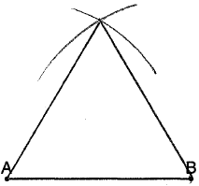

PTS: 2 REF: 011032ge STA: G.G.20 TOP: Constructions

33 ANS:
5. 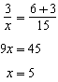

PTS: 2 REF: 011033ge STA: G.G.46 TOP: Side Splitter Theorem

34 ANS:
6. The centroid divides each median into segments whose lengths are in the ratio 2 : 1. and

PTS: 2 REF: 011034ge STA: G.G.43 TOP: Centroid

35 ANS:
36, because a dilation does not affect angle measure. 10, because a dilation does affect distance.

PTS: 4 REF: 011035ge STA: G.G.59 TOP: Properties of Transformations

36 ANS:
because opposite sides of a parallelogram are congruent. because of the Isosceles Triangle Theorem. because of the transitive property. JKLM is a rhombus because all sides are congruent.

PTS: 4 REF: 011036ge STA: G.G.27 TOP: Quadrilateral Proofs

37 ANS:
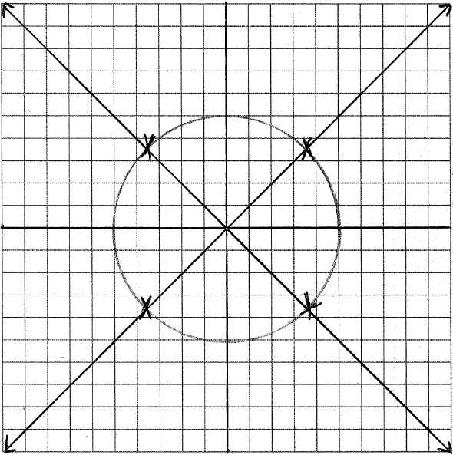

PTS: 4 REF: 011037ge STA: G.G.23 TOP: Locus

38 ANS:
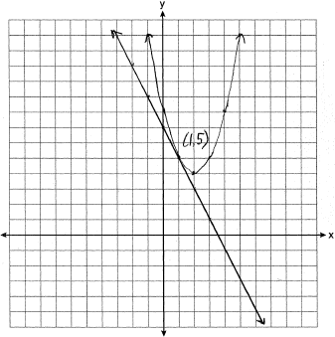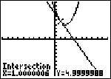

PTS: 6 REF: 011038ge STA: G.G.70 TOP: Quadratic-Linear Systems

