1 If a, b, and c are all positive real numbers, which graph could represent the sketch of the graph of ?
1) | 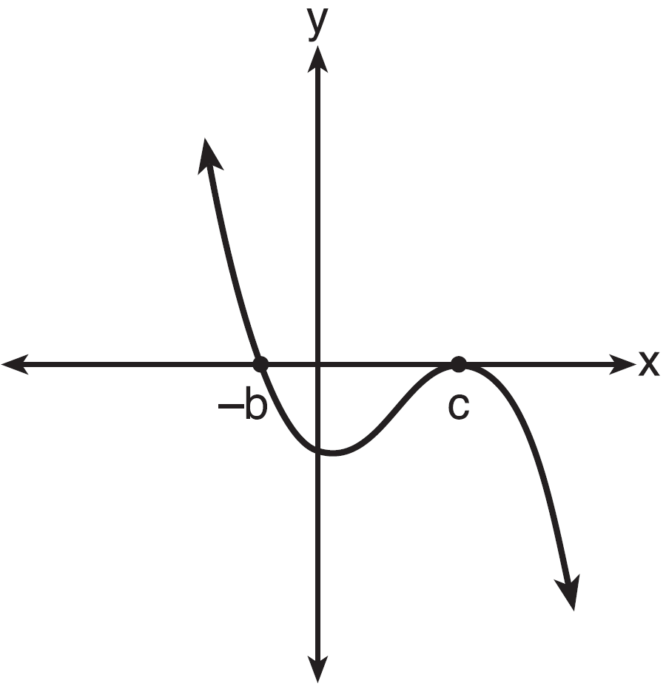 | 3) | 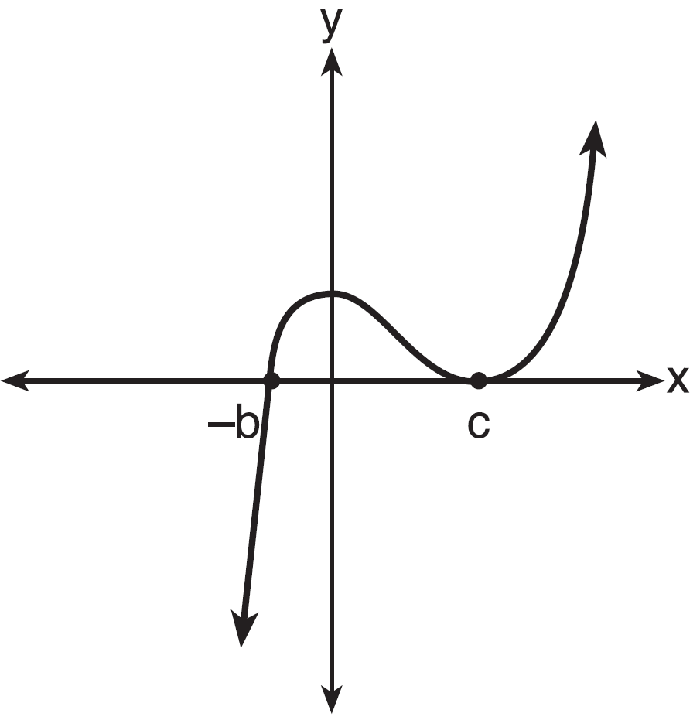
2) | 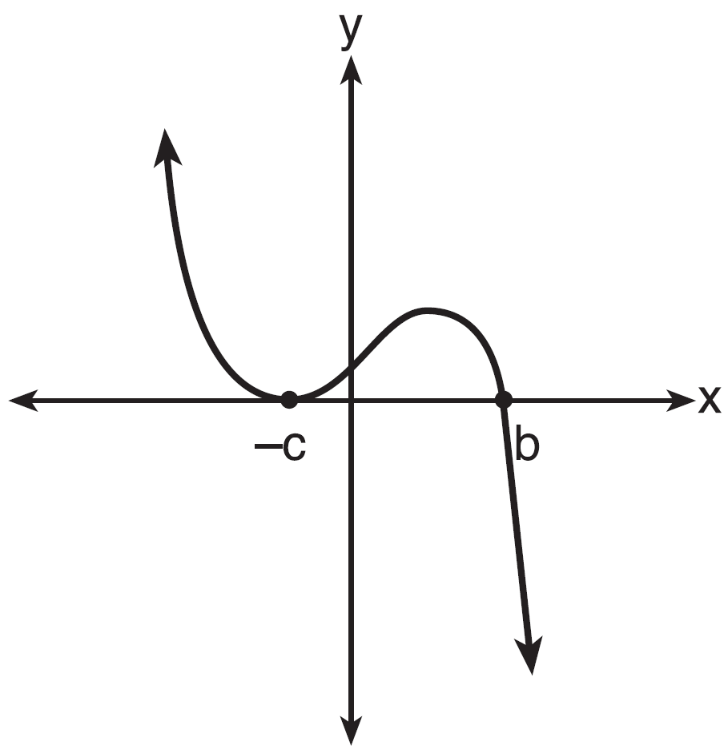 | 4) | 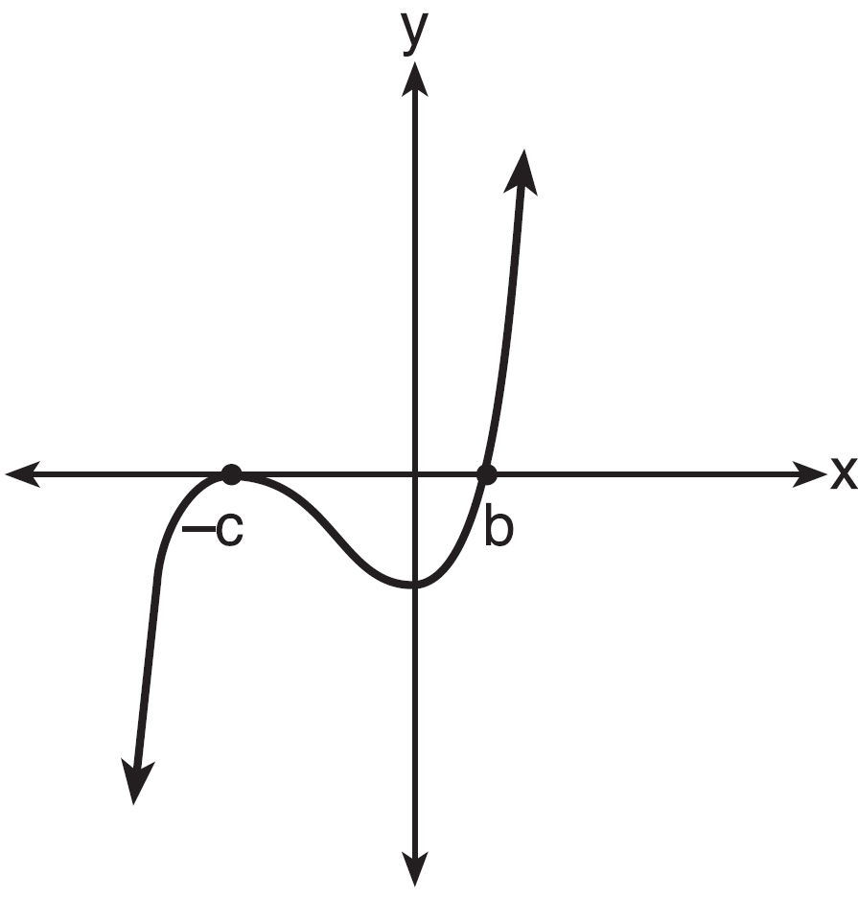

2 Which equation represents a parabola with a focus of and a directrix of ?
1) |  | 3) | 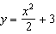
2) |  | 4) | 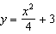

3 If the terminal side of angle , in standard position, passes through point , what is the numerical value of ?
1) |  | 3)
2) |  | 4)

4 A study of the annual population of the red-winged blackbird in Ft. Mill, South Carolina, shows the population, , can be represented by the function , where the t represents the number of years since the study began. In terms of the monthly rate of growth, the population of red-winged blackbirds can be best approximated by the function
1) |  | 3)
2) |  | 4) | 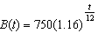

5 Use the properties of rational exponents to determine the value of y for the equation:
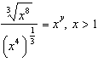

6 Write in form, where y is a real number.

7 Use an appropriate procedure to show that is a factor of the function . Explain your answer.

8 Solve algebraically for all values of x:

9 Monthly mortgage payments can be found using the formula below:

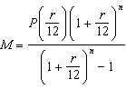

M = monthly payment
P = amount borrowed
r = annual interest rate
n = number of monthly payments

The Banks family would like to borrow $120,000 to purchase a home. They qualified for an annual interest rate of 4.8%. Algebraically determine the fewest number of whole years the Banks family would need to include in the mortgage agreement in order to have a monthly payment of no more than $720.

10 Solve the following system of equations algebraically for all values of x, y, and z:
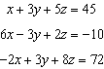

11 Write an explicit formula for , the nth term of the recursively defined sequence below.
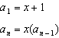
For what values of x would when ?

12 Stephen’s Beverage Company is considering whether to produce a new brand of cola. The company will launch the product if at least 25% of cola drinkers will buy the product. Fifty cola drinkers are randomly selected to take a blind taste-test of products A, B, and the new product. Nine out of fifty participants preferred Stephen’s new cola to products A and B. The company then devised a simulation based on the requirement that 25% of cola drinkers will buy the product. Each dot in the graph shown below represents the proportion of people who preferred Stephen’s new product, each of sample size 50, simulated 100 times.

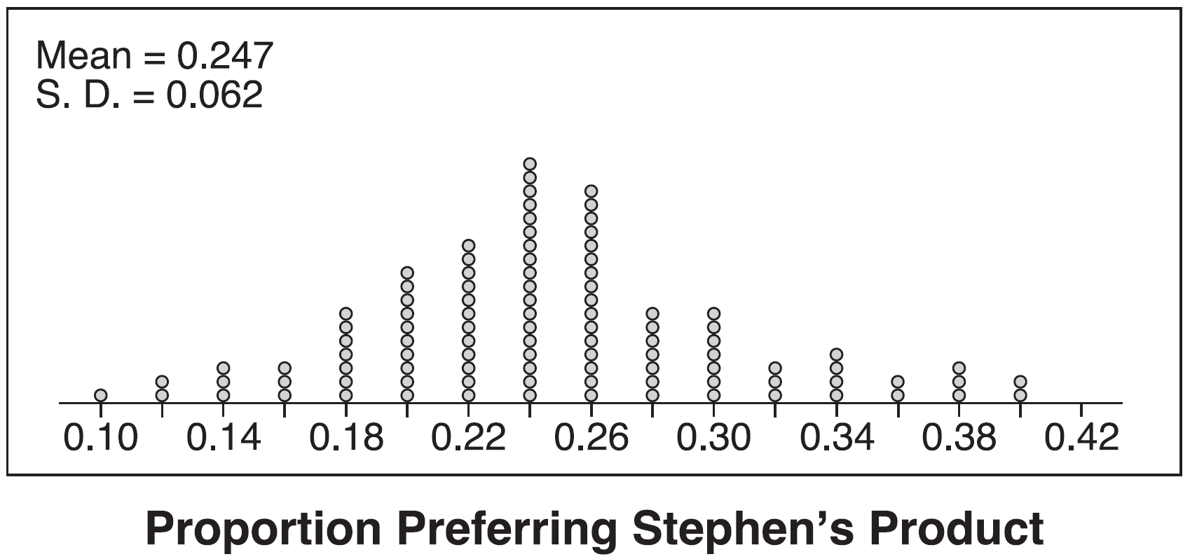

Assume the set of data is approximately normal and the company wants to be 95% confident of its results. Does the sample proportion obtained from the blind taste-test, nine out of fifty, fall within the margin of error developed from the simulation? Justify your answer. The company decides to continue developing the product even though only nine out of fifty participants preferred its brand of cola in the taste-test. Describe how the simulation data could be used to support this decision.

13 In contract negotiations between a local government agency and its workers, it is estimated that there is a 50% chance that an agreement will be reached on the salaries of the workers. It is estimated that there is a 70% chance that there will be an agreement on the insurance benefits. There is a 20% chance that no agreement will be reached on either issue. Find the probability that an agreement will be reached on both issues. Based on this answer, determine whether the agreement on salaries and the agreement on insurance are independent events. Justify your answer.

14 The ocean tides near Carter Beach follow a repeating pattern over time, with the amount of time between each low and high tide remaining relatively constant. On a certain day, low tide occurred at 8:30 a.m. and high tide occurred at 3:00 p.m. At high tide, the water level was 12 inches above the average local sea level; at low tide it was 12 inches below the average local sea level. Assume that high tide and low tide are the maximum and minimum water levels each day, respectively. Write a cosine function of the form , where A and B are real numbers, that models the water level, , in inches above or below the average Carter Beach sea level, as a function of the time measured in t hours since 8:30 a.m. On the grid below, graph one cycle of this function.



People who fish in Carter Beach know that a certain species of fish is most plentiful when the water level is increasing. Explain whether you would recommend fishing for this species at 7:30 p.m. or 10:30 p.m. using evidence from the given context.

15 What is the solution set of the equation 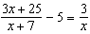?
1) | 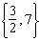 | 3) | 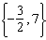
2) | 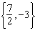 | 4) | 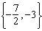

16 Functions f, g, and h are given below.

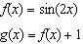

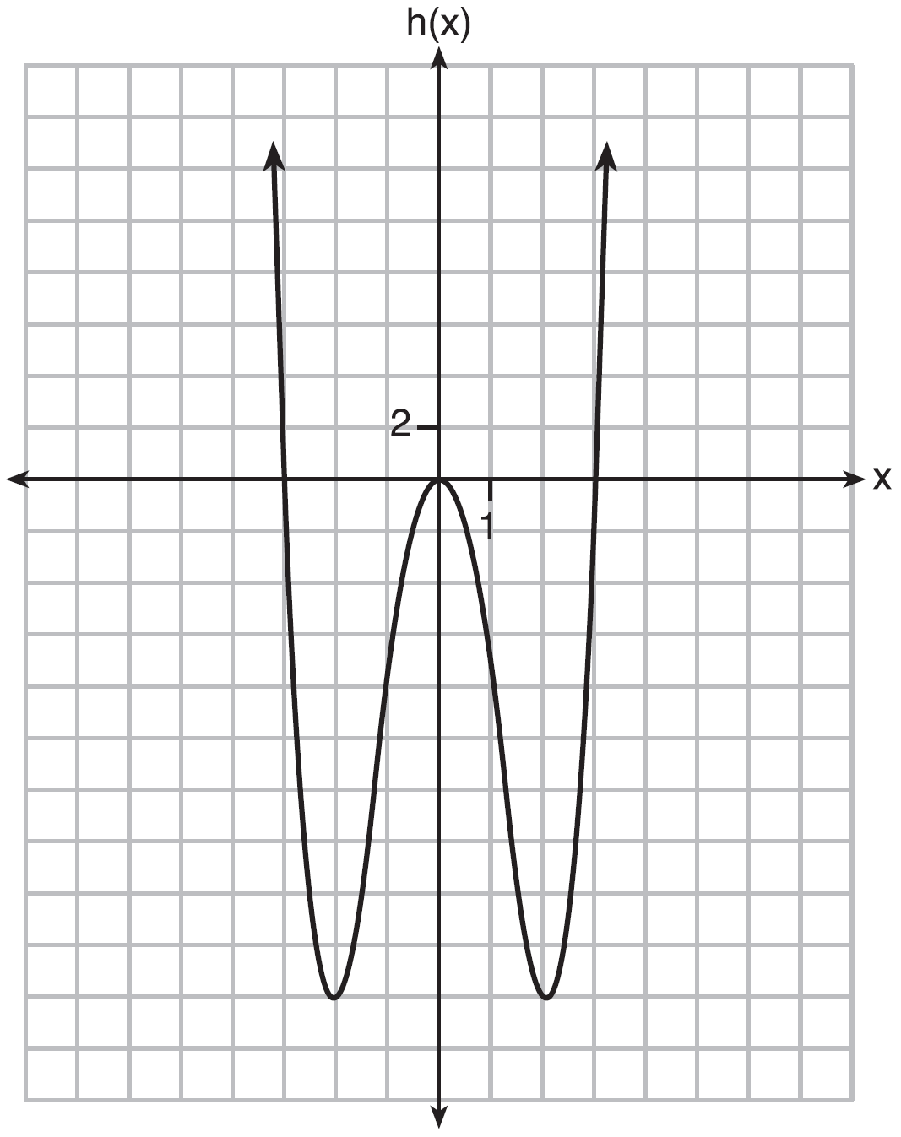

Which statement is true about functions f, g, and h?
1) | and are odd, is even. | 3) | is odd, is neither, is even.
2) | and are even, is odd. | 4) | is even, is neither, is odd.

17 The expression 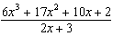 equals
1) | 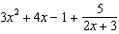 | 3) | 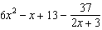
2) | 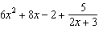 | 4) | 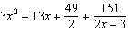

18 The solutions to the equation 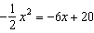 are
1) |  | 3)
2) |  | 4)

19 What is the completely factored form of ?
1) |  | 3)
2) |  | 4)

20 Which statement is incorrect for the graph of the function 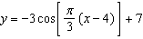?
1) | The period is 6. | 3) | The range is [4,10].
2) | The amplitude is 3. | 4) | The midline is .

21 Algebraically determine the values of x that satisfy the system of equations below.
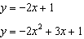

22 The results of a poll of 200 students are shown in the table below:

 | Preferred Music Style
 | Techno | Rap | Country
Female | 54 | 25 | 27
Male | 36 | 40 | 18

For this group of students, do these data suggest that gender and preferred music styles are independent of each other? Justify your answer.

23 For the function , find .

24 Given: 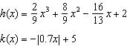
State the solutions to the equation , rounded to the nearest hundredth.

25 Algebraically prove that the difference of the squares of any two consecutive integers is an odd integer.

26 Rewrite the expression 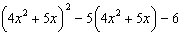 as a product of four linear factors.

27 After sitting out of the refrigerator for a while, a turkey at room temperature (68°F) is placed into an oven at 8 a.m., when the oven temperature is 325°F. Newton’s Law of Heating explains that the temperature of the turkey will increase proportionally to the difference between the temperature of the turkey and the temperature of the oven, as given by the formula below:

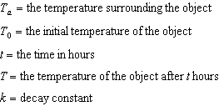

The turkey reaches the temperature of approximately 100° F after 2 hours. Find the value of k, to the nearest thousandth, and write an equation to determine the temperature of the turkey after t hours. Determine the Fahrenheit temperature of the turkey, to the nearest degree, at 3 p.m.

28 Seventy-two students are randomly divided into two equally-sized study groups. Each member of the first group (group 1) is to meet with a tutor after school twice each week for one hour. The second group (group 2), is given an online subscription to a tutorial account that they can access for a maximum of two hours each week. Students in both groups are given the same tests during the year. A summary of the two groups’ final grades is shown below:

 | Group 1 | Group 2
 | 80.16 | 83.8
 | 6.9 | 5.2

Calculate the mean difference in the final grades (group 1 – group 2) and explain its meaning in the context of the problem. A simulation was conducted in which the students’ final grades were rerandomized 500 times. The results are shown below.

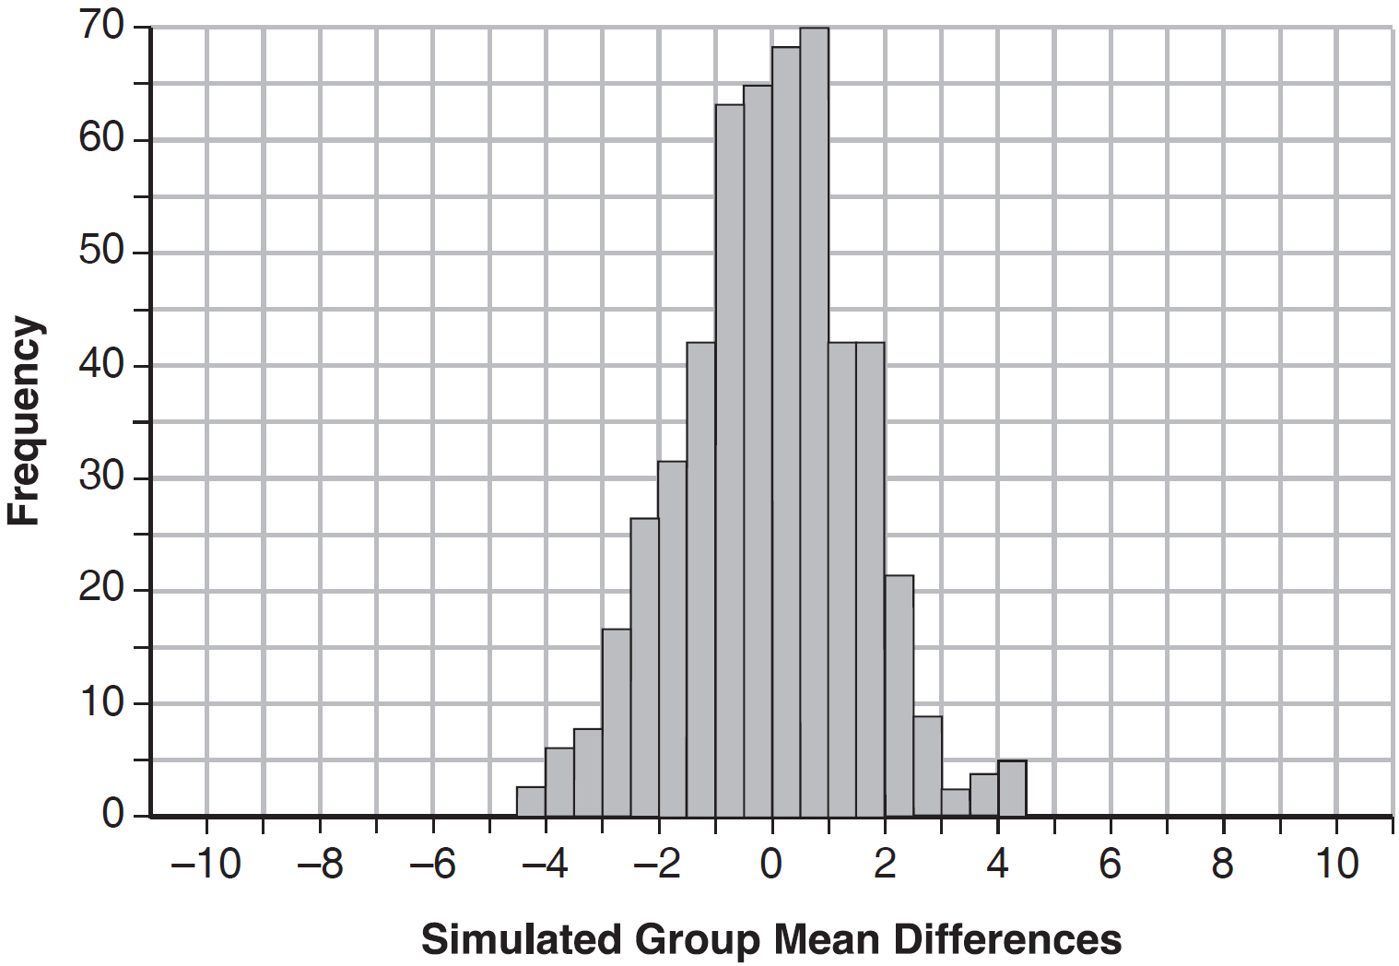

Use the simulation to determine if there is a significant difference in the final grades. Explain your answer.

29 Given , , and , algebraically determine all the zeros of .

30 Two versions of a standardized test are given, an April version and a May version. The statistics for the April version show a mean score of 480 and a standard deviation of 24. The statistics for the May version show a mean score of 510 and a standard deviation of 20. Assume the scores are normally distributed. Joanne took the April version and scored in the interval 510-540. What is the probability, to the nearest ten thousandth, that a test paper selected at random from the April version scored in the same interval? Maria took the May version. In what interval must Maria score to claim she scored as well as Joanne?

31 Titanium-44 is a radioactive isotope such that every 63 years, its mass decreases by half. For a sample of titanium-44 with an initial mass of 100 grams, write a function that will give the mass of the sample remaining after any amount of time. Define all variables. Scientists sometimes use the average yearly decrease in mass for estimation purposes. Use the average yearly decrease in mass of the sample between year 0 and year 10 to predict the amount of the sample remaining after 40 years. Round your answer to the nearest tenth. Is the actual mass of the sample or the estimated mass greater after 40 years? Justify your answer.
1 ANS: 1
The zeros of the polynomial are at , and c. The sketch of a polynomial of degree 3 with a negative leading coefficient should have end behavior showing as x goes to negative infinity, goes to positive infinity. The multiplicities of the roots are correctly represented in the graph.

PTS: 2 REF: spr1501aii NAT: A.APR.B.3 TOP: Zeros of Polynomials
KEY: AII

2 ANS: 4
A parabola with a focus of and a directrix of is sketched as follows: 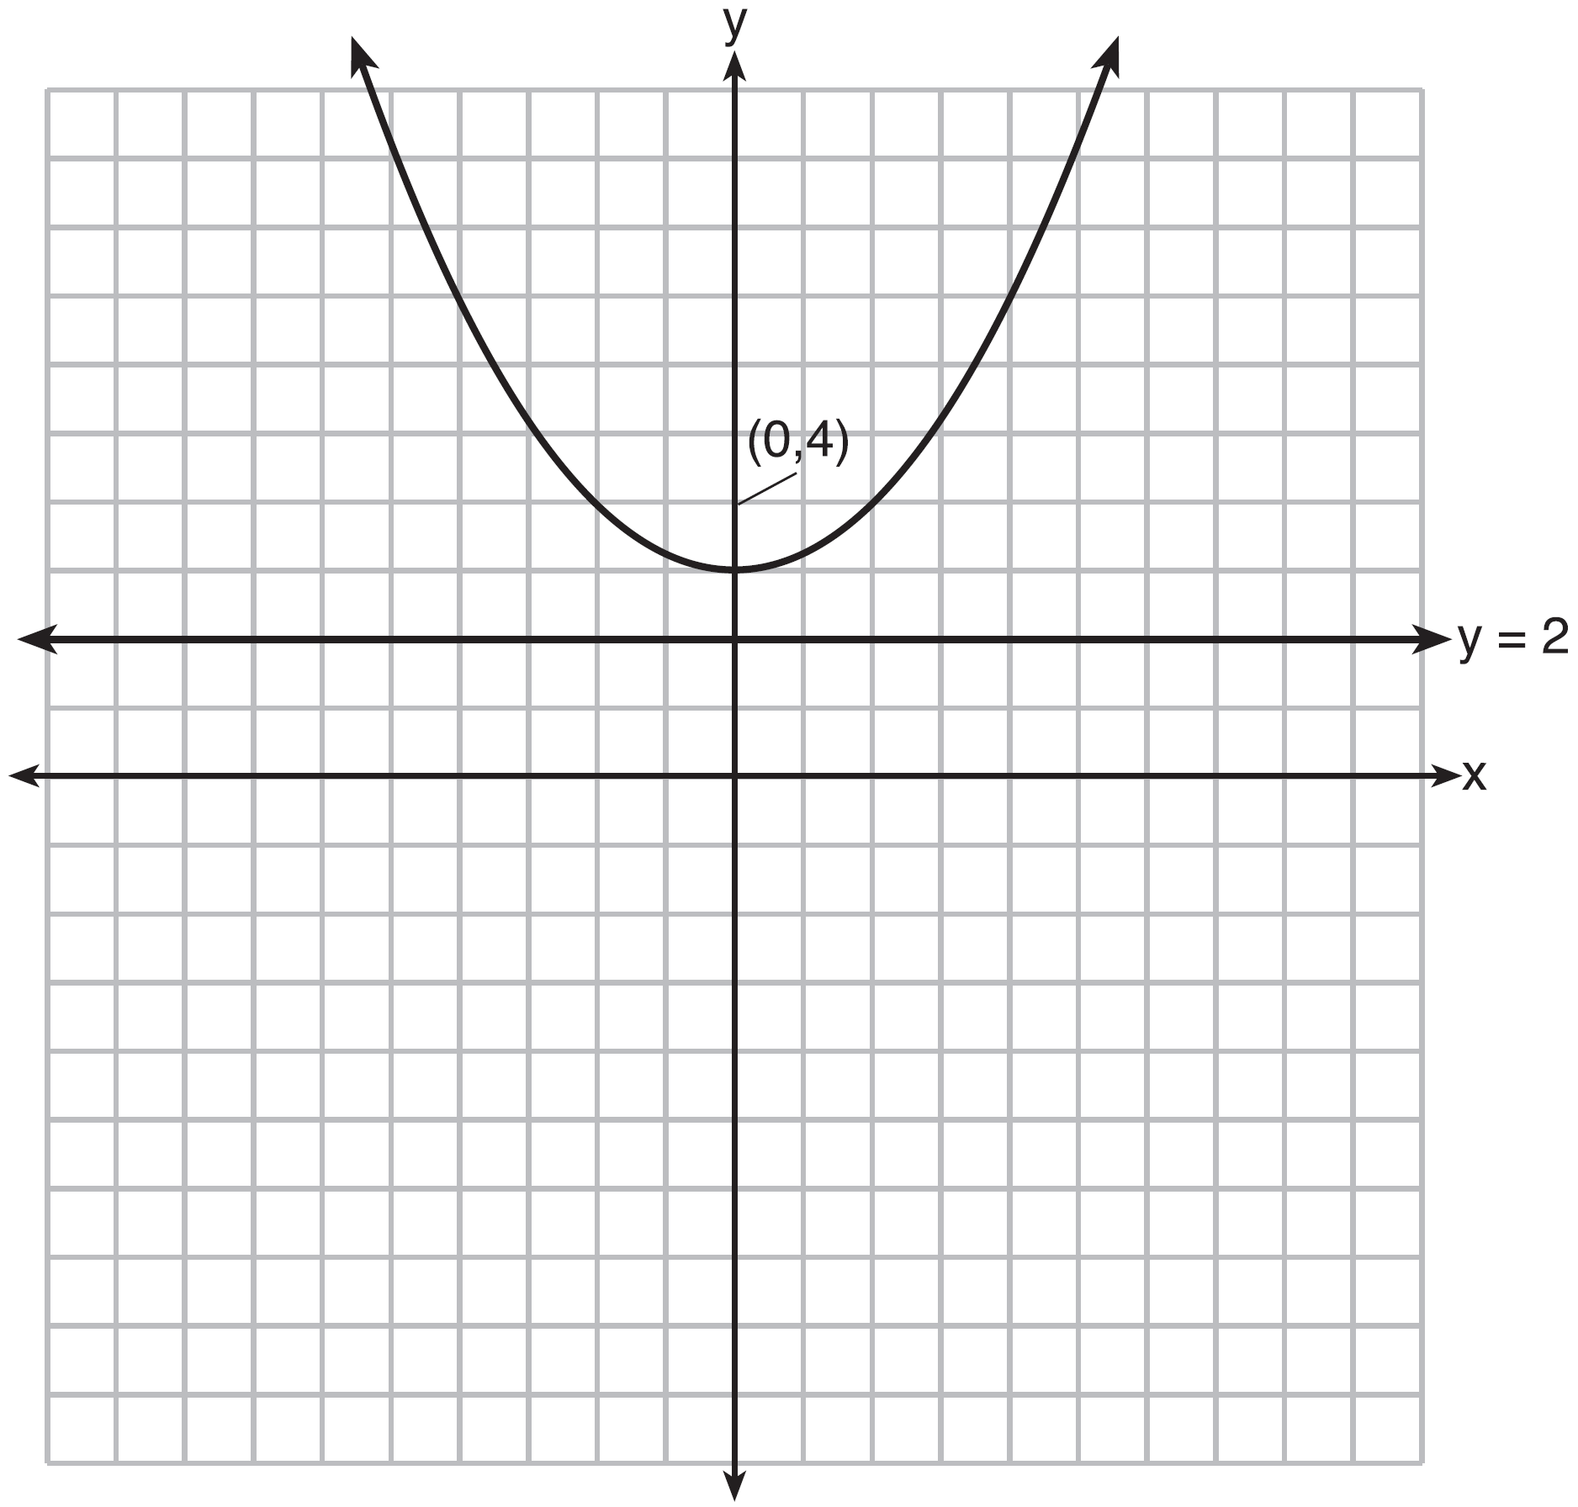By inspection, it is determined that the vertex of the parabola is . It is also evident that the distance, p, between the vertex and the focus is 1. It is possible to use the formula to derive the equation of the parabola as follows: 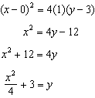
or A point on the parabola must be the same distance from the focus as it is from the directrix. For any such point , the distance to the focus is and the distance to the directrix is . Setting this equal leads to: 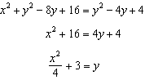

PTS: 2 REF: spr1502aii NAT: G.GPE.A.2 TOP: Graphing Quadratic Functions

3 ANS: 1
A reference triangle can be sketched using the coordinates in the second quadrant to find the value of . 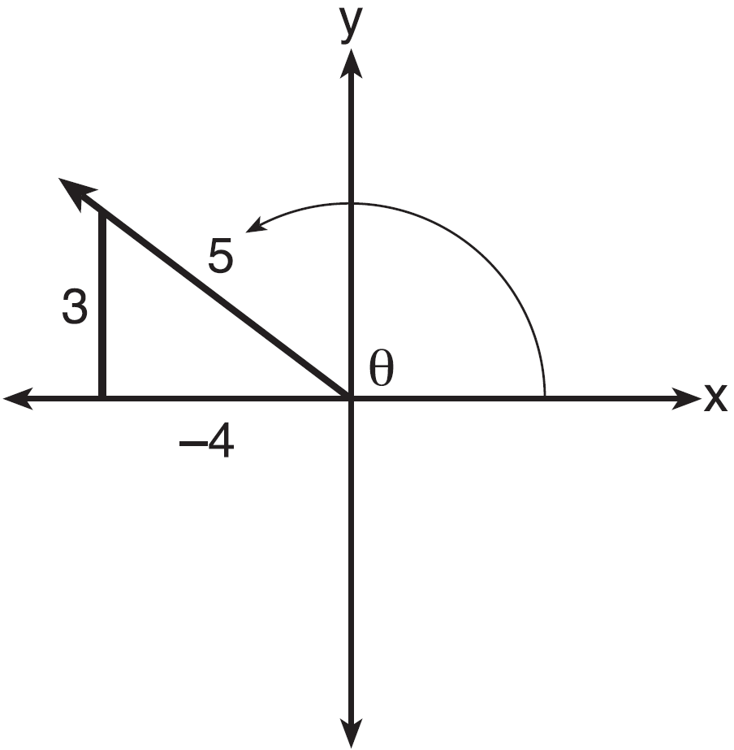

PTS: 2 REF: spr1503aii NAT: F.TF.A.2 TOP: Determining Trigonometric Functions
KEY: extension to reals

4 ANS: 2
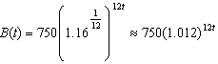 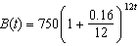 is wrong, because the growth is an annual rate that is not compounded monthly.

PTS: 2 REF: spr1504aii NAT: A.SSE.B.3 TOP: Modeling Exponential Functions
KEY: AII

5 ANS:
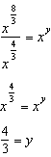

PTS: 2 REF: spr1505aii NAT: N.RN.A.2 TOP: Radicals and Rational Exponents
KEY: numbers

6 ANS:
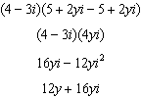

PTS: 2 REF: spr1506aii NAT: N.CN.A.2 TOP: Operations with Complex Numbers

7 ANS:
Any method that demonstrates 4 is a zero of confirms that is a factor, as suggested by the Remainder Theorem. 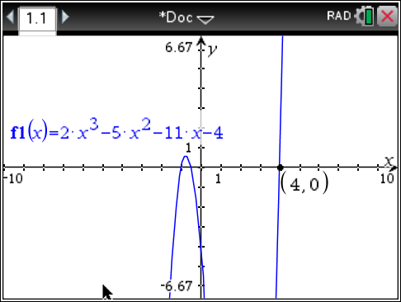

PTS: 2 REF: spr1507aii NAT: A.APR.B.2 TOP: Remainder Theorem

8 ANS:
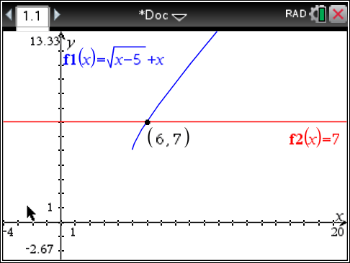 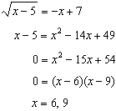 is extraneous.

PTS: 2 REF: spr1508aii NAT: A.REI.A.2 TOP: Solving Radicals
KEY: extraneous solutions

9 ANS:
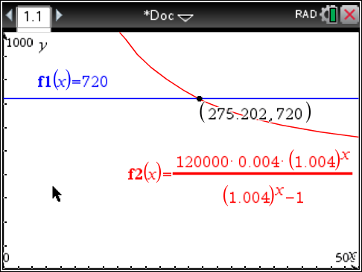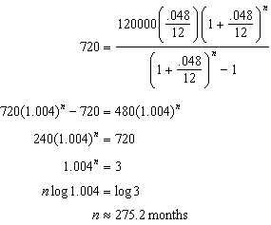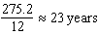

PTS: 4 REF: spr1509aii NAT: A.CED.A.1 TOP: Exponential Growth

10 ANS:
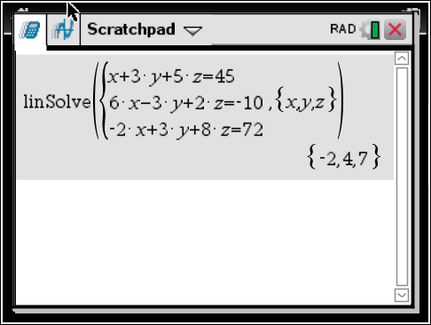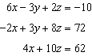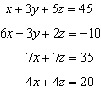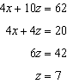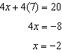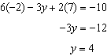

PTS: 4 REF: spr1510aii NAT: A.REI.C.6 TOP: Solving Linear Systems
KEY: three variables

11 ANS:
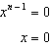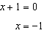

PTS: 4 REF: spr1511aii NAT: F.BF.A.2 TOP: Sequences

12 ANS:
Yes. The margin of error from this simulation indicates that 95% of the observations fall within of the simulated proportion, 0.25. The margin of error can be estimated by multiplying the standard deviation, shown to be 0.06 in the dotplot, by 2, or applying the estimated standard error formula, 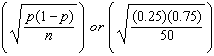 and multiplying by 2. The interval includes plausible values for the true proportion of people who prefer Stephen’s new product. The company has evidence that the population proportion could be at least 25%. As seen in the dotplot, it can be expected to obtain a sample proportion of 0.18 (9 out of 50) or less several times, even when the population proportion is 0.25, due to sampling variability. Given this information, the results of the survey do not provide enough evidence to suggest that the true proportion is not at least 0.25, so the development of the product should continue at this time.

PTS: 4 REF: spr1512aii NAT: S.IC.B.4 TOP: Analysis of Data

13 ANS:
This scenario can be modeled with a Venn Diagram: 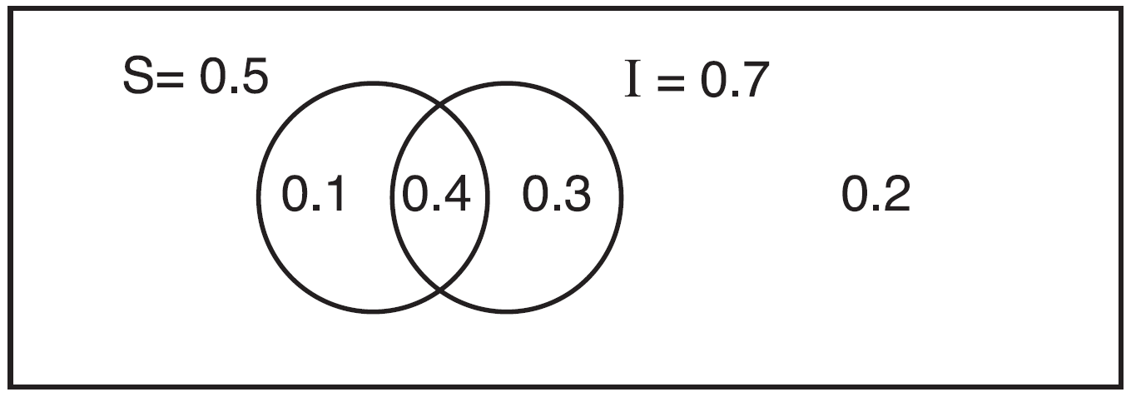 Since . Then, 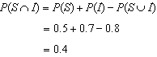 If S and I are independent, then the Product Rule must be satisfied. However, . Therefore, salary and insurance have not been treated independently.

PTS: 4 REF: spr1513aii NAT: S.CP.A.2 TOP: Theoretical Probability

14 ANS:
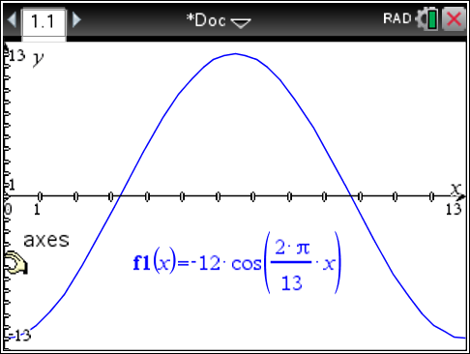The amplitude, 12, can be interpreted from the situation, since the water level has a minimum of and a maximum of 12. The value of A is since at 8:30 it is low tide. The period of the function is 13 hours, and is expressed in the function through the parameter B. By experimentation with technology or using the relation 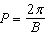 (where P is the period), it is determined that 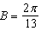. 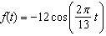 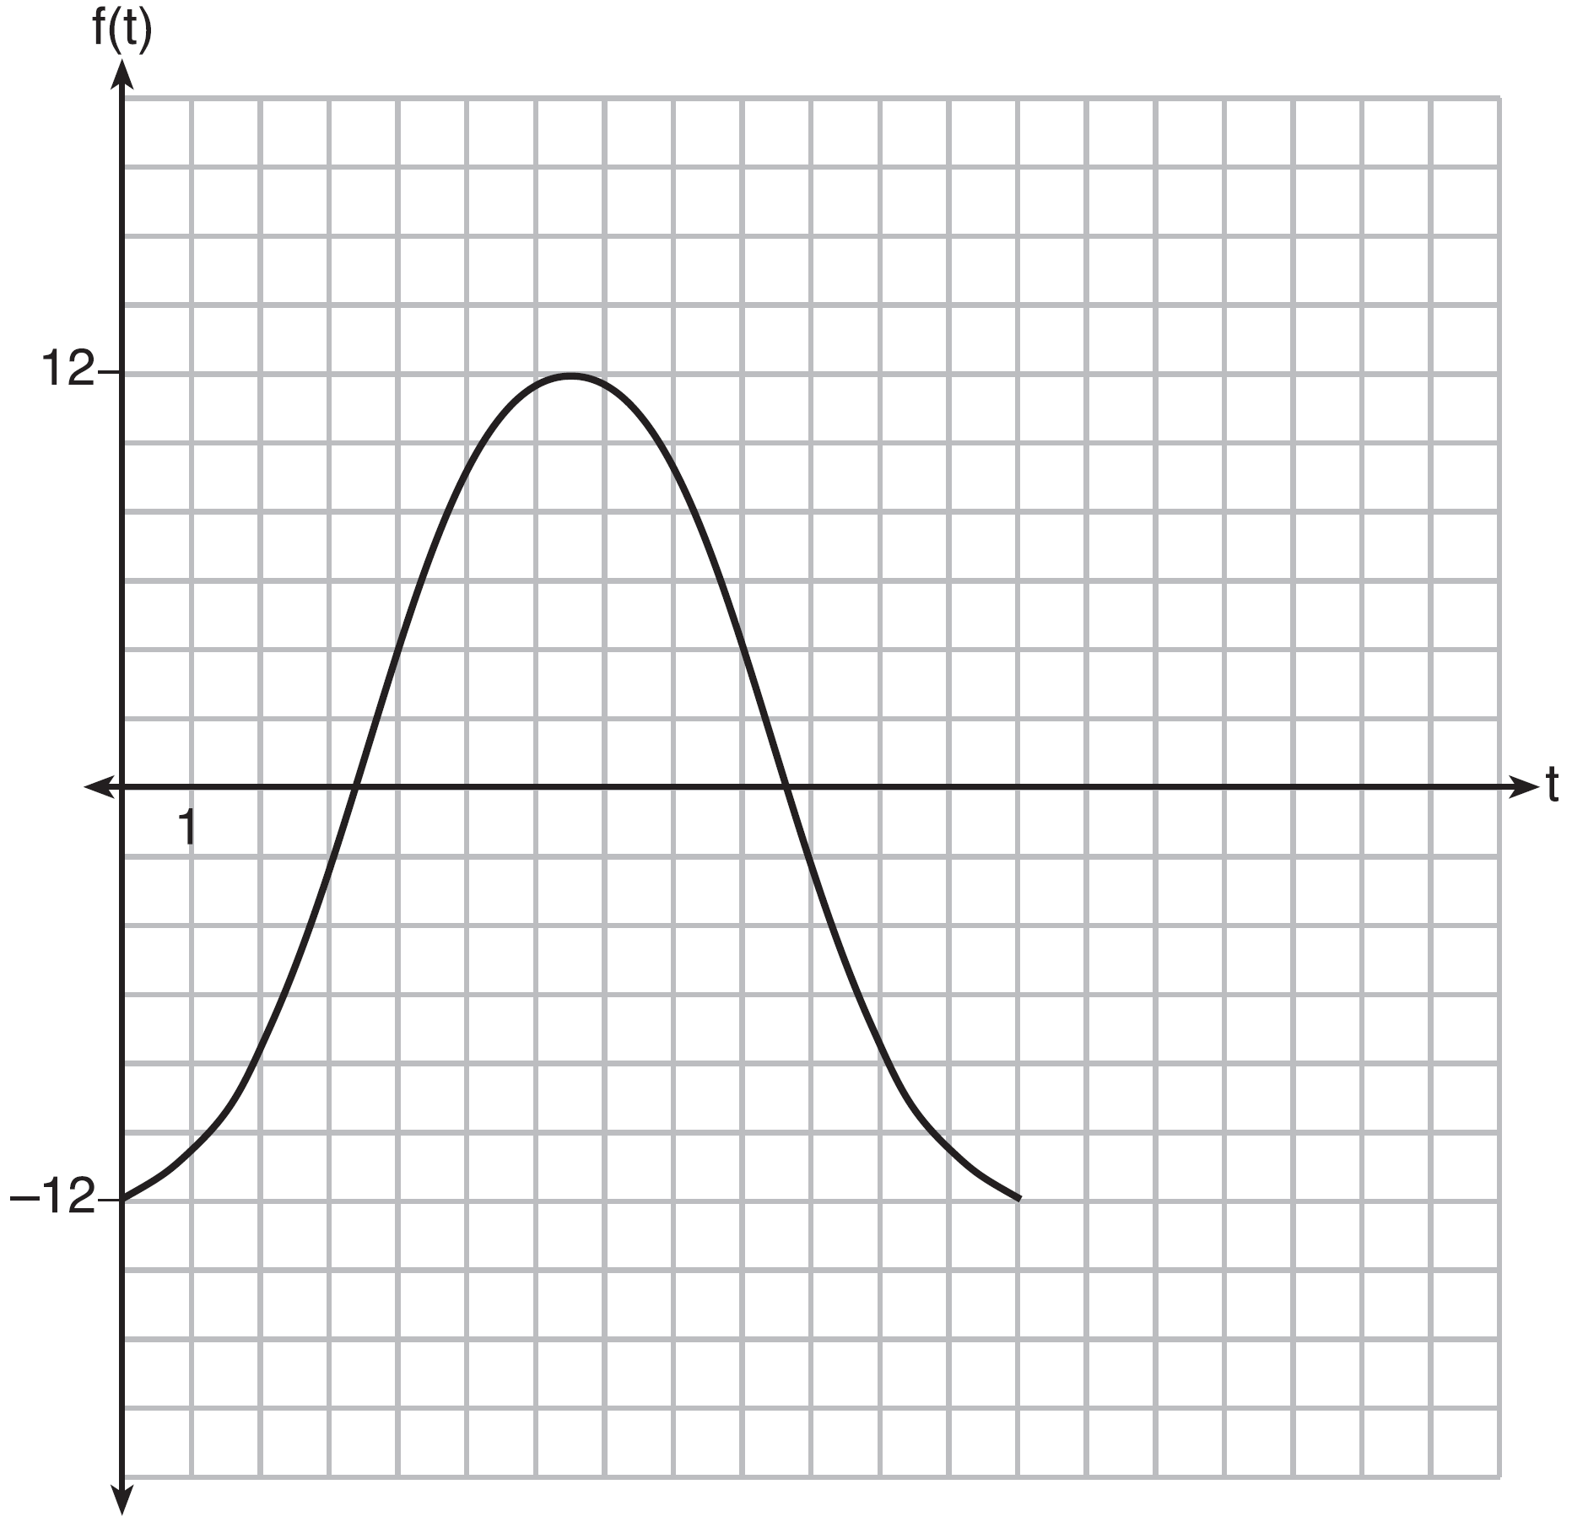
In order to answer the question about when to fish, the student must interpret the function and determine which choice, 7:30 pm or 10:30 pm, is on an increasing interval. Since the function is increasing from to (which corresponds to 9:30 pm to 4:00 am), 10:30 is the appropriate choice.

PTS: 6 REF: spr1514aii NAT: F.IF.C.7 TOP: Graphing Trigonometric Functions
KEY: graph

15 ANS: 4
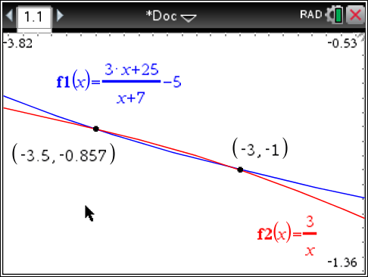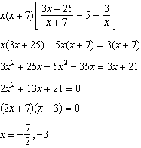

PTS: 2 REF: fall1501aii NAT: A.REI.A.2 TOP: Solving Rationals
KEY: rational solutions

16 ANS: 3
, so is odd. , so is not even. , so is not odd. , so is even.

PTS: 2 REF: fall1502aii NAT: F.BF.B.3 TOP: Even and Odd Functions

17 ANS: 1
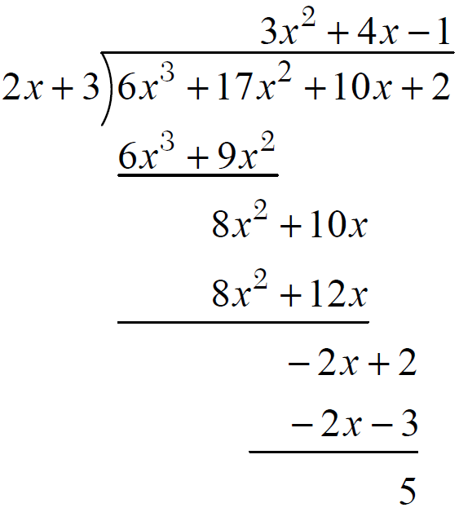

PTS: 2 REF: fall1503aii NAT: A.APR.D.6 TOP: Rational Expressions

18 ANS: 3
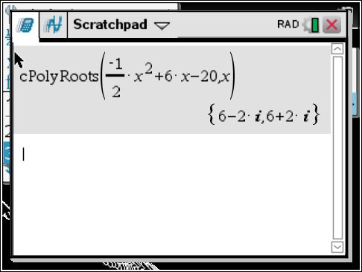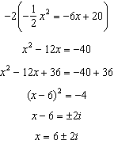

PTS: 2 REF: fall1504aii NAT: A.REI.B.4 TOP: Solving Quadratics
KEY: complex solutions | completing the square

19 ANS: 4
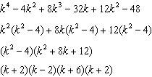

PTS: 2 REF: fall1505aii NAT: A.SSE.A.2 TOP: Factoring Polynomials
KEY: factoring by grouping

20 ANS: 4
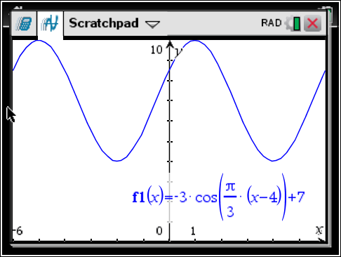 As the range is [4,10], the midline is 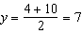.

PTS: 2 REF: fall1506aii NAT: F.IF.C.7 TOP: Graphing Trigonometric Functions
KEY: mixed

21 ANS:
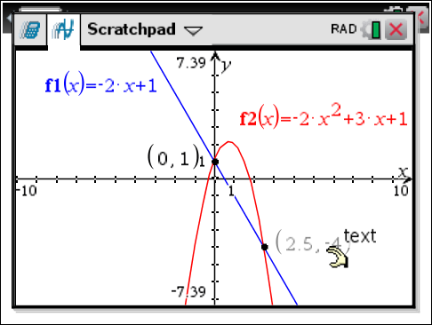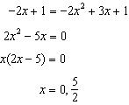

PTS: 2 REF: fall1507aii NAT: A.REI.C.7 TOP: Quadratic-Linear Systems
KEY: AII

22 ANS:
Based on these data, the two events do not appear to be independent. 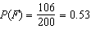, while 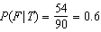, 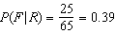, and 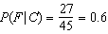. The probability of being female are not the same as the conditional probabilities. This suggests that the events are not independent.

PTS: 2 REF: fall1508aii NAT: S.CP.A.4 TOP: Conditional Probability

23 ANS:
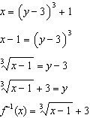

PTS: 2 REF: fall1509aii NAT: F.BF.B.4 TOP: Inverse of Functions
KEY: equations

24 ANS:
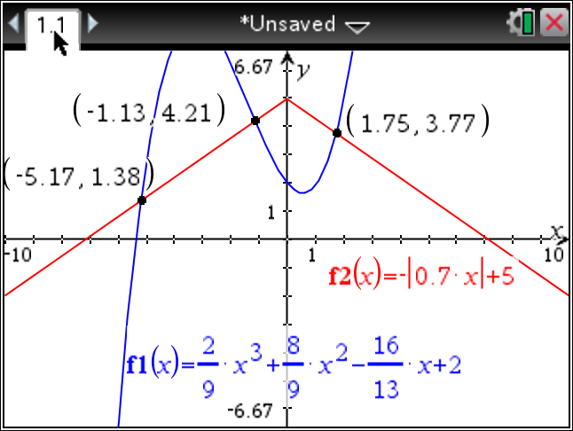

PTS: 2 REF: fall1510aii NAT: A.REI.D.11 TOP: Other Systems
KEY: AII

25 ANS:
Let x equal the first integer and equal the next. . is an odd integer.

PTS: 2 REF: fall1511aii NAT: A.APR.C.4 TOP: Polynomial Identities

26 ANS:
The expression is of the form or . Let :
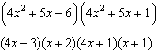

PTS: 2 REF: fall1512aii NAT: A.SSE.A.2 TOP: Factoring Polynomials
KEY: a>1

27 ANS:
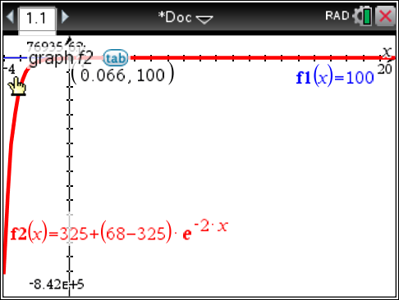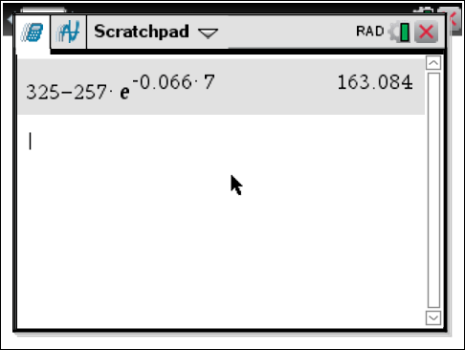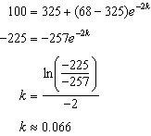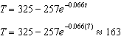

PTS: 4 REF: fall1513aii NAT: F.LE.A.4 TOP: Exponential Growth

28 ANS:
The mean difference between the students’ final grades in group 1 and group 2 is –3.64. This value indicates that students who met with a tutor had a mean final grade of 3.64 points less than students who used an on-line subscription. One can infer whether this difference is due to the differences in intervention or due to which students were assigned to each group by using a simulation to rerandomize the students’ final grades many (500) times. If the observed difference –3.64 is the result of the assignment of students to groups alone, then a difference of –3.64 or less should be observed fairly regularly in the simulation output. However, a difference of –3 or less occurs in only about 2% of the rerandomizations. Therefore, it is quite unlikely that the assignment to groups alone accounts for the difference; rather, it is likely that the difference between the interventions themselves accounts for the difference between the two groups’ mean final grades.

PTS: 4 REF: fall1514aii NAT: S.IC.B.5 TOP: Analysis of Data

29 ANS:
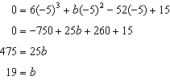
-5 | 6 | 19 | -52 | 15
 |  | -30 | 55 | 15
 | 6 | -11 | 3 | 0
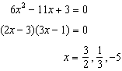

PTS: 4 REF: fall1515aii NAT: A.APR.B.2 TOP: Remainder Theorem

30 ANS:
normcdf(510, 540, 480, 24) = 0.0994 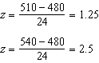 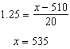 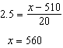 535-560

PTS: 4 REF: fall1516aii NAT: S.ID.A.4 TOP: Normal Distributions
KEY: probability

31 ANS:
, where t is time in years, and is the amount of titanium-44 left after t years. 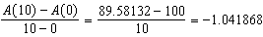 The estimated mass at is . The actual mass is . The estimated mass is less than the actual mass.

PTS: 6 REF: fall1517aii NAT: F.LE.A.2 TOP: Modeling Exponential Functions
KEY: AII

