1 A grocery store owner wonders how many customers bring reusable bags to the store. An employee stands at the store entrance for two hours and counts the number of people bringing in reusable bags. This type of study is best classified as
1) | a census | 3) | an observational study
2) | an experiment | 4) | a survey

2 The graph of is positive on which interval?
1) |  | 3)
2) |  | 4)

3 Tim deposits $300 into a savings account. The annual interest rate is 2.7% and compounds monthly. He uses the equation 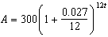 to determine how much money he will have after t years. Which equation is equivalent to Tim's equation?
1) | 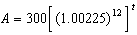 | 3) | 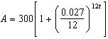
2) |  | 4) | 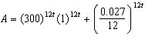

4 Which equation is true for all real values of x?
1) |  | 3)
2) |  | 4)

5 The solution of 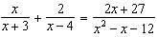 is
1) |  | 3) | 3
2) |  | 4) | 7

6 The cost, in dollars, of a single-ride fare in the New York City subway in the years since 1904 is listed in the table below.
Years since 1904 (x) | 0 | 49 | 72 | 91 | 99 | 111
Fare (y) | $0.05 | $0.15 | $0.50 | $1.50 | $2.00 | $2.75
Which equation best models the cost of a single-ride fare based on these data?
1) |  | 3)
2) |  | 4)

7 Which expression is equivalent to 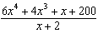?
1) | 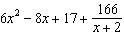 | 3) | 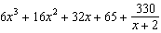
2) | 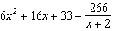 | 4) | 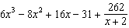

8 The solution to the equation is
1) |  | 3)
2) | 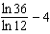 | 4) | 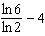

9 The asymptote of the graph of is
1) |  | 3)
2) |  | 4)

10 The probability of having math homework is and the probability of having English homework is . The probability of having math homework or having English homework is . What is the probability of having math homework and having English homework?
1) |  | 3)
2) |  | 4)

11 The solution set of the equation is
1) |  | 3)
2) |  | 4)

12 Given , the expression 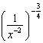 is equivalent to
1) |  | 3)
2) | 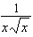 | 4) | 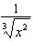

13 The graph of which function has a period of 3?
1) | 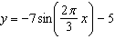 | 3)
2) | 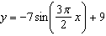 | 4)

14 Which graph could represent a 4th degree polynomial function with a positive leading coefficient, 2 real zeros, and 2 imaginary zeros?
1) | 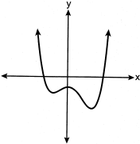 | 3) | 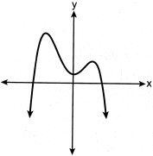
2) | 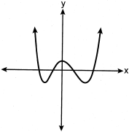 | 4) | 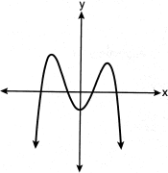

15 Given i is the imaginary unit, which expression is equivalent to ?
1) |  | 3)
2) |  | 4)

16 What is the focus of the parabola ?
1) |  | 3)
2) |  | 4)

17 Given and , what is a solution of to the nearest tenth?
1) | 1.1 | 3) | 3.9
2) | 3.7 | 4) | 4.3

18 The volume of a cardboard box can be modeled by , which is the product of the length, width, and height, x. If the length can be represented by and the width can be represented by , then which function represents ?
1) |  | 3)
2) |  | 4)

19 The expression 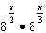 is equivalent to
1) |  | 3)
2) |  | 4)

20 If is an angle in standard position whose terminal side passes through the point , which statement is true?
1) |  | 3)
2) |  | 4)

21 What is the value of y for the system shown below?
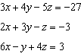
1) |  | 3) | 3
2) | 6 | 4)

22 The number of employees who work nights and weekends at a department store is summarized in the table below.

 | Works Nights | Doesn’t Work Nights
Works Weekends | 8 | 40
Doesn’t Work Weekends | 12 | 60

Let N represent the event "works nights" and let W represent the event "works weekends." Based on the table, are N and W independent events?
1) | Yes, because . | 3) | No, because .
2) | Yes, because . | 4) | No, because .

23 Which expression is equivalent to ?
1) |  | 3)
2) |  | 4)

24 A research assistant receives a first year salary of $90,000 and a 2% annual raise throughout the first ten years of employment. In total, how much money will be earned over the first ten years, to the nearest dollar?
1) | $91,837 | 3) | $877,917
2) | $109,709 | 4) | $985,475

25 On the axes below, graph .

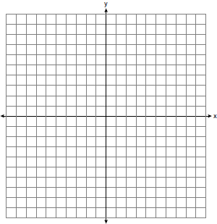

26 Is a factor of ? Justify your answer.

27 Over the set of integers, factor the expression completely.

28 The monthly unemployment rate of towns in the United States is approximately normally distributed with a mean rate of 5.2% and a standard deviation of 1.6%. Determine the percentage of towns, to the nearest integer, that have a monthly unemployment rate greater than 6%.

29 The function 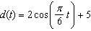 models the water depth, in feet, at a location in a bay, t hours since the last high tide. Determine the minimum water depth of the location, in feet, and justify your answer.

30 A brewed cup of coffee contains 130 mg of caffeine. The half-life of caffeine in the bloodstream is 5.5 hours. Write a function, to represent the amount of caffeine in the bloodstream t hours after drinking one cup of coffee.

31 Markus is a long-distance walker. In one race, he walked 55 miles in t hours and in another race walked 65 miles in hours. His rates are shown in the equations below.
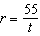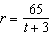
Markus walked at an equivalent rate, r, for each race. Determine the number of hours that each of the two races took.

32 Solve the equation algebraically. Express the answer in form.

33 The population of China, in millions, can be modeled by the function , where x is the number of years since 1900. The population of India since 1900 is summarized in the table below:

Years since 1900 | Population (millions)
0 | 243
10 | 254
20 | 268
30 | 285
40 | 324
50 | 376.3
60 | 450.6
70 | 555.1
80 | 699
60 | 873.3
100 | 1056.6
110 | 1234.3
120 | 1380

Which country's population had a greater average rate of change between 1950 and 2020? Justify your answer.

34 In a packaging plant, a machine packs boxes with jars. The machine's manufacturer states that a box is packed, on average, every 42 seconds. To test that claim, the packaging plant randomly selects a sample of 10 boxes and finds the sample mean to be 49.8 seconds. The company ran a simulation of 1000 trials based on the manufacturer's claim. The approximately normal results are shown below.

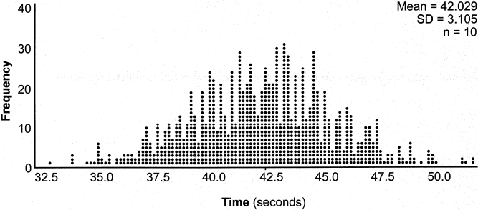

Based on the simulation, determine an interval containing the middle 95% of plausible mean times. Round your answer to the nearest hundredth. Is the time 49.8 seconds unusual? Use statistical evidence to justify your answer.

35 Consider the function . Is an even function? Justify your answer. Write an equation for , the function that results after is shifted up 5 units. Write an equation for , the inverse of .

36 Solve the system of equations shown below algebraically:
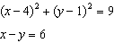

37 Taylor wants to open an investment account with the $1200 she received for her birthday. She has narrowed her choices down to two banks. America's Bank offers 6.4% annual interest compounded quarterly. Barnyard Bank offers 6.35% annual interest compounded continuously. Write functions for and to represent the value of her investment with America's Bank and Barnyard Bank as a function of time, t, in years. Taylor would like to invest the $1200 into one bank for ten years making no additional deposits and no withdrawals. With which bank will Taylor earn the most money? Justify your answer. Taylor chooses to invest her money in Barnyard Bank. Algebraically determine how long, to the nearest tenth of a year, it will take her initial investment to triple assuming she makes no deposits or withdrawals.
1 ANS: 3 PTS: 2 REF: 082401aii NAT: S.IC.B.3
TOP: Analysis of Data

2 ANS: 2
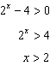

PTS: 2 REF: 082402aii NAT: F.IF.C.7 TOP: Graphing Exponential Functions

3 ANS: 1
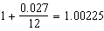

PTS: 2 REF: 082403aii NAT: A.SSE.B.3 TOP: Modeling Exponential Functions

4 ANS: 1
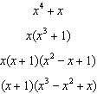

PTS: 2 REF: 082404aii NAT: A.APR.C.4 TOP: Polynomial Identities

5 ANS: 4
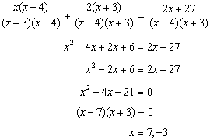 is extraneous.

PTS: 2 REF: 082405aii NAT: A.REI.A.2 TOP: Solving Rationals

6 ANS: 1 PTS: 2 REF: 082406aii NAT: S.ID.B.6
TOP: Regression KEY: choose model

7 ANS: 4
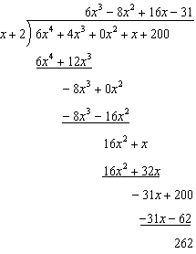

PTS: 2 REF: 082407aii NAT: A.APR.D.6 TOP: Rational Expressions
KEY: division

8 ANS: 4
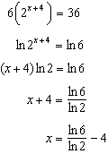

PTS: 2 REF: 082408aii NAT: F.LE.A.4 TOP: Exponential Equations
KEY: without common base

9 ANS: 2 PTS: 2 REF: 082409aii NAT: F.IF.C.7
TOP: Graphing Logarithmic Functions

10 ANS: 3
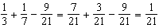

PTS: 2 REF: 082410aii NAT: S.CP.B.7 TOP: Addition Rule

11 ANS: 2
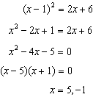 is extraneous.

PTS: 2 REF: 082411aii NAT: A.REI.A.2 TOP: Solving Radicals

12 ANS: 2
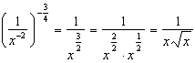

PTS: 2 REF: 082412aii NAT: N.RN.A.2 TOP: Radicals and Rational Exponents
KEY: variables

13 ANS: 1
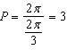

PTS: 2 REF: 082413aii NAT: F.IF.C.7 TOP: Graphing Trigonometric Functions
KEY: period

14 ANS: 1 PTS: 2 REF: 082414aii NAT: F.IF.C.7
TOP: Graphing Polynomial Functions

15 ANS: 4

PTS: 2 REF: 082415aii NAT: N.CN.A.2 TOP: Operations with Complex Numbers

16 ANS: 1
In vertex form, the parabola is 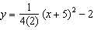. The vertex is and .

PTS: 2 REF: 082416aii NAT: G.GPE.A.2 TOP: Graphing Quadratic Functions

17 ANS: 2
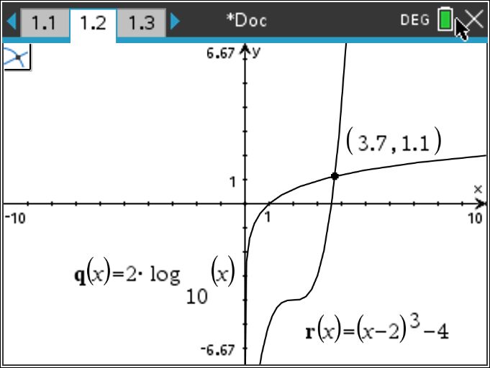

PTS: 2 REF: 082417aii NAT: A.REI.D.11 TOP: Other Systems

18 ANS: 2

PTS: 2 REF: 082418aii NAT: F.BF.A.1 TOP: Operations with Functions

19 ANS: 1
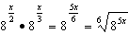

PTS: 2 REF: 082419aii NAT: N.RN.A.2 TOP: Radicals and Rational Exponents

20 ANS: 4
Since the terminal side of passes through , . 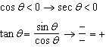

PTS: 2 REF: 082420aii NAT: F.TF.A.2 TOP: Determining Trigonometric Functions
KEY: extension to reals

21 ANS: 3
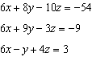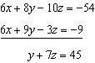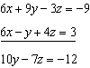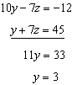

PTS: 2 REF: 082421aii NAT: A.REI.C.6 TOP: Solving Linear Systems
KEY: three variables

22 ANS: 1
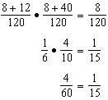

PTS: 2 REF: 082422aii NAT: S.CP.A.4 TOP: Conditional Probability

23 ANS: 3

PTS: 2 REF: 082423aii NAT: A.SSE.A.2 TOP: Factoring Polynomials

24 ANS: 4
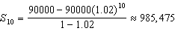

PTS: 2 REF: 082424aii NAT: A.SSE.B.4 TOP: Series
KEY: geometric

25 ANS:
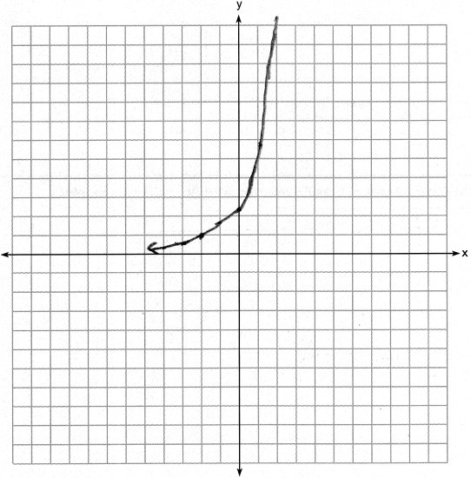

PTS: 2 REF: 082425aii NAT: F.IF.C.7 TOP: Graphing Exponential Functions

26 ANS:
Since there is no remainder when the cubic is divided by , this binomial is a factor.
-3 | 7 | 27 | 9 | -27
 |  | -21 | -18 | 27
 | 7 | 6 | -9 | 0

PTS: 2 REF: 082426aii NAT: A.APR.B.2 TOP: Remainder and Factor Theorems

27 ANS:

PTS: 2 REF: 082427aii NAT: A.SSE.A.2 TOP: Factoring Polynomials

28 ANS:
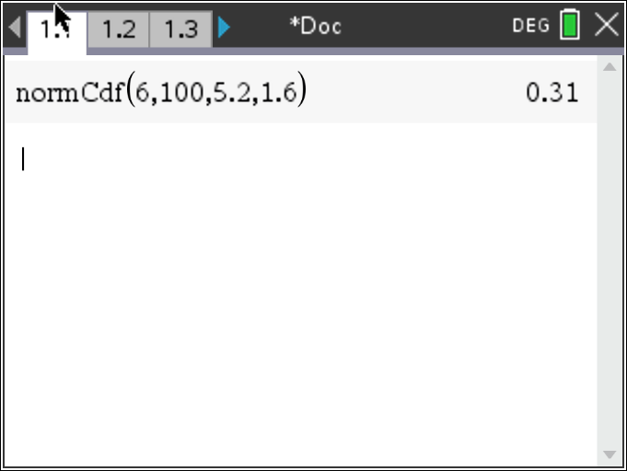

PTS: 2 REF: 082428aii NAT: S.ID.A.4 TOP: Normal Distributions

29 ANS:

PTS: 2 REF: 082429aii NAT: F.IF.B.4 TOP: Graphing Trigonometric Functions

30 ANS:
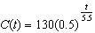

PTS: 2 REF: 082430aii NAT: F.BF.A.1 TOP: Modeling Exponential Functions

31 ANS:
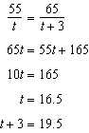

PTS: 2 REF: 082431aii NAT: A.CED.A.1 TOP: Modeling Rationals

32 ANS:
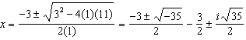

PTS: 2 REF: 082432aii NAT: A.REI.B.4 TOP: Solving Quadratics

33 ANS:
China: 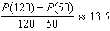 India: 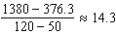 India

PTS: 4 REF: 082433aii NAT: F.IF.B.6 TOP: Rate of Change

34 ANS:
. Yes, since 49.8 falls outside the 95% interval.

PTS: 4 REF: 082434aii NAT: S.IC.A.2 TOP: Analysis of Data

35 ANS:
No, because 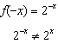 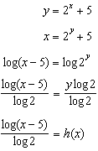

PTS: 4 REF: 082435aii NAT: F.BF.B.4 TOP: Inverse of Functions
KEY: exponential

36 ANS:
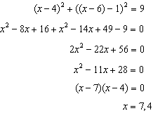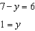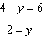

PTS: 4 REF: 082436aii NAT: A.REI.C.7 TOP: Quadratic-Linear Systems

37 ANS:
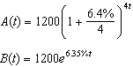 Barnyard because 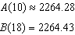 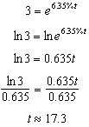

PTS: 6 REF: 082437aii NAT: A.CED.A.1 TOP: Exponential Growth

