1 A group of high school students wanted to collect information on how many times per week students exercised. If they want the least biased results they should survey every fifth student at the school who is
1) | entering the gym | 3) | entering the library
2) | in the junior class | 4) | entering the building

2 Given , which expression is equivalent to 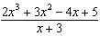?
1) |  | 3)
2) | 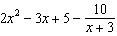 | 4) | 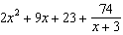

3 The table below shows the food preferences of sports fans whose favorite sport is football or baseball.

Favorite Food to Eat While Watching Sports
 | Wings | Pizza | Hot Dogs
Football | 14 | 20 | 6
Baseball | 6 | 12 | 42

The probability that a fan prefers pizza given that the fan prefers football is
1) |  | 3)
2) |  | 4)

4 If , then the inverse function is
1) | 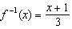 | 3) | 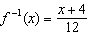
2) | 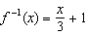 | 4) | 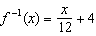

5 The graph of a quadratic function is shown below.

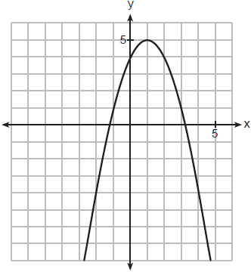

When the graph of is drawn on the same axes, one solution to this system is
1) |  | 3)
2) |  | 4)

6 What is the solution of ?
1) |  | 3)
2) |  | 4) | 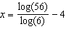

7 In a survey of people who recently bought a laptop, 45% said they were looking for a large screen, 31% said they were looking for a fast processor, and 58% said they wanted a large screen or a fast processor. If a survey respondent is selected at random, what is the probability that the respondent wanted both a large screen and a fast processor?
1) | 76% | 3) | 77%
2) | 14% | 4) | 18%

8 In the quadratic formula, is called the discriminant. The function has a discriminant value of 8, and has a discriminant value of . The quadratic graphs, and , are shown below.

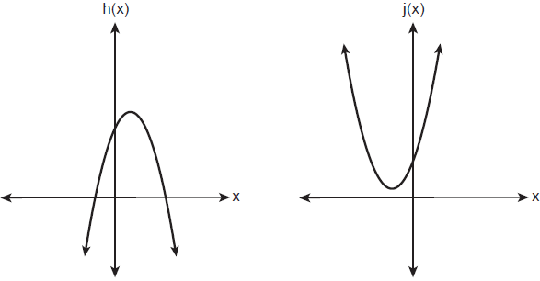

Which quadratic functions have imaginary roots?
1) | and | 3) | and
2) | and | 4) | and

9 The element Americium has a half-life of 25 minutes. Given an initial amount, , which expression could be used to determine the amount of Americium remaining after t minutes?
1) | 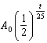 | 3) | 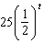
2) | 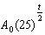 | 4) | 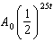

10 Which function has the greatest y-intercept?
1) |  | 3)
2) |  | 4)

11 According to the USGS, an agency within the Department of Interior of the United States, the frog population in the U.S. is decreasing at the rate of 3.79% per year. A student created a model, , to estimate the population in a pond after t years. The student then created a model that would predict the population after d decades. This model is best represented by
1) |  | 3)
2) |  | 4)

12 What is the value of when 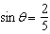 and is in quadrant II?
1) | 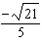 | 3) | 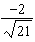
2) | 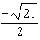 | 4) | 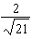

13 A population is normally distributed with a mean of 23 and a standard deviation of 1.2. The percentage of the population that falls below 21, to the nearest hundredth, is
1) | 0.05 | 3) | 8.29
2) | 4.78 | 4) | 91.30

14 Audra is interested in studying the number of students entering kindergarten in the Ahlville Central School District over the next several years. Using data dating back to 2015, she determines that the number of kindergarteners is decreasing at an exponential rate. She creates a formula to model this situation , where x is the number of years since 2015 and y is the number of students entering kindergarten. If there were 105 students entering kindergarten in Ahlville in 2015, which statement about Audra’s formula is true?
1) | a is positive and b is negative. | 3) | Both a and b are positive.
2) | a is negative and b is positive. | 4) | Both a and b are negative.

15 The solution set for the equation is
1) |  | 3)
2) |  | 4)

16 The George family would like to borrow $45,000 to purchase a new boat. They qualified for a loan with an annual interest rate of 6.75%. The monthly loan payment can be found using the formula below.
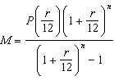
monthly payment
amount borrowed
annual interest rate
number of monthly payments

What is the monthly payment if they would like to pay off the loan in five years?
1) | $262.99 | 3) | $915.24
2) | $252.13 | 4) | $885.76

17 A retailer advertises that items will be discounted by 10% every Monday until they are sold. In how many weeks will an item costing $50 first be sold for under half price?
1) | 7 | 3) | 5
2) | 6 | 4) | 4

18 The graph of the function is shown below.

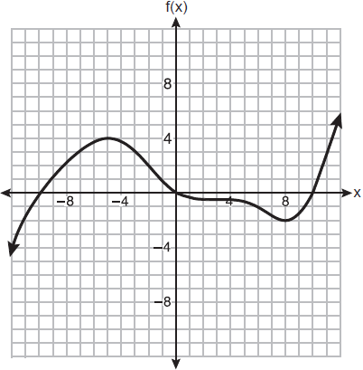

In which interval is always positive?
1) |  | 3)
2) |  | 4)

19 If and , then how many real solutions are there to the equation ?
1) | 1 | 3) | 6
2) | 2 | 4) | 4

20 Which expression is a factor of ?
1) |  | 3)
2) |  | 4)

21 The expression 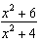 is equivalent to
1) |  | 3) | 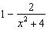
2) | 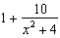 | 4) | 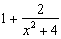

22 Stone Manufacturing has developed a cost model, , where x is the number of sprockets sold, in thousands. The sales price can be modeled by and the company’s revenue by . The company's profits, , could be modeled by
1) |  | 3)
2) |  | 4)

23 Which function is even?
1) |  | 3)
2) |  | 4)

24 The graph of a cubic polynomial function is shown below.

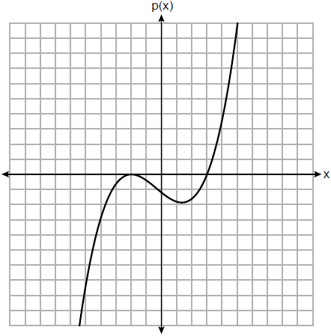

If is written as a product of linear factors, which factor would appear twice?
1) |  | 3)
2) |  | 4)

25 Factor the expression completely.

26 Algebraically determine the values of x that satisfy the system of equations below:
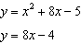

27 Solve the equation . Write your solution in form.

28 On the coordinate plane below, sketch at least one cycle of a cosine function with a midline at , an amplitude of 3, and a period of .

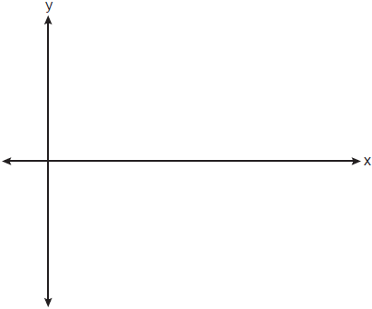

29 Given i is the imaginary unit, simplify as a polynomial in standard form.

30 Consider the parabola given by 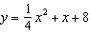 with vertex and focus . Use this information to explain how to determine the equation of the directrix.

31 Write 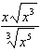 as a single term in simplest form, with a rational exponent.

32 A fruit fly population can be modeled by the equation , where P represents the number of fruit flies after t days. What is the average rate of change of the population, rounded to the nearest hundredth, over the interval ? Include appropriate units in your answer.

33 Sketch on the axes below.

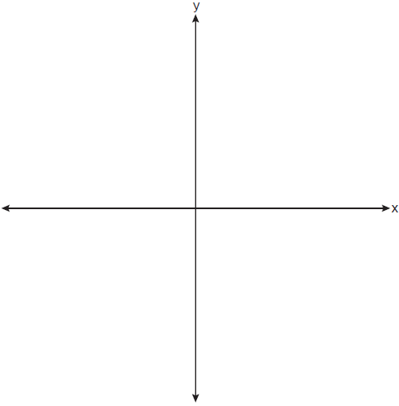

Describe the end behavior of as . Describe the end behavior of as

34 Solve for x algebraically: 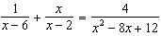

35 Solve the following system of equations algebraically for x, y, and z.
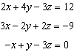

36 Two classes of students were entered into an experiment to see whether using an interactive whiteboard leads to better grades. It was observed that the mean grade of students in the class with the interactive whiteboard was 0.6 points higher than the class without it. To determine if the observed difference is statistically significant, the classes were rerandomized 5000 times to study these random differences in the mean grades. The output of the simulation is summarized in the histogram below.

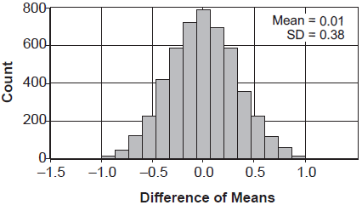

Determine an interval containing the middle 95% of the simulation results. Round your answer to the nearest hundredth. Does the interval indicate that the difference between the classes’ grades is significant? Explain.

37 The Manford family started savings accounts for their twins, Abby and Brett, on the day they were born. They invested $8000 in an account for each child. Abby’s account pays 4.2% annual interest compounded quarterly. Brett’s account pays 3.9% annual interest compounded continuously. Write a function, , for Abby’s account and a function, , for Brett’s account that calculates the value of each account after t years. Determine who will have more money in their account when the twins turn 18 years old, and find the difference in the amounts in the accounts to the nearest cent. Algebraically determine, to the nearest tenth of a year, how long it takes for Brett’s account to triple in value.
1 ANS: 4 PTS: 2 REF: 082301aii NAT: S.IC.B.3
TOP: Analysis of Data

2 ANS: 2
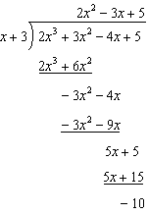

PTS: 2 REF: 082302aii NAT: A.APR.D.6 TOP: Rational Expressions
KEY: division

3 ANS: 1
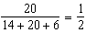

PTS: 2 REF: 082303aii NAT: S.CP.A.4 TOP: Conditional Probability

4 ANS: 3
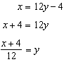

PTS: 2 REF: 082304aii NAT: F.BF.B.4 TOP: Inverse of Functions
KEY: linear

5 ANS: 4
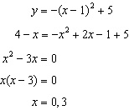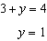

PTS: 2 REF: 082305aii NAT: A.REI.C.7 TOP: Quadratic-Linear Systems

6 ANS: 1
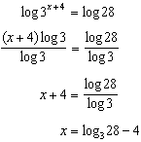

PTS: 2 REF: 082306aii NAT: A.CED.A.1 TOP: Exponential Equations
KEY: without common base

7 ANS: 4

PTS: 2 REF: 082307aii NAT: S.CP.B.7 TOP: Theoretical Probability

8 ANS: 2 PTS: 2 REF: 082308aii NAT: A.REI.B.4
TOP: Using the Discriminant KEY: determine nature of roots given equation, graph, table

9 ANS: 1 PTS: 2 REF: 082309aii NAT: F.BF.A.1
TOP: Modeling Exponential Functions

10 ANS: 4
; ; ;

PTS: 2 REF: 082310aii NAT: F.IF.C.9 TOP: Comparing Functions

11 ANS: 2

PTS: 2 REF: 082311aii NAT: A.SSE.B.3 TOP: Modeling Exponential Functions

12 ANS: 3
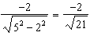

PTS: 2 REF: 082312aii NAT: F.TF.C.8 TOP: Determining Trigonometric Functions

13 ANS: 2 PTS: 2 REF: 082313aii NAT: S.ID.A.4
TOP: Normal Distributions KEY: percent

14 ANS: 3

PTS: 2 REF: 082314aii NAT: F.BF.A.1 TOP: Modeling Exponential Functions

15 ANS: 3
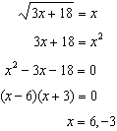 is extraneous.

PTS: 2 REF: 082315aii NAT: A.REI.A.2 TOP: Solving Radicals
KEY: extraneous solutions

16 ANS: 4
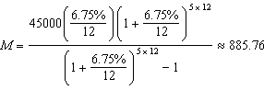

PTS: 2 REF: 082316aii NAT: F.IF.B.4 TOP: Evaluating Exponential Expressions

17 ANS: 1
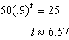

PTS: 2 REF: 082317aii NAT: F.LE.A.2 TOP: Modeling Exponential Functions

18 ANS: 4 PTS: 2 REF: 082318aii NAT: F.IF.B.4
TOP: Graphing Polynomial Functions

19 ANS: 2
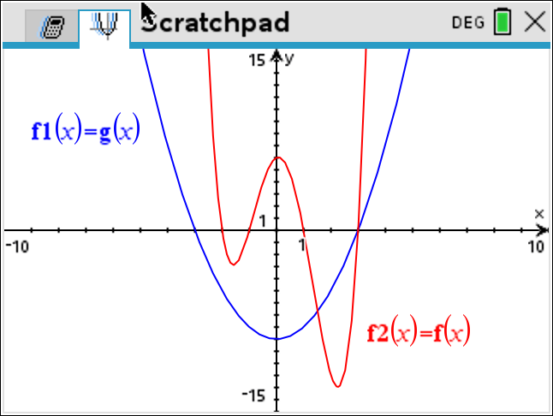

PTS: 2 REF: 082319aii NAT: A.REI.D.11 TOP: Other Systems

20 ANS: 1
-2 | 1 | -1 | -11 | 5 | 30
 |  | -2 | 6 | 10 | -30
 | 1 | -3 | -5 | 15 | 0
Since there is no remainder when the quartic is divided by , this binomial is a factor.

PTS: 2 REF: 082320aii NAT: A.APR.B.2 TOP: Remainder and Factor Theorems

21 ANS: 4
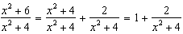

PTS: 2 REF: 082321aii NAT: A.APR.D.7 TOP: Addition and Subtraction of Rationals

22 ANS: 3

PTS: 2 REF: 082322aii NAT: F.BF.A.1 TOP: Operations with Functions

23 ANS: 2
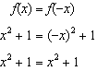

PTS: 2 REF: 082323aii NAT: F.BF.B.3 TOP: Even and Odd Functions

24 ANS: 2 PTS: 2 REF: 082324aii NAT: A.APR.B.3
TOP: Graphing Polynomial Functions

25 ANS:
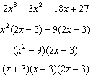

PTS: 2 REF: 082325aii NAT: A.SSE.A.2 TOP: Factoring Polynomials

26 ANS:
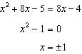

PTS: 2 REF: 082326aii NAT: A.REI.C.7 TOP: Quadratic-Linear Systems

27 ANS:
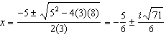

PTS: 2 REF: 082327aii NAT: A.REI.B.4 TOP: Solving Quadratics
KEY: complex solutions | quadratic formula

28 ANS:
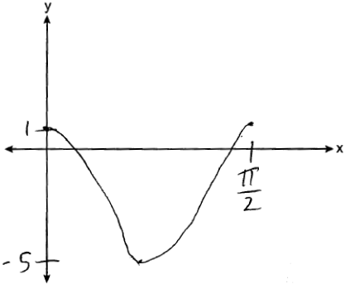

PTS: 2 REF: 082328aii NAT: F.IF.C.7 TOP: Graphing Trigonometric Functions
KEY: graph

29 ANS:

PTS: 2 REF: 082329aii NAT: N.CN.A.2 TOP: Operations with Complex Numbers

30 ANS:
p is the distance from the focus to the vertex: . p is the distance from the directrix to the vertex: 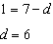.

PTS: 2 REF: 082330aii NAT: G.GPE.A.2 TOP: Graphing Quadratic Functions

31 ANS:
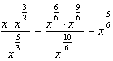

PTS: 2 REF: 082331aii NAT: N.RN.A.2 TOP: Radicals and Rational Exponents

32 ANS:
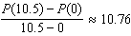 fruit flies per day

PTS: 2 REF: 082332aii NAT: F.IF.B.6 TOP: Rate of Change

33 ANS:
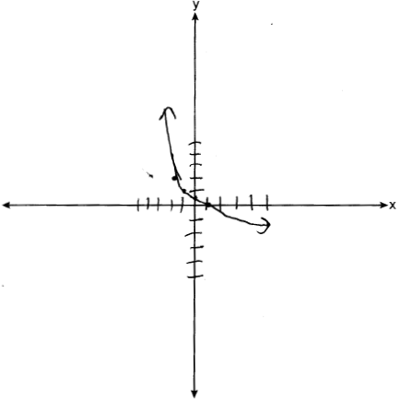 As . As .

PTS: 4 REF: 082333aii NAT: F.IF.C.7 TOP: Graphing Logarithmic Functions

34 ANS:
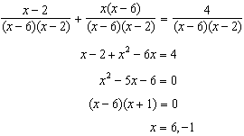. 6 is extraneous.

PTS: 2 REF: 082334aii NAT: A.REI.A.2 TOP: Solving Rationals

35 ANS:
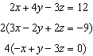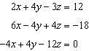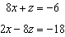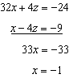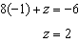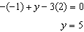

PTS: 4 REF: 082335aii NAT: A.REI.C.6 TOP: Solving Linear Systems
KEY: three variables

36 ANS:
. No, since 0.6 falls within the 95% interval.

PTS: 4 REF: 082336aii NAT: S.IC.B.5 TOP: Analysis of Data

37 ANS:
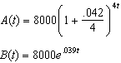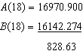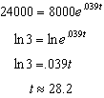

PTS: 6 REF: 082337aii NAT: A.CED.A.1 TOP: Exponential Growth

