1 The Hot and Tasty Coffee chain conducts a survey of its customers at its location at the Staten Island ferry terminal. After the survey is completed, the statistical consultant states that 70% of customers who took the survey said the most important factor in choosing where to get their coffee is how fast they are served. Based on this result, Hot and Tasty Coffee can infer that
1) | most of its customers in New York State care most about being served quickly | 3) | most of its customers at the Staten Island ferry terminal care most about being served quickly
2) | coffee drinkers care less about taste and more about being served quickly | 4) | most of its customers at transportation terminals and stations care most about being served quickly

2 Given that i is the imaginary unit, the expression is equivalent to
1) |  | 3)
2) |  | 4)

3 The equation below can be used to model the height of a tide in feet, , on a beach at t hours.
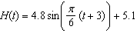
Using this function, the amplitude of the tide is
1) |  | 3) | 3
2) | 4.8 | 4) | 5.1

4 In watching auditions for lead singer in a band, Liem became curious as to whether there is an association between how animated the lead singer is and the amount of applause from the audience. He decided to watch each singer and rate the singer on a scale of 1 to 5, where 1 is the least animated and 5 is the most animated. He did this for all 5 nights of auditions and found that the more animated singers did receive louder applause. The study Liem conducted would be best described as
1) | experimental | 3) | a sample survey
2) | observational | 4) | a random assignment

5 In the diagram of a unit circle below, point A, 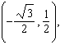 represents the point where the terminal side of intersects the unit circle.

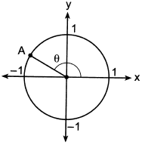

What is ?
1) | 30º | 3) | 135º
2) | 120º | 4) | 150º

6 Consider the function . Which statement is true?
1) | is a factor of . | 3) | 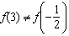
2) | is a factor of . | 4) | 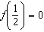

7 Which sketch could represent the function ?
1) | 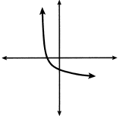 | 3) | 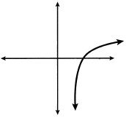
2) | 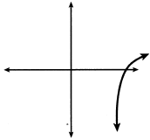 | 4) | 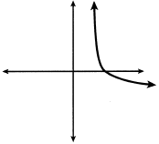

8 Which equation has roots of and ?
1) |  | 3)
2) |  | 4)

9 A local university has a current enrollment of 12,000 students. The enrollment is increasing continuously at a rate of 2.5% each year. Which logarithm is equal to the number of years it will take for the population to increase to 15,000 students?
1) | 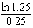 | 3) | 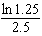
2) | 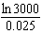 | 4) | 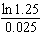

10 What is the total number of points of intersection of the graphs of the equations and ?
1) | 1 | 3) | 3
2) | 2 | 4) | 0

11 The amount of a substance, , in grams, remaining after t days is modeled by 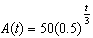. Which statement is false?
1) | In 20 days, there is no substance remaining. | 3) | The amount of the substance remaining can also be modeled by  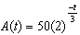.
2) | After two half-lives, there is 25% of the substance remaining. | 4) | After one week, there is less than 10g of the substance remaining.

12 A parabola that has a vertex at and a focus of has an equation of
1) | 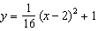 | 3) | 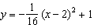
2) | 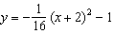 | 4) | 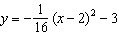

13 The expression 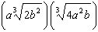 is equivalent to
1) |  | 3)
2) |  | 4)

14 Given , as
1) |  | 3)
2) |  | 4)

15 For all values of x for which the expression is defined, 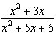 is equivalent to
1) | 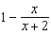 | 3) | 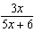
2) | 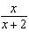 | 4) | 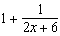

16 A recursive formula for the sequence is
1) |  | 3)
2) | 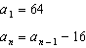 | 4) | 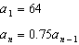

17 Which expression is equivalent to 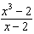?
1) |  | 3)
2) | 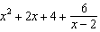 | 4) | 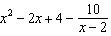

18 What is the solution set of the equation 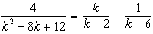?
1) |  | 3)
2) |  | 4)

19 Given the polynomial identity , which equation must also be true for all values of x and y?
1)
2)
3)
4)

20 Given 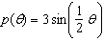 on the interval , the function p
1) | decreases, then increases | 3) | decreases throughout the interval
2) | increases, then decreases | 4) | increases throughout the interval

21 A company fired several employees in order to save money. The amount of money the company saved per year over five years following the loss of employees is shown in the table below.

Year | Amount Saved  (in dollars)
1 | 59,000
2 | 64,900
3 | 71,390
4 | 78,529
5 | 86,381.9

Which expression determines the total amount of money saved by the company over 5 years?
1) | 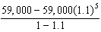 | 3) | 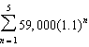
2) | 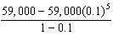 | 4) | 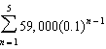

22 A rush-hour commuter train has arrived on time 64 of its first 80 days. As arrivals continue, which equation can be used to find x, the number of consecutive days that the train must arrive on schedule to raise its on-time performance rate to 90%?
1) | 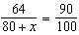 | 3) | 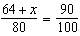
2) | 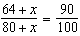 | 4) | 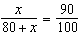

23 Given 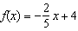, which statement is true of the inverse function ?
1) | is a line with slope . | 3) | passes through the point .
2) | is a line with slope . | 4) | has a y-intercept at .

24 The amount of a substance, , that remains after t days can be given by the equation 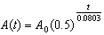, where represents the initial amount of the substance. An equivalent form of this equation is
1) |  | 3)
2) |  | 4)

25 Determine the average rate of change, in mph, from 2 to 4 hours on the graph shown below.

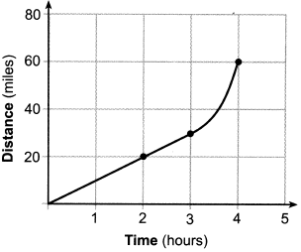

26 Factor the expression completely.

27 Solve algebraically for all values of x:

28 Given that 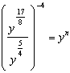, where , determine the value of n.

29 Given 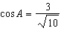 and , determine the value of in radical form.

30 According to a study done at a hospital, the average weight of a newborn baby is 3.39 kg, with a standard deviation of 0.55 kg. The weights of all the newborns in this hospital closely follow a normal distribution. Last year, 9256 babies were born at this hospital. Determine, to the nearest integer, approximately how many babies weighed more than 4 kg.

31 The table below shows the results of gender and music preference. Based on these data, determine if the events "the person is female" and "the person prefers classic rock" are independent of each other. Justify your answer.

 | Rap | Techno | Classic Rock | Classical
Male | 39 | 17 | 42 | 12
Female | 17 | 37 | 36 | 15

32 Algebraically determine the solution set for the system of equations below.
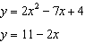

33 When observed by researchers under a microscope, a smartphone screen contained approximately 11,000 bacteria per square inch. Bacteria, under normal conditions, double in population every 20 minutes.
a) Assuming an initial value of 11,000 bacteria, write a function, , that can be used to model the population of bacteria, p, on a smartphone screen, where t represents the time in minutes after it is first observed under a microscope.
b) Using from part a, determine algebraically, to the nearest hundredth of a minute, the amount of time it would take for a smartphone screen that was not touched or cleaned to have a population of 1,000,000 bacteria per square inch.

34 The function models the volume, in cubic inches, of a rectangular solid for . Graph over the domain .



To the nearest tenth of a cubic inch, what is the maximum volume of the rectangular solid?

35 Given and , state the quotient and remainder of , in the form 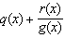. Is a root of ? Explain your answer.

36 State officials claim 82% of a community want to repeal the 30 mph speed limit on an expressway. A community organization devises a simulation based on the claim that 82% of the community supports the repeal. Each dot on the graph below represents the proportion of community members who support the repeal. The graph shows 200 simulated surveys, each of sample size 60.

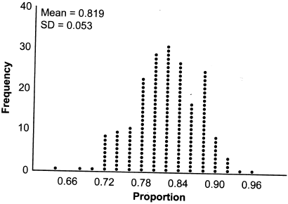

Based on the simulation, determine an interval containing the middle 95% of plausible proportions. Round your answer to the nearest thousandth. The community organization conducted its own sample survey of 60 people and found 70% supported the repeal. Based on the results of the simulation, explain why the organization should question the State officials' claim.

37 A technology company is comparing two plans for speeding up its technical support time. Plan A can be modeled by the function and plan B can be modeled by the function where x is the number of customer service representatives employed by the company and and represent the average wait time, in minutes, of each customer. Graph and in the interval on the set of axes below.

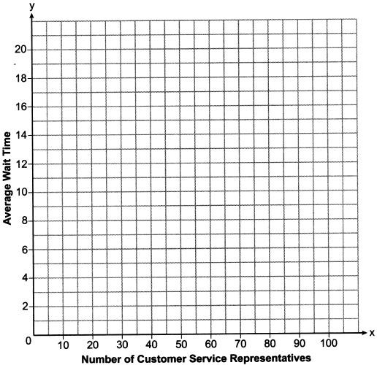

To the nearest integer, solve the equation . Determine, to the nearest minute, . Explain what this value represents in the given context.
1 ANS: 3 PTS: 2 REF: 082201aii NAT: S.IC.B.3
TOP: Analysis of Data KEY: type

2 ANS: 4

PTS: 2 REF: 082202aii NAT: N.CN.A.2 TOP: Operations with Complex Numbers

3 ANS: 2 PTS: 2 REF: 082203aii NAT: F.IF.C.7
TOP: Graphing Trigonometric Functions KEY: amplitude

4 ANS: 2 PTS: 2 REF: 082204aii NAT: S.IC.B.3
TOP: Analysis of Data KEY: type

5 ANS: 4 PTS: 2 REF: 082205aii NAT: F.TF.A.2
TOP: Unit Circle

6 ANS: 2
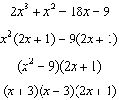

PTS: 2 REF: 082206aii NAT: A.APR.B.2 TOP: Remainder Theorem

7 ANS: 4
Translate the parent log function 2 to the right and reflect over the x-axis.

PTS: 2 REF: 082207aii NAT: F.IF.C.7 TOP: Graphing Logarithmic Functions

8 ANS: 1
The product of the roots equals 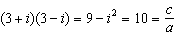. OR
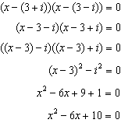

PTS: 2 REF: 082208aii NAT: A.REI.B.4 TOP: Complex Conjugate Root Theorem

9 ANS: 4
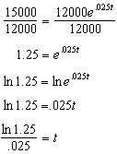

PTS: 2 REF: 082209aii NAT: F.LE.A.4 TOP: Exponential Growth

10 ANS: 1
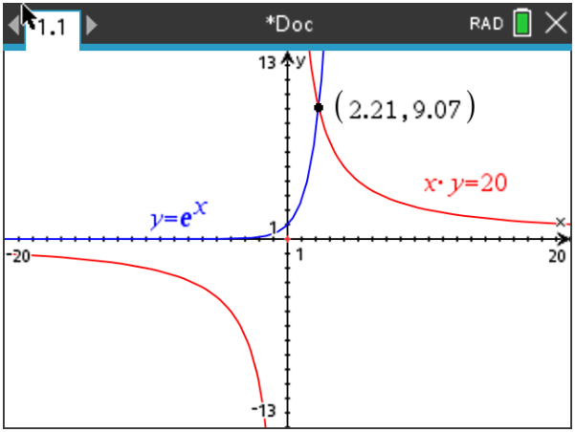

PTS: 2 REF: 082210aii NAT: A.REI.D.11 TOP: Other Systems

11 ANS: 1
1) ; 2) ; 3) true; 4)

PTS: 2 REF: 082211aii NAT: F.LE.B.5 TOP: Modeling Exponential Functions

12 ANS: 3
The distance from the vertex to the focus, p, is 4. Since the focus is below the vertex, p is negative. 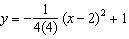

PTS: 2 REF: 082212aii NAT: G.GPE.A.2 TOP: Graphing Quadratic Functions

13 ANS: 1
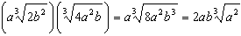

PTS: 2 REF: 082213aii NAT: N.RN.A.2 TOP: Operations with Radicals
KEY: with variables, index > 2

14 ANS: 3 PTS: 2 REF: 082214aii NAT: F.IF.C.7
TOP: Graphing Exponential Functions

15 ANS: 2
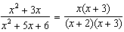

PTS: 2 REF: 082215aii NAT: A.APR.D.6 TOP: Rational Expressions
KEY: factoring

16 ANS: 4
1) is a correct formula, but not recursive

PTS: 2 REF: 082216aii NAT: F.LE.A.2 TOP: Sequences
KEY: recursive

17 ANS: 2
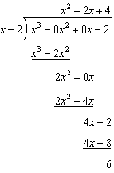

PTS: 2 REF: 082217aii NAT: A.APR.D.6 TOP: Rational Expressions
KEY: division

18 ANS: 3
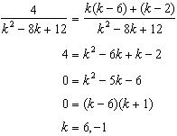 is extraneous

PTS: 2 REF: 082218aii NAT: A.REI.A.2 TOP: Solving Rationals

19 ANS: 1
2) ; 3) ; 4) 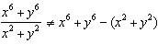

PTS: 2 REF: 082219aii NAT: A.APR.C.4 TOP: Polynomial Identities

20 ANS: 4 PTS: 2 REF: 082220aii NAT: F.IF.B.4
TOP: Graphing Trigonometric Functions

21 ANS: 1 PTS: 2 REF: 082221aii NAT: F.BF.B.6
TOP: Sigma Notation KEY: represent

22 ANS: 2 PTS: 2 REF: 082222aii NAT: A.CED.A.1
TOP: Modeling Rationals

23 ANS: 3
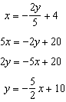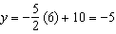

PTS: 2 REF: 082223aii NAT: F.BF.B.4 TOP: Inverse of Functions
KEY: linear

24 ANS: 1
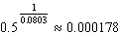

PTS: 2 REF: 082224aii NAT: A.SSE.B.3 TOP: Modeling Exponential Functions

25 ANS:
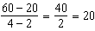

PTS: 2 REF: 082225aii NAT: F.IF.B.6 TOP: Rate of Change

26 ANS:

PTS: 2 REF: 082226aii NAT: A.SSE.A.2 TOP: Factoring Polynomials
KEY: factoring by grouping

27 ANS:
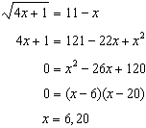 20 is extraneous.

PTS: 2 REF: 082227aii NAT: A.REI.A.2 TOP: Solving Radicals
KEY: extraneous solutions

28 ANS:
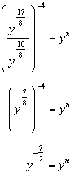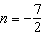

PTS: 2 REF: 082228aii NAT: A.APR.D.6 TOP: Expressions with Negative Exponents
KEY: variables

29 ANS:
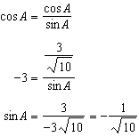

PTS: 2 REF: 082229aii NAT: F.TF.C.8 TOP: Determining Trigonometric Functions

30 ANS:

PTS: 2 REF: 082230aii NAT: S.ID.A.4 TOP: Normal Distributions
KEY: predict

31 ANS:
No, because 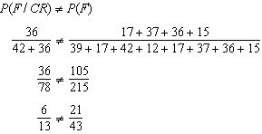

PTS: 2 REF: 082231aii NAT: S.CP.A.4 TOP: Conditional Probability

32 ANS:
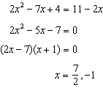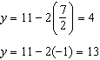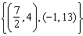

PTS: 2 REF: 082232aii NAT: A.REI.C.7 TOP: Quadratic-Linear Systems

33 ANS:
a) 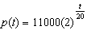; b) 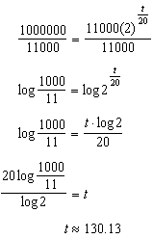

PTS: 4 REF: 082233aii NAT: F.LE.A.4 TOP: Exponential Growth

34 ANS:
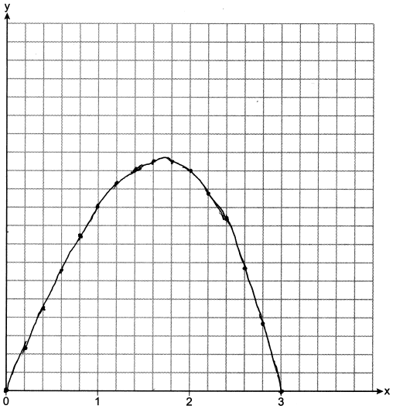 12.6

PTS: 4 REF: 082234aii NAT: F.IF.C.7 TOP: Graphing Polynomial Functions

35 ANS:
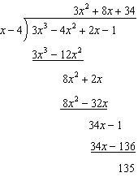 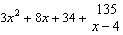 is not a root of because has a remainder.

PTS: 4 REF: 082235aii NAT: A.APR.D.6 TOP: Rational Expressions
KEY: division

36 ANS:
. Since .70 does not fall within the 95% interval.

PTS: 4 REF: 082236aii NAT: S.IC.A.2 TOP: Analysis of Data

37 ANS:
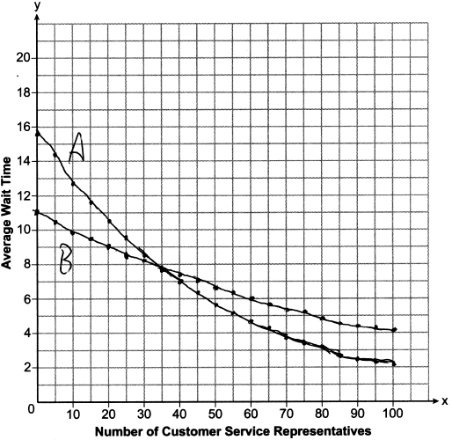35; , which represents the difference of the average wait time when there are 100 CSRs between the plans.

PTS: 6 REF: 082237aii NAT: A.REI.D.11 TOP: Other Systems

