1 When the expression is rewritten as the product of two binomials, the result is
1) |  | 3)
2) |  | 4)

2 The first term of a geometric sequence is 8 and the fourth term is 216. What is the sum of the first 12 terms of the corresponding series?
1) | 236,192 | 3) | 2,125,760
2) | 708,584 | 4) | 6,377,288

3 Perry invested in property that cost him $1500. Five years later it was worth $3000, and 10 years from his original purchase, it was worth $6000. Assuming the growth rate remains the same, which type of function could he create to find the value of his investment 30 years from his original purchase?
1) | exponential function | 3) | quadratic function
2) | linear function | 4) | trigonometric function

4 If , then m equals
1) |  | 3) | 3
2) |  | 4) | 6

5 If 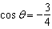 and is in Quadrant III, then is equivalent to
1) | 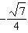 | 3)
2) |  | 4)

6 A veterinary pharmaceutical company plans to test a new drug to treat a common intestinal infection among puppies. The puppies are randomly assigned to two equal groups. Half of the puppies will receive the drug, and the other half will receive a placebo. The veterinarians monitor the puppies. This is an example of which study method?
1) | census | 3) | survey
2) | observational study | 4) | controlled experiment

7 The expression 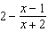 is equivalent to
1) | 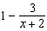 | 3) | 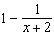
2) | 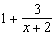 | 4) | 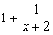

8 Which description could represent the graph of , if a is an integer?
1) | As , as , and the graph has 3 x-intercepts. | 3) | As , as , and the graph has 4 x-intercepts.
2) | As , as , and the graph has 3 x-intercepts. | 4) | As , as , and the graph has 4 x-intercepts.

9 After Roger’s surgery, his doctor administered pain medication in the following amounts in milligrams over four days.

Day (n) | 1 | 2 | 3 | 4
Dosage (m) | 2000 | 1680 | 1411.2 | 1185.4

How can this sequence best be modeled recursively?
1) | 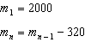 | 3) | 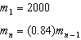
2) |  | 4)

10 The expression 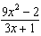 is equivalent to
1) | 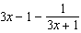 | 3) | 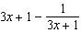
2) | 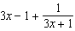 | 4) | 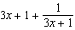

11 If is an even function, which function must also be even?
1) |  | 3)
2) |  | 4)

12 The average monthly temperature of a city can be modeled by a cosine graph. Melissa has been living in Phoenix, Arizona, where the average annual temperature is 75°F. She would like to move, and live in a location where the average annual temperature is 62°F. When examining the graphs of the average monthly temperatures for various locations, Melissa should focus on the
1) | amplitude | 3) | period
2) | horizontal shift | 4) | midline

13 Consider the probability statements regarding events A and B below.
;
; and
What is ?
1) | 0.1 | 3) | 0.375
2) | 0.25 | 4) | 0.667

14 Given , the expression is equivalent to
1) |  | 3) | 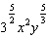
2) |  | 4) | 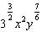

15 What is the solution set of the equation 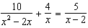?
1) |  | 3)
2) |  | 4)

16 What are the solution(s) to the system of equations shown below?
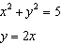
1) | and | 3) | and
2) |  | 4) | , only

17 If $5000 is put into a savings account that pays 3.5% interest compounded monthly, how much money, to the nearest ten cents, would be in that account after 6 years, assuming no money was added or withdrawn?
1) | $5177.80 | 3) | $6146.30
2) | $5941.30 | 4) | $6166.50

18 The Fahrenheit temperature, , of a heated object at time t, in minutes, can be modeled by the function below. is the surrounding temperature, is the initial temperature of the object, and k is a constant.
Coffee at a temperature of 195°F is poured into a container. The room temperature is kept at a constant 68°F and . Coffee is safe to drink when its temperature is, at most, 120°F. To the nearest minute, how long will it take until the coffee is safe to drink?
1) | 7 | 3) | 11
2) | 10 | 4) | 18

19 The mean intelligence quotient (IQ) score is 100, with a standard deviation of 15, and the scores are normally distributed. Given this information, the approximate percentage of the population with an IQ greater than 130 is closest to
1) | 2% | 3) | 48%
2) | 31% | 4) | 95%

20 After examining the functions and over the interval , Lexi determined that the correct number of solutions to the equation is
1) | 1 | 3) | 3
2) | 2 | 4) | 0

21 Evan graphed a cubic function, , and determined the roots of to be and 2. What is the value of b, if ?
1) | 1 | 3)
2) | 2 | 4)

22 The equation 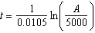 relates time, t, in years, to the amount of money, A, earned by a $5000 investment. Which statement accurately describes the relationship between the average rates of change of t on the intervals [6000, 8000] and [9000, 12,000]?
1) | A comparison cannot be made because the intervals are different sizes. | 3) | The average rate of change is larger for the interval [6000, 8000].
2) | The average rate of change is equal for both intervals. | 4) | The average rate of change is larger for the interval [9000, 12,000].

23 What is the inverse of 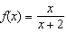, where ?
1) | 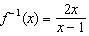 | 3) | 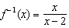
2) | 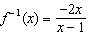 | 4) | 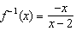

24 A study of black bears in the Adirondacks reveals that their population can be represented by the function , where t is the number of years since the study began. Which function is correctly rewritten to reveal the monthly growth rate of the black bear population?
1) |  | 3)
2) | 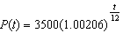 | 4) | 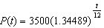

25 At Andrew Jackson High School, students are only allowed to enroll in AP U.S. History if they have already taken AP World History or AP European History. Out of 825 incoming seniors, 165 took AP World History, 66 took AP European History, and 33 took both. Given this information, determine the probability a randomly selected incoming senior is allowed to enroll in AP U.S. History.

26 Explain what a rational exponent, such as means. Use this explanation to evaluate .

27 Write 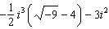 in simplest form.

28 A person’s lung capacity can be modeled by the function 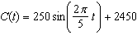, where represents the volume in mL present in the lungs after t seconds. State the maximum value of this function over one full cycle, and explain what this value represents.

29 Determine for which polynomial(s) is a factor. Explain your answer.
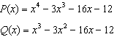

30 On July 21, 2016, the water level in Puget Sound, WA reached a high of 10.1 ft at 6 a.m. and a low of ft at 12:30 p.m. Across the country in Long Island, NY, Shinnecock Bay’s water level reached a high of 2.5 ft at 10:42 p.m. and a low of ft at 5:31 a.m. The water levels of both locations are affected by the tides and can be modeled by sinusoidal functions. Determine the difference in amplitudes, in feet, for these two locations.

31 Write a recursive formula, , to describe the sequence graphed below.

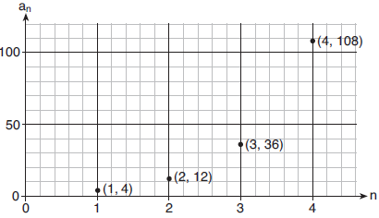

32 Sketch the graphs of 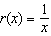 and on the set of axes below. Determine, to the nearest tenth, the positive solution of .

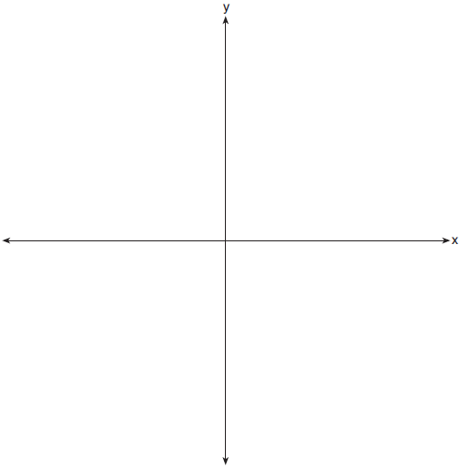

33 A population of 950 bacteria grows continuously at a rate of 4.75% per day. Write an exponential function, , that represents the bacterial population after t days and explain the reason for your choice of base. Determine the bacterial population after 36 hours, to the nearest bacterium.

34 Write an equation for a sine function with an amplitude of 2 and a period of . On the grid below, sketch the graph of the equation in the interval 0 to .



35 Mary bought a pack of candy. The manufacturer claims that 30% of the candies manufactured are red. In her pack, 14 of the 60 candies are red. She ran a simulation of 300 samples, assuming the manufacturer is correct. The results are shown below.

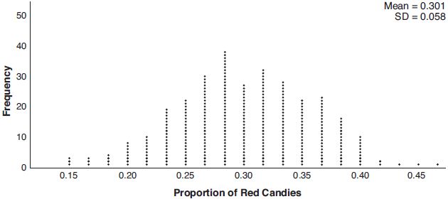

Based on the simulation, determine the middle 95% of plausible values that the proportion of red candies in a pack is within. Based on the simulation, is it unusual that Mary’s pack had 14 red candies out of a total of 60? Explain.

36 a) Algebraically determine the roots, in simplest form, to the equation below.
b) Consider the system of equations below.
The graph of this system confirms the solution from part a is imaginary. Explain why.

37 The Beaufort Wind Scale was devised by British Rear Admiral Sir Francis Beaufort, in 1805 based upon observations of the effects of the wind. Beaufort numbers, B, are determined by the equation , where s is the speed of the wind in mph, and B is rounded to the nearest integer from 0 to 12.

Beaufort Wind Scale
Beaufort Number | Force of Wind
0 | Calm
1 | Light air
2 | Light breeze
3 | Gentle breeze
4 | Moderate breeze
5 | Fresh breeze
6 | Steady breeze
7 | Moderate gale
8 | Fresh gale
9 | Strong gale
10 | Whole gale
11 | Storm
12 | Hurricane

Using the table above, classify the force of wind at a speed of 30 mph. Justify your answer. In 1946, the scale was extended to accommodate strong hurricanes. A strong hurricane received a B value of exactly 15. Algebraically determine the value of s, to the nearest mph. Any B values that round to 10 receive a Beaufort number of 10. Using technology, find an approximate range of wind speeds, to the nearest mph, associated with a Beaufort number of 10.
1 ANS: 2
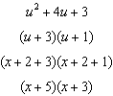

PTS: 2 REF: 081901aii NAT: A.SSE.A.2 TOP: Factoring Polynomials
KEY: higher power

2 ANS: 3
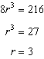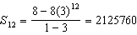

PTS: 2 REF: 081902aii NAT: A.SSE.B.4 TOP: Series

3 ANS: 1 PTS: 2 REF: 081903aii NAT: F.LE.A.2
TOP: Families of Functions

4 ANS: 2 PTS: 2 REF: 081904aii NAT: A.SSE.A.2
TOP: Factoring Polynomials KEY: higher power

5 ANS: 1
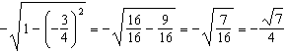

PTS: 2 REF: 081905aii NAT: F.TF.C.8 TOP: Determining Trigonometric Functions

6 ANS: 4 PTS: 2 REF: 081906aii NAT: S.IC.B.3
TOP: Analysis of Data KEY: type

7 ANS: 2
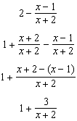

PTS: 2 REF: 081907aii NAT: A.APR.D.7 TOP: Addition and Subtraction of Rationals

8 ANS: 2 PTS: 2 REF: 081908aii NAT: F.IF.B.4
TOP: Graphing Polynomial Functions

9 ANS: 3 PTS: 2 REF: 081909aii NAT: F.LE.A.2
TOP: Sequences KEY: recursive

10 ANS: 1
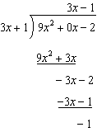

PTS: 2 REF: 081910aii NAT: A.APR.D.6 TOP: Rational Expressions
KEY: division

11 ANS: 2 PTS: 2 REF: 081911aii NAT: F.BF.B.3
TOP: Even and Odd Functions

12 ANS: 4 PTS: 2 REF: 081912aii NAT: F.IF.C.7
TOP: Graphing Trigonometric Functions KEY: mixed

13 ANS: 2
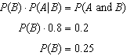

PTS: 2 REF: 081913aii NAT: S.CP.A.3 TOP: Conditional Probability

14 ANS: 4
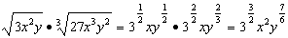

PTS: 2 REF: 081914aii NAT: N.RN.A.2 TOP: Operations with Radicals
KEY: with variables, index > 2

15 ANS: 4
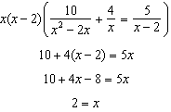 2 is extraneous.

PTS: 2 REF: 081915aii NAT: A.REI.A.2 TOP: Solving Rationals
KEY: rational solutions

16 ANS: 3
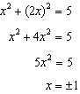

PTS: 2 REF: 081916aii NAT: A.REI.C.7 TOP: Quadratic-Linear Systems

17 ANS: 4
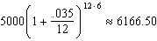

PTS: 2 REF: 081917aii NAT: A.CED.A.1 TOP: Exponential Growth

18 ANS: 4
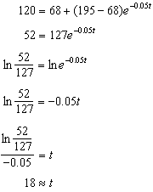

PTS: 2 REF: 081918aii NAT: F.LE.A.4 TOP: Exponential Decay

19 ANS: 1
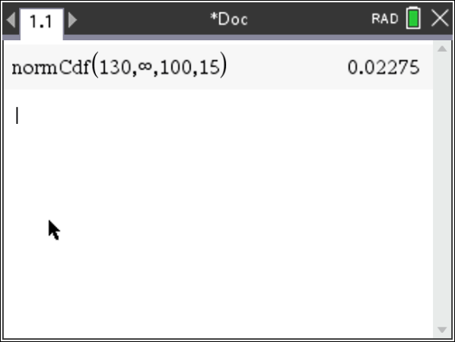

PTS: 2 REF: 081919aii NAT: S.ID.A.4 TOP: Normal Distributions
KEY: percent

20 ANS: 2
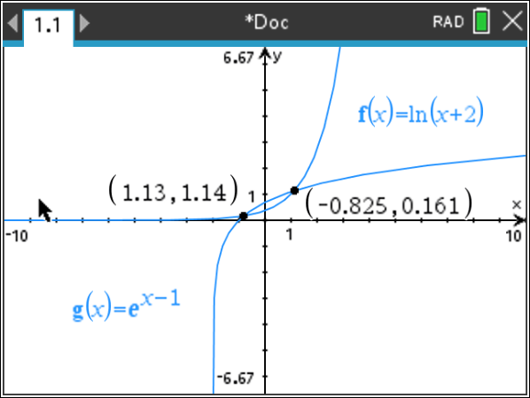

PTS: 2 REF: 081920aii NAT: A.REI.D.11 TOP: Other Systems

21 ANS: 4

PTS: 2 REF: 081921aii NAT: A.APR.B.3 TOP: Graphing Polynomial Functions

22 ANS: 3
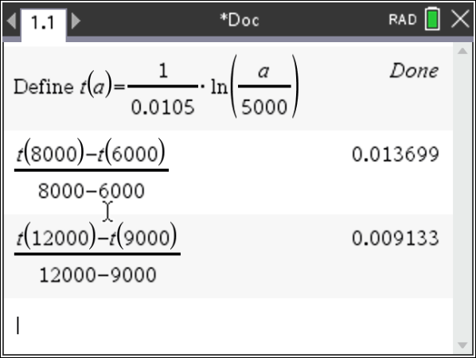

PTS: 2 REF: 081922aii NAT: F.IF.B.6 TOP: Rate of Change

23 ANS: 2
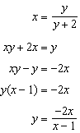

PTS: 2 REF: 081924aii NAT: F.BF.B.4 TOP: Inverse of Functions
KEY: other

24 ANS: 1
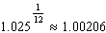

PTS: 2 REF: 081924aii NAT: A.SSE.B.3 TOP: Modeling Exponential Functions

25 ANS:
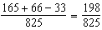

PTS: 2 REF: 081925aii NAT: S.CP.B.6 TOP: Conditional Probability

26 ANS:
The denominator of the rational exponent represents the index of a root, and the numerator of the rational exponent represents the power of the base. 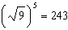

PTS: 2 REF: 081926aii NAT: N.RN.A.1 TOP: Radicals and Rational Exponents

27 ANS:
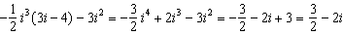

PTS: 2 REF: 081927aii NAT: N.CN.A.2 TOP: Operations with Complex Numbers

28 ANS:
The maximum lung capacity of a person is 2700 mL.

PTS: 2 REF: 081928aii NAT: F.IF.B.4 TOP: Graphing Trigonometric Functions

29 ANS:
is a factor of since .

PTS: 2 REF: 081929aii NAT: A.APR.B.2 TOP: Remainder Theorem

30 ANS:
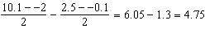

PTS: 2 REF: 081930aii NAT: F.IF.C.7 TOP: Graphing Trigonometric Functions
KEY: amplitude

31 ANS:
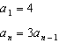

PTS: 2 REF: 081931aii NAT: F.LE.A.2 TOP: Sequences
KEY: recursive

32 ANS:
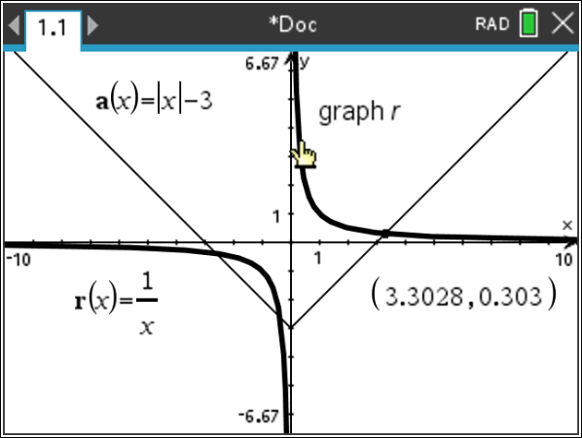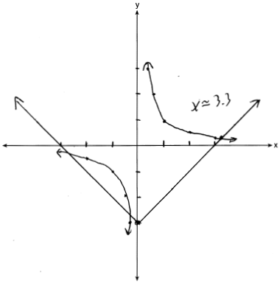

PTS: 2 REF: 081932aii NAT: A.REI.D.11 TOP: Other Systems

33 ANS:
The base is e because growth is continuous. 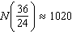

PTS: 4 REF: 081933aii NAT: F.LE.A.2 TOP: Modeling Exponential Functions

34 ANS:
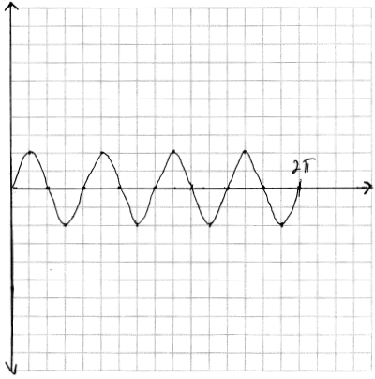

PTS: 4 REF: 081934aii NAT: F.IF.C.7 TOP: Graphing Trigonometric Functions
KEY: graph

35 ANS:
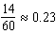. It is not unusual because 0.23 falls within this interval.

PTS: 4 REF: 081935aii NAT: S.IC.B.5 TOP: Analysis of Data

36 ANS:
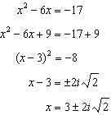The solution is imaginary because the parabola and line do not intersect.

PTS: 4 REF: 081936aii NAT: A.REI.B.4 TOP: Solving Quadratics
KEY: complex solutions | completing the square

37 ANS:
, which is a steady breeze. 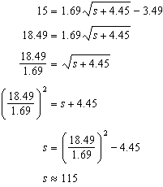 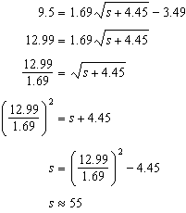 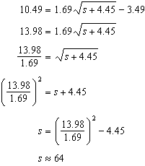 55-64

PTS: 6 REF: 081937aii NAT: A.REI.A.2 TOP: Solving Radicals
KEY: context

