1 The solution of , to the nearest thousandth, is
1) | 0.583 | 3) | 4.220
2) | 1.945 | 4) | 14.066

2 A researcher randomly divides 50 bean plants into two groups. He puts one group by a window to receive natural light and the second group under artificial light. He records the growth of the plants weekly. Which data collection method is described in this situation?
1) | observational study | 3) | survey
2) | controlled experiment | 4) | systematic sample

3 If and , which operation would not result in a polynomial expression?
1) |  | 3)
2) |  | 4)

4 Consider the function and the graph of below.

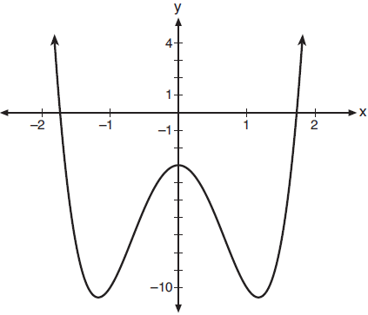

Which statement is true?
1) | has three real roots and has two real roots. | 3) | has two real roots and has three real roots.
2) | has one real root and has two real roots. | 4) | has three real roots and has four real roots.

5 Which expression is equivalent to 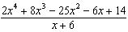?
1) | 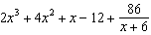 | 3) | 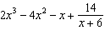
2) |  | 4)

6 Given 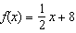, which equation represents the inverse, ?
1) |  | 3) | 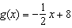
2) |  | 4) | 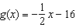

7 The value(s) of x that satisfy are
1) |  | 3)
2) |  | 4)

8 Stephanie found that the number of white-winged cross bills in an area can be represented by the formula , where t represents the number of years since 2010. Which equation correctly represents the number of white-winged cross bills in terms of the monthly rate of population growth?
1) |  | 3) | 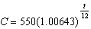
2) |  | 4)

9 The roots of the equation are
1) | 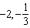 | 3) | 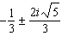
2) | 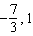 | 4) | 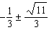

10 The average depreciation rate of a new boat is approximately 8% per year. If a new boat is purchased at a price of $75,000, which model is a recursive formula representing the value of the boat n years after it was purchased?
1) |  | 3)
2) | 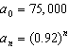 | 4) | 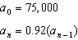

11 Given 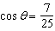, where is an angle in standard position terminating in quadrant IV, and , what is the value of ?
1) |  | 3)
2) |  | 4)

12 For , which expression is equivalent to 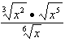?
1) |  | 3)
2) |  | 4)

13 Jake wants to buy a car and hopes to save at least $5000 for a down payment. The table below summarizes the amount of money he plans to save each week.

Week | 1 | 2 | 3 | 4 | 5
Money Saved, in Dollars | 2 | 5 | 12.5 | 31.25 | ...

Based on this plan, which expression should he use to determine how much he has saved in n weeks?
1) | 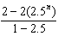 | 3) | 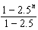
2) | 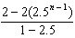 | 4) | 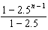

14 Which expression is equivalent to ?
1) |  | 3)
2) |  | 4)

15 If , , and , where i is the imaginary unit, then equals
1) |  | 3)
2) |  | 4)

16 Which sketch best represents the graph of ?
1) | 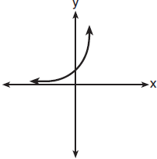 | 3) | 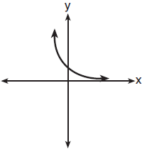
2) | 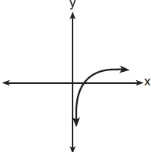 | 4) | 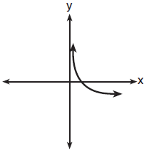

17 The graph below represents national and New York State average gas prices.

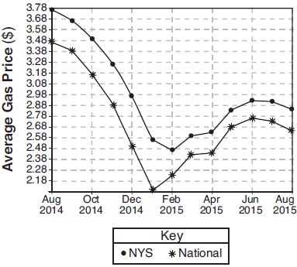

If New York State's gas prices are modeled by and , which expression best approximates the national average x months from August 2014?
1) |  | 3)
2) |  | 4)

18 Data for the students enrolled in a local high school are shown in the Venn diagram below.

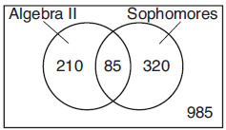

If a student from the high school is selected at random, what is the probability that the student is a sophomore given that the student is enrolled in Algebra II?
1) |  | 3)
2) |  | 4) | 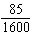

19 If and , then what is the solution for ?
1) | 1.65 | 3) | 5.62
2) | 3.14 | 4) | no solution

20 Which function's graph has a period of 8 and reaches a maximum height of 1 if at least one full period is graphed?
1) | 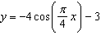 | 3)
2) | 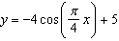 | 4)

21 Given , the solution of is
1) |  | 3)
2) | 2, only | 4)

22 The height above ground for a person riding a Ferris wheel after t seconds is modeled by 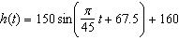 feet. How many seconds does it take to go from the bottom of the wheel to the top of the wheel?
1) | 10 | 3) | 90
2) | 45 | 4) | 150

23 The parabola described by the equation 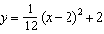 has the directrix at . The focus of the parabola is
1) |  | 3)
2) |  | 4)

24 A fast-food restaurant analyzes data to better serve its customers. After its analysis, it discovers that the events D, that a customer uses the drive-thru, and F, that a customer orders French fries, are independent. The following data are given in a report:

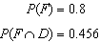

Given this information, is
1) | 0.344 | 3) | 0.57
2) | 0.3648 | 4) | 0.8

25 Over the set of integers, factor the expression .

26 Express the fraction 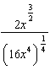 in simplest radical form.

27 The world population was 2560 million people in 1950 and 3040 million in 1960 and can be modeled by the function , where t is time in years after 1950 and is the population in millions. Determine the average rate of change of in millions of people per year, from . Round your answer to the nearest hundredth.

28 The scores of a recent test taken by 1200 students had an approximately normal distribution with a mean of 225 and a standard deviation of 18. Determine the number of students who scored between 200 and 245.

29 Algebraically solve for x: 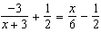

30 Graph over the domain on the set of axes below.

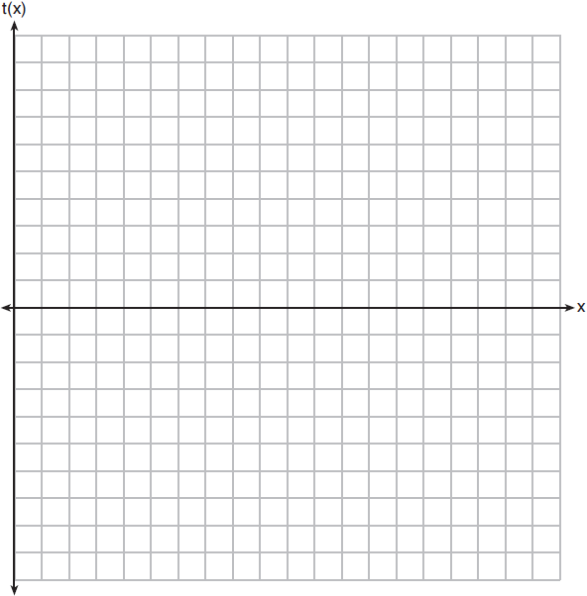

31 Solve the following system of equations algebraically. 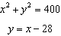

32 Some smart-phone applications contain "in-app" purchases, which allow users to purchase special content within the application. A random sample of 140 users found that 35 percent made in-app purchases. A simulation was conducted with 200 samples of 140 users assuming 35 percent of the samples make in-app purchases. The approximately normal results are shown below.

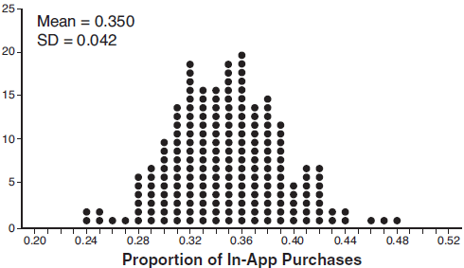

Considering the middle 95% of the data, determine the margin of error, to the nearest hundredth, for the simulated results. In the given context, explain what this value represents.

33 Solve the following system of equations algebraically for all values of x, y, and z:
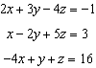

34 Evaluate given . Explain what your answer tells you about as a factor. Algebraically find the remaining zeros of .

35 Determine, to the nearest tenth of a year, how long it would take an investment to double at a 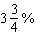 interest rate, compounded continuously.

36 To determine if the type of music played while taking a quiz has a relationship to results, 16 students were randomly assigned to either a room softly playing classical music or a room softly playing rap music. The results on the quiz were as follows:

Classical: 74, 83, 77, 77, 84, 82, 90, 89
Rap: 77, 80, 78, 74, 69, 72, 78, 69

John correctly rounded the difference of the means of his experimental groups as 7. How did John obtain this value and what does it represent in the given context? Justify your answer. To determine if there is any significance in this value, John rerandomized the 16 scores into two groups of 8, calculated the difference of the means, and simulated this process 250 times as shown below.

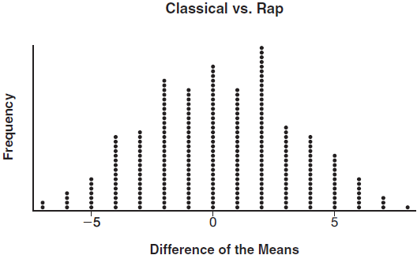

Does the simulation support the theory that there may be a significant difference in quiz scores? Explain.

37 A major car company analyzes its revenue, , and costs , in millions of dollars over a fifteen-year period. The company represents its revenue and costs as a function of time, in years, x, using the given functions.
The company's profits can be represented as the difference between its revenue and costs. Write the profit function, , as a polynomial in standard form. Graph on the set of axes below over the domain .

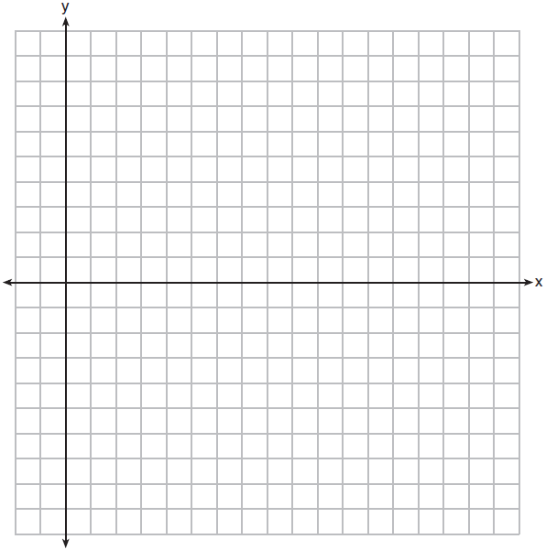

Over the given domain, state when the company was the least profitable and the most profitable, to the nearest year. Explain how you determined your answer.
1 ANS: 4
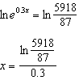

PTS: 2 REF: 081801aii NAT: F.LE.A.4 TOP: Exponential Equations
KEY: without common base

2 ANS: 2 PTS: 2 REF: 081802aii NAT: S.IC.B.3
TOP: Analysis of Data KEY: type

3 ANS: 4 PTS: 2 REF: 081803aii NAT: F.BF.A.1
TOP: Operations with Functions

4 ANS: 1 PTS: 2 REF: 081804aii NAT: F.IF.C.9
TOP: Comparing Functions

5 ANS: 3
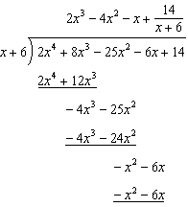

PTS: 2 REF: 081805aii NAT: A.APR.D.6 TOP: Rational Expressions
KEY: division

6 ANS: 2
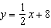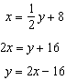

PTS: 2 REF: 081806aii NAT: F.BF.B.4 TOP: Inverse of Functions
KEY: linear

7 ANS: 3
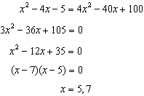

PTS: 2 REF: 081807aii NAT: A.REI.A.2 TOP: Solving Radicals
KEY: extraneous solutions

8 ANS: 2

PTS: 2 REF: 081808aii NAT: A.SSE.B.3 TOP: Modeling Exponential Functions

9 ANS: 3
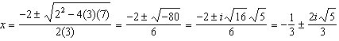

PTS: 2 REF: 081809aii NAT: A.REI.B.4 TOP: Solving Quadratics
KEY: complex solutions | quadratic formula

10 ANS: 4 PTS: 2 REF: 081810aii NAT: F.LE.A.2
TOP: Sequences

11 ANS: 2
If , 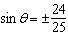, and 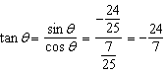

PTS: 2 REF: 081811aii NAT: F.TF.C.8 TOP: Determining Trigonometric Functions

12 ANS: 3
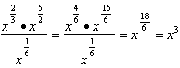

PTS: 2 REF: 081812aii NAT: N.RN.A.2 TOP: Operations with Radicals
KEY: with variables, index > 2

13 ANS: 1 PTS: 2 REF: 081813aii NAT: A.SSE.B.4
TOP: Series

14 ANS: 4
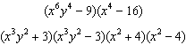

PTS: 2 REF: 081814aii NAT: A.SSE.A.2
TOP: Factoring the Difference of Perfect Squares KEY: multivariable AII

15 ANS: 3

PTS: 2 REF: 081815aii NAT: N.CN.A.2 TOP: Operations with Complex Numbers

16 ANS: 2 PTS: 2 REF: 081816aii NAT: F.IF.C.7
TOP: Graphing Logarithmic Functions KEY: bimodalgraph

17 ANS: 4 PTS: 2 REF: 081817aii NAT: F.BF.B.3
TOP: Transformations with Functions

18 ANS: 2
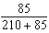

PTS: 2 REF: 081818aii NAT: S.CP.A.1 TOP: Venn Diagrams

19 ANS: 3 PTS: 2 REF: 081819aii NAT: A.REI.D.11
TOP: Other Systems

20 ANS: 1
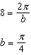

PTS: 2 REF: 081820aii NAT: F.IF.B.4 TOP: Graphing Trigonometric Functions
KEY: maximum/minimum

21 ANS: 4
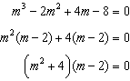

PTS: 2 REF: 081821aii NAT: A.APR.D.6 TOP: Solving Polynomial Equations

22 ANS: 2
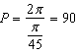

PTS: 2 REF: 081822aii NAT: F.IF.C.7 TOP: Graphing Trigonometric Functions
KEY: period

23 ANS: 4
The vertex is and .

PTS: 2 REF: 081823aii NAT: G.GPE.A.2 TOP: Graphing Quadratic Functions

24 ANS: 4 PTS: 2 REF: 081824aii NAT: S.CP.A.3
TOP: Conditional Probability

25 ANS:

PTS: 2 REF: 081825aii NAT: A.SSE.A.2 TOP: Factoring Polynomials
KEY: higher power

26 ANS:
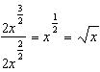

PTS: 2 REF: 081826aii NAT: N.RN.A.2 TOP: Radicals and Rational Exponents
KEY: variables

27 ANS:
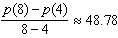

PTS: 2 REF: 081827aii NAT: F.IF.B.6 TOP: Rate of Change

28 ANS:

PTS: 2 REF: 081828aii NAT: S.ID.A.4 TOP: Normal Distributions
KEY: predict

29 ANS:
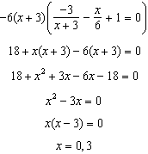

PTS: 2 REF: 081829aii NAT: A.REI.A.2 TOP: Solving Rationals
KEY: rational solutions

30 ANS:
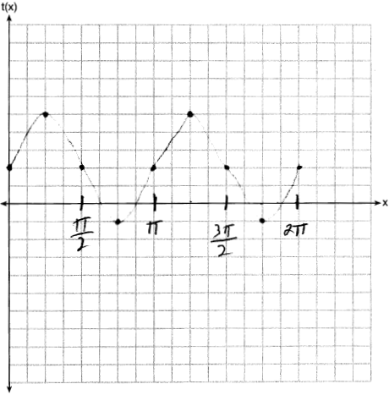

PTS: 2 REF: 081830aii NAT: F.IF.C.7 TOP: Graphing Trigonometric Functions
KEY: graph

31 ANS:
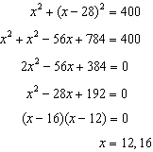

PTS: 2 REF: 081831aii NAT: A.REI.C.7 TOP: Quadratic-Linear Systems

32 ANS:
The percent of users making in-app purchases will be within 8% of 35%.

PTS: 2 REF: 081832aii NAT: S.IC.B.4 TOP: Analysis of Data

33 ANS:
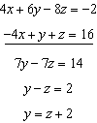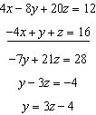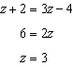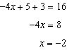

PTS: 4 REF: 081833aii NAT: A.REI.C.6 TOP: Solving Linear Systems
KEY: three variables

34 ANS:
; is a factor of ; 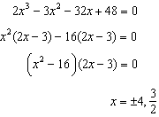

PTS: 4 REF: 081834aii NAT: A.APR.B.2 TOP: Remainder Theorem

35 ANS:
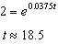

PTS: 4 REF: 081835aii NAT: F.LE.A.4 TOP: Exponential Growth

36 ANS:
John found the means of the scores of the two rooms and subtracted the means. The mean score for the classical room was 7 higher than the rap room (82-75). Yes, there is less than a 5% chance this difference occurring due to random chance. It is likely the difference was due to the music.

PTS: 4 REF: 081836aii NAT: S.IC.B.5 TOP: Analysis of Data

37 ANS:
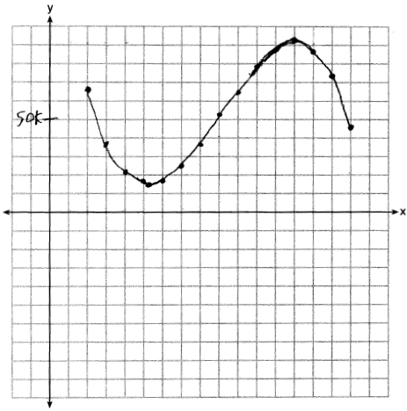 Least profitable at year 5 because there is a minimum in . Most profitable at year 13 because there is a maximum in .

PTS: 6 REF: 081837aii NAT: F.IF.C.7 TOP: Graphing Polynomial Functions

