1 Which equation has as a solution?
1) |  | 3)
2) |  | 4)

2 Which statement(s) about statistical studies is true?
I. A survey of all English classes in a high school would be a good sample to determine the number of hours students throughout the school spend studying.
II. A survey of all ninth graders in a high school would be a good sample to determine the number of student parking spaces needed at that high school.
III. A survey of all students in one lunch period in a high school would be a good sample to determine the number of hours adults spend on social media websites.
IV. A survey of all Calculus students in a high school would be a good sample to determine the number of students throughout the school who don’t like math.
1) | I, only | 3) | I and III
2) | II, only | 4) | III and IV

3 To the nearest tenth, the value of x that satisfies is
1) | 2.5 | 3) | 5.8
2) | 2.6 | 4) | 5.9

4 The lifespan of a 60-watt lightbulb produced by a company is normally distributed with a mean of 1450 hours and a standard deviation of 8.5 hours. If a 60-watt lightbulb produced by this company is selected at random, what is the probability that its lifespan will be between 1440 and 1465 hours?
1) | 0.3803 | 3) | 0.8415
2) | 0.4612 | 4) | 0.9612

5 Which factorization is incorrect?
1) |  | 3)
2) |  | 4)

6 Sally’s high school is planning their spring musical. The revenue, R, generated can be determined by the function , where t represents the price of a ticket. The production cost, C, of the musical is represented by the function . What is the highest ticket price, to the nearest dollar, they can charge in order to not lose money on the event?
1) |  | 3)
2) |  | 4)

7 The set of data in the table below shows the results of a survey on the number of messages that people of different ages text on their cell phones each month.

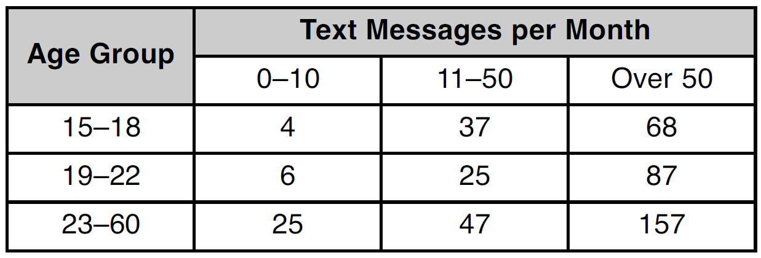

If a person from this survey is selected at random, what is the probability that the person texts over 50 messages per month given that the person is between the ages of 23 and 60?
1) |  | 3)
2) |  | 4)

8 A recursive formula for the sequence is
1) | 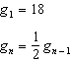 | 3) | 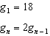
2) | 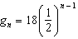 | 4)

9 Kristin wants to increase her running endurance. According to experts, a gradual mileage increase of 10% per week can reduce the risk of injury. If Kristin runs 8 miles in week one, which expression can help her find the total number of miles she will have run over the course of her 6-week training program?
1) | 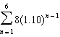 | 3) | 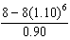
2) | 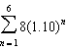 | 4) | 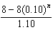

10 A sine function increasing through the origin can be used to model light waves. Violet light has a wavelength of 400 nanometers. Over which interval is the height of the wave decreasing, only?
1) |  | 3)
2) |  | 4)

11 The expression 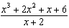 is equivalent to
1) |  | 3)
2) | 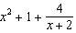 | 4) | 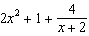

12 A candidate for political office commissioned a poll. His staff received responses from 900 likely voters and 55% of them said they would vote for the candidate. The staff then conducted a simulation of 1000 more polls of 900 voters, assuming that 55% of voters would vote for their candidate. The output of the simulation is shown in the diagram below.

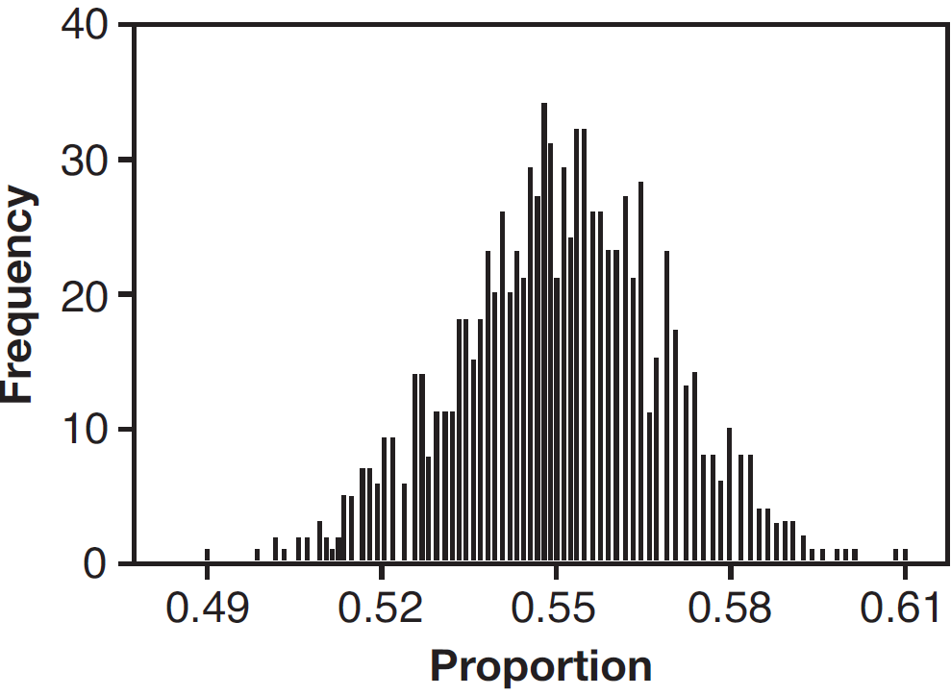

Given this output, and assuming a 95% confidence level, the margin of error for the poll is closest to
1) | 0.01 | 3) | 0.06
2) | 0.03 | 4) | 0.12

13 An equation to represent the value of a car after t months of ownership is 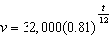. Which statement is not correct?
1) | The car lost approximately 19% of its value each month. | 3) | The value of the car when it was purchased was $32,000.
2) | The car maintained approximately 98% of its value each month. | 4) | The value of the car 1 year after it was purchased was $25,920.

14 Which equation represents an odd function?
1) |  | 3)
2) |  | 4)

15 The completely factored form of is
1) |  | 3)
2) |  | 4)

16 Which diagram shows an angle rotation of 1 radian on the unit circle?
1) | 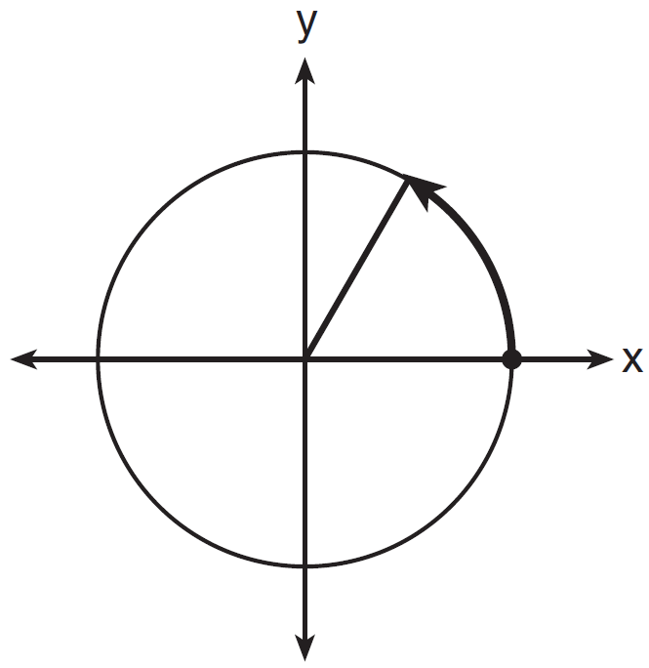 | 3) | 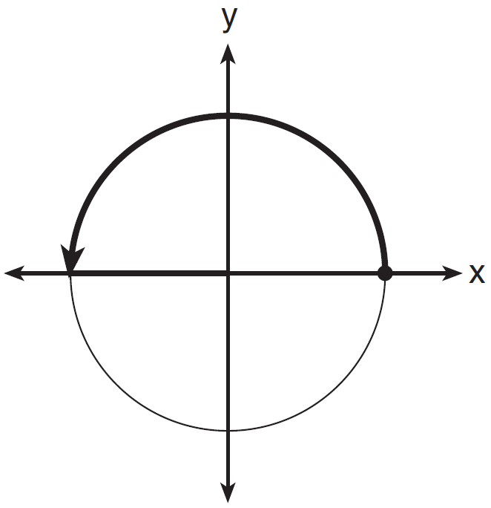
2) | 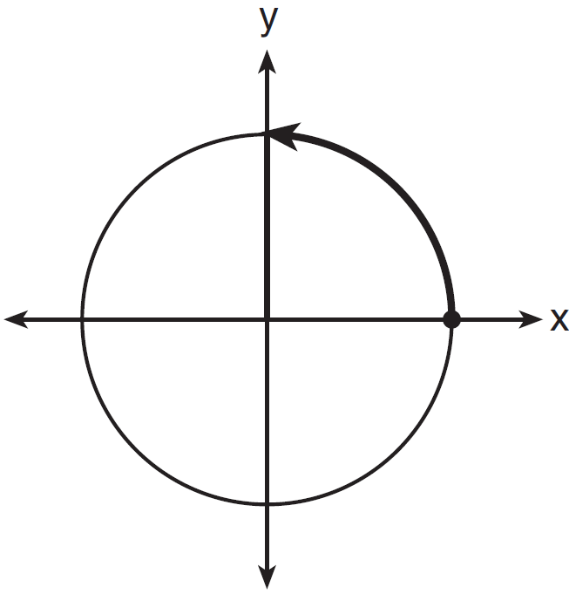 | 4) | 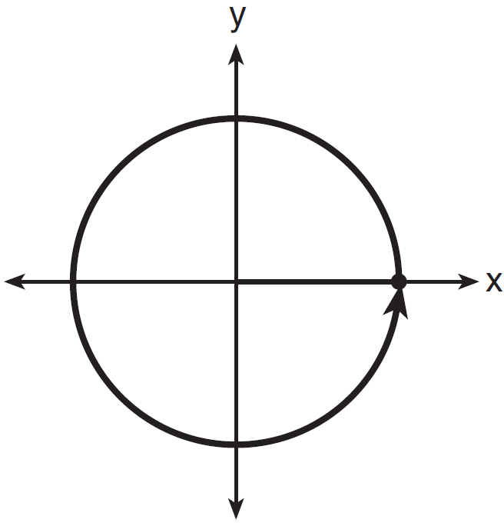

17 The focal length, F, of a camera’s lens is related to the distance of the object from the lens, J, and the distance to the image area in the camera, W, by the formula below.

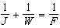

When this equation is solved for J in terms of F and W, J equals
1) |  | 3) | 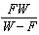
2) | 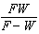 | 4) | 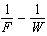

18 The sequence can also be written as
1) |  | 3)
2) |  | 4)

19 Which equation represents the set of points equidistant from line and point R shown on the graph below?
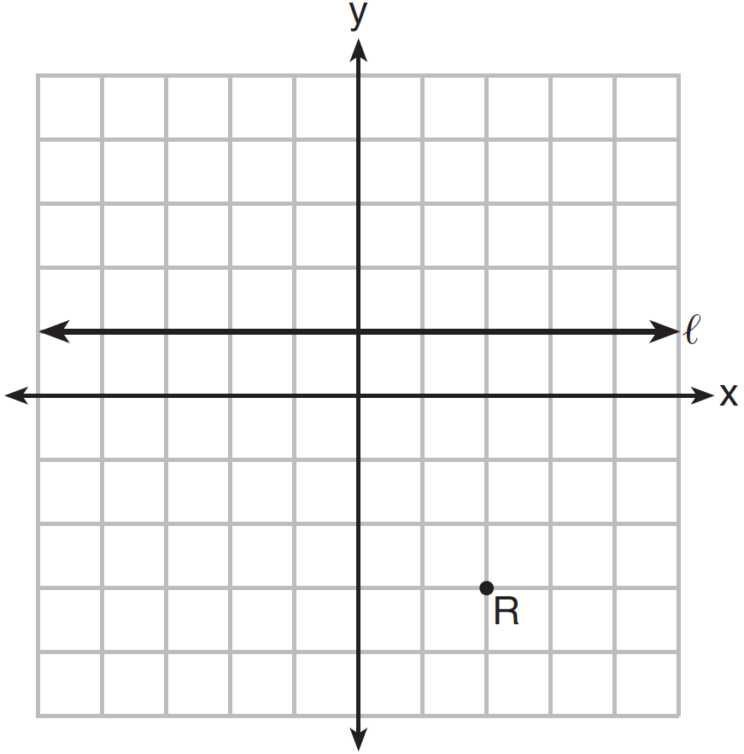
1) | 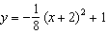 | 3) | 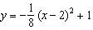
2) | 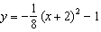 | 4) | 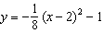

20 Mr. Farison gave his class the three mathematical rules shown below to either prove or disprove. Which rules can be proved for all real numbers?
I
II
III
1) | I, only | 3) | II and III
2) | I and II | 4) | I and III

21 The graph of is shown below.

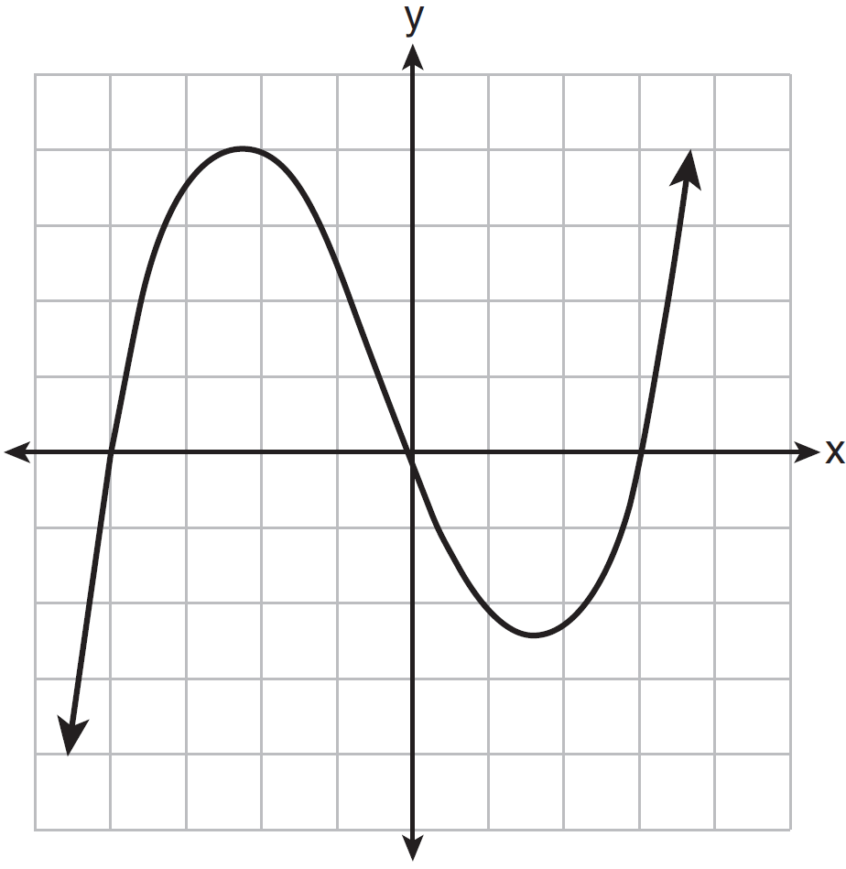

What is the remainder when is divided by ?
1) |  | 3) | 0
2) |  | 4) | 4

22 A payday loan company makes loans between $100 and $1000 available to customers. Every 14 days, customers are charged 30% interest with compounding. In 2013, Remi took out a $300 payday loan. Which expression can be used to calculate the amount she would owe, in dollars, after one year if she did not make payments?
1) | 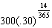 | 3) | 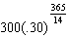
2) | 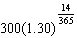 | 4) | 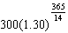

23 Which value is not contained in the solution of the system shown below?
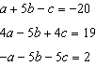
1) |  | 3) | 3
2) | 2 | 4)

24 In 2010, the population of New York State was approximately 19,378,000 with an annual growth rate of 1.5%. Assuming the growth rate is maintained for a large number of years, which equation can be used to predict the population of New York State t years after 2010?
1) |  | 3)
2) | 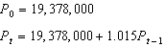 | 4) | 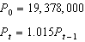

25 The volume of air in a person’s lungs, as the person breathes in and out, can be modeled by a sine graph. A scientist is studying the differences in this volume for people at rest compared to people told to take a deep breath. When examining the graphs, should the scientist focus on the amplitude, period, or midline? Explain your choice.

26 Explain how 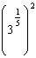 can be written as the equivalent radical expression .

27 Simplify , where i is the imaginary unit.

28 Using the identity , find the value of , to the nearest hundredth, if is –0.7 and is in Quadrant II.

29 Elizabeth waited for 6 minutes at the drive thru at her favorite fast-food restaurant the last time she visited. She was upset about having to wait that long and notified the manager. The manager assured her that her experience was very unusual and that it would not happen again. A study of customers commissioned by this restaurant found an approximately normal distribution of results. The mean wait time was 226 seconds and the standard deviation was 38 seconds. Given these data, and using a 95% level of confidence, was Elizabeth’s wait time unusual? Justify your answer.

30 The x-value of which function’s x-intercept is larger, f or h? Justify your answer.

x | h(x)
 | 6
0 | 4
1 | 2
2 | 0
3

31 The distance needed to stop a car after applying the brakes varies directly with the square of the car’s speed. The table below shows stopping distances for various speeds.

Speed (mph) | 10 | 20 | 30 | 40 | 50 | 60 | 70
Distance (ft) | 6.25 | 25 | 56.25 | 100 | 156.25 | 225 | 306.25

Determine the average rate of change in braking distance, in ft/mph, between one car traveling at 50 mph and one traveling at 70 mph. Explain what this rate of change means as it relates to braking distance.

32 Given events A and B, such that , , and , determine whether A and B are independent or dependent.

33 Find algebraically the zeros for . On the set of axes below, graph .



34 One of the medical uses of Iodine–131 (I–131), a radioactive isotope of iodine, is to enhance x-ray images. The half-life of I–131 is approximately 8.02 days. A patient is injected with 20 milligrams of I–131. Determine, to the nearest day, the amount of time needed before the amount of I–131 in the patient’s body is approximately 7 milligrams.

35 Solve the equation algebraically, and justify the solution set.

36 Ayva designed an experiment to determine the effect of a new energy drink on a group of 20 volunteer students. Ten students were randomly selected to form group 1 while the remaining 10 made up group 2. Each student in group 1 drank one energy drink, and each student in group 2 drank one cola drink. Ten minutes later, their times were recorded for reading the same paragraph of a novel. The results of the experiment are shown below.

Group 1  (seconds) | Group 2  (seconds)
17.4 | 23.3
18.1 | 18.8
18.2 | 22.1
19.6 | 12.7
18.6 | 16.9
16.2 | 24.4
16.1 | 21.2
15.3 | 21.2
17.8 | 16.3
19.7 | 14.5

Ayva thinks drinking energy drinks makes students read faster. Using information from the experimental design or the results, explain why Ayva’s hypothesis may be incorrect. Using the given results, Ayva randomly mixes the 20 reading times, splits them into two groups of 10, and simulates the difference of the means 232 times.

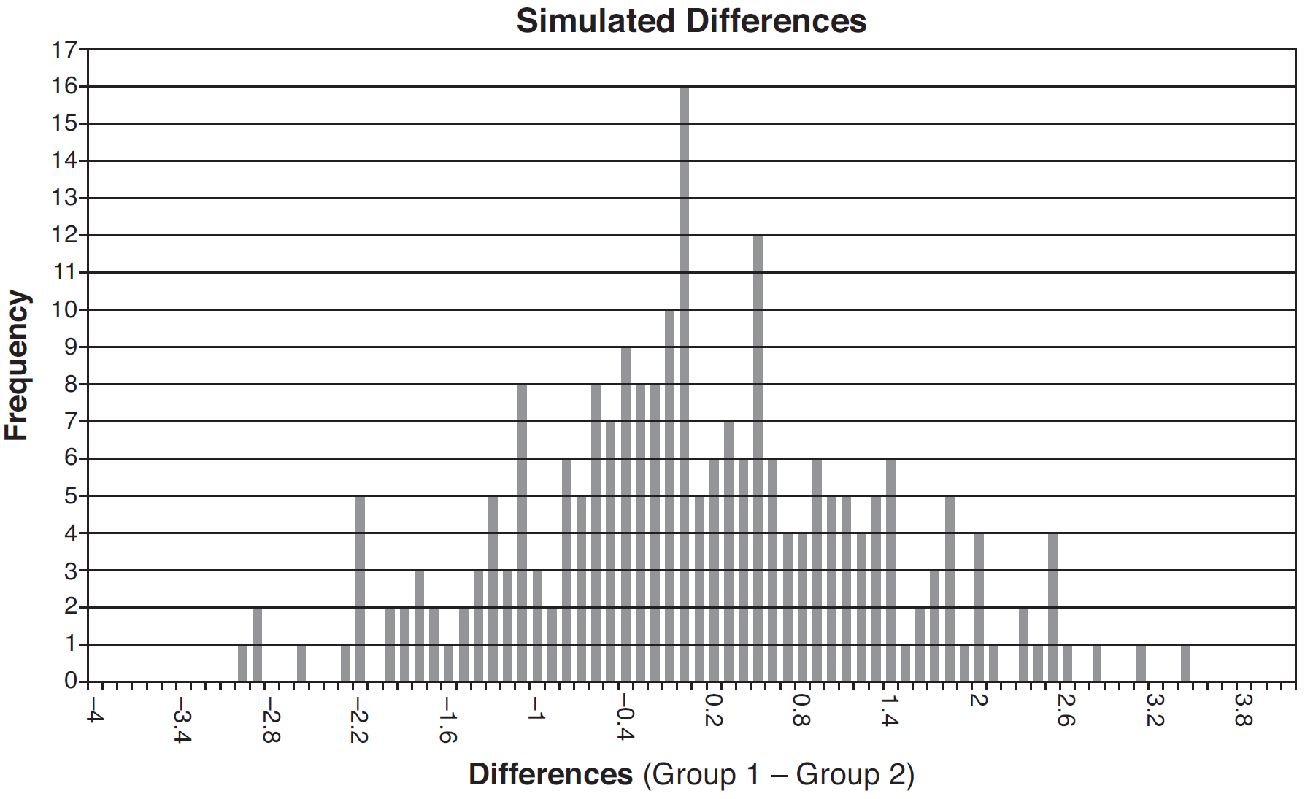

Ayva has decided that the difference in mean reading times is not an unusual occurrence. Support her decision using the results of the simulation. Explain your reasoning.

37 Seth’s parents gave him $5000 to invest for his 16th birthday. He is considering two investment options. Option A will pay him 4.5% interest compounded annually. Option B will pay him 4.6% compounded quarterly. Write a function of option A and option B that calculates the value of each account after n years. Seth plans to use the money after he graduates from college in 6 years. Determine how much more money option B will earn than option A to the nearest cent. Algebraically determine, to the nearest tenth of a year, how long it would take for option B to double Seth’s initial investment.
1 ANS: 4
If is one solution, the other is . 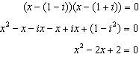

PTS: 2 REF: 081601aii NAT: A.REI.B.4 TOP: Complex Conjugate Root Theorem

2 ANS: 1
II. Ninth graders drive to school less often; III.Students know little about adults; IV. Calculus students love math!

PTS: 2 REF: 081602aii NAT: S.IC.B.3 TOP: Analysis of Data
KEY: bias

3 ANS: 2
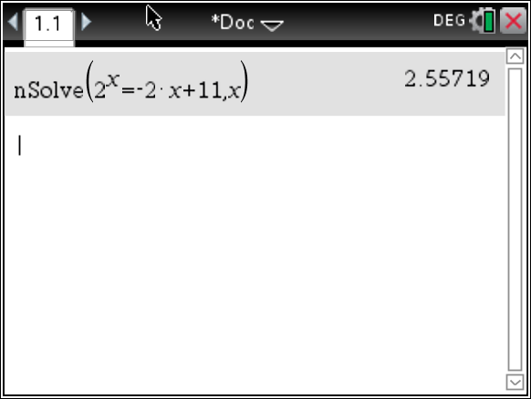

PTS: 2 REF: 081603aii NAT: A.REI.D.11 TOP: Other Systems
KEY: AII

4 ANS: 3
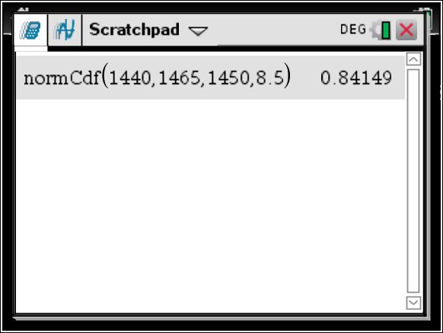

PTS: 2 REF: 081604aii NAT: S.ID.A.4 TOP: Normal Distributions
KEY: probability

5 ANS: 3

PTS: 2 REF: 081605aii NAT: A.SSE.A.2 TOP: Factoring Polynomials
KEY: factoring by grouping

6 ANS: 3
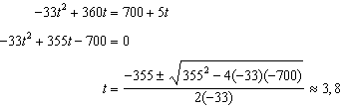

PTS: 2 REF: 081606aii NAT: A.REI.D.11 TOP: Quadratic-Linear Systems
KEY: AII

7 ANS: 1
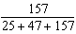

PTS: 2 REF: 081607aii NAT: S.CP.A.4 TOP: Conditional Probability

8 ANS: 1
(2) is not recursive

PTS: 2 REF: 081608aii NAT: F.BF.A.2 TOP: Sequences

9 ANS: 1 PTS: 2 REF: 081609aii NAT: F.BF.B.6
TOP: Sigma Notation KEY: represent

10 ANS: 2 PTS: 2 REF: 081610aii NAT: F.IF.B.4
TOP: Graphing Trigonometric Functions KEY: increasing/decreasing

11 ANS: 2
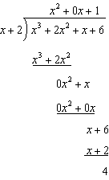

PTS: 2 REF: 081611aii NAT: A.APR.D.6 TOP: Rational Expressions

12 ANS: 2
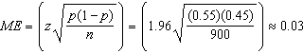

PTS: 2 REF: 081612aii NAT: S.IC.B.4 TOP: Analysis of Data

13 ANS: 1
The car lost approximately 19% of its value each year.

PTS: 2 REF: 081613aii NAT: F.LE.B.5 TOP: Modeling Exponential Functions

14 ANS: 1
The graph of is unchanged when rotated 180º about the origin.

PTS: 2 REF: 081614aii NAT: F.BF.B.3 TOP: Even and Odd Functions

15 ANS: 3
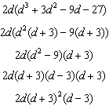

PTS: 2 REF: 081615aii NAT: A.SSE.A.2 TOP: Factoring Polynomials
KEY: factoring by grouping

16 ANS: 1 PTS: 2 REF: 081616aii NAT: F.TF.A.1
TOP: Unit Circle

17 ANS: 3
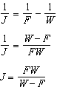

PTS: 2 REF: 081617aii NAT: A.REI.A.2 TOP: Solving Rationals
KEY: rational solutions

18 ANS: 3 PTS: 2 REF: 081618aii NAT: F.LE.A.2
TOP: Sequences

19 ANS: 4
The vertex is and . 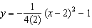

PTS: 2 REF: 081619aii NAT: G.GPE.A.2 TOP: Graphing Quadratic Functions

20 ANS: 4

PTS: 2 REF: 081620aii NAT: A.APR.C.4 TOP: Polynomial Identities

21 ANS: 3
Since is a factor of , there is no remainder.

PTS: 2 REF: 081621aii NAT: A.APR.B.2 TOP: Remainder Theorem

22 ANS: 4 PTS: 2 REF: 081622aii NAT: F.BF.A.1
TOP: Modeling Exponential Functions KEY: AII

23 ANS: 2
Combining (1) and (3): 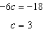 Combining (1) and (2): 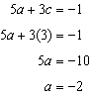 Using (3): 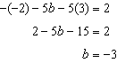

PTS: 2 REF: 081623aii NAT: A.REI.C.6 TOP: Solving Linear Systems
KEY: three variables

24 ANS: 4 PTS: 2 REF: 081624aii NAT: F.BF.A.2
TOP: Sequences

25 ANS:
Amplitude, because the height of the graph shows the volume of the air.

PTS: 2 REF: 081625aii NAT: F.IF.C.7 TOP: Graphing Trigonometric Functions
KEY: mixed

26 ANS:
Applying the commutative property, can be rewritten as 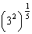 or . A fractional exponent can be rewritten as a radical with the denominator as the index, or 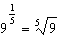.

PTS: 2 REF: 081626aii NAT: N.RN.A.1 TOP: Radicals and Rational Exponents

27 ANS:

PTS: 2 REF: 081627aii NAT: N.CN.A.2 TOP: Operations with Complex Numbers

28 ANS:
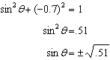 Since is in Quadrant II, and 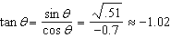

PTS: 2 REF: 081628aii NAT: F.TF.C.8 TOP: Determining Trigonometric Functions

29 ANS:
Using a 95% level of confidence, standard deviations sets the usual wait time as 150-302 seconds. 360 seconds is unusual.

PTS: 2 REF: 081629aii NAT: S.IC.B.6 TOP: Analysis of Data

30 ANS:
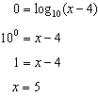 The x-intercept of h is . f has the larger value.

PTS: 2 REF: 081630aii NAT: F.IF.C.9 TOP: Comparing Functions
KEY: AII

31 ANS:
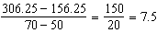 Between 50-70 mph, each additional mph in speed requires 7.5 more feet to stop.

PTS: 2 REF: 081631aii NAT: F.IF.B.6 TOP: Rate of Change
KEY: AII

32 ANS:
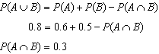 A and B are independent since 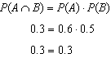

PTS: 2 REF: 081632aii NAT: S.CP.A.2 TOP: Theoretical Probability

33 ANS:
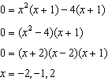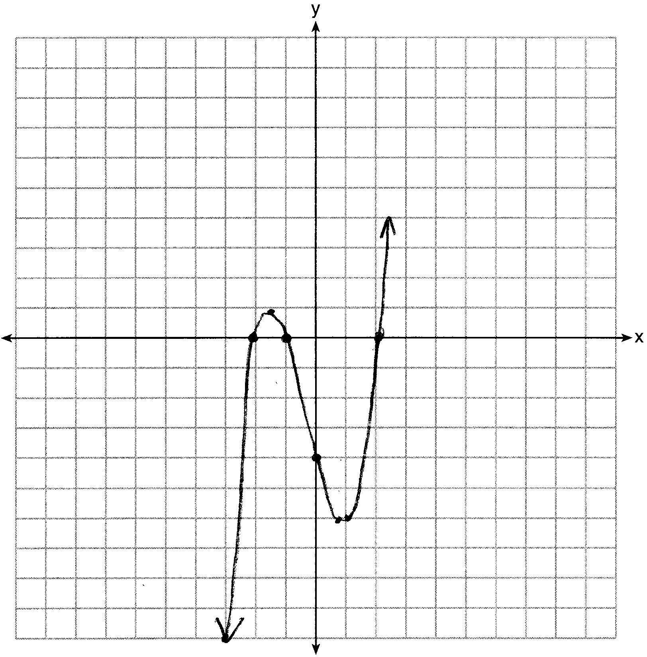

PTS: 4 REF: 081633aii NAT: F.IF.C.7 TOP: Graphing Polynomial Functions

34 ANS:
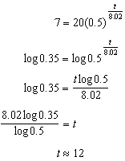

PTS: 4 REF: 081634aii NAT: F.LE.A.4 TOP: Exponential Decay

35 ANS:
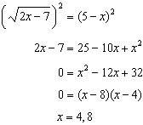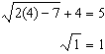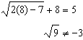

PTS: 4 REF: 081635aii NAT: A.REI.A.2 TOP: Solving Radicals
KEY: extraneous solutions

36 ANS:
Some of the students who did not drink energy drinks read faster than those who did drink energy drinks. Differences of -1.4 and less occur or about 10% of the time, so the difference is not unusual.

PTS: 4 REF: 081636aii NAT: S.IC.B.5 TOP: Analysis of Data

37 ANS:
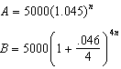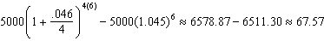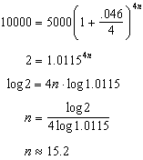

PTS: 6 REF: 081637aii NAT: A.CED.A.1 TOP: Exponential Growth

