1 The population of Austin, Texas from 1850 to 2010 is summarized in the table below.

Year | 1850 | 1870 | 1890 | 1910 | 1930 | 1950 | 1970 | 1990 | 2010
Population | 629 | 4428 | 14,575 | 29,860 | 53,120 | 132,459 | 251,808 | 494,290 | 790,390

Over which period of time was the average rate of change in population the greatest?
1) | 1850 to 1910 | 3) | 1950 to 1970
2) | 1990 to 2010 | 4) | 1890 to 1970

2 Which expression is not equivalent to ?
1) |  | 3)
2) |  | 4)

3 What are the zeros of ?
1) |  | 3)
2) |  | 4)

4 If is an angle in standard position whose terminal side passes through the point , what is the numerical value of ?
1) |  | 3) | 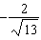
2) |  | 4) | 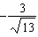

5 The average monthly temperature, , in degrees Fahrenheit, over a 12 month period, can be modeled by 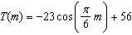, where m is in months. What is the range of temperatures, in degrees Fahrenheit, of this function?
1) |  | 3)
2) |  | 4)

6 Which expression is an equivalent form of ?
1) |  | 3)
2) |  | 4)

7 The expression is equivalent to
1) |  | 3)
2) |  | 4)

8 Which equation best represents the graph below?

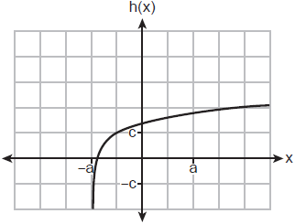
1) |  | 3)
2) |  | 4)

9 Which function has the characteristic as ?
1) | 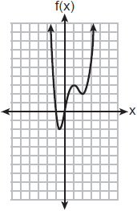 | 3)
2) | 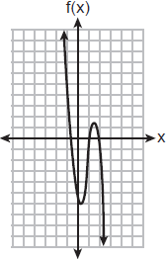 | 4)

10 The expression is equivalent to
1) |  | 3)
2) |  | 4)

11 What is the solution for the system of equations below?
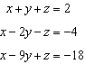
1) |  | 3)
2) |  | 4)

12 The roots of the equation are
1) |  | 3)
2) |  | 4)

13 Which expression is equivalent to 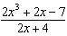?
1) | 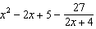 | 3) | 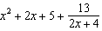
2) | 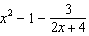 | 4) | 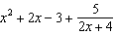

14 A popular celebrity tracks the number of people, in thousands, who have followed her on social media since January 1, 2015. A summary of the data she recorded is shown in the table below:

Number of  Months Since January 2015 | 2 | 11 | 16 | 20 | 27 | 35 | 47 | 50 | 52
Number of Social Media Followers  (thousands) | 3.1 | 7.5 | 29.7 | 49.7 | 200.3 | 680.3 | 5200.3 | 8109.3 | 12,107.1

The celebrity uses an exponential regression equation to model the data. According to the model, about how many followers did she have on June 1, 2018?
1) | 13,000,000 | 3) | 1,850,000
2) | 5,420,000 | 4) | 790,000

15 Luminescence is the emission of light that is not caused by heat. A luminescent substance decays according to the function below.

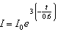

This function can be best approximated by
1) | 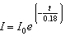 | 3)
2) |  | 4)

16 The heights of the students at Central High School can be modeled by a normal distribution with a mean of 68.1 and a standard deviation of 3.4 inches. According to this model, approximately what percent of the students would have a height less than 60 inches or greater than 75 inches?
1) | 0.86% | 3) | 2.12%
2) | 1.26% | 4) | 2.98%

17 Marissa and Sydney are trying to determine if there is enough interest in their school to put on a senior musical. They randomly surveyed 100 members of the senior class and 43% of them said they would be interested in being in a senior musical. Marissa and Sydney then conducted a simulation of 500 more surveys, each of 100 seniors, assuming that 43% of the senior class would be interested in being in the musical. The output of the simulation is shown below.

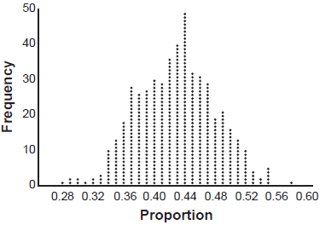

The standard deviation of the simulation is closest to
1) | 0.02 | 3) | 0.09
2) | 0.05 | 4) | 0.43

18 For , which statement is true?
1) | and are even functions. | 3) | and 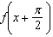 are odd functions.
2) | and are odd functions. | 4) | is an odd function and is an even function.

19 The solution set of 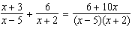 is
1) |  | 3)
2) |  | 4)

20 Given x and y are positive, which expressions are equivalent to ?

I. 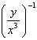 II. III. 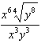
1) | I and II, only | 3) | II and III, only
2) | I and III, only | 4) | I, II, and III

21 Given the inverse function 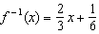, which function represents ?
1) | 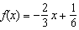 | 3) | 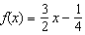
2) | 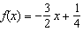 | 4) | 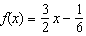

22 How many equations below are identities?
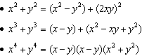
1) | 1 | 3) | 3
2) | 2 | 4) | 0

23 If the focus of a parabola is and the directrix is , what is an equation for the parabola?
1) |  | 3)
2) |  | 4)

24 John and Margaret deposit $500 into a savings account for their son on his first birthday. They continue to make a deposit of $500 on the child's birthday, with the last deposit being made on the child's 21st birthday. If the account pays 4% annual interest, which equation represents the amount of money in the account after the last deposit is made?
1) |  | 3)
2) | 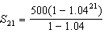 | 4) | 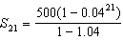

25 The business office of a local college wishes to determine the methods of payment that will be used by students when buying books at the beginning of a semester. Explain how the office can gather an appropriate sample that minimizes bias.

26 Determine the solution of algebraically.

27 The population of bacteria, , in hundreds, after t hours can be modeled by the function . Determine whether the population is increasing or decreasing over time. Explain your reasoning.

28 The polynomial function has a factor of . Determine the value of a.

29 Write a recursive formula for the sequence

30 Solve algebraically for x to the nearest thousandth:

31 For all values of x for which the expression is defined, write the expression below in simplest form.

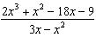

32 An app design company believes that the proportion of high school students who have purchased apps on their smartphones in the past 3 months is 0.85. A simulation of 500 samples of 150 students was run based on this proportion and the results are shown below.

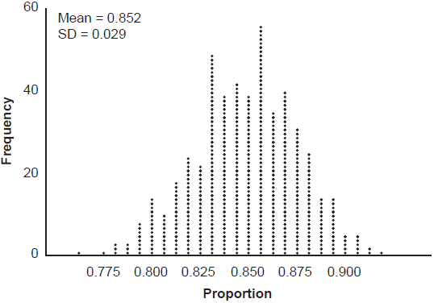

Suppose a sample of 150 students from your high school showed that 88% of students had purchased apps on their smartphones in the past 3 months. Based on the simulation, would the results from your high school give the app design company reason to believe their assumption is incorrect? Explain.

33 Patricia creates a cubic polynomial function, , with a leading coefficient of 1. The zeros of the function are 2, 3, and . Write an equation for . Sketch on the set of axes below.

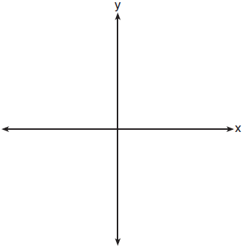

34 A public radio station held a fund-raiser. The table below summarizes the donor category and method of donation.

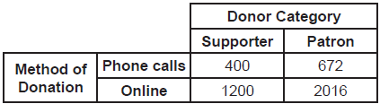

To the nearest thousandth, find the probability that a randomly selected donor was categorized as a supporter, given that the donation was made online. Do these data indicate that being a supporter is independent of donating online? Justify your answer.

35 Algebraically solve the system:
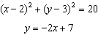

36 On a certain tropical island, there are currently 500 palm trees and 200 flamingos. Suppose the palm tree population is decreasing at an annual rate of 3% per year and the flamingo population is growing at a continuous rate of 2% per year. Write two functions, and , that represent the number of palm trees and flamingos on this island, respectively, x years from now. State the solution to the equation , rounded to the nearest year. Interpret the meaning of this value within the given context.

37 The volume of air in an average lung during breathing can be modeled by the graph below.

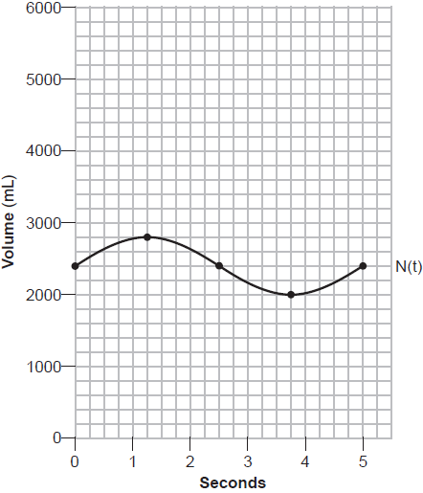

Using the graph, write an equation for , in the form . That same lung, when engaged in exercise, has a volume that can be modeled by , where is volume in mL and t is time in seconds. Graph at least one cycle of on the same grid as . How many times during the 5-second interval will ?
1 ANS: 2
1) 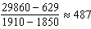; 2) 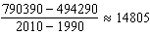; 3) 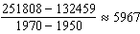; 4) 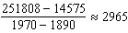

PTS: 2 REF: 062301aii NAT: F.IF.B.6 TOP: Rate of Change

2 ANS: 3 PTS: 2 REF: 062302aii NAT: A.SSE.A.2
TOP: Factoring Polynomials

3 ANS: 4
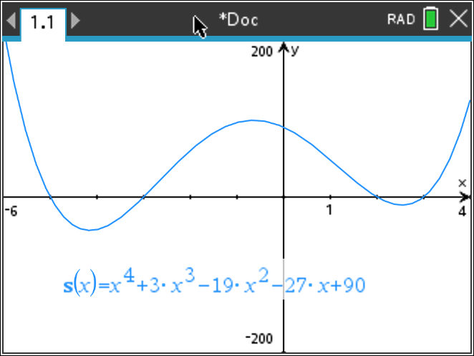

PTS: 2 REF: 062303aii NAT: A.APR.B.3 TOP: Solving Polynomial Equations

4 ANS: 2
; 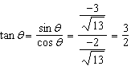

PTS: 2 REF: 062304aii NAT: F.TF.A.2 TOP: Determining Trigonometric Functions
KEY: extension to reals

5 ANS: 2
;

PTS: 2 REF: 062305aii NAT: F.IF.A.2 TOP: Domain and Range
KEY: real domain, trigonometric

6 ANS: 2
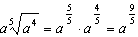

PTS: 2 REF: 062306aii NAT: N.RN.A.2 TOP: Radicals and Rational Exponents

7 ANS: 3

PTS: 2 REF: 062307aii NAT: N.CN.A.2 TOP: Operations with Complex Numbers

8 ANS: 1 PTS: 2 REF: 062308aii NAT: F.IF.C.7
TOP: Graphing Logarithmic Functions

9 ANS: 4 PTS: 2 REF: 062309aii NAT: F.IF.C.9
TOP: Comparing Functions

10 ANS: 2
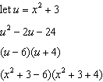

PTS: 2 REF: 062310aii NAT: A.SSE.A.2 TOP: Factoring Polynomials

11 ANS: 3
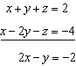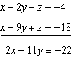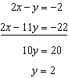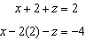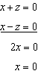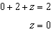

PTS: 2 REF: 062311aii NAT: A.REI.C.6 TOP: Solving Linear Systems
KEY: three variables

12 ANS: 1
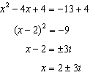

PTS: 2 REF: 062312aii NAT: A.REI.B.4 TOP: Solving Quadratics
KEY: complex solutions | completing the square

13 ANS: 1
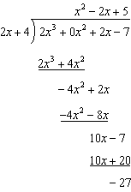

PTS: 2 REF: 062313aii NAT: A.APR.D.6 TOP: Rational Expressions
KEY: division

14 ANS: 3

PTS: 2 REF: 062314aii NAT: S.ID.B.6 TOP: Regression
KEY: exponential

15 ANS: 3
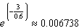

PTS: 2 REF: 062315aii NAT: A.SSE.B.3 TOP: Modeling Exponential Functions

16 ANS: 4
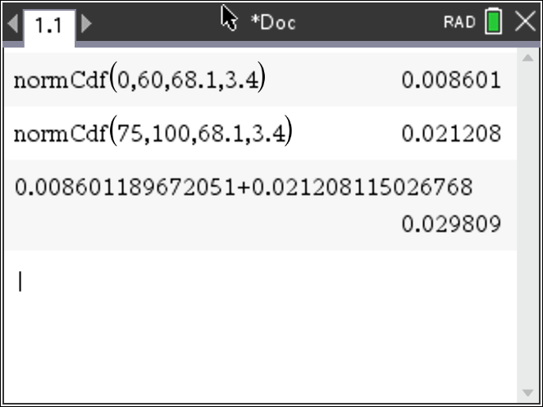

PTS: 2 REF: 062316aii NAT: S.ID.A.4 TOP: Normal Distributions
KEY: percent

17 ANS: 2
contains about 95% of the data.

PTS: 2 REF: 062317aii NAT: S.IC.B.4 TOP: Analysis of Data

18 ANS: 1 PTS: 2 REF: 062318aii NAT: F.BF.B.3
TOP: Even and Odd Functions

19 ANS: 1
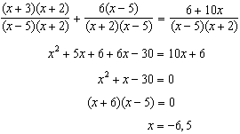 5 is extraneous.

PTS: 2 REF: 062319aii NAT: A.REI.A.2 TOP: Solving Rationals

20 ANS: 4
I. 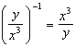; II. 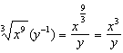; III. 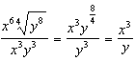

PTS: 2 REF: 062320aii NAT: N.RN.A.2 TOP: Radicals and Rational Exponents

21 ANS: 3
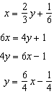

PTS: 2 REF: 062321aii NAT: F.BF.B.4 TOP: Inverse of Functions
KEY: linear

22 ANS: 4
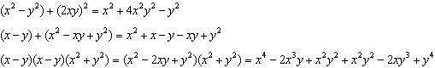

PTS: 2 REF: 062322aii NAT: A.APR.C.4 TOP: Polynomial Identities

23 ANS: 2
Since the distance from the focus to the directrix is 2, and the vertex of the parabola is . 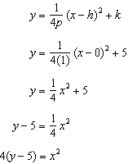

PTS: 2 REF: 062323aii NAT: G.GPE.A.2 TOP: Graphing Quadratic Functions

24 ANS: 2 PTS: 2 REF: 062324aii NAT: A.SSE.B.4
TOP: Series KEY: geometric

25 ANS:
Pick random names from a list of all students and ask each one his method.

PTS: 2 REF: 062325aii NAT: S.IC.B.3 TOP: Analysis of Data

26 ANS:
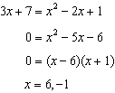 is extraneous.

PTS: 2 REF: 062326aii NAT: A.REI.A.2 TOP: Solving Radicals
KEY: extraneous solutions

27 ANS:
, so is increasing.

PTS: 2 REF: 062327aii NAT: F.IF.C.7 TOP: Graphing Exponential Functions

28 ANS:
; 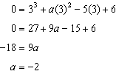

PTS: 2 REF: 062328aii NAT: A.APR.B.2 TOP: Remainder and Factor Theorems

29 ANS:
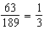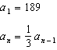

PTS: 2 REF: 062329aii NAT: F.LE.A.2 TOP: Sequences
KEY: recursive

30 ANS:
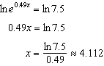

PTS: 2 REF: 062330aii NAT: F.LE.A.4 TOP: Exponential Equations
KEY: without common base

31 ANS:

PTS: 2 REF: 062331ai NAT: A.APR.D.6 TOP: Rational Expressions
KEY: factoring

32 ANS:
No. . 0.88 falls within this interval.

PTS: 2 REF: 062332aii NAT: S.IC.A.2 TOP: Analysis of Data

33 ANS:
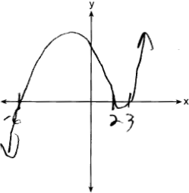

PTS: 4 REF: 062333aii NAT: F.IF.C.7 TOP: Graphing Polynomial Functions

34 ANS:
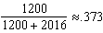. Yes, because 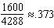 also.

PTS: 4 REF: 062334aii NAT: S.CP.A.4 TOP: Conditional Probability

35 ANS:
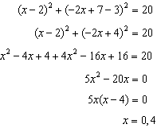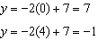

PTS: 4 REF: 062335aii NAT: A.REI.C.7 TOP: Quadratic-Linear Systems

36 ANS:
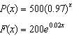; 18; The number of palm trees and flamingos will be equal in 18 years.

PTS: 4 REF: 062336aii NAT: A.REI.D.11 TOP: Other Systems

37 ANS:
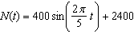. 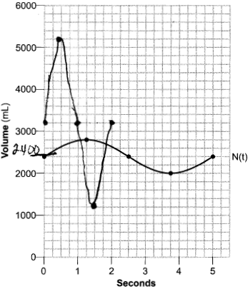 4 times.

PTS: 6 REF: 062337aii NAT: F.IF.C.7 TOP: Graphing Trigonometric Functions
KEY: graph

