1 The graphs of the equations and are drawn on the same set of axes. One solution of this system is
1) |  | 3)
2) |  | 4)

2 Which statement is true about the graph of 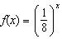?
1) | The graph is always increasing.
2) | The graph is always decreasing.
3) | The graph passes through .
4) | The graph has an asymptote, .

3 For all values of x for which the expression is defined, 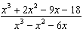, in simplest form, is equivalent to
1) | 3 | 3) | 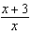
2) |  | 4) | 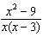

4 A scatterplot showing the weight, w, in grams, of each crystal after growing t hours is shown below.

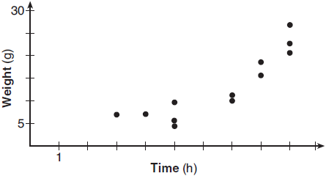

The relationship between weight, w, and time, t, is best modeled by
1) |  | 3)
2) |  | 4)

5 Where i is the imaginary unit, the expression is equivalent to
1) |  | 3)
2) |  | 4)

6 Which function is even?
1) |  | 3)
2) |  | 4)

7 The function models the number of grams in a sample of cesium-137 that remain after t years. On which interval is the sample's average rate of decay the fastest?
1) |  | 3) | [15,25]
2) |  | 4)

8 Which expression can be rewritten as ?
1) |  | 3) | 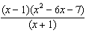
2) |  | 4) | 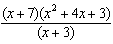

9 What is the solution set of the equation 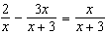?
1) |  | 3)
2) |  | 4) | 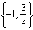

10 The depth of the water at a marker 20 feet from the shore in a bay is depicted in the graph below.

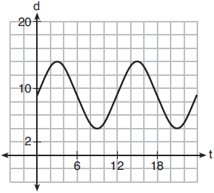

If the depth, d, is measured in feet and time, t, is measured in hours since midnight, what is an equation for the depth of the water at the marker?
1) | 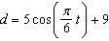
2) | 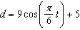
3) | 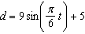
4) | 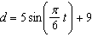

11 On a given school day, the probability that Nick oversleeps is 48% and the probability he has a pop quiz is 25%. Assuming these two events are independent, what is the probability that Nick oversleeps and has a pop quiz on the same day?
1) | 73% | 3) | 23%
2) | 36% | 4) | 12%

12 If is a factor of , what is the value of k?
1) | 0 | 3) | 3
2) | 2 | 4)

13 The profit function, , for a company is the cost function, , subtracted from the revenue function, . The profit function for the Acme Corporation is and the revenue function is . The cost function for the Acme Corporation is
1) |  | 3)
2) |  | 4)

14 The populations of two small towns at the beginning of 2018 and their annual population growth rate are shown in the table below.

Town | Population | Annual Population  Growth Rate
Jonesville | 1240 | 6% increase
Williamstown | 890 | 11% increase

Assuming the trend continues, approximately how many years after the beginning of 2018 will it take for the populations to be equal?
1) | 7 | 3) | 68
2) | 20 | 4) | 125

15 What is the inverse of ?
1) |  | 3)
2) |  | 4)

16 A 4th degree polynomial has zeros , 3, , and . Which graph could represent the function defined by this polynomial?
1) | 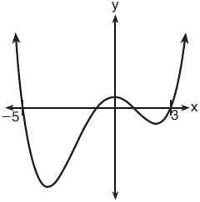 | 3) | 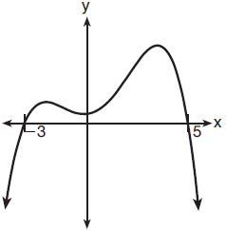
2) | 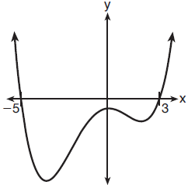 | 4) | 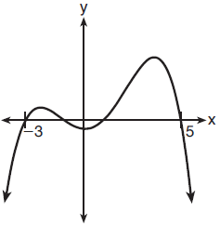

17 The weights of bags of Graseck's Chocolate Candies are normally distributed with a mean of 4.3 ounces and a standard deviation of 0.05 ounces. What is the probability that a bag of these chocolate candies weighs less than 4.27 ounces?
1) | 0.2257 | 3) | 0.7257
2) | 0.2743 | 4) | 0.7757

18 The half-life of iodine-131 is 8 days. The percent of the isotope left in the body d days after being introduced is 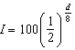. When this equation is written in terms of the number e, the base of the natural logarithm, it is equivalent to . What is the approximate value of the constant, k?
1) |  | 3)
2) | 0.087 | 4) | 11.542

19 The graph of is translated to the right 1 unit and down 1 unit. The coordinates of the x-intercept of the translated graph are
1) |  | 3)
2) |  | 4)

20 For positive values of x, which expression is equivalent to 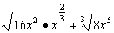
1) |  | 3)
2) |  | 4)

21 Which equation represents a parabola with a focus of and a directrix of ?
1) |  | 3)
2) |  | 4)

22 Given the following polynomials
Which identity is true?
1) |  | 3)
2) |  | 4)

23 On average, college seniors graduating in 2012 could compute their growing student loan debt using the function , where t is time in years. Which expression is equivalent to and could be used by students to identify an approximate daily interest rate on their loans?
1) | 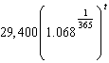 | 3) | 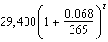
2) | 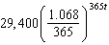 | 4) | 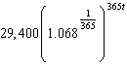

24 A manufacturing plant produces two different-sized containers of peanuts. One container weighs x ounces and the other weighs y pounds. If a gift set can hold one of each size container, which expression represents the number of gift sets needed to hold 124 ounces?
1) | 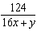 | 3) | 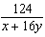
2) | 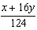 | 4) | 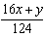

25 A survey about television-viewing preferences was given to randomly selected freshmen and seniors at Fairport High School. The results are shown in the table below.

Favorite Type of Program
 | Sports | Reality Show | Comedy Series
Senior | 83 | 110 | 67
Freshmen | 119 | 103 | 54

A student response is selected at random from the results. State the exact probability the student response is from a freshman, given the student prefers to watch reality shows on television.

26 On the grid below, graph the function on the domain .

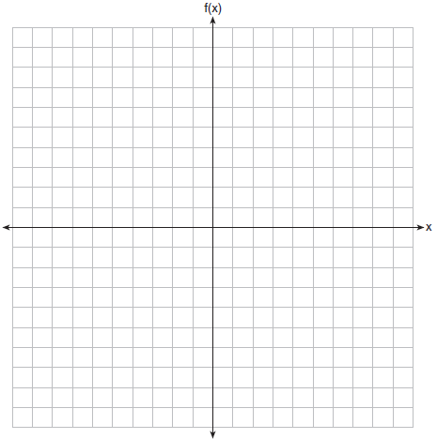

27 Solve the equation . Express the answer in form.

28 Chuck's Trucking Company has decided to initiate an Employee of the Month program. To determine the recipient, they put the following sign on the back of each truck.



The driver who receives the highest number of positive comments will win the recognition. Explain one statistical bias in this data collection method.

29 Determine the quotient and remainder when is divided by . Express your answer in the form 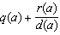.

30 The recursive formula to describe a sequence is shown below.
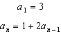
State the first four terms of this sequence. Can this sequence be represented using an explicit geometric formula? Justify your answer.

31 The Wells family is looking to purchase a home in a suburb of Rochester with a 30-year mortgage that has an annual interest rate of 3.6%. The house the family wants to purchase is $152,500 and they will make a $15,250 down payment and borrow the remainder. Use the formula below to determine their monthly payment, to the nearest dollar.
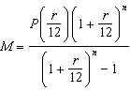
monthly payment
amount borrowed
annual interest rate
total number of monthly payments

32 An angle, , is in standard position and its terminal side passes through the point . Find the exact value of .

33 Solve algebraically for all values of x:

34 Joseph was curious to determine if scent improves memory. A test was created where better memory is indicated by higher test scores. A controlled experiment was performed where one group was given the test on scented paper and the other group was given the test on unscented paper. The summary statistics from the experiment are given below.

 | Scented Paper | Unscented Paper
 | 23 | 18
s_{x} | 2.898 | 2.408

Calculate the difference in means in the experimental test grades (scented -unscented). A simulation was conducted in which the subjects' scores were rerandomized into two groups 1000 times. The differences of the group means were calculated each time. The results are shown below.

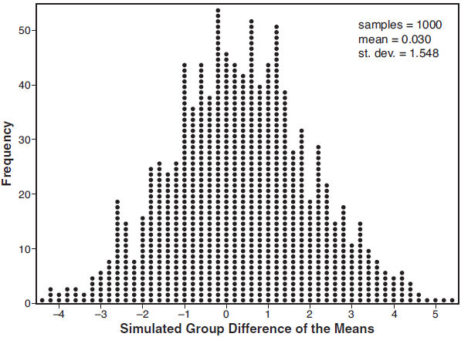

Use the simulation results to determine the interval representing the middle 95% of the difference in means, to the nearest hundredth. Is the difference in means in Joseph's experiment statistically significant based on the simulation? Explain.

35 Carla wants to start a college fund for her daughter Lila. She puts $63,000 into an account that grows at a rate of 2.55% per year, compounded monthly. Write a function, , that represents the amount of money in the account t years after the account is opened, given that no more money is deposited into or withdrawn from the account. Calculate algebraically the number of years it will take for the account to reach $100,000, to the nearest hundredth of a year.

36 The height, in cm, of a piston, is given by the equation 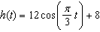, where t represents the number of seconds since the measurements began. Determine the average rate of change, in cm/sec, of the piston's height on the interval . At what value(s) of t, to the nearest tenth of a second, does in the interval ? Justify your answer.

37 Website popularity ratings are often determined using models that incorporate the number of visits per week a website receives. One model for ranking websites is , where x is the number of visits per week in thousands and is the website's popularity rating. According to this model, if a website is visited 16,000 times in one week, what is its popularity rating, rounded to the nearest tenth? Graph on the axes below.

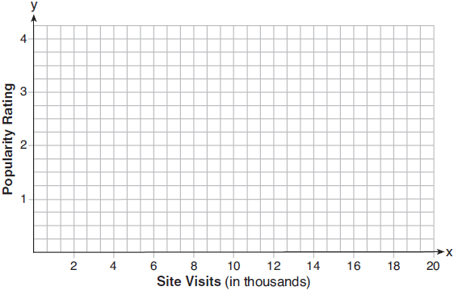

An alternative rating model is represented by 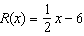, where x is the number of visits per week in thousands. Graph on the same set of axes. For what number of weekly visits will the two models provide the same rating?
1 ANS: 2
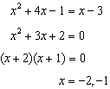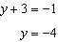

PTS: 2 REF: 061801aii NAT: A.REI.C.7 TOP: Quadratic-Linear Systems
KEY: AII

2 ANS: 2 PTS: 2 REF: 061802aii NAT: F.IF.C.7
TOP: Graphing Exponential Functions KEY: AII

3 ANS: 3
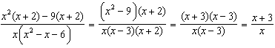

PTS: 2 REF: 061803aii NAT: A.APR.D.6 TOP: Rational Expressions
KEY: factoring

4 ANS: 2 PTS: 2 REF: 061804aii NAT: S.ID.B.6
TOP: Regression KEY: choose model

5 ANS: 3

PTS: 2 REF: 061805aii NAT: N.CN.A.2 TOP: Operations with Complex Numbers

6 ANS: 2
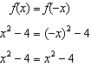

PTS: 2 REF: 061806aii NAT: F.BF.B.3 TOP: Even and Odd Functions

7 ANS: 1
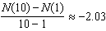, 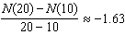, 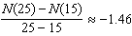, 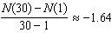

PTS: 2 REF: 061807aii NAT: F.IF.B.6 TOP: Rate of Change
KEY: AII

8 ANS: 1

PTS: 2 REF: 061808aii NAT: A.APR.C.4 TOP: Polynomial Identities

9 ANS: 4
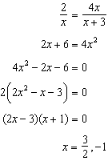

PTS: 2 REF: 061809aii NAT: A.REI.A.2 TOP: Solving Rationals

10 ANS: 4
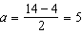, 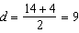

PTS: 2 REF: 061810aii NAT: F.TF.B.5 TOP: Modeling Trigonometric Functions

11 ANS: 4

PTS: 1 REF: 061811aii NAT: S.CP.A.2 TOP: Probability of Compound Events
KEY: probability

12 ANS: 3
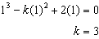

PTS: 2 REF: 061812aii NAT: A.APR.B.3 TOP: Zeros of Polynomials
KEY: AII

13 ANS: 1
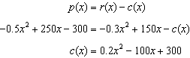

PTS: 2 REF: 061813aii NAT: F.BF.A.1 TOP: Operations with Functions

14 ANS: 1
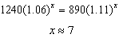

PTS: 2 REF: 061814aii NAT: A.REI.D.11 TOP: Other Systems
KEY: AII

15 ANS: 3
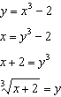

PTS: 2 REF: 061815aii NAT: F.BF.B.4 TOP: Inverse of Functions
KEY: equations

16 ANS: 2 PTS: 2 REF: 061816aii NAT: F.IF.C.7
TOP: Graphing Polynomial Functions KEY: bimodalgraph

17 ANS: 2
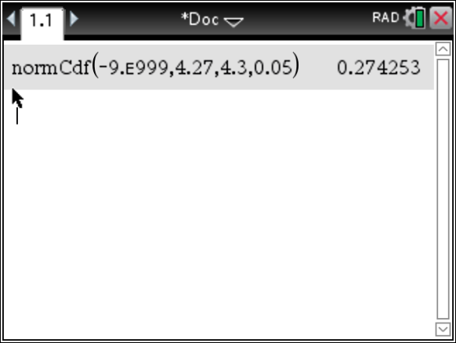

PTS: 2 REF: 061817aii NAT: S.ID.A.4 TOP: Normal Distributions
KEY: probability

18 ANS: 1
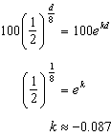

PTS: 2 REF: 061818aii NAT: A.SSE.B.3 TOP: Modeling Exponential Functions
KEY: AII

19 ANS: 4
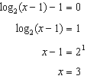

PTS: 2 REF: 061819aii NAT: F.IF.C.7 TOP: Graphing Logarithmic Functions

20 ANS: 2
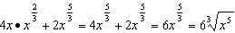

PTS: 2 REF: 061820aii NAT: N.RN.A.2 TOP: Operations with Radicals
KEY: with variables, index > 2

21 ANS: 4
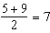, vertex: ; , 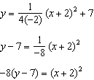

PTS: 2 REF: 061821aii NAT: G.GPE.A.2 TOP: Graphing Quadratic Functions

22 ANS: 4
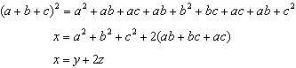

PTS: 2 REF: 061822aii NAT: A.APR.C.4 TOP: Polynomial Identities

23 ANS: 4
1 year = 365 days

PTS: 2 REF: 061823aii NAT: A.SSE.B.3 TOP: Modeling Exponential Functions
KEY: AII

24 ANS: 3 PTS: 2 REF: 061824aii NAT: A.CED.A.1
TOP: Modeling Rationals

25 ANS:
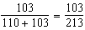

PTS: 2 REF: 061825aii NAT: S.CP.A.4 TOP: Conditional Probability

26 ANS:
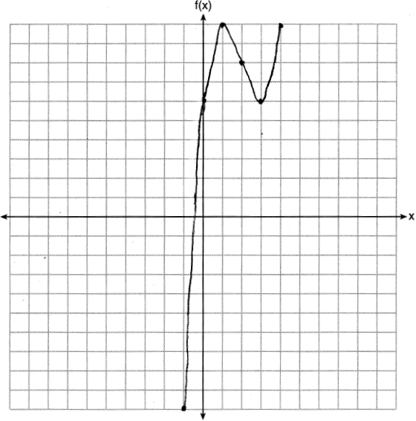

PTS: 2 REF: 061826aii NAT: F.IF.C.7 TOP: Graphing Polynomial Functions

27 ANS:
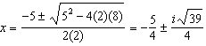

PTS: 2 REF: 061827aii NAT: A.REI.B.4 TOP: Solving Quadratics
KEY: complex solutions | quadratic formula

28 ANS:
Self selection is a cause of bias because people with more free time are more likely to respond.

PTS: 2 REF: 061828aii NAT: S.IC.B.3 TOP: Analysis of Data
KEY: bias

29 ANS:
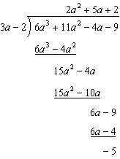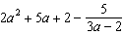

PTS: 2 REF: 061829aii NAT: A.APR.D.6 TOP: Division of Polynomials

30 ANS:
; No, because there is no common ratio: 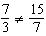

PTS: 4 REF: 061830aii NAT: F.IF.A.3 TOP: Sequences
KEY: term

31 ANS:
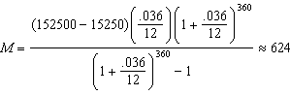

PTS: 2 REF: 061831aii NAT: A.SSE.B.4 TOP: Series

32 ANS:
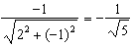

PTS: 2 REF: 061832aii NAT: F.TF.A.2 TOP: Determining Trigonometric Functions
KEY: extension to reals

33 ANS:
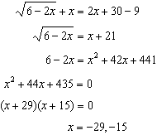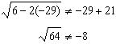, so is extraneous.

PTS: 4 REF: 061833aii NAT: A.REI.A.2 TOP: Solving Radicals
KEY: extraneous solutions

34 ANS:
, , Yes, a difference of 5 or more occurred three times out of a thousand, which is statistically significant.

PTS: 4 REF: 061834aii NAT: S.IC.B.5 TOP: Analysis of Data

35 ANS:
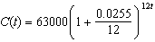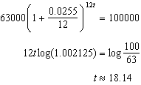

PTS: 4 REF: 061835aii NAT: A.CED.A.1 TOP: Exponential Growth

36 ANS:
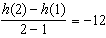, at , using a graphing calculator to find where .

PTS: 4 REF: 061836aii NAT: F.IF.B.4 TOP: Graphing Trigonometric Functions

37 ANS:
, 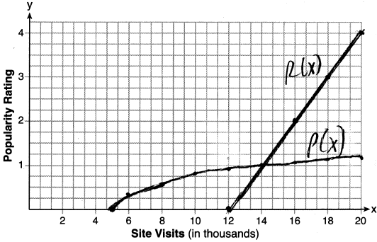, 14000
PTS: 6 REF: 061837aii NAT: A.REI.D.11 TOP: Other Systems
KEY: AII

