1 The graph of the function is sketched below.

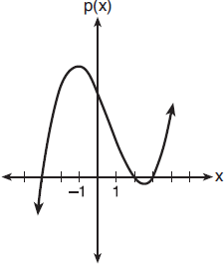

Which equation could represent ?
1) |  | 3)
2) |  | 4)

2 What is the solution to ?
1) | 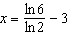 | 3) | 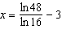
2) |  | 4)

3 Cheap and Fast gas station is conducting a consumer satisfaction survey. Which method of collecting data would most likely lead to a biased sample?
1) | interviewing every 5th customer to come into the station | 3) | interviewing customers who call an 800 number posted on the customers' receipts
2) | interviewing customers chosen at random by a computer at the checkout | 4) | interviewing every customer who comes into the station on a day of the week chosen at random out of a hat

4 The expression is equivalent to
1) |  | 3)
2) |  | 4)

5 If and , an approximate solution for the equation is
1) | 1.96 | 3)
2) | 11.29 | 4)

6 Given the parent function , which phrase best describes the transformation used to obtain the graph of , if a and b are positive constants?
1) | right a units, up b units | 3) | left a units, up b units
2) | right a units, down b units | 4) | left a units, down b units

7 The solution to the equation is
1) |  | 3) | 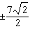
2) |  | 4) | 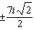

8 Which equation is represented by the graph shown below?

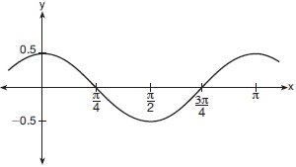
1) | 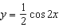
2)
3) | 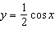
4) | 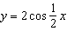

9 A manufacturing company has developed a cost model, , where x is the number of items sold, in thousands. The sales price can be modeled by . Therefore, revenue is modeled by . The company's profit, , could be modeled by
1) |  | 3)
2) |  | 4)

10 A game spinner is divided into 6 equally sized regions, as shown in the diagram below.

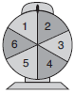

For Miles to win, the spinner must land on the number 6. After spinning the spinner 10 times, and losing all 10 times, Miles complained that the spinner is unfair. At home, his dad ran 100 simulations of spinning the spinner 10 times, assuming the probability of winning each spin is . The output of the simulation is shown in the diagram below.

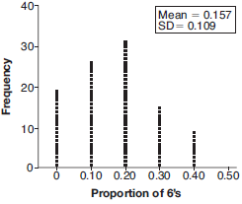

Which explanation is appropriate for Miles and his dad to make?
1) | The spinner was likely unfair, since the number 6 failed to occur in about 20% of the simulations. | 3) | The spinner was likely not unfair, since the number 6 failed to occur in about 20% of the simulations.
2) | The spinner was likely unfair, since the spinner should have landed on the number 6 by the sixth spin. | 4) | The spinner was likely not unfair, since in the output the player wins once or twice in the majority of the simulations.

11 Which binomial is a factor of ?
1) |  | 3)
2) |  | 4)

12 Given that and 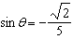, what is a possible value of ?
1) | 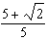 | 3) | 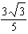
2) | 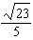 | 4) | 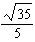

13 A student studying public policy created a model for the population of Detroit, where the population decreased 25% over a decade. He used the model , where P is the population, in thousands, d decades after 2010. Another student, Suzanne, wants to use a model that would predict the population after y years. Suzanne's model is best represented by
1) |  | 3)
2) |  | 4)

14 The probability that Gary and Jane have a child with blue eyes is 0.25, and the probability that they have a child with blond hair is 0.5. The probability that they have a child with both blue eyes and blond hair is 0.125. Given this information, the events blue eyes and blond hair are
I: dependent
II: independent
III: mutually exclusive
1) | I, only | 3) | I and III
2) | II, only | 4) | II and III

15 Based on climate data that have been collected in Bar Harbor, Maine, the average monthly temperature, in degrees F, can be modeled by the equation . The same governmental agency collected average monthly temperature data for Phoenix, Arizona, and found the temperatures could be modeled by the equation . Which statement can not be concluded based on the average monthly temperature models x months after starting data collection?
1) | The average monthly temperature variation is more in Bar Harbor than in Phoenix. | 3) | The maximum average monthly temperature for Bar Harbor is 79° F, to the nearest degree.
2) | The midline average monthly temperature for Bar Harbor is lower than the midline temperature for Phoenix. | 4) | The minimum average monthly temperature for Phoenix is 20° F, to the nearest degree.

16 For , which expressions are equivalent to one divided by the sixth root of x?
I. II. III.
1) | I and II, only | 3) | II and III, only
2) | I and III, only | 4) | I, II, and III

17 A parabola has its focus at and its directrix is . The equation of this parabola could be
1) |  | 3)
2) | 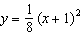 | 4) | 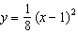

18 The function models the population of a city, in millions, t years after 2010. As of today, consider the following two statements:
I. The current population is 110 million.
II. The population increases continuously by approximately 3.9% per year.
This model supports
1) | I, only | 3) | both I and II
2) | II, only | 4) | neither I nor II

19 To solve 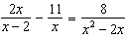, Ren multiplied both sides by the least common denominator. Which statement is true?
1) | 2 is an extraneous solution. | 3) | 0 and 2 are extraneous solutions.
2) | is an extraneous so1ution. | 4) | This equation does not contain any extraneous solutions.

20 Given , which function can be used to generate the sequence ?
1) |  | 3)
2) |  | 4)

21 The function 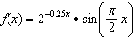 represents a damped sound wave function. What is the average rate of change for this function on the interval , to the nearest hundredth?
1) | -3.66 | 3) | -0.26
2) | -0.30 | 4) | 3.36

22 Mallory wants to buy a new window air conditioning unit. The cost for the unit is $329.99. If she plans to run the unit three months out of the year for an annual operating cost of $108.78, which function models the cost per year over the lifetime of the unit, , in terms of the number of years, n, that she owns the air conditioner.
1) |  | 3) | 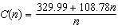
2) |  | 4) | 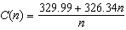

23 The expression 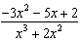 can be rewritten as
1) | 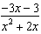 | 3)
2) | 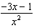 | 4)

24 Jasmine decides to put $100 in a savings account each month. The account pays 3% annual interest, compounded monthly. How much money, S, will Jasmine have after one year?
1) |  | 3)
2) | 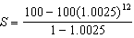 | 4) | 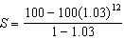

25 Given , find the value of . What does your answer tell you about as a factor of ? Explain.

26 The weight of a bag of pears at the local market averages 8 pounds with a standard deviation of 0.5 pound. The weights of all the bags of pears at the market closely follow a normal distribution. Determine what percentage of bags, to the nearest integer, weighed less than 8.25 pounds.

27 Over the set of integers, factor the expression completely.

28 The graph below represents the height above the ground, h, in inches, of a point on a triathlete's bike wheel during a training ride in terms of time, t, in seconds.

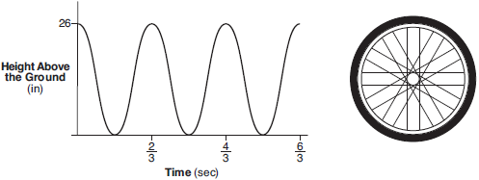

Identify the period of the graph and describe what the period represents in this context.

29 Graph on the set of axes below.

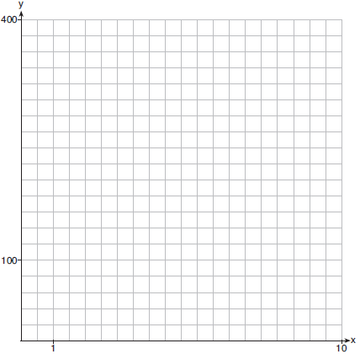

30 Solve algebraically for all values of x:

31 Write as a single term with a rational exponent.

32 Data collected about jogging from students with two older siblings are shown in the table below.

 | Neither Sibling  Jogs | One Sibling  Jogs | Both Siblings  Jogs
Student Does  Not Jog | 1168 | 1823 | 1380
Student Jogs | 188 | 416 | 400

Using these data, determine whether a student with two older siblings is more likely to jog if one sibling jogs or if both siblings jog. Justify your answer.

33 Solve the following system of equations algebraically for all values of x, y, and z:
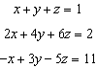

34 Jim is looking to buy a vacation home for $172,600 near his favorite southern beach. The formula to compute a mortgage payment, M, is 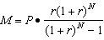 where P is the principal amount of the loan, r is the monthly interest rate, and N is the number of monthly payments. Jim's bank offers a monthly interest rate of 0.305% for a 15-year mortgage. With no down payment, determine Jim's mortgage payment, rounded to the nearest dollar. Algebraically determine and state the down payment, rounded to the nearest dollar, that Jim needs to make in order for his mortgage payment to be $1100.

35 Graph on the set of axes below. Use an appropriate scale to include both intercepts.

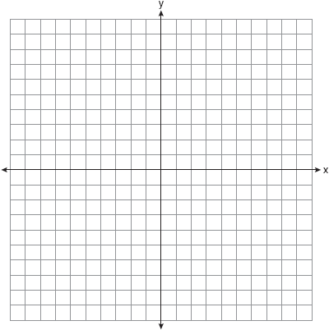

Describe the behavior of the given function as x approaches -3 and as x approaches positive infinity.

36 Charlie's Automotive Dealership is considering implementing a new check-in procedure for customers who are bringing their vehicles for routine maintenance. The dealership will launch the procedure if 50% or more of the customers give the new procedure a favorable rating when compared to the current procedure. The dealership devises a simulation based on the minimal requirement that 50% of the customers prefer the new procedure. Each dot on the graph below represents the proportion of the customers who preferred the new check-in procedure, each of sample size 40, simulated 100 times.

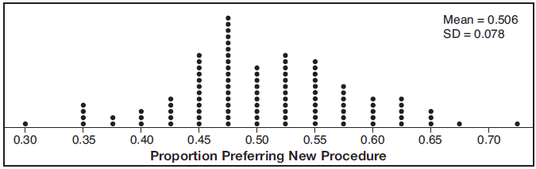

Assume the set of data is approximately normal and the dealership wants to be 95% confident of its results. Determine an interval containing the plausible sample values for which the dealership will launch the new procedure. Round your answer to the nearest hundredth. Forty customers are selected randomly to undergo the new check-in procedure and the proportion of customers who prefer the new procedure is 32.5%. The dealership decides not to implement the new check-in procedure based on the results of the study. Use statistical evidence to explain this decision.

37 A radioactive substance has a mass of 140 g at 3 p.m. and 100 g at 8 p.m. Write an equation in the form 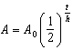 that models this situation, where h is the constant representing the number of hours in the half-life, is the initial mass, and A is the mass t hours after 3 p.m. Using this equation, solve for h, to the nearest ten thousandth. Determine when the mass of the radioactive substance will be 40 g. Round your answer to the nearest tenth of an hour.
1 ANS: 1 PTS: 2 REF: 061701aii NAT: A.APR.B.3
TOP: Zeros of Polynomials KEY: AII

2 ANS: 1
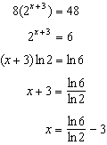

PTS: 2 REF: 061702aii NAT: F.LE.A.4 TOP: Exponential Equations
KEY: without common base

3 ANS: 3
Self selection causes bias.

PTS: 2 REF: 061703aii NAT: S.IC.B.3 TOP: Analysis of Data
KEY: bias

4 ANS: 2

PTS: 2 REF: 061704aii NAT: N.CN.A.2 TOP: Operations with Complex Numbers

5 ANS: 2
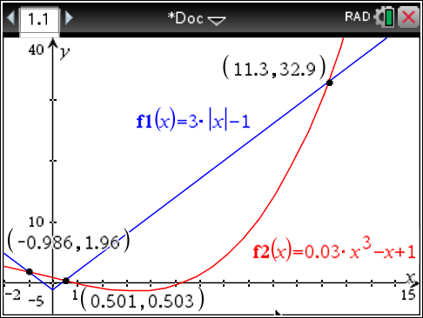

PTS: 2 REF: 061705aii NAT: A.REI.D.11 TOP: Other Systems
KEY: AII

6 ANS: 4 PTS: 2 REF: 061706aii NAT: F.IF.B.4
TOP: Graphing Trigonometric Functions

7 ANS: 4
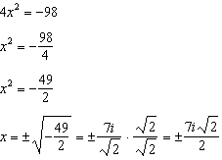

PTS: 2 REF: 061707aii NAT: A.REI.B.4 TOP: Solving Quadratics
KEY: complex solutions | taking square roots

8 ANS: 1 PTS: 2 REF: 061708aii NAT: F.IF.C.7
TOP: Graphing Trigonometric Functions KEY: identify

9 ANS: 2

PTS: 2 REF: 061709aii NAT: F.BF.A.1 TOP: Operations with Functions

10 ANS: 3 PTS: 2 REF: 061710aii NAT: S.IC.A.2
TOP: Analysis of Data

11 ANS: 1
2 | 1 | 0 | -4 | -4 | 8
 |  | 2 | 4 | 0 | -8
 | 1 | 2 | 0 | -4 | 0
Since there is no remainder when the quartic is divided by , this binomial is a factor.

PTS: 2 REF: 061711aii NAT: A.APR.B.2 TOP: Remainder Theorem

12 ANS: 2
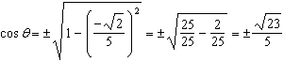

PTS: 2 REF: 061712aii NAT: F.TF.C.8 TOP: Determining Trigonometric Functions

13 ANS: 3
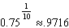

PTS: 2 REF: 061713aii NAT: A.SSE.B.3 TOP: Modeling Exponential Functions
KEY: AII

14 ANS: 2
The events are independent because 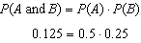.
If , then the events are not mutually exclusive because 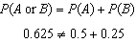

PTS: 2 REF: 061714aii NAT: S.CP.B.7 TOP: Theoretical Probability

15 ANS: 4
 | Bar Harbor | Phoenix
Minimum | 31.386 | 66.491
Midline | 55.3 | 86.729
Maximum | 79.214 | 106.967
Range | 47.828 | 40.476

PTS: 2 REF: 061715aii NAT: F.IF.B.4 TOP: Graphing Trigonometric Functions
KEY: maximum/minimum

16 ANS: 4 PTS: 2 REF: 061716aii NAT: N.RN.A.2
TOP: Radicals and Rational Exponents KEY: variables

17 ANS: 4
The vertex is and . 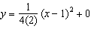

PTS: 2 REF: 061717aii NAT: G.GPE.A.2 TOP: Graphing Quadratic Functions

18 ANS: 2
The 2010 population is 110 million.

PTS: 2 REF: 061718aii NAT: F.LE.B.5 TOP: Modeling Exponential Functions

19 ANS: 1
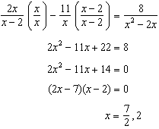

PTS: 2 REF: 061719aii NAT: A.REI.A.2 TOP: Solving Rationals

20 ANS: 3 PTS: 2 REF: 061720aii NAT: F.LE.A.2
TOP: Sequences KEY: AII

21 ANS: 3
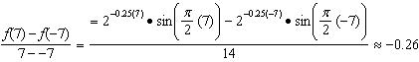

PTS: 2 REF: 061721aii NAT: F.IF.B.6 TOP: Rate of Change
KEY: AII

22 ANS: 3 PTS: 2 REF: 061722aii NAT: A.CED.A.1
TOP: Modeling Rationals

23 ANS: 4
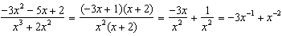

PTS: 2 REF: 061723aii NAT: A.APR.D.6 TOP: Expressions with Negative Exponents
KEY: variables

24 ANS: 2 PTS: 2 REF: 061724aii NAT: A.SSE.B.4
TOP: Series

25 ANS:
. Since there is a remainder when the cubic is divided by , this binomial is not a factor.
2 | 1 | -4 | 4 | 6
 |  | 2 | -4 | 0
 | 1 | -2 | 0 | -6

PTS: 2 REF: 061725aii NAT: A.APR.B.2 TOP: Remainder Theorem

26 ANS:
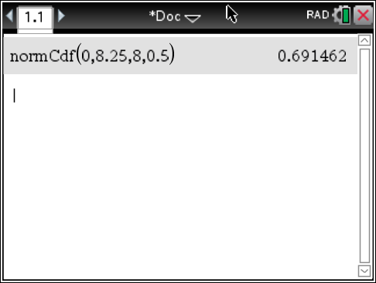 69

PTS: 2 REF: 061726aii NAT: S.ID.A.4 TOP: Normal Distributions
KEY: percent

27 ANS:

PTS: 2 REF: 061727aii NAT: A.SSE.A.2 TOP: Factoring Polynomials
KEY: factoring by grouping

28 ANS:
period is . The wheel rotates once every second.

PTS: 2 REF: 061728aii NAT: F.IF.C.7 TOP: Graphing Trigonometric Functions
KEY: period

29 ANS:
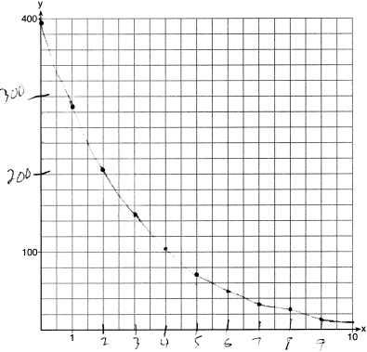

PTS: 2 REF: 061729aii NAT: F.IF.C.7 TOP: Graphing Exponential Functions
KEY: AII

30 ANS:
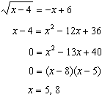 is extraneous.

PTS: 2 REF: 061730aii NAT: A.REI.A.2 TOP: Solving Radicals
KEY: extraneous solutions

31 ANS:
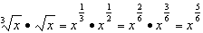

PTS: 2 REF: 061731aii NAT: N.RN.A.2 TOP: Operations with Radicals
KEY: with variables, index > 2

32 ANS:
A student is more likely to jog if both siblings jog. 1 jogs: 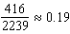. both jog: 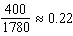

PTS: 2 REF: 061732aii NAT: S.CP.A.4 TOP: Conditional Probability

33 ANS:
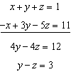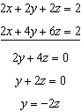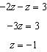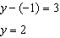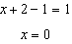

PTS: 4 REF: 061733aii NAT: A.REI.C.6 TOP: Solving Linear Systems
KEY: three variables

34 ANS:
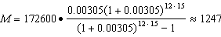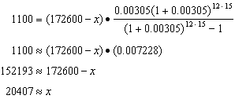

PTS: 4 REF: 061734aii NAT: A.SSE.B.4 TOP: Series

35 ANS:
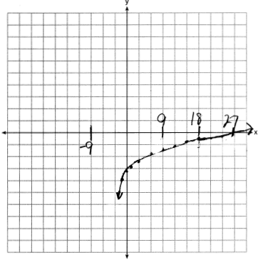 As . As .

PTS: 4 REF: 061735aii NAT: F.IF.C.7 TOP: Graphing Logarithmic Functions

36 ANS:
. The 32.5% value falls below the 95% confidence level.

PTS: 4 REF: 061736aii NAT: S.IC.B.5 TOP: Analysis of Data

37 ANS:
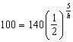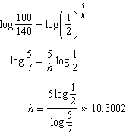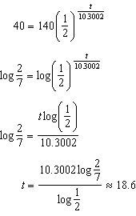

PTS: 6 REF: 061737aii NAT: F.LE.A.4 TOP: Exponential Decay

