1 When and d is a positive integer, the expression 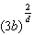 is equivalent to
1) | 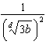 | 3) | 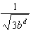
2) | 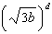 | 4) | 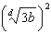

2 Julie averaged 85 on the first three tests of the semester in her mathematics class. If she scores 93 on each of the remaining tests, her average will be 90. Which equation could be used to determine how many tests, T, are left in the semester?
1) | 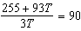 | 3) | 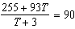
2) | 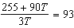 | 4) | 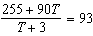

3 Given i is the imaginary unit, in simplest form is
1) |  | 3)
2) |  | 4)

4 Which graph has the following characteristics?
• three real zeros
•
•
1) | 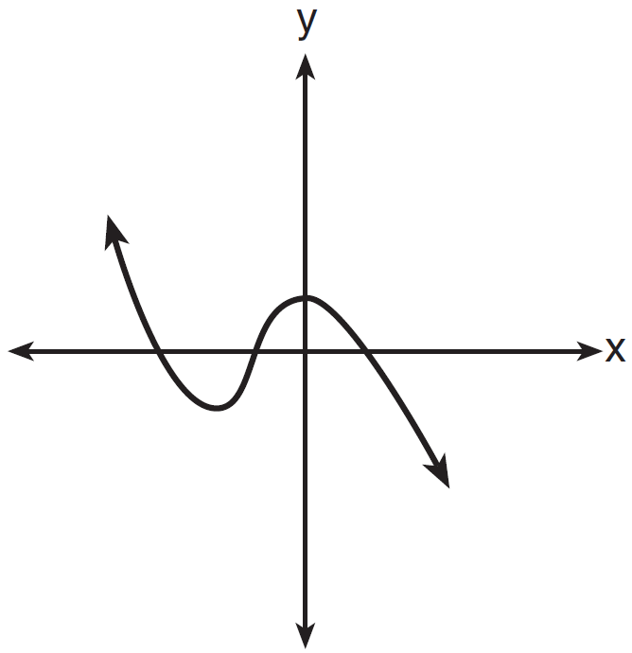 | 3) | 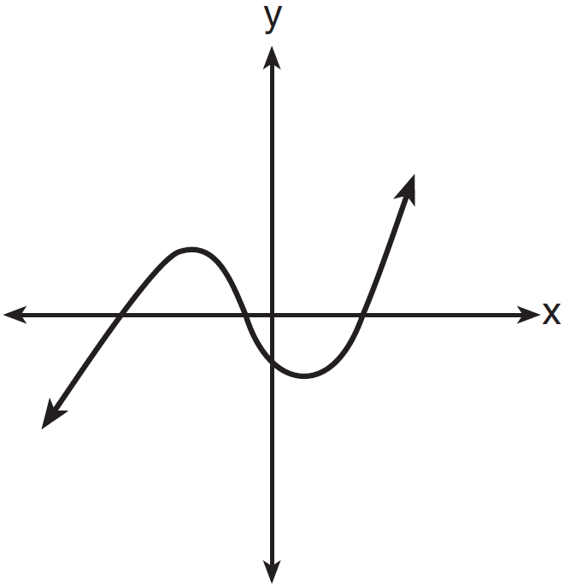
2) | 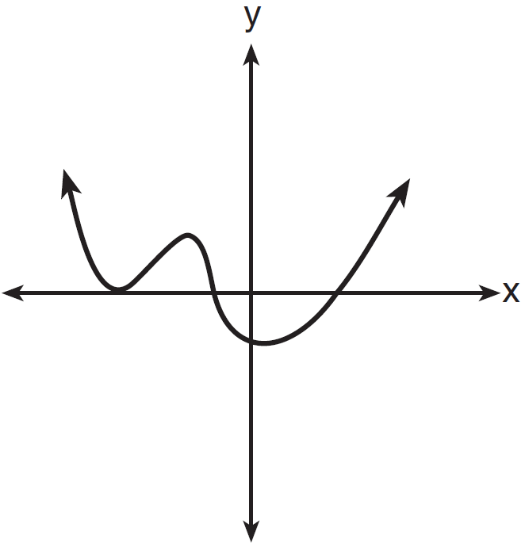 | 4) | 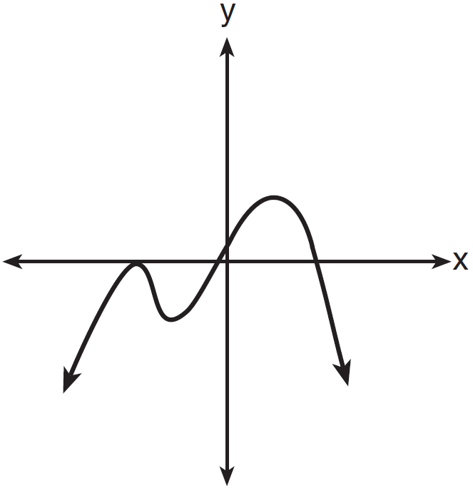

5 The solution set for the equation is
1) |  | 3)
2) |  | 4)

6 The zeros for are
1) |  | 3)
2) |  | 4)

7 Anne has a coin. She does not know if it is a fair coin. She flipped the coin 100 times and obtained 73 heads and 27 tails. She ran a computer simulation of 200 samples of 100 fair coin flips. The output of the proportion of heads is shown below.

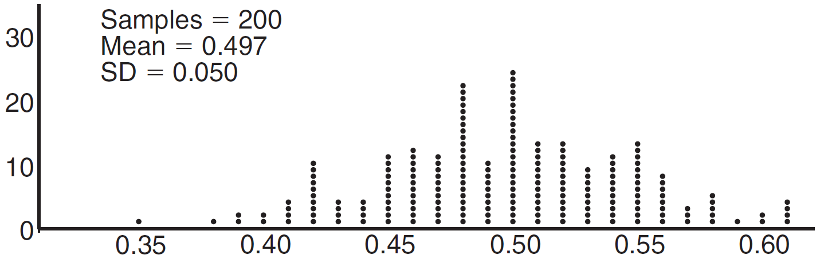

Given the results of her coin flips and of her computer simulation, which statement is most accurate?
1) | 73 of the computer's next 100 coin flips will be heads. | 3) | Her coin is not fair.
2) | 50 of her next 100 coin flips will be heads. | 4) | Her coin is fair.

8 If and , then which statement is not true?
1) |  | 3)
2) |  | 4) | 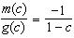

9 The heights of women in the United States are normally distributed with a mean of 64 inches and a standard deviation of 2.75 inches. The percent of women whose heights are between 64 and 69.5 inches, to the nearest whole percent, is
1) | 6 | 3) | 68
2) | 48 | 4) | 95

10 The formula below can be used to model which scenario?
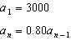
1) | The first row of a stadium has 3000 seats, and each row thereafter has 80 more seats than the row in front of it. | 3) | A bank account starts with a deposit of $3000, and each year it grows by 80%.
2) | The last row of a stadium has 3000 seats, and each row before it has 80 fewer seats than the row behind it. | 4) | The initial value of a specialty toy is $3000, and its value each of the following years is 20% less.

11 Sean's team has a baseball game tomorrow. He pitches 50% of the games. There is a 40% chance of rain during the game tomorrow. If the probability that it rains given that Sean pitches is 40%, it can be concluded that these two events are
1) | independent | 3) | mutually exclusive
2) | dependent | 4) | complements

12 A solution of the equation is
1) | 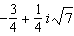 | 3) | 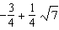
2) | 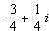 | 4)

13 The Ferris wheel at the landmark Navy Pier in Chicago takes 7 minutes to make one full rotation. The height, H, in feet, above the ground of one of the six-person cars can be modeled by 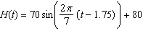, where t is time, in minutes. Using for one full rotation, this car's minimum height, in feet, is
1) | 150 | 3) | 10
2) | 70 | 4) | 0

14 The expression 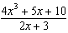 is equivalent to
1) | 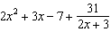 | 3) | 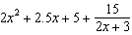
2) | 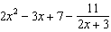 | 4) | 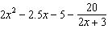

15 Which function represents exponential decay?
1) |  | 3) | 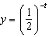
2) |  | 4)

16 Given 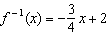, which equation represents ?
1) | 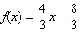 | 3) | 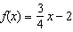
2) | 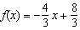 | 4) | 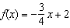

17 A circle centered at the origin has a radius of 10 units. The terminal side of an angle, , intercepts the circle in Quadrant II at point C. The y-coordinate of point C is 8. What is the value of ?
1) |  | 3)
2) |  | 4)

18 Which statement about the graph of is false?
1) | The asymptote has equation . | 3) | The domain is the set of positive reals.
2) | The graph has no y-intercept. | 4) | The range is the set of all real numbers.

19 The equation is equivalent to
1) |  | 3)
2) |  | 4)

20 There was a study done on oxygen consumption of snails as a function of pH, and the result was a degree 4 polynomial function whose graph is shown below.

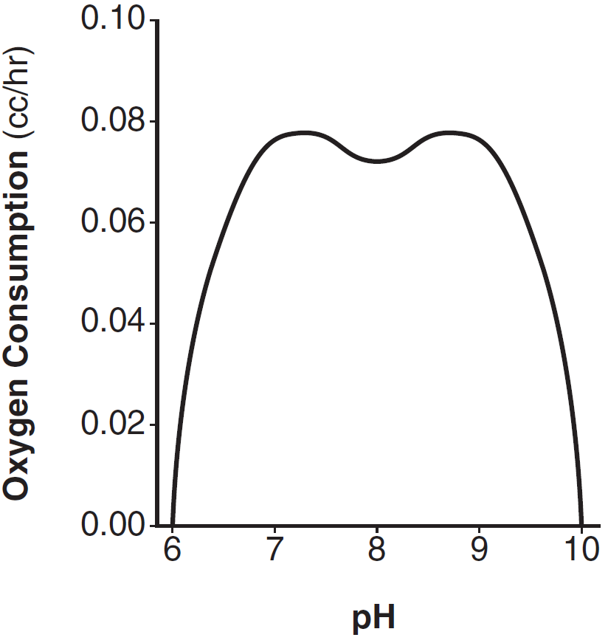

Which statement about this function is incorrect?
1) | The degree of the polynomial is even. | 3) | At two pH values, there is a relative maximum value.
2) | There is a positive leading coefficient. | 4) | There are two intervals where the function is decreasing.

21 Last year, the total revenue for Home Style, a national restaurant chain, increased 5.25% over the previous year. If this trend were to continue, which expression could the company's chief financial officer use to approximate their monthly percent increase in revenue? [Let m represent months.]
1) |  | 3)
2) | 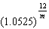 | 4) | 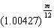

22 Which value, to the nearest tenth, is not a solution of if and ?
1) |  | 3) | 2.1
2) |  | 4) | 4.7

23 The population of Jamesburg for the years 2010-2013, respectively, was reported as follows:
250,000 250,937 251,878 252,822
How can this sequence be recursively modeled?
1) |  | 3) | 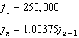
2) |  | 4) | 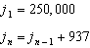

24 The voltage used by most households can be modeled by a sine function. The maximum voltage is 120 volts, and there are 60 cycles every second. Which equation best represents the value of the voltage as it flows through the electric wires, where t is time in seconds?
1) |  | 3)
2) |  | 4)

25 Solve for x: 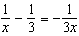

26 Describe how a controlled experiment can be created to examine the effect of ingredient X in a toothpaste.

27 Determine if is a factor of . Explain your answer.

28 On the axes below, graph one cycle of a cosine function with amplitude 3, period , midline , and passing through the point .

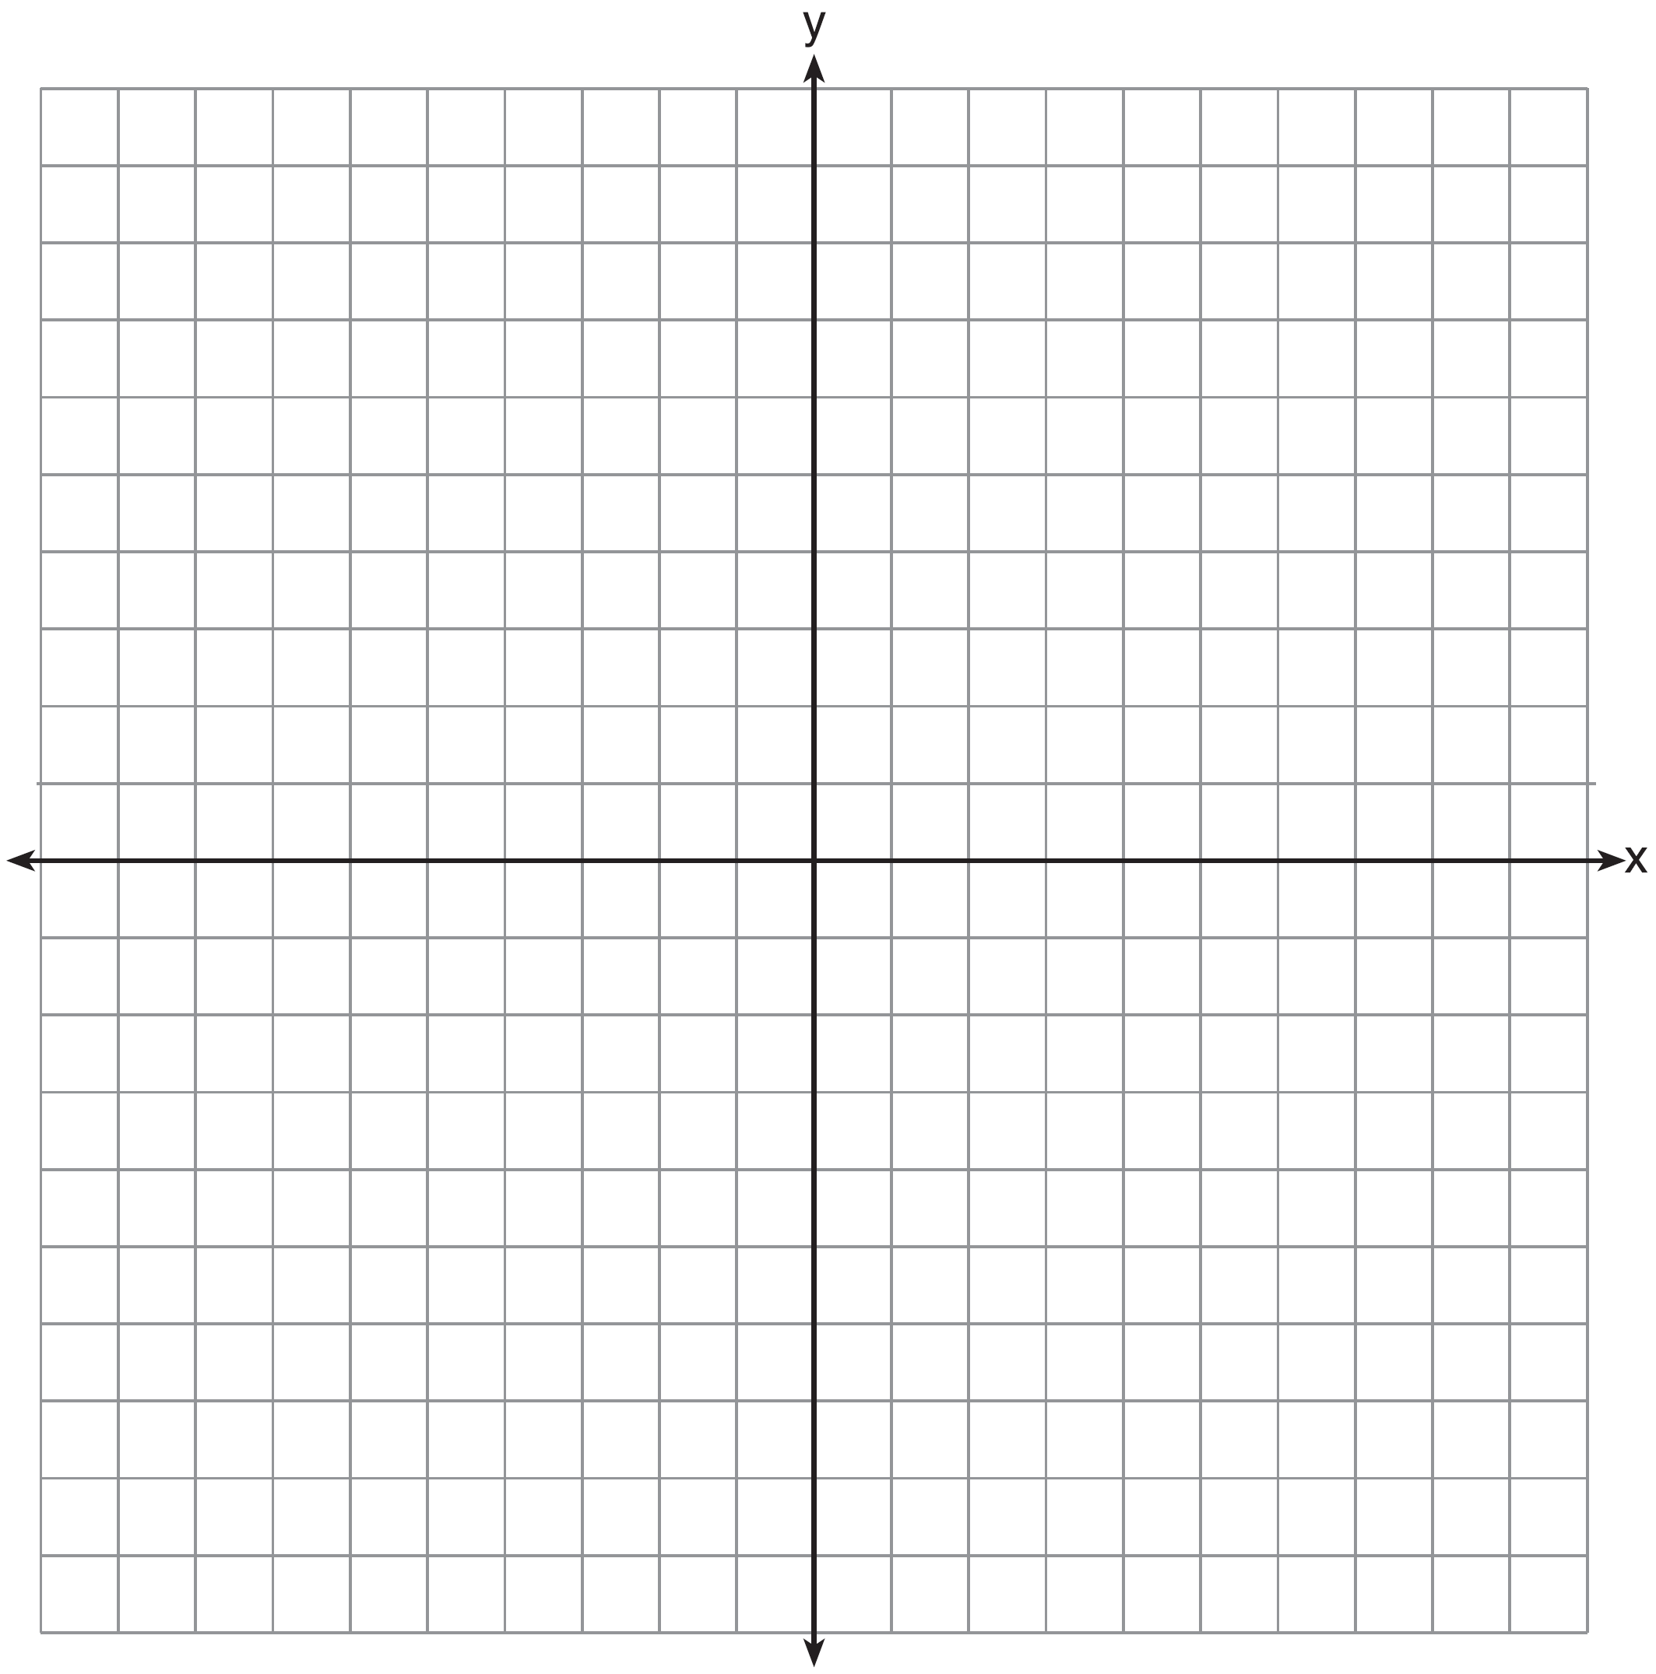

29 A suburban high school has a population of 1376 students. The number of students who participate in sports is 649. The number of students who participate in music is 433. If the probability that a student participates in either sports or music is 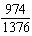, what is the probability that a student participates in both sports and music?

30 The directrix of the parabola has the equation . Find the coordinates of the focus of the parabola.

31 Algebraically prove that 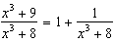, where .

32 A house purchased 5 years ago for $100,000 was just sold for $135,000. Assuming exponential growth, approximate the annual growth rate, to the nearest percent.

33 Solve the system of equations shown below algebraically.
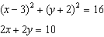

34 Alexa earns $33,000 in her first year of teaching and earns a 4% increase in each successive year. Write a geometric series formula, , for Alexa's total earnings over n years. Use this formula to find Alexa's total earnings for her first 15 years of teaching, to the nearest cent.

35 Fifty-five students attending the prom were randomly selected to participate in a survey about the music choice at the prom. Sixty percent responded that a DJ would be preferred over a band. Members of the prom committee thought that the vote would have 50% for the DJ and 50% for the band. A simulation was run 200 times, each of sample size 55, based on the premise that 60% of the students would prefer a DJ. The approximate normal simulation results are shown below.

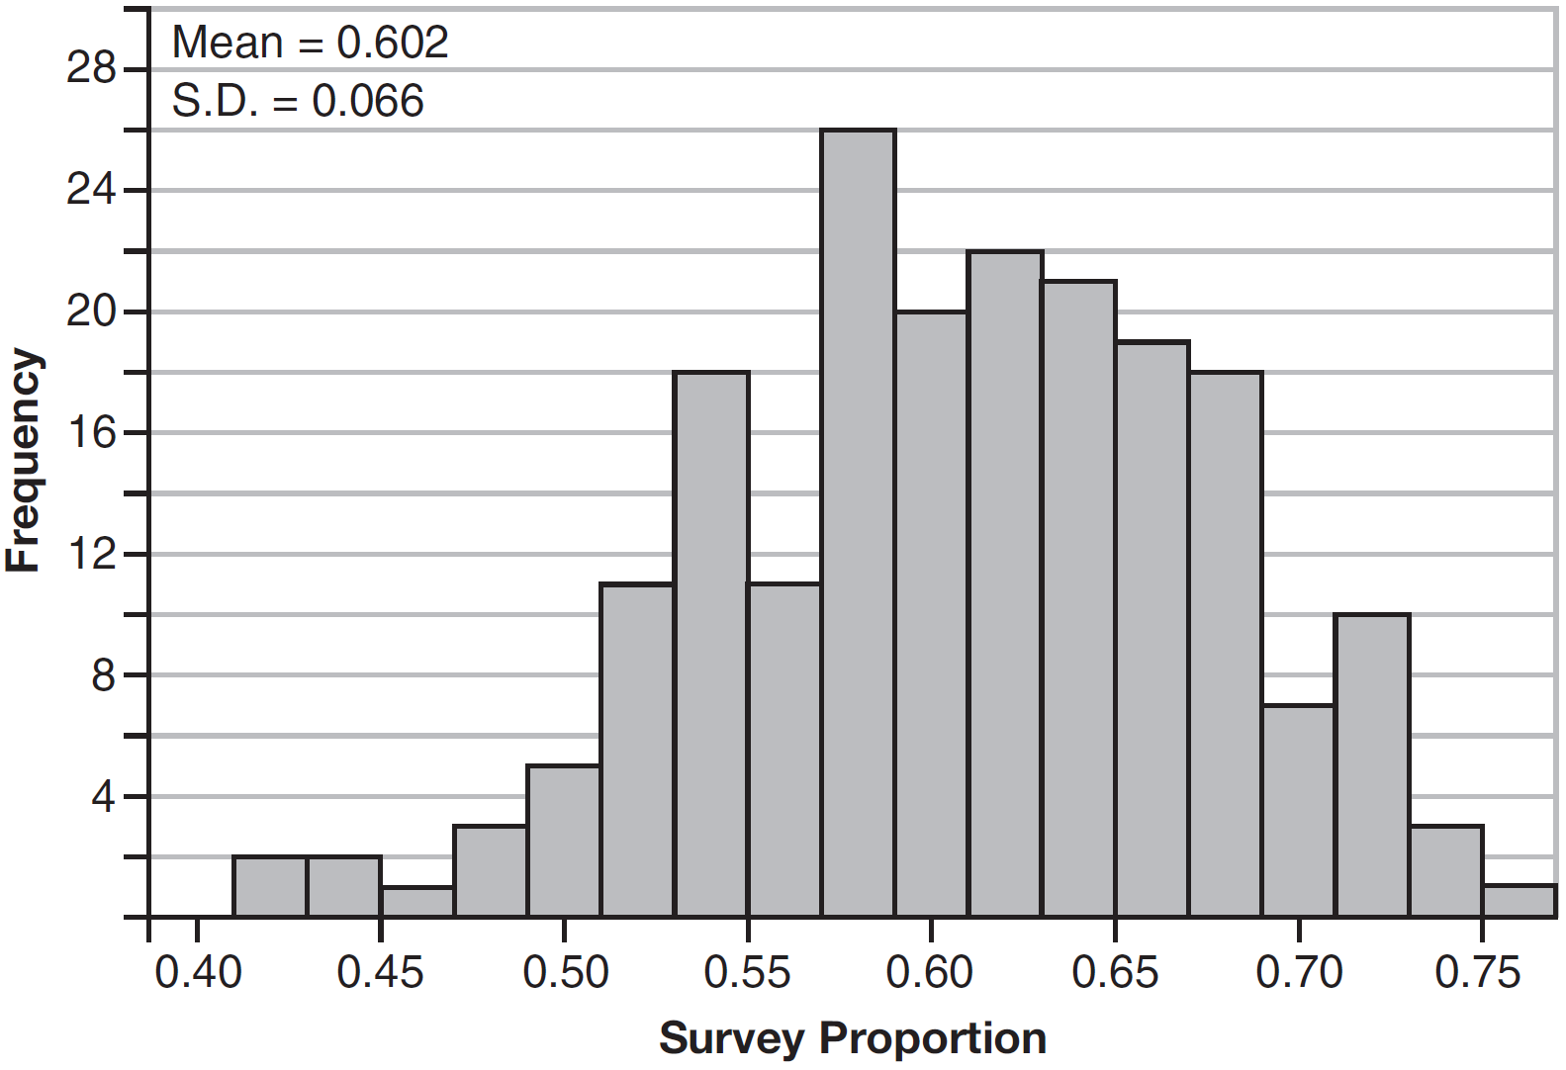

Using the results of the simulation, determine a plausible interval containing the middle 95% of the data. Round all values to the nearest hundredth. Members of the prom committee are concerned that a vote of all students attending the prom may produce a split. Explain what statistical evidence supports this concern.

36 Which function shown below has a greater average rate of change on the interval ? Justify your answer.

x | f(x)
 | 0.3125
 | 0.625
 | 1.25
 | 2.5
0 | 5
1 | 10
2 | 20
3 | 40
4 | 80
5 | 160
6 | 320

37 Drugs break down in the human body at different rates and therefore must be prescribed by doctors carefully to prevent complications, such as overdosing. The breakdown of a drug is represented by the function , where is the amount left in the body, is the initial dosage, r is the decay rate, and t is time in hours. Patient A, , is given 800 milligrams of a drug with a decay rate of 0.347. Patient B, , is given 400 milligrams of another drug with a decay rate of 0.231. Write two functions, and , to represent the breakdown of the respective drug given to each patient. Graph each function on the set of axes below.



To the nearest hour, t, when does the amount of the given drug remaining in patient B begin to exceed the amount of the given drug remaining in patient A? The doctor will allow patient A to take another 800 milligram dose of the drug once only 15% of the original dose is left in the body. Determine, to the nearest tenth of an hour, how long patient A will have to wait to take another 800 milligram dose of the drug.
1 ANS: 4 PTS: 2 REF: 061601aii NAT: N.RN.A.2
TOP: Radicals and Rational Exponents KEY: variables

2 ANS: 3 PTS: 2 REF: 061602aii NAT: A.CED.A.1
TOP: Modeling Rationals

3 ANS: 2

PTS: 2 REF: 061603aii NAT: N.CN.A.2 TOP: Operations with Complex Numbers

4 ANS: 3
The graph shows three real zeros, and has end behavior matching the given end behavior.

PTS: 2 REF: 061604aii NAT: A.APR.B.3 TOP: Zeros of Polynomials
KEY: AII

5 ANS: 3
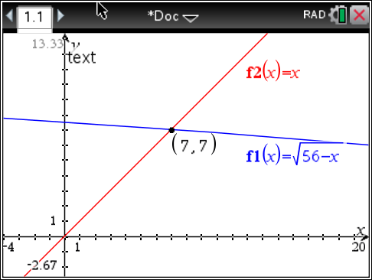 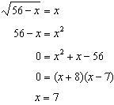 is extraneous.

PTS: 2 REF: 061605aii NAT: A.REI.A.2 TOP: Solving Radicals
KEY: extraneous solutions

6 ANS: 1
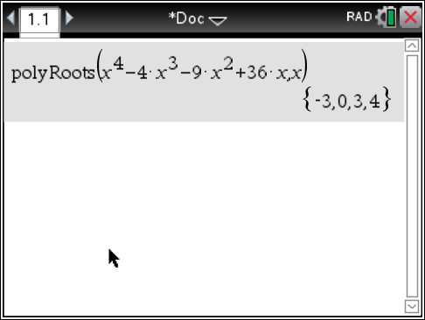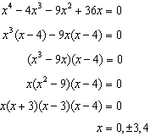

PTS: 2 REF: 061606aii NAT: A.APR.B.3 TOP: Zeros of Polynomials
KEY: AII

7 ANS: 3 PTS: 2 REF: 061607aii NAT: S.IC.A.2
TOP: Analysis of Data

8 ANS: 4
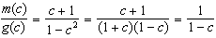

PTS: 2 REF: 061608aii NAT: F.BF.A.1 TOP: Operations with Functions

9 ANS: 2
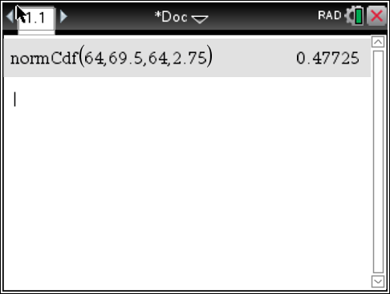 represents approximately 48% of the data.

PTS: 2 REF: 061609aii NAT: S.ID.A.4 TOP: Normal Distributions
KEY: percent

10 ANS: 4
The scenario represents a decreasing geometric sequence with a common ratio of 0.80.

PTS: 2 REF: 061610aii NAT: F.BF.A.2 TOP: Sequences

11 ANS: 1
The probability of rain equals the probability of rain, given that Sean pitches.

PTS: 2 REF: 061611aii NAT: S.CP.A.3 TOP: Conditional Probability

12 ANS: 1
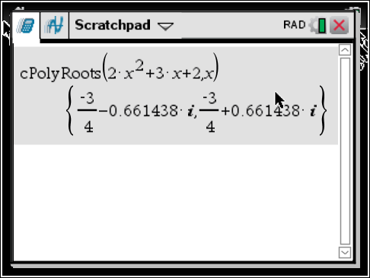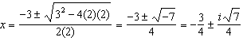

PTS: 2 REF: 061612aii NAT: A.REI.B.4 TOP: Solving Quadratics
KEY: complex solutions | quadratic formula

13 ANS: 3
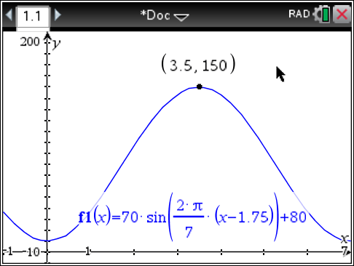 is at a minimum at

PTS: 2 REF: 061613aii NAT: F.IF.B.4 TOP: Graphing Trigonometric Functions
KEY: maximum/minimum

14 ANS: 2
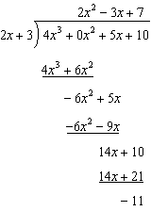

PTS: 2 REF: 061614aii NAT: A.APR.D.6 TOP: Rational Expressions

15 ANS: 4
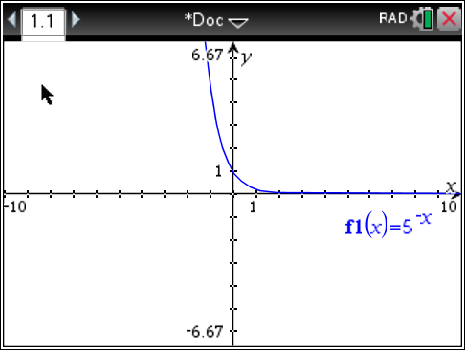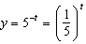

PTS: 2 REF: 061615aii NAT: F.IF.C.8 TOP: Modeling Exponential Functions

16 ANS: 2
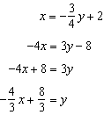

PTS: 2 REF: 061616aii NAT: F.BF.B.4 TOP: Inverse of Functions
KEY: equations

17 ANS: 1
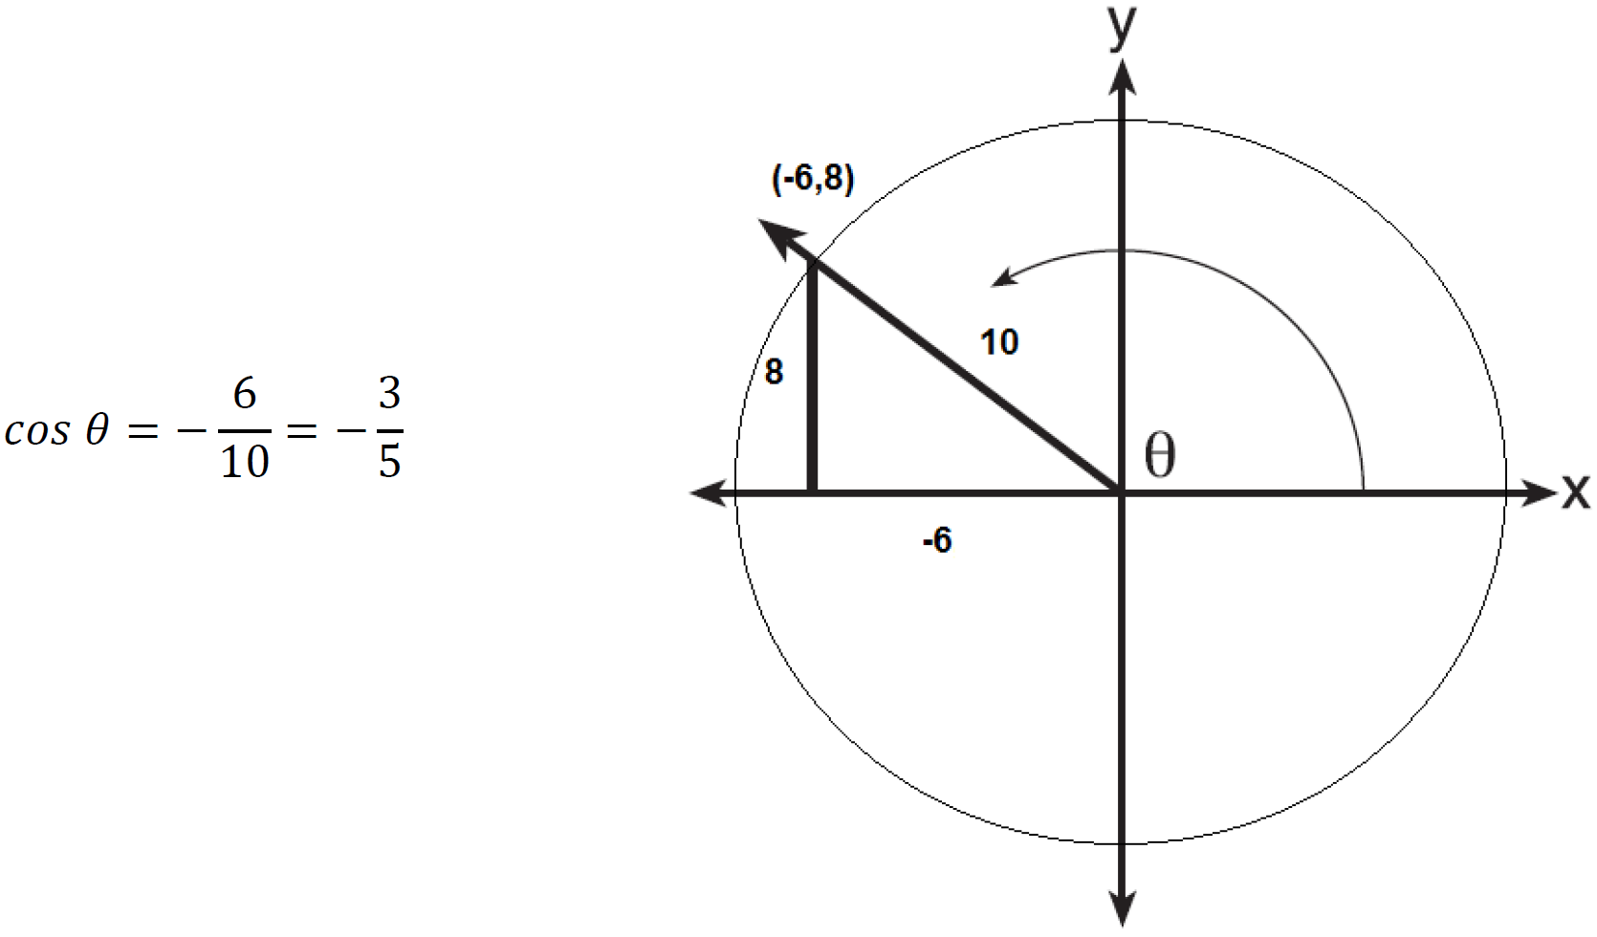

PTS: 2 REF: 061617aii NAT: F.TF.A.2 TOP: Determining Trigonometric Functions
KEY: extension to reals

18 ANS: 1
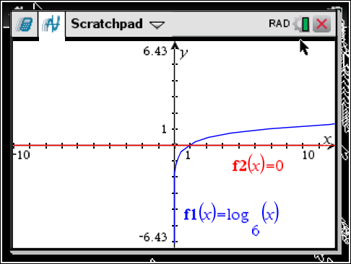

PTS: 2 REF: 061618aii NAT: F.IF.C.7 TOP: Graphing Logarithmic Functions

19 ANS: 4
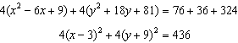

PTS: 2 REF: 061619aii NAT: G.GPE.A.1 TOP: Equations of Circles
KEY: completing the square

20 ANS: 2 PTS: 2 REF: 061620aii NAT: F.IF.B.4
TOP: Graphing Polynomial Functions

21 ANS: 3
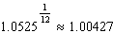

PTS: 2 REF: 061621aii NAT: F.BF.A.1 TOP: Modeling Exponential Functions
KEY: AII

22 ANS: 4
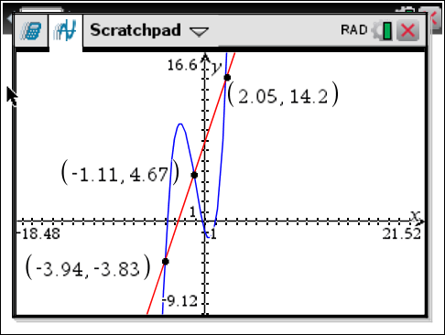

PTS: 2 REF: 061622aii NAT: A.REI.D.11 TOP: Other Systems
KEY: AII

23 ANS: 3 PTS: 2 REF: 061623aii NAT: F.BF.A.2
TOP: Sequences

24 ANS: 4
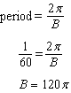

PTS: 2 REF: 061624aii NAT: F.TF.B.5 TOP: Modeling Trigonometric Functions

25 ANS:
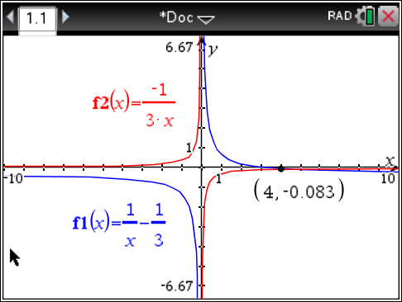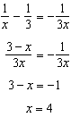

PTS: 2 REF: 061625aii NAT: A.REI.A.2 TOP: Solving Rationals
KEY: rational solutions

26 ANS:
Randomly assign participants to two groups. One group uses the toothpaste with ingredient X and the other group uses the toothpaste without ingredient X.

PTS: 2 REF: 061626aii NAT: S.IC.B.3 TOP: Analysis of Data
KEY: type

27 ANS:
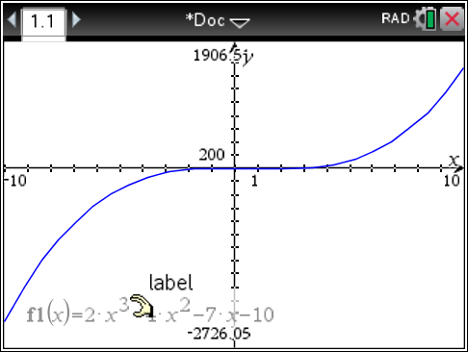 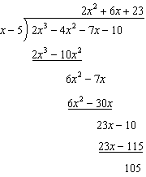 Since there is a remainder, is not a factor.

PTS: 2 REF: 061627aii NAT: A.APR.B.2 TOP: Remainder Theorem

28 ANS:
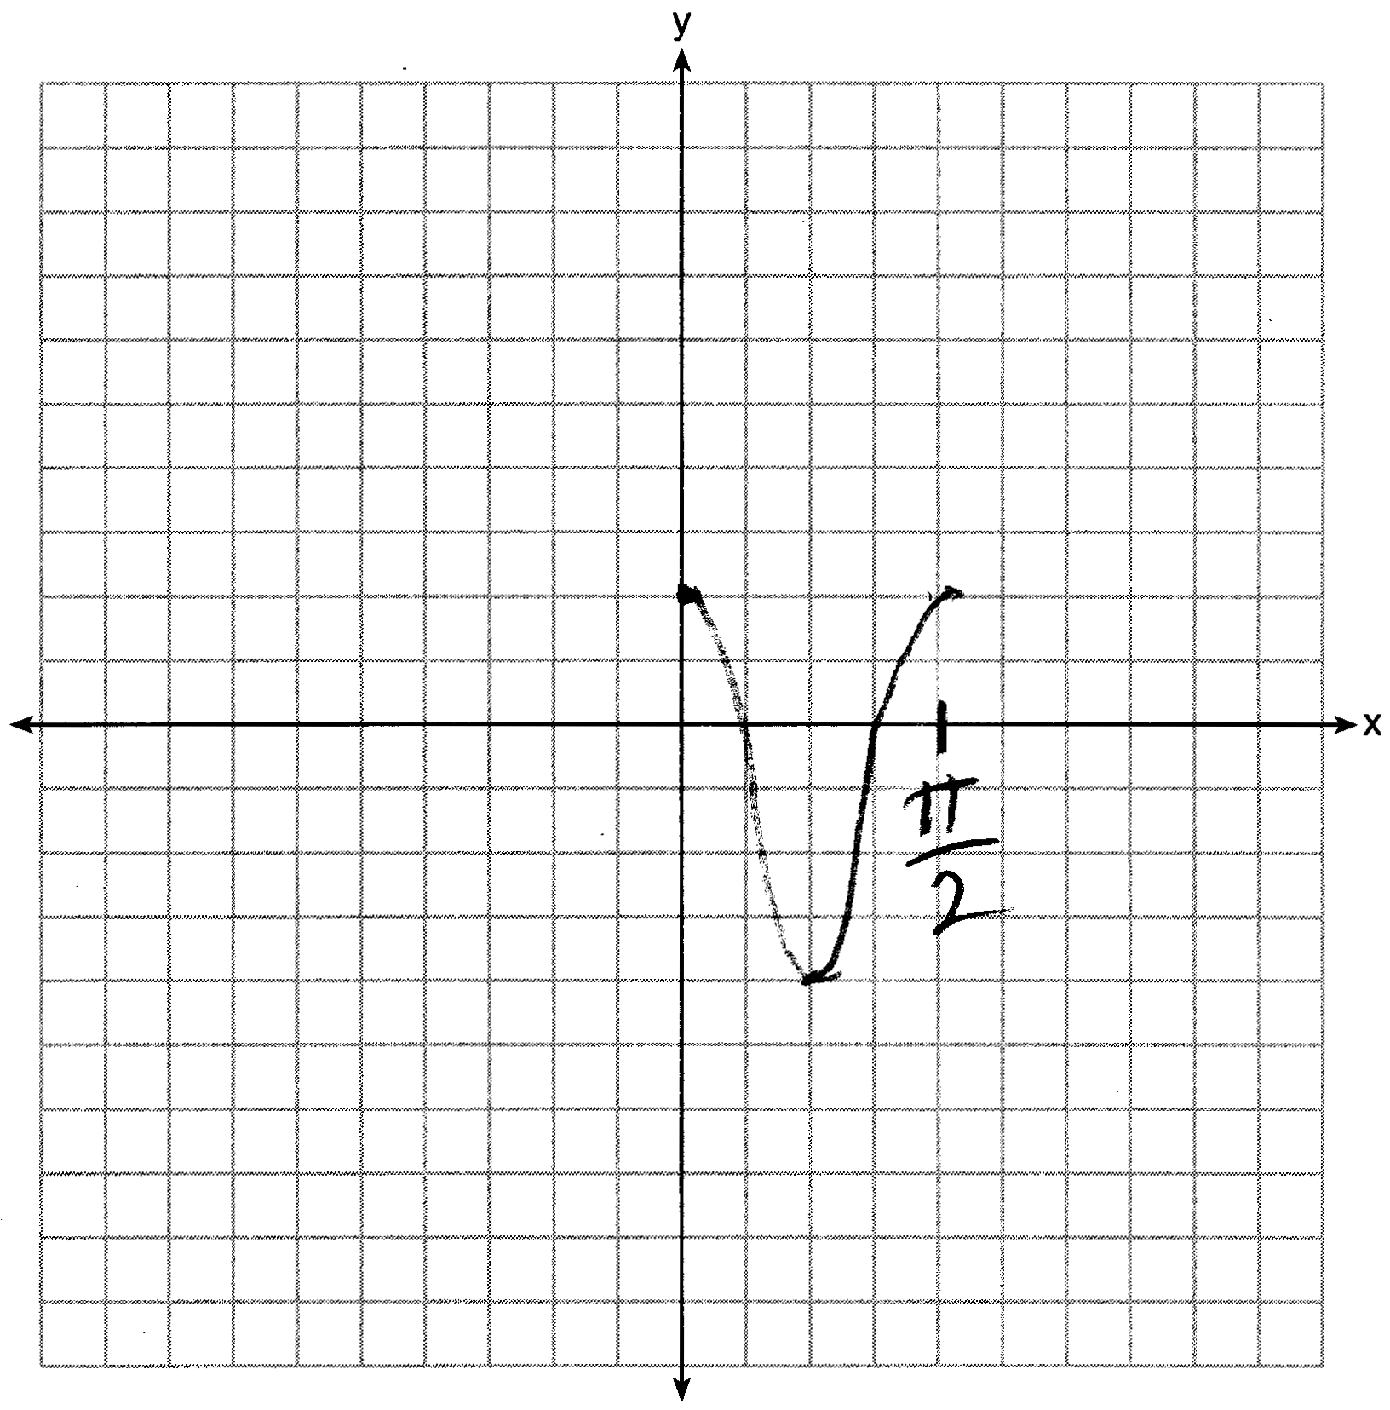

PTS: 2 REF: 061628aii NAT: F.IF.C.7 TOP: Graphing Trigonometric Functions
KEY: graph

29 ANS:

PTS: 2 REF: 061629aii NAT: S.CP.B.7 TOP: Theoretical Probability

30 ANS:
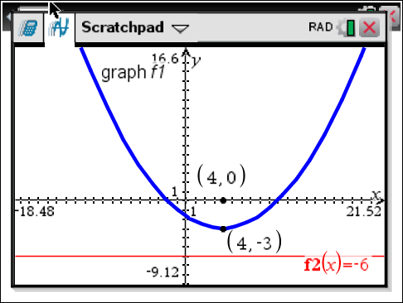 The vertex of the parabola is . The x-coordinate of the focus and the vertex is the same. Since the distance from the vertex to the directrix is 3, the distance from the vertex to the focus is 3, so the y-coordinate of the focus is 0. The coordinates of the focus are .

PTS: 2 REF: 061630aii NAT: G.GPE.A.2 TOP: Graphing Quadratic Functions

31 ANS:
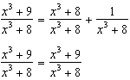

PTS: 2 REF: 061631aii NAT: A.APR.C.4 TOP: Polynomial Identities

32 ANS:
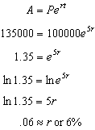

PTS: 2 REF: 061632aii NAT: F.LE.A.4 TOP: Exponential Growth

33 ANS:
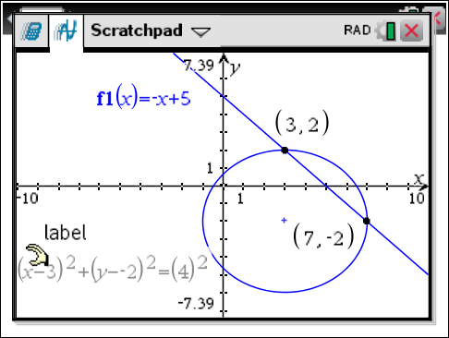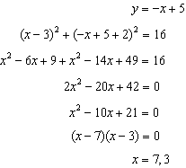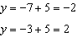

PTS: 4 REF: 061633aii NAT: A.REI.C.7 TOP: Quadratic-Linear Systems
KEY: AII

34 ANS:
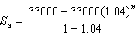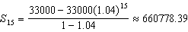

PTS: 4 REF: 061634aii NAT: A.SSE.B.4 TOP: Series

35 ANS:
. Since 0.50 falls within the 95% interval, this supports the concern there may be an even split.

PTS: 4 REF: 061635aii NAT: S.IC.B.5 TOP: Analysis of Data

36 ANS:
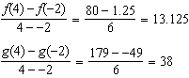 has a greater rate of change

PTS: 4 REF: 061636aii NAT: F.IF.B.6 TOP: Rate of Change
KEY: AII

37 ANS:
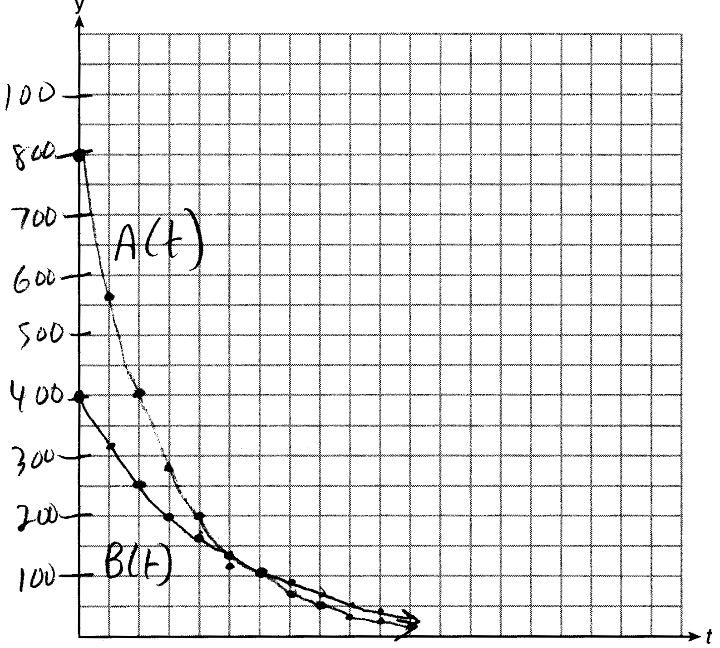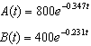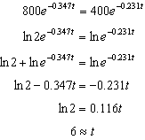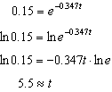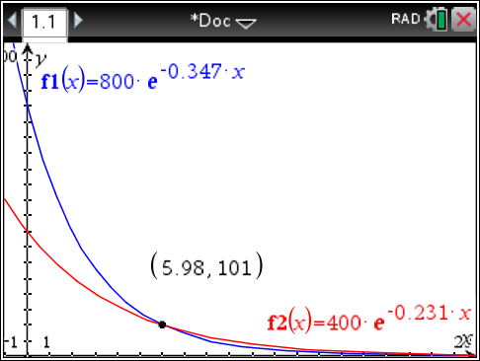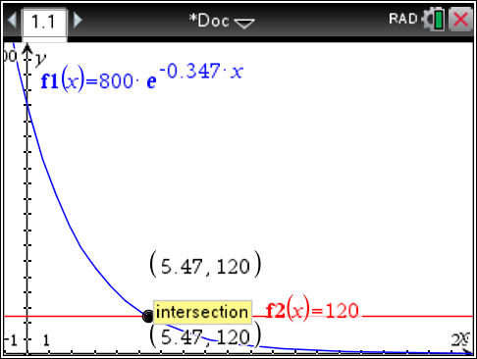

PTS: 6 REF: 061637aii NAT: A.REI.D.11 TOP: Other Systems
KEY: AII

