1 A cafeteria food manager studied the lunchtime eating habits of a group of employees in their office building. The purpose of the study was to determine the proportion of employees who purchased lunch in the cafeteria, brought their lunch from home, or purchased lunch from an outside vendor. This collection of data would best be classified as
1) | a census | 3) | an observational study
2) | an experiment | 4) | a simulation

2 Which graph has imaginary roots?
1) | 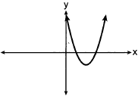 | 3) | 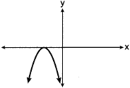
2) | 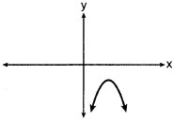 | 4) | 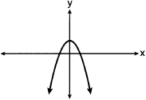

3 Given 3 is a root of , what are the other unique roots of ?
1) | , only | 3) | , 1 and 5
2) | and 0 | 4) | , and 0

4 Given 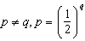, expressed in logarithmic form, is equivalent to
1) | 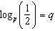 | 3)
2) | 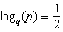 | 4)

5 Which graph best represents the graph of , where a and b are positive real numbers?
1) | 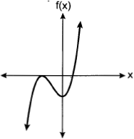 | 3) | 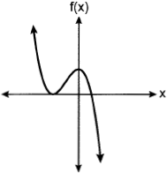
2) | 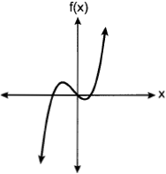 | 4) | 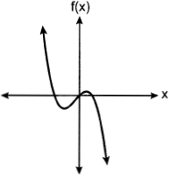

6 The equations and approximately model the growth of two separate populations where . What is the best approximation of the time, t, at which the populations are the same?
1) |  | 3) | 5.1
2) | 0.3 | 4) | 21.3

7 Given and , the point of intersection in Quadrant II is
1) |  | 3)
2) |  | 4)

8 The rational expression 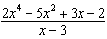 is equivalent to
1) | 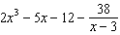 | 3) | 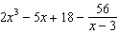
2) | 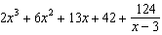 | 4) | 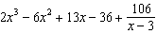

9 The equation of the parabola that has its focus at the point and directrix at is
1) | 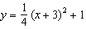 | 3) | 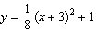
2) | 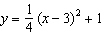 | 4) | 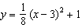

10 The seventh term of the geometric sequence is
1) |  | 3)
2) |  | 4)

11 A company wishes to determine the cooking time for one pound of spaghetti. The company's technicians cooked one pound of spaghetti and recorded the time needed for the spaghetti to be ready to eat. Repeating this process 35 times resulted in an approximately normal distribution, with a mean of 9.82 minutes and a standard deviation of 1.4 minutes. In which interval should the middle 95% of cooking times fall?
1) |  | 3)
2) |  | 4)

12 Given and , what is for all defined values?
1) |  | 3)
2) |  | 4)

13 Which equation is equivalent to 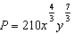
1) |  | 3)
2) |  | 4)

14 The average cost of a gallon of milk in the United States between the years of 1995 and 2018 can be modeled by the equation , where represents the cost, in dollars, and t is time in years since January 1995. During this time period, in what year did reach its maximum?
1) | 1995 | 3) | 2014
2) | 2013 | 4) | 2018

15 The temperature, F, in degrees Fahrenheit, after t hours of a roast put into an oven is given by the equation . What was the temperature of the roast when it was put into the oven?
1) | 325 | 3) | 185
2) | 200 | 4) | 140

16 The roots of the equation in simplest form are
1) |  | 3)
2) |  | 4)

17 Which equation does not represent an identity?
1) |  | 3)
2) |  | 4)

18 Two surveys were conducted to estimate the proportion of teens who use social media at least once per day.

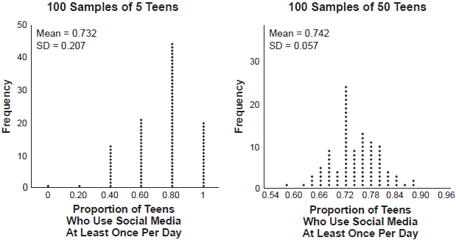

Based on these results, it was determined that approximately 75% of teens use social media at least once per day. What is the best explanation of the difference in the results between the two surveys?
1) | The smaller sample size of five teens resulted in a smaller margin of error and should provide a more accurate estimate. | 3) | The larger sample size of 50 teens resulted in a smaller margin of error and should provide a more accurate estimate.
2) | The smaller sample size of five teens resulted in a bigger margin of error and should provide a more accurate estimate. | 4) | The larger sample size of 50 teens resulted in a bigger margin of error and should provide a more accurate estimate.

19 Given and , the value of b is
1) | 1 | 3) | 3
2) |  | 4)

20 Robert is buying a car that costs $22,000. After a down payment of $4000, he borrows the remainder from a bank, a six year loan at 6.24% annual interest rate. The following formula can be used to calculate his monthly loan payment.

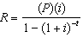
R = monthly payment
P = loan amount
i = monthly interest rate
t = time, in months

Robert's monthly payment will be
1) | $298.31 | 3) | $307.35
2) | $300.36 | 4) | $367.10

21 Given 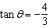 where 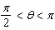, what is the value of ?
1) |  | 3)
2) |  | 4)

22 To solve the equation 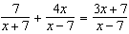, Joan's first step is to multiply both sides by the least common denominator. Which statement is true?
1) | is an extraneous solution. | 3) | 7 is an extraneous solution.
2) | 7 and are extraneous solutions. | 4) | There are no extraneous solutions.

23 Beginning July 1, 2019, Michelle deposited $250 into an account that yields 0.15% each month. She continued to make $250 deposits into this account on the first of each month for 3 years. Which expression represents the amount of money that was in the account after her last deposit was made on June 1, 2022?
1) |  | 3) | 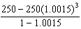
2) |  | 4) | 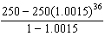

24 A study of the red tailed hawk population in a given area shows the population, , can be represented by the function where t represents the number of years since the study began. In terms of the monthly rate of growth, the population can be best approximated by the function
1) |  | 3)
2) | 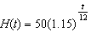 | 4) | 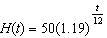

25 Factor completely.

26 Determine if is a factor of . Explain your answer.

27 An initial investment of $1000 reaches a value, , according to the model , where t is the time in years. Determine the average rate of change, to the nearest dollar per year, of this investment from year 2 to year 7.

28 When 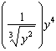 is written in the form , what is the value of n? Justify your answer.

29 The heights of the members of a ski club are normally distributed. The average height is 64.7 inches with a standard deviation of 4.3 inches. Determine the percentage of club members, to the nearest percent, who are between 67 inches and 72 inches tall.

30 The explicit formula represents the number of seats in each row in a movie theater, where n represents the row number. Rewrite this formula in recursive form.

31 Express 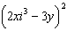 in simplest form.

32 A survey was given to 1250 randomly selected high school students at the end of their junior year. The survey offered four post-graduation options: two-year college, four-year college, military, or work. Of the 1250 responses, 475 chose a four-year college. State one possible conclusion that can be made about the population of high school juniors, based on this survey.

33 A researcher wants to determine if nut allergies and milk allergies are related to each other. The researcher surveyed 1500 people and asked them if they are allergic to nuts or milk. The survey results are summarized in the table below.

 | Allergic to Nuts | Not Allergic to Nuts
Allergic to Milk | 3 | 42
Not Allergic to Milk | 12 | 1443

Determine the probability that a randomly selected survey respondent is allergic to milk. Determine the probability that a randomly selected survey respondent is allergic to milk, given that the person is allergic to nuts. Based on the survey data, determine whether nut allergies and milk allergies are independent events. Justify your answer.

34 Algebraically solve for x:

35 During the summer, Adam saved $4000 and Betty saved $3500. Adam deposited his money in Bank A at an annual rate of 2.4% compounded monthly. Betty deposited her money in Bank B at an annual rate of 4% compounded quarterly. Write two functions that represent the value of each account after t years if no other deposits or withdrawals are made, where Adam's account value is represented by , and Betty's by . Using technology, determine, to the nearest tenth of a year, how long it will take for the two accounts to have the same amount of money in them. Justify your answer.

36 On the graph below, draw at least one complete cycle of a sine graph passing through point that has an amplitude of 3, a period of , and a midline at .

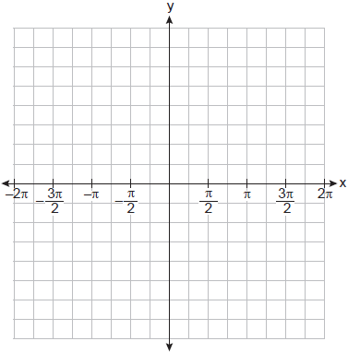

Based on your graph, state an interval in which the graph is increasing.

37 A manufacturer of sweatshirts finds that profits and costs fluctuate depending on the number of products created. Creating more products doesn't always increase profits because it requires additional costs, such as building a larger facility or hiring more workers. The manufacturer determines the profit, , in thousands of dollars, as a function of the number of sweatshirts sold, x, in thousands. This function, p, is given below.

Graph , over the interval , on the set of axes below.

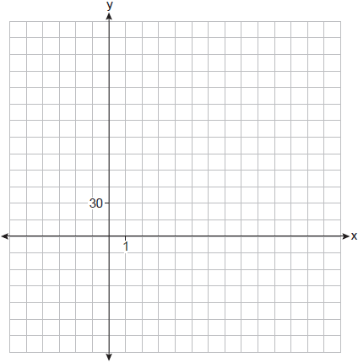

Over the given interval, state the coordinates of the maximum of p and round all values to the nearest integer. Explain what this point represents in terms of the number of sweatshirts sold and profit. Determine how many sweatshirts, to the nearest whole sweatshirt, the manufacturer would need to produce in order to first make a positive profit. Justify your answer.
1 ANS: 3 PTS: 2 REF: 012401aii NAT: S.IC.B.3
TOP: Analysis of Data

2 ANS: 2 PTS: 2 REF: 012402aii NAT: A.REI.B.4
TOP: Using the Discriminant KEY: determine nature of roots given equation

3 ANS: 2
3 | 1 | -1 | -21 | 45 | 0
 |  | 3 | 6 | -45 | 0
 | 1 | 2 | -15 | 0 | 0
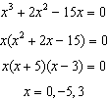

PTS: 2 REF: 012403aii NAT: A.APR.B.3 TOP: Solving Polynomial Equations

4 ANS: 3 PTS: 2 REF: 012404aii NAT: A.APR.B.3
TOP: Express Exponentials as Logarithms

5 ANS: 1 PTS: 2 REF: 012405aii NAT: A.APR.B.3
TOP: Graphing Polynomial Functions

6 ANS: 3
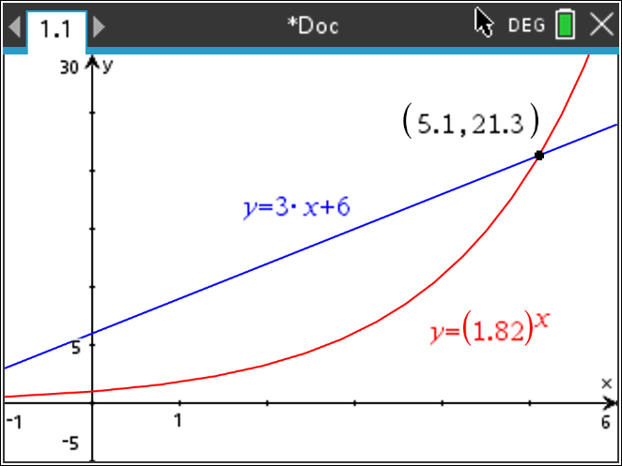

PTS: 2 REF: 012406aii NAT: A.REI.D.11 TOP: Other Systems

7 ANS: 4
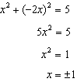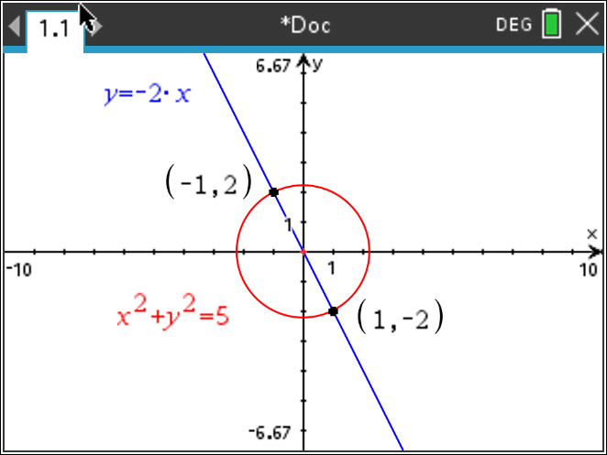

PTS: 2 REF: 012407aii NAT: A.REI.C.7 TOP: Quadratic-Linear Systems

8 ANS: 2
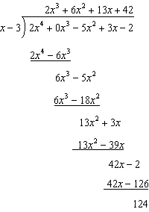

PTS: 2 REF: 012408aii NAT: A.APR.D.6 TOP: Rational Expressions
KEY: division

9 ANS: 1
Distance from the focus to the directrix is 2, so . Vertex is . 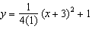

PTS: 2 REF: 012409aii NAT: G.GPE.A.2 TOP: Graphing Quadratic Functions

10 ANS: 3
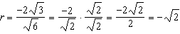

PTS: 2 REF: 012410aii NAT: F.BF.A.1 TOP: Sequences
KEY: explicit

11 ANS: 2

PTS: 2 REF: 012411aii NAT: S.IC.B.4 TOP: Analysis of Data

12 ANS: 1
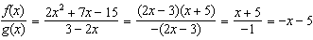

PTS: 2 REF: 012412aii NAT: F.BF.A.1 TOP: Operations with Functions

13 ANS: 3
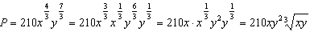

PTS: 2 REF: 012413aii NAT: N.RN.A.2 TOP: Radicals and Rational Exponents

14 ANS: 2
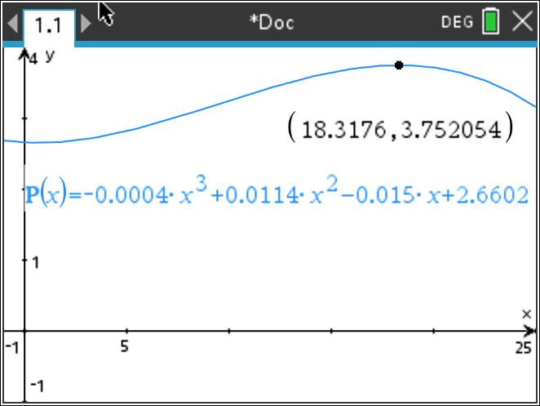

PTS: 2 REF: 012414aii NAT: F.IF.B.4 TOP: Graphing Polynomial Functions

15 ANS: 4

PTS: 2 REF: 012415aii NAT: F.IF.B.4 TOP: Evaluating Exponential Expressions

16 ANS: 3
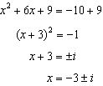

PTS: 2 REF: 012416aii NAT: A.REI.B.4 TOP: Solving Quadratics
KEY: complex solutions | completing the square

17 ANS: 4

PTS: 2 REF: 012417aii NAT: A.APR.C.4 TOP: Polynomial Identities

18 ANS: 3 PTS: 2 REF: 012418aii NAT: S.IC.B.6
TOP: Analysis of Data

19 ANS: 2
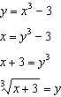

PTS: 2 REF: 012419aii NAT: F.BF.B.4 TOP: Inverse of Functions
KEY: polynomial

20 ANS: 2
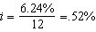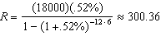

PTS: 2 REF: 012420aii NAT: F.IF.B.4 TOP: Evaluating Exponential Expressions

21 ANS: 1
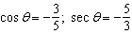

PTS: 2 REF: 012421aii NAT: F.TF.C.8 TOP: Determining Trigonometric Functions

22 ANS: 3
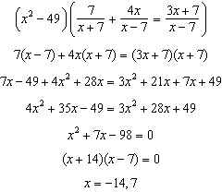

PTS: 2 REF: 012422aii NAT: A.REI.A.2 TOP: Solving Rationals

23 ANS: 4 PTS: 2 REF: 012423aii NAT: A.SSE.B.4
TOP: Series KEY: geometric

24 ANS: 1
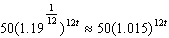

PTS: 2 REF: 012424aii NAT: A.SSE.B.3 TOP: Modeling Exponential Functions

25 ANS:

PTS: 2 REF: 012425aii NAT: A.SSE.A.2 TOP: Factoring Polynomials

26 ANS:
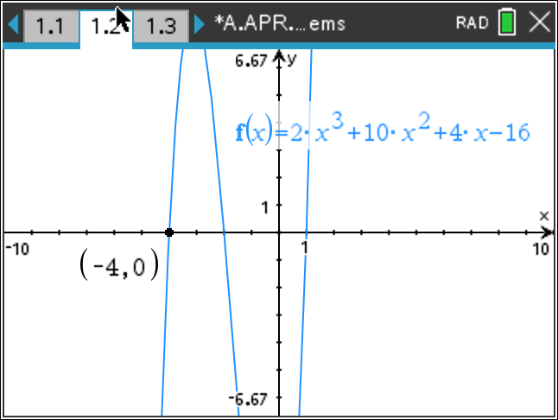 Since is a zero, is a factor.

PTS: 2 REF: 012426aii NAT: A.APR.B.2 TOP: Remainder and Factor Theorems

27 ANS:
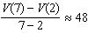

PTS: 2 REF: 012427aii NAT: F.IF.B.6 TOP: Rate of Change

28 ANS:
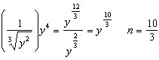

PTS: 2 REF: 012428aii NAT: N.RN.A.2 TOP: Radicals and Rational Exponents

29 ANS:
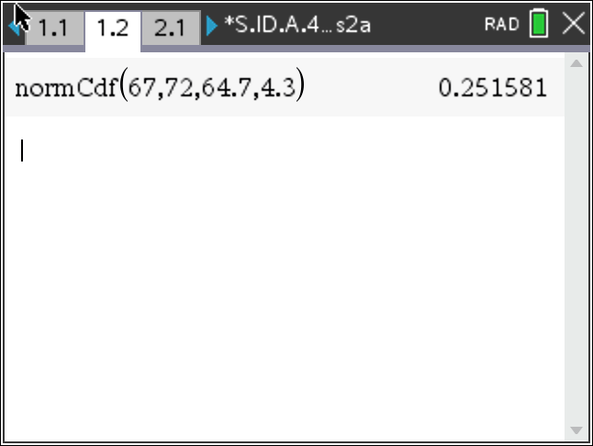 25

PTS: 2 REF: 012429aii NAT: S.ID.A.4 TOP: Normal Distributions
KEY: percent

30 ANS:
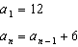

PTS: 2 REF: 012430aii NAT: F.BF.A.2 TOP: Sequences

31 ANS:
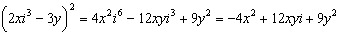

PTS: 2 REF: 012431aii NAT: N.CN.A.2 TOP: Operations with Complex Numbers

32 ANS:
About 38% 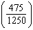 of high school juniors in the population will choose a four-year college.

PTS: 2 REF: 012432aii NAT: S.IC.A.2 TOP: Analysis of Data

33 ANS:
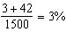 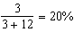 No, because a person is more likely to be allergic milk if he is also allergic to nuts.

PTS: 4 REF: 012433aii NAT: S.CP.A.4 TOP: Conditional Probability

34 ANS:
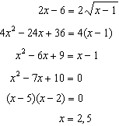 2 is extraneous.

PTS: 4 REF: 012434aii NAT: A.REI.A.2 TOP: Solving Radicals
KEY: extraneous solutions

35 ANS:
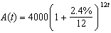 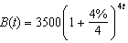 8.4, the value of t for which

PTS: 4 REF: 012435aii NAT: A.REI.D.11 TOP: Other Systems

36 ANS:
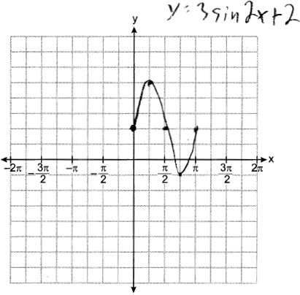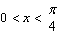

PTS: 4 REF: 012436aii NAT: F.IF.C.7 TOP: Graphing Trigonometric Functions
KEY: graph

37 ANS:
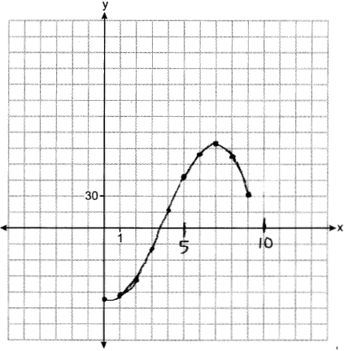 If 7000 sweatshirts are sold, the profit is $78,000. 3,549, because that is when is first greater than 0.

PTS: 6 REF: 012437aii NAT: F.IF.C.7 TOP: Graphing Polynomial Functions

