1 Which expression is equivalent to ?
1) |  | 3)
2) |  | 4)

2 To the nearest tenth, the solution to the equation is
1) | 1.1 | 3) | 6.3
2) | 2.5 | 4) | 68.5

3 The value of an automobile t years after it was purchased is given by the function . Which statement is true?
1) | The value of the car increases 84% each year. | 3) | The value of the car increases 16% each year.
2) | The value of the car decreases 84% each year. | 4) | The value of the car decreases 16% each year.

4 Which function represents exponential decay?
1) | 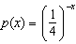 | 3)
2) |  | 4) | 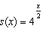

5 The expression 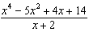 is equivalent to
1) | 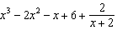 | 3) | 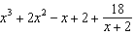
2) | 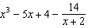 | 4) | 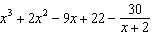

6 The sum of the first 20 terms of the series is
1) |  | 3) | 1,743,392,200
2) |  | 4) | 2,324,522,934

7 If , then 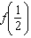
1) | equals 0 and is a factor of | 3) | does not equal 0 and is not a factor of
2) | equals 0 and is a factor of | 4) | does not equal 0 and is a factor of

8 If , the value of k is
1) |  | 3) | 3
2) |  | 4) | 6

9 What is the solution set of the equation 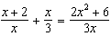?
1) |  | 3)
2) |  | 4)

10 How many real solutions exist for the system of equations below?
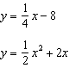
1) | 1 | 3) | 3
2) | 2 | 4) | 0

11 Which equation represents a polynomial identity?
1) |  | 3)
2) |  | 4)

12 Given , the expression can be rewritten as
1) |  | 3) | 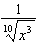
2) |  | 4)

13 A cyclist pedals a bike at a rate of 60 revolutions per minute. The height, h, of a pedal at time t, in seconds, is plotted below.
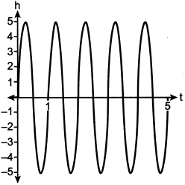

The graph can be modeled by the function , where k is equal to
1) | 1 | 3) | 60
2) |  | 4)

14 Which statement about data collection is most accurate?
1) | A survey about parenting styles given to every tenth student entering the library will provide unbiased results. | 3) | Margin of error increases as sample size increases.
2) | An observational study allows a researcher to determine the cause of an outcome. | 4) | A survey collected from a random sample of students in a school can be used to represent the opinions of the school population.

15 If 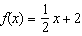, then the inverse function is
1) | 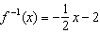 | 3)
2) | 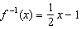 | 4)

16 Given , for what values of x will ?
1) | , only | 3) | or
2) | or | 4) | , only

17 For which approximate value(s) of x will ?
1) |  | 3)
2) |  | 4) | , only

18 Consider a cubic polynomial with the characteristics below.
• exactly one real root
• as
Given and , which equation represents a cubic polynomial with these characteristics?
1) |  | 3)
2) |  | 4)

19 Betty conducted a survey of her class to see if they like pizza. She gathered 200 responses and 65% of the voters said they did like pizza. Betty then ran a simulation of 400 more surveys, each with 200 responses, assuming that 65% of the voters would like pizza. The output of the simulation is shown below.

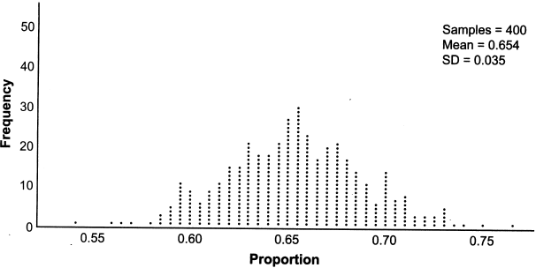

Considering the middle 95% of the data, what is the margin of error for the simulation?
1) | 0.01 | 3) | 0.05
2) | 0.02 | 4) | 0.07

20 If 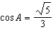 and , what is the value of ?
1) |  | 3)
2) | 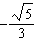 | 4)

21 A tree farm initially has 150 trees. Each year, 20% of the trees are cut down and 80 seedlings are planted. Which recursive formula models the number of trees, , after n years?
1) | 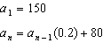 | 3)
2) | 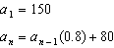 | 4)

22 Which equation represents a parabola with a focus of and directrix of ?
1) |  | 3)
2) |  | 4)

23 Mia has a student loan that is in deferment, meaning that she does not need to make payments right now. The balance of her loan account during her deferment can be represented by the function , where x is the number of years since the deferment began. If the bank decides to calculate her balance showing a monthly growth rate, an approximately equivalent function would be
1) |  | 3)
2) | 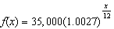 | 4) | 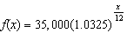

24 Which graph shows a quadratic function with two imaginary zeros?
1) | 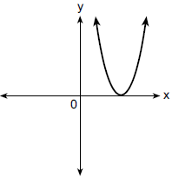 | 3) | 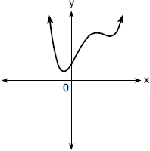
2) | 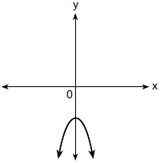 | 4) | 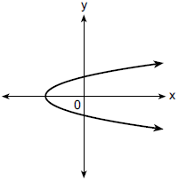

25 Algebraically determine the zeros of the function below.

26 Given , solve the equation for x algebraically.

27 Given 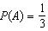 and 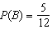, where A and B are independent events, determine .

28 The scores on a collegiate mathematics readiness assessment are approximately normally distributed with a mean of 680 and a standard deviation of 120. Determine the percentage of scores between 690 and 900, to the nearest percent.

29 Consider the data in the table below.

x | 1 | 2 | 3 | 4 | 5 | 6
y | 3.9 | 6 | 11 | 18.1 | 28 | 40.3

State an exponential regression equation to model these data, rounding all values to the nearest thousandth.

30 Write the expression as a polynomial in standard form.
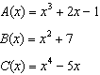

31 Over the set of integers, completely factor .

32 Natalia's teacher has given her the following information about angle .
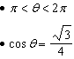
Explain how Natalia can determine if the value of is positive or negative.

33 Solve the equation algebraically.

34 Joette is playing a carnival game. To win a prize, one has to correctly guess which of five equally sized regions a spinner will land on, as shown in the diagram below.
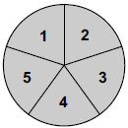

She complains that the game is unfair because her favorite number, 2, has only been spun once in ten times she played the game. State the proportion of 2's that were spun. State the theoretical probability of spinning a 2. The simulation output below shows the results of simulating ten spins of a fair spinner, repeated 100 times.
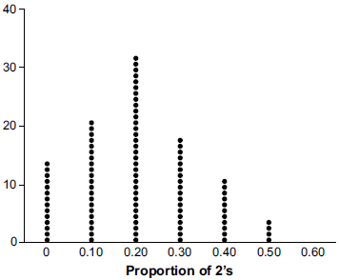
Does the output indicate that the carnival game was unfair? Explain your answer.

35 Graph on the axes below.

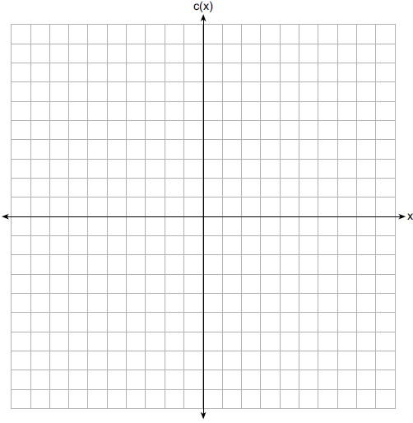

Describe the end behavior of as x approaches positive infinity. Describe the end behavior of as x approaches negative infinity.

36 The monthly high temperature (ºF) in Buffalo, New York can be modeled by , where m is the number of the month and . Find the average rate of change in the monthly high temperature between June and October, to the nearest hundredth. Explain what this value represents in the given context.

37 Objects cool at different rates based on the formula below.
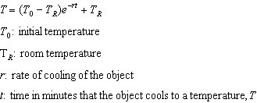
Mark makes T-shirts using a hot press to transfer designs to the shirts. He removes a shirt from a press that heats the shirt to 400°F. The rate of cooling for the shirt is 0.0735 and the room temperature is 75°F. Using this information, write an equation for the temperature of the shirt, T, after t minutes. Use the equation to find the temperature of the shirt, to the nearest degree, after five minutes. At the same time, Mark's friend Jeanine removes a hoodie from a press that heats the hoodie to 450°F. After eight minutes, the hoodie measured 270°F. The room temperature is still 75°F. Determine the rate of cooling of the hoodie, to the nearest ten thousandth. The T-shirt and hoodie were removed at the same time. Determine when the temperature will be the same, to the nearest minute.
1 ANS: 1
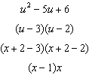

PTS: 2 REF: 012301aii NAT: A.SSE.A.2 TOP: Factoring Polynomials
KEY: higher power

2 ANS: 2
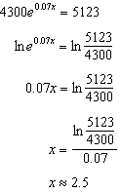

PTS: 2 REF: 012302aii NAT: F.LE.A.4 TOP: Exponential Equations
KEY: without common base

3 ANS: 4 PTS: 2 REF: 012303aii NAT: F.LE.B.5
TOP: Modeling Exponential Functions

4 ANS: 2
, 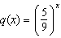, ,

PTS: 2 REF: 012304aii NAT: F.IF.C.7 TOP: Graphing Exponential Functions

5 ANS: 1
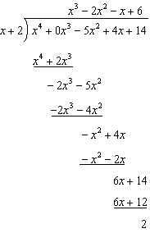

PTS: 2 REF: 012305aii NAT: A.APR.D.6 TOP: Rational Expressions
KEY: division

6 ANS: 3
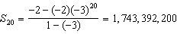

PTS: 2 REF: 012306aii NAT: A.SSE.B.4 TOP: Series
KEY: geometric

7 ANS: 2
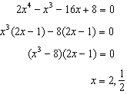

PTS: 2 REF: 012307aii NAT: A.APR.B.2 TOP: Remainder and Factor Theorems

8 ANS: 3
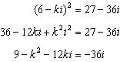
Set real part equal to real part: 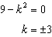 Set imaginary part equal to imaginary part: 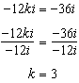

PTS: 2 REF: 012308aii NAT: N.CN.A.2 TOP: Operations with Complex Numbers

9 ANS: 3
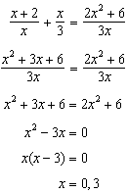 0 is extraneous.

PTS: 2 REF: 012309aii NAT: A.REI.A.2 TOP: Solving Rationals

10 ANS: 4
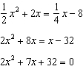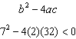

PTS: 2 REF: 012310aii NAT: A.REI.C.7 TOP: Quadratic-Linear Systems

11 ANS: 2 PTS: 2 REF: 012311aii NAT: A.APR.C.4
TOP: Polynomial Identities

12 ANS: 3
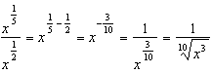

PTS: 2 REF: 012312aii NAT: N.RN.A.2 TOP: Radicals and Rational Exponents

13 ANS: 2
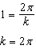

PTS: 2 REF: 012313aii NAT: F.TF.B.5 TOP: Modeling Trigonometric Functions

14 ANS: 4 PTS: 2 REF: 012314aii NAT: S.IC.B.3
TOP: Analysis of Data

15 ANS: 3
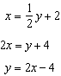

PTS: 2 REF: 012315aii NAT: F.BF.B.4 TOP: Inverse of Functions
KEY: linear

16 ANS: 2
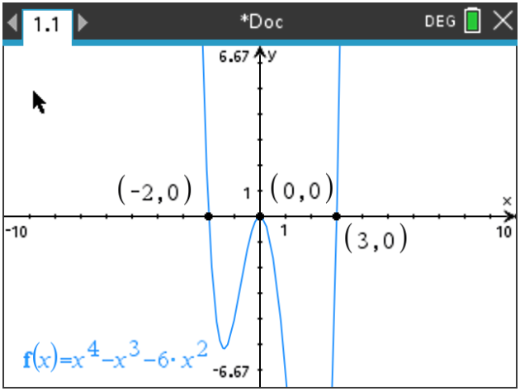

PTS: 2 REF: 012316aii NAT: F.IF.B.4 TOP: Graphing Polynomial Functions

17 ANS: 3
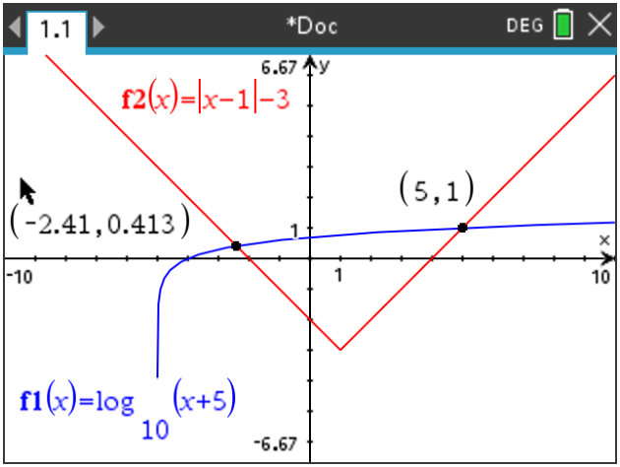

PTS: 2 REF: 012317aii NAT: A.REI.D.11 TOP: Other Systems

18 ANS: 2
1) ; 3) quartic polynomial; 4) three real roots

PTS: 2 REF: 012318aii NAT: A.APR.B.3 TOP: Graphing Polynomial Functions

19 ANS: 4
or 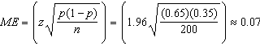

PTS: 2 REF: 012319aii NAT: S.IC.B.4 TOP: Analysis of Data

20 ANS: 3
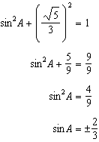 Since , 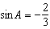

PTS: 2 REF: 012320aii NAT: F.TF.C.8 TOP: Determining Trigonometric Functions

21 ANS: 2 PTS: 2 REF: 012321aii NAT: F.BF.A.2
TOP: Sequences

22 ANS: 4
The distance between the focus and directrix is . p is half this distance, or 2. The vertex of the parabola is . Since the directrix is above the focus, the parabola faces downward. 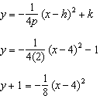

PTS: 2 REF: 012322aii NAT: G.GPE.A.2 TOP: Graphing Quadratic Functions

23 ANS: 1
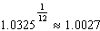

PTS: 2 REF: 012323aii NAT: A.SSE.B.3 TOP: Modeling Exponential Functions

24 ANS: 2
1) 1 real, mult. 2; 3) not a quadratic; 4) not a function.

PTS: 2 REF: 012324aii NAT: F.IF.C.7 TOP: Graphing Polynomial Functions

25 ANS:
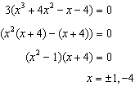

PTS: 2 REF: 012325aii NAT: A.APR.B.3 TOP: Solving Polynomial Equations

26 ANS:
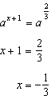

PTS: 2 REF: 012326aii NAT: A.CED.A.1 TOP: Exponential Equations
KEY: common base shown

27 ANS:
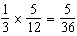

PTS: 2 REF: 012327aii NAT: S.CP.A.2 TOP: Probability of Compound Events
KEY: probability

28 ANS:
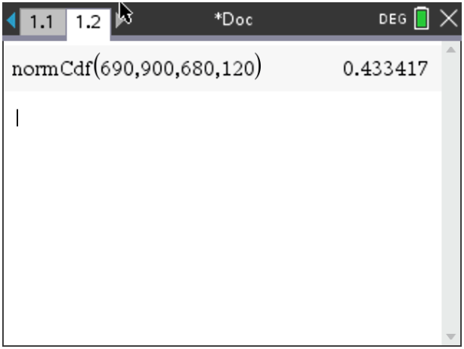 43

PTS: 2 REF: 012328aii NAT: S.ID.A.4 TOP: Normal Distributions
KEY: percent

29 ANS:

PTS: 2 REF: 012329aii NAT: S.ID.B.6 TOP: Regression
KEY: exponential

30 ANS:
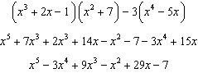

PTS: 2 REF: 012330aii NAT: F.BF.A.1 TOP: Operations with Functions

31 ANS:
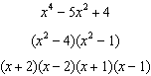

PTS: 2 REF: 012331aii NAT: A.SSE.A.2 TOP: Factoring Polynomials

32 ANS:
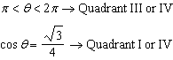 must be in Quadrant IV, where is negative.

PTS: 2 REF: 012332aii NAT: F.TF.A.2 TOP: Finding the Terminal Side of an Angle

33 ANS:
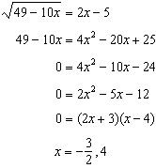 is extraneous.

PTS: 4 REF: 012333aii NAT: A.REI.A.2 TOP: Solving Radicals
KEY: extraneous solutions

34 ANS:
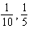, and no, since 0.10 clearly falls within 95% of 0.20.

PTS: 4 REF: 012334aii NAT: S.IC.A.2 TOP: Analysis of Data

35 ANS:
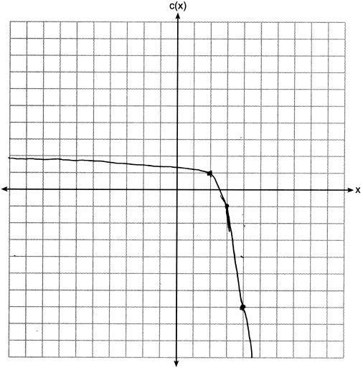 . .

PTS: 4 REF: 012335aii NAT: F.IF.C.7 TOP: Graphing Exponential Functions

36 ANS:
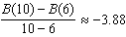. The average monthly high temperature decreases about 4º each month from June and October.

PTS: 4 REF: 012336aii NAT: F.IF.B.6 TOP: Rate of Change

37 ANS:
, , 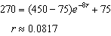, 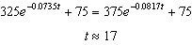

PTS: 6 REF: 012337aii NAT: A.CED.A.1

