1 The expression is equivalent to
1) | 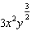 | 3) | 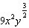
2) |  | 4)

2 Chet has $1200 invested in a bank account modeled by the function , where is the value of his account, in dollars, after n months. Chet's debt is modeled by the function , where is the value of debt, in dollars, after n months. After n months, which function represents Chet's net worth, ?
1) |  | 3)
2) |  | 4)

3 Emmeline is working on one side of a polynomial identity proof used to form Pythagorean triples. Her work is shown below:
Step 1:
Step 2:
Step 3:
Step 4:
What statement is true regarding Emmeline's work?
1) | Emmeline's work is entirely correct. | 3) | There are mistakes in step 2 and step 4.
2) | There is a mistake in step 2, only. | 4) | There is a mistake in step 4, only.

4 Susan won $2,000 and invested it into an account with an annual interest rate of 3.2%. If her investment were compounded monthly, which expression best represents the value of her investment after t years?
1) |  | 3) | 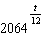
2) | 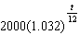 | 4) | 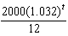

5 Consider the end behavior description below.
• as
• as
Which function satisfies the given conditions?
1) |  | 3)
2) | 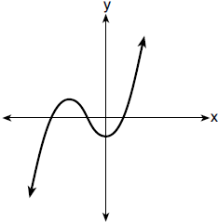 | 4) | 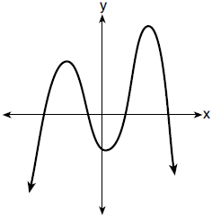

6 The expression is equivalent to
1) |  | 3)
2) |  | 4)

7 Given , the expression 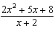 is equivalent to
1) | 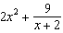 | 3) | 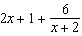
2) | 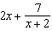 | 4) | 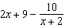

8 Which situation best describes conditional probability?
1) | finding the probability of an event occurring two or more times | 3) | finding the probability of two independent events occurring at the same time
2) | finding the probability of an event occurring only once | 4) | finding the probability of an event occurring given another event had already occurred

9 Which expression is not a solution to the equation ?
1) | 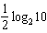 | 3)
2) |  | 4)

10 What is the solution set of ?
1) |  | 3)
2) |  | 4)

11 Consider the data in the table below.
 | Right Handed | Left Handed
Male | 87 | 13
Female | 89 | 11

What is the probability that a randomly selected person is male given the person is left handed?
1) |  | 3)
2) |  | 4)

12 The function can be used to predict the temperature of a cup of hot chocolate in degrees Fahrenheit after x minutes. What is the approximate average rate of change of the temperature of the hot chocolate, in degrees per minute, over the interval ?
1) |  | 3) | 0.11
2) |  | 4) | 8.93

13 A recursive formula for the sequence is
1) | 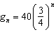 | 3) | 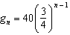
2) | 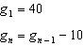 | 4) | 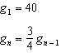

14 The J& B candy company claims that 45% of the candies it produces are blue, 30% are brown, and 25% are yellow. Each bag holds 65 candies. A simulation was run 200 times, each of sample size 65, based on the premise that 45% of the candies are blue. The results of the simulation are shown below.

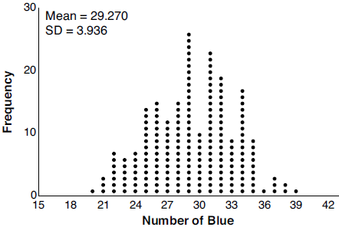

Bonnie purchased a bag of J& B's candy and counted 24 blue candies. What inference can be made regarding a bag of J& B's with only 24 blue candies?
1) | The company is not meeting their production standard. | 3) | The company should change their claim to 37% blue candies are produced.
2) | Bonnie's bag was a rarity and the company should not be concerned. | 4) | Bonnie's bag is within the middle 95% of the simulated data supporting the company's claim.

15 Which investigation technique is most often used to determine if a single variable has an impact on a given population?
1) | observational study | 3) | controlled experiment
2) | random survey | 4) | formal interview

16 As increases from to 0 radians, the value of will
1) | decrease from 1 to 0 | 3) | increase from to 0
2) | decrease from 0 to | 4) | increase from 0 to 1

17 Consider the following patterns:
I.
II.
III.
IV. 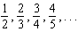
Which pattern is geometric?
1) | I | 3) | III
2) | II | 4) | IV

18 Consider the system below.

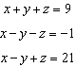

Which value is not in the solution, , of the system?
1) |  | 3) | 11
2) |  | 4) | 4

19 Which statement regarding polynomials and their zeros is true?
1) | has zeros of 1 and , only. | 3) | has zeros of and .
2) | has zeros of 4 and a, only. | 4) | has zeros of and a.

20 If a solution of is expressed in simplest form, the value of b is
1) | 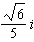 | 3)
2) |  | 4)

21 Which value, to the nearest tenth, is the smallest solution of if 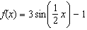 and ?
1) |  | 3)
2) |  | 4) | 1.4

22 Expressed in simplest form, is
1) |  | 3)
2) |  | 4)

23 Written in simplest form, the fraction 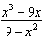, where , is equivalent to
1) |  | 3) | 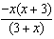
2) |  | 4) | 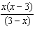

24 According to a study, 45% of Americans have type O blood. If a random number generator produces three-digit values from 000 to 999, which values would represent those having type O blood?
1) | between 000 and 045, inclusive | 3) | between 000 and 449, inclusive
2) | between 000 and 444, inclusive | 4) | between 000 and 450, inclusive

25 For n and , is the expression 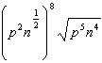 equivalent to ? Justify your answer.

26 Show why is a factor of . Justify your answer.

27 Describe the transformation applied to the graph of that forms the new function .

28 The parabola 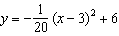 has its focus at . Determine and state the equation of the directrix. (The use of the grid below is optional.)



29 Given the geometric series write a geometric series formula, , for the sum of the first n terms. Use the formula to find the sum of the first 10 terms, to the nearest tenth.

30 Visible light can be represented by sinusoidal waves. Three visible light waves are shown in the graph below. The midline of each wave is labeled .

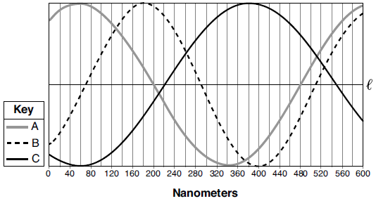

Based on the graph, which light wave has the longest period? Justify your answer.

31 Biologists are studying a new bacterium. They create a culture with 100 of the bacteria and anticipate that the number of bacteria will double every 30 hours. Write an equation for the number of bacteria, B, in terms of the number of hours, t, since the experiment began.

32 Graph on the set of axes below.

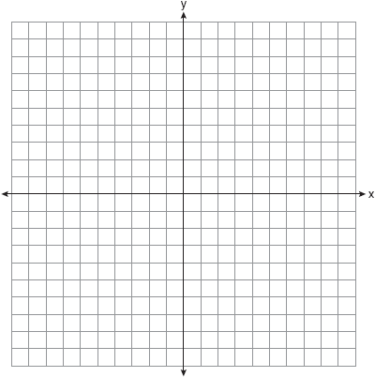

33 Sonja is cutting wire to construct a mobile. She cuts 100 inches for the first piece, 80 inches for the second piece, and 64 inches for the third piece. Assuming this pattern continues, write an explicit equation for , the length in inches of the nth piece. Sonja only has 40 feet of wire to use for the project and wants to cut 20 pieces total for the mobile using her pattern. Will she have enough wire? Justify your answer.

34 Graph the following function on the axes below.

State the domain of f. State the equation of the asymptote.

35 Algebraically solve the following system of equations.
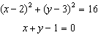

36 The table below gives air pressures in kPa at selected altitudes above sea level measured in kilometers.

x | Altitude (km) | 0 | 1 | 2 | 3 | 4 | 5
y | Air Pressure (kPa) | 101 | 90 | 79 | 70 | 62 | 54

Write an exponential regression equation that models these data rounding all values to the nearest thousandth. Use this equation to algebraically determine the altitude, to the nearest hundredth of a kilometer, when the air pressure is 29 kPa.

37 Sarah is fighting a sinus infection. Her doctor prescribed a nasal spray and an antibiotic to fight the infection. The active ingredients, in milligrams, remaining in the bloodstream from the nasal spray, , and the antibiotic, , are modeled in the functions below, where t is the time in hours since the medications were taken.
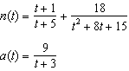
Determine which drug is made with a greater initial amount of active ingredient. Justify your answer. Sarah's doctor told her to take both drugs at the same time. Determine algebraically the number of hours after taking the medications when both medications will have the same amount of active ingredient remaining in her bloodstream.
1 ANS: 1
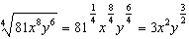

PTS: 2 REF: 012001aii NAT: N.RN.A.2 TOP: Radicals and Rational Exponents
KEY: variables

2 ANS: 3 PTS: 2 REF: 012002aii NAT: F.BF.A.1
TOP: Operations with Functions

3 ANS: 3 PTS: 2 REF: 012003aii NAT: A.APR.C.4
TOP: Polynomial Identities

4 ANS: 1
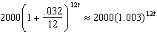

PTS: 2 REF: 012004aii NAT: F.BF.A.1 TOP: Modeling Exponential Functions

5 ANS: 3 PTS: 2 REF: 012005aii NAT: F.IF.B.4
TOP: Graphing Polynomial Functions

6 ANS: 3
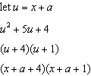

PTS: 2 REF: 012006aii NAT: A.SSE.A.2 TOP: Factoring Polynomials
KEY: multivariable

7 ANS: 3
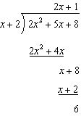

PTS: 2 REF: 012007aii NAT: A.APR.D.6 TOP: Rational Expressions
KEY: division

8 ANS: 4 PTS: 2 REF: 012008aii NAT: S.CP.A.3
TOP: Conditional Probability

9 ANS: 4
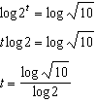 2) 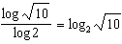, 1) 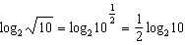, 3) 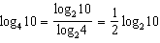

PTS: 2 REF: 012009aii NAT: F.LE.A.4 TOP: Exponential Equations
KEY: without common base

10 ANS: 2
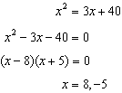. is an extraneous solution.

PTS: 2 REF: 012010aii NAT: A.REI.A.2 TOP: Solving Radicals
KEY: extraneous solutions

11 ANS: 4
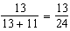

PTS: 2 REF: 012011aii NAT: S.CP.A.4 TOP: Conditional Probability

12 ANS: 1
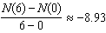

PTS: 2 REF: 012012aii NAT: F.IF.B.6 TOP: Rate of Change

13 ANS: 4
(1) and (3) are not recursive

PTS: 2 REF: 012013aii NAT: F.LE.A.2 TOP: Sequences
KEY: recursive

14 ANS: 4 PTS: 2 REF: 012014aii NAT: S.IC.B.5
TOP: Analysis of Data

15 ANS: 3 PTS: 2 REF: 012015aii NAT: S.IC.B.3
TOP: Analysis of Data KEY: type

16 ANS: 4 PTS: 2 REF: 012016aii NAT: F.IF.B.4
TOP: Graphing Trigonometric Functions KEY: increasing/decreasing

17 ANS: 1
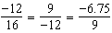

PTS: 2 REF: 012017aii NAT: F.IF.A.3 TOP: Sequences
KEY: difference or ratio

18 ANS: 1
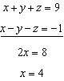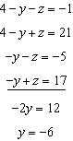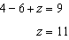

PTS: 2 REF: 012018aii NAT: A.REI.C.6 TOP: Solving Linear Systems
KEY: three variables

19 ANS: 4
1) is also a zero. 2) a is the only zero. 3) is the only zero. 4) .

PTS: 2 REF: 012019aii NAT: A.APR.B.3 TOP: Solving Polynomial Equations

20 ANS: 2
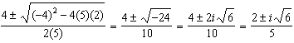

PTS: 2 REF: 012020aii NAT: A.REI.B.4 TOP: Solving Quadratics
KEY: complex solutions | quadratic formula

21 ANS: 2
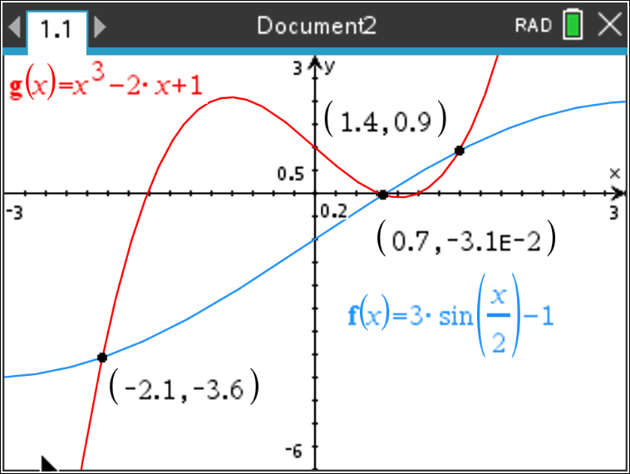

PTS: 2 REF: 012021aii NAT: A.REI.D.11 TOP: Other Systems

22 ANS: 1

PTS: 2 REF: 012022aii NAT: N.CN.A.2 TOP: Operations with Complex Numbers

23 ANS: 1
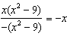

PTS: 2 REF: 012023aii NAT: A.APR.D.6 TOP: Rational Expressions
KEY: factoring

24 ANS: 3
between 000 and 449, inclusive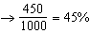

PTS: 2 REF: 012024aii NAT: S.IC.B.3 TOP: Analysis of Data
KEY: type

25 ANS:
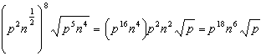

PTS: 2 REF: 012025aii NAT: N.RN.A.2 TOP: Radicals and Rational Exponents

26 ANS:
Since , there is no remainder when is divided by , and so is a factor.

PTS: 2 REF: 012026aii NAT: A.APR.B.2 TOP: Remainder Theorem

27 ANS:
Translation 3 units right and 4 units up

PTS: 2 REF: 012027aii NAT: F.IF.C.7 TOP: Graphing Exponential Functions

28 ANS:
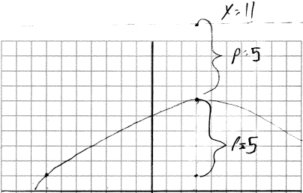 vertex , focus , , directrix

PTS: 2 REF: 012028aii NAT: G.GPE.A.2 TOP: Graphing Quadratic Functions

29 ANS:
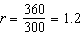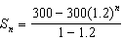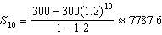

PTS: 2 REF: 012029aii NAT: A.SSE.B.4 TOP: Series

30 ANS:
Light wave C. The periods for A, B, and C are 280, 220 and 320.

PTS: 2 REF: 012030aii NAT: F.IF.C.7 TOP: Graphing Trigonometric Functions
KEY: period

31 ANS:
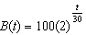

PTS: 2 REF: 012031aii NAT: F.LE.A.2 TOP: Modeling Exponential Functions

32 ANS:
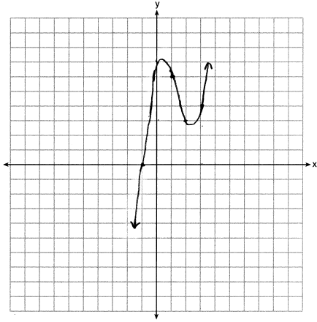

PTS: 2 REF: 012032aii NAT: F.IF.C.7 TOP: Graphing Polynomial Functions

33 ANS:
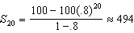 No, because .

PTS: 4 REF: 012033aii NAT: A.SSE.B.4 TOP: Series

34 ANS:
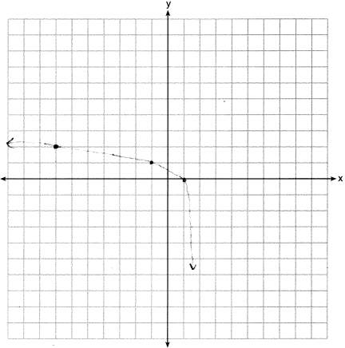Domain: , Asymptote

PTS: 4 REF: 012034aii NAT: F.IF.C.7 TOP: Graphing Logarithmic Functions

35 ANS:
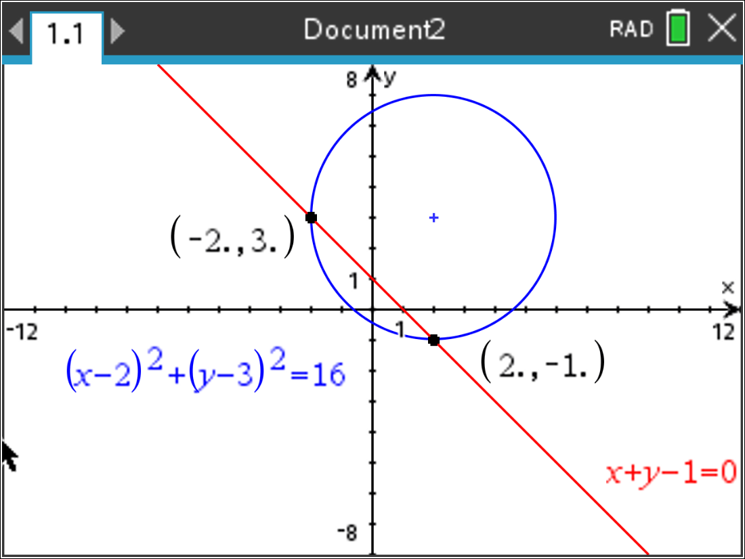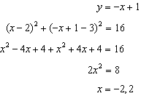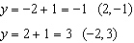

PTS: 4 REF: 012035aii NAT: A.REI.C.7 TOP: Quadratic-Linear Systems

36 ANS:
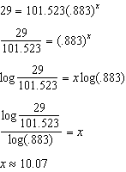

PTS: 4 REF: 012036aii NAT: S.ID.B.6 TOP: Regression
KEY: exponential

37 ANS:
antibiotic 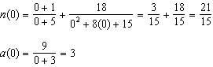 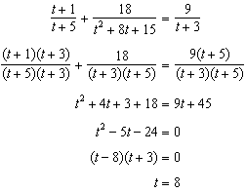

PTS: 6 REF: 012037aii NAT: A.REI.A.2 TOP: Solving Rationals
KEY: rational solutions

