1 Suppose two sets of test scores have the same mean, but different standard deviations, and , with . Which statement best describes the variability of these data sets?
1) | Data set one has the greater variability. | 3) | The variability will be the same for each data set.
2) | Data set two has the greater variability. | 4) | No conclusion can be made regarding the variability of either set.

2 If and is the image of after a translation five units to the left, which equation represents ?
1) |  | 3)
2) |  | 4)

3 When factoring to reveal the roots of the equation , which equations can be used?
I.
II.
III.
1) | I and II, only | 3) | II and III, only
2) | I and III, only | 4) | I, II, and III

4 When a ball bounces, the heights of consecutive bounces form a geometric sequence. The height of the first bounce is 121 centimeters and the height of the third bounce is 64 centimeters. To the nearest centimeter, what is the height of the fifth bounce?
1) | 25 | 3) | 36
2) | 34 | 4) | 42

5 The solutions to the equation are
1) | 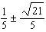 | 3) | 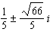
2) | 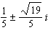 | 4) | 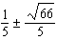

6 Julia deposits $2000 into a savings account that earns 4% interest per year. The exponential function that models this savings account is , where t is the time in years. Which equation correctly represents the amount of money in her savings account in terms of the monthly growth rate?
1) |  | 3)
2) |  | 4)

7 Tides are a periodic rise and fall of ocean water. On a typical day at a seaport, to predict the time of the next high tide, the most important value to have would be the
1) | time between consecutive low tides | 3) | average depth of water over a 24-hour period
2) | time when the tide height is 20 feet | 4) | difference between the water heights at low and high tide

8 An estimate of the number of milligrams of a medication in the bloodstream t hours after 400 mg has been taken can be modeled by the function below.
,
where
Over what time interval does the amount of medication in the bloodstream strictly increase?
1) | 0 to 2 hours | 3) | 2 to 6 hours
2) | 0 to 3 hours | 4) | 3 to 6 hours

9 Which representation of a quadratic has imaginary roots?
1) | 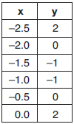 | 3) | 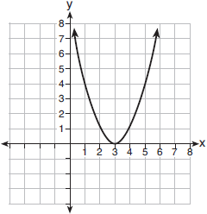
2) |  | 4)

10 A random sample of 100 people that would best estimate the proportion of all registered voters in a district who support improvements to the high school football field should be drawn from registered voters in the district at a
1) | football game
2) | supermarket
3) | school fund-raiser
4) | high school band concert

11 Which expression is equivalent to where i is the imaginary unit and x is a real number?
1) |  | 3) | 2
2) |  | 4)

12 Suppose events A and B are independent and is 0.2. Which statement could be true?
1) |  | 3)
2) |  | 4)

13 The function is plotted on the graph shown below.

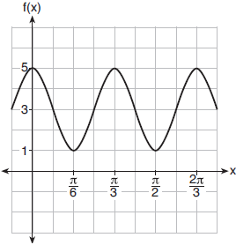

What are the values of a, b, and c?
1) |  | 3)
2) |  | 4) | 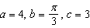

14 Which equation represents the equation of the parabola with focus and directrix ?
1) | 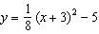 | 3) | 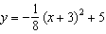
2) | 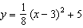 | 4) | 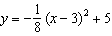

15 What is the solution set of the equation 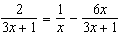?
1) | 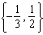 | 3)
2) | 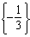 | 4) | 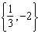

16 Savannah just got contact lenses. Her doctor said she can wear them 2 hours the first day, and can then increase the length of time by 30 minutes each day. If this pattern continues, which formula would not be appropriate to determine the length of time, in either minutes or hours, she could wear her contact lenses on the nth day?
1) | 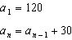 | 3) | 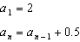
2) |  | 4)

17 If where , then the inverse of the function is
1) |  | 3)
2) |  | 4)

18 Kelly-Ann has $20,000 to invest. She puts half of the money into an account that grows at an annual rate of 0.9% compounded monthly. At the same time, she puts the other half of the money into an account that grows continuously at an annual rate of 0.8%. Which function represents the value of Kelly-Ann's investments after t years?
1) |  | 3)
2) |  | 4)

19 Which graph represents a polynomial function that contains as a factor?
1) | 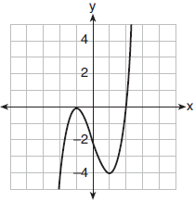 | 3) | 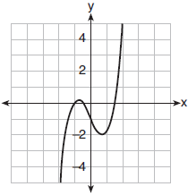
2) | 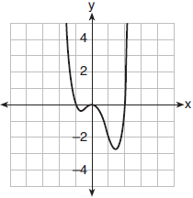 | 4) | 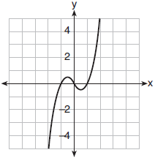

20 Sodium iodide-131, used to treat certain medical conditions, has a half-life of 1.8 hours. The data table below shows the amount of sodium iodide-131, rounded to the nearest thousandth, as the dose fades over time.

Number  of  Half Lives | 1 | 2 | 3 | 4 | 5
Amount of  Sodium  Iodide-131 | 139.000 | 69.500 | 34.750 | 17.375 | 8.688

What approximate amount of sodium iodide-131 will remain in the body after 18 hours?
1) | 0.001 | 3) | 0.271
2) | 0.136 | 4) | 0.543

21 Which expression(s) are equivalent to 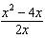, where ?
I. 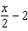 II. 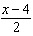 III. 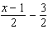
1) | II, only | 3) | II and III
2) | I and II | 4) | I, II, and III

22 Consider , and defined by the graph below.

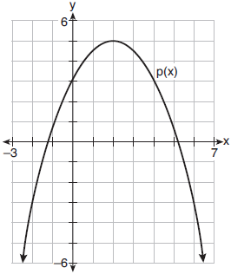

The difference between the values of the maximum of p and minimum of f is
1) | 0.25 | 3) | 3.25
2) | 1.25 | 4) | 10.25

23 The scores on a mathematics college-entry exam are normally distributed with a mean of 68 and standard deviation 7.2. Students scoring higher than one standard deviation above the mean will not be enrolled in the mathematics tutoring program. How many of the 750 incoming students can be expected to be enrolled in the tutoring program?
1) | 631 | 3) | 238
2) | 512 | 4) | 119

24 How many solutions exist for 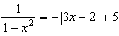?
1) | 1 | 3) | 3
2) | 2 | 4) | 4

25 Justify why 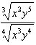 is equivalent to 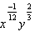 using properties of rational exponents, where and .

26 The zeros of a quartic polynomial function are 2, , 4, and . Use the zeros to construct a possible sketch of the function, on the set of axes below.

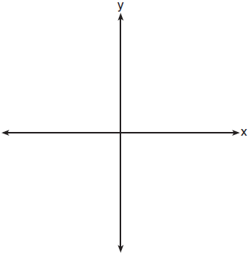

27 Erin and Christa were working on cubing binomials for math homework. Erin believed they could save time with a shortcut. She wrote down the rule below for Christa to follow.
Does Erin's shortcut always work? Justify your result algebraically.

28 The probability that a resident of a housing community opposes spending money for community improvement on plumbing issues is 0.8. The probability that a resident favors spending money on improving walkways given that the resident opposes spending money on plumbing issues is 0.85. Determine the probability that a randomly selected resident opposes spending money on plumbing issues and favors spending money on walkways.

29 Rowan is training to run in a race. He runs 15 miles in the first week, and each week following, he runs 3% more than the week before. Using a geometric series formula, find the total number of miles Rowan runs over the first ten weeks of training, rounded to the nearest thousandth.

30 The average monthly high temperature in Buffalo, in degrees Fahrenheit, can be modeled by the function , where t is the month number . State, to the nearest tenth, the average monthly rate of temperature change between August and November. Explain its meaning in the given context.

31 Point 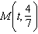 is located in the second quadrant on the unit circle. Determine the exact value of t.

32 On the grid below, graph the function

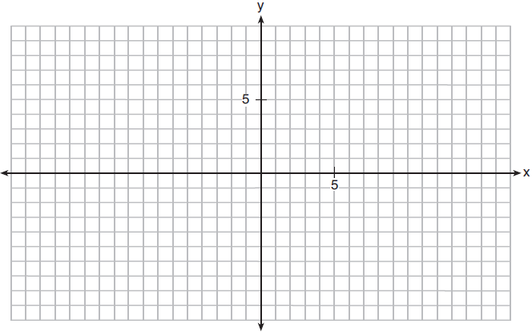

33 Solve the following system of equations algebraically for all values of a, b, and c.
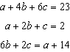

34 Given and , determine in the form 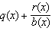. Is a factor of ? Explain.

35 A radio station claims to its advertisers that the mean number of minutes commuters listen to the station is 30. The station conducted a survey of 500 of their listeners who commute. The sample statistics are shown below.

29.11
20.718

A simulation was run 1000 times based upon the results of the survey. The results of the simulation appear below.

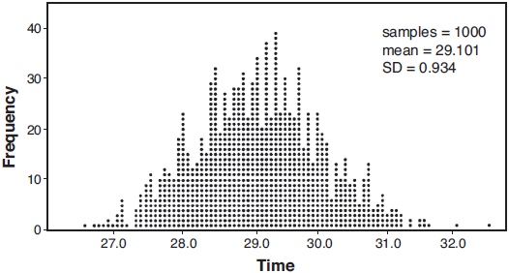

Based on the simulation results, is the claim that commuters listen to the station on average 30 minutes plausible? Explain your response including an interval containing the middle 95% of the data, rounded to the nearest hundredth.

36 Solve the given equation algebraically for all values of x.

37 Tony is evaluating his retirement savings. He currently has $318,000 in his account, which earns an interest rate of 7% compounded annually. He wants to determine how much he will have in the account in the future, even if he makes no additional contributions to the account. Write a function, , to represent the amount of money that will be in his account in t years. Graph where on the set of axes below.

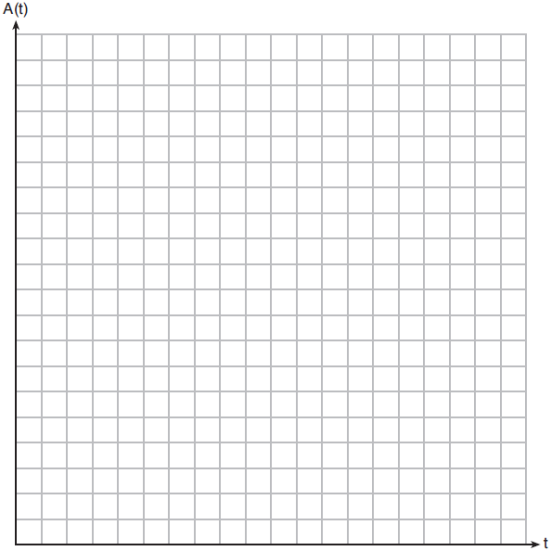

Tony's goal is to save $1,000,000. Determine algebraically, to the nearest year, how many years it will take for him to achieve his goal. Explain how your graph of confirms your answer.
1 ANS: 2 PTS: 2 REF: 011901aii NAT: S.ID.A.4
TOP: Normal Distributions KEY: mean and standard deviation

2 ANS: 1 PTS: 2 REF: 011902aii NAT: F.IF.C.7
TOP: Graphing Logarithmic Functions

3 ANS: 1
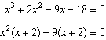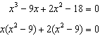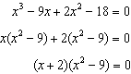

PTS: 2 REF: 011903aii NAT: A.APR.B.3 TOP: Solving Polynomial Equations

4 ANS: 2
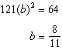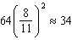

PTS: 2 REF: 011904aii NAT: F.IF.A.3 TOP: Sequences
KEY: term

5 ANS: 2
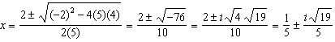

PTS: 2 REF: 011905aii NAT: A.REI.B.4 TOP: Solving Quadratics
KEY: complex solutions | quadratic formula

6 ANS: 3
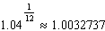

PTS: 2 REF: 011906aii NAT: A.SSE.B.3 TOP: Modeling Exponential Functions

7 ANS: 1
The time of the next high tide will be the midpoint of consecutive low tides.

PTS: 2 REF: 011907aii NAT: F.IF.C.7 TOP: Graphing Trigonometric Functions
KEY: mixed

8 ANS: 1
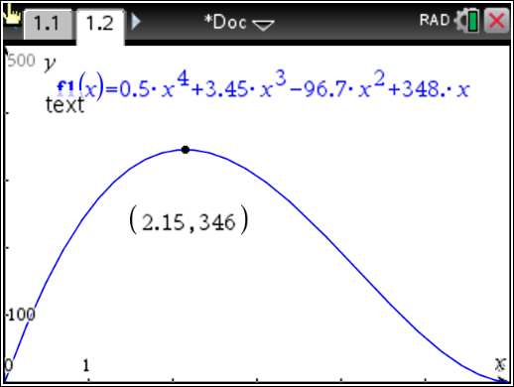

PTS: 2 REF: 011908aii NAT: F.IF.B.4 TOP: Graphing Polynomial Functions

9 ANS: 4
(1) quadratic has two roots and both are real and , (2) , (3) the real root is 3, with a multiplicity of 2, (4)

PTS: 2 REF: 011909aii NAT: A.REI.B.4 TOP: Using the Discriminant
KEY: determine nature of roots given equation, graph, table

10 ANS: 2 PTS: 2 REF: 011910aii NAT: S.IC.B.3
TOP: Analysis of Data KEY: bias

11 ANS: 1
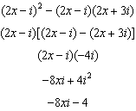

PTS: 2 REF: 011911aii NAT: N.CN.A.2 TOP: Operations with Complex Numbers

12 ANS: 2
(1) , (2) , (3) 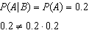, (4)

PTS: 2 REF: 011912aii NAT: S.CP.A.3 TOP: Conditional Probability

13 ANS: 1
The cosine function has been translated +3. Since the maximum is 5 and the minimum is 1, the amplitude is 2. 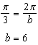.

PTS: 2 REF: 011913aii NAT: F.TF.B.5 TOP: Modeling Trigonometric Functions

14 ANS: 3
The vertex is and . 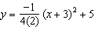

PTS: 2 REF: 011914aii NAT: G.GPE.A.2 TOP: Graphing Quadratic Functions

15 ANS: 3
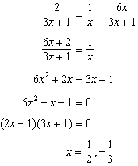 is extraneous.

PTS: 2 REF: 011915aii NAT: A.REI.A.2 TOP: Solving Rationals

16 ANS: 4

PTS: 2 REF: 011916aii NAT: F.LE.A.2 TOP: Sequences

17 ANS: 3 PTS: 2 REF: 011917aii NAT: F.BF.B.4
TOP: Inverse of Functions KEY: other

18 ANS: 4
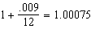

PTS: 2 REF: 011918aii NAT: A.SSE.B.3 TOP: Modeling Exponential Functions

19 ANS: 1

PTS: 2 REF: 011919aii NAT: A.APR.B.3 TOP: Graphing Polynomial Functions

20 ANS: 3
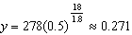

PTS: 2 REF: 011920aii NAT: F.LE.A.2 TOP: Modeling Exponential Functions

21 ANS: 4
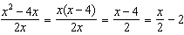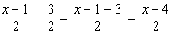

PTS: 2 REF: 011921aii NAT: A.APR.D.6 TOP: Rational Expressions
KEY: factoring

22 ANS: 4
The maximum of p is 5. The minimum of f is (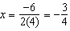 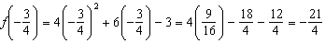). 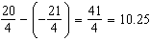

PTS: 2 REF: 011922aii NAT: F.IF.C.9 TOP: Comparing Functions

23 ANS: 1

PTS: 2 REF: 011923aii NAT: S.ID.A.4 TOP: Normal Distributions
KEY: predict

24 ANS: 4
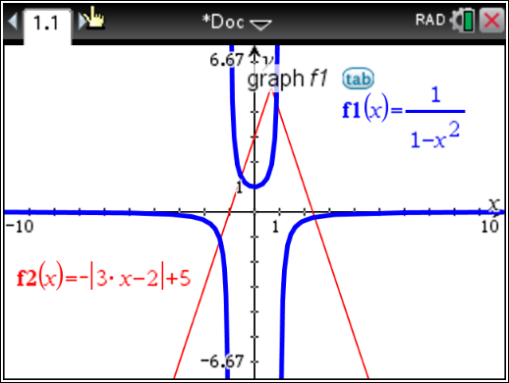

PTS: 2 REF: 011924aii NAT: A.REI.D.11 TOP: Other Systems

25 ANS:
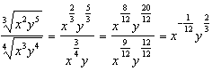

PTS: 2 REF: 011925aii NAT: N.RN.A.2 TOP: Radicals and Rational Exponents
KEY: variables

26 ANS:
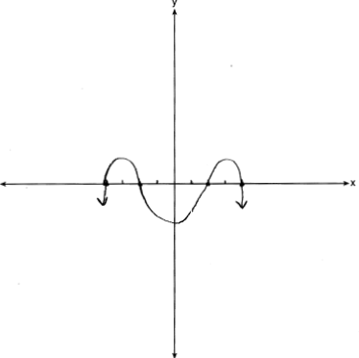

PTS: 2 REF: 011926aii NAT: F.IF.C.7 TOP: Graphing Polynomial Functions

27 ANS:
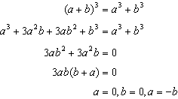No. Erin’s shortcut only works if , or .

PTS: 2 REF: 011927aii NAT: A.APR.C.4 TOP: Polynomial Identities

28 ANS:

PTS: 2 REF: 011928aii NAT: S.CP.A.3 TOP: Conditional Probability

29 ANS:
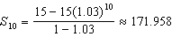

PTS: 2 REF: 011929aii NAT: A.SSE.B.4 TOP: Series

30 ANS:
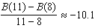 The average monthly high temperature decreases 10.1º each month from August to November.

PTS: 2 REF: 011930aii NAT: F.IF.B.6 TOP: Rate of Change

31 ANS:
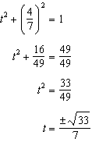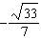

PTS: 2 REF: 011931aii NAT: F.TF.A.2 TOP: Unit Circle

32 ANS:
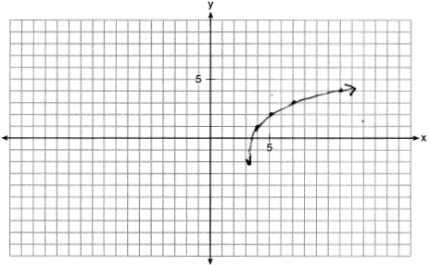

PTS: 2 REF: 011932aii NAT: F.IF.C.7 TOP: Graphing Logarithmic Functions

33 ANS:
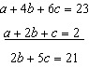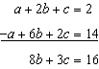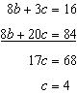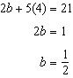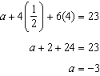

PTS: 4 REF: 011933aii NAT: A.REI.C.6 TOP: Solving Linear Systems
KEY: three variables

34 ANS:
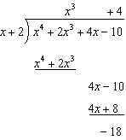 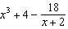. No, because there is a remainder.

PTS: 4 REF: 011934aii NAT: A.APR.D.6 TOP: Rational Expressions
KEY: division

35 ANS:
. Yes, since 30 falls within the 95% interval.

PTS: 4 REF: 011935aii NAT: S.IC.A.2 TOP: Analysis of Data

36 ANS:
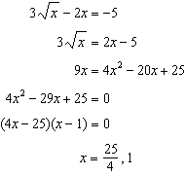1 is extraneous.

PTS: 4 REF: 011936aii NAT: A.REI.A.2 TOP: Solving Radicals
KEY: extraneous solutions

37 ANS:
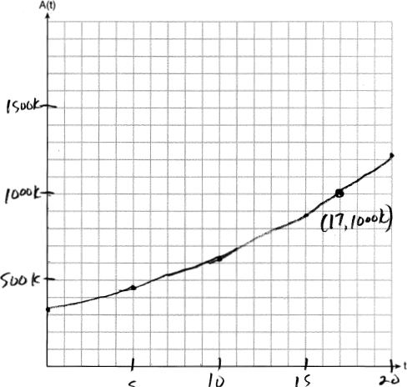 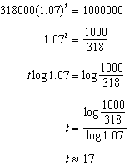 The graph of nearly intersects the point .

PTS: 6 REF: 011937aii NAT: A.CED.A.1 TOP: Exponential Growth

