1 The operator of the local mall wants to find out how many of the mall's employees make purchases in the food court when they are working. She hopes to use these data to increase the rent and attract new food vendors. In total, there are 1023 employees who work at the mall. The best method to obtain a random sample of the employees would be to survey
1) | all 170 employees at each of the larger stores
2) | 50% of the 90 employees of the food court
3) | every employee
4) | every 30th employee entering each mall entrance for one week

2 What is the solution set for x in the equation below?
1) |  | 3)
2) |  | 4)

3 For the system shown below, what is the value of z?
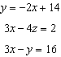
1) | 5 | 3) | 6
2) | 2 | 4) | 4

4 The hours of daylight, y, in Utica in days, x, from January 1, 2013 can be modeled by the equation . How many hours of daylight, to the nearest tenth, does this model predict for February 14, 2013?
1) | 9.4 | 3) | 12.1
2) | 10.4 | 4) | 12.2

5 A certain pain reliever is taken in 220 mg dosages and has a half-life of 12 hours. The function 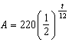 can be used to model this situation, where A is the amount of pain reliever in milligrams remaining in the body after t hours. According to this function, which statement is true?
1) | Every hour, the amount of pain reliever remaining is cut in half. | 3) | In 24 hours, there is no pain reliever remaining in the body.
2) | In 12 hours, there is no pain reliever remaining in the body. | 4) | In 12 hours, 110 mg of pain reliever is remaining.

6 The expression can not be written as
1) |  | 3)
2) |  | 4)

7 There are 440 students at Thomas Paine High School enrolled in U.S. History. On the April report card, the students' grades are approximately normally distributed with a mean of 79 and a standard deviation of 7. Students who earn a grade less than or equal to 64.9 must attend summer school. The number of students who must attend summer school for U.S. History is closest to
1) | 3 | 3) | 10
2) | 5 | 4) | 22

8 For a given time, x, in seconds, an electric current, y, can be represented by . Which equation is not equivalent?
1) |  | 3) | 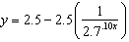
2) | 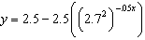 | 4)

9 What is the quotient when is divided by ?
1) |  | 3)
2) |  | 4)

10 Judith puts $5000 into an investment account with interest compounded continuously. Which approximate annual rate is needed for the account to grow to $9110 after 30 years?
1) | 2% | 3) | 0.02%
2) | 2.2% | 4) | 0.022%

11 If and , where , an expression for could be
1) |  | 3)
2) |  | 4)

12 The solutions to 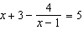 are
1) | 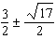 | 3) | 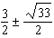
2) | 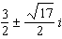 | 4) | 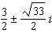

13 If , where a, b, and c are positive, then t equals
1) | 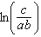 | 3) | 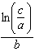
2) | 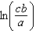 | 4) | 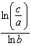

14 For which values of x, rounded to the nearest hundredth, will ?
1) | 2.29 and 3.63 | 3) | 2.84 and 3.17
2) | 2.37 and 3.54 | 4) | 2.92 and 3.06

15 The terminal side of , an angle in standard position, intersects the unit circle at 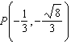. What is the value of ?
1) |  | 3)
2) | 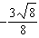 | 4) | 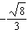

16 What is the equation of the directrix for the parabola ?
1) |  | 3)
2) |  | 4)

17 The function below models the average price of gas in a small town since January 1st.
, where .
If is the average price of gas in dollars and t represents the number of months since January 1st, the absolute maximum reaches over the given domain is about
1) | $1.60 | 3) | $4.01
2) | $3.92 | 4) | $7.73

18 Written in simplest form, 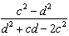 where , is equivalent to
1) | 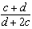 | 3) | 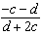
2) | 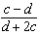 | 4) | 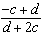

19 If , what is the remainder of ?
1) |  | 3) | 40
2) | 0 | 4) | 240

20 The results of simulating tossing a coin 10 times, recording the number of heads, and repeating this 50 times are shown in the graph below.

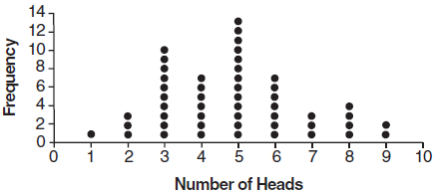

Based on the results of the simulation, which statement is false?
1) | Five heads occurred most often, which is consistent with the theoretical probability of obtaining a heads. | 3) | Obtaining three heads or fewer occurred 28% of the time.
2) | Eight heads is unusual, as it falls outside the middle 95% of the data. | 4) | Seven heads is not unusual, as it falls within the middle 95% of the data.

21 What is the inverse of ?
1) | 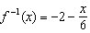 | 3) | 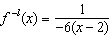
2) | 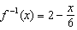 | 4)

22 Brian deposited 1 cent into an empty non-interest bearing bank account on the first day of the month. He then additionally deposited 3 cents on the second day, 9 cents on the third day, and 27 cents on the fourth day. What would be the total amount of money in the account at the end of the 20th day if the pattern continued?
1) | $11,622,614.67 | 3) | $116,226,146.80
2) | $17,433,922.00 | 4) | $1,743,392,200.00

23 If the function represents exponential growth, which statement about is false?
1) | and
2) | The y-intercept is .
3) | The asymptote is .
4) | The x-intercept is .

24 At her job, Pat earns $25,000 the first year and receives a raise of $1000 each year. The explicit formula for the nth term of this sequence is . Which rule best represents the equivalent recursive formula?
1) |  | 3) | ,
2) |  | 4) | ,

25 Elizabeth tried to find the product of and , and her work is shown below.
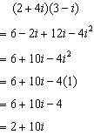
Identify the error in the process shown and determine the correct product of and .

26 A runner is using a nine-week training app to prepare for a "fun run." The table below represents the amount of the program completed, A, and the distance covered in a session, D, in miles.

A |  |  |  |  | 1
D | 2 | 2 | 2.25 | 3 | 3.25

Based on these data, write an exponential regression equation, rounded to the nearest thousandth, to model the distance the runner is able to complete in a session as she continues through the nine-week program.

27 A formula for work problems involving two people is shown below.
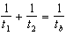
the time taken by the first person to complete the job
the time taken by the second person to complete the job
the time it takes for them working together to complete the job
Fred and Barney are carpenters who build the same model desk. It takes Fred eight hours to build the desk while it only takes Barney six hours. Write an equation that can be used to find the time it would take both carpenters working together to build a desk. Determine, to the nearest tenth of an hour, how long it would take Fred and Barney working together to build a desk.

28 Completely factor the following expression:

29 Researchers in a local area found that the population of rabbits with an initial population of 20 grew continuously at the rate of 5% per month. The fox population had an initial value of 30 and grew continuously at the rate of 3% per month. Find, to the nearest tenth of a month, how long it takes for these populations to be equal.

30 Consider the function and the function q represented in the table below.

x | q(x)
 | 0
0 | 0
1
2 | 0

Determine which function has the smaller minimum value for the domain . Justify your answer.

31 The zeros of a quartic polynomial function h are , , and 3. Sketch a graph of on the grid below.



32 Explain why equals 27.

33 Given: and
Express as a polynomial in standard form.

34 A student is chosen at random from the student body at a given high school. The probability that the student selects Math as the favorite subject is . The probability that the student chosen is a junior is . If the probability that the student selected is a junior or that the student chooses Math as the favorite subject is , what is the exact probability that the student selected is a junior whose favorite subject is Math? Are the events "the student is a junior" and "the student's favorite subject is Math" independent of each other? Explain your answer.

35 In a random sample of 250 men in the United States, age 21 or older, 139 are married. The graph below simulated samples of 250 men, 200 times, assuming that 139 of the men are married.

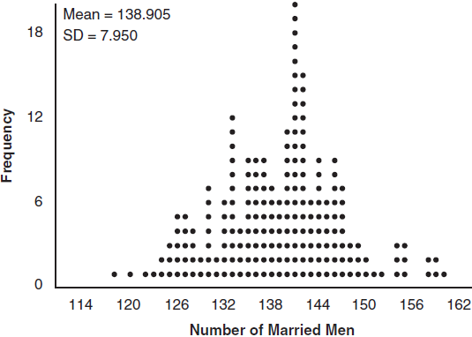

a) Based on the simulation, create an interval in which the middle 95% of the number of married men may fall. Round your answer to the nearest integer.
b) A study claims "50 percent of men 21 and older in the United States are married." Do your results from part a contradict this claim? Explain.

36 The graph of is shown below. The function has a leading coefficient of 1.

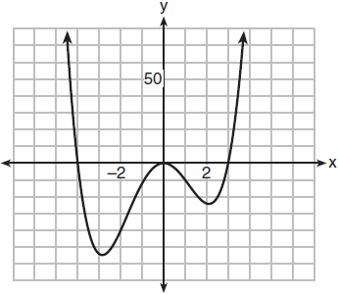

Write an equation for . The function g is formed by translating function f left 2 units. Write an equation for .

37 The resting blood pressure of an adult patient can be modeled by the function P below, where is the pressure in millimeters of mercury after time t in seconds.
On the set of axes below, graph over the domain .

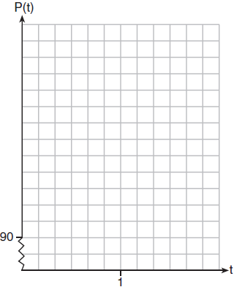

Determine the period of P. Explain what this value represents in the given context. Normal resting blood pressure for an adult is 120 over 80. This means that the blood pressure oscillates between a maximum of 120 and a minimum of 80. Adults with high blood pressure (above 140 over 90) and adults with low blood pressure (below 90 over 60) may be at risk for health disorders. Classify the given patient's blood pressure as low, normal, or high and explain your reasoning.
1 ANS: 4 PTS: 2 REF: 011801aii NAT: S.IC.B.3
TOP: Analysis of Data KEY: bias

2 ANS: 3
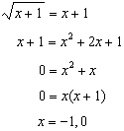

PTS: 2 REF: 011802aii NAT: A.REI.A.2 TOP: Solving Radicals
KEY: extraneous solutions

3 ANS: 4
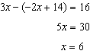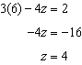

PTS: 2 REF: 011803aii NAT: A.REI.C.6 TOP: Solving Linear Systems
KEY: three variables

4 ANS: 2 PTS: 2 REF: 011804aii NAT: F.TF.A.2
TOP: Determining Trigonometric Functions KEY: radians

5 ANS: 4 PTS: 2 REF: 011805aii NAT: F.LE.B.5
TOP: Modeling Exponential Functions

6 ANS: 2 PTS: 2 REF: 011806aii NAT: A.APR.C.4
TOP: Polynomial Identities

7 ANS: 3

PTS: 2 REF: 011807aii NAT: S.ID.A.4 TOP: Normal Distributions
KEY: predict

8 ANS: 4 PTS: 2 REF: 011808aii NAT: A.SSE.B.3
TOP: Modeling Exponential Functions KEY: AII

9 ANS: 4
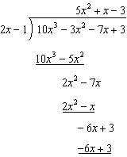

PTS: 2 REF: 011809aii NAT: A.APR.D.6 TOP: Rational Expressions

10 ANS: 1
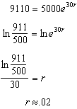

PTS: 2 REF: 011810aii NAT: F.LE.A.4 TOP: Exponential Growth

11 ANS: 4
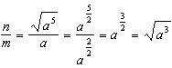

PTS: 2 REF: 011811aii NAT: N.RN.A.2 TOP: Radicals and Rational Exponents
KEY: variables

12 ANS: 1
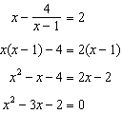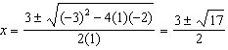

PTS: 2 REF: 011812aii NAT: A.REI.A.2 TOP: Solving Rationals
KEY: rational solutions

13 ANS: 3
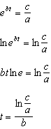

PTS: 2 REF: 011813aii NAT: F.LE.A.4 TOP: Exponential Growth

14 ANS: 1 PTS: 2 REF: 011814aii NAT: A.REI.D.11
TOP: Other Systems KEY: AII

15 ANS: 1 PTS: 2 REF: 011815aii NAT: F.TF.A.2
TOP: Unit Circle

16 ANS: 1
In vertex form, the parabola is 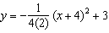. The vertex is and .

PTS: 2 REF: 011816aii NAT: G.GPE.A.2 TOP: Graphing Quadratic Functions

17 ANS: 3
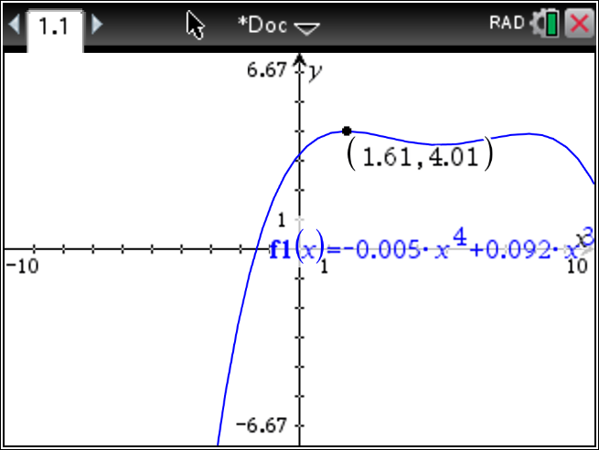

PTS: 2 REF: 011817aii NAT: F.IF.B.4 TOP: Graphing Polynomial Functions

18 ANS: 3
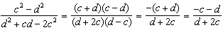

PTS: 2 REF: 011818aii NAT: A.APR.D.6 TOP: Rational Expressions
KEY: a > 0

19 ANS: 4

PTS: 2 REF: 011819aii NAT: A.APR.B.2 TOP: Remainder Theorem

20 ANS: 2 PTS: 2 REF: 011820aii NAT: S.IC.A.2
TOP: Analysis of Data

21 ANS: 2
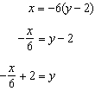

PTS: 2 REF: 011821aii NAT: F.BF.B.4 TOP: Inverse of Functions
KEY: equations

22 ANS: 2
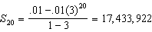

PTS: 2 REF: 011822aii NAT: A.SSE.B.4 TOP: Series

23 ANS: 4
There is no x-intercept.

PTS: 2 REF: 011823aii NAT: F.IF.C.7 TOP: Graphing Exponential Functions
KEY: AII

24 ANS: 3 PTS: 2 REF: 011824aii NAT: F.BF.A.2
TOP: Sequences

25 ANS:
, and not 1;

PTS: 2 REF: 011825aii NAT: N.CN.A.2 TOP: Operations with Complex Numbers

26 ANS:

PTS: 2 REF: 011826aii NAT: S.ID.B.6 TOP: Regression
KEY: exponential AII

27 ANS:
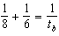; 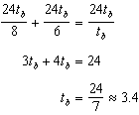

PTS: 2 REF: 011827aii NAT: A.CED.A.1 TOP: Modeling Rationals

28 ANS:

PTS: 2 REF: 011828aii NAT: A.SSE.A.2 TOP: Factoring Polynomials
KEY: factoring by grouping

29 ANS:
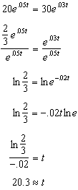

PTS: 2 REF: 011829aii NAT: A.REI.D.11 TOP: Other Systems
KEY: AII

30 ANS:
q has the smaller minimum value for the domain . h’s minimum is and q’s minimum is .

PTS: 2 REF: 011830aii NAT: F.IF.C.9 TOP: Comparing Functions
KEY: AII

31 ANS:
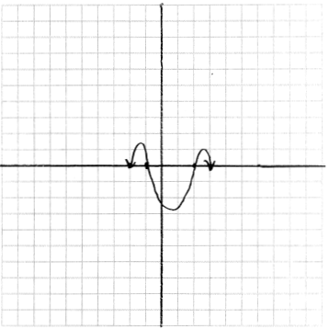

PTS: 2 REF: 011831aii NAT: F.IF.C.7 TOP: Graphing Polynomial Functions

32 ANS:
The denominator of the rational exponent represents the index of a root, and the 4th root of 81 is 3 and 3³ is 27.

PTS: 2 REF: 011832aii NAT: N.RN.A.1 TOP: Radicals and Rational Exponents

33 ANS:
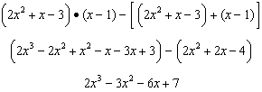

PTS: 4 REF: 011833aii NAT: F.BF.A.1 TOP: Operations with Functions

34 ANS:
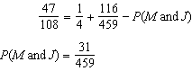; No, because 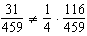

PTS: 4 REF: 011834aii NAT: S.CP.A.3 TOP: Conditional Probability

35 ANS:
. No, since 125 (50% of 250) falls within the 95% interval.

PTS: 4 REF: 011835aii NAT: S.IC.A.2 TOP: Analysis of Data

36 ANS:
;

PTS: 4 REF: 011836aii NAT: A.APR.B.3 TOP: Zeros of Polynomials

37 ANS:
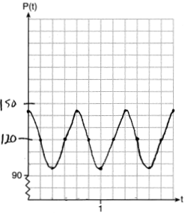 The period of P is , which means the patient’s blood pressure reaches a high every second and a low every second. The patient’s blood pressure is high because 144 over 96 is greater than 120 over 80.

PTS: 6 REF: 011837aii NAT: F.IF.C.7 TOP: Graphing Trigonometric Functions
KEY: graph

